Artificial Intelligence
The University of Toledo
(College of Engineering)
(EECS 4740/5740)

Instructor: Ashish Kharel  Email: Ashish.Kharel@utoledo.edu  Office Hours: T,TR: 2:15PM to 4:00PM  Office Location: NI 2022  Office Phone: (419) 530-8153  Term: Fall 2026  Course Website: Blackboard Learn | Class Location: NE2109  Class Day/Time: TTR, 12.55 pm–2.15 pm  Lab Location: None Day/Time: None  Credit Hours: 3

Assignment 4: Constraint Satisfaction and Logical Agents — Zoning a Map and Exploring Wumpus World in Python (72 points)
Academic Integrity & AI Policy (The "Dumbbell vs. Forklift" Protocol)
In this course, AI tools must function like a dumbbell (building your cognitive capability through deliberate effort), not a forklift (doing the work for you while your skills remain stagnant).
- Prohibited: Copy-pasting problem statements into Large Language Models (LLMs) like ChatGPT, Claude, or Gemini to generate solutions, or submitting text/code written by an AI.
- Permitted: Using AI as a tutoring partner to clarify general background concepts, explain syntax errors, or generate supplementary practice drills.
What This Assignment Is About
Last week had two topics that look unrelated. Lecture 7 showed how to describe a problem as variables, domains, and constraints (a CSP) and solve it with backtracking. Lectures 8 and 9 showed how a Wumpus World agent can prove a square is safe without visiting it, by checking every possible world that fits what it knows. You will run a small version of each in Python. In the end you will see why they belong together: both are a search over assignments of values to variables.
How to Work on It
- Download a4_starter.py from Blackboard. Most of the code is already written. You only fill in a few TODO lines (each one is a single short line). Replace the pass under a TODO with your line. First, type your name in TODO 0.
- Run the file after each part. It prints one section per part, and every section starts with a line Student: your name.

Part 1: Describe the Problem — A CSP for Zoning Eight Towns (16 Points)
We reuse the map from Lecture 7: eight Northwest Ohio towns and thirteen roads. The towns must be sorted into three emergency-dispatch zones, Red, Green, and Blue, so that any two towns joined by a road are in different zones. The starter file already holds the towns, the colors, and the thirteen roads.
Code | Town | Code | Town
T | Toledo | I | Findlay
M | Maumee | L | Lima
B | Bowling Green | N | Napoleon
F | Fremont | S | Sandusky

Question 1.1: Write the Zoning Problem as a CSP (6 Points)
No code. In one short line each: (a) What are the variables? (b) What is the domain of each variable? (c) How many constraints are there, and what does one say? (d) How many colorings would we have to test if we tried every possible one?
The variables are the eight towns: T, M, B, N, F, S, I, L. The domain of each town is Red, Green, Blue. There are 13 constraints and it says that for every road on the map, its town must differ. It would be 3^8=6,516 colorings.
Question 1.2: Look at the Roads (4 Points)
build_neighbors is already written, so run the file as it is. Screenshot the Part 1 output (the list of towns and their neighbors). Your screenshot must show the Student: line with your own name. A screenshot without your name will not be graded. Then answer from the screenshot: (a) Which towns are next to Findlay? (b) Which towns have the fewest roads, and how many?
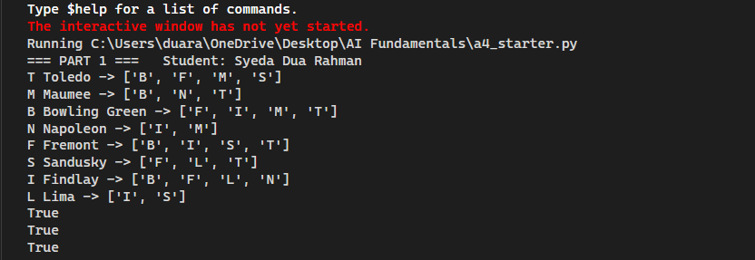
Bowling Green, Fremont, Lima, and Napolean are next to Findlay. Lima and Napolean has the fewest roads- only 2.
Question 1.3: Check One Color Choice (6 Points)
is_consistent answers one question: if we give town this color, does it clash with a neighbor that already has a color? The assignment holds only the towns colored so far, for example {'T': 'Red'}. The loop is written for you. Write the one-line check in TODO 1.
def is_consistent(town, color, assignment, neighbors):
"""
True if giving `town` this `color` clashes with NO neighbor that
already has a color. `assignment` holds only the towns colored so far,
e.g. {'T': 'Red'}. A town that is not in it has no color yet.
"""
for n in neighbors[town]:
# TODO 1: if neighbor n already has this color, return False
# (hint: assignment.get(n) is None when n has no color yet)
pass
return True

In your write-up: (1) your finished is_consistent function, (2) a screenshot of the Part 1 output showing the last three lines (they should read False, True, True). Your screenshot must show the Student: line with your own name. A screenshot without your name will not be graded. (3) One sentence: why is the third result True even though Toledo is Red?
1)
def is_consistent(town, color, assignment, neighbors):
"""
True if giving `town` this `color` clashes with NO neighbor that
already has a color. `assignment` holds only the towns colored so far,
e.g. {'T': 'Red'}. A town that is not in it has no color yet.
"""
for n in neighbors[town]:

# TODO 1: if neighbor n already has this color, return False
# (hint: assignment.get(n) is None when n has no color yet)
if assignment.get(n) == color:
return False

return True

2)
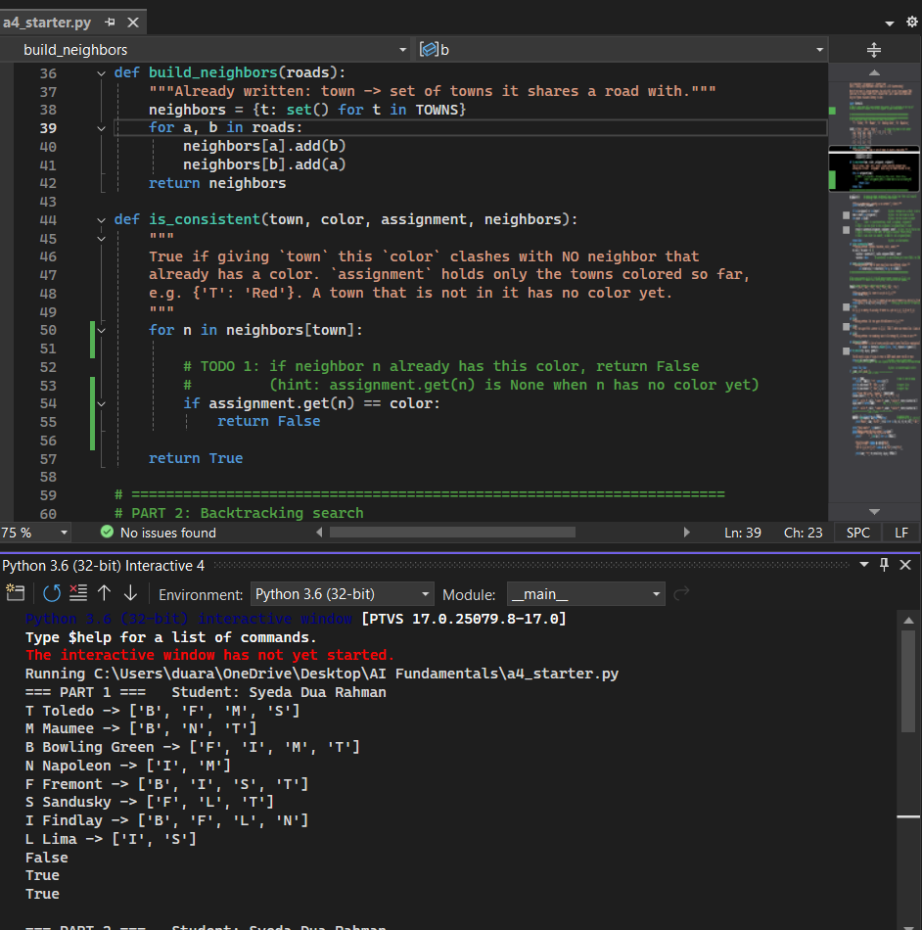

3) The third line is true, even though Toledo is red because the test is testing the towns not next to Toledo, so toledo’s red doesn’t clash.

Part 2: Solve It — Backtracking (28 Points)
Now the search itself. In Lecture 7 we traced backtracking by hand on this exact map. This time the computer does it. We count calls (how many times backtrack ran) and undos (how many times a color had to be taken back).
Question 2.1: Complete the Backtracking Function (12 Points)
The list order says which town is colored next. Everything is written except four short lines. Follow the hints in TODO 2 to TODO 5. The recursive call is already written for you.
def backtrack(assignment, neighbors, order):
"""Plain backtracking, exactly as on Lecture 7, slide 8."""
global bt_calls, bt_undos
bt_calls += 1

if len(assignment) == len(order): # given: everyone has a color, so we are done
return assignment
town = order[len(assignment)] # given: the next town to color

for color in COLORS: # given: try the colors in order
# TODO 2: if the color is NOT consistent, skip it with `continue`
# (hint: is_consistent(town, color, assignment, neighbors))
pass
# TODO 3: put the color in the assignment: assignment[town] = color
pass
result = backtrack(assignment, neighbors, order) # given: try to finish the map
# TODO 4: if result is not None, we found a solution: return result
pass
# TODO 5: that color led nowhere, so UNDO it: del assignment[town]
pass
bt_undos += 1 # given: count the undo
return None # given: no color worked

In your write-up: your finished backtrack function.
def backtrack(assignment, neighbors, order):
"""Plain backtracking, exactly as on Lecture 7, slide 8."""
global bt_calls, bt_undos
bt_calls += 1

if len(assignment) == len(order): # given: everyone has a color, so we are done
return assignment
town = order[len(assignment)] # given: the next town to color

for color in COLORS: # given: try the colors in order
# TODO 2: if the color is NOT consistent, skip it with `continue`
# (hint: is_consistent(town, color, assignment, neighbors))
if not is_consistent(town,color,assignment,neighbors):
continue

# TODO 3: put the color in the assignment: assignment[town] = color
assignment[town]= color
result = backtrack(assignment, neighbors, order) # given: try to finish the map
# TODO 4: if result is not None, we found a solution: return result
if result is not None:
return result
# TODO 5: that color led nowhere, so UNDO it: del assignment[town]
del assignment[town]
bt_undos += 1 # given: count the undo
return None # given: no color worked

Question 2.2: Run the Lecture's Order (8 Points)
The Part 2 output runs the order T, M, B, N, F, S, I, L (the same as the slide "A trace on our own map"). Screenshot the Part 2 output. Your screenshot must show the Student: line with your own name. A screenshot without your
name will not be graded. Then, in one or two sentences, say how many calls and undos it took, and which colors were undone (see the slide "Where it fails, and how backtracking recovers"). 12 calls and it took 3 undos. The colors undone were: S=Blue, F=Green, N= Red.
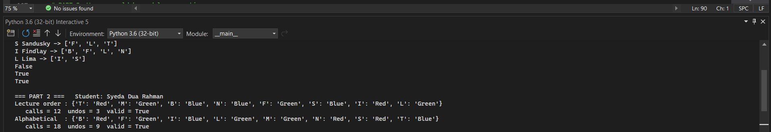
Question 2.3: Change the Order (8 Points)
The same Part 2 output also tries alphabetical order (B, F, I, L, M, N, S, T), the exercise from the end of Lecture 7. Screenshot that output (it is the same screenshot as 2.2 if both lines are visible; otherwise take a second one). Then answer in one sentence: which order needed fewer calls, and why might the order matter?
The lecture order needed fewer calls ( 12 vs 18 ) and it matters because the alphabetical order resulted in conflicts after several steps and the search wasted work on branches that already had issues from the beginning: the towns listed first in the lecture order had more road connections than the roads in the alphabetical order.

Part 3: Know It — Wumpus World by Model Enumeration (28 Points)
Wumpus World is the example from Lecture 8. The agent started in square [1,1] and felt no breeze, then stepped to [2,1] and felt a breeze. It cannot see pits. A breeze means at least one pit is in a square next to it. The agent wants to know which squares are safe.
We use seven true/false symbols: B11, B21, P11, P12, P21, P22, P31. For example, P12 means "there is a pit in square [1,2]" and B21 means "there is a breeze in square [2,1]". A model is one complete way the world could be: a True or False for every symbol. The agent's knowledge base (KB) is five rules (from the slide "Truth tables for inference"):
Rule | In English | In logic
R1 | There is no pit in [1,1]. | ¬P11
R2 | [1,1] is breezy if and only if there is a pit in [1,2] or [2,1]. | B11 ⇔ (P12 ∨ P21)
R3 | [2,1] is breezy if and only if there is a pit in [1,1], [2,2], or [3,1]. | B21 ⇔ (P11 ∨ P22 ∨ P31)
R4 | The agent felt no breeze in [1,1]. | ¬B11
R5 | The agent felt a breeze in [2,1]. | B21

Each rule is a tiny Python function that takes a model m (a dictionary like {'B11': False, 'P12': True, ...}) and returns True or False. In Python, use not, or, and and, and use == for "if and only if". r1, r2, and r4 are already written.
Question 3.1: Write Two Rules as Python (8 Points)
Write r3 (TODO 6, copy the pattern of r2) and r5 (TODO 7). Each is a single return line.
def r3(m):
"""
R3: [2,1] is breezy if and only if there is a pit in [1,1], [2,2] or [3,1].
TODO 6: write one return line. Copy the pattern of r2.
"""
pass

def r5(m):
"""R5: the agent felt a breeze in [2,1]. TODO 7: write one return line. (Look at B21.)"""
pass

In your write-up: (1) your finished r3 and r5, (2) a screenshot of the Part 3 output showing the "Model A" and "Model B" lines. Your screenshot must show the Student: line with your own name. A screenshot without your name will not be graded. (3) One sentence: Model A has every symbol False. Which rule does it break, and why?

def r3(m):
"""
R3: [2,1] is breezy if and only if there is a pit in [1,1], [2,2] or [3,1].
TODO 6: write one return line. Copy the pattern of r2.
"""
return m['B21'] == (m['P11'] or m['P22'] or m['P31'])
def r5(m):
"""R5: the agent felt a breeze in [2,1]. TODO 7: write one return line. (Look at B21.)"""
return m['B21']
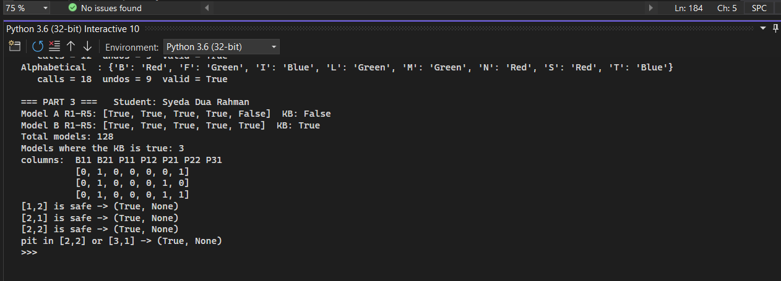
Model A breaks r5 because every symbol is false, so b21 is false, but r5 said the agent felt a breeze in [2,1], so B21 should be true
Question 3.2: Which Worlds Fit? (6 Points)
all_models is already written: it lists every possible model (every True/False combination of the seven symbols). Screenshot the Part 3 output that shows the total number of models, the number where the KB is true, and the rows for those models. Your screenshot must show the Student: line with your own name. A screenshot without your name will not be graded. Then answer: (a) Why is the total that number? (b) Looking at the rows, which squares have no pit in every row?

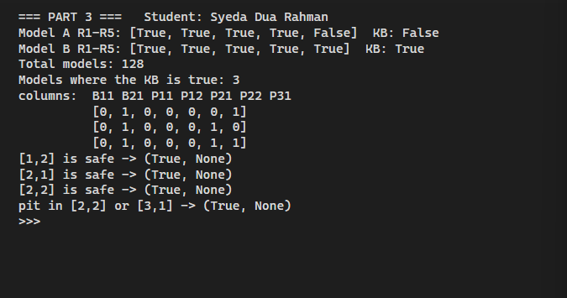
- The total number is that because each 7 symbols can either be true or false, so the number of models is 2^7=128.
- P11, P12, and P21 have zeros in all rows, so they have no pit.

Question 3.3: The Counterexample Hunter (10 Points)
A knowledge base entails a sentence if the sentence is true in every model where the KB is true. To test it, hunt for a counterexample: a model where the KB is true but the sentence is false. This is the slide "Inference by enumeration (Counterexample Hunter)." Write the check in TODO 8.
def tt_entails(kb, alpha, symbols):
"""
The "counterexample hunter" from Lecture 9, slide 7.
The KB entails alpha if alpha is true in EVERY model where the KB is true.
"""
for m in all_models(symbols): # given: look at every model
# TODO 8: if kb(m) is True and alpha(m) is False, this model is a counterexample.
# Return the pair (False, m).
pass
return True, None # given: no counterexample exists

In your write-up: (1) your finished tt_entails, (2) a screenshot of the Part 3 output showing the four lines about "[1,2] is safe", "[2,1] is safe", "[2,2] is safe", and "pit in [2,2] or [3,1]". Your screenshot must show the Student: line with your own name. A screenshot without your name will not be graded.

def tt_entails(kb, alpha, symbols):
"""
The "counterexample hunter" from Lecture 9, slide 7.
The KB entails alpha if alpha is true in EVERY model where the KB is true.
"""
for m in all_models(symbols): # given: look at every model
# TODO 8: if kb(m) is True and alpha(m) is False, this model is a counterexample.
# Return the pair (False, m).
if kb(m) and not alpha(m):
return False, m
return True, None
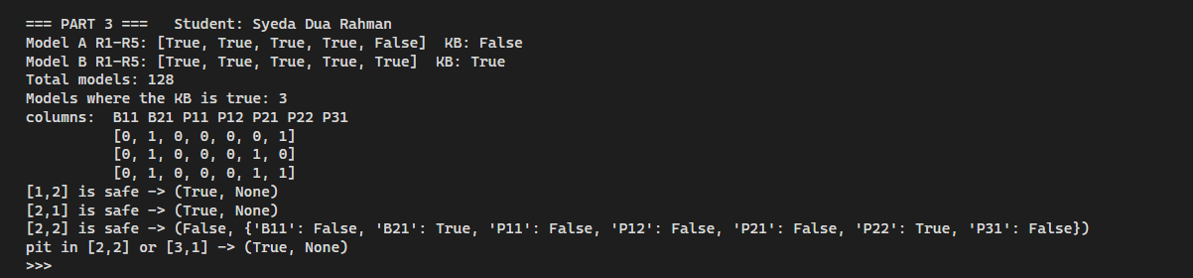

Question 3.4: What Does the Agent Learn? (4 Points)
In two or three sentences, using your screenshots from 3.2 and 3.3: (a) Which square can the agent safely walk into next? (b) Why can it not call [2,2] safe?
The agent can safely walk into square [1,2] and [2,1] because they both show true and none. It can’t call [2,2] safe because a counterexample was found where KB is true and p22 is true as well.

Submission
Submit your completed a4_starter.py (renamed to include your name) along with a PDF or Word write-up (you may use this document as the template). The write-up is what gets graded, so it must contain your finished code, your screenshots (each showing your name), and your written answers. Submit both files to Blackboard by Sunday, October 11, 11:59 PM.
The total points for this assignment is 72. The penalty for late submission is that the assignment will not be graded.
You will need to answer all the parts in this report.
Please feel free to use this doc as your template for the assignment.

