

Alzheimer’s Disease: Pathophysiology, Diagnosis, and Emerging Therapeutics – A Review

Toka Gamal, Khalid Mohamed, Yassi boules, Youssef Asaad, Ibrahim Hassan, Thomas Adly, Ziad Ibrahim, Hamdy Ahmed, Toqa Ashraf.

Under supervision of Dr. Osama Badran
2026

Abstract
Alzheimer's Disease (AD) is a highly prevalent neurodegenerative disease, a major health concern throughout the world, and by far the leading cause of dementia globally. Its characteristics are of a progressive nature that involves decline of memory, function and cognition. It can be associated with behavioral and psychological symptoms (BPSD) that occur through all stages of dementia. The physiopathology of AD is complicated; it is considered to be multifactorial, with theories relating to accumulation of amyloid- (A) plaque, tau protein hyperphosphorylation which results in neurofibrillary tangles, cholinergic deficit, excitotoxicity with NMDA receptor stimulation, and neuroinflammation. This review will provide a broad description of Alzheimer's disease and covers aspects such as symptoms, pathophysiology, progression throughout stages of preclinical, mild cognitive impairment and dementia.
Both non-modifiable and modifiable factors such as exercise and cardiovascular risk reduction, should be recognized in the prevention of AD. The review also describes current available treatment such as cholinesterase inhibitors like donepezil, rivastigmine and the NMDA receptor antagonist memantine, mentioning mechanism of action, dose, and side effects. Emphasis on the crucial aspect of polypharmacy, elderly patients and drug-drug interactions will be placed in the context of medication compliance. We also illustrated newer strategies for the treatment of AD like disease-modifying therapy that includes anti-amyloid antibodies, new targets of tau pathology, gene and RNA therapy. At the end, the author points out the contribution of artificial intelligence and machine learning that can offer a novel method in the management of AD through analysis of various data types, allowing earliest diagnosis and classification of the patients and accelerate the discovery of drugs for AD and moving toward precise medicine in the context of Alzheimer's disease.
Introduction
Alzheimer's disease (AD) represents the most frequent cause of cognitive disability and dementia in the elderly (age over 65 years) worldwide. AD is currently considered as a global public health problem by the WHO. However, despite significant advances in knowledge regarding pathogenesis of AD and conceptualization of the disease since Alois Alzheimer reported the first case in 1907 [1], AD remains an inexorably progressive neurological condition that typically results in decline of cognitive and functional abilities and typically begins with memory loss particularly inability to recall new information followed by disorientation and confusion in time and space and poor judgement. Later the patients may experience language problems (aphasia, anomia), impaired executive functions and problems in performing routine daily activities. Behavioral and psychological symptoms such as changes in mood, depression, anxiety, irritability, social withdrawal, and possibly hallucinations and delusions in later stages of AD can also occur. [2]
Figure 1 show Neuropathological features of Alzheimer’s disease compared to a healthy brain.

Pathophysiology:
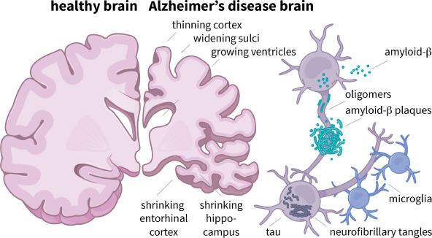
These pathological events are accumulation of toxic forms of amyloid-beta (Abeta), neurofibrillary tangles of hyperphosphorylated tau and acetylcholine depletion, excitotoxicity and neurodegeneration caused perhaps by overactive microglia which secrete neurotoxins and inflammatory agents. Persons carrying these pathological features might be totally symptom free or clinically manifest with symptoms ranging from a minor forgetfulness to a total devastating memory and cognitive loss. [1].
Figure 2 Key pathological hallmarks and neurochemical mechanisms underlying Alzheimer’s disease.

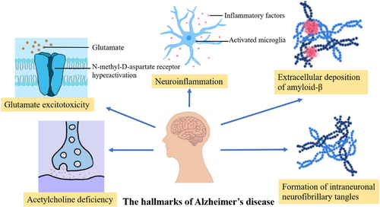
With the advancement of AD, additional neuropsychiatric symptoms might be experienced such as intermittent confusion, disorientation, altered behavior and emotion, agitation/aggression and eventually delusion/hallucination in late stage [3]. Because it is expected that a mild decline of cognition will occur with normal aging, distinguishing a decline related to AD from that of normal aging (processing speed, some memories, language, visuospatial, and executive functions). Thus because of difficulties of diagnosis and then, a historic thought that the lack of benefit of diagnosis, because the non-availability of a disease modifying treatment, the diagnosis of AD is generally believed to be lacking, with reports stating that more than half of all those suffering from AD dementia may never receive a diagnosis. [4]
stages of Alzheimer’s Disease:
According to the NIA-AA guidelines, 2011, 3 stages of AD were proposed: preclinical AD (pathological processes at the time of normal cognition), MCI (symptomatic predementia) and dementia [5].
Preclinical AD: first stage of the normal cognition to AD dementia continuum which is characterized by the onset of the aforementioned pathophysiological processes such as the accumulation of toxic Ab species and hyperphosphorylated tau protein. Toxic Ab species and hyperphosphorylated tau protein are found in both CSF and blood, thus they can be used as a marker to diagnosis the disease [5].
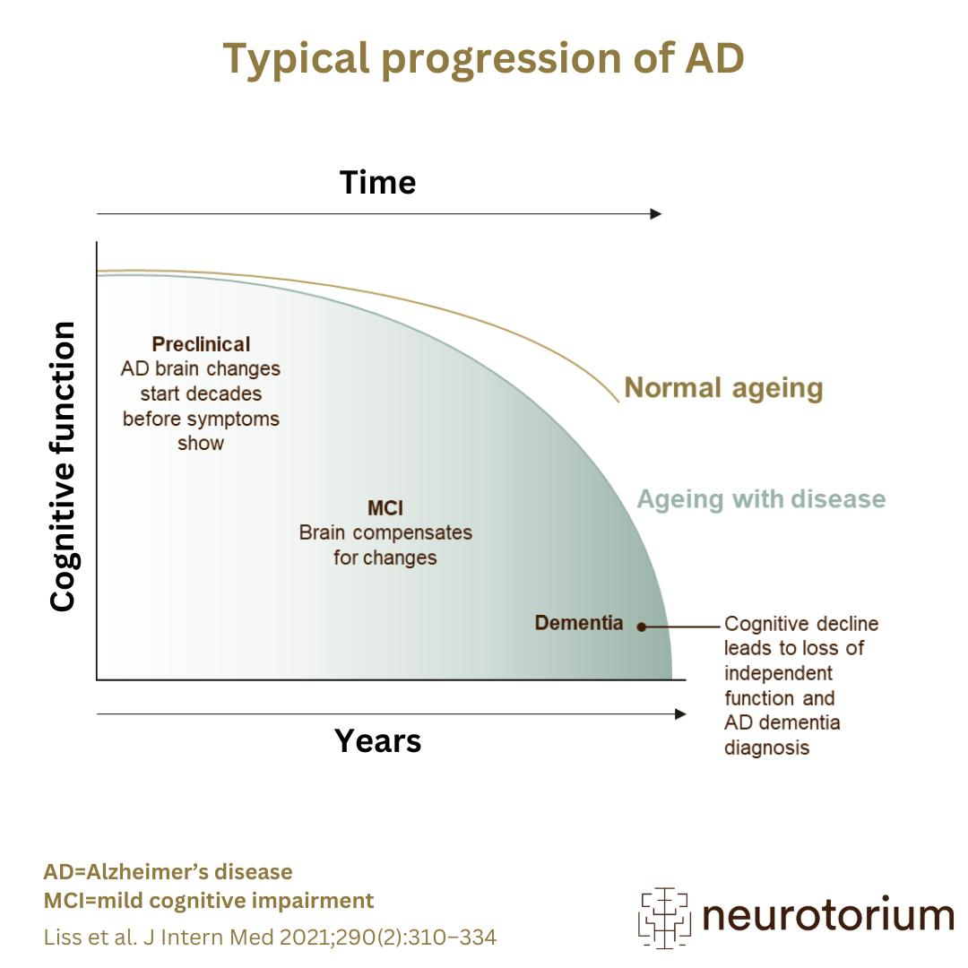
Symptomatic predementia MCI: which can be regarded as a pre-dementia stage between normal aging and dementia, are the people with the onset of observable cognitive decline, especially memory loss but still independent in all activities of daily living. However, MCI is considered a symptomatic predementia stage and MCI does not inevitably progress to Alzheimer's dementia, despite being increased risk of disease development.[6]
Alzheimer's dementia: individuals in this stage present a significant functional and cognitive impairment that affects their independence; cognitive deficits consist of severe memory loss, aphasia, impaired judgement and changes in behavior; at the end stage patients depend entirely on their caregivers. [6]
Figure 3 stages and progression of Alzheimer’s Disease

Risk Factors for Alzheimer’s Disease
Alzheimer's disease (AD) is a multifaceted neurodegenerative condition caused by interaction of genetic, environment and life style associated risk factors which can be classified under two categories: non-modifiable risk factors and modifiable risk factors; both being involved in the occurrence and progression of AD.
1. Non-modifiable risk factors:
1.1 Age:
Age is considered as the greatest risk factor for Alzheimer's disease. After the age of 65 years, the incidence and prevalence rates of AD double approximately every 5 years and with each decade increase in age after 65 years. Age-associated changes like increased cellular damage, mitochondrial dysfunction, enhanced free radical generation and subsequent oxidative stress seem to contribute to neurodegeneration.
1.2 Genetics:
The predisposition to the AD depends upon inheritance which leads to its occurrence either in young or late life. The gene encoding for apolipoprotein E 4 (APOE 4) allele is identified as strongest genetic risk factor of late-onset AD (LOAD) that mediates Aβ aggregation and clearance. However, mutations in amyloid precursor protein (APP), presenilin 1 (PSEN1) and presenilin 2 (PSEN2) genes are responsible for occurrence of early onset familial Alzheimer's disease and mediate Aβ processing.
1.3 Family history:
The existence of a positive family history for AD among relatives also raises the risk of developing the disease in an individual.[7]
2. Modifiable risk factors:
2.1 Cardiovascular and metabolic diseases:
The cardiovascular function is also related to cognition. Hypertension, Diabetes Mellitus, hyperlipidemia, obesity increase the vascular damage and also affect the cerebral blood flow as well as Aβ deposition, hence contributing to either Alzheimer's or vascular dementia, suggesting a shared pathogenic mechanism.
2.2 Lifestyle factors:
There is some epidemiological evidence that lifestyle factors affect the incidence of AD. Sedentary life, cigarette smoking, high intake of alcohol, unhealthy dietary patterns are found to be risk factors, and vice versa regular physical exercise and healthy life style-Mediterranean diet have been implicated in reducing inflammation and oxidative stress for neuroprotection.
2.3 Educational Level and Cognitive Reserve
There appears to be an association between lower levels of education and an increased risk of AD. This is based on the theory of cognitive reserve, which implies that greater levels of education and engagement in intellectual pursuits will make the brain's reserves more able to compensate for the neurodegeneration of AD thus delaying the clinical onset of dementia.[7]
Prevention of AD relies on minimizing factors that increase the risk of it and protecting the brain. There is currently no cure for AD, but it is strongly believed that cardiovascular health is beneficial due to strong associations between conditions like hyperlipidemia, diabetes, hypertension, and an increased risk of AD. A healthy lifestyle is believed to offer benefits such as prevention or delays in cognitive decline due to regular physical exercise and a good diet, with the Mediterranean diet proving of great benefit. Giving up smoking and minimizing alcohol intake also offers benefits, along with intellectual stimulation, education and social contact all helping to create a greater cognitive reserve. [7]
Aim of the study:
Thus, the article presents the general picture of Alzheimer's Disease by first elaborating the definition, main signs and the symptoms and course of the illness. Particular attention will be paid to its course and progression from the initial process at the level of members of the nerve cell to the typical stages of dementia at the advanced stage in order to explain why this happens. The review aims at describing the most important risk factors of Alzheimer's Disease, such as non-modifiable (age and genetic predisposition), modifiable lifestyle risk factors, and cardiovascular disease factors, as an accurate knowledge of such factors can help in the identification of persons at risk as well as in the prevention.
Another important goal of this review is to describe how pharmacological agents may be used in Alzheimer's Disease treatment, will cover the agents mostly used such as Donepezil, Rivastigmine, Memantine and they will be analyzed under the aspect of mechanisms of action, indications, dosage, and side effects. Drug interactions will also be underlined, especially in the elderly population whose therapy is most commonly polypharmacy, taking into account the possible interactions between drugs used for Alzheimer's disease treatment and more widely used drugs, such as antihypertensives, antidepressants and the need of careful pharmacotherapy planning with regard to individual needs.
Lastly the article will discuss the adherence to treatment and support necessary for better treatment outcome taking into account factors which influence adherence to therapy, effects of cognitive deterioration and complicated dosage and support measures which can improve treatment adherence and effectiveness.
In the last section the article will review on the available and developing strategies of prevention which could possibly delay the onset of the disease or slowing of the process and influence of risk and comorbidity factors, the interventions which must be provided in specific situations, and the integration of new research in order to provide a general view of the AD and indicate the fields where further research is required.
management of Alzheimer's disease:
At present, there is no cure for AD and there is a lack of efficacious drugs that produce noticeable results. Only 2 types of drugs are approved by the Food and Drug Administration (FDA) for treatment of cognitive impairment in AD. One of the drug types are cholinesterase inhibitors (e.g. Donepezil, galantamine and rivastigmine). These inhibitors bind to the enzymes that break down acetylcholine and inhibit the hydrolysis of acetylcholine, thereby increasing cholinergic neurotransmission. [8].
Acetylcholine is a major neurotransmitter in the nervous system, and the receptor binding involved in functions related to memory and learning relies upon it. Research has also provided evidence from a biopsy taken from AD patients 3.5 years from onset of symptoms, showing that the neurotransmitter pathology begins early in the disease and that reduced synthesis of acetylcholine and activity of choline acetyltransferase correlates strongly with the cognitive deficit experienced. [9]. The aims of therapeutic treatment therefore is to partially overcome presynaptic cholinergic deficit.
Donepezil:
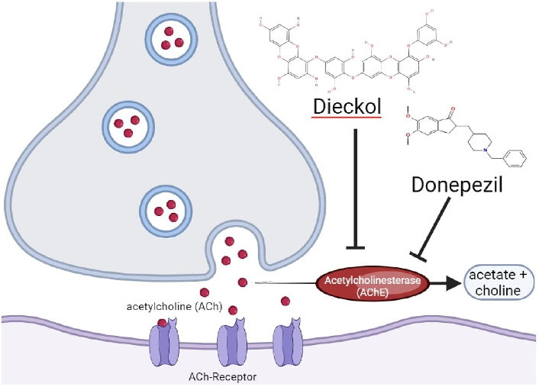
Only donepezil among the above mentioned compounds have proven effect in terms of temporarily reducing functional decline and improving cognition, general clinical impression, activities of daily living and behavioral disturbance in patients suffering from AD. So far all centrally acting acetylcholinesterase inhibitors (AChEIs) have been approved for the treatment ofmild to moderate AD; however donepezil is the only selectively acting AChEI approved for the treatment ofall stages (mild, moderate and severe) of AD. Donepezil, in contrast to the other ChEIs also has a long half-life enabling administration on a once-daily basis, greater tolerability through greater specificity for central AChE inhibition, and absence of an effect on the kinetics of the drug by food consumption; also minimal interaction with other drugs. Furthermore donepezil is readily absorbed orally and has an oral relative bioavailability of 100% in comparison to the other drugs.
Figure 4 Donepezil inhibit the effect of acetylcholinesterase.

recommendations and cautions for donepezil:
Donepezil has been FDA-approved for treating severe AD in the U.S. And Canada. Advere effects (AEs) are markedly increased in the higher dose (10mg/day) product than in the 5mg/day one. In summary, the AEs at the higher dose product are loss of appetite, nausea, vomiting, diarrhea and rhinitis.[10] Although the lower dose product may be favorable in terms of AEs, in 2010 FDA-approved 23mg/day donepezil product for the treatment of patients with moderate to severe AD, based on the results from a phase 3 clinical trial demonstrating that switching to donepezil 23mg/day yielded improved cognitive function and functional outcomes compared to stable treatment with donepezil 10mg/day.[11]
For Donepezil daily treatment, the recommended dose is started at 5mg/day which is increased to 10mg/day after 4-6 weeks of treatment. Moderately to severely AD patients recognized as patients receiving stable donepezil treatment at 10mg tablet daily for at least 3 months are eligible to increase to Aricept 23mg tablet daily. Note that drugs like Donepezil that have cholinergic effects typically exhibit gastrointestinal side effects. The result from a multicenter study involving 529 patients with mild-to-severe AD indicated 32 donepezil-related AEs were likely: diarrhea, agitation, nausea and insomnia. The report found at least 1 in every 3% patients developed neuropsychiatric AE; none had unexpected AE or death attributed to donepezil. [12]
Warnings and Contraindications with donepezil:
In patients with hepatic impairment: no dose adjustment of donepezil is necessary in patients with hepatic impairment, even those with compensated liver cirrhosis.
In patients with renal impairment: no dose adjustment is necessary in patients with moderate- or severe renal impairment. In hemodialysis patients the starting dose is 2.5mg QD, which is then increased to 5mg QD as per the patient's clinical condition.
In pregnancy: Donepezil has a pregnancy category C and has no data on use during pregnancy with regards to congenital malformations.
In the elderly: The elimination half-life is increased to approximately 100 hours in the elderly due to a greater apparent steady state volume of distribution. No dose adjustment is necessary because clearance remains the same for all ages.
General supportive measures are most important for donepezil overdose and the poisoning control center must be contacted immediately. Cholinergic crisis in donepezil overdose is characterized by nausea, vomiting, increased salivation and diaphoresis. Hypotension and bradycardia are additional features which occur in a cholinergic crisis and if severe, can lead to respiratory arrest, collapse, and convulsions. The presentation of donepezil toxicity is similar to that of a beta blocker overdose; hence, the diagnosis must be reconsidered if no response to appropriate treatment is achieved.
Drug Interactions:
It is possible for there to be an additive effect between donepezil and other cholinesterase inhibitors, such as neostigmine and physostigmine. It could potentially prolong the action of depolarizing neuromuscular blocking agents, such as suxamethonium.
It is possible for an increase in risk of bradycardia when combined with beta-blockers such as carvedilol, metoprolol, atenolol, and propranolol.
An increase in clearance of donepezil is possible when taken with inducers of CYP2D6 and CYP3A4, such as phenytoin, carbamazepine, phenobarbital, rifampin, and dexamethasone. The drug levels of donepezil could therefore be lowered.
CYP3A4 and CYP2D6 inhibitors, such as ketoconazole and quinidine, can theoretically inhibit the metabolism of donepezil. The clinical significance of such interaction is unknown.
Memantine:
Memantine acts as an antagonist on the NMDA (N-methyl-D-aspartic acid) subtype of the glutamate receptor. Glutamate is a most important neurotransmitter in the brain; it is involved in the processing of information and nervous system development and mediatesfast post-synaptic transmission in the nervous system via its interaction with postsynaptic receptors (such as NMDA, AMPA receptors etc.). The overactivation of the NMDA receptor results in overactivation of glutamate causing excitotoxicity, the neuronal damage in the local area may be further aggravated.13The NMDA receptor is a cationic channel permeable to positive Na+, K+ and in some instances Ca2+ ions, allowing the post-synaptic membrane to depolarise causing excitation of the post-synaptic neurone. Hence memantine acts by blocking overactivation of the NMDA receptor, thereby counteracting the effects of excess levels of glutamate in the brain and protecting the neurone against glutamine induced excitotoxicity. Administration of memantine may have a neuroprotective and even neurorestorative effect in AD and other neurodegenerative disease states; it is used to treat moderately and severe cases of AD. Slowing of the process of AD is predominantly achieved by increasing cholinergic activity whilst decreasing glutamate hyperactivation; although the specific mechanism by which it acts is not completely understood due to the complexity of pathogenesis in AD, the mechanism for effective drugs such as memantine may partly be inferred. There are currently no drugs which are able to cure AD, only delay the progress of the disease.14
There are five single drug treatments and one combination drug treatment currently licensed by the FDA. Donepezil and memantine are the only drugs licensed to be used in combination, and treatment using combination therapy involving memantine with ChEI although not licensed, has been favored by many researchers and concluded to be highly efficacious in patients with advanced AD by the guidelines and scientific societies. The reason for such a conclusion arises from the fact that each drug is able to compensate the weakness of the other for symptomatic treatment, thus improving overall efficacy as compared to monotherapy. [15]
The combination of memantine and donepezil for AD has benefit and disadvantage compared to monotherapy, which has better cognitive function and greater global patient assessment score as benefit, but poor tolerance to combination therapy in patients body as disadvantage, as other research found patients on combination of ChEI plus memantine reported significantly higher adverse effect compared with memantine monotherapy.
Memantine can cause a series of side effect, most frequent side effects include: hallucinations, confusion, headache, dizziness, high blood pressure, somnolence, and agitation, Less frequent side effects include: anxiety, hypertonia, astriction, diarrhea, nausea, anorexia, cough, shortness of breath, etc.
Memantine is a good tolerated drug up to about 28 mg per day but it can be increased to a therapeutic maintenance dose each week to get a good tolerated result and minimize side effect. It can be reached by a weekly increase of 5mg up to week four as: first week: memantine 5 mg after breakfast; second week: memantine 10mg after breakfast; third week: memantine 15 mg after breakfast; the therapeutic maintenance dose is 20 mg per day [16]
Warnings and Contraindications of memantine:
Box Warnings: Hypersensitivity to memantine hydrochloride, or to any excipient.
Warnings and precautions:
Genitourinary conditions: Conditions which increase urine pH, e.g. Renal tubular acidosis. Reduction in urinary elimination of memantine may occur with this condition.
Cardiovascular disease: Higher incidence of Cardiac Failure, Angina and Hypertension observed in clinical trials.
Hepatic impairment: Caution in severe hepatic impairment. It has not been determined what effect such impairment would have on pharmacokinetics. [18]
Overdose symptoms/signs: include agitiation, asthenia, confusion, visual hallucinations, vertigo, coma, delayed walking, somnolence, dizziness, lethargy, loss of consciousness, ECG changes, bradycardia, increased blood pressure, psychosis, restlessness, stupor, unsteady gait, vomiting, and weakness. Awareness of these adverse effects is required if it is co-administered to the patient on other medications and/or alcohol. [17]
Drug-Drug Interactions:
Alkalizing drugs: Alkalinization of the urine to a pH of 8 could reduce the memantine clearance by as much as 80% and potentially also increases the risk of side effects. Use with caution with carbonic anhydrase inhibitors and sodium bicarbonate.
NMDA antagonists: Combination with other NMDA antagonists (amantadine, ketamine, dextromethorphan) has been described with increased neuro-psychiatric side effects but more recently studies have demonstrated the safety of co-administering memantine with amantadine and/or dextromethorphan. Use with caution. [18]

Rivastigmine:
Rivastigmine is an agent used to treat and manage neurodegenerative disease and more specifically dementia in both Parkinson and Alzheimer disease. It belongs to the class of cholinesterase inhibitor drugs. There are two different types of cholinesterase enzyme that can hydrolyze acetylcholine within the brain. The two types are acetylcholinesterase (AChE) and butyrylcholinesterase (BuChE). AChE is concentrated at the synaptic junctions between nerves as well as at sites where high levels of activity occur within the cerebral cortex. BuChE is primarily concentrated in the glial cells within the brain and contributes to mediating cholinergic activity. Over the course of time and aging within a human being, the activity of these two enzymes becomes increased. In pathologies such as Alzheimer disease, cholinesterase enzyme up regulation becomes greater. Unlike many other cholinesterase inhibitors, rivastigmine has been shown to reversibly bind and inhibit both enzymes and overall acetylcholinesterase.19
Rivastigmine comes in oral capsules, oral liquid and transdermal patches. Oral capsules come in 1.5 mg, 3 mg, 4.5 mg and 6 mg sizes. The oral solution has a concentration of 2.0 mg per mL. Transdermal patches come in 4.6 mg, 9.5 mg, and 13.3 mg per 24 hours. Alzheimer disease; mild to moderate dementia: 3 to 6 mg daily PO q 12 hr. Initiate at 1.5 mg PO q 12 hr, then titrate up by 1.5 mg per dose every 2 weeks as tolerated. The max daily dose is 12 mg.
All doses should be administered with meals. Re-titrate with 1.5 mg if dose has been interrupted for longer than 3 days. No dose adjustment is needed with renal impairment. For hepatic impairment, no dose adjustment is needed for Child- Pugh class A and B. For Child- Pugh class C, dose is undefined.
Gastrointestinal effects are a primary adverse event of rivastigmine therapy. Nausea and vomiting occur as the main acute adverse effects during the initial phase of dosing when dosage increases towards a therapeutic level. Vomiting and nausea can be somewhat circumvented if therapy begins with a slow titrating regimen and administered with food when an oral form of the drug is being prescribed. It has been stated that rivastigmine has had the highest rate of GI adverse events compared to the other drugs of its class in one study of cholinesterase inhibitor therapy in the treatment of Alzheimer dementia.[20]
Common adverse effects: extrapyramidal symptoms, sleep disturbance, muscle cramps, weakness. Although the other less common adverse effects listed above usually occur at lower frequencies during the maintenance phase when the drug has reached a fixed dose, central nervous system effects have been reported when rivastigmine is taken long term; although CNS effects appear to occur much more infrequently in patients treated with rivastigmine when compared to those treated with its sister drug donepezil. With long-term administration of rivastigmine, there have also been increased rates of death.
Contraindications:
Do not use in a patient with previous hypersensitivity reaction to rivastigmine.
Use with caution in patients who have any of the following risk factors: Cardiac conduction disorders, Bradyarrhythmia or sick sinus syndrome, COPD or asthma, Active peptic ulcer disease or increased risk of GI bleed, Seizure disorder or risk, and patient weighing less than 50 kg.
The risk of toxicity to the drug should be assessed, even though this is very uncommon. Common signs of toxicity include severe GI side effects, allergenic skin reactions and central nervous system symptoms. Any cutaneous reaction caused by application of the patch should prompt the removal of the patch until it can be re-applied to a new area, at least 48 hours after discontinuation of the first patch. Symptoms that do not resolve in 48 hours and a severe cutaneous reaction require discontinuing rivastigmine.
Recent Developments in Alzheimer’s Treatments:
Disease-Modifying Therapies (ANTI-AMYLOID MONOCLONAL ANTIBODIES):
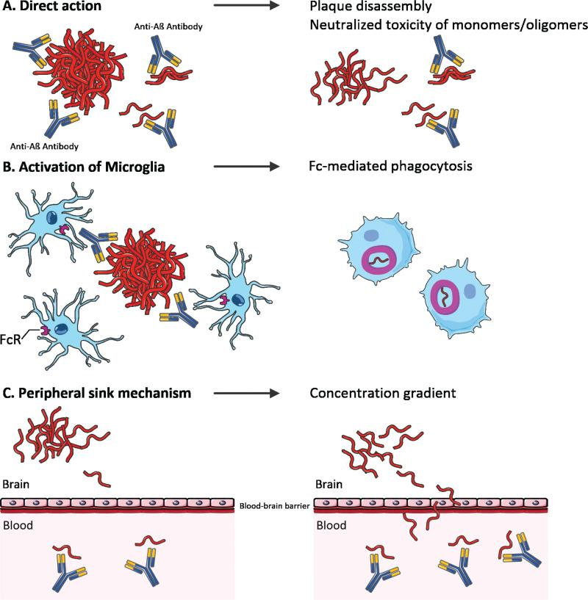
DMTs have emerged as a paradigm change in the management of AD, shifting from treatments solely addressing symptomatic improvement to those altering the underlying disease pathophysiology. Rather than the short-lived symptomatic benefit produced by conventional therapies like cholinesterase inhibitors or NMDA receptor antagonists, DMTs slow or prevent the disease course by targeting the major molecular drivers: principally amyloid- (A) pathology.
Development of DMTs is based on the amyloid cascade hypothesis which suggests that aggregation and accumulation of A in the brain leads to a series of pathological changes in neurons, including tau pathology, synaptic loss, neuronal death etc. Among the key agents, Aducanumab is the first drug being approved in terms of a strong amyloid clearance but its efficacy in terms of cognition is debatable due to heterogeneous trial results. Lecanemab has shown modest but statistically significant cognitive benefit in early AD patients, possibly due to the preferential targeting of soluble protofibrils A, while Donanemab, another agent targets pyroglutamate-modified A and displays fast plaque clearance and hints for cessation after achieving amyloid negativity. [22]
Figure 5 Proposed mechanisms of anti-amyloid-β (Aβ) antibodies.
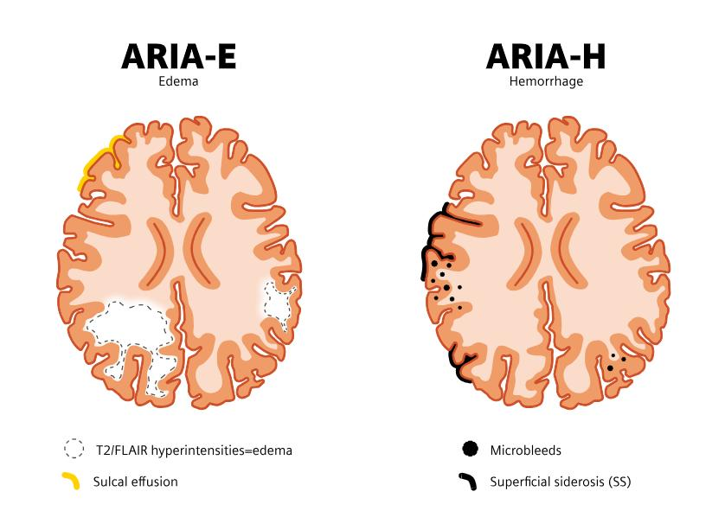
However, the implementation of DMTs is currently limited by various restrictions. ARIA, including amyloid related imaging abnormalities, such as vasogenic edema (ARIA-E) and microhemorrages (ARIA-H), have been noted as a potential side-effect, and thus, patients require close follow up and routine neuroimaging. The clinical effects noted are modest, and merely demonstrate a slowing rather than an improvement in disease progression. DMTs should also be considered as a treatment during the very early and prodromal stages of Alzheimer's disease.
Figure 6 Side effects of Disease Modifying Therapies

Anti-Tau Therapies: The Next Wave in Alzheimer’s Disease Treatment:
The new next-generation AD therapy will be an anti-tau therapy since tau pathology is more correlated with neurodegeneration and clinical worsening than the amyloid burden. Tau is a microtubule-associated protein necessary for integrity of neuronal cytoskeleton. During disease abnormal hyperphosphorylation and aggregation of tau causes intracellular accumulation of NFTs and neuronal dysfunction/death. One important aspect making tau a better therapeutic target is its prion-like propagation. Tau is released from diseased neurons, transferred synoptically to neighboring neurons where it induces tau pathology. The process follows the disease progression and clinical course of AD patients quite well.
Mechanisms of Anti-Tau Therapeutic Strategies:
Current anti-tau approaches aim to interfere with different stages of tau pathology:
Inhibition of tau aggregation:
Prevents formation of toxic oligomers and fibrils
Immunotherapy (monoclonal antibodies):
Targets extracellular tau to block inter-neuronal spread
Reduction of tau phosphorylation:
Modulates kinase/phosphatase activity
Microtubule stabilization:
Compensates for loss of tau function.
Out of these the most clinically advanced is passive immunotherapy with monoclonal antibodies [23]. Posdinemab is a humanized monoclonal antibody which specifically targets and binds to abnormal tau species especially extracellularly transmissible tau species. Targeting this tau in interstitial fluid can be expected to: prevent cell-to-cell propagation of tau aggregates and slow down neurodegeneration. Phase I/II trials to date have shown: A decrease in tau load (monitored with tau PET imaging), A favorable safety profile and A potential delay in disease progression (still under investigation). However, like other anti-tau agents, efficacy data is still emerging, and large phase III trials need to be conducted before therapy can be considered efficacious.
Gene-Based and Molecular Therapies in Alzheimer’s Disease:
Gene based and molecular therapies have an emerging and revolutionary role to play in the therapeutic management of Alzheimer's disease (AD). In this novel therapeutic paradigm, disease pathogenesis is targeted at a genetic and transcriptional level, and not by modulating the underlying pathophysiology with conventional drug therapies alone, with the hope of establishing durable or even prophylactic therapeutic interventions.
The primary gene therapy targets in AD include the apolipoprotein E (APOE) gene and more specifically the APOE4 genotype which represents the major risk factor for late onset AD. APOE gene therapy approaches include lowering APOE expression, or a conversion of the pathogenic APOE4 variant to the less pathogenic APOE2 or APOE3 variants. These strategies will likely involve viral vectors, the most commonly cited examples being adeno-associated viruses (AAV) for delivering the therapeutic gene to central nervous system tissue.
Gene editing technologies, most notably CRISPR/Cas9 systems, have further broaden the therapeutic potential in AD. The use of such technologies can facilitate specific modifications to genetic loci associated with the disease. For instance, CRISPR based gene editing has been investigated for its ability to selectively ablate or correct pathogenic variants such as APOE4 to reduce amyloid deposition, neuroinflammation, and synaptic dysfunction. Although off-target effects, delivery efficiency and long-term safety represent significant challenges.
Simultaneously, an array of RNA-based therapeutics are in development including antisense oligonucleotides (ASOs) and small interfering RNA (siRNA) to modulate gene expression at a post-transcriptional level. This class of drugs may potentially down regulate pathogenic gene expression for instance to decreasetauor specific amyloid forming enzyme synthesis (e.g., BACE1), while offering a reversible mechanism of gene modulation and high specificity; both are currently in the early phases of clinical trials.
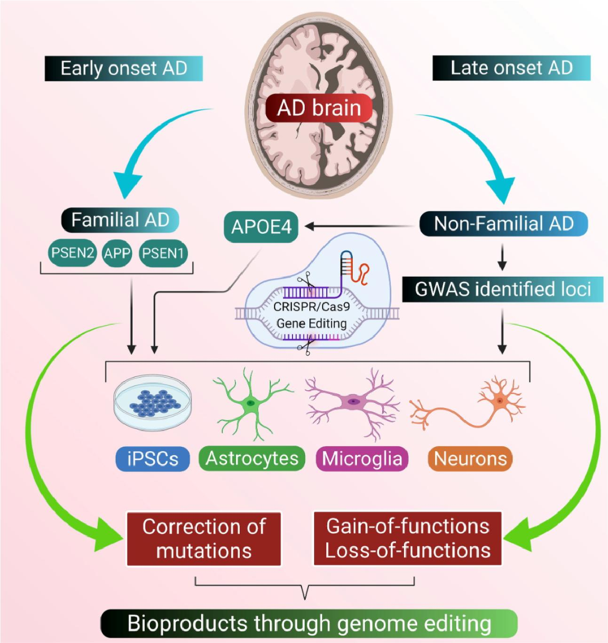
However, most gene and molecular therapy applications in AD are currently still experimental. The major constraints to the application of these treatments are: efficient and targeted drug delivery through the blood brain barrier, the possible immunogenicity, and the need to ensure long term therapeutic benefit without the unwanted side effects. It is of particular promise to gene/molecular therapy approach in a prevention setting and/or individuals with a high genetic profile where early application of the therapeutic regime might potentially avert/delay AD in a number of cases.
Figure 7 Gene-Based and
Molecular Therapies

Recommendation: Integration of Artificial Intelligence and Machine Learning in Alzheimer’s Disease Management:
The adoption of Artificial Intelligence (AI) and Machine Learning (ML) in AD research and care is recommended as a strategic priority to improve diagnostic accuracy, enhance treatment effectiveness and accelerate drug development. AD is an extremely complex, multifactorial and heterogeneous disorder, and traditional analytical approaches are typically unable to unravel complex disease mechanisms and pathways. AI-based tools offers an efficient approach for analyzing high-dimensional, multimodal datasets. It is recommended that AI/ML tools be systematically employed in early diagnostic pipelines, whereby their capabilities can assist in uncovering pre-symptomatic and preclinical disease phenotypes in the cognitive assessment, neuroimaging (MRI, PET) and fluid biomarker data. The successful detection of early AD phenotypes is vital in enabling timely
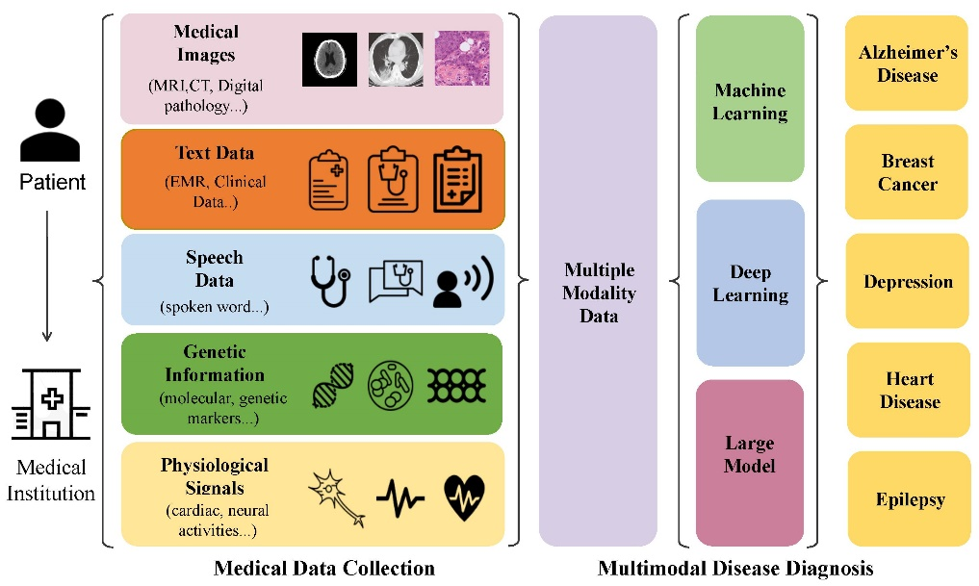
commencement of disease-modifying therapies, which may be more effective when initiated early. AI tools should be applied across all neuroimaging data to increase detection of amyloid and tau pathology, and structural and functional brain changes, while minimizing variability to support clinicians in decision-making using deep learning algorithms. AI techniques also holds great potential within drug discovery and development. The implementation of AI in patient stratification is also necessary in order to move toward patient-specific therapy. The use of genetic, biomarker, image, and clinical data can allow for patients to be divided into biologically similar subgroups, ultimately leading to improved therapy selection and better clinical trial success. A recommendation here is to utilize a multimodal data integration framework whereby AI serves as the hub from which to derive clinically meaningful models from multiple types of data, following along with precision medicine concepts to achieve person-specific management of AD. As such, AI and machine learning should be considered as key pillars of future AD treatment.
Figure 8 Integration of Artificial Intelligence and Machine Learning in Alzheimer’s Disease
Conclusion:
The clinical management and progression of Alzheimer's Disease: novel therapeutic strategies to combat an increasing global challenge and improve patient outcome. Alzheimer’s disease (AD) is a complex, multifaceted neurodegenerative condition which places a heavy social, medical and economic burden. Despite recent advancements in the understanding of AD pathogenesis, few treatments are available and those that are are symptomatic, having minimal impact on the slowing of cognitive decline. Cholinesterase inhibitors and NMDA antagonists continue to dominate treatment regimes however, their effectiveness highlights the need for disease-modifying agents. While novel treatment approaches are now emerging targeting amyloid and tau pathology through disease-modifying drugs, it must be considered that we are challenged by concerns regarding effectiveness, safety, and ability to achieve early diagnosis. Future strategies such as gene based and RNA based therapies could provide a novel route towards managing Alzheimer's, particularly for at risk individuals although at present these techniques are in the preliminary stages of development. We cannot ignore the potential of AI and machine learning in both research and the clinical management of Alzheimer's Disease. These innovative strategies may well speed up progress in diagnostics, the personalizing of treatment and the discovery of novel targets and drugs, a step that will undoubtedly involve the design of multimodal, data-driven platforms. It is undeniable that management must take an integrative and multifaceted approach. Early diagnostics, risk factor reduction, pharmacotherapy with established pharmaceutical treatments, and incorporation of newer technologies are all key in improving patient prognosis. Further research must now look toward the design of combination therapies and suitable biomarkers for the selection of treatment as well as for the successful integration of AI technologies into the clinical environment.
references
- Atri A. The Alzheimer’s disease clinical spectrum: diagnosis and management. Med Clin North Am. 2019;103(2):263–93.
- Lane, C. A., Hardy, J., & Schott, J. M. (2018). Alzheimer's disease. European journal of neurology, 25(1), 59-70.‏
- Spanic E, Langer Horvat L, Hof PR, et al. Role of microglial cells in Alzheimer’s disease tau propaga tion. Front Aging Neurosci. 2019;11:271.
- Alzheimer’s Association. 2021 Alzheimer’s disease facts and figures. Alzheimers Dement. 2021;17(3): 327–406.
- Kern S, Zetterberg H, Kern J, et al. Prevalence of preclinical Alzheimer disease: comparison of current classification systems. Neurology. 2018;90(19): e1682–91.
- Sperling RA, Aisen PS, Beckett LA, et al. Toward defining the preclinical stages of Alzheimer’s dis ease: recommendations from the National Institute on Aging-Alzheimer’s Association workgroups on diagnostic guidelines for Alzheimer’s disease. Alz heimers Dement. 2011;7(3):280–92.
- Armstrong, R. A. (2019). Risk factors for Alzheimer’s disease. Folia neuropathologica, 57(2), 87-105.‏
- Adlimoghaddam, A., Neuendorff, M., Roy, B., & Albensi, B. C. (2018). A review of clinical treatment considerations of donepezil in severe Alzheimer's disease. CNS neuroscience & therapeutics, 24(10), 876-888.‏
- Francis PT, Sims NR, Procter AW, Bowen DM. Cortical pyramidal neurone loss may cause glutamatergic hypoactivity and cognitive impairment in Alzheimer's disease: investigative and therapeutic perspectives. J Neurochem. 1993; 60(5): 1589-1604.
- Birks J, Harvey RJ. Donepezil for dementia due to Alzheimer's disease. Cochrane Database Syst Rev. 2006 (1): CD001190.
- Farlow MR, Salloway S, Tariot PN, et al. Effectiveness and tolerability of high-dose (23 mg/d) versus standard-dose (10 mg/d) donepezil in moderate to severe Alzheimer's disease: a 24-week, randomized, double-blind study. Clin Ther. 2010; 32(7): 1234-1251.
- Carrasco MM, Aguera L, Gil P, Morinigo A, Leon T. Safety and effectiveness of donepezil on behavioral symptoms in patients with Alzheimer disease. Alzheimer Dis Assoc Disord. 2011; 25(4): 333-340.
- Shafiei-Irannejad, V., Abbaszadeh, S., Janssen, P. M., & Soraya, H. (2021). Memantine and its benefits for cancer, cardiovascular and neurological disorders. European Journal of Pharmacology, 910, 174455.‏
- Marotta, G., Basagni, F., Rosini, M., & Minarini, A. (2020). Memantine derivatives as multitarget agents in Alzheimer’s disease. Molecules, 25(17), 4005.‏
- Morató, X., Pytel, V., Jofresa, S., Ruiz, A., & Boada, M. (2022). Symptomatic and disease-modifying therapy pipeline for Alzheimer’s disease: Towards a personalized polypharmacology patient-centered approach. International journal of molecular sciences, 23(16), 9305.‏
- Al_hussaniy, H. A., Alkhafaje, Z., Altamimi, Z. S., Oraibi, A. I., Abdalhassan, A. H., Abdulhamza, H. M., & AL-Zobaidy, M. J. (2023). Memantine and its role in parkinsonism, seizure, depression, migraine headache, and Alzheimer’s disease. Pharmacia, 70, 291-297.‏
- Safer, U., Doruk, H., & Tasci, I. (2015). Memantine overdose in a non-demented older adult. Geriatrics & Gerontology International, 15(3).‏
- Kuns, B., Rosani, A., Patel, P., & Varghese, D. (2024). Memantine. In StatPearls [Internet]. StatPearls Publishing.‏
- Kandiah, N., Pai, M. C., Senanarong, V., Looi, I., Ampil, E., Park, K. W., ... & Christopher, S. (2017). Rivastigmine: the advantages of dual inhibition of acetylcholinesterase and butyrylcholinesterase and its role in subcortical vascular dementia and Parkinson’s disease dementia. Clinical interventions in aging, 697-707.‏
- Hansen, R. A., Gartlehner, G., Webb, A. P., Morgan, L. C., Moore, C. G., & Jonas, D. E. (2008). Efficacy and safety of donepezil, galantamine, and rivastigmine for the treatment of Alzheimer’s disease: a systematic review and meta-analysis. Clinical interventions in aging, 3(2), 211-225.‏
- Sevigny J, Chiao P, Bussière T, et al. The antibody aducanumab reduces Abeta plaques in Alzheimer's disease. Nature. 2016; 537: 50-56.
- Sevigny J, Chiao P, Bussière T, et al. The antibody aducanumab reduces Aβ plaques in Alzheimer’s disease. Nature. 2016;537(7618):50–56.
- Wang Y, Mandelkow E. Tau in physiology and pathology. Nat Rev Neurosci. 2016;17(1):5–21.

