Freight Rate Prediction: Validation Approach and December Forecast
Machine Learning Engineer assessment | Duaa Fatima

1. Summary
The model predicts the posted rate of a load from its lane, distance, equipment, weight, date and two market signals. It is trained on the 48,000 labeled loads from Jan–Oct 2025 and used to predict the 12,000 loads of Nov–Dec 2025. The final model is a two-stage model: a robust linear model for the smooth, extrapolating part (time trend, market level, distance scaling, equipment) followed by gradient boosting on the residual for lanes, weight and short-haul effects. In a time-based backtest it reaches MAE $116 (MAPE 5.0%, median error 2.5%), 28% lower MAE than a naive rate-per-mile baseline ($161).

2. Data quality issues and handling
Issue found | Evidence | Handling
Negative weights | 292 train / 145 validation rows (e.g. -36,559 lb) | Sign error: use absolute value, keep a flag
Weight capped | 1,204 loads sit exactly at 47,500 lb | Treated as "47,500 or more"; added a cap flag
Missing weight | 300 train / 165 validation | Median weight of the same equipment type (from training data only)
Missing market_index | 374 train / 249 validation | market_index is one number per day plus noise (std 0.025): use the daily median of all loads that day
Distance floor | Distance never below 70 mi even when cities are 7 mi apart | Real minimum, not an error: flagged, and straight-line distance added as a clean second view
Rate spikes | ~310 long-haul loads at $5–14 per mile vs ~$2.2 typical | Unpredictable label noise: robust losses (Huber, absolute error) instead of deleting rows
Unseen cities | 8 validation cities (1,461 loads on unseen lanes) are absent from training | Latitude/longitude and distance instead of city IDs

3. Validation and data split
The split is by time, not random. Training data covers Jan–Oct and the loads to predict are Nov–Dec, so the real task is forecasting the future. A random split would test on days the model has already seen and would overstate accuracy. I used a forward-chained backtest with a 2-month horizon, matching the real task:
- Fold 1: train Jan–Apr, test May–Jun
- Fold 2: train Jan–Jun, test Jul–Aug
- Fold 3: train Jan–Aug, test Sep–Oct
Everything learned from data (weight fill values, model weights) is fitted on the training part of each fold only. The market signals are built from feature columns only (never from rates), so using validation.csv for them is not target leakage. A second stress test hides 8 random cities from training and evaluates only on loads touching them, which simulates the unseen cities in validation.csv.

4. Results
Backtest, mean of 3 folds | MAE ($) | RMSE ($) | MAPE (%) | Median APE (%)
Naive: equipment x distance bucket | 161.33 | 644.75 | 7.04 | 4.31
Single-stage boosting | 118.96 | 634.07 | 5.04 | 2.51
Two-stage (final) | 116.04 | 628.77 | 5.04 | 2.50

Unseen-city stress test (2,516 loads) | MAE ($) | RMSE ($) | MAPE (%) | Median APE (%)
Naive: equipment x distance bucket | 146.46 | 670.06 | 6.42 | 3.42
Single-stage boosting | 152.90 | 675.52 | 6.22 | 3.71
Two-stage (final) | 107.49 | 663.65 | 4.47 | 1.74

- Why two stages: trees cannot extrapolate, and rates drift upward about 3% over the year, so a tree-only model under-predicts future months. The linear stage carries the trend forward. In the normal backtest the gain over single-stage is modest (about 2.5% MAE); on unseen cities it is large ($107 vs $153).
- RMSE is dominated by the rate spikes (about $630 whichever model is used; $219 when spikes are excluded), so MAE, MAPE and median error are the more informative metrics here.
- Error is uneven across folds: MAE is $95 (May–Jun), $153 (Jul–Aug) and $101 (Sep–Oct). Jul–Aug is when market_index fell fastest and the model lagged by about 4%. Nov–Dec has a steadier index, so I expect results closer to the other two folds, but this is an estimate, not a guarantee.

5. Fixed December prediction chart
The chart below is produced by the provided score.py from the completed December file. The fixed inputs are Lexington to Fort Wayne, 360 miles, Dry Van, 32,000 lb; only the date changes. The December file contains no market_index or quote_signal, so both are filled from validation.csv for the same dates (daily median of market_index, and the median quote_signal of Dry Van loads that day), exactly how they were built for training.
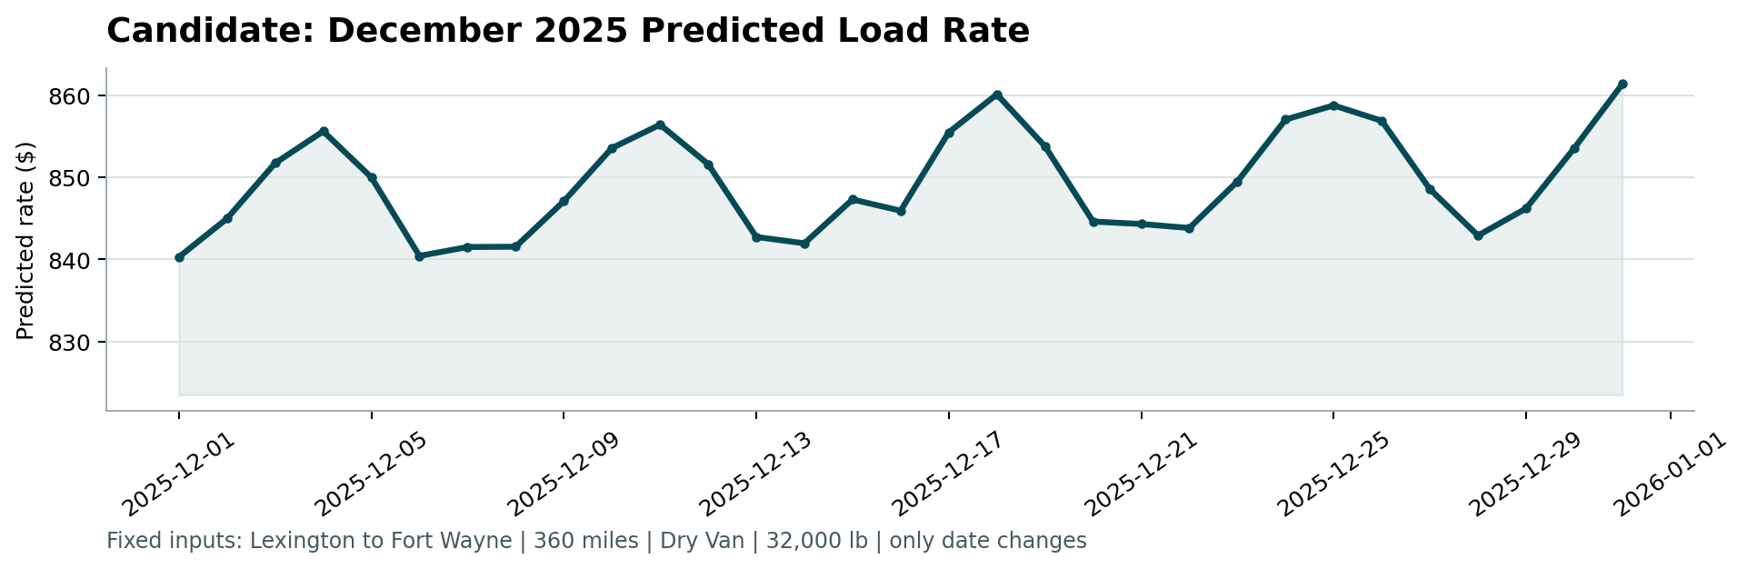
Predictions range from $840 to $861 (about $2.36 per mile, in line with the training median for 300–600 mile hauls). The visible 7-day cycle comes from the weekly cycle in market_index; the slight rise reflects the learned upward trend. The overall swing is small (about ±1%), because for a fixed lane only the market signals move the price. The training data has no December, so any holiday effect on Dec 24–26 is not captured.

6. Limitations
- Nov–Dec is extrapolation: the model has never seen those months, only their market_index and quote_signal values.
- Rate spikes (~0.6% of loads) are not predictable from the available features and cap the achievable RMSE.
- The model lags when the market moves quickly (Jul–Aug fold). A feature capturing market momentum could help but did not improve the backtest in my tests.

