Quantum-Assisted DNA Fragment Ordering for Time-Critical Genomic Diagnostics
Qiskit Fall Fest 2026 Hackathon · Healthcare track
Team: [add team name and members before submitting]
GitHub repository: [add link before submitting]

1. Problem and who it serves
In time-critical oncology and infectious-disease diagnostics, a sequencer produces many short DNA fragments (reads) that must be put back in order before variants can be called. The ordering is a limited-time decision with two goals that pull against each other:
- Contiguity: place fragments so that neighbours overlap as much as possible, which gives a compact, well-supported sequence.
- Reliability: avoid weak junctions, meaning neighbours that overlap by fewer than τ = 3 bases. Repeated sequence makes short overlaps ambiguous, and these are the junctions where assemblers join the wrong fragments and produce a misassembly.
The people served are laboratory bioinformaticians and the clinicians who rely on their reports. A wrong junction can hide or invent a variant. The task is to find an ordering that is contiguous but not misled by repeats, within a fixed compute budget. Our model is a deliberately small, simulator-friendly core of this problem. It is not a production assembler.

2. Formulation

2.1 Test instance
The hidden genome is TACACCATACCAT (13 bases). It is cut into N = 4 shuffled reads of length 6. The ground-truth order is used only to score results; no optimiser sees it. The overlap o_ij is the length of the longest proper suffix of fragment i that equals a prefix of fragment j.
Fragment | Sequence | o → F0 | o → F1 | o → F2 | o → F3
F0 | ATACCA | 0 | 5 | 0 | 4
F1 | TACCAT | 2 | 0 | 1 | 5
F2 | TACACC | 0 | 0 | 0 | 3
F3 | ACCATA | 3 | 2 | 2 | 0
Table 1. Reads and pairwise overlap matrix (rows: left fragment, columns: right fragment).
The instance was found by random search so that a repeat produces a tempting wrong answer. We say this plainly because it makes the instance illustrative, not representative.

2.2 Variables, objective and constraints
- Variables: x[i,t] ∈ {0,1}, equal to 1 if fragment i is placed at position t. This gives N² = 16 binary variables, one qubit each (qubit index i·N + t).
- Constraints: every fragment is used once (Σ_t x[i,t] = 1) and every position holds one fragment (Σ_i x[i,t] = 1). They enter the objective as quadratic penalties A·(1 − Σ x)².
- Objective: maximise Σ_t W[i,j]·x[i,t]·x[j,t+1] with W_ij = o_ij − λ·[o_ij < τ]. The first term rewards contiguity and the second charges λ for every weak junction. Sweeping λ traces the trade-off between the two goals.
- Why a nonlinear weak-junction term: every ordering has exactly N − 1 junctions, so subtracting a constant from all overlaps would not change the optimum. The indicator [o_ij < τ] is what makes reliability a separate objective.
- Penalty weight A: chosen as the smallest value from a candidate list for which the exact QUBO ground state is the unique valid optimum. A = 3 for both λ = 0 and λ = 3.
The QUBO is converted to an Ising Hamiltonian with x = (1 − Z)/2 and handed to Qiskit as a SparsePauliOp. A unit test checks that the Qiskit operator reproduces the QUBO energy on basis states.

2.3 The trade-off on this instance
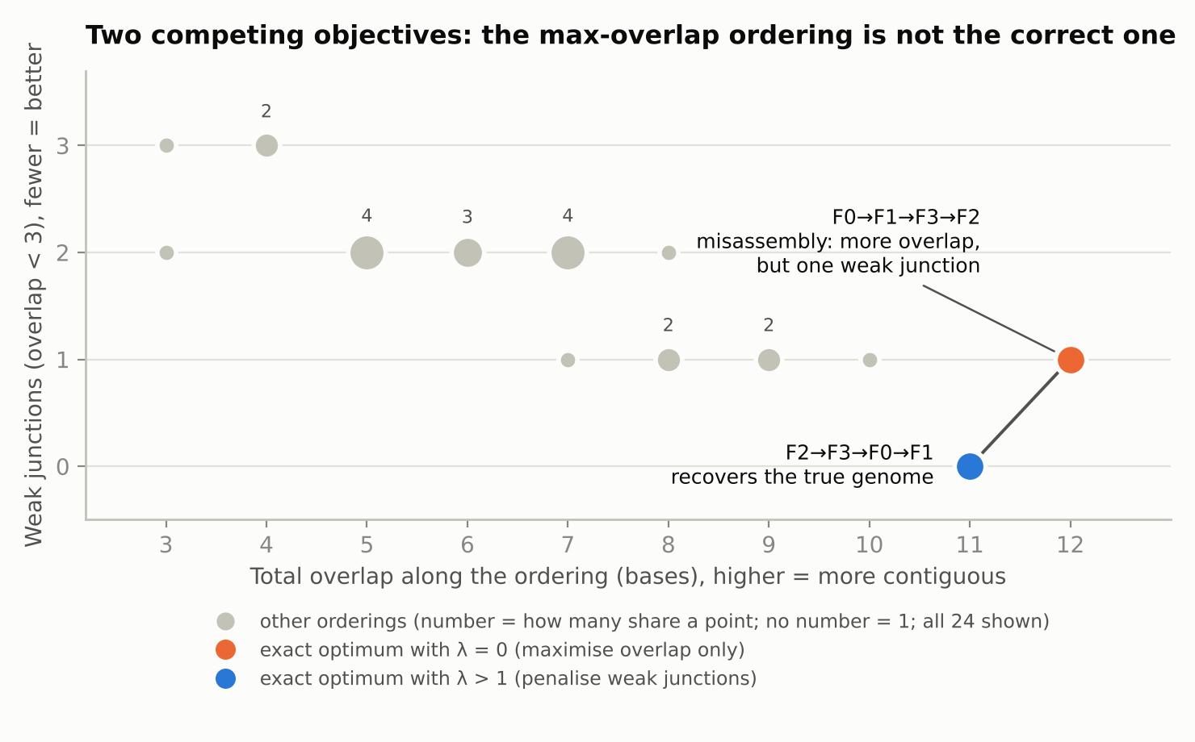
Figure 1. All 24 orderings. Pure maximum overlap (λ = 0) selects a misassembly with total overlap 12 and one weak junction. Penalising weak junctions (λ > 1) selects the true genome with overlap 11 and none.
λ | Exact optimum | Total overlap | Weak junctions | Unique? | Matches true genome
0 | F0→F1→F3→F2 | 12 | 1 | yes | no
0.5 | F0→F1→F3→F2 | 12 | 1 | yes | no
1 | F2→F3→F0→F1 | 11 | 0 | tie | yes
1.5 | F2→F3→F0→F1 | 11 | 0 | yes | yes
2 | F2→F3→F0→F1 | 11 | 0 | yes | yes
3 | F2→F3→F0→F1 | 11 | 0 | yes | yes
4 | F2→F3→F0→F1 | 11 | 0 | yes | yes
Table 2. Exact optimum for each λ. At λ = 1 the two orderings score exactly the same (11), so the tie-break decides. The correct ordering is the unique optimum for every λ > 1.

3. Why QAOA
- Natural fit: the problem is a QUBO, which is an Ising model, so the cost Hamiltonian maps directly onto QAOA's RZ and RZZ phase-separation gates. No problem-specific oracle is needed.
- Sampling, not just a value: QAOA returns a distribution over bitstrings. We decode each shot, discard invalid permutations, and keep the best valid ordering. That fits an objective where we want a good ordering, not an expectation.
- CVaR objective: we train with both the expected energy and CVaR (α = 0.1), which optimises the best 10% of shots and suits sampling-based selection (Barkoutsos et al., 2020).
- Fits the simulator: 16 qubits is exact in a statevector simulator, so we can compute true probabilities instead of noisy estimates.
We do not claim QAOA is the best tool here. Section 6 explains why a classical solver wins at this size. The quantum circuit is the part that generates candidate orderings, and the classical code only optimises angles, filters, decodes and scores.

4. Implementation
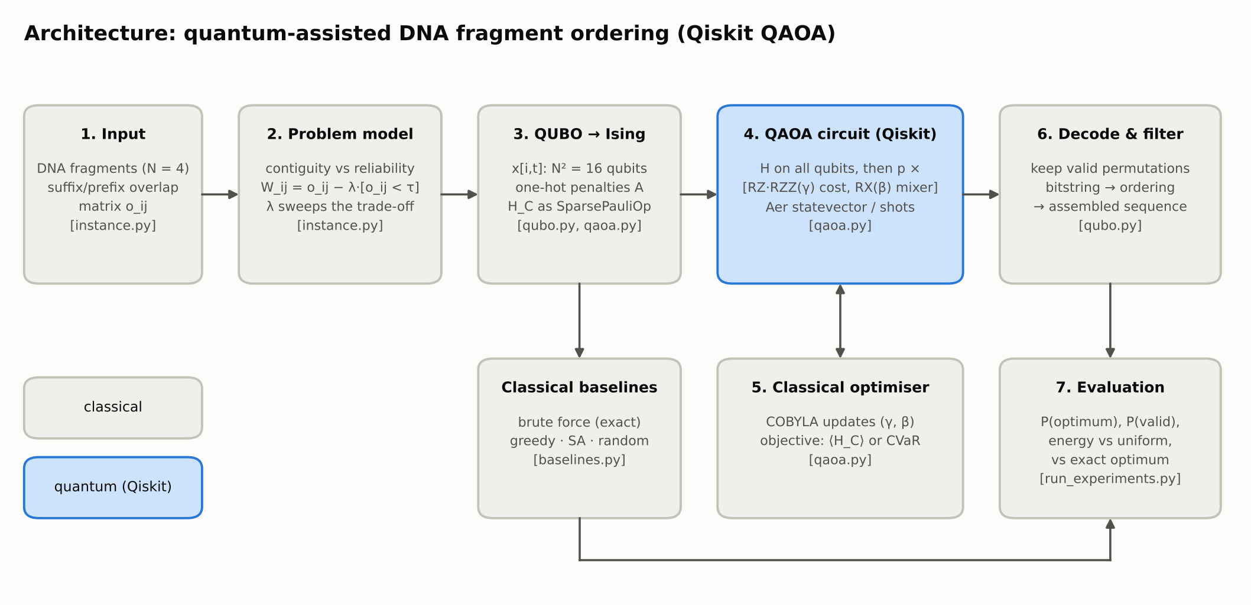
Figure 2. Architecture. Blue is the quantum (Qiskit) component, grey is classical. File names are in brackets.
- Stack: Qiskit 2.x, Qiskit Aer statevector simulator, NumPy, SciPy (COBYLA).
- Circuit: Hadamard on all 16 qubits, then p repetitions of an RZ/RZZ cost layer (angle γ) and an RX mixer (angle β).
- Training: COBYLA with 5 restarts and up to 200 iterations each. Restart 0 uses a linear-ramp initialisation (Sack and Serbyn, 2021) and the others are random. All randomness is seeded (2026).
- Tests: 7 unit tests confirm that the true order reassembles the genome, that the QUBO ground state equals the brute-force optimum for λ = 0 to 5, that exactly 24 states are valid, and that the Qiskit Hamiltonian matches the QUBO energy.
Layers p | Qubits | Circuit depth | CX gates | Total gates
1 | 16 | 95 | 168 | 380
2 | 16 | 142 | 336 | 712
3 | 16 | 201 | 504 | 1044
4 | 16 | 248 | 672 | 1376
Table 3. Transpiled circuit size (basis gates rz, sx, x, cx).

5. Results

5.1 QAOA against random sampling (λ = 3)
p | Objective | P(valid) | P(optimum) | Mean energy | P(optimum in 4,096 shots)
1 | expected energy | 2.2% | 0.21% | 7.30 | 100.0%
1 | CVaR | 3.0% | 0.31% | 9.56 | 100.0%
2 | expected energy | 5.5% | 0.56% | 3.05 | 100.0%
2 | CVaR | 6.4% | 0.76% | 4.51 | 100.0%
3 | expected energy | 7.7% | 0.83% | 4.87 | 100.0%
3 | CVaR | 9.1% | 1.69% | 3.38 | 100.0%
4 | expected energy | 6.7% | 0.94% | 1.90 | 100.0%
4 | CVaR | 7.6% | 1.47% | 1.29 | 100.0%
 | Uniform random | 0.037% | 0.0015% | 43.50 | 6.1%
Table 4. Exact simulator probabilities. The optimal energy is −11, so a lower mean energy is better. The random-sampling figure in the last column is the analytic value.
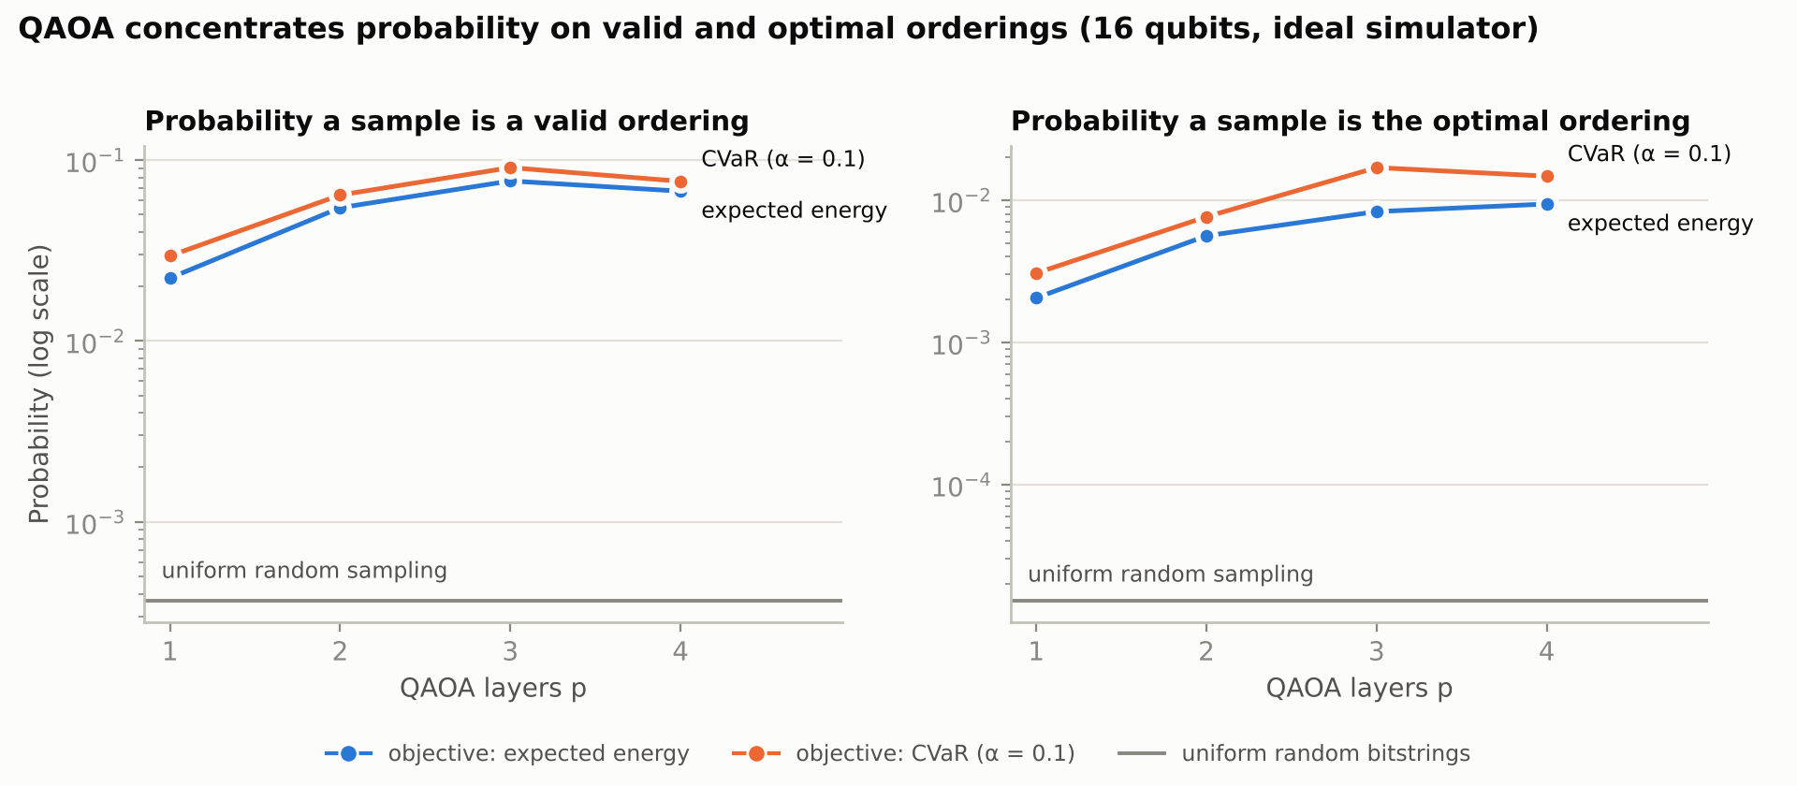
Figure 3. Probability of measuring a valid ordering (left) and the optimal ordering (right), against the number of layers. Log scale.
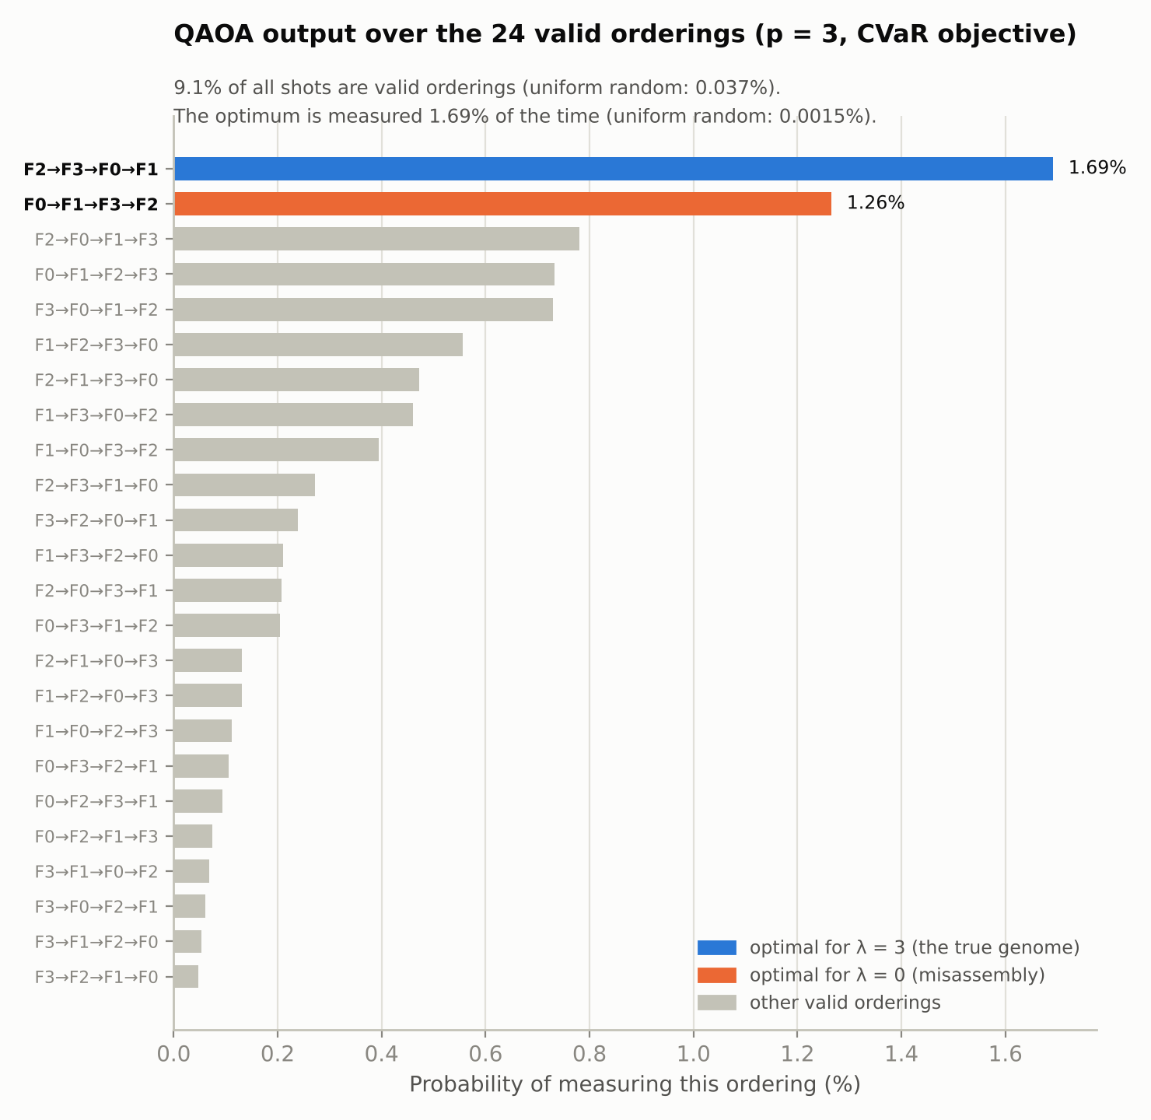
Figure 4. Distribution over the 24 valid orderings for the best run (p = 3, CVaR). The true genome is the most likely ordering. The misassembly, which is the next-best solution of this Hamiltonian, is second.

5.2 Comparison with classical and exact baselines (λ = 3)
Method | Finds the optimum | Time | Notes
Brute force (exact) | exact, 100% | 28 µs | enumerates all 24 permutations
Greedy (multi-start) | finds optimum | 46 µs | deterministic
Simulated annealing, permutations | 96% of 100 runs | 12.7 ms per run
Simulated annealing, same QUBO | 100% of 50 runs | 48.2 ms per run | same 16-bit encoding as QAOA
Random bitstrings (4,096 shots) | 5% of 200 repeats | n/a | analytic value 6.1%
QAOA (p = 3, CVaR) | optimum in 4,096 shots in ~100% of cases | 33 s to train | about 1,000 statevector simulations
Table 5. Success of each method at finding the exact optimum. QAOA time is the training time on a CPU simulator, not a hardware time.

5.3 What the results show
- QAOA clearly does work. At p = 3 with CVaR, 9.1% of shots are valid orderings (about 248× the random rate) and 1.69% are the optimum (about 1,108× the random rate).
- CVaR beats expected energy for the probability of hitting the optimum at every depth we tried, which is what a sampling-based solver cares about.
- Most of the gain is in feasibility. The optimum is only about 4.5× more likely than an average valid ordering. QAOA mainly learns the permutation constraints and then nudges probability toward good orderings. It does not sharply isolate the optimum.
- Not monotone in p. Going from p = 3 to p = 4 lowered P(valid) and, for CVaR, P(optimum). A deeper circuit can represent better states, so this points to the optimiser (a capped COBYLA budget and local minima), not to the algorithm.
- The objective matters. With λ = 0 (pure overlap) at p = 4, QAOA reaches P(optimum) of 0.43% and 0.77% (expected energy and CVaR). Changing λ changes the target the circuit learns.

6. Limitations
- No quantum advantage. With N = 4 there are only 24 candidate orderings. Brute force solves the instance exactly in tens of microseconds and greedy also finds the optimum. QAOA needed tens of seconds of simulation to reach the same answer.
- Ideal simulator only. There is no noise model and no hardware run. The p = 4 circuit has depth 248 and 672 CX gates, which would be dominated by noise on current devices.
- Qubit scaling is poor. The one-hot encoding needs N² qubits, and the valid fraction N!/2^(N²) falls very fast, so most of the Hilbert space is invalid. Real assemblers work on de Bruijn or string graphs with millions of reads, which is far outside this model.
- Hand-picked and tuned. The instance was found by random search to show a misassembly, and λ, τ and A were tuned on this one instance. Results on other instances may differ.
- Optimiser limits. Non-monotone behaviour with p, a fixed COBYLA budget and 5 restarts mean the numbers are a lower bound on what QAOA could reach with more tuning.
- Simplified biology. The model uses exact suffix/prefix overlaps and ignores sequencing errors, reverse-complement strands and coverage.
What the project does show is a complete, tested path from a clinical-style trade-off to a Qiskit circuit, with an exact baseline that tells us when the answer is right.

7. Reproducibility and credits
- Setup and commands are in the README. Run pytest -q tests, then python run_experiments.py (about 5 minutes), then python plots.py.
- All code was written for this hackathon and nothing was copied from tutorials or other teams. QAOA, CVaR and the linear-ramp initialisation are implemented from the papers below.
References
- Farhi, Goldstone, Gutmann. A Quantum Approximate Optimization Algorithm. arXiv:1411.4028 (2014).
- Barkoutsos et al. Improving Variational Quantum Optimization using CVaR. Quantum 4, 256 (2020).
- Sack, Serbyn. Quantum annealing initialization of the Quantum Approximate Optimization Algorithm. Quantum 5, 491 (2021).
- Lucas. Ising formulations of many NP problems. Frontiers in Physics 2, 5 (2014).

