Quantum Grover Adaptive Search for Radiotherapy Beam-Angle Selection under a Beam Limit
Qiskit Fall Fest 2026 · The Quantum Optimization Challenge · Domain: Healthcare
Code: https://github.com/DuaanXahmed/Quantum-Radiotherapy-Beam-Selection · 3-minute demo: link added at submission
At a glance. A radiotherapy plan must choose which gantry angles to use. We select up to k = 4 of 12 candidate beams on a synthetic 2-D phantom to cover a tumour while sparing a nearby organ at risk (OAR) and normal tissue, subject to a hard OAR maximum-dose limit. The 4096 possible plans map one-to-one onto the basis states of 12 qubits. A from-scratch Grover Adaptive Search (GAS) in Qiskit uses a phase oracle that marks feasible plans better than the current best and finds the minimum.
Result. The exact optimum is {60°, 90°, 240°, 270°} (F = 0.03803, unique). GAS found it in 100% of 100 seeded runs with a mean of 126 oracle calls (median 120). Classical unstructured search needs (N+1)/2 = 2048 evaluations. That is 16× more, and the gap widens as the problem grows (7×, 8×, 16×, 36× for n = 8, 10, 12, 14 beams; GAS queries grow as about N^0.47 for n = 10–14, vs N¹ for unstructured search).
Honest caveat. This is a query-count advantage under an ideal oracle. At n = 12, classical methods that use the structure need fewer queries: greedy 43, annealing 62, random search over only the 204 feasible plans 102.5. Against that last baseline the picture across sizes is mixed (GAS fewer at n = 8, 10, 14, more at n = 12). Our oracle is a precomputed truth table. Section 6 sets out what a real advantage would require.

1. What is the problem
Who it serves. Medical physicists and radiation oncologists who plan external-beam radiotherapy. The patients treated with those plans benefit. About half of all cancer patients receive radiotherapy at some point in their treatment, so plan quality and machine time matter at scale.
The decision. A linear accelerator rotates around the patient on a gantry. The planner picks which gantry angles deliver radiation beams. Every beam adds dose to the tumour, but it also passes through healthy tissue on the way in and out. Three objectives compete:
- (a) Tumour coverage: deliver the prescribed dose (1.0) uniformly to the tumour;
- (b) Organ-at-risk (OAR) sparing: keep dose low in a nearby critical organ (e.g. spinal cord or rectum);
- (c) Normal-tissue sparing: limit the integral dose to everything else.
The limited resource is the number of beams. Each extra beam lengthens treatment and machine time and adds QA workload, so clinics cap it. Beam-angle selection is a non-convex combinatorial problem: with n candidate angles there are 2ⁿ candidate plans.

1.1 Formulation
Decision variables. x_a ∈ {0, 1} for a = 0 … 11 (x_a = 1 means beam a at angle 30·a° is used), giving N = 2¹² = 4096 plans. The dose to voxel v is linear in x:
d_v(x) = Σₐ xₐ · D[a, v]
Objective (minimise; the weights express clinical priorities):
F(x) = w_T · mean_tumour (d_v − 1)² + w_O · mean_OAR d_v² + w_N · mean_normal d_v²
with defaults w_T = 1, w_O = 1, w_N = 0.05. Hard constraints:
- C1 beam limit: Σₐ xₐ ≤ k = 4. This leaves 794 of 4096 plans (= Σ_(j≤4) C(12, j), verified in code);
- C2 OAR maximum dose: max_(v∈OAR) d_v(x) ≤ 0.6. This is a dose-volume-style limit and it is not quadratic in x. With C1 it leaves M = 204 feasible plans.
Table 1. Test instance. It is synthetic, with no patient data. All seeds are fixed.
Item | Value
Phantom | 21×21 voxel grid; body = disk of radius 10 (317 voxels)
Tumour (target) | disk, radius 3, at the isocentre (29 voxels)
Organ at risk | disk, radius 2, centred at (x, y) = (0.3, -5.7) (13 voxels)
Normal tissue | rest of the body (275 voxels)
Candidate beams | 12 gantry angles 0°, 30°, …, 330°; parallel strip 7 voxels wide
Dose model | exp(−0.05 · depth from body surface) inside the strip; each beam scaled to 0.25 at the isocentre (≈ 4 beams reach the prescription 1.0)
Search space | N = 4096 plans; 794 satisfy C1; 204 satisfy C1 and C2
Exact optimum | {60°, 90°, 240°, 270°}, F = 0.03803; runner-up {60°, 90°, 270°, 300°}, F = 0.03974 (unique, gap 1.7e-03)

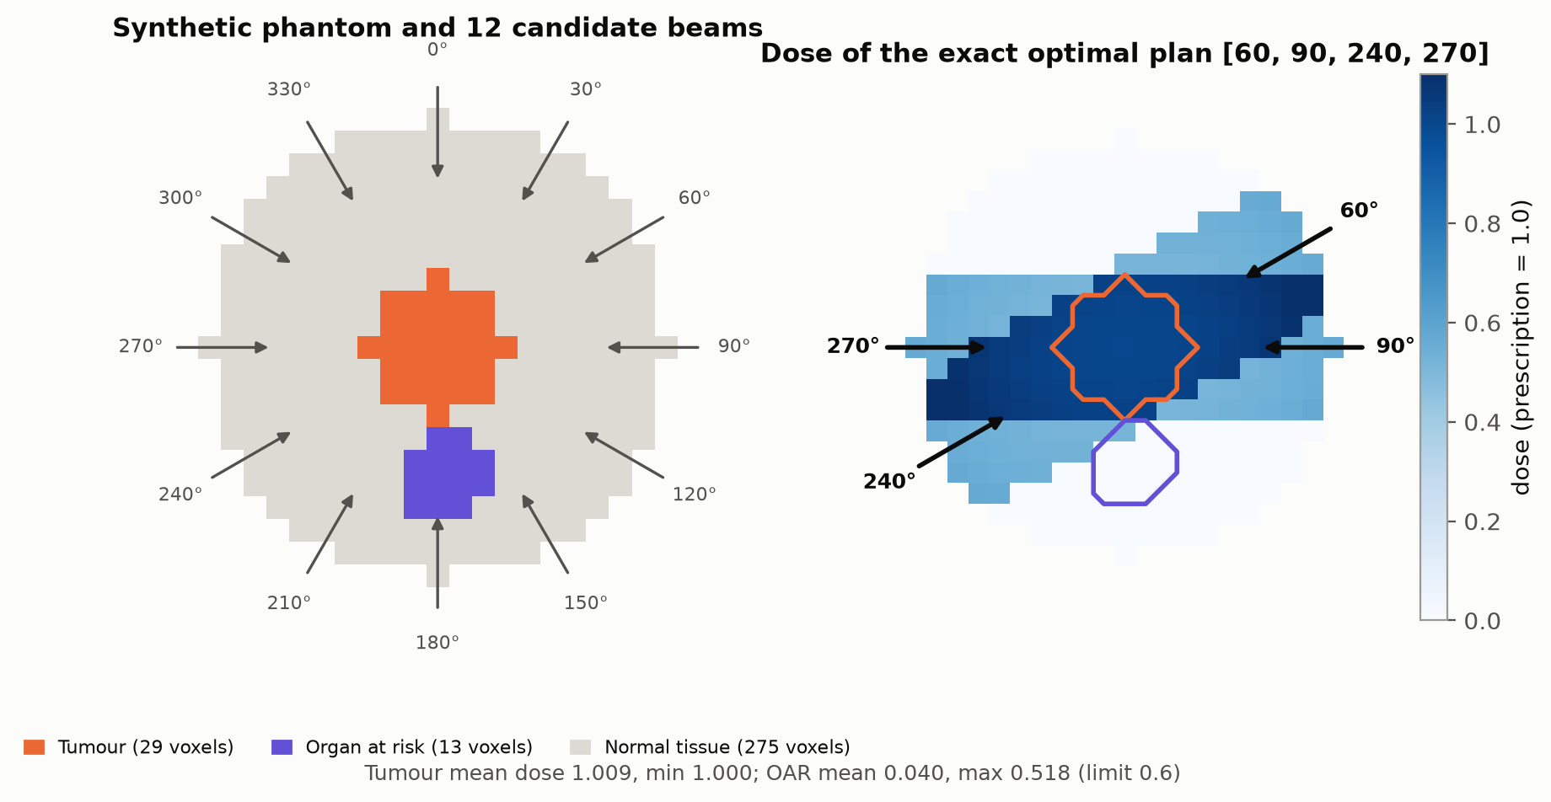
Figure 1. Left: the phantom and the 12 candidate beam directions. Right: dose of the exact optimal plan. It avoids the 6 beams that pass through most of the OAR (0°, 30°, 150°, 180°, 210°, 330°; each covers ≥ 69% of OAR voxels) and uses the 4 beams that touch at most one OAR voxel (60°, 90°, 240°, 270°). It covers the tumour (min dose 1.000) and keeps the OAR maximum at 0.518, below the 0.6 limit.

2. Why this problem
- It is a real clinical bottleneck. Many clinics still choose beam angles from templates ("class solutions") or planner experience. Better angles can give the same tumour dose with less damage to organs. Fewer beams mean shorter treatments.
- It is the kind of problem the challenge asks for. It has three competing objectives and a hard limit on a scarce resource (beams). Section 5 shows the trade-off quantitatively: as the OAR weight w_O rises, the optimal plan changes (3 distinct optima across w_O ∈ {0, 0.5, 1, 2, 5}).
- It is hard in general. The objective over beam sets is non-convex. Real planning uses 36–180 candidate angles (10° to 2° spacing) and 5–9 beams. Choosing 7 of 72 angles alone gives C(72, 7) ≈ 1.5e+09 plans, each needing its own fluence optimisation.
- The constraints are not quadratic. Maximum-dose limits like C2 are what clinicians actually write down. A QUBO/QAOA formulation must approximate them with penalties and slack qubits. Grover search can enforce them exactly, which makes this a good fit for the algorithm we chose.
- Originality. Quantum work in healthcare usually targets scheduling or equipment allocation. We are not aware of a Grover-based treatment-planning demonstration of this kind. We built a dose model, a constrained clinical objective and a Pareto study around it.

3. Existing classical methods
Beam-angle optimisation (BAO) has been studied since the early 1990s (e.g. Bortfeld & Schlegel, 1993). The main families are:
Table 2. Classical approaches to beam-angle selection.
Approach | How it works | Guarantee / weakness
Class solutions / templates | Equi-spaced or site-specific standard angles chosen by the planner | Fast; no optimality, ignores the patient's anatomy
Exhaustive enumeration | Evaluate every plan | Exact; cost grows as 2ⁿ (or C(n, k))
Greedy / iterative beam addition | Add the beam that helps most, repeat | Fast; can get stuck (non-convex)
Simulated annealing, genetic algorithms | Stochastic local search over beam sets | Good in practice; no certificate of optimality, needs tuning
Mixed-integer programming (branch-and-bound) | Binary beam variables + dose constraints, solved exactly | Exact with proof of optimality; can become very slow at clinical scale
Beam's-eye-view scoring | Rank single beams by target-vs-OAR overlap | Cheap; ignores how beams interact

Baselines we implemented on the same instance (all seeded, same cost function, results in Table 7):
- Brute force: all 4096 plans, and the 204 feasible plans only. Exact; 89 ms in Python.
- Random search without replacement: 1000 seeded trials; analytic (N+1)/2 = 2048.5 over all plans and (M+1)/2 = 102.5 over feasible plans.
- Greedy forward selection: 43 evaluations; finds the optimum at the default weights but only at 4 of 5 weight settings.
- Simulated annealing: constraint-aware, with flip and swap moves, 300 steps, 100 seeds; success 98%.
- NNLS lower bound: continuous beam intensities with no beam limit (scipy nnls). F ≥ 0.01983 for every plan, which certifies how good the optimum is.
Takeaway. At 12 beams classical methods solve this instance easily. That is intended: the small size lets us check the quantum result against an exact answer. The difficulty is in scaling. Exact methods grow exponentially, and fast heuristics give no guarantee (greedy fails at w_O = 0).

4. Why we need quantum computing
Finding a plan that is feasible and better than the current best is a search with a yes/no test. Without exploitable structure, a classical algorithm needs about N/(2M) evaluations to find one of M marked items among N. Grover's algorithm needs about (π/4)·√(N/M) oracle calls. That is a provable quadratic reduction in queries (Grover, 1996). Dürr and Høyer (1996) turned this into minimum finding with O(√N) queries: repeat Grover search with a threshold that falls each time. Boyer, Brassard, Høyer and Tapp (1998) showed how to do this when M is unknown, using a random iteration count. Gilliam, Woerner and Gonciulea (2021) applied the scheme to constrained binary optimisation and called it Grover Adaptive Search.
Table 3. Why GAS rather than QAOA for this problem.
 | Grover Adaptive Search (ours) | QAOA / VQE (QUBO-based)
Cost function | Any computable F(x) | Must be quadratic (QUBO) or a low-order polynomial
Constraint C1 (Σx ≤ k) | Checked exactly inside the oracle | Penalty term + slack qubits
Constraint C2 (max dose ≤ 0.6) | Checked exactly inside the oracle | No exact quadratic form; needs approximation
Penalty tuning | None | Penalty weights must be tuned; infeasible outputs are possible
Guarantee | Provable query bound O(√N); exact optimum with high probability | Heuristic; approximation ratio depends on depth p and training
Qubits here | 12 (one per beam), 0 ancillas | 12 + slack qubits for C1

So the quantum part is not a showcase: it is the search engine. The circuit does the work of finding an improving plan, and the classical side only checks the one plan that was measured. We do not claim a wall-clock speedup at this size; the claim is about how the number of queries grows (Section 5.6).

5. The quantum solution

5.1 Mapping the problem to qubits
Qubit a represents beam a. The computational basis state |i⟩ on 12 qubits is the plan whose beam a is on exactly when bit a of i is 1. This is Qiskit's little-endian order, so qubit 0 is beam 0° and the leftmost character of a measured bitstring is beam 330°. The optimum {60°, 90°, 240°, 270°} is the state |001100001100⟩ (index 780). Starting from H^⊗12|0⟩, the register holds all 4096 plans in equal superposition.

5.2 Oracle, diffuser and Grover iteration
O_y |x⟩ = −|x⟩ if x satisfies C1 and C2 and F(x) < y, O_y |x⟩ = |x⟩ otherwise
W = H^⊗n X^⊗n (multi-controlled Z) X^⊗n H^⊗n = −(2|s⟩⟨s| − I), G = W · O_y
The oracle is a `DiagonalGate` built from a ±1 truth table, so it carries both hard constraints and the threshold exactly. The diffuser uses an 11-controlled phase(π) gate (`mcp`). After r iterations the probability of measuring one of the M marked plans is sin²((2r+1)θ), where sin²θ = M/N (Figure 3).

5.3 Grover Adaptive Search loop
- Initialise: draw a random feasible plan x₀ (seeded) and set y = F(x₀), best = x₀, m = 1, λ = 6/5.
- Pick r uniformly from {0, …, ⌈m⌉ − 1} (BBHT schedule; this handles the unknown M).
- Build H^⊗12 · (W O_y)^r, measure 1 shot on AerSimulator (seeded), and decode the bitstring into a plan x.
- Evaluate F(x) and the constraints classically. If x is feasible and F(x) < y: set y ← F(x), best ← x, m ← 1, and rebuild O_y. Otherwise: m ← min(λm, √N).
- Stop after 25 consecutive non-improving rounds or an oracle budget of 30√N = 1920 calls. Return best.
Termination rule (our adaptation). With λ = 6/5 the iteration range m needs ⌈log_λ √N⌉ = 23 failures to reach its √N cap. We therefore stop after ⌈log_λ √N⌉ + 2 = 25 failures, a rule that scales with N. The commonly quoted '15 rounds' stops while r ≤ 15. That is too few to amplify the last 1–2 improving plans out of 4096, and the ablation in Table 4 shows the effect clearly.
Table 4. Termination-rule ablation (same seeds).
Consecutive failures before stop | Runs | Success (exact optimum) | Mean oracle calls to optimum | Mean total oracle calls
15 | 50 | 26% | 41.1 | 65.3
20 | 50 | 80% | 106.0 | 182.3
25 (ours) | 50 | 100% | 126.4 | 347.7

5.4 Architecture and circuit resources
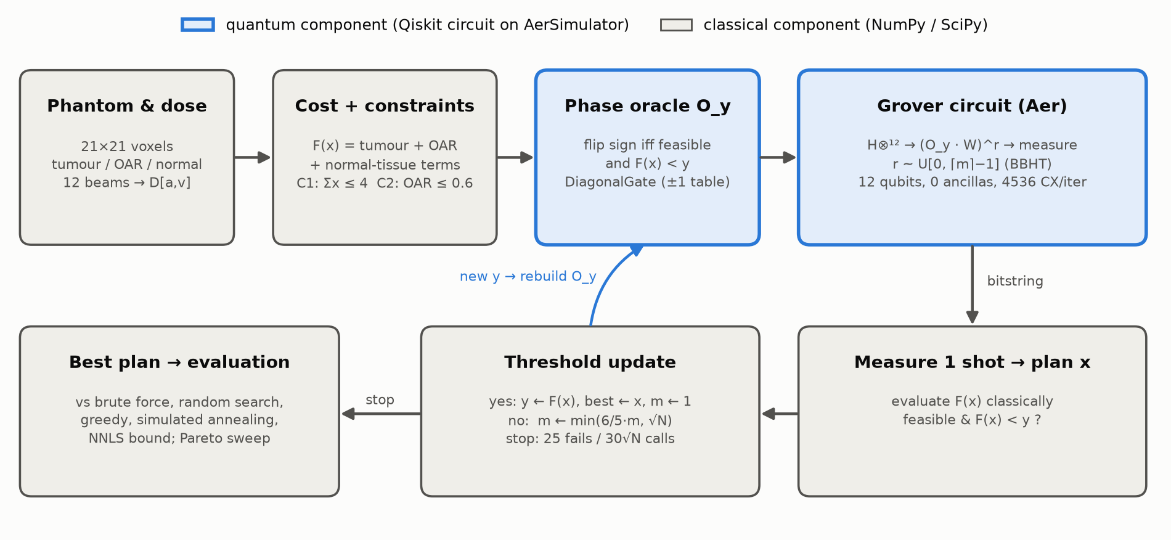
Figure 2. Hybrid architecture. Blue = quantum components (Qiskit circuits on AerSimulator); grey = classical components. The only quantum-to-classical link is a single measured bitstring per round.
Table 5. Circuit statistics (Qiskit transpile, optimization_level = 1, seed 0).
Quantity | Value
Qubits / ancillas | 12 / 0
One Grover iteration, logical | depth 6: 1 DiagonalGate (oracle), 1 multi-controlled phase, 24 H, 24 X
One iteration transpiled to {cx, rz, sx, x} | depth 8,449, 9,246 gates, 4,536 CX
of which oracle | 4,094 CX (depth 8,170); ≈ 2ⁿ, as expected for an arbitrary diagonal
of which diffuser | 442 CX (depth 280)

The transpiled numbers matter: an arbitrary truth-table oracle costs about 2ⁿ two-qubit gates. This is the main practical limitation (Section 6).

5.5 Validation
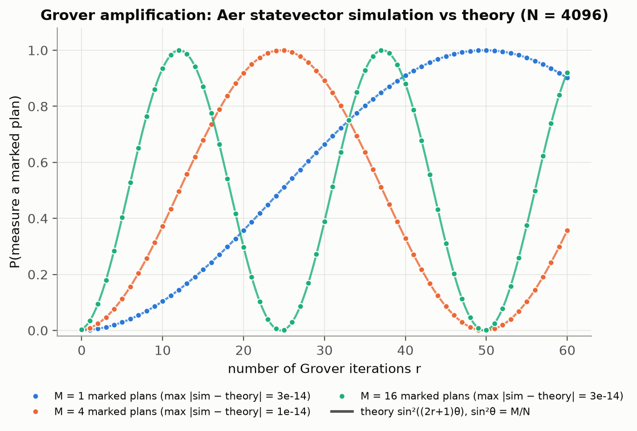
Figure 3. Probability of measuring a marked plan after r Grover iterations: Aer statevector simulation (dots) vs the formula sin²((2r+1)θ) (lines) for M = 1, 4, 16 marked plans. Maximum deviation 3e-14, i.e. exact to machine precision.
The pytest suite (9 tests) checks: the feasible count (794 under C1); F against a beam-by-beam manual calculation; the qubit-to-beam bit order; that the oracle flips exactly the feasible, below-threshold plans; that one and two Grover iterations match theory; the diffuser as an inversion about the mean; and that a seeded GAS run returns the brute-force optimum and is reproducible.

5.6 Results
Trade-off between objectives (exact enumeration).
Table 6. Exact optimum for each OAR weight (every optimum unique).
w_O | Optimal beams | F | Tumour error | OAR mean dose | OAR max dose | Greedy finds it?
0 | {90°, 180°, 270°, 330°} | 0.01181 | 2.08e-04 | 0.499 | 0.545 | no
0.5 | {60°, 90°, 240°, 270°} | 0.02770 | 1.13e-04 | 0.040 | 0.518 | yes
1 | {60°, 90°, 240°, 270°} | 0.03803 | 1.13e-04 | 0.040 | 0.518 | yes
2 | {60°, 90°, 240°, 270°} | 0.05870 | 1.13e-04 | 0.040 | 0.518 | yes
5 | {60°, 90°, 270°} | 0.09061 | 5.96e-02 | 0.018 | 0.233 | yes

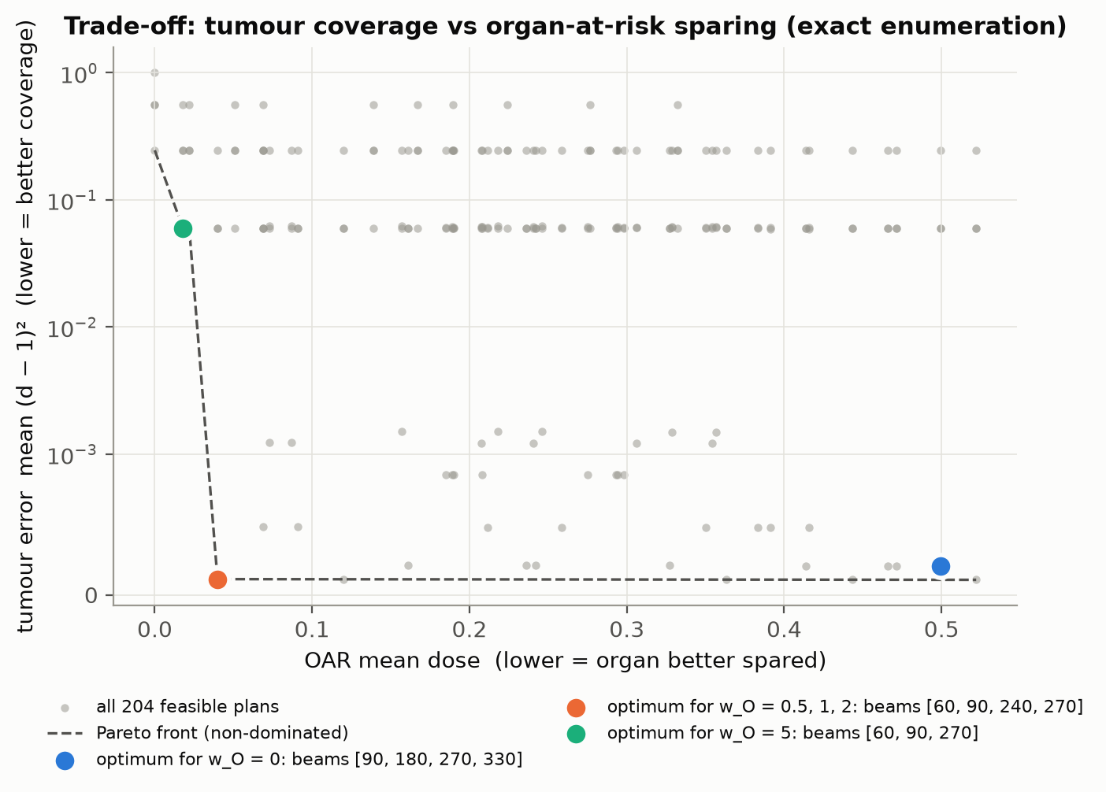
Figure 4. Every feasible plan (grey) in the tumour-error vs OAR-dose plane, the Pareto front, and the optima for each w_O. Raising w_O moves the optimum from an OAR-crossing 4-beam plan to an OAR-avoiding 4-beam plan, and finally to a 3-beam plan that gives up tumour coverage to protect the organ. The w_O = 0 plan sits off the front in this 2-D view because it trades the third objective (normal-tissue dose).
GAS vs classical baselines (n = 12, N = 4096, default weights).
Table 7. GAS (100 seeds) vs classical baselines.
Method | Queries to reach optimum (mean) | Success | Total cost per run | Notes
GAS (quantum, ours) | 126 oracle calls (median 120) | 100% | 347 oracle calls, 80 F-evaluations | Provable O(√N) queries; cost-agnostic oracle
Brute force (all plans) | 4096 | 100% | 4096 evaluations | Exact
Brute force (feasible plans only) | 204 | 100% | 204 evaluations | Exact; needs the feasible set listed in advance
Random search, all plans | 2048.5 (sim. 2011) | 100% | until found | Unstructured classical reference
Random search, feasible only | 102.5 (sim. 105) | 100% | until found | Uses structure
Greedy forward selection | 43 | yes | 43 | Heuristic; fails at 1 of 5 weights
Simulated annealing | 62 | 98% | 301 | Heuristic; needs tuning
NNLS continuous bound | n/a | n/a | 1 solve | F ≥ 0.01983 (optimum is 1.92× the bound)

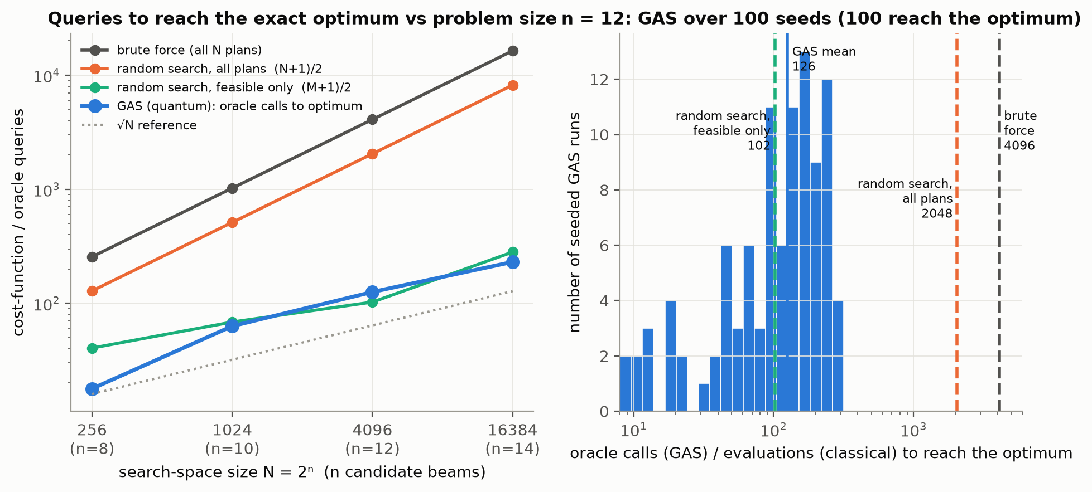
Figure 5. Left: queries needed to reach the exact optimum as the number of candidate beams grows (mean over seeded runs). GAS follows the √N reference while unstructured search grows as N. Right: the distribution of GAS oracle calls over seeds at n = 12, compared with the classical references.
Table 8. Scaling study: same phantom with n equi-spaced candidate angles, k = 4.
n beams | N | Feasible M | √N | GAS calls to opt. | GAS / √N | Random (N+1)/2 | Random ÷ GAS | Random feasible (M+1)/2 | GAS success
8 | 256 | 80 | 16 | 17.8 | 1.11 | 128.5 | 7.2× | 40.5 | 98% (60)
10 | 1024 | 136 | 32 | 63.1 | 1.97 | 512.5 | 8.1× | 68.5 | 98% (60)
12 | 4096 | 204 | 64 | 125.7 | 1.96 | 2048.5 | 16.3× | 102.5 | 100% (100)
14 | 16384 | 562 | 128 | 230.6 | 1.80 | 8192.5 | 35.5× | 281.5 | 100% (20)

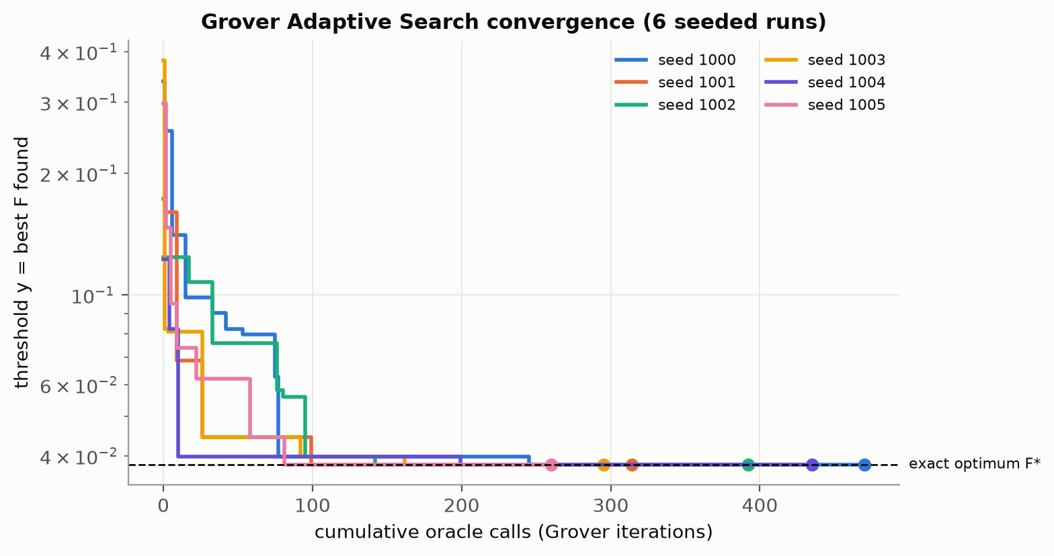
Figure 6. GAS convergence: the threshold y (best cost so far) against cumulative oracle calls for six seeded runs. Each step down is a measured plan that beat the previous best. The flat tail is the stopping phase, where no better plan exists.
Reading the results. (1) GAS is correct: it returned the unique brute-force optimum in 100% of runs. (2) It needed 126 oracle calls on average, 2.0·√N, against 2048 for unstructured classical search. The ratio grows from 7× to 36× as n grows from 8 to 14. A log-log fit over n = 10–14 gives GAS queries ∝ N^0.47, close to the ideal Dürr–Høyer N^0.5 and far below the N¹ of unstructured search. Over all sizes the fit is N^0.60, because at n = 8 80 of 256 plans are feasible and zero-iteration rounds (plain sampling, no oracle calls) often hit the optimum, which makes the smallest instance unusually cheap. (3) GAS does not robustly beat structure-aware classical methods. At n = 12, greedy needs 43 evaluations, annealing 62 and random search over the 204 feasible plans 102.5, all fewer than GAS's 126. Against feasible-only random search the result is mixed across sizes: GAS needs fewer queries at n = 8, 10, 14 and more at n = 12. (4) Including the stopping phase, a run costs 347 oracle calls. Proving that nothing better exists is the expensive part, as in classical search.

6. Limitations and honest reflection
- The advantage is in query count only. There is no wall-clock speedup on a simulator: a GAS run takes about 0.8 s, while brute force takes 89 ms. There is also no advantage over structured solvers (branch-and-bound / MIQP) or over methods that use the feasible-set structure (Table 7).
- The oracle is a precomputed truth table, which means every plan is already evaluated classically to build it. A real oracle would compute dose, cost and constraints with reversible arithmetic circuits on error-corrected hardware. Our truth-table oracle already needs 4,094 CX gates per call. Babbush et al. (PRX Quantum 2021) show that such overheads can cancel a quadratic speedup at realistic sizes.
- 12 qubits can be brute-forced. Clinical planning uses about 36–180 angles, continuous beam intensities (fluence maps), 3-D anatomy and Monte-Carlo dose. Our instance is a deliberately small, verifiable model of that decision.
- The phantom and dose model are simplified: 2-D synthetic geometry, no scatter, no penumbra, no tissue heterogeneity. The weights and the OAR limit were tuned on this one instance. The OAR centre was placed 0.3 voxels off the symmetry axis so that mirror-image plans do not tie (Section 8).
- The stopping rule is a design choice. With 25 failures GAS succeeded in 100% of runs; with 15 it succeeded in 26%. GAS is probabilistic and gives no certificate of optimality, unlike brute force or branch-and-bound.
- The simulator is ideal and noise-free. This is a research prototype, not clinical software, and must not be used for treatment decisions.
Next technical step. GAS currently searches all 2ⁿ plans, although only plans with ≤ k beams can be feasible. Preparing a Dicke-state superposition over the ≤ k-beam plans instead of H^⊗n would shrink the quantum search space from 4096 to 794 plans and the query count by about √(4096/794) ≈ 2.3×. That closes most of the gap to structure-aware classical search while keeping the exact constraint handling.

7. Conclusion: the final message
What we built. We turned a real radiotherapy decision (which beams, under a beam limit and a hard organ-dose limit) into a 12-qubit search problem. We then solved it with a Grover Adaptive Search written from scratch in Qiskit, where the quantum circuit does the search and every number is checked against an exact classical answer.
What we found. GAS returned the exact optimal plan in 100% of 100 seeded runs. It needed about 126 oracle calls, compared with 2048 for unstructured classical search, and that gap widens with every beam added. The oracle enforces non-quadratic clinical constraints exactly, without penalties or extra qubits. QUBO-based methods cannot do this.
The final message. Quantum search is a natural engine for constrained treatment-plan selection, because any clinical rule a planner can compute becomes part of the oracle. Its benefit is a provable √N reduction in queries, not faster planning today. To matter clinically it needs fault-tolerant hardware, efficient arithmetic oracles and much larger beam sets. Until then, the honest role of this work is a verified, reproducible blueprint for that future, with clear evidence of where classical methods still win.

8. Reproducibility and credits
Run it. `pip install -r requirements.txt`, then `pytest -q`, then `python run_experiments.py` (full run 252 s; `--quick` < 60 s), then `python plots.py` and `python make_report.py`. Seeds: GAS 1000+i, SA 2000+i, scaling 3000+i, random search 7. Python 3.12.14, Qiskit 2.6.2, Qiskit Aer 0.18.2, NumPy 2.5.4. All numbers in this report are read from results/results.json.
Design choices. OAR centre (0.3, −5.7) rather than (0, −6): with a perfectly symmetric phantom every asymmetric plan has a mirror twin of equal cost, so the optima at w_O = 0 and w_O = 5 tied. The small offset makes every optimum unique. Simulated annealing uses swap moves in addition to bit flips, because plain flips get trapped at the beam limit and that would make the baseline unfairly weak.
Originality statement. All code was written by the team. No `qiskit_optimization` (GroverOptimizer) or tutorial code is used. Only core Qiskit circuit primitives (`DiagonalGate`, `mcp`, `transpile`) and Qiskit Aer appear.
References
- L. K. Grover, “A fast quantum mechanical algorithm for database search,” STOC 1996; arXiv:quant-ph/9605043.
- C. Dürr and P. Høyer, “A quantum algorithm for finding the minimum,” 1996; arXiv:quant-ph/9607014.
- M. Boyer, G. Brassard, P. Høyer and A. Tapp, “Tight bounds on quantum searching,” Fortschritte der Physik 46, 493 (1998).
- A. Gilliam, S. Woerner and C. Gonciulea, “Grover Adaptive Search for Constrained Polynomial Binary Optimization,” Quantum 5, 428 (2021).
- R. Babbush et al., “Focus beyond quadratic speedups for error-corrected quantum advantage,” PRX Quantum 2, 010103 (2021).
- T. Bortfeld and W. Schlegel, “Optimization of beam orientations in radiation therapy: some theoretical considerations,” Physics in Medicine and Biology 38, 291 (1993).

