Tutorial

First download the “Setup File” and edit the content. You can also use your own excel file but must conform to the structure outlined below for better file optimization for SimaPro.
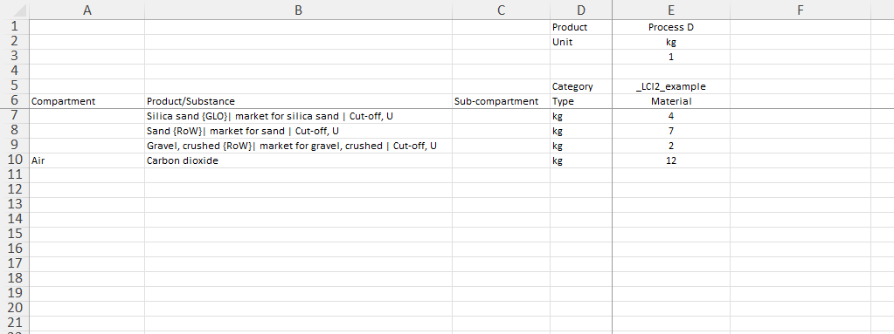
In the “Setup File”:

-Process D is the name of your unit process (You can change it)
-1 kg is your functional unit (You can change it)
-Category Type is where your working directory is located, and so “_LCI2_example” is the working directory I am creating and saving all my unit processes (for this illustration). See image below:
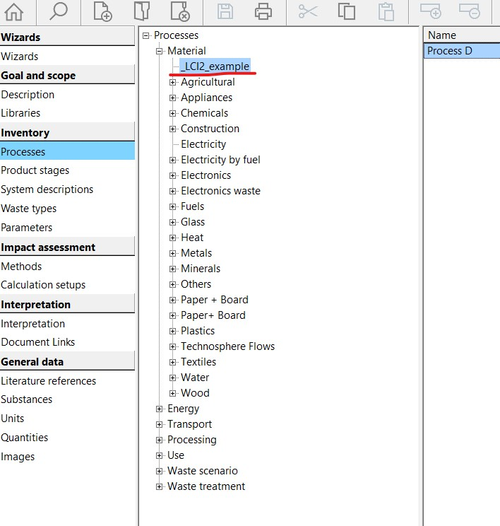

-Compartment in the “Setup File” section “Air” are your environmental releases, you can also have “water”, “soil” …etc
-Product/substance
Silica sand {GLO}| market for silica sand | Cut-off, U: here is the unit process within Simapro I want to use for creating my unit Process D (for this illustration). (You can change it)
-Carbon dioxide
This is the air emission. You can include all the other releases (to water, soil…etc) based on the model you want to build.
You can create hundreds of unit processes in one Excel sheet or multiple sheets, and the web app will automatically convert everything for you, ready to be imported into SimaPro.

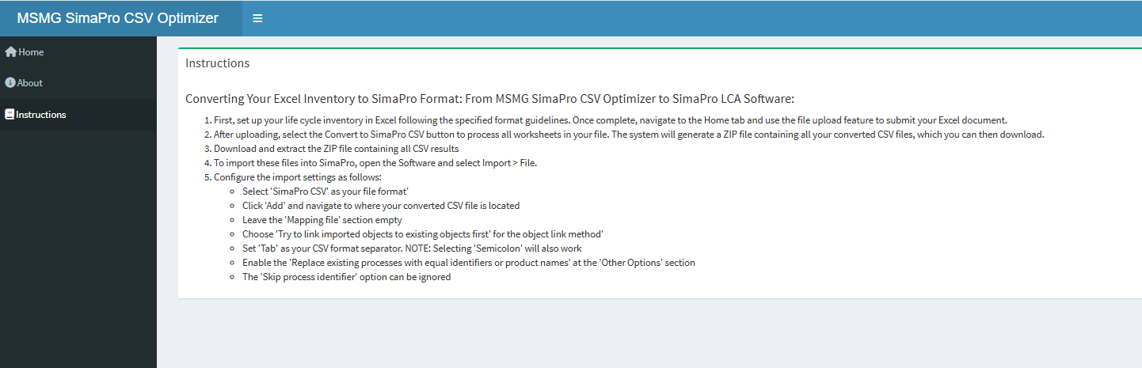
Software Instruction (Also available here )

First, set up your life cycle inventory in Excel following the specified format guidelines. Once complete, navigate to the Home tab and use the file upload feature to submit your Excel document.
After uploading, select the "Convert to SimaPro CSV" button to process all worksheets in your file. The system will generate a ZIP file containing all your converted CSV files, which you can then download.
To import these files into SimaPro, open the program and select Import > File. Configure the import settings as follows:
- Click "Add" and navigate to where your converted CSV file is located
- Leave the Mapping file empty
- Select "SimaPro CSV" as your file format
- Choose "Try to link imported objects to existing objects first" for the object link method
- Set "Tab" as your CSV format separator. "Selecting 'Semicolon' will also work."
- Enable the " Replace existing processes with equal identifiers or product names" at the Other Options
- “The 'Skip process identifier' option can be ignored
Importing:
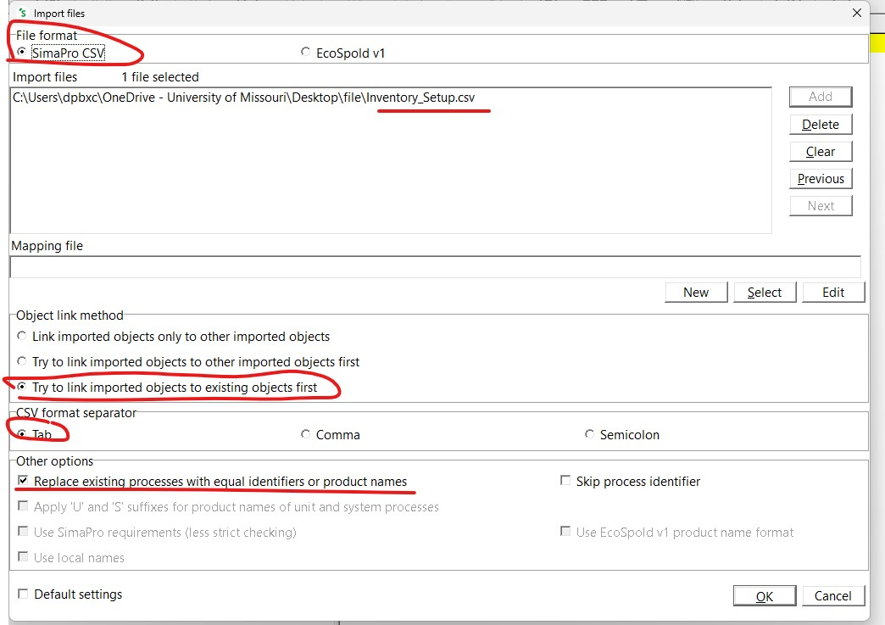

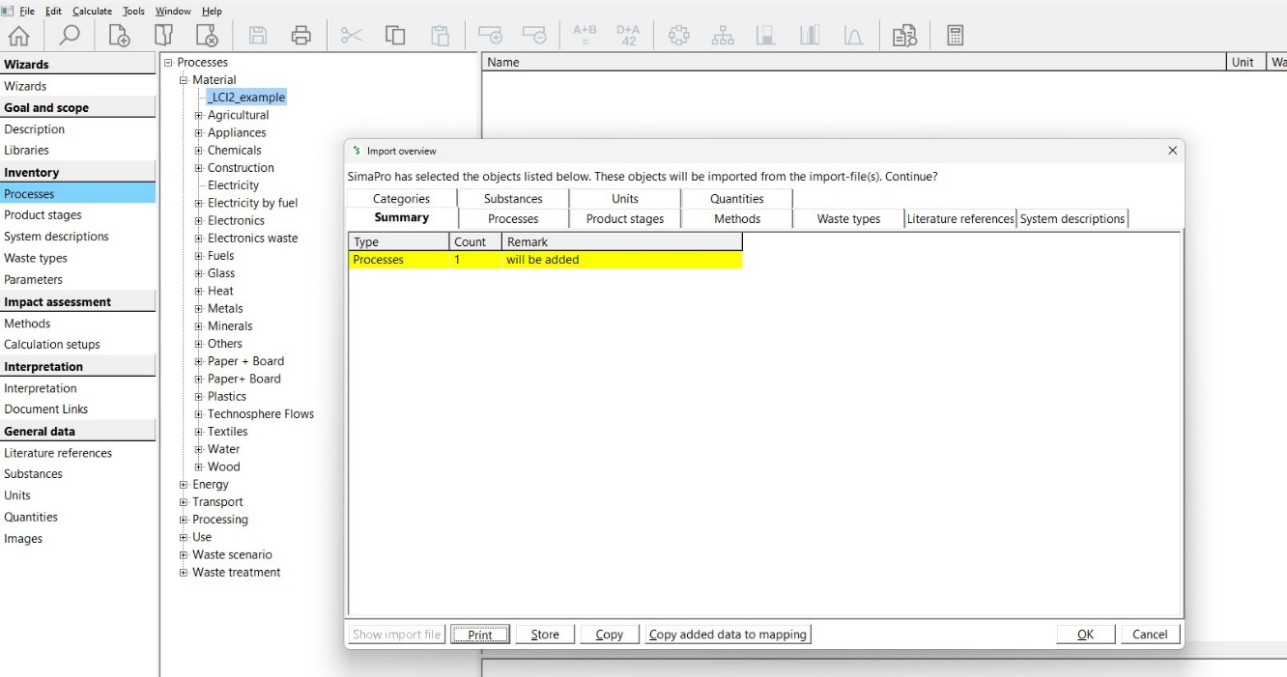

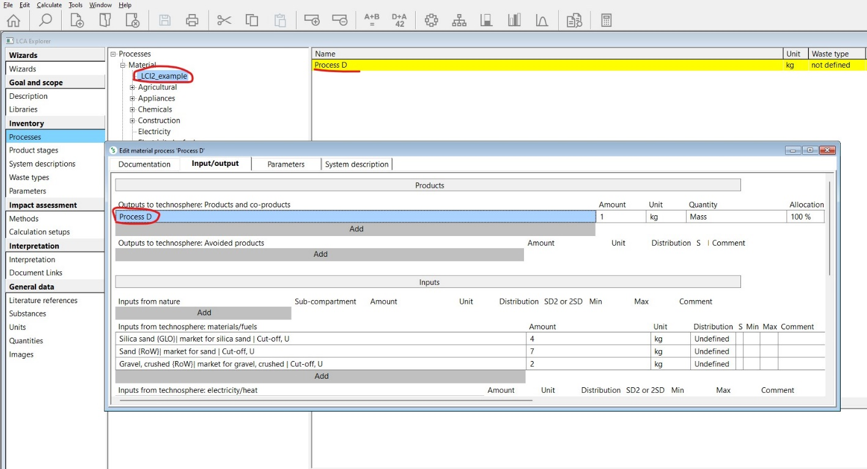
Final Output:

