ADVANCED APPLICATIONS: LAB 2

Environment

Core Emscripten can be cloned from GitHub sources.

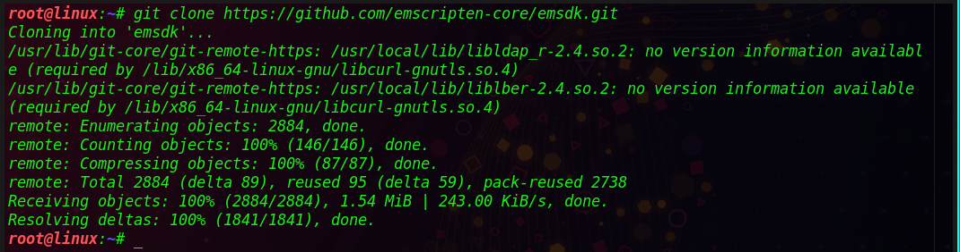

Figure github clone

The latest SDK tools can be install using ‘install latest’ command in the cloned repository.

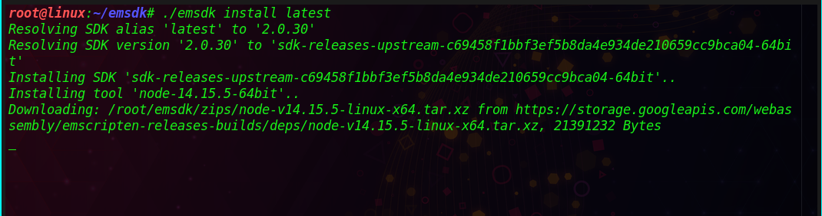

Figure SDK installation

Latest installed SDK can be made available to current user by activating. Instructions are written to ‘.emscripten’ file located at the current user’s directory.

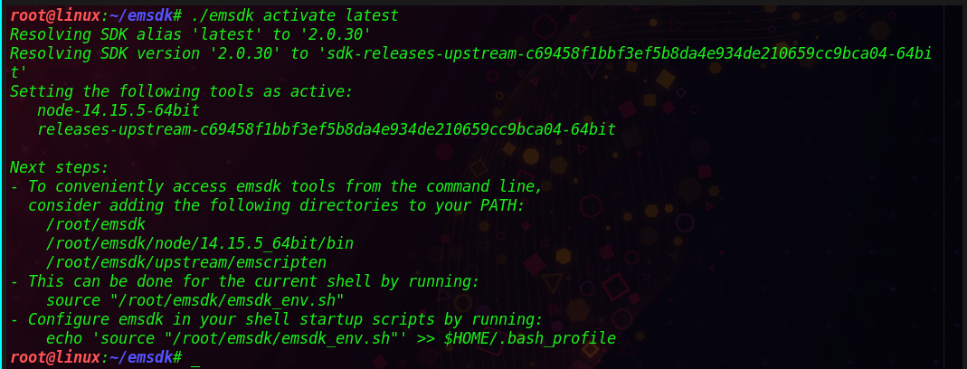

Figure Installed SDK

Active PATH and environmental variables for the current terminal available in the user context are set using source command.

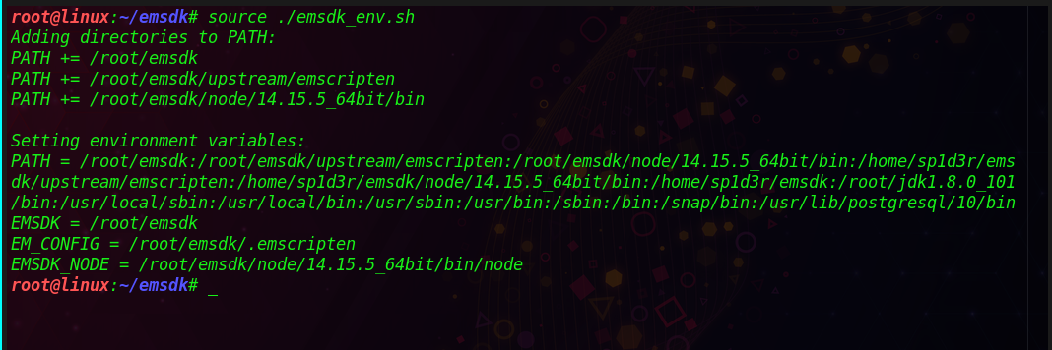

.

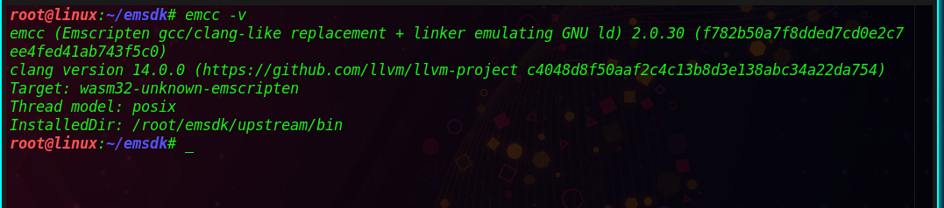.

Figure emsdk installation complete

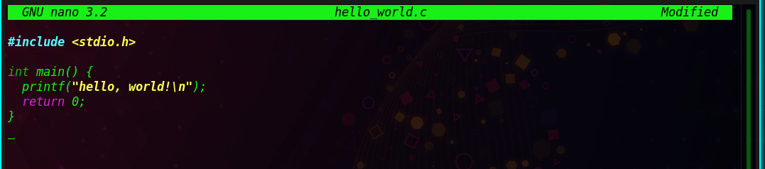

Figure 5 codes with environment variables

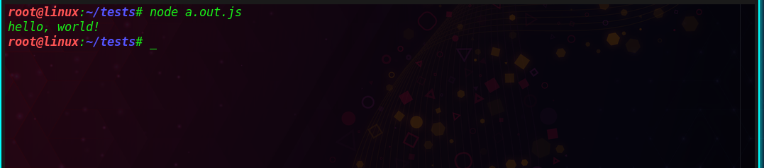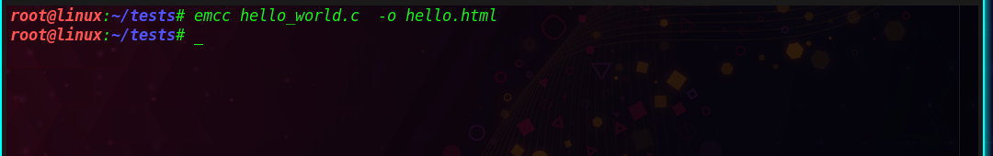

Code base transpiling

A sort algorithm developed in c++ is transpiled in this case to native code.

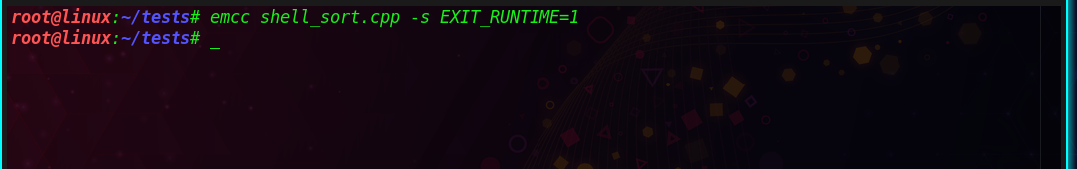

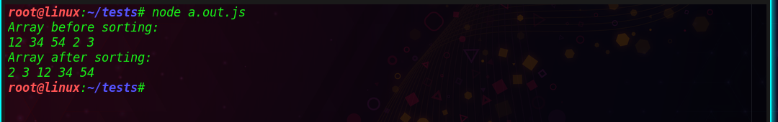

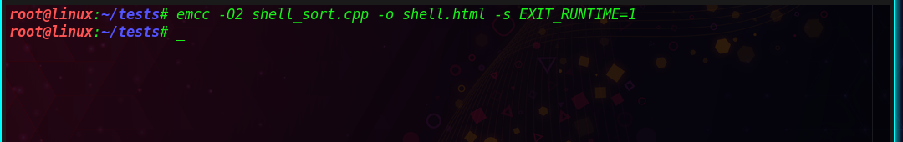.

Results can be viewed in web browser

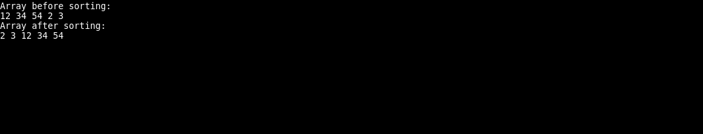

Analysis of performance

Code accumulated on Web-Assembly runs at 1.55 occasions more slow than local code. This is because of the accompanying reasons:

• Code contained in Web-Assembly contains twice a greater number of burdens and stores than local code.

• Web-Assembly requires more security dynamic checks and hence contains a greater number of branches than local code.

Appendix

#include <iostream>

using namespace std;

/\* c code for sorting \*/

int shellSort(int arr[], int n)

{

for (int gap = n/2; gap > 0; gap /= 2)

{

for (int i = gap; i < n; i += 1)

{

int temp = arr[i];

int j;

for (j = i; j >= gap && arr[j - gap] > temp; j -= gap)

arr[j] = arr[j - gap];

arr[j] = temp;

}

}

return 0;

}

void printArray(int arr[], int n)

{

for (int i=0; i<n; i++)

cout << arr[i] << " ";

}

int main()

{

int arr[] = {12, 34, 54, 2, 3}, i;

int n = sizeof(arr)/sizeof(arr[0]);

cout << "Array before sorting: \n";

printArray(arr, n);

shellSort(arr, n);

cout << "\nArray after sorting: \n";

printArray(arr, n);

return 0;

}