CS 7345 ADVANCED APPLICATIONS: LAB 4

NETWORKING

Environment

Core Emscripten can be cloned from GitHub sources.

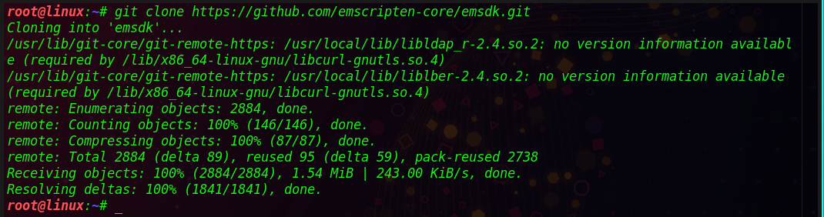

The latest SDK tools can be install using ‘install latest’ command in the cloned repository.

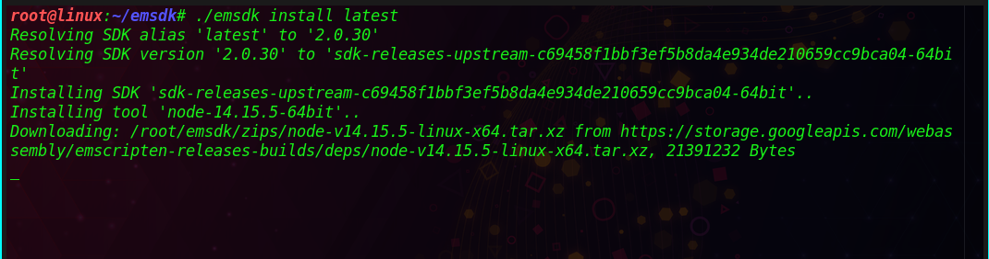

Latest installed SDK can be made available to current user by activating. Instructions are written to ‘.emscripten’ file located at the current user’s directory.

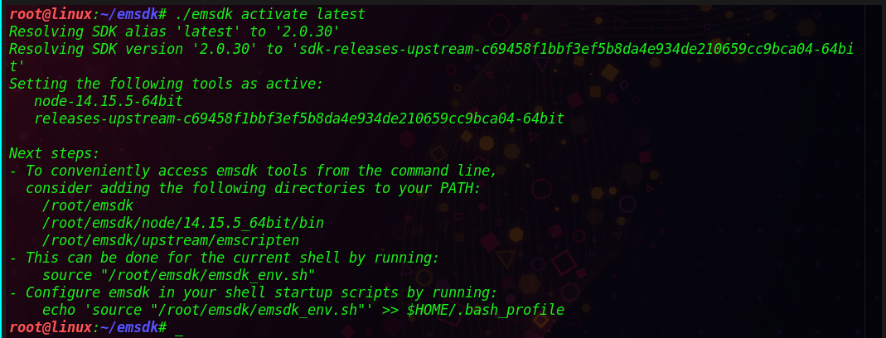

Active PATH and environmental variables for the current terminal available in the user context are set using source command.

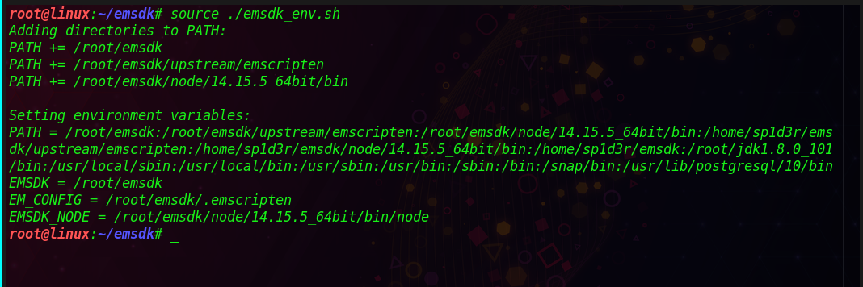

.

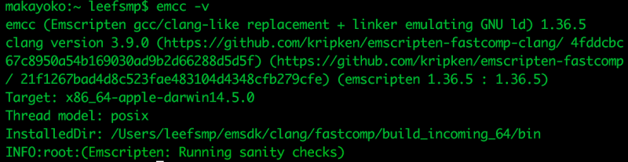.

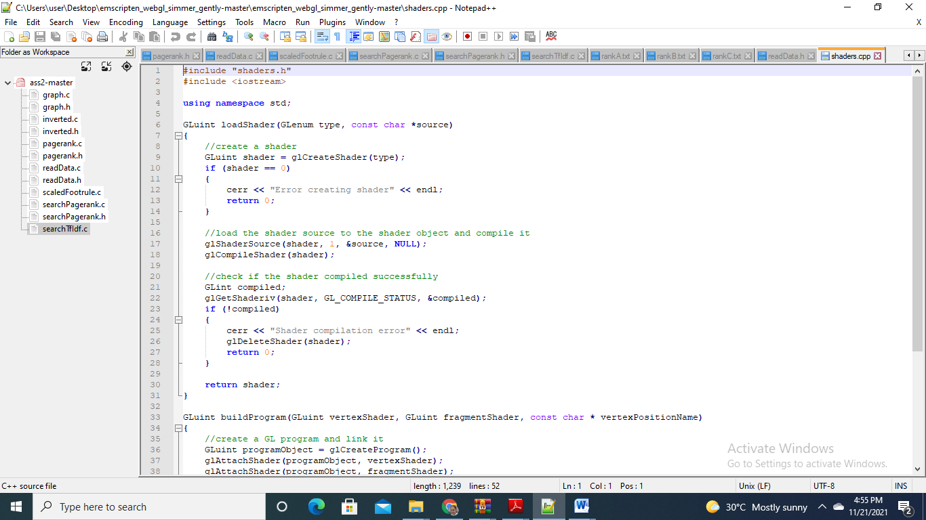

Figure 5 codes with environment variables

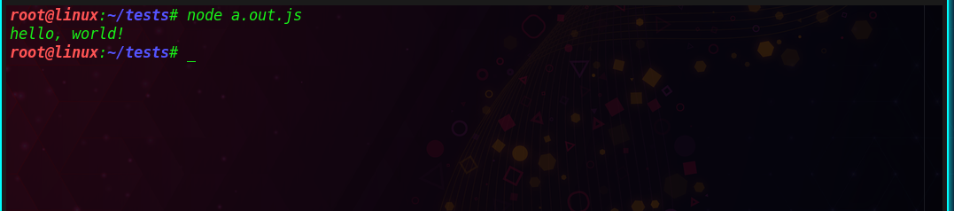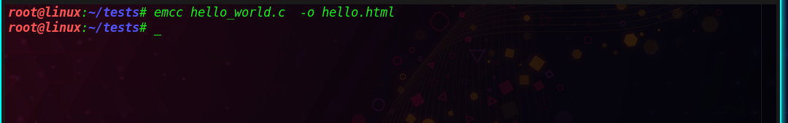

Code base transpiling

A sort algorithm developed in c++ is transpiled in this case to native code.

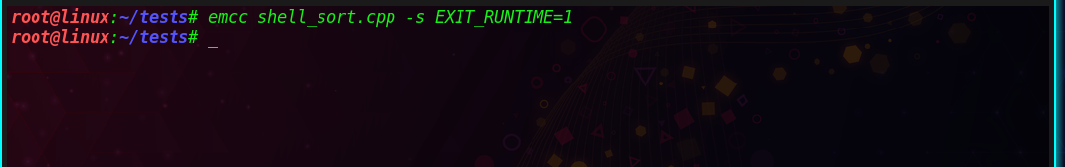



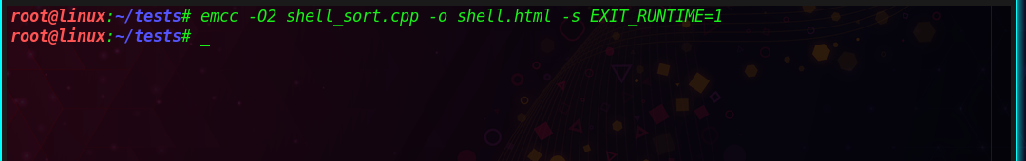.

Results can be viewed in web browser

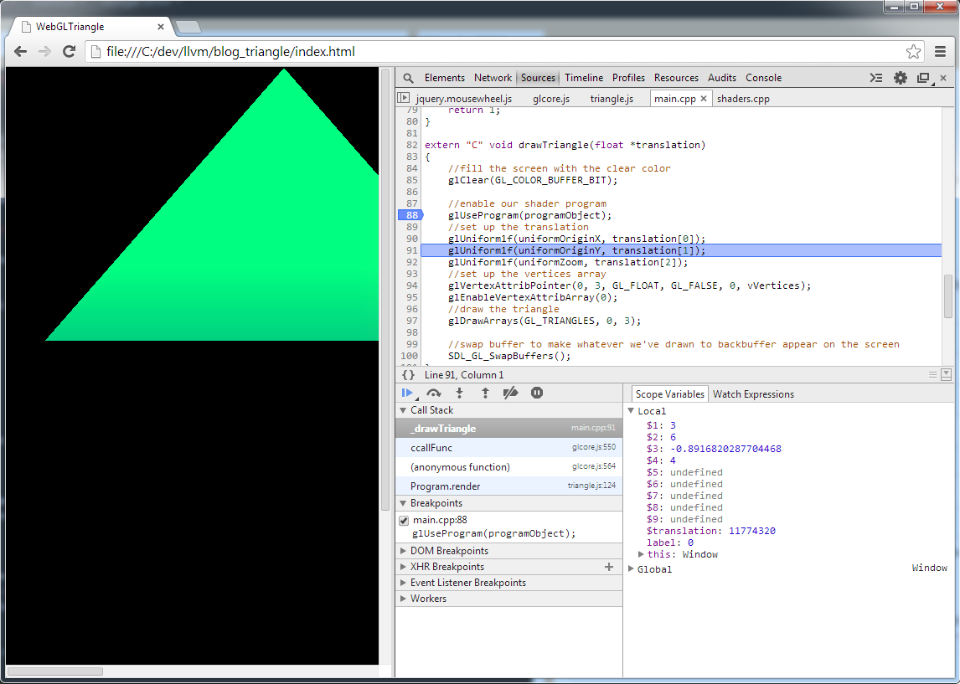

Analysis of performance

Code accumulated on Web-Assembly runs at 1.55 occasions more slow than local code. This is because of the accompanying reasons:

• Code contained in Web-Assembly contains twice a greater number of burdens and stores than local code.

• Web-Assembly requires more security dynamic checks and hence contains a greater number of branches than local code.

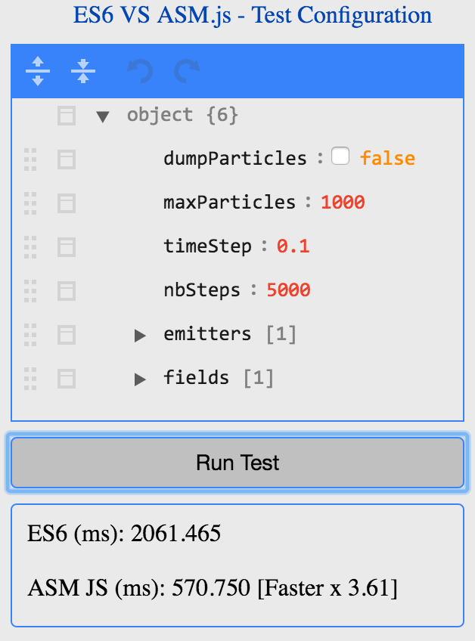

Results

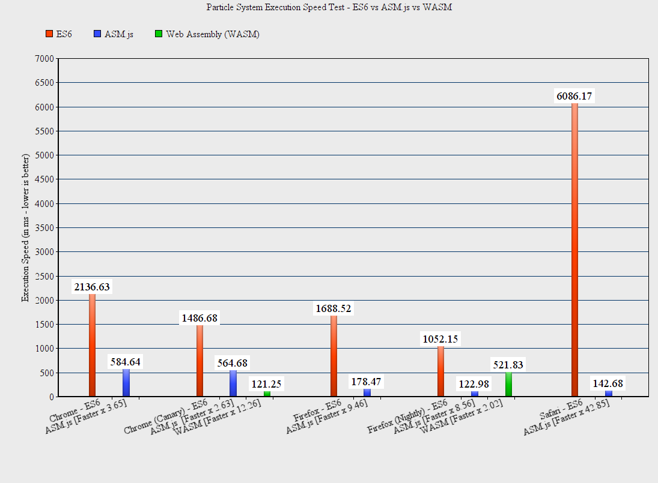

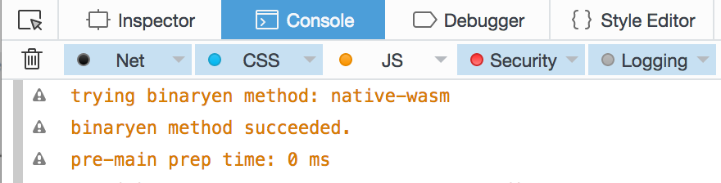

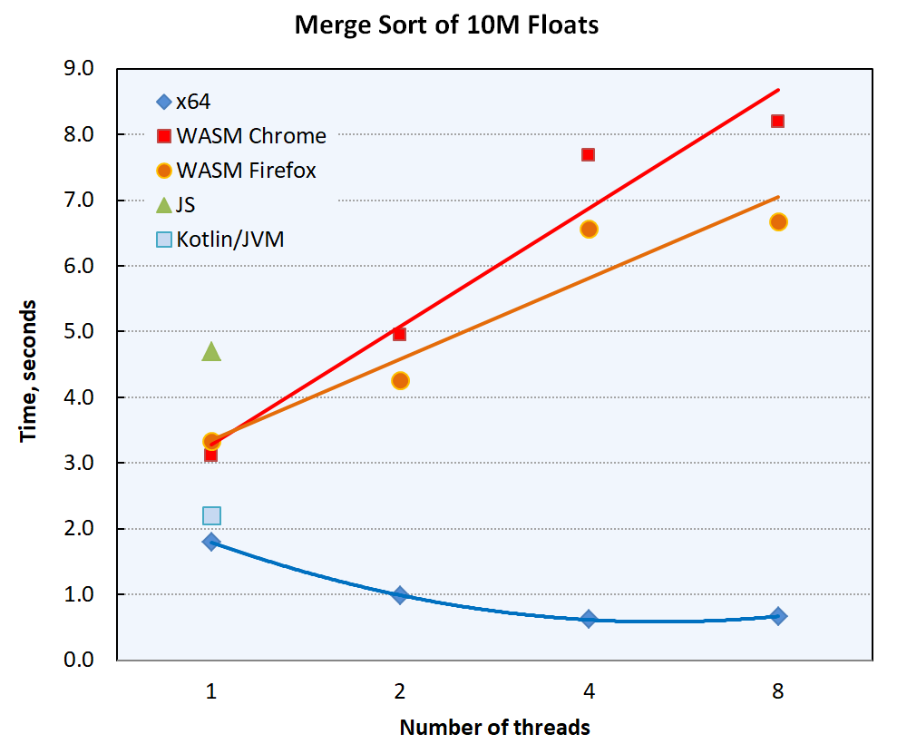

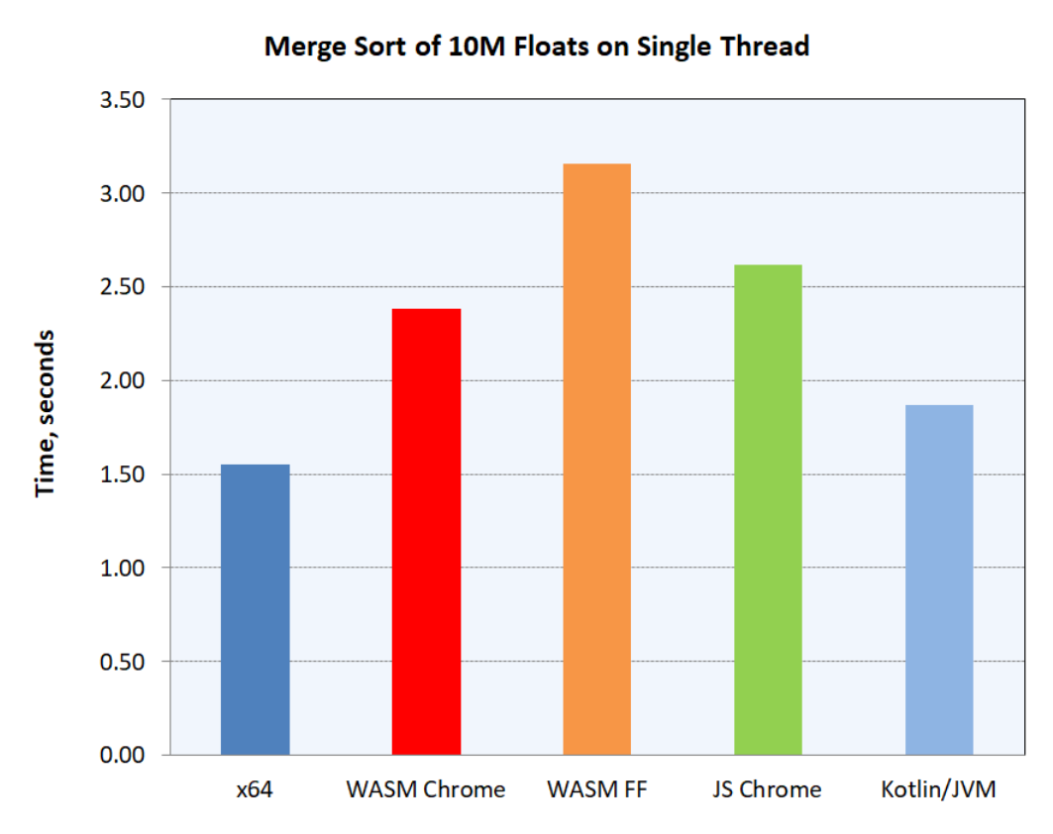

Appendix

// Single- or multi-threaded merge sort

#include <array>

#include <cassert>

#include <chrono>

#include <cstring>

#include <iostream>

#include <future>

#include <string>

// To build single-threaded code, change SINGLE_THREADED to true:

constexpr bool SINGLE_THREADED = false;

static const size_t N = 10'000'000; // size of the array to sort

using value_t = float;

using array = std::array<value_t, N>;

// The following are only for multi-threaded code

//#define FORCE_ASYNC

#undef FORCE_ASYNC

#ifdef FORCE_ASYNC

#define ASYNC std::launch::async,

#else

#define ASYNC

#endif

constexpr size_t N_LEVELS = 2; // 1 level -> 2 threads, 2 -> 4 threads, 3 -> 8 threads

constexpr size_t MAX_THREADS = 1 << N_LEVELS;

static_assert(N > MAX_THREADS, "N is too small!");

constexpr std::array<size_t, MAX_THREADS + 1> ComputeArrIndices() noexcept {

std::array<size_t, MAX_THREADS + 1> n{};

for (size_t i = 0; i < MAX_THREADS; ++i) {

n[i] = i * N / MAX_THREADS;

}

n[MAX_THREADS] = N;

return n;

}

namespace util {

template<typename TimeT = std::chrono::microseconds,

typename ClockT = std::chrono::high_resolution_clock,

typename DurationT = double>

class Stopwatch {

public:

Stopwatch() noexcept { start(); }

void start() noexcept { _start = _end = ClockT::now(); }

DurationT stop() noexcept { _end = ClockT::now(); return elapsed(); }

DurationT elapsed() const { return static_cast<DurationT>(std::chrono::duration_cast<TimeT>(_end-_start).count()); }

private:

std::chrono::time_point<ClockT> _start, _end;

};

} // namespace util

// Merges two sections of arr[]: arr[l..m] and arr[m+1..r]

void merge(array& arr, array& tmp, size_t l, size_t m, size_t r) {

assert(l <= m && m <= r);

const size_t n1 = m - l + 1; // on the left

const size_t n2 = r - m; // on the right

// Copy data to left and right temp arrays (replacing loops with memcpy makes

// no discernible difference--optimizing compilers must be doing this).

for (size_t i = 0; i < n1; ++i) {

tmp[l + i] = arr[l + i];

}

for (size_t i = 0; i < n2; ++i) {

tmp[m + 1 + i] = arr[m + 1 + i];

}

// Merge the temp arrays back into arr[l..r]

size_t i = 0, j = 0, k = l;

while (i < n1 && j < n2) {

arr[k++] = (tmp[l + i] <= tmp[m + 1 + j])? tmp[l + i++] : tmp[m + 1 + j++];

}

#if 0

// Copy the remaining elements of the left array, if any

while (i < n1) {

arr[k++] = tmp[l + i++];

}

// Copy the remaining elements of the right array, if any

while (j < n2) {

arr[k++] = tmp[m + 1 + j++];

}

#else

if (i < n1) {

std::memcpy(&arr[k], &tmp[l + i], (n1-i)*sizeof(value_t));

}

if (j < n2) {

std::memcpy(&arr[k], &tmp[m + 1 + j], (n2-j)*sizeof(value_t));

}

#endif

}

void mergeSort(array& arr, array& tmp, size_t l, size_t r) {

if (l < r) {

const size_t m = l + (r - l) / 2; // = (l + r)/2

mergeSort(arr, tmp, l, m);

mergeSort(arr, tmp, m + 1, r);

merge(arr, tmp, l, m, r);

}

}

int main()

{

std::cout << "Sorting "<< N <<" floats on "<< (SINGLE_THREADED? "single thread" : std::to_string(MAX_THREADS)+" threads") << std::endl;

// Allocate arrays on the heap (to avoid stack overflow)

auto pArr = std::make_unique<std::array<value_t, N>>();

auto pTmp = std::make_unique<std::array<value_t, N>>();

auto& arr = *(pArr.get());

auto& tmp = *(pTmp.get());

// Random initialize the array

for (size_t i = 0; i < N; ++i) {

arr[i] = rand() / static_cast<value_t>(RAND_MAX);

}

tmp.fill(value_t{}); // not needed, really

util::Stopwatch<> stopwatch;

if constexpr (SINGLE_THREADED) { // ==========================================

mergeSort(arr, tmp, 0, N - 1);

}

else // multiple threads =====================================================

{

// Build indices of sub-arrays for the highest level.

// For lower levels, it'll be traversed with `stride` depending on the level.

static const std::array<size_t, MAX_THREADS + 1> n = ComputeArrIndices();

static std::array<std::future<void>, MAX_THREADS> sort_future;

if constexpr (N_LEVELS == 1) //---------------------------------------------

{

sort_future[0] = std::async(ASYNC [&arr, &tmp] { mergeSort(arr, tmp, n[0], n[1]-1); });

sort_future[1] = std::async(ASYNC [&arr, &tmp] { mergeSort(arr, tmp, n[1], n[2]-1); });

}

else if constexpr (N_LEVELS == 2) //----------------------------------------

{

// Sort four sub-arrays

static auto sort_future0 = std::async(ASYNC [&arr, &tmp] { mergeSort(arr, tmp, n[0], n[1]-1); });

static auto sort_future1 = std::async(ASYNC [&arr, &tmp] { mergeSort(arr, tmp, n[1], n[2]-1); });

static auto sort_future2 = std::async(ASYNC [&arr, &tmp] { mergeSort(arr, tmp, n[2], n[3]-1); });

static auto sort_future3 = std::async(ASYNC [&arr, &tmp] { mergeSort(arr, tmp, n[3], n[4]-1); });

// Merge two sub-arrays

sort_future[0] = std::async(ASYNC [&arr, &tmp] {

sort_future0.get(); sort_future1.get(); merge(arr, tmp, n[0], n[1]-1, n[2]-1);

});

sort_future[1] = std::async(ASYNC [&arr, &tmp] {

sort_future2.get(); sort_future3.get(); merge(arr, tmp, n[2], n[3]-1, n[4]-1);

});

}

else if constexpr (N_LEVELS > 2) // 8 or more threads ----------------------

{

// Sort sub-arrays

for (size_t i = 0; i < MAX_THREADS; ++i) {

sort_future[i] = std::async(ASYNC [&arr, &tmp, i] { mergeSort(arr, tmp, n[i], n[i + 1]-1); });

}

// Process each level by spawning worker threads to merge sub-arrays

for (size_t level = N_LEVELS; level > 0; --level) {

constexpr size_t one = 1;

const size_t N_threads = one << level; // # of threads for this level

const size_t stride = one << (N_LEVELS - level); // stride for indices in `n`

// On 1st pass, wait for mergeSort() futures; later--on merge() futures from previous pass

const size_t N_to_wait = (level == N_LEVELS)? MAX_THREADS : 2 * N_threads;

for (size_t i = 0; i < N_to_wait; ++i) {

sort_future[i].get();

}

// Merge sub-arrays

for (size_t i = 0; i < N_threads; ++i) {

sort_future[i] = std::async(ASYNC

[&arr, &tmp, i, stride] { // stride is a power of 2 => stride/2 below is integer

merge(arr, tmp, n[stride*i], n[stride*i + stride/2]-1, n[stride*(i+1)]-1);

});

}

} // level loop

} //------------------------------------------------------------------------

sort_future[0].get();

sort_future[1].get();

merge(arr, tmp, n[0], n[MAX_THREADS/2] - 1, n[MAX_THREADS] - 1);

} // =========================================================================

const auto elapsed_uS = stopwatch.stop();

// Check that the array is indeed sorted

const bool ok = [&arr]() {

for (size_t i = 1; i < N; ++i) if (arr[i - 1] > arr[i]) return false;

return true;

}();

std::cout << "Sorted " << (ok ? "successfully" : "UNSUCCESSFULLY")

<< " in " << elapsed_uS / 1'000'000 << " seconds" << std::endl;

return (ok)? 0 : 13;

}