1. **Memory Map:**

**RAM :**

* Size:20 KB
* Start address:0x20000000
* End address:0x20005000

**ROM:**

* Size:128 KB ,128 pages each 1KB size
* Start address:0x08000000
* End address:0x0801FFFF  
    
  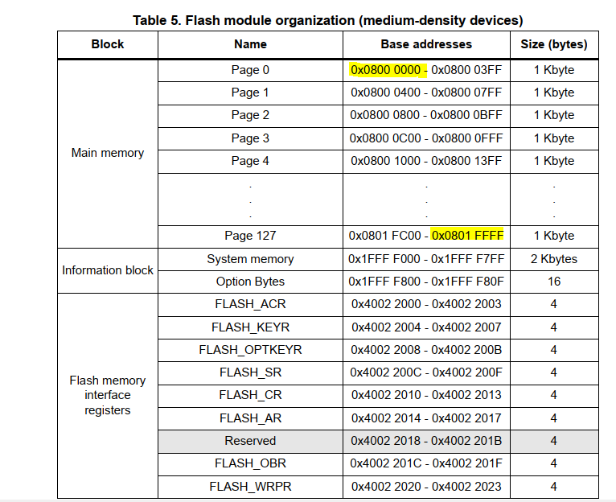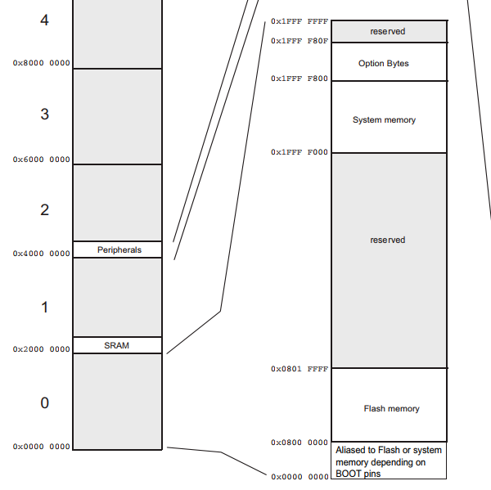

1. **Boot Configuration via GPIO pins: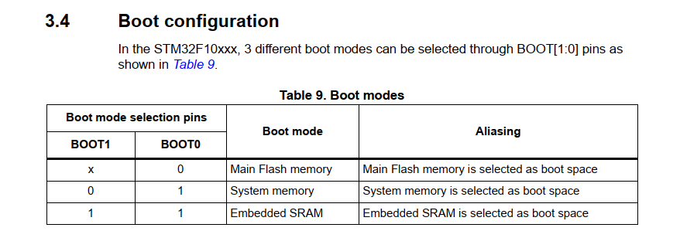 3. Bootloader workflow:**