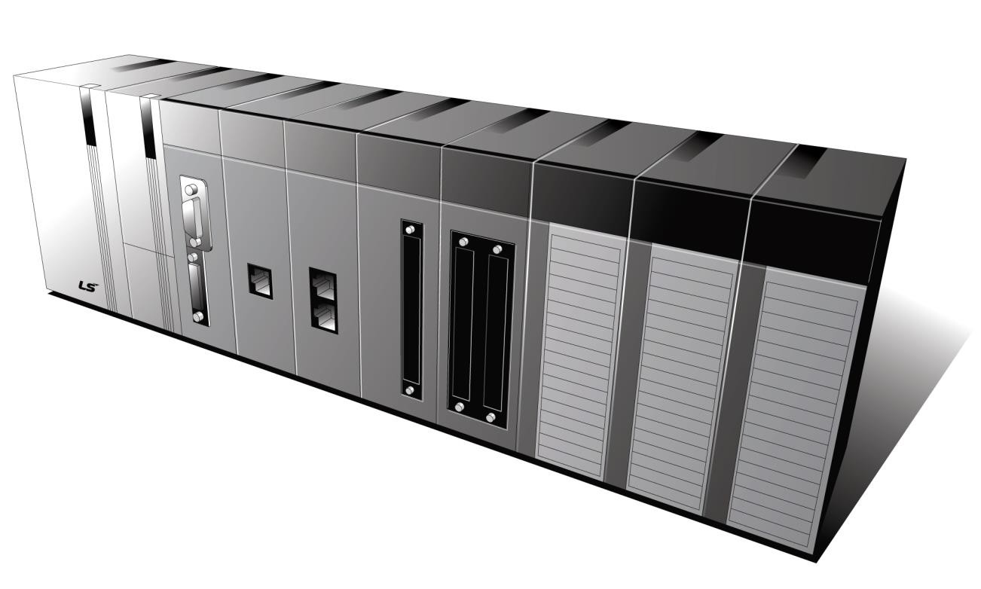

Programmable Logic Control

Ethernet/IP I/F Module

XGT Series

XGL-EIPT


Safety Instruction

Before using the product …

For your safety and effective operation, please read the safety instructions thoroughly before using the product.

- Safety Instructions should always be observed in order to prevent accident or risk with the safe and proper use the product.

- Instructions are divided into “Warning” and “Caution”, and the meaning of the terms is as follows.

 Warning

Caution
This symbol indicates the possibility of serious injury or death if some applicable instruction is violated

This symbol indicates the possibility of severe or slight injury, and property damages if some applicable instruction is violated

Moreover, even classified events under its caution category may develop into serious accidents relying on situations. Therefore we strongly advise users to observe all precautions properly just like warnings.

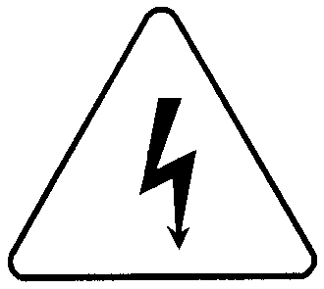
- The marks displayed on the product and in the user’s manual have the following meanings. Be careful! Danger may be expected.
Be careful! Electric shock may occur.

- The user’s manual even after read shall be kept available and accessible to any user of the product.

1

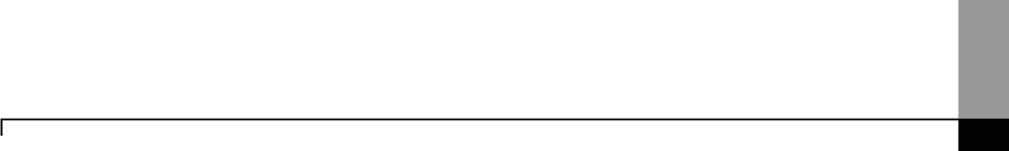
Safety Instruction

Safety Instructions for design process
Warning

  - Please install a protection circuit on the exterior of PLC so that the whole system may operate safely regardless of failures from external power or PLC. Any abnormal output or operation from PLC may cause serious problems to safety in whole system.
    - Install protection units on the exterior of PLC like an interlock circuit that deals with opposite operations such as emergency stop, protection circuit, and forward/reverse rotation or install an interlock circuit that deals with high/low limit under its position controls.
    - If any system error (watch-dog timer error, module installation error, etc.) is detected during CPU operation in PLC, all output signals are designed to be turned off and stopped for safety. However, there are cases when output signals remain active due to device failures in Relay and TR which can’t be detected. Thus, you are recommended to install an addition circuit to monitor the output status for those critical outputs which may cause significant problems.
  - Never overload more than rated current of output module nor allow to have a short circuit.

Over current for a long period time maycause a fire .

  - Never let the external power of the output circuit to be on earlier than PLC power, which may cause accidents from abnormal output oroperation.
  - Please install interlock circuits in the sequence program for safe operations in the system when exchange data with PLC or modify operation modes using a computer or other external equipments Read specific instructions thoroughly when conducting control operations with PLC.

2

Safety Instruction

Safety Instructions for design process
Caution

 I/O signal or communication line shall be wired at least 100mm away from a high-voltage cable or power line. Fail to follow this

Safety Instructions on installation process

Caution

- Use PLC only in the environment specified in PLC manual or general standard of data sheet. If not, electric shock, fire, abnormal operation of the product may be caused.
- Before install or remove the module, be sure PLC power is off. If not, electric shock or damage on the product may be caused.
- Be sure that every module is securely attached after adding a module or an extension connector. If the product is installed loosely or incorrectly, abnormal operation, error or dropping may be caused. In addition, contact failures under poor cable installation will be causing malfunctions as well.
- Be sure that screws get tighten securely under vibrating environments. Fail to do so will put the product under direct vibrations which will cause electric shock, fire and abnormal operation.
- Do not come in contact with conducting parts in each module, which may cause electric shock, malfunctions or abnormal operation.

3

Safety Instruction

Safety Instructions for wiring process
Warning
- Prior to wiring works, make sure that every power is turned off. If not, electric shock or damage on the product may be caused.
- After wiring process is done, make sure that terminal covers are installed properly

before its use. Fail to install the cover may cause electric shocks.

Caution

  - Check rated voltages and terminal arrangements in each product prior to its wiring process. Applying incorrect voltages other than rated voltages and misarrangement among terminals may cause fire or malfunctions.
  - Secure terminal screws tightly applying with specified torque. If the screws get loose, short circuit, fire or abnormal operation may be caused. Securing screws too tightly will cause damages to the module or malfunctions, short circuit, and dropping.
  - Be sure to earth to the ground using Class 3 wires for FG terminals which is exclusively used for PLC. If the terminals not grounded correctly, abnormal operation or electric shock may be caused.

Don’t let any foreign materials such as wiring waste inside the module while wiring,

which may cause fire, damage on the product or abnormal operation.

  - Make sure that pressed terminals get tighten following the specified torque. External connector type shall be pressed or soldered using proper equipments.

4

Safety Instruction

Safety Instructions for test-operation and maintenance
Warning
- Don’t touch the terminal when powered. Electric shock or abnormal operation may occur.

- Prior to cleaning or tightening the terminal screws, let all the external power off including PLC power. If not, electric shock or abnormal operation may occur.
- Don’t let the battery recharged, disassembled, heated, short or soldered. Heat, explosion or ignition may cause injuries or fire.

Caution

- Do not make modifications or disassemble each module. Fire, electric shock or abnormal operation may occur.
- Prior to installing or disassembling the module, let all the external power off including PLC power. If not, electric shock or abnormal operation may occur.
- Keep any wireless equipment such as walkie-talkie or cell phones at least 30cm away from PLC. If not, abnormal operation may be caused.
- When making a modification on programs or using run to modify functions under PLC operations, read and comprehend all contents in the manual fully. Mismanagement will cause damages to products and accidents.
- Avoid any physical impact to the battery and prevent it from dropping as well. Damages to battery may cause leakage from its fluid. When battery was dropped or exposed under strong impact, never reuse the battery again. Moreover skilled workers are needed when exchanging batteries.

5

Safety Instruction

Safety Instructions for waste disposal

Caution
 Product or battery waste shall be processed as industrial waste. The waste may discharge

toxic materials or explode itself.

6

Revision History

Revision History

Version | Date | Contents | Revised position
V 1.0 | ’09.12 | First edition | -
V 1.1 | ’11.05 | How to enable link through flag added | CH 6.3.1
V 2.0 | ’12.06 | Add service setting by tag | CH5, 6
V 2.1 | ’14.09 | XG5000 V4.0 UI Updated | Entire
V2.2 | ’20.05 | Format and contents modification according to the change of company name(LSIS -> LS ELECTRIC)
V2.3 | ’24.06 | Change in warranty period | -

7

About User’s Manual

Thank you for purchasing PLC of LS ELECTRIC Co., Ltd.
Before use, make sure to carefully read and understand the User’s Manual about the functions, performances, installation and programming of the product you purchased in order for correct use and importantly, let the end user and maintenance administrator to be provided with the User’s Manual.

The User’s Manual describes the product. If necessary, you may refer to the following description and order accordingly. In addition, you may connect our website (http://www.ls-electric.com/) and download the information as a PDF file.

Relevant User’s Manuals
Title | Description
XG5000 User’s Manual (for XGK, XGB) | XG5000 software user manual describing online function such as programming, print, monitoring, debugging by using XGK, XGB  CPU
XG5000 User’s Manual (for XGI, XGR) | XG5000 software user manual describing online function such as programming, print, monitoring, debugging by using XGI,  XGR CPU
XGK/XGB Instructions & Programming  User’s Manual | User’s manual for programming to explain how to use  instructions that are used PLC system with XGK, XGB CPU.
XGI/XGR/XEC Instructions & Programming User’s Manual | User’s manual for programming to explain how to use  instructions that are used PLC system with XGI, XGR, XEC CPU.
XGK CPU User’s Manual  (XGK-CPUU/CPUH/CPUA/CPUS/CPUE) | XGK-CPUU/CPUH/CPUA/CPUS/CPUE user manual describing about XGK CPU module, power module, base, IO module, specification of extension cable and system configuration, EMC  standard
XGI CPU User’s Manual  (XGI-CPUU/D,CPUU,CPUH,CPUS,CPUE) | XGI-CPUU/D,CPUU,CPUH,CPUS,CPUE user manual  describing about XGI CPU module, power module, base, IO module, specification of extension cable and system configuration, EMC standard
XGR redundant series User’s Manual | XGR- CPUH/F, CPUH/T user manual describing about XGR CPU module, power module, extension drive, base, IO module, specification of extension cable and system configuration, EMC  standard

Current XGL-EIPT manual is written based on the following version. Related OS version list
Product name | OS version
XGK-CPUU, CPUH, CPUA, CPUS, CPUE | V4.2
XGI-CPUU/D, CPUU, CPUH, CPUS, CPUE | V4.0
XGR-CPUH/F, CPUH/T, CPUH/S | V2.6
XG5000 | V4.0

8

Table of Content

◎ Contents ◎

Chapter 1 Overview

  - Overview 1-1
  - Features 1-2
  - Product Components 1-3
    - Indication of Type Names 1-3
    - The Number of Installation available – units by CPUs 1-3
  - Software for Using Products 1-4
    - Confirms for Software 1-4
1.4.2 XG5000 1-4
1.4.3 Confirmation of Versions 1-5

Chapter 2 Specification
  - General Specification - 2-1

  - Performance Specification
  - Name in Each Part
  - Cable Standards
2-2
2-3
2-5

    - UTP Cable 2-5

Chapter 3 Installation and Test operation
  - Installation Environment - 3-1
  - Cautions when Handling 3-2 3.3 The Order for Setting up Products till Running 3-3
  - I/O Allotment and Device Information 3-4
    - I/O Allotment 3-4
    - Available device area per CPU series - 3-10 3.5 Installation of Products 3-11
3.5.1 Installation of XGL-EIPT 3-11
  - Test operation 3-13
    - Directions when Configuring Systems 3-13

Chapter 4 System Configuration
  - Configuration of a Usable System 4-1
    - System Configuration using a Switch 4-1
    - System Configuration not using a Switch 4-1
  - Configuration of an unusable System 4-2
    - System Configuration using a Switch 4-2
    - Configuration of a Ring System (Configuration of a XGL-EIPT Ring) 4-2

9

Chapter 5 Installation of Software and Communication Parameters

  - Installation and Execution of Software 5-1
    - Installation of XG5000 5-1
    - Installation of USB Device Drive 5-4
    - Confirmation on the Installation of USB Device Driver 5-7
  - How to Register Communication Modules 5-15
    - In case of Offline 5-15
    - In case of Online 5-17
    - In case of Reading Parameter stored in PLC 5-19
    - How to Set-up Modules 5-20
  - EtherNet/IP Communication Method 6-1
Chapter 6 EIP Service
    - EtherNet/IP Terms 6-1
    - EDS File 6-1
    - Periodic Communication (Implicit) System 6-2
    - Aperiodic Communication (Explicit) System 6- 3
  - EIP Service 6-4
  - Tag setup 6-5
  - Setup of Periodic/Non-periodic Communication Service 6-8
    - Periodic Client Communication Service 6-8
    - Setup of Non-periodic Client Communication Service 6-15
    - Periodic Server Communication Service 6-17
  - 5 Operation Start 6- 19
6.5.1 XG 5000 Set- up 6- 19
  - Use Examples 6- 21
    - Communication with Rockwell 1756- ENBT Communication Module 6- 21

Chapter 7 Diagnosis
  - System Diagnosis 7-1
  - System Diagnosis Items and Contents 7-3
  - Troubleshooting 7- 8
    - Check-out through LED in Communication Module 7-8
    - Check out of Module Errors through XG5000 7-9
    - Check-out on Module Errors through System Log 7-10

  - Remote Communication control
    - Introduction
7-12
7-12

    - Setting and Connection 7-13
Table of Content

Appendix
A . 1 T e r ms A - 1
A . 2 F l ag L i s t A - 5
    - Special Relay ( F) List A- 5
    - Communication Relay (L) List A-13
A. 3 External Dimension A-14

10

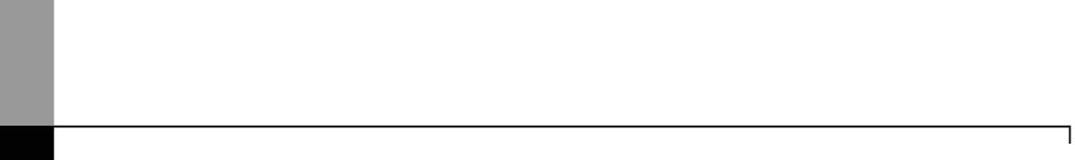
1-1

Chapter 1 Overview

Chapter 1 Overview

1.1 Overview

This user guide is made out to describe EtherNet/IP I/F module (Referred to as “EPI Module”) among XGT PLC system networks. EtherNet/IP is the protocols where Common Industrial Protocol (CIP: industrial protocols used in common, such as Device Net, ControlNet, CompoNet, etc) has been laid on an upper layer of open protocol Ethernet. Thus, EtherNet/IP allows DeviceNet, ControlNet, and CompoNet developers to secure the interoperability between multi-band and lower network devices by applying the same objects and profiles. EIP module provides two Ethernet Ports (Ethernet Port) and the switch function required for the existing STAR system is built in and it is the module for transmitting data between PCCs or between PLC and EtherNet/IP I/F IO module.

Make a program in reference with these following user guides

- XG5000 User Guide
- XGK Instructions
- XGK User Guide
- XGI Instructions
- XGI User Guide
- XGR Instructions
- XGR User Guide

Be careful of these configuration items when you constitute XGT EIP module system.

- XGT PLC XG5000 Programming Tool: Over V4.0
- XGK CPU: Over V4.2
- XGI CPU: Over V4.0
- XGR CPU: Over V2.6



Chapter 1 Overview
1-2

1.2 Features

XGT EtherNet/IP I/F Module have the following features.

- Communication Methods: Extensive Client Messaging Support
  - Encapsulated Messages, UCMM Explicit Messaging
  - Class 3 Connected Explicit Messaging(Server Only)
  - Class 1 Connected Implicit(IO) Messaging(Cyclic I/O Service Only)
- Compatibility: XGT EtherNet/IP I/F meet EtherNet/IP Conformance Test Suite Version 2.10
- 100BASE-TX media is provided and 100Mbps/ (Full Duplex) are supported.
- It is possible to be equipped with 24 units per CPU and installation to basic base and extension base is available. However, only installation to base is possible in XGR system. .
- With the built - in switch, there is no need to install a separate switch and hub and wiring is saved and flexibility in installation is provided.
- As Auto Cross Over- function is provided, cabling job is convenient.
- A variety of diagnose functions, the states information of modules and networks are provided.
▶The state of a communication module
▶The state of a communication service(EIP, Non-circular server)
  - Auto Scan-function providing an information of own corporation’s and other corporations’ modules connected into network
  - The kinds of packets and the quantity of data received by communication module (Network load – prediction is available)
▶The diagnosis function through network is available

1-3

Chapter 1 Overview

1.3 Product Components

Indication of Type Names

Components of XGT EtherNet/IP I/F module product are described.

Type Name | Components | Remarks
XGL-EIPT | Electric 2 –port EtherNet/IP Module | More than category 5

The Number of Installation available – units by CPUs

Up to 24 units of XGT EtherNet/IP I/F module are possible to be installed regardless of basic base and extension base. However, when XGR CPU is applied, it is possible to be installed into the basic base. To achieve the maximum performance, if possible, install this module to the basic module. The following table shows the kinds of services which are possible to be used by CPUs. When you configure the system, consider the number of communication modules.

Segment | XGK |  |  |  |  | XGI |  |  |  |  | XGR
Segment | CPUH | CPUU | CPUA | CPUS | CPUE | CPUU | CPUH | CPUS | CPUE | CPUU/D | CPUH/T | CPUH/F | CPUH/S
Number of P2P use  modules(maximum) | 8 units |  |  |  |  |  |  |  |  |  | 6 units
Maximum number of modules(server use  modules included) | 24 units |  |  |  |  |  |  |  |  |  | 6 units

Chapter 1 Overview
1-4

1.4 Software for Using Products

The following explains main programming tools and other production software for using EIP module. For more exact application of programs and communication, refer to the contents below and apply it to systems.

1.4.1 Confirms for Software

Segment | Component Products | Communication Set-up Tool
XGL-EIPT | Communication Module for XGT | XG5000

Notice
- To use the above program, download from the current website you are visiting. In case you can not use the internet, visit near agencies and ask for CD-ROM for installation.
Internet Web - address : http://www.lselectric.co.kr/
- To program XG5000, use RS-232C port and USB of CUP module. For cable, refer to the XGT catalogue. (USB-301A, K1C-050A)

1.4.2 XG5000
XG5000 is the software for dedicatedly using all communication modules including Ethernet/IP I/F module for basic parameter set-up, frame make-up, module and network diagnosis.

The following illustration shows the initial screen of XG5000.
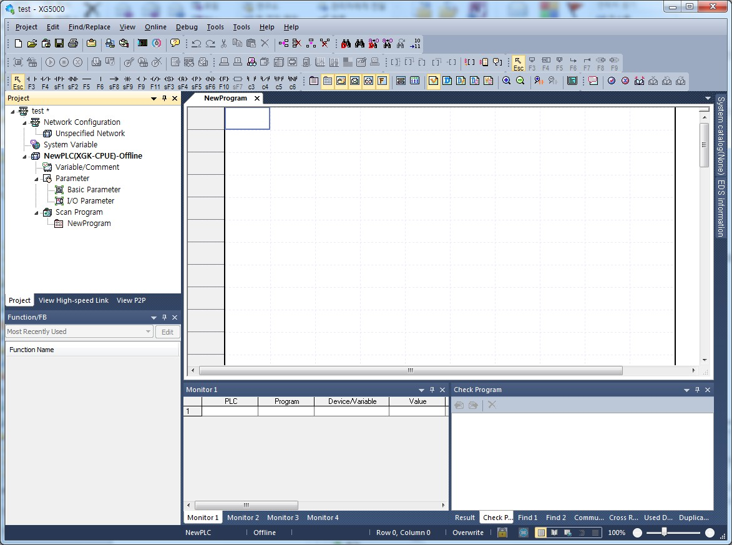
[Figure 1.4.1] XG5000 – Initial Screen

1-5

Chapter 1 Overview

Confirmation of Versions
Check out the version of the module before using XGT EtherNet/IP I/F.

      - Confirmation through XG5000
To read the information of a communication module, access to the communication module.
.
If interface is normally maintained with CPU, the information like the following illustration can be got.

        - Execute XG5000.
        - Connect with CPU via access through [Online]-[Connect] on menu.
        - When connected with CPU, execute the diagnosis of XG5000.
        - Locate the mouse to the communication module in system diagnosis screen of online menu.
        - Double-click the communication module or click right button of mouse and select Detailed Module Information.

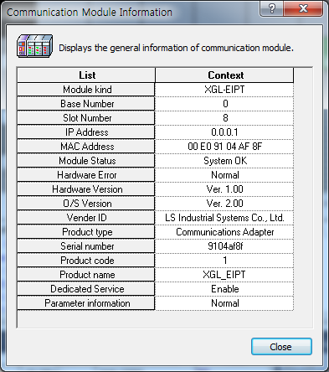` [Figure 1.4.2] Confirmation of Versions through XG5000

      - Confirmation of Versions through Case Label of Products
In each module, the information of the module product is attached to the exterior case.
In case there is no connector with PC and it is impossible to check out online, confirmation is available after you remove the module in case. The label attached to the backside of a product and the type name and the version information is marked.

Chapter 1 Overview
1-6

2-1

Chapter 2 Specification

Chapter 2 Specification
2.1 General Specification
The general specification of XGT series is as follows.
No. | Items | Specifications |  |  |  |  |  |  | Related standards
1 | Ambient  temperature | 0 ~ 55 °C
2 | Storage  temperature | −25 ~ +70 °C
3 | Ambient humidity | 5 ~ 95%RH(Non-condensing)
4 | Storage humidity | 5 ~ 95%RH(Non-condensing)
5 | Vibration resistance | Occasional vibration |  |  |  |  |  | -
5 | Vibration resistance | Frequency |  | Acceleration |  | Amplitude |  | How many times | IEC61131-2
5 | Vibration resistance | 5 ≤ f < 8.4Hz |  | − |  | 3.5mm |  | 10 times each directions (X, Yand Z) | IEC61131-2
5 | Vibration resistance | 8.4 ≤ f ≤ 150Hz |  | 9.8m/s2(1G) |  | − |  | 10 times each directions (X, Yand Z) | IEC61131-2
5 | Vibration resistance | Continuous vibration |  |  |  |  |  | 10 times each directions (X, Yand Z) | IEC61131-2
5 | Vibration resistance | Frequency |  | Acceleration |  | Amplitude |  | 10 times each directions (X, Yand Z) | IEC61131-2
5 | Vibration resistance | 5 ≤ f < 8.4Hz |  | − |  | 1.75mm |  | 10 times each directions (X, Yand Z) | IEC61131-2
5 | Vibration resistance | 8.4 ≤ f ≤ 150Hz |  | 4.9m/s2(0.5G) |  | − |  | 10 times each directions (X, Yand Z) | IEC61131-2
6 | Shock resistance | - Peakacceleration: 147 m/s2(15G)  - Duration: 11ms  - Half-sine, 3 times each direction per each axis |  |  |  |  |  |  | IEC61131-2
7 | Noise resistance | Square wave Impulse noise | AC: ±1,500 V  DC : ±900V |  |  |  |  |  | LS ELECTRIC  standard
7 | Noise resistance | Electrostatic discharge | Voltage: 4kV (Contact discharge) |  |  |  |  |  | IEC61131-2  IEC61000-1-2
7 | Noise resistance | Radiated electromagnetic field  noise | 80 ~ 1000 MHz, 10V/m |  |  |  |  |  | IEC61131-2,  IEC61000-1-3
7 | Noise resistance | Fast transient/bust noise | Segment |  | Power supplymodule |  | Digital/analog input/output  communication interface |  | IEC61131-2 IEC61000-1-4
7 | Noise resistance | Fast transient/bust noise | Voltage |  | 2kV |  | 1kV |  | IEC61131-2 IEC61000-1-4
8 | Operation  ambience | Free from corrosive gases and excessive dust
9 | Altitude | Less than 2,000m
10 | Pollution degree | Less than 2
11 | Cooling method | Air-cooling

N0ote
- IEC (International Electrotechnical Commission):
An international nongovernmental organization which promotes internationally cooperated standardization in electric/electronic field, publishes international standards and manages applicable estimation system related with.
- Pollution degree:
An index indicating pollution degree of the operating environment which decides insulation performance of the devices. For instance, Pollution degree 2 indicates the state generally that only non-conductive pollution occurs. However, this state contains temporary conduction due to dew
produced.

Chapter 2 Specification
2-2

2.2 Performance Specification

The following table describes the specification of system configuration in accordance with Ethernet/IP I/F module’s media. When you configure systems, refer to the below table.

Item |  | Standard
Transmission Standard | Transmission Speed | 100Mbps
Transmission Standard | Transmission Method | Base Band
Transmission Standard | Maximum Extension Distance  between Nodes | 100m
Transmission Standard | Communication Zone Excess  Method | CSMA/CD
Transmission Standard | Frame Error – Checking Method | CRC 32 = X32 + X26 + X23+ ,,,,, + X2 + X+ 1
Transmission Standard | The Number of Maximum Installments (When server is  included ) | 24 units*주commet1)
Topology |  | Line , Star
Diagnosis Function |  | Module Information , Service State , Media Information ,  Auto Scan, Ping Test
Service | Periodic Cline t | Implicit IO Client
Service | Aperiodic Client | UCMM Client
Service | Periodic Server | Implicit IO Server
The Number of Connections (Client/Server) | TCP | 64/128
The Number of Connections (Client/Server) | CIP(IO Communication) | 64/128
The Number of Maximum Services |  | 8
The Number of Maximum Installments |  | 24
Media |  | UTP/STP Category 5
Basic Standards | Dimension (mm) | 98(H) X 27(W) X 90(D)
Basic Standards | Consumption Current (mA) | 400
Basic Standards | Weight (g) | 102

Notice
- As XGR CPU can be installed into basic base, the number of maximum installments is limited to 6 units .
- 정상 통신 보장의 경우 EIP블록 64개에 대해 각 블록 당 최대/최소 데이터로 설정 시 정상 동작이 가능한 송신주기를 의미합니다
  - 정상통신 보장 기준은 시스템에서 하나의 XGT EtherNet/IP I/F 모듈만 주기 클라이언트로 동작하고 나머지 모듈은 주기 서버로 동작할 경우를 조건으로 합니다.
  - 비주기 서버 또는 네트워크의 부하에 따라서 차이가 있을 수 있습니다.
  - 데이터 수신 시 주기, 비주기를 포함한 모든 통신서비스(서버 포함)는 CPU의 한 스캔당 7000바이트를 넘을 수 없습니다.
  - 스캔 당 수신 데이터(바이트) 초과 여부는 (30×총 수신 블록 수) + 총 수신 블록의 설정 데이터 크기로 판단할 수 있습니다.
  - 이때 시스템은 하나의 EtherNet/IP I/F 모듈이 주기 클라이언트로 동작하고 나머지 국은 서버로 동작할 때를 조건으로 합니다.

Chapter 2 Specification

2.3 Name in Each Part

The name in each module is as follows.

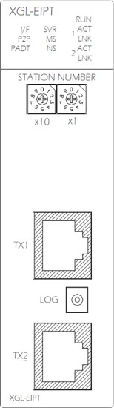
LED Display
IP Set-up Switch

Ethernet Connector (Channel No. 1) LOG Switch
Ethernet Connector (Channel No.2)

[Figure 2.3.1] The Front View for Module PLC

2-3
- LED Names and Contents

Silk Mark | LED State | Contents
RUN | ON | Power -on and Process normally operating
RUN | OFF | Power –off and Process abnormally operating
I/F | OFF | I/F operating normally with CPU
I/F | Flicker/OFF | I/F operating abnormally with CPU
P2P | ON | In case of stetting up P2P Service
P2P | OFF | In case of canceling P2P Service
PADT | ON | XG5000 being connected via remote control
PADT | OFF | XG5000 remote connection has been released
SVR | ON | When exterior client has been connected, Light ON
SVR | OFF | When there is no exterior client connection, Light OFF
MS | Green Light ON | When normal operating
MS | Green Light flickers | When configuration for device is not over
MS | Red Light flickers | In case of wrong set-up or restorable errors happened
MS | Red Light ON | When errors which are impossible to restore have been made
MS | Red Green Light flickers | When self-diagnosis is proceeding
NS | Green Light flickers | When there is no connection of a device
NS | Green Light ON | When there is connection more than 1 with a device at least
NS | Red Light flickers | When Timeout with a device more than 1 unit happened
NS | Red Light ON | When repeated IP address has been detected
NS | Red / Green Light flickers | When self-diagnosis is preceding
n ACT | Flicker | In case of frame – transmitted and received (n=1,2)
n LNK | ON | When network link has been formed (n=1,2)
n LNK | OFF | When network link has not been formed (n=1,2)

Chapter 2 Specification
2-4

- Log Switch
In case of reading Log in communication module and needing to store the Log, if you push it for more than 1 second, it is stored into Flash area from Memory area. The Log in the memory area is the one erased when power is supplied again and the Log in Flash area is the one which is maintained when power is supplied again.
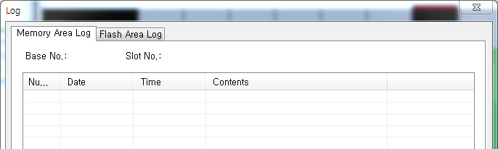

- IP Set-up Switch (1~89)

        - IP Set-up Switch (1~89)
When IP address has not been inserted via XG5000 within 10 seconds after power was supplied, switch value ‘192.168.250’ is set up.

        - IP Set-up Switch (90~98)
This switch is designed for setting up the inside of communication. If you change it arbitrary, it may cause problems.

        - IP Set-up Switch (90~98)
This switch functions to configure the system into a ring form and when set-up is not finished, normal operation is impossible. It is possible to form a ring system in terms of appearance by supporting 2 connectors but actual ring system is not supported.

Chapter 2 Specification

2.4 Cable Standards

UTP Cable
UTP cable is classified into the 3 types according to the following standards.
      - With or without Shield: 3 Types (UTP, FTP, STP)
      - Used - frequency Band: 7 Categories (Category 1 ~ Category 7)
      - Inflammable Grade: 4 Grades (CMX, CM, CMR, CMP)
- Kinds of Cables with or without Shield

Classification | Details | Use
UTP(or U.UTP) | Unshielded Cables for High Speed – Signals | Maximum 200MHz  Voice +Information (Data)+ Low grade Video Signal
FTP(or S.UTP) | 1 Layer Shield, Cable Core only shielded  * Shield Materials: AL/Plastic Complex Foil Or Copper Braid | Maximum 100MHz  Electro Magnetic Interference (EMI) and Electric Stability is considered  Voice + Information (Data) + Low grade Video Signal
STP(or S.STP) | Dual - shielded Construction, Pair Shielded Cables or Core Shielded Cables  - Pair - shielded Materials : AL/Plastic Complex Foil  - Core - shielded Materials : AL/Plastic Complex Foil or Copper Braid | Maximum 500MHz  Voice + Information (Data)+ Video Signal An Alternative to 75Ω – Coaxial Cable
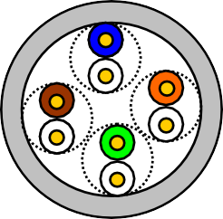
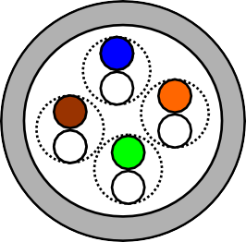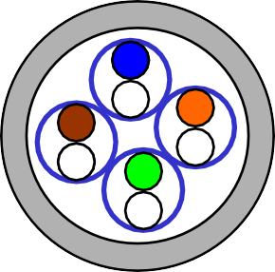

UTP
FTP
STP

2-5

Notice
- UTP : Unshielded Twisted Paired Copper Cable FTP : (Overall) Foiled Twisted Paired Copper Cable
STP : (Overall) Shielded(and Shielded Individually Pair)Twisted Paired Copper Cable
- Patch Cable(or Patch Cord)
Instead of Solid Conductors, Stranded Conductors may be used for the purpose of improving the Flexibility of a UTP 4Pair Cable. The materials and sizes of strands used are regulated in accordance with UL444, and representative sizes and materials are Un-coated AWG 24 (7/0203A).
In other words, diameter of unshielded wire is 0.203mm and wires are stranded in 1+6 structure. The materials are
annealed coopers.

Chapter 2 Specification
2-6

- Classification by Frequencies used
Classification | Frequency used (MHz) | Transmission  Speed(Mbps) | Uses
Category 1 | Voice Frequency | 1 | Telephone Network (2 Pair)
Category 2 | 4 | 4 | Multi- Pair Communication Cable
Category 3 | 16 | 16 | Telephone Network + Computation  Network
Category 4 | 20 | 20 | - Computation Network – Transmission Speed Up  - Low-loss Communication Cable
Category 5 and Enhanced  Category 5 | 100 | 100 | - Digital Telephone Network + Computation Network  - Low Loss, Wideband Cable

Notice
1) The classification currently applied at home and abroad is Category 3, 5, Enhanced Category 5, and Category
6. Category 4 is not now used as Category 5 appears. Category 7 is in STP structure and it is at a development stage over the world.

- Classification by Inflammable Grades(Base on UL Certification )
Segment | Induced  Calorie | Induced Time | Combustion  Length | Smoke  Regulation | Remarks
CMP | 88(kW) | 20 minutes | Less than 73m/min | Regulated | - For Installing ceilings without duct  - Plenum Cable  - UL 910 (Plenum Test)
CMR | 150(kW) | 30 minutes | Less than 3.6m | Not Regulated | - Vertical Installation Type  - Non-Plenum Cable  - UL 1666(Riser Test)
CM | 21(kW) | 20 minutes | Less than 2.4m | Not regulated | - General Type  - Non-Plenum Cable  - UL 1581(VTFT Test)
CMX | 1(kW) | 1 minute | Less than 0.5m | Not regulated | - Restrictive Use  - Non-Plenum Cable  - UL 1581 (VW-1 Test)

Notice
1) CMG is located in the middle grade between CM and CMR, but generally it is not applied to LAN Cable such as UTP Cable.
Example) CMG: CAS FT4 (VTFT Test), similar to CM of UL 1581.
→Burner Angle (Horizontality → 45 degree – Upward) and Sample Conditions (1/2 interval arrangement
→ A Bundle of 6 ones x 6 units) are different.

2-7

Chapter 2 Specification

- An Example (CTP-LAN5) of Category - 5 Twisted Pair Cable(UTP)

Items | Units |  | Values
Conductor Resistance  (Maximum) | Ω/km |  | 93.5
Insulation Resistance  (Minimum) | MΩ/km |  | 2500
Anti- voltage | V/minute |  | AC 500
Characteristic  Impedance | Ω(1~100MHz) |  | 100 ± 15
Attenuation | Less than dB/100m | 10MHz | 6.5
Attenuation | Less than dB/100m | 16MHz | 8.2
Attenuation | Less than dB/100m | 20MHz | 9.3
Near End Cross-talk Attenuation | Less than dB/100m | 10MHz | 47
Near End Cross-talk Attenuation | Less than dB/100m | 16MHz | 44
Near End Cross-talk Attenuation | Less than dB/100m | 20MHz | 42

Chapter 2 Specification
2-8

3-1

Chapter 3 Installation and Test operation

Chapter 3 Installation and Test operation
3.1 Installation Environment

This product is very reliable regardless of installation environments, but to guaranty the reliability and stability of the system, pay attention to the following items.
- Environment Conditions
  - Install in the control board where waterproof and dustproof are possible.
  - The places where constant impacts or vibrations are imposed.
  - The places where direct rays are not directly exposed .
  - The places where dew is not formed by the rapid change in temperature.
  - The places where surrounding temperature is maintained to be at 0-55℃.

- Installation Constructions
  - Make sure wiring leavings are not inserted inside the PLC when you process screw holes or do wiring jobs.
  - Install the places where it is easy to control.
  - Do not install into the same panel as high press machine.
  - Make sure the distance to the duct and the surrounding module is maintained to be more than 50㎜.
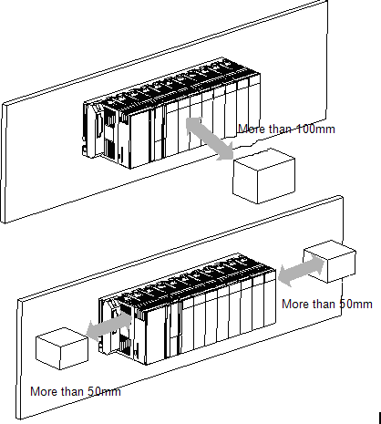
  - Put to earth where surrounding noise environment is good.

Chapter 3 Installation and Test operation
3-2

3.2 Cautions when Handling

Observe the following directions when you configure the system using EtherNet/IP I/F module.

- Do not drop or impose strong impact.
- Do not separate PCB from the case. It may cause malfunctions.
- Make sure foreign objects are not put into the upper area of the module while you do wiring jobs.
- If foreign objects are entered, remove them.
- Do not remove the module when light is ON.
- Use standard cables and install within maximum distance.
- Make sure communication lines are not affected by surges and inductive noises that may occur from alternating current or current parts.
- In case the machinery or the substances that may generate high temperature are nearby you or when wires directly come into contact oil and other things for a long time when you do wiring jobs, it may cause a short cut, damage, or malfunctions.
- When you do wirings during pipe arrangement, it is necessary to put to earth to pipes.
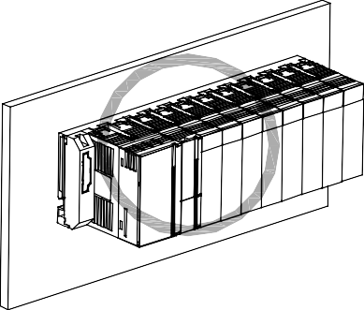
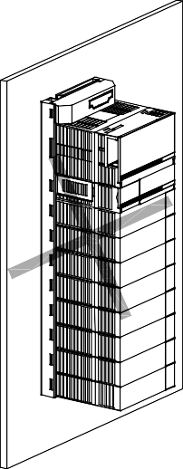
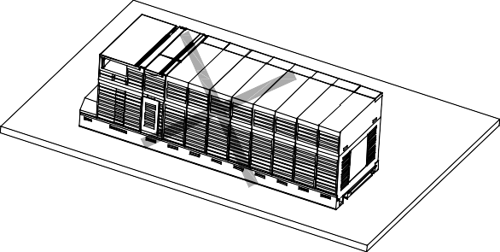

3-3

Chapter 3 Installation and Test operation

3.3 The Order for Setting up Products till Running

The following describes the order of installing or setting up products. Install the system and setting up the parameter so that they can operate in order.
Start
- Check out the sizes and standards to be used
- Install the module to the base
- Check out the location of the base and the slot

- Check out the LED state of a communication module after power is authorized. (RUN: Green)

- Connect to CPU using XG5000

- Carry out “Read” in XG5000
- The module appears in project window after executing “Read”

- Set up the basic parameter
  - IP Address, Subnet Mask, Gateway

- Install the necessary EDS file

- Set up EIP parameter
  - Channels, Functions, Starting Conditions, Data Sizes and Areas, Types

- Execute “Write Parameter” and “Enable Link”

- Execute EIP communication

3.4 I/O Allotment and Device Information

I/O Allotment
      - Using XGK CPU
        - How to Configure the Basic System
The features of the basic system, which is configured after the basic base and the extension base are connected through cables, are as follows. The step number of bases is restricted in accordance with kinds of CPUs and the allotment method of In/Output number. Thus, it is possible to select a fixed type and a variable type.

Segment | XGK-CPUE | XGK-CPUS | XGK-CPUA | XGK-CPUH | XGK-CPUU
The Step Number s of Maximum Extension | 1step | 3 steps | 3 steps | 7steps | 7steps
The Installation Number of Maximum In/Output Module s | 24 modules | 48modules | 48modules | 96 modules | 96 modules
Maximum In/Output Point | 1,536 point | 3,072 point | 3,072 point | 6,144point | 6,144point
Maximum Extension Distance | 15m

        - Allotment of In/Output Numbers(Fixed Type)
          - For each slot of a base, 64 points are allotted regardless of a module installed or not and kinds of modules.
          - In one base, in/output numbers for 16 slots are allotted. In other words, the starting number of base 1 will be P00640.(Refer to 2.3.2)
          - The example of allotment of in/output numbers in the slot base 12 is as follows.

SlotNo.
P W R | C P U | I 1  6 | I 1  6 | I 3  2 | I 6  4 | O 1  6 | O 3  2 | O 3  2 | O 6  4 | I 3  2 | O 1  6 | O 3  2 | O 3  2

0 1 2 3 4 5 6 7 8 9 10 11

P3F P7F P11FP15FP19FP23FP27FP31FP35FP39FP43FP47F
P0
~
P40
~
P80
~
P120
~
P160
~
P200
~
P240
~
P280
~
P320
~
P440
~
P360
~
P400
~

        - Allotment of Output Numbers (Variable Type)
          - Points are allotted in accordance with the installation modules by slots.
          - Installation modules are designated by parameters, designated points are allotted.
          - The slots not designated by I/O parameter are automatically allotted according to installation modules (8 points
- module is allotted to be 16 points).
          - The empty slot not designated by I/O parameter is processed to be 16 points.
          - Using I/O parameter, you can designate points only without designating a module.
          - For the slots which special modules and communication modules have been installed, 16 points are allotted.
          - The example of allotment of in/output numbers in the slot base 12 is as follows.

SlotNo.

Chapter 3 Installation and Test operation
3-4
0 1 2 3 4 5 6 7 8 9 10 11

P0F P1F P3F P7F P8F P10FP12FP16FP18FP19FP21FP23F
P00
~
P10
~
P20
~
P40
~
P80
~
P90
~
P110
~
P130
~
P170
~
P220
~
P190
~
P200
~
P  W R | C P U | I 1  6 | I 1  6 | I 3  2 | I 6  4 | O 1  6 | O 3  2 | O 3  2 | O 6  4 | I 3  2 | O 1  6 | O 3  2 | O 3  2

Chapter 3 Installation and Test operation

        - When Configuring the Maximum System
- The Maximum Configure of the Basic System (Point- fixed Type)

System Configuration Example.1

- I/O Point – fixed Type
- XGK-CPUH
- 8 Slot Base

BasicBase (BaseNo.0)

Extension Cable

Extension Base
Slot No. 0 1 2 3 4 5 6 7
 |  |  | P0000 | P0040 | P0080 | P0120 | P0160 | P0200 | P0240 | P0280
 | Power | CPU | ~ | ~ | ~ | ~ | ~ | ~ | ~ | ~
 |  |  | P003F | P007F | P011F | P015F | P019F | P023F | P027F | P031F

BaseNo. .
 |  | Power | P0640  ~ P067F | P0680  ~ P071F | P0720  ~ P075F | P0760  ~ P079F | P0800  ~ P083F | P0840  ~ P087F | P0880  ~ P091F | P0920  ~ P095F

 |  | Power | P1280  ~ P131F | P1320  ~ P135F | P1360  ~ P139F | P1400  ~ P143F | P1440  ~ P147F | P1480  ~ P151F | P1520  ~ P155F | P1560  ~ P159F

 |  |  |  |  |  | Slot No. | 0 | 1 | 2 | 3 | 4 | 5 | 6 | 7
 |  |  |  |  |  | Slot No | 0 | 1 | 2 | 3 | 4 | 5 | 6 | 7

Set-upSwitch:1

1 2 3 4

Slot: No. 0 1 2 3 4 5 6 7
 |  | Power | P1920  ~ P195F | P1960  ~ P199F | P2000  ~ P203F | P2040  ~ P207F | P2080  ~ P211F | P2120  ~ P215F | P2160  ~ P219F | P2200  ~ P223F
Slot No. 0 1 2 3 4 5 6 7
 |  | Power | P2560  ~ P259F | P2600  ~ P263F | P2640  ~ P267F | P2680  ~ P271F | P2720  ~ P275F | P2760  ~ P279F | P2800  ~ P283F | P2840  ~ P287F
Slot No. 0 1 2 3 4 5 6 7
 |  | Power | P3200  ~ P323F | P3240  ~ P327F | P3280  ~ P331F | P3320  ~ P335F | P3360  ~ P339F | P3400  ~ P343F | P3440  ~ P347F | P3480  ~ P351F

Slot No. 0 1 2 3 4 5 6 7
 |  | Power | P3840  ~ P387F | P3880  ~ P391F | P3920  ~ P395F | P3960  ~ P399F | P4000  ~ P403F | P4040  ~ P407F | P4080  ~ P411F | P4120  ~ P415F
Slot No. 0 1 2 3 4 5 6 7
 |  | Power | P4480  ~ P451F | P4520  ~ P455F | P4560  ~ P459F | P4600  ~ P463F | P4640  ~ P467F | P4680  ~ P471F | P4720  ~ P475F | P4760  ~ P479F

3-5

Chapter 3 Installation and Test operation
3-6

- The Maximum Configuration of the Basic System (Points - Variable Type)
Slot NO. 0
1
2
3
4
5
6
7
System Configuration Example 2
BasicBase
(BaseNO.:0)
- I/O Points Variable Type
- XGK-CPUH
- 8 Slot Base
Extension Cable
Extension Base
Slot NO. 0
1
2
3
4
5
6
7
P0080 P0090 P0100 P0110 P0120 P0130 P0140 P0150
Power
~
~
~
~
~
~
~
~
- When 16 points P008F P009F P010F P011F P012F P013F P014F P015F
module installed
BaseNO.
Set-upSwitch:1
Slot NO 0
1
2
3
4
5
6
7
1 2 3 4
Slot NO. 0
1
2
3
4
5
6
7
Slot NO. 0
1
2
3
4
5
6
7
Slot NO. 0
1
2
3
4
5
6
7
Slot NO. 0
1
2
3
4
5
6
7
Slot NO. 0
1
2
3
4
5
6
7
P0550
~ P055F
P0540
~ P054F
P0530
~ P053F
P0520
~ P052F
P0510
~ P051F
P0500
~ P050F
P0490
~ P049F
P0480
~ P048F

Power
P0470
~ P047F
P0460
~ P046F
P0450
~ P045F
P0440
~ P044F
P0430
~ P043F
P0420
~ P042F
P0410
~ P041F
P0400
~ P040F

Power
P0390
~ P039F
P0380
~ P038F
P0370
~ P037F
P0360
~ P036F
P0350
~ P035F
P0340
~ P034F
P0330
~ P033F
P0320
~ P032F

Power
P0310
~ P031F
P0300
~ P030F
P0290
~ P029F
P0280
~ P028F
P0270
~ P027F
P0260
~ P026F
P0250
~ P025F
P0240
~ P024F

Power
P0230
~ P023F
P0220
~ P022F
P0210
~ P021F
P0200
~ P020F
P0190
~ P019F
P0180
~ P018F
P0170
~ P017F
P0160
~ P016F

Power

 |  |  | P0000 | P0010 | P0020 | P0030 | P0040 | P0050 | P0060 | P0070
 | Power | CPU | ~ | ~ | ~ | ~ | ~ | ~ | ~ | ~
 |  |  | P000F | P001F | P002F | P003F | P004F | P005F | P006F | P007F

 |  | Power | P0560  ~ P056F | P0570  ~ P057F | P0580  ~ P058F | P0590  ~ P059F | P0600  ~ P060F | P0610  ~ P061F | P0620  ~ P062F | P0630  ~ P063F

3-7

Chapter 3 Installation and Test operation

      - When using XGI CPU
- The Configuration Method of the Basic System
Segment | XGI-CPUE | XGI-CPUS | XGI-CPUH | XGI-CPUU | XGI-XPUU/D
The Number of Maximum Extension Steps | 1 stage | 3 stages | 7 stages | 7 stages | 7 stages
The Number of Maximum In/Output Modules | 24 modules | 48 modules | 96 modules | 96 modules | 96 modules
Maximum In/Output Points | 1,536 points | 3,072 points | 6,144 points | 6,144 points | 6,144 points
Maximum Extension Distance | 15m
- In/Output numbers are allotted to be 64 points fixed per the slot of a base.
- To each slot of a base is allotted, 64 points are allotted regardless of with or without the installation and kinds.
- The installation location of special modules and the number of uses are not restrictive.
- In case of special modules, fixed in/output numbers are not allotted, unlike digital in/output modules.
- Special modules are controlled by exclusive function blocks and memories are automatically allotted.
- The example of allotment of in/output numbers in12 Slot Base is asfolows.
SlotNO. 0 1 2 3 4 5 6 7 8 9 10 11
Pow C I I O O O O O O O O O O P 1 1 3 6 1 3 3 6 3 1 3 3
er U 6 6 2 4 6 2 2 4 2 6 2 2

%QX 0.11.0 ~ 31
%QX 0.10.0 ~ 31
%QX 0.9.0 ~ 15
%IX 0.8.0 ~ 31
Base NO. 1

Notice
- The basic base is fixed at 0 in base NO, and the extension base has a switch extending base numbers.
- Only if themodule type set up through I/O parameter corresponds to the type of the module actually installed running starts.

- When Configuring the Big System

System Configuration Example 2

BasicBase (BaseNO.:0)
Slot no. 0 1 2 3 4 5 6 7

- XGI-CPUU
- 8 Slot Base
- When installing 16 modules

ExtensionCable

ExtensionBase BaseNo.
Set-up Switch: 1

Slot no. 0
 |  |  | 0.0.0 | 0.1.0 | 0.2.0 | 0.3.0 | 0.4.0 | 0.5.0 | 0.6.0 | 0.7.0
 | Power | CPU | ~ | ~ | ~ | ~ | ~ | ~ | ~ | ~
 |  |  | 0.0.16 | 0.1.15 | 0.2.15 | 0.3.15 | 0.4.15 | 0.5.15 | 0.6.15 | 0.7.15

Slot no. 0
 |  |  |  | Power | 1.0.0  ~ 1.0.16 | 1.1.0  ~ 1.1.15 | 1.2.0  ~ 1.2.15 | 1.3.0  ~ 1.3.15 | 1.4.0  ~ 1.4.15 | 1.5.0  ~ 1.5.15 | 1.6.0  ~ 1.6.15 | 1.7.0  ~ 1.7.15

1 2 3 4 5 6 7

1 2 3 4 5 6 7

Chapter 3 Installation and Test operation
3-8
1 2 3 4
 |  |  |  |  |  | Power | 2.0.0  ~ 2.0.16 | 2.1.0  ~ 2.1.15 | 2.2.0  ~ 2.2.15 | 2.3.0  ~ 2.3.15 | 2.4.0  ~ 2.4.15 | 2.5.0  ~ 2.5.15 | 2.6.0  ~ 2.6.15 | 2.7.0  ~ 2.7.15

Slot no. 0 1 2 3 4 5 6 7
 |  |  |  |  |  | Power | 3.0.0  ~ 3.0.16 | 3.1.0  ~ 3.1.15 | 3.2.0  ~ 3.2.15 | 3.3.0  ~ 3.3.15 | 3.4.0  ~ 3.4.15 | 3.5.0  ~ 3.5.15 | 3.6.0  ~ 3.6.15 | 3.7.0  ~ 3.7.15
Slot no. 0 1 2 3 4 5 6 7
 |  |  |  |  | Power | 4.0.0  ~ 4.0.16 | 4.1.0  ~ 4.1.15 | 4.2.0  ~ 4.2.15 | 4.3.0  ~ 4.3.15 | 4.4.0  ~ 4.4.15 | 4.5.0  ~ 4.5.15 | 4.6.0  ~ 4.6.15 | 4.7.0  ~ 4.7.15
Slot no. 0 1 2 3 4 5 6 7
 |  |  |  |  | Power | 5.0.0  ~ 5.0.16 | 5.1.0  ~ 5.1.15 | 5.2.0  ~ 5.2.15 | 5.3.0  ~ 5.3.15 | 5.4.0  ~ 5.4.15 | 5.5.0  ~ 5.5.15 | 5.6.0  ~ 5.6.15 | 5.7.0  ~ 5.7.15
Slot no. 0 1 2 3 4 5 6 7
 |  |  |  | Power | 6.0.0  ~ 6.0.16 | 6.1.0  ~ 6.1.15 | 6.2.0  ~ 6.2.15 | 6.3.0  ~ 6.3.15 | 6.4.0  ~ 6.4.15 | 6.5.0  ~ 6.5.15 | 6.6.0  ~ 6.6.15 | 6.7.0  ~ 6.7.15
Slot no. 0 1 2 3 4 5 6 7
Location for terminal resistor
 |  |  |  | Power | 7.0.0  ~ 7.0.16 | 7.1.0  ~ 7.1.15 | 7.2.0  ~ 7.2.15 | 7.3.0  ~ 7.3.15 | 7.4.0  ~ 7.4.15 | 7.5.0  ~ 7.5.15 | 7.6.0  ~ 7.6.15 | 7.7.0  ~ 7.7.15

Chapter 3 Installation and Test operation

When using the XGR CPU
        - How to configure the basic system
Classification XGR-CPUU
Configuration of basic • Install basic base of same configuration double base
Max. extension base • Available to install 1~31 extension bases
Max. equip-able IO • Available to install up to 372 at extension base module no.
- In case of 16 points module: 5,952 point

Max. IO points

Max. extension distance
- In case of 32 points module: 11,904 point
- In case of 64 points module: 23,808 point
- Between base
- Optical: 2 ㎞
  - Electricity: 100 m
- Total max. distance
  - Optical: 64 ㎞(When configuring 31 extension bases)
  - Electricity: 3.2 ㎞ (When configuring 31 extension bases)
- IO number start value of each base is determined by base number set in extension drive module. (1~31)
- IO number in base is fixed as 64 per slot.
Each slot is allocated 64 points regardless of module equipment and type
- Special module doesn’t use IO number to control unlike digital IO module. It uses U device and dedicated function block
- IO number allocation of 12 slot base is as follows.

Slot no. 0 1 2 3 4 5 6 7 8 9 10 11

IO number allocation of extension base
Base No. 1
Output 16
Output 32
Output 64
Input 16
Input 32
Input 64
Output 64
Output 32
Output 16
Input 64
Input 32
Input 16
Extension drive
Power
Power

%QX1.11.0~15
%QX1.10.0~31
%QX1.9.0~63
%IX1.8.0~15

IO number of basic base

- IO number doesn’t have meaning in basic base because only communication module can be equipped.
- Thought basic base doesn’t use IO number, it is allocated same with 12 slot extension base.
- Base number of basic base is 0 and it is positioned at the first of IO number.

3-9
Note
- Redundant basic base is fixed as ‘0’. In the extension base, there is switch to set base number.
- Redundant CPU can be installed at basic base.
- Redundant CPU is CPU module occupying two slots.
- In order to start, module type set by IO parameter should be same with real equipped module type.
- When remote connection by using Cnet I/F module, station number of extension drive available to connection is limited 1~15.

Chapter 3 Installation and Test operation
3-10

Available device area per CPU series

CPU type | Area | Range | Size (word) | Reference
XGK | P | P0~P2047 | 2048 | Read/Write/Monitor available
XGK | M | M0~M2047 | 2048 | Read/Write/Monitor available
XGK | K | K0~K2047 | 2048 | Read/Write/Monitor available
XGK | F | F0~F2047 | 2048 | Read/Monitor available  (Write: available from 1025 word)
XGK | T | T0~T2047 | 2048 | Read/Write/Monitor available
XGK | C | C0~2047 | 2048 | Read/Write/Monitor available
XGK | L | L0~L11263 | 11264 | Read/Write/Monitor available
XGK | N | N0~N21503 | 21504 | Read/Write/Monitor available
XGK | D | D0~D32767 | 32768 | Read/Write/Monitor available, XGK–CPUH
XGK | D | D0~D19999 | 20000 | Read/Write/Monitor available, XGK–CPUS
XGK | R | R0~R32767 | 32768 | Read/Write/Monitor available
XGK | ZR | ZR0~ZR65535 | 65536 | Read/Write/Monitor available
XGI | I | IW0.0.0~IW127.15.3 | 8192 | Read/Write/Monitor available
XGI | Q | QW0.0.0~QW127.15.3 | 8192 | Read/Write/Monitor available
XGI | M | MW0~MW131071 | 131072 | Read/Write/Monitor available
XGI | R | RW0~RW32767 | 32768 | Read/Write/Monitor available
XGI | W | WW0~WW65535 | 65536 | Read/Write/Monitor available
XGR | I | IW0.0.0~IW127.15.3 | 8192 | Read/Write/Monitor available
XGR | Q | QW0.0.0~QW127.15.3 | 8192 | Read/Write/Monitor available
XGR | M | MW0~MW131071 | 131072 | Read/Write/Monitor available
XGR | R | RW0~RW32767 | 32768 | Read/Write/Monitor available
XGR | W | WW0~WW65535 | 65536 | Read/Write/Monitor available
Common | U | U0~U4095 | 4096 | Monitor available

Note
- ZR device is available only at XGK-CPUH.
- ZR device should request by using “W”.
Ex) When requesting word size from ZR0, you should request as “%WW000”.
- At U device, address of bit monitoring is hexadecimal and monitoring address of word area is decimal.

3-11

Chapter 3 Installation and Test operation

3.5 Installation of Products

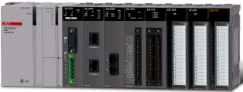
    - Installation of XGL-EIPT

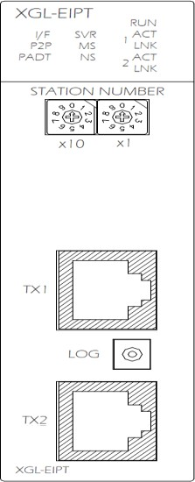
[Illustration 3.6.1] How to Install 100BASE-TX
8 Pin - RJ45 Plug
Twist Pair Cable

The maximum segment distance of 100BASE-TX reaches 100m. (The distance between modules) Straight cables and cross cables are used.
If a cross cable is used when connected between these communications modules, the time for connecting links can be shortened.
This module doesn’t support a ring system.
When configuring a ring form, IP address switch of a module – front view must be set up at ’99.’
Then, a ring system is formed in external aspect, but the service for a ring system will not be supported.
If IP address switch is not set up at 99’after formed in a ring, data burst may happen and modules can not execute normal actions.
Pin NO. | Signal | Straight Cable between  Cables | 1:1 Cross Cable
1 | TD+ | 1-1 | 1-3
2 | TD- | 2-2 | 2-6
3 | RD+ | 3-3 | 3-1
6 | RD- | 6-6 | 6-2
4,5,7,8 | Not used | - | -

Notice
- 100BASE-TX cable is designed to be weak in cable structure, so only if cables are twisted (Two wires are stranded) after No.1 (TD+) and No. 2 (TD-) wires are twisted and No. 3 and No. 6 are twisted with each other. wiring will be strong in strength.
- For cable terminal treatment and manufacture, consult with professional providers to install

Chapter 3 Installation and Test operation
3-12

How to Install UTP
        - For reliable transmission of 100Mbps signal using UTP cables, Patch Cord, Line Cord, Patch Panel, DVO(Data Voice Outlet), etc must meet 5 spec (Category 5 Spec.- EIA/TIA-568A).
        - Make sure the length of patch code will be over 7m in cross-connect, If the length exceeds 7m, the length corresponding to 90m, as much as the allowable value in Horizontal Distribution System, must be deducted.
        - Make sure the length of line cord does not exceed 3m in line cord length. If the length exceeds 3m, as much as the length corresponding to 90m, the allowable value in Horizontal Distribution System, must be deducted.
        - Make sure the loose of paired pitch of UIP cable in case of disconnection to patch panel and DVD does not exceed the following dimension.
        - Maximum Paired Pitch – Loose : Category 5 : 13mm, Category 3 : 26mm
        - Use jumper wires in DC cross-connect system. Then, also the loose of paired pitch must not exceed the above standards. Especially, in case of seriously bending cables, pay attention so that damage or separation between pairs does not happen.
        - Maximum Curvature Diameter : 4 Pair Cable : 4 times the Diameter
Cable more than 25 Pair: 10 times the Diameter
        - Make sure the maximum tensile force while using does not exceed 110N (11.3Kgf) based on 4 Pair
        - Make sure jumper cables and patch codes are loosely disconnected. When tightly connected, the features of category 5 may lower. When using Tie-wrap, make sure cables are not stressed.
        - Make sure proper distance is maintained between EMI source and UTP cable when installing cables.

The proper distance in each case is as follows.
Conditions | Minimum Separation Distance
Conditions | Less than 2.0KVA | 2.5 KVA | More than 5.0KVA
In case unshielded power lines or electric facilities are open and are in the state of being closely located nearby non- metal pipes | 127mm | 305mm | 610mm
In case unshielded power lines or electric facilities are in the state of being located nearby buried metal pipes | 64mm | 152mm | 305mm
In case buried metal pipes the power line (or the same shields)are in the state of being located nearby buried metal pipes | - | 76mm | 152mm

Notice
1) In case voltage reaches 480V and electric power source reaches more than 5KVA, separated calculation is required.

3-13

Chapter 3 Installation and Test operation

3.6 Test Operation

Directions when Configuring Systems
      - To use P2P service including this module, make sure IP Addresses of all channels are different from IP addresses of all other channels.
      - To use communication cables, select the ones in designated sizes. Using cables that have not been designated may cause serious communication obstacles.
      - Check out whether cables are disconnected or short-circuited before installing communication cables.
      - Completely tighten the connectors of communication cables so that cable connections can be fixed.
      - Incomplete cable connections may cause serious obstacles to communication.
      - In case of connecting communication cables to a long distance, make sure cables are not separated from power lines or inductive noises.
      - Coaxial cables are low in flexibility, so they must be re-branched lowering down at least more than 30 cm from the connector in communication module, and if cables are bent on the square and forcibly transformed, it may cause the destruction of the connector located in the communication module.
      - In case LED does not normally operate, refer to ‘Chapter 10 Troubleshooting’ and check out causes. If something is wrong even if actions have been taken, contact Warranty Service Center.

Chapter 3 Installation and Test operation
3-14

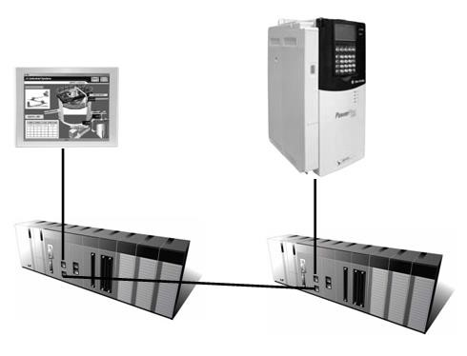
4-1

Chapter 4 System Configuration

Chapter 4 System Configuration

EtherNet/IP I/F modules can be installed regardless of XGT CPU modules. The number of maximum installments reaches 24 units including basic bases and extension bases. For EIP service, 8 units can be used as EIP service to the maximum. If used as an aperiodic server, 24 units can be used to the maximum.

It is possible for the communication system using this module to be applied to a variety of configurations. This chapter describes the examples of the cases when system configuration is available and unavailable by applications.

4.1 Configuration of a Usable System

System Configuration using a Switch

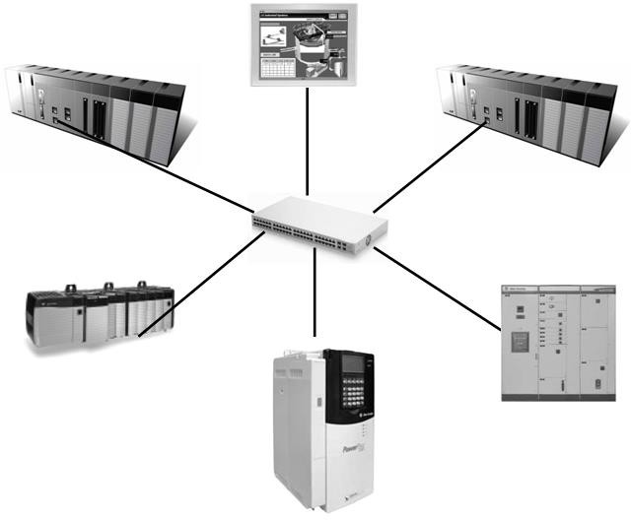

    - System Configuration not using a Switch

Chapter 4 System Configuration
4-2

4.2 Configuration of an unusable System

System Configuration using a Switch
It is impossible for EtherNet/IP I/F module to normally operate as data burst happens when each module is connected to each switch of 2 communication ports.
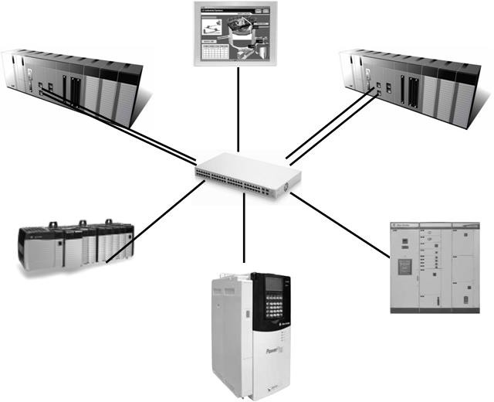

Configuration of a Ring System (Configuration of a XGL-EIPT Ring)
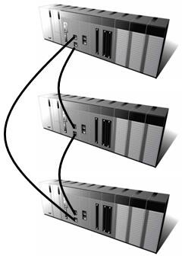EtherNet/IP I/F does not support a ring system. When you configure a ring form, it is necessary to set up the IP address switch of the module – front view at ’99.’ Then, it is configured into a ring system in external aspect, but the service on an actual ring system is not supported. In case IP address switch is not set up at NO. ‘99’ after configured into a ring, data burst happens and the module does not normally execute operations.

5-1

Chapter 5 Installation of Software and Communication Parameters

Chapter 5 Installation of Software and Communication Parameters

5.1 Installation and Execution of Software

To use software XG5000, it is necessary to install XG5000. Then, only if the version of XG5000 is over V4.0, it is possible to use XGT EtherNet/IP I/F module. The requirements for system needed to execute are as follows.

      - PC and Memory: It is necessary to need a computer with more than 128MB memory and the memory with more than 512MB is recommended.
      - Communication Port: RS-232C serial port or USB port are required.
      - Hard Disk: The area where more than 200MB is possible to use is required.
      - Mouse: A mouse that can be connected with a computer is required.
      - Monitor: The resolution must reach more than 1024 X 768.
      - Window: It is possible to execute in Window 2000/XP/VISTA. However, if several applications including other products are executed, XG5000 can be on the blitz due to the restriction to using memories.

Installation of XG5000

      - Execute the installation file.
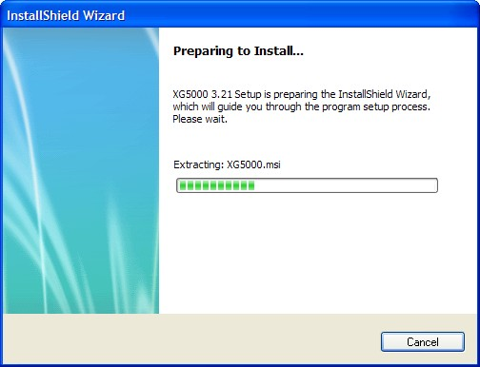
      - InstallShield Wizard prepares for installation as follows.

Chapter 5 Installation of Software and Communication Parameters
5-2

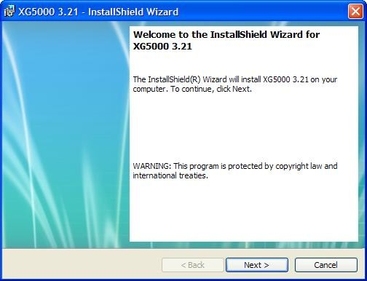

      - Click next button.

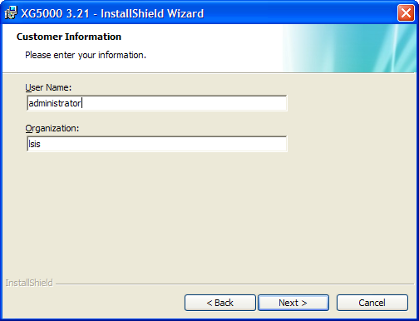
      - Insert a company’s name and press next button.

      - Designate the folder that XG5000 will be installed. If you want to change the folder, click” Index” and enter or select new folder. As XG5000 needs installation space of 200MByte, select the disk with enough room. If the installation room is not enough, warning message is on and thus, it is impossible to proceed to next step.

      - If you have selected a folder, press next button.

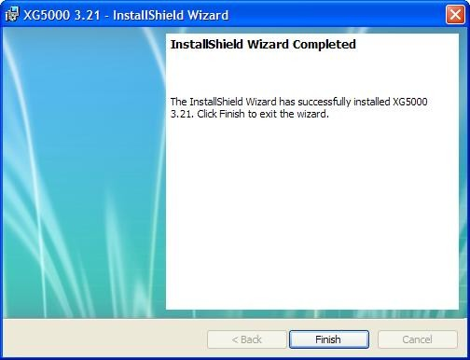
5-3

Chapter 5 Installation of Software and Communication Parameters
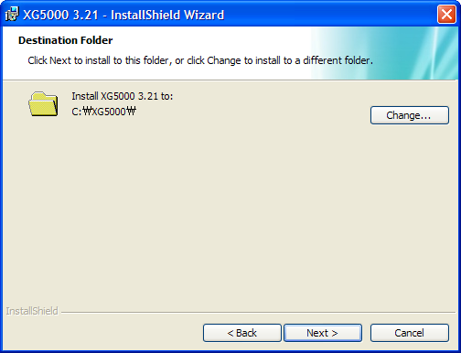

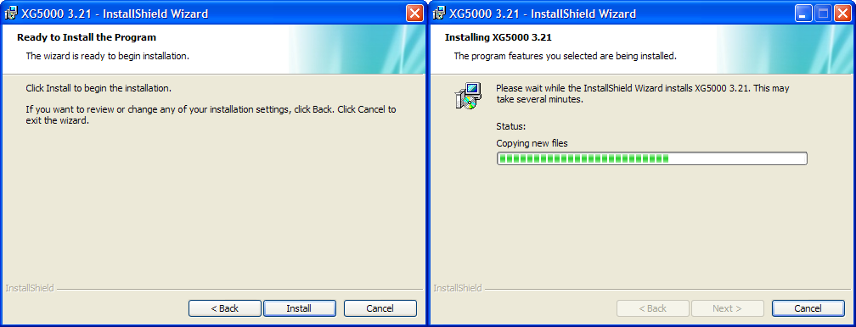
      - Check out the installation path and press next button. Install as follows.
XG5000 USB device drive install screen appears while installing, and soon, installation is completed as follows.

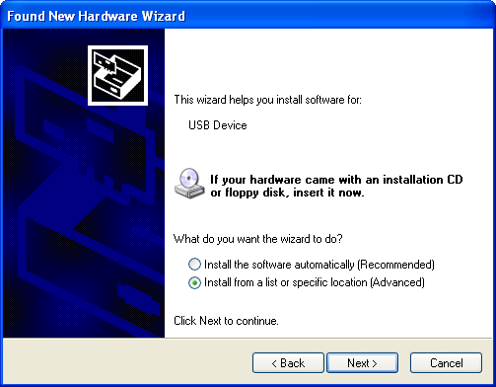

Chapter 5 Installation of Software and Communication Parameters
5-4

Installation of USB Device Drive
When you install XG5000 into Window XP for the first time, install USB Device Drive additionally. Even if USB is not connected, install USB device drive as follows.
However, in Window 2000, USB device drive is automatically installed when XG5000 is installed, and in Window XP, install it additionally.

      - Check out whether there are driver folders in the folder XG5000 has been installed into. In Drivers folder, there are two drive files - GmUSBD.sys, GmUSBD.inf. If there is no folder or drive file, install XG again.
      - Turn off PLC power and connect USB connector to PC. When connected, new hardware search Wizard Dialogue Box appears
      - Order a user to install the device drive.
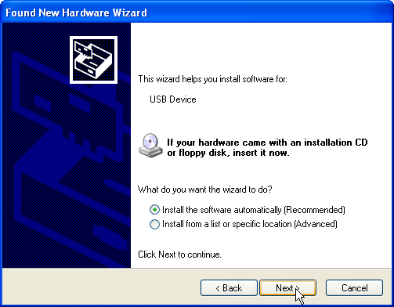

      - Select “Installation in List or Particular Location (High Grade)” of the options in new hardware search wizard dialogue box” and press next button.

5-5

Chapter 5 Installation of Software and Communication Parameters

      - Select “Search the Most Suitable Drive in this Location” of drive search options and check out “Include Next Location when Searching”
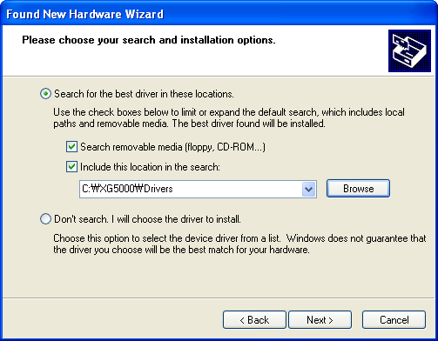

      - Press “Search” button
Select Drivers Folder where XG5000 has been installed in “Index Dialogue Box”
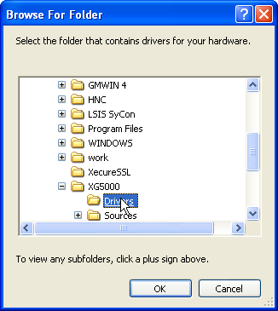

Chapter 5 Installation of Software and Communication Parameters
5-6

      - Press “Ok” button. The computer searches for the folder you selected.
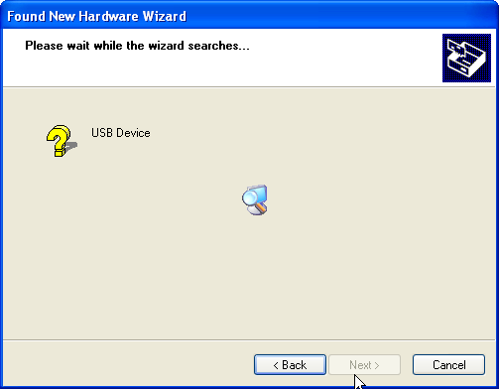

      - If the computer selects the most suitable device drive, it will ask to install the device driver selected. As USB device driver stably operates in Window operating system, press the button “Continue”.

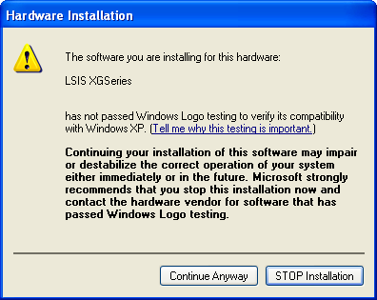

      - The completion of a device driver is completed; the dialogue box for installation like this appears. If you press “Finish” button, driver installation is terminated.

5-7

Chapter 5 Installation of Software and Communication Parameters

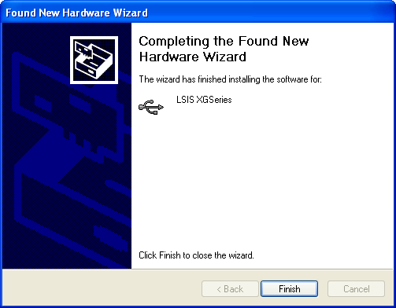

Confirmation on the Installation of USB Device Driver
If USB is not connected, confirm the installation of device driver as follows.
- Click the right button in “My Computer” on the desktop and select menu [Management].

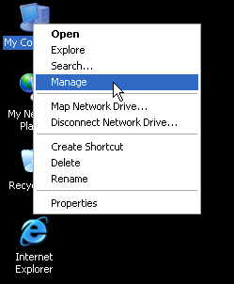

  - The computer management dialogue box appears like this. In the left tree list of the dialogue box, extension proceeds in this order - [Computer Management (Local)] - [System Tool] - [ Device Manager ].
  - The items appearing in the list can differently come out with each other according to the devices installed in the computer.

    - In case of normal state

Chapter 5 Installation of Software and Communication Parameters
5-8

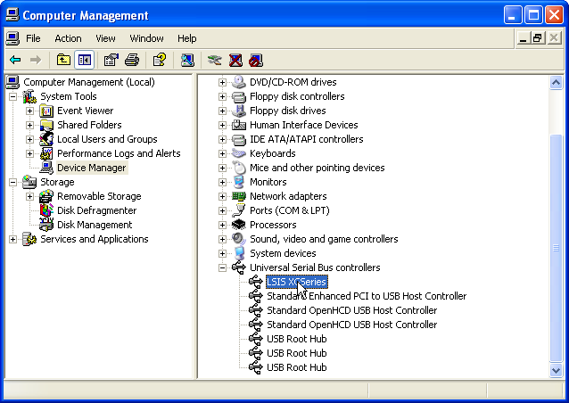
If the list [LGIS XG Series] located in the lower of [Universal Serial Bus] appears, the device driver has been normally installed.

    - In case of abnormal state
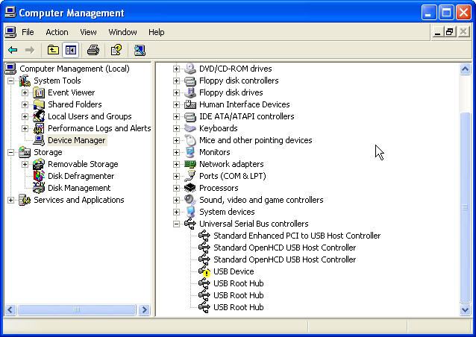
The following illustration appears, it is the case the device drive has not normally been installed.

In case of not normally installed, reinstall according to the following order.

    - Click the right button in the device driver where “Exclamation Mark” appears.
    - Select Menu [Driver Update]

5-9

Chapter 5 Installation of Software and Communication Parameters
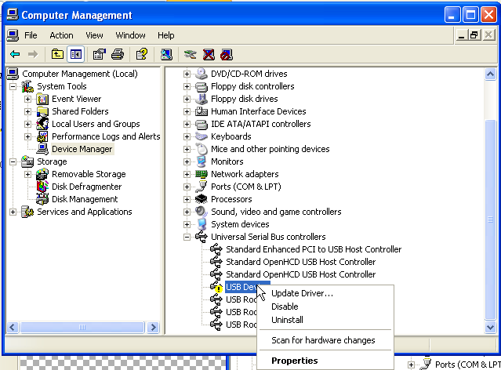

    - Hardware Update Wizard Dialogue Box appears. Select Option “Installation in List or Particular Location (High Grade)”List and press next button. The following procedures are manual and are the same to the installation of the device driver.

Chapter 5 Installation of Software and Communication Parameters
5-10

If not installed, reinstall according to the following order.

- In case a device driver has been wrongly installed or is problematic, execute Hardware Update Wizard Start.
- Select Option “Installation from a List or a specific location (Advanced)” List and press next button.

- Search and Installation Option “Do not research”. Select “Directly Select the Driver You Will install” and press next button.
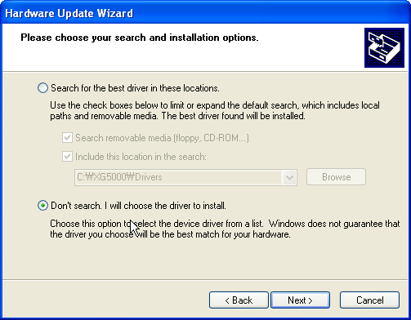

5-11

Chapter 5 Installation of Software and Communication Parameters

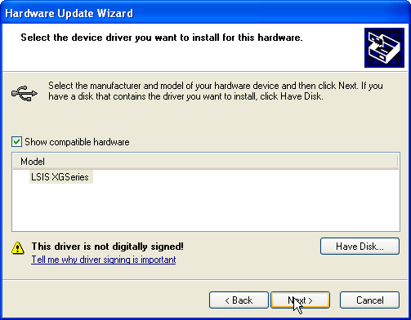
- Press button “Disc Loaded”.

- If Installation Dialogue Box appears from the disc appears, press button “Search.”
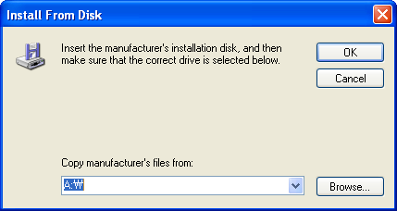

Chapter 5 Installation of Software and Communication Parameters
5-12

- Move to the folder File XG5000 has been installed from File Search Dialogue Box. If drivers fold selected, GmUSBD.inf file appears. Select this file and press button “Open.”
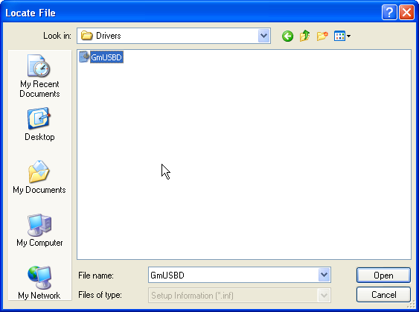

- The directory with device driver files appears on the location of the manufacture’s file. Press button “Ok.”
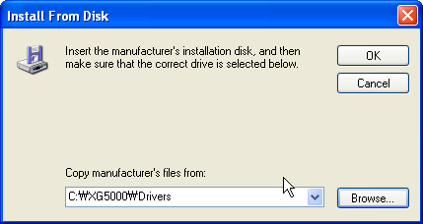

5-13

Chapter 5 Installation of Software and Communication Parameters

- Select “Select LGIS XG Series”drive in hardware indication list in select dialogue box for selecting drive which is compatible and press button “Next.”
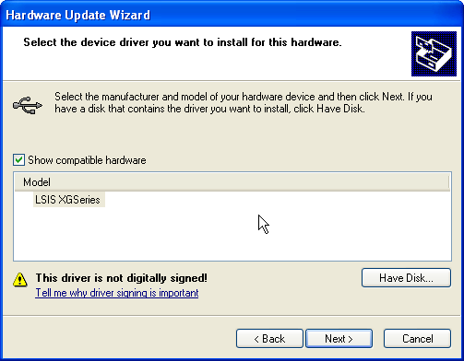

- The Dialogue Box for Hardware Installation appears. Press button “Continue” and proceed with installation.
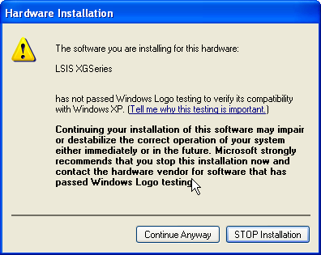

Chapter 5 Installation of Software and Communication Parameters
5-14

- Dialogue Box for Hardware Update Wizard Completed appears. Press button “Finish” and complete the installation of device drive.
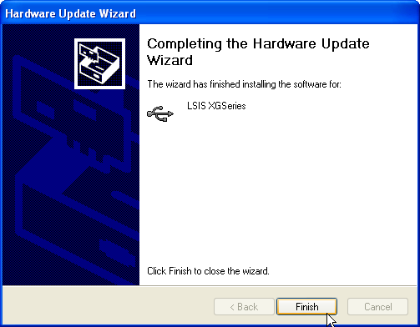

5-15

Chapter 5 Installation of Software and Communication Parameters

5.2 How to Register Communication Modules

To use Ethernet/IP I/F module, communication parameter must be made up in XG5000 and to set up the system on Ethernet/IP I/F module, the module must be registered to XG5000.
How to register Ethernet/IP I/F module located at discretion is as follows in accordance with the state of on/off line.

In case of Offline

This is the way used in setting up communication modules and making up communication related parameters in the state of not connected with PLC. The execution method is as follows.

      - After execute XG5000, select ‘File-> ‘New File ’or click ( ).
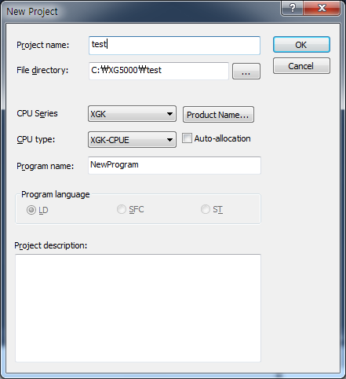
      - Create the projects that you will store in the project name, and select the names of the projects to be stored and the CPU types of PLC that you selected.
      - If you register a communication module without connected to XGT, Use a “Communication module setting” window. If Ethernet/IP is to be registered on base 0 and slot 3, Set it in the following procedure at a project Window.

        - Right click [unspecified Network] -> [add item] -> [Communication module]

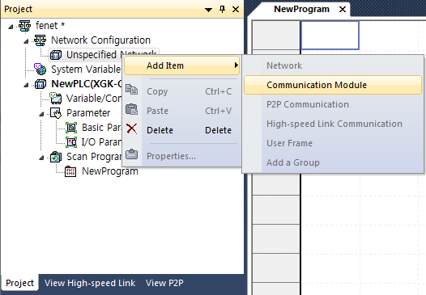
[Fig 5.2.4] Select communication module menu

Chapter 5 Installation of Software and Communication Parameters
5-16

        - Click [Select communication module] -> [Add module]
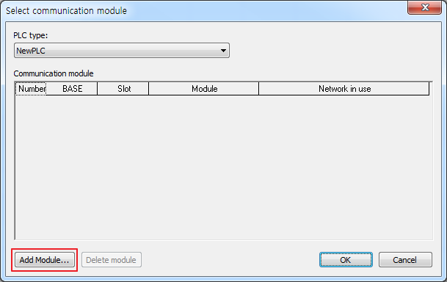
[Fig 5.2.5] Add module

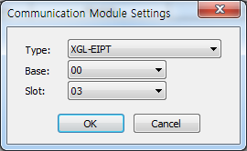
        - [Communication module settings] -> select module type, base, slot

[Fig. 5.2.6] Communication module setting Ethernet/IP module is registered on Slot 3 of Base 0 is as shown below;
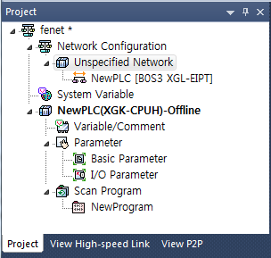
[Fig. 5.2.7] Manually register communication module

5-17

Chapter 5 Installation of Software and Communication Parameters

In case of Online

To register the communication module in online state, using XG5000, the methods in NO. 1 and NO. 2 are the same as the one in registering modules of EtherNet/IP in offline state. The execution order afterwards is as follows.

      - Create Project Name you will store and select ‘PLC Series” type applied to PLC series and PLC CPU type for CPU.
      - If not connected, check out the state of connection with PLC or select ‘Online ‘-> ‘Connection Set-up,’ or select the connection method by clicking icon . As a connection method, there is a method using RS-232C, a method using cables, and a method using Ethernet module and EtherNet/IP module. As a connection method, select Local in case of directly connecting with PLC. The remote connection steps will be described in 7.4 remote connection.

      - When normally connected, the lower menus of online menus are activated.
      - To check out the modules installed to the current base, select ‘Online’ → ‘Read’ or click icon , communication modules existing in the main base and the extension base are automatically searched for and the information of installation modules appears on the project window. In case the module registered in offline state are different from the information of PLC currently connected or kinds of communication modules, check out whether they have changed or not with the above message.
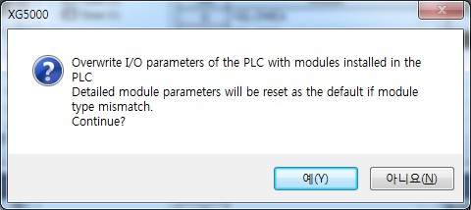

Chapter 5 Installation of Software and Communication Parameters
5-18

      - The list of the communication module installed to a product is created on “Project Window.”
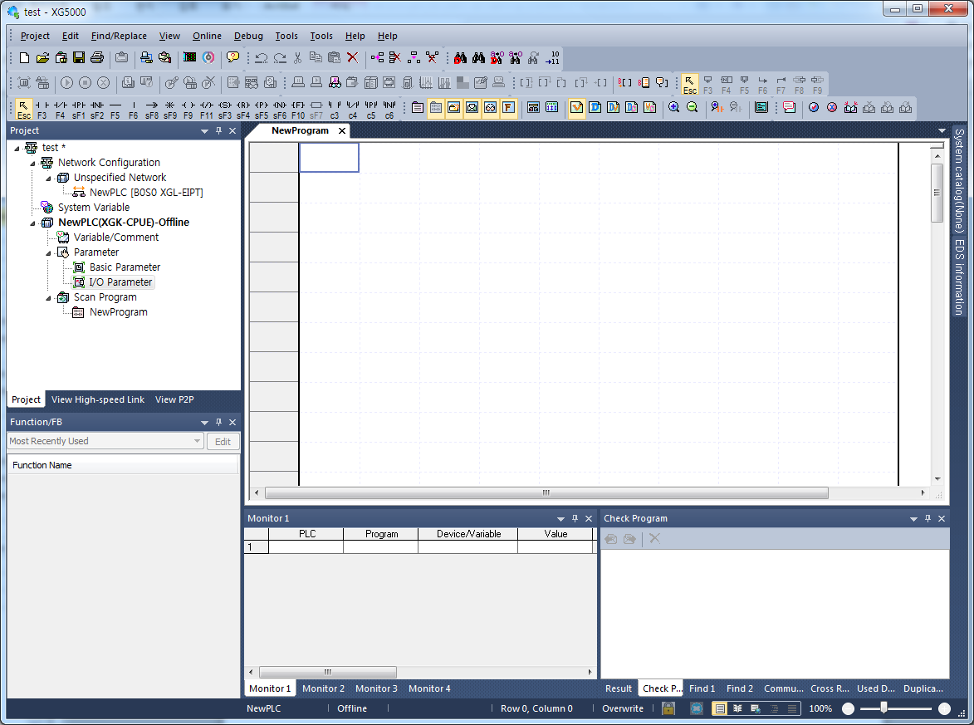

5-19

Chapter 5 Installation of Software and Communication Parameters

In case of Reading Parameter stored in PLC

The method for reading the basic set-up values for the communication module stored in PLC and for reading P2P set- up values are in the below order.
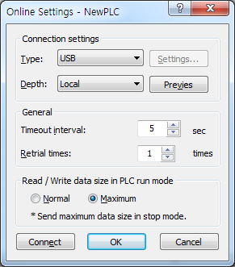
      - Select “Read” from PLC in the File.

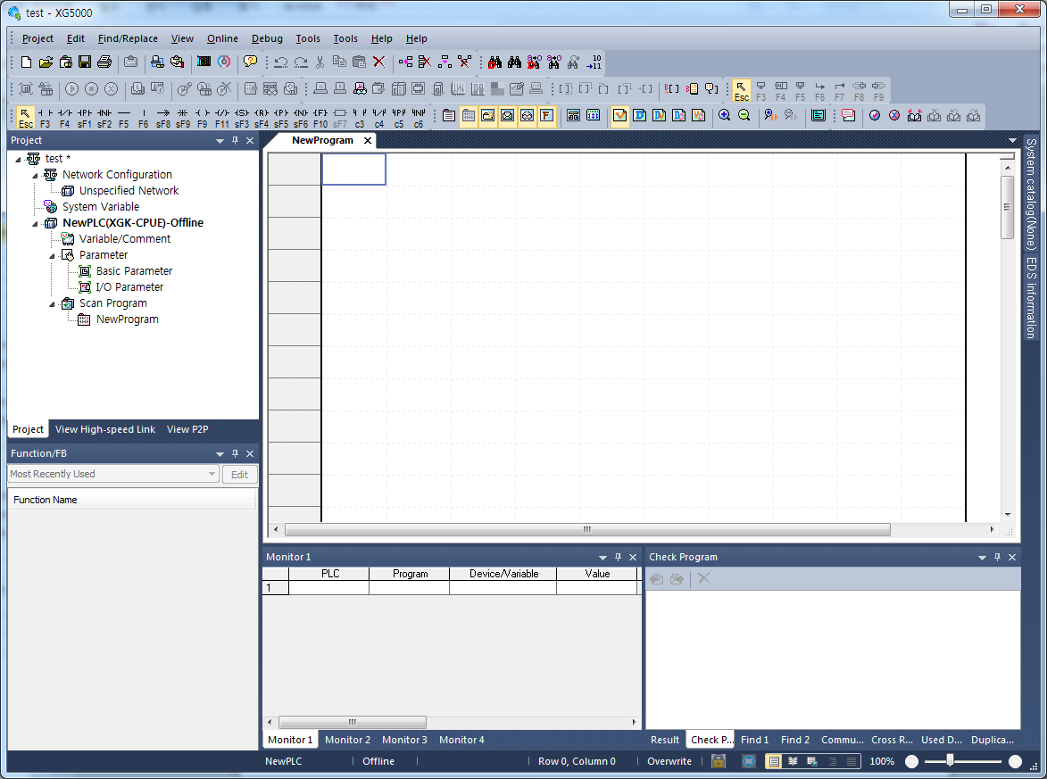
      - It is possible to check out the basic set-up values and P2P set-up values stored in PLC.

Chapter 5 Installation of Software and Communication Parameters
5-20

How to Set-up Modules

To operate EtherNet/IP I/F modules, set up in the following order.
      - Execution Order
- Enter in the Project Window
In the base where online → project window → module will be installed, the communication module set- up window appears as follows.
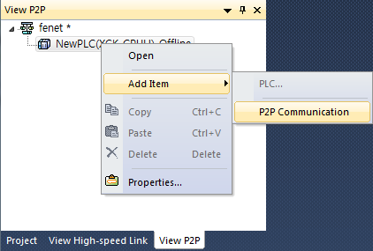
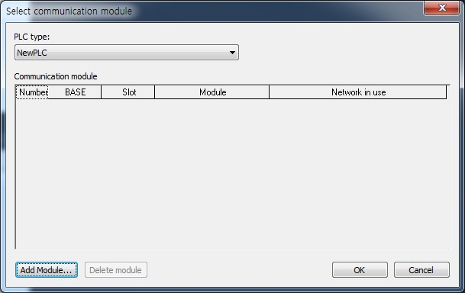

- I/O Information - Read
Select Online → Online after Connection → Diagnosis → I/O information – Read and read the module installed to the current base.

5-21

Chapter 5 Installation of Software and Communication Parameters

      - Operation Check –out
- Select Online → Communication module setting → System Diagnosis or click icon ().
- Click the right button of the mouse in the module of the‘System Diagnosis’ Window and check out whether communication has been in normal state or not after clicking Communication Module Information ’or State by Services.
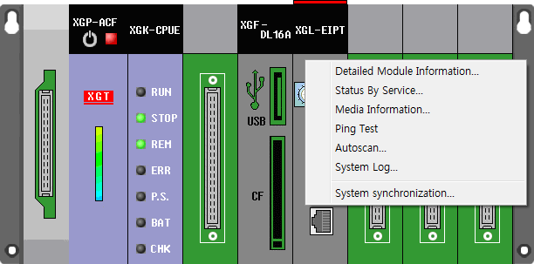

Chapter 5 Installation of Software and Communication Parameters
5-22

6-1

Chapter 6 EIP Service

Chapter 6 EIP Service
6.1 EtherNet/IP Communication Method

The communicant method of EtherNet/IP is divided into Implicit Communication Method and Explicit Communication Method and each method is again divided into client and server function. In XGT EtherNet/IP IF module, Implicit communication method is provided by periodic client /periodic server and explicit communication method is provided by aperiodic client/aperiodic server.
The periodic client/server is similar to the high speed link of the existing XGT communication service, which is the service used when data is transmitted and received periodically. The aperiodic /server method is the communication method used when particular events happen. In XGT EtherNet/IP I/F module these two services are incorporated into EIP service and provided.

EtherNet/IP Terms
      - Implicit Messaging: Suggestive message, the message where the information has been implicated to the minimum other than data (In XGT EtherNet/IP I/F module the message is provided via client /periodic server communication)
      - Explicit Messaging: Clear message, including all information that can translate frames other than data
(In XGT EtherNet/IP I/F module the message is provided via aperiodic client communication)
      - Client: The subject requiring information
      - Server: The subject that provides information at request
      - Producer: The entity that create producers, information
      - Consumer: The entity that receives consumer information and consumes it
      - Tag: Nameplate , Named Variable
      - EDS File: The abbreviation for Electric Data Sheets. The file where the information on the device and on the communication set –up is recorded
      - RPI: The abbreviation for Requested Packet Interval, meaning the period when Packet will be sent (In XGT EtherNet/IP I/F module, packet is provided at transmission period)

EDS File
Electrical Description Script (EDS) File is a description on devices and it includes the information about a product type and connection, as well as Vendor ID. In EtherNet/IP I/F module it is the basic principle to set up using EDS File. To install RDS Fie, EDS register menu of XG-PD should be set up.

Chapter 6 EIP Service
6-2

Periodic Communication (Implicit) System
Implicit Message provided in periodic communication in XGT EtherNet/IP I/F module means a suggestive and implied message. As this message contains header information to the minimum except for the data in frame, it also refers to the message which is impossible to see what data means. In addition, if we translate it in different way, this message means that header information is small in quantity, so the process of translating the frame has been simplified and it is possible to process data quickly. In EtherNet/IP, connection between client and server is set up with the parameter for sending this data.
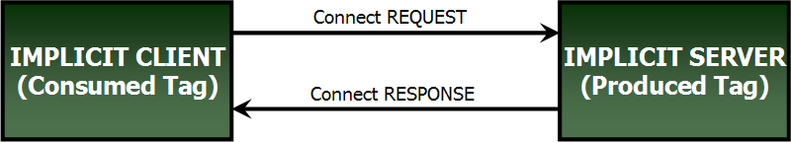
Client requires connection and it becomes the object that receives and consumes data, and sever comes to transmit the said data in transmission period (Requested Packet Interval: RPI) like the way client wants. Thus, client comes to set up consumed tag and server will set up produced tag (XGT EtherNet/IP IF: Input Only Type).

[Illustration 5.1] Client and Server in XGT EtherNet/IP I/F - Module Periodic Communication

Notice
Implicit Server is created also in Implicit Client. Server can set up timeout in the period that client grants according to types. Using data that client provides, it is possible to output to his own module .

6-3

Chapter 6 EIP Service

Aperiodic Communication (Explicit) System
Explicit Message provided in aperiodic communication from XGT EtherNet/IP I/F module means clear and explicit message. This message also means that all information which is possible to translate data to date frame. Thus, even though it takes some time to translate frame, if the message we want is sent without the process of setting parameter, frame is translated from server and the response is made.
In general it is utilized as monitoring data to aperiodic data rather than control data.
The following table shows the parameter items set up when XGT EtherNet/IP I/f module is used.

Parame ter | Inferior Configuration | Set-up Items | Set-up Scope | Set-up or Not |  |  | Remarks
 |  |  |  | Periodic  Client | Periodic  Server | Aperiodic  Client | Remarks
EIP | EIP  Configuration |  |  | o | x | x | Drag & drop from EDS File
EIP | EIP Channel |  | 0-63 | x | o | o | Set up other’s IP
EIP | EIP Block | Channel | 0-63 | o | o | o | Enter the channel you will use of set up  channels in EIP channel
EIP | EIP Block | Operation  Mode | Pursuant to  EIP Channel | o | o | o | Automatically displayed in accordance  with set up channels
EIP | EIP Block | I/O Type | Defined in  EDS | o | x | x | Select I/O type defined in EDS
EIP | EIP Block | Connection  Type | Multicast,  Point to Point | o | x | x | Select one among connection types  defined in EDS
EIP | EIP Block | Function | Write, Read, Tag Read,  Tag Write | x | x | o | Select one among aperiodic clients
EIP | EIP Block | Parameter | Defined in EDS | o | x | o | Set up the parameter defined in EDS  - In case of aperiodic client, only read/write can be set up for read /write
EIP | EIP Block | Parameter  Contents | Defined in  EDS | x | x |  | Display the contents set up in the  Parameter
EIP | EIP Block | Mobile  Conditions | Special Flag,  Contact Point | x | x | o | Set up mobile conditions
EIP | EIP Block | Transmitting  Period | 20-10000 | o | x | X | Period transmitting data
EIP | EIP Block | Timeout | 0-7 | o | x | X | Transmission Period – Timeout(0-7)
EIP | EIP Block | Data Type | BIT,1/2/4/8  BYTE | o | o | o | Set up a data type
EIP | EIP Block | Tag Set- up/  Local Tag | XGT PLC  Device | o | o | O | The device area of the local axis where  “Write” or “Read” is executed you will
EIP | EIP Block | Tag Set- up/ Remote Tag | TAG | o | x | o | Designate Other’s TAG(Maximum 40 letters)  In case remote station is XGT PLC, it is  set up as “% + Device Name” (Ex.% MW200)
EIP | EIP Block | Tag Set- up/Size |  | o | o | O | Periodic Client/Server : Maximum 500 Byte  Aperiodic Client : Maximum 1400 Byte

Chapter 6 EIP Service
6-4

6.2 EIP Service

EtherNet/IP is divided into a periodic message service (Implicit Service), and an aperiodic message service (Explicit Service). In XGL-EIPT module these two services are incorporated to be provided as periodic/client server and aperiodic client.
In Periodic Client / Server Service the tag for communication must be set up in parameter system. Thus, client and server tag must be shared with information for communication when parameter is exchanged. In XGT EhterNet/IP I/F module, client and server must be set up with XG5000. Make sure client is set up in periodic client and sever is set up with periodic server. For the detail contents, see 6.3.
Aperiodic client service must be communicated after you put the tag to be communicated and communication set-up. Thus, when required from client, server receives al information in frame and translates, and responds. In other words, it is the service without setting up from server side.

In this part, EIP types and use methods provided to a user are described. The flowing refers to the order for making up the program using EIP.
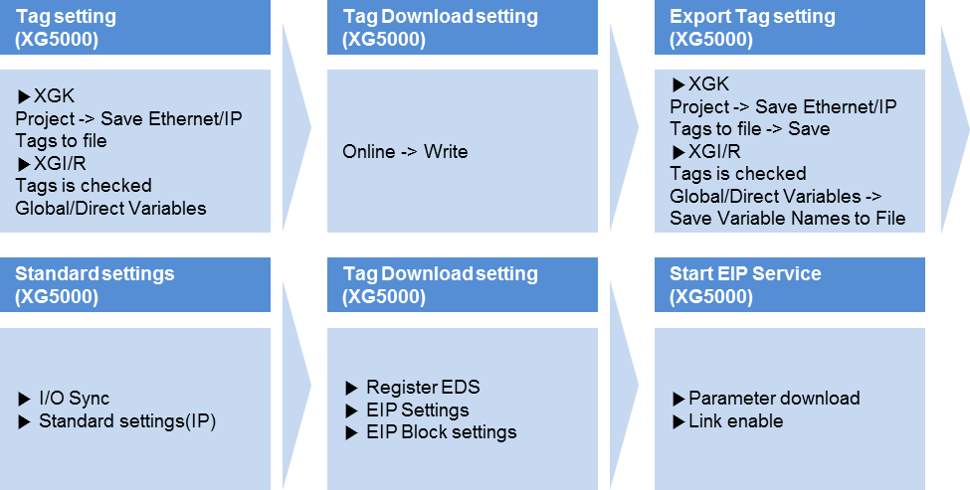

6-5

Chapter 6 EIP Service
6.3 Tag setup

- XGK
For XGK CPU, you can set up the tag in “EtherNet/Export IP tag” of the project menu. After setting, it is saved as file(.csv) and imports the set file in XG-PD for edition. For more details, refer to the below setup procedures.
Order | Set-up  Procedure | How to Set up
1 | Set up XG-5000 EtherNet/IP variable | 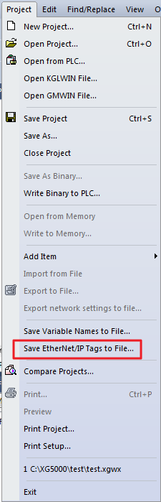  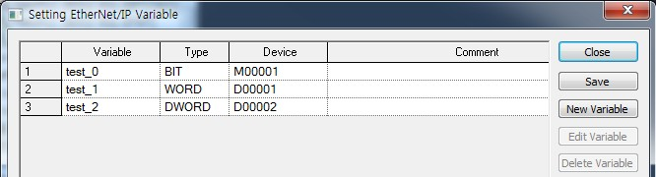  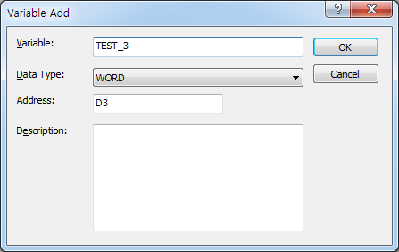
1 | - Select Project -> EtherNet/Export IP tag.  - Set up the EtherNet/IP variable by adding variables.  - Saved the set variables.

Chapter 6 EIP Service
6-6

- XGI/R
When you apply XGI/R CPU, you can set up tags in the “global/direct variable” of XG5000 project and tick the checkbox of EIP for setup. For more details, refer to the below setup procedures.
Order | Set-up  Procedure | How to Set up
1 | Declare XG- 5000  global variable | 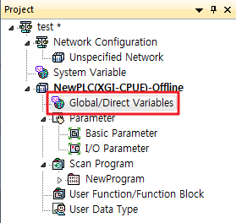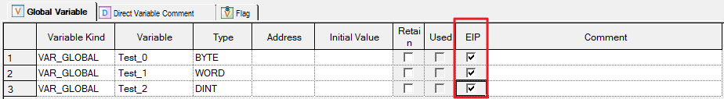  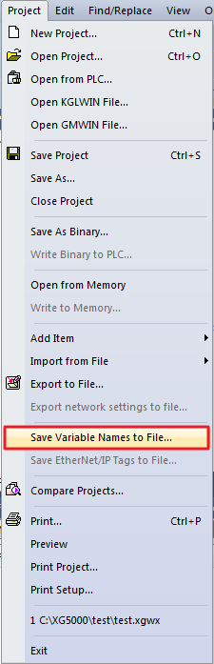
1 | - Declare the variable to be used as tag in XG5000.  - Tick the EIP Check Box to be used in EtherNet/IP.  - Save it as the ‘Project -> variable/ descriptive file’.

6-7

Chapter 6 EIP Service

6.4 Setup of Periodic/Non-periodic Communication Service

    - Periodic client communication service
After setting the communication modules and basic parameters with XG5000, use the mouse to drag the EDS file of the opposing station to be communicated and start setup.

      - Basic parameters setup and EDS registration
Order | Set – up  Procedure |  | How to Set up
1 | Setup of communication module |  | 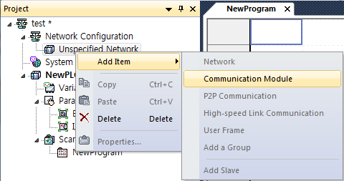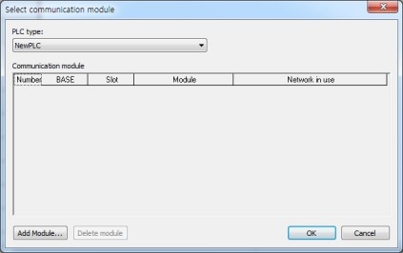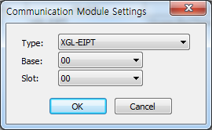
1 | - Click the desired base with the right mouse button to select the EtherNet/IP I/F module.  - Double-click the communication module to set up the basic parameters.
2 | Registration of EDS file | 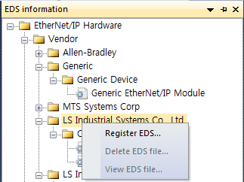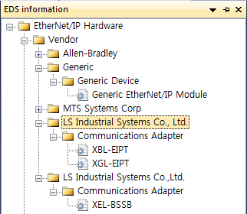
2 | - Register the EDS file of the targeted communication module.  - Click ‘XG5000 -> EDS information window’  - After completing the above procedures, you can see the registered EDS file in the EDS file information window.

Chapter 6 EIP Service
6-8

Order | Set-up  Procedure | How to Set up
3 | EIP service registration | 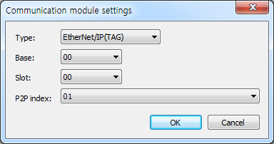  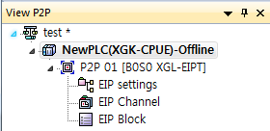
3 | Double-click the P2P(EIP)in the window for setting up P2P(EIP) and enter the module and slot number.

6-9

Chapter 6 EIP Service

      - EIP Configuration and parameters setting
Order | Set-up  Procedure | How to Set up
1 | EIP  Configuration | 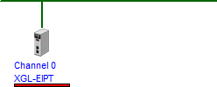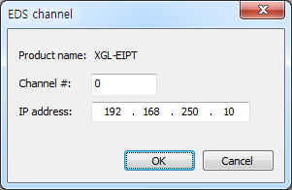
1 | - Drag the registered EDS file from the EDS information window and paste it to the EIP configuration window.  - The channel setup window will be displayed at the same time as pasting.  - Set up the channel number and ID address in the setup window.
2 | Confirm EIP channel information | 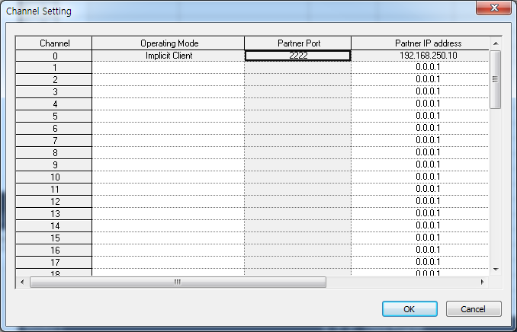
2 | - Drag the registered EDS file from the EDS information window and paste it to the EIP configuration window.  - The channel setup window will be displayed at the same time as pasting.  - Set up the channel number and ID address in the setup window.

Chapter 6 EIP Service
6-10

Order | Set-up  Procedure | How to Set up
3 | EIP  Block Set-up
3 | - Channel: Drag the EDS file to display the set channel. If several channels are set, a user can select the desired channel number to configure the block.  - Operation mode: It is displayed depending on the set channel; displayed as periodic client, non-periodic client and periodic server.  - I/O type: Indicates the name of the connection defined in the EDS file of the relevant device. The communication with the server side will be opened based on the connection method set here.  - Access mode: Sets up how to communicate with the server. The information supported depending on the module is recorded in EDS and MULTICAST, Point To Point(UNICAST) may be available.  - Parameters: Means the parameters of the server side that should be set by a user. For more details on parameters, refer to the server manual.  ▶When selecting Read Only(ID):  - T2O Tag Size : Data size to be read from the server side  - Input Assembly Instance(8bit) : Block number of the server to be read  ▶When selecting Read Only(Tag):  (1) T2O Tag Size : Data size to be read from the server side  - Details of parameters: Displays the details of the set parameters.  - Transmission cycle (ms): Means the transmission cycle of the data and the setting range is 20~10000 ms.  - Time-out: Set the value of the integer multiple of the time set as the transmission cycle(ms) and set the time to report error when the frame does not exist within the set time. The setting range is transmission cycle ×0~7.  - Data type : Indicates the data type.  - local tag : Set the area to read or write local data.  Select the variable imported from XG-PD by double-clicking or input the variable that you know for setting.  - Remote tag : Input the set Producer Tag to the opposing station for the period communication.

Chapter 6 EIP Service
6-11

Order | Set-up  Procedure | How to Set up
 | Write | 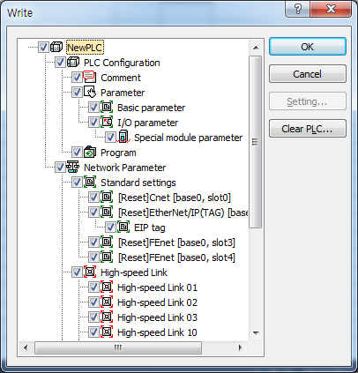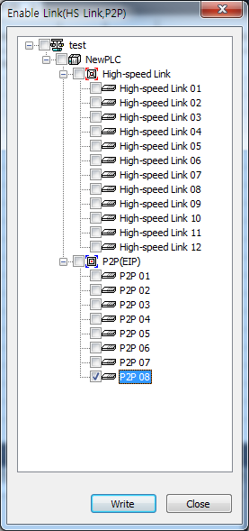
 | parameters
 | and
 | Link Enable
4
 | 1) After clicking ‘Online → Write’, check the set P2P(EIP) and click ‘OK’.
 | 2) After clicking ‘Online → Communication module setting → Link Enable’, check the P2P(EIP) and click ‘Write’.
 | 3) If you do not check Link Enable, the set EIP will not be operated.

Chapter 6 EIP Service
6-12

* Enable Link through flag
It describes “Enable Link” method through flag. The following XG5000 version, CPU OS version is needed.

Item | Version
XG5000 | V3.61 or above
XGR CPU | V1.91 or above
XGI CPU | V3.4 or above
XGK CPU | V3.7 or above

Flag list related with “Enable Link”
-XGR
Flag | Data type | Device | Description
_HS_ENABLE_STATE | ARRAY[0..11] OF BOOL | %FX19040 | HS link enable/disable current state
_HS_REQ | ARRAY[0..11] OF BOOL | %FX31520 | HS link enable/disable request
_HS_REQ_NUM | ARRAY[0..11] OF BOOL | %FX31536 | HS link enable/disable setting
_P2P_ENABLE_STATE | ARRAY[0..7] OF BOOL | %FX19072 | P2P enable/disable current state
_P2P_REQ | ARRAY[0..7] OF BOOL | %FX31552 | P2P enable/disable request
_P2P_REQ_NUM | ARRAY[0..7] OF BOOL | %FX31568 | P2P enable/disable setting

-XGI
Flag | Data type | Device | Description
_HS_ENABLE_STATE | ARRAY[0..11] OF BOOL | %FX15840 | HS link enable/disable current state
_HS_REQ | ARRAY[0..11] OF BOOL | %FX16480 | HS link enable/disable request
_HS_REQ_NUM | ARRAY[0..11] OF BOOL | %FX16496 | HS link enable/disable setting
_P2P_ENABLE_STATE | ARRAY[0..7] OF BOOL | %FX15872 | P2P enable/disable current state
_P2P_REQ | ARRAY[0..7] OF BOOL | %FX16512 | P2P enable/disable request
_P2P_REQ_NUM | ARRAY[0..7] OF BOOL | %FX16528 | P2P enable/disable setting

-XGK
Flag | Data type | Device | Description
_HS1_ENABLE_STATE | BIT | F09600 | HS link 1 enable/disable current state
_HS2_ENABLE_STATE | BIT | F09601 | HS link 2 enable/disable current state
_HS3_ENABLE_STATE | BIT | F09602 | HS link 3 enable/disable current state
_HS4_ENABLE_STATE | BIT | F09603 | HS link 4 enable/disable current state
_HS5_ENABLE_STATE | BIT | F09604 | HS link 5 enable/disable current state
_HS6_ENABLE_STATE | BIT | F09605 | HS link 6 enable/disable current state
_HS7_ENABLE_STATE | BIT | F09606 | HS link 7 enable/disable current state
_HS8_ENABLE_STATE | BIT | F09607 | HS link 8 enable/disable current state
_HS9_ENABLE_STATE | BIT | F09608 | HS link 9 enable/disable current state
_HS10_ENABLE_STATE | BIT | F09609 | HS link 10 enable/disable current state
_HS11_ENABLE_STATE | BIT | F0960A | HS link 11 enable/disable current state
_HS12_ENABLE_STATE | BIT | F0960B | HS link 12 enable/disable current state
_HS1_REQ | BIT | F10300 | HS link 1 enable/disable request
_HS2_REQ | BIT | F10301 | HS link 2 enable/disable request
_HS3_REQ | BIT | F10302 | HS link 3 enable/disable request
_HS4_REQ | BIT | F10303 | HS link 4 enable/disable request
_HS5_REQ | BIT | F10304 | HS link 5 enable/disable request
_HS6_REQ | BIT | F10305 | HS link 6 enable/disable request
_HS7_REQ | BIT | F10306 | HS link 7 enable/disable request
_HS8_REQ | BIT | F10307 | HS link 8 enable/disable request
_HS9_REQ | BIT | F10308 | HS link 9 enable/disable request

6-13

Chapter 6 EIP Service

Flag | Data type | Device | Description
_HS10_REQ | BIT | F10309 | HS link 10 enable/disable request
_HS11_REQ | BIT | F1030A | HS link 11 enable/disable request
_HS12_REQ | BIT | F1030B | HS link 12 enable/disable request
_HS1_REQ_NUM | BIT | F10310 | HS link 1 enable/disable setting
_HS2_REQ_NUM | BIT | F10311 | HS link 2 enable/disable setting
_HS3_REQ_NUM | BIT | F10312 | HS link 3 enable/disable setting
_HS4_REQ_NUM | BIT | F10313 | HS link 4 enable/disable setting
_HS5_REQ_NUM | BIT | F10314 | HS link 5 enable/disable setting
_HS6_REQ_NUM | BIT | F10315 | HS link 6 enable/disable setting
_HS7_REQ_NUM | BIT | F10316 | HS link 7 enable/disable setting
_HS8_REQ_NUM | BIT | F10317 | HS link 8 enable/disable setting
_HS9_REQ_NUM | BIT | F10318 | HS link 9 enable/disable setting
_HS10_REQ_NUM | BIT | F10319 | HS link 10 enable/disable setting
_HS11_REQ_NUM | BIT | F1031A | HS link 11 enable/disable setting
_HS12_REQ_NUM | BIT | F1031B | HS link 12 enable/disable setting
_P2P1_ENABLE_STATE | BIT | F09620 | P2P1 enable/disable current state
_P2P2_ENABLE_STATE | BIT | F09621 | P2P2 enable/disable current state
_P2P3_ENABLE_STATE | BIT | F09622 | P2P3 enable/disable current state
_P2P4_ENABLE_STATE | BIT | F09623 | P2P4 enable/disable current state
_P2P5_ENABLE_STATE | BIT | F09624 | P2P5 enable/disable current state
_P2P6_ENABLE_STATE | BIT | F09625 | P2P6 enable/disable current state
_P2P7_ENABLE_STATE | BIT | F09626 | P2P7 enable/disable current state
_P2P8_ENABLE_STATE | BIT | F09627 | P2P8 enable/disable current state
_P2P1_REQ | BIT | F10320 | P2P1 enable/disable request
_P2P2_REQ | BIT | F10321 | P2P2 enable/disable request
_P2P3_REQ | BIT | F10322 | P2P3 enable/disable request
_P2P4_REQ | BIT | F10323 | P2P4 enable/disable request
_P2P5_REQ | BIT | F10324 | P2P5 enable/disable request
_P2P6_REQ | BIT | F10325 | P2P6 enable/disable request
_P2P7_REQ | BIT | F10326 | P2P7 enable/disable request
_P2P8_REQ | BIT | F10327 | P2P8 enable/disable request
_P2P1_REQ_NUM | BIT | F10330 | P2P1 enable/disable setting
_P2P2_REQ_NUM | BIT | F10331 | P2P2 enable/disable setting
_P2P3_REQ_NUM | BIT | F10332 | P2P3 enable/disable setting
_P2P4_REQ_NUM | BIT | F10333 | P2P4 enable/disable setting
_P2P5_REQ_NUM | BIT | F10334 | P2P5 enable/disable setting
_P2P6_REQ_NUM | BIT | F10335 | P2P6 enable/disable setting
_P2P7_REQ_NUM | BIT | F10336 | P2P7 enable/disable setting
_P2P8_REQ_NUM | BIT | F10337 | P2P8 enable/disable setting

- How to enable link
-HS link/P2P enable/disable setting flag ON → HS link/P2P enable/disable request flag ON
- How to disable link
-HS link/P2P enable/disable setting flag OFF → HS link/P2P enable/disable request flag ON
- You can monitor the Enable/Disable state of the each link through “enable/disable current states” flag.

Chapter 6 EIP Service
6-14

Setup of Non-periodic Client Communication Service
The non-periodic communication is the service to read or write the opposing tag data. It can be used similarly to XGT’s P2P service and you can use it by setting the opposing tag data without setting EDS.

      - Basic Parameter Setup and EIP Service Registration
Order | Set-up  Procedure | How to Set up
1 | Communication module setup | 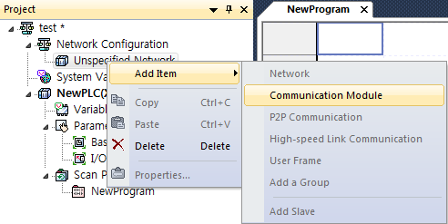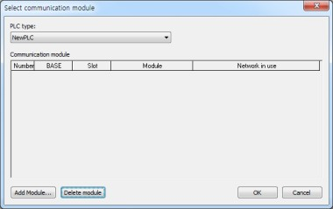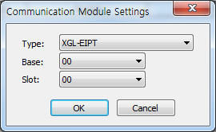
1 | - Click the desired base with the right mouse button to select EtherNet/IP I/F module.  - Double-click the communication module to set up the basic parameters.
2 | EIP service registration | 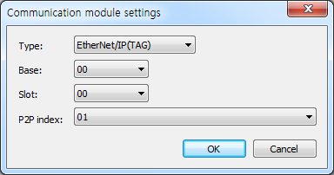  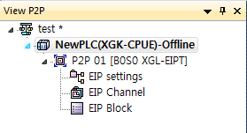
2 | Double click the P2P(EIP) of the P2P(EIP) setup window and then, enter the module and slot number.

6-15

Chapter 6 EIP Service

      - EIP Configuration and parameters setting
Order | Set-up  Procedure | Hot to Set up
1 | EIP Channel Information Check-out | 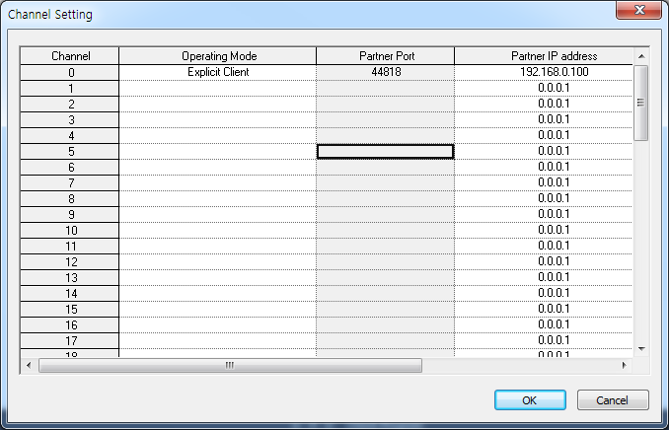
1 | - After double-clicking the EIP channel, set the operation mode as the non-periodic client.  - Input the IP address of the opposing station.
2 | Block Set-up | - Example of Tag Read  - Example of Read  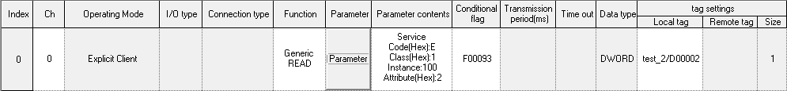  - Example of Parameter Set-up  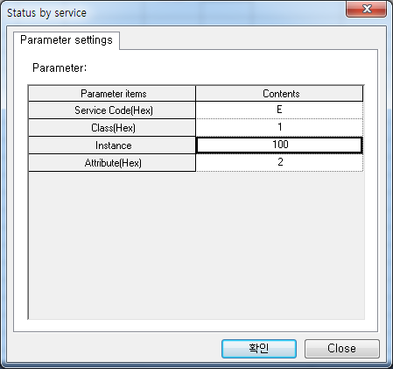
2 | - Channel: Selects and uses one among the channels set as non-periodic client.  - Operation mode: Displays the operation mode depending on the set channel.  - Functions: There are ‘Read Tag’command that reads and saves the tag data from the server; ‘Write Tag’ command that saves the data to the server; ‘Read/Write’ that inputs directly the parameters not tag.  - Parameters : Can be set only when setting ‘Read/Write’ in Functions.  - Service Code(Hex) : Input the service code to be used. (Ex.: 0E : Get ,10 : Set)  - Class(Hex) : Input the Class to set parameters.  - Instance(Hex) : Input the instance to set parameters.  - Attribute(Hex) : Input the Attribute to set parameters.  - Operation conditions : Sets the operation conditions to send messages.  - Data type : If you select the local tag, the data type of the selected tag will be displayed.  - Tag setup: Set up the client’s (own) tag in the local tag, server’s tag in the remote tag and then, fix the size.  - Size: Sets up the size depending on the data type.

Chapter 6 EIP Service
6-16

Periodic Server Communication Service
For the periodic communication using EtherNet/IP I/F module, even in case of the module operated by the server, you need to set up the tag size, address.

      - Basic Parameter Set-up and EIP Service Registry
Order | Set-up  Procedure | How to Set up
1 | Communication module setup
1 | - Click the desired base with the right mouse button to select EtherNet/IP I/F module.  - Double-click the communication module to set up the basic parameters.
2 | EIP service registration
2 | Double click the P2P(EIP) of the P2P(EIP) setup window and then, enter the module and slot number.

6-17

Chapter 6 EIP Service

      - EIP Channel and Parameter Set-up
Order | Set - up  Procedure | How to Set up
1 | EIP channel Information check | 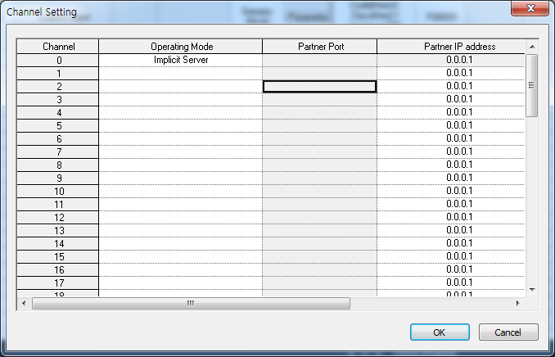
1 | - After double-clicking EIP channel, set the operation mode as the periodic server.  - The module for which the basic parameters are set is operated as the periodic server so you do not need to input the IP address of the opposing station.
2 | Block Set-up
2 | - Channel : Select and use the one among the channels where periodic servers have been set up  - Operating Mode: The operation mode of the channel set up according to the channel set-up is displayed.  - Date Type: Enter the data type of the tag that you will set up.  - Local Tag: This tag is the device area of the module operating via server.  - Size: The data size of the module operating via server.

Chapter 6 EIP Service
6-18

6.5 Start of Operation

The operation of the XGT EtherNet/IP I/F module is largely divided into periodic communication service and aperiodic communication service.
For set - up contents, refer to 5.3 and 5.4.

6.5.1 XG5000 Set-up

Order | Set-up  Procedure | How to Set up
1 | Connection Set-up | 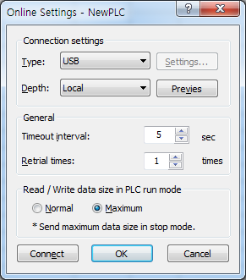
1 | - Online → Select Connection setting or Click Icon ().  - After setting up the connection option suitable for a use’s environment, click “Connection.”
2 | Read I/O Information | Select Online → Read or click icon (), and read the information loaded in the module
3 | Enable Link
3 | - Online → Communication module setting → Link Enable or click icon ( ).  - Check out EIP where set-up has been completed and click “Write”

Chapter 6 EIP Service
6-19

Order | Set-up  Procedure | How to Set up
3 | Operation Check-out | 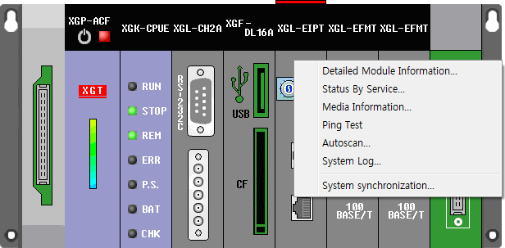
3 | - Select Online → Communication module setting → System Diagnosis or click icon ().  - After clicking the module, press the right side of the mouse, then it is possible to check out whether communication has been successfully done by clicking frame monitoring or the state by services.  * For the details on system diagnosis, refer to Diagnosis Function Chapter 7.

Chapter 6 EIP Service
6-20

6.6 Examples

6.6.1 Communication with Rockwell 1756-ENBT Communication Module
- System Configuration
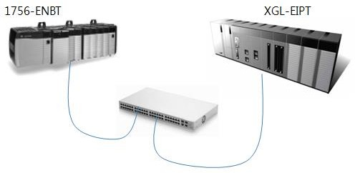

Segment | 1756-ENBT | XGL-EIPT
IP Address | 192.168.250.41 | 192.168.250.52

- Setup of 1756-ENBT Consumer, XGL-EIPT Producer
- setup of XGT Ethernet/IP I/F module parameter

XGT is used as producer so refer to the details of the above 6.3.3 to set it as periodic server.

Order | Set-up  Procedure | How to Set up
1 | Tag setup | 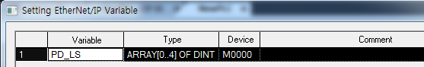
2 | Block setup
2 | - Channel: Selects one among the channels set as periodic server.  - Operation mode: Displays the operation mode depending on the set channel.  - Data type: Shows the data type of the set tag.  - Local tag: Selects the tag operated by tag.  - Size: Shows the size of the selected tag.

6-21

Chapter 6 EIP Service

- Rockwell 1756-ENBT Communication Module and Communication Set-up Set up Rockwell’s Client using Rockwell’s S/W(RSLogix 5000).
Order | Set-up  Procedure | How to Set up
1 | Module Set - up | 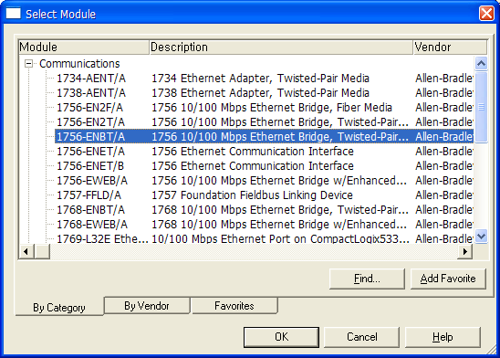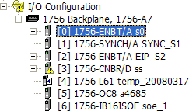
1 | Search for the module in I/O Configuration and install it
2 | Network Module Installation | 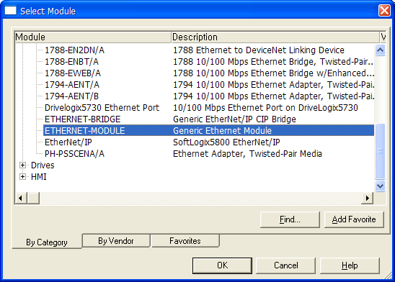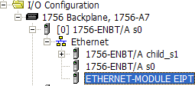
2 | - If ENBT Module has been installed, extend it into network and install the module of the network connected.  - Herein, the installation of Rockwell’s module only is available, and modules, not Rockwell’s one, are possible to set up, using Generic Device.  - For the connection of XGT EtherNet/IP I/F Module, set up Generic Device.

Chapter 6 EIP Service
6-22

Order | Set-up  Procedure | How to Set up
3 | Network Address and Connection Information Input | 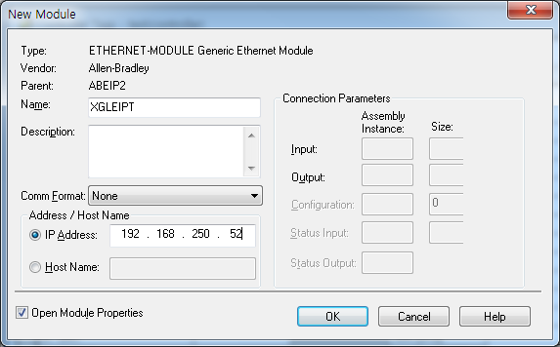
3 | - Name: Input the name to be used for the module.  - IP Address: Input XGL-EIPT module’s IP.  - Comm Format: Input None.
4 | Consumer tag setup | 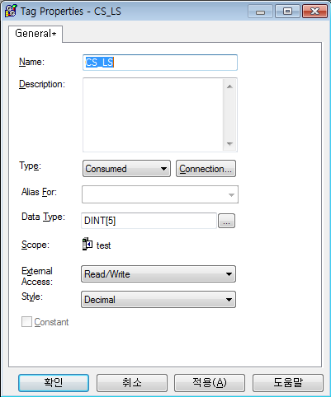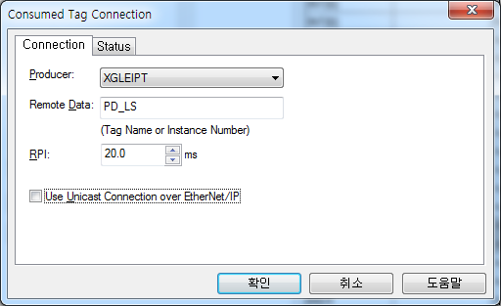
4 | - Name: Input the name of the consumer tag.  - Data Type: Input the data type to be communicated.  - Connection: Input the producer tag to be connected with the consumed tag.  - RPI: Input the transmission cycle that the producer will receive.

6-23

Chapter 6 EIP Service

- Setup of 1756-ENBT Producer, XGL-EIPT Consumer
XGT is used as the producer so refer to the details of the above 6.3.1. Periodic Client Setup.
Order | Set-up  Procedure | How to Set up
1 | Set up channel with Generic EDS | 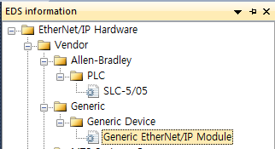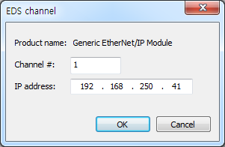
1 | - Select the Generic EtherNet/IP Module in the EDS information window and drag it to the EIP configuration window.  - IP Address: Input the IP of 1756-ENBT module.
2 | Block setup
2 | - I/O type: Select 6. Input Only(Tag Type).  - Parameter: Input the size of the consumer tag. The size is the number of data types.  - Local tag: Select the consumer tag to be communicated with the producer.

Chapter 6 EIP Service
6-24

- Rockwell 1756-ENBT Communication setup

You can set up the producer of Rockwell by using Rockwell’s S/W(RSLogix 5000).
If the procedures 1) ~ 3) of the above consumer setup have already established, you only need to set up the producer tag.

Order | Set-up  Procedure | How to Set up
1 | Producer tag setup | 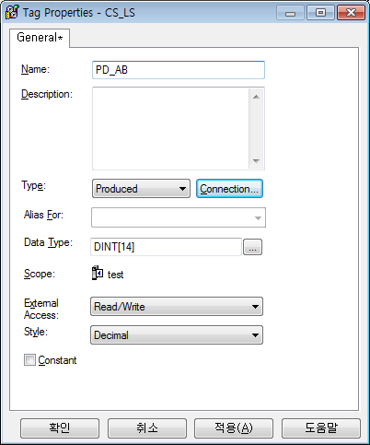
1 | - Name: You can input the name of the producer tag.  - Data Type: You can input the data type to be communicated.

7-1

Chapter 7 Diagnosis

Chapter 7 Diagnosis

This chapter describes how to check out systems and modules, how to check out network state, and how to download 0/S. When checking out states of system configuration and EtherNet/IP I/F Module, a user should review the following procedure.
7.1 System Diagnosis

This diagnosis is the method to check out the state of EtherNet/IP I/F Module and systems. If click ‘Online’ → ‘Communication module setting’ → ‘System Diagnosis’ after clicking ‘Online’ → ‘Connection’ on XG5000, the system diagnosis screen is open as seen in [Figure 7.1.1] and Module Information Window is open in system diagnosis below as seen in [Figure 7.1.2].
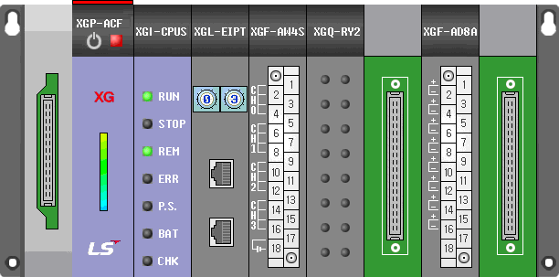
[Figure 7.1.1] System Diagnosis Screen
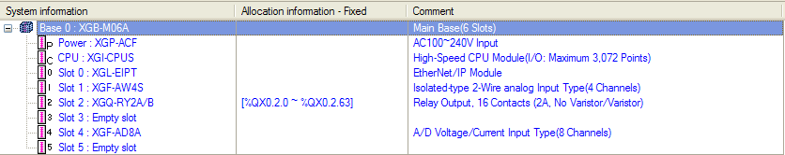
[Figure 7.1.2] Module Information Window

When Extension Base has been connected, if a user clicks the extension base on module information window to open System Diagnosis Screen, the system diagnosis screen of the extension base appears. The above [Figure 7.1.1] and [Figure 7.1.2] show the main base system diagnosis screen of the system composed of the main base and the extension base. If a user clicks the base 1 in [Figure 7.1.2] to see the system diagnosis screen of the extension base in the above Figure, he can see the extension base diagnosis screen in Figure [7.1.3].

Chapter 7 Diagnosis
7-2

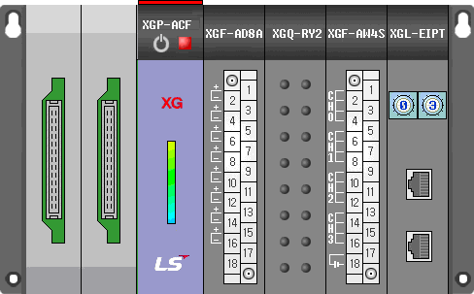
[Figure 7.1.3] Extension Base System Diagnosis Screen

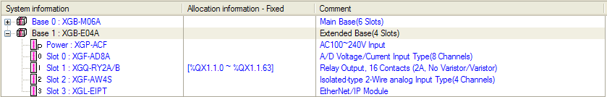

[Figure 7.1.4] Extension Base Module - Information Window

7-3

Chapter 7 Diagnosis

7.2 System Diagnosis Items and Contents

This part describes the diagnosis items and contents of EtherNet/IP I/F Module provided from XG5000.
Order | Diagnosis Items | How to Set up and Contents
1 | System Diagnosis | 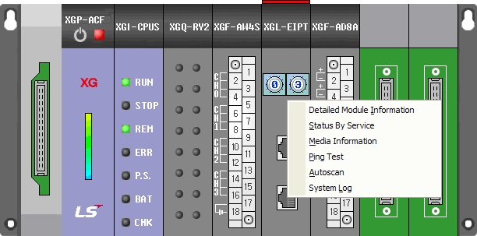
1 | - Select ‘Connection’ → ‘Online’ → ‘Communication module setting’ → ‘System Diagnosis’  - Put the mouse on XGL-EIPT and click it with the right side of the mouse to check out the diagnosis information of EtnerNet/IP I/F Module a user wants.
2 | Communication Module Information | 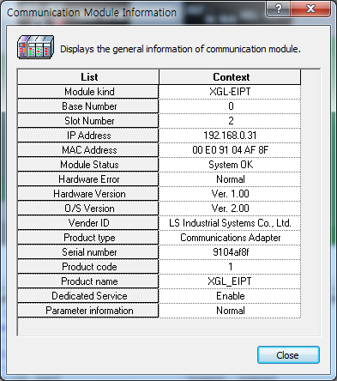
2 | The general information of EtherNet/IP I/F Module is displayed.  - Module Kind: Displays kinds of modules (XGL-EIPT).  - Base No. : Displays the base location of the module installed.  - Slot No.: Displays the slot location of the module located.  - IP Address: Displays IP address set up in module.  - MAC Address: Displays MAC address set up in the modules.  - Module Status: Displays the state of the module.  - Hardware Error: Displays whether the error of the hardware has been made or not.  - Hardware Version: Displays the version of the hardware.  - OS Version: Displays the version of module OS.  - Vender ID: Vendor ID of Displays EtherNet/IP Module  - Product Type: Displays the Product Type of Ethernet/IP  - Serial No.: Displays the serial no. of the module.  - Product Code: Displays the code No. of the module  - Product Name : Displays the name of the module  - Dedicated service: Displays when operation channel exists as aperiodic server  - System parameter information: Displays basic parameter setting status

Chapter 7 Diagnosis
7-4

Order | Diagnosis Items | How to Set up and Contents
3 | State by Services EIP Service | 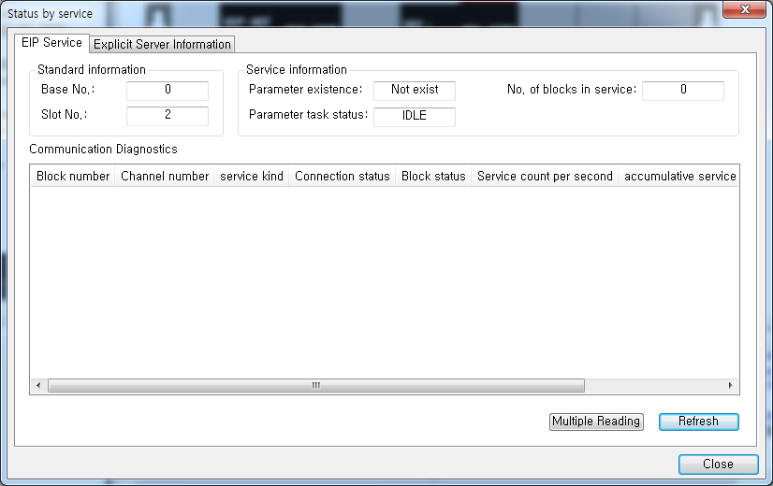
3 | 1) Specific Flag Information Window  - Block No. : Displays the index of the parameter that a user set up with EIP Service.  - Channel No.: Displays the number of the channel that a user set up in each block.  - Service Kind: Displays the type of the service that a user set up : Implicit Client / Implicit Server / Explicit Client  - Connection Status: Displays whether EIP Block has been connected or not.  ▶CONNECT: State that connection has been completed  ▶IDLE: State that connection has not been completed  - Block Status: Displays the block state of EIP Block  ▶NONEXIST: State that the set-up of connection has not been done  ▶REGSESSION: State that TCP Connection has been completed and EtherNet/IP Connection is in the process of being set up  ▶READY: State that communication is available  ▶BUSY: State that response on required frame has not been received yet  - Service Count per Second: Displays how many times the service has been carried out per 1 second.  - Accumulative Service Count : Displays the number of services till now  - Accumulative Error Count : Displays the number of errors till now

Chapter 7 Diagnosis
7-5

Order | Diagnosis Items | How to Set up and Contents
4 | State by Services  Explicit Server Information | 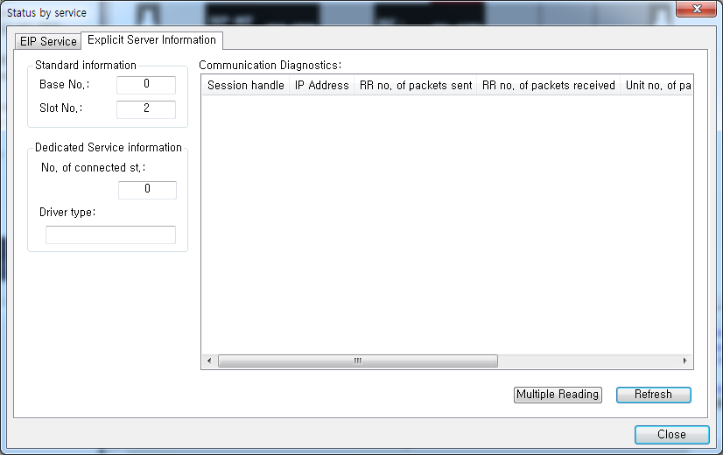
4 | - Session Handle : The original number granted to connected client  - IP Address : IP Address of connected client  - The Number of RR packets sent: The Number of Transmission Packets of the Message in the form of Request/Reply  - The Number of RR Packets received: The Number of Reception Packets of the Message in the form of Request/Reply  - The Number of Unit Packets sent: The Number of Transmission Packets of the Message used after connection set-up  - The Number of Unit Packets received: The Number of Reception Packets of the Message used after connection set-up  - The Number of Error Packets : The Number of Error Packets coming into Server
5 | Media Information | 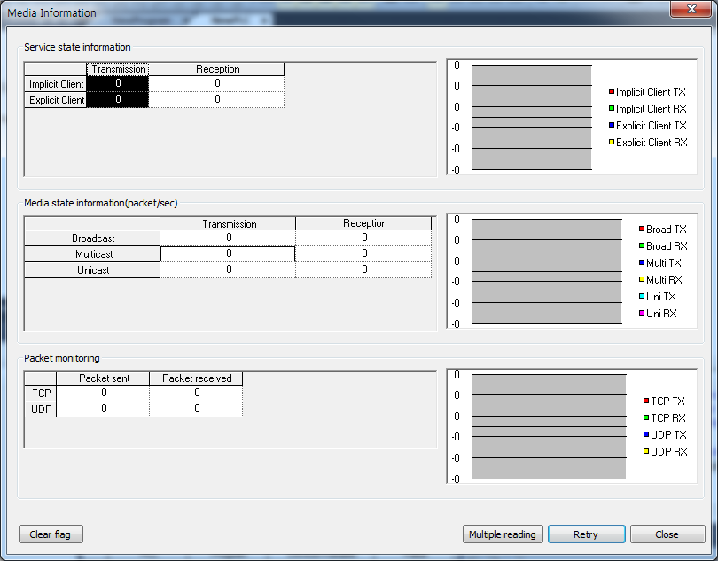
5 | - Service State Information: Displays the number of service completed in EtherNet/IP I/F Module.  - Media State Information: Displays the packet quantity per second in service type of EtherNet/IP I/F Module.  - Packet Monitoring

Chapter 7 Diagnosis
7-6

Order | Diagnosis Items | How to Set up and Contents
6 | Ping Test | 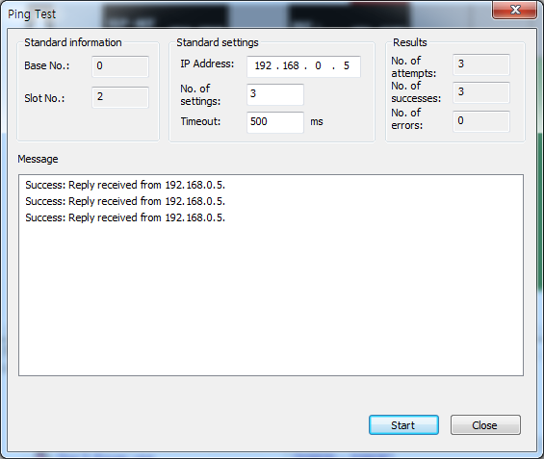
6 | It is possible to check out the operation state of an opponent country by entering an opponent country’s IP Address  In case of not receiving the signal from an opponent country, it is necessary to check out the basic set-up  information
7 | Auto Scan | 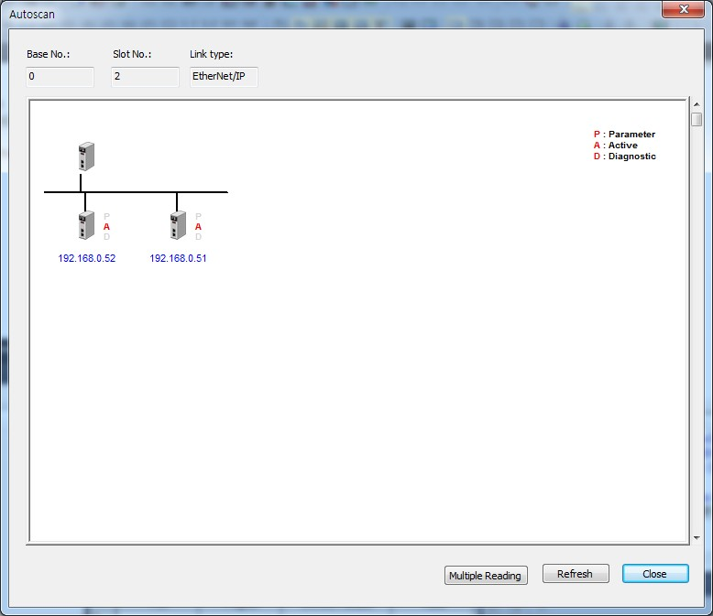
7 | A user can check out the system configuration state of the whole system.  - Parameter: In case EIP Parameter is set up, it is marked as P.’  ▶Active: The module operating normally (Online State) is marked as‘A.’  - Diagnostic: The module that diagnosis needs to be marked as ‘D.’

Chapter 7 Diagnosis
7-7

Order | Diagnosis Items | How to Set up and Contents
8 | System Log | 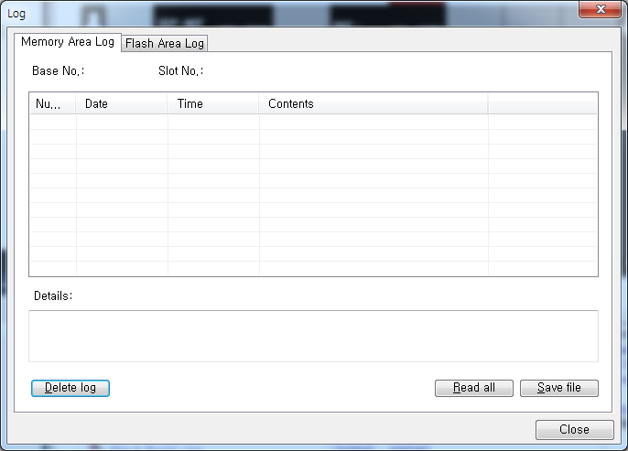
8 | In case a user cannot check out the performance of errors and services or stores the contents of the current memory area into flash, when pressing the Log switch, memory area log is automatically stored to flash.  - Memory Area Log: Displays the history when errors and the problems in service performance are made. In case of Memory Area Log, when the power is turned off, it automatically extinct.  - Flash Area Log: When a user presses the log switch on the module’s front side, the log of the memory area is stored into memory, and even if the power is turned off, the history can be maintained.

Chapter 7 Diagnosis
7-8

7.3 Troubleshooting

This part describes causes and actions on failures and errors that may happen in operating systems. When a user wants to check out errors and problems in EtherNet/IP I/F Module, the following procedure will help you check out those malfunctions. When judging whether the module is in abnormal state or not, make sure to take actions in order, using Troubleshooting. Do not repair and disassemble at your discretion.

Check-out through LED in Communication Module
This check-out is the way of checking out the state of the module to see whether it is defective or not.
      - Abnormal Operation Display
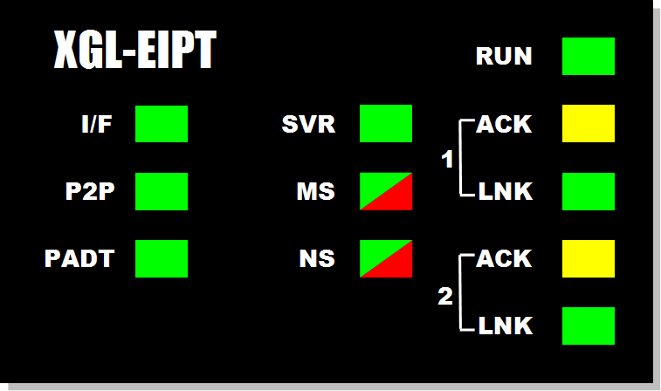
LED located on the front side of EtherNet/IP I/F Module enables a user to check out.
[Figure 7.3.1] LED of EtherNet/IP I/F Module

LED Contents | Error Contents | Actions
RUN | Light out after supplying the module power | 1) Check out whether EtherNet/IP Communication Modules has been properly installed or not  - Check out whether the DC 5V – supply power for power module has been normal or not.  - Check out whether the communication module has been properly installed to the base  2) Consult with Warranty Service Center
I/F | Operation stops when light is on and off | - Check out whether CPU and Communication Modules have been properly installed  - Consult with Warranty Service Center
P2P | Light is off during service for command languages | - Check out whether command language has been properly entered or not  - Check out connection has been properly done or not  - Check out whether Link Enable in Menu is on or not
PADT | Light is off during remote connection service | - Check out whether telephone office numbers for remote connection(PADT) have been properly set up or not  - Check out whether PADT Program – Remote Connection has been canceled
SVR | Light is off during server  operation | 1) Check out whether the connection with client has been properly done
MS | Red light is on and off | 1) Check out the basic set-up and supply power again
MS | Red light is on | - Supply power again  - Consult with Warranty Service Center

7-9

Chapter 7 Diagnosis

LED Contents | Error Contents | Actions
NS | Red light is on and off | 1)Check out the device where Timeout happened
NS | Red light is off | 1) Set up IP Address again (Find the same IP Address)
ACT | Light is off during normal  communication | - Check out the transmission or reception parameter  - Check out whether connection has been properly done
LNK | Light is off during normal  communication | - Check out whether cables have been properly connected ports  - Check out whether an opponent’s port is normally operating ha been

Check out of Module Errors through XG5000
It is possible to simply monitor errors of the module through XG5000 Program. After connecting RS-232C or USB Connector to CPU, check out online’ → ‘PLC History’, ‘PLC Error /Warning’in XG5000.
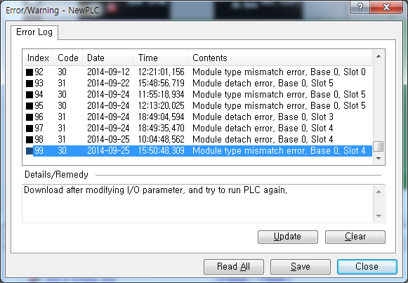

[Figure 7.3.2] PLC History - Specific Information Monitor

In case hard errors or CPU interface errors are made to the module, naturally LED abnormally operates, but it is possible to figure out this state, using exclusive programs.
[Figure 7.7.2] will help a user check out error/warning information through PLC history from [Online] of XG5000 and it is possible to solve problems by referring to “Details and Actions” contents.

Chapter 7 Diagnosis
7-10

Check-out on Module Errors through System Log

It is possible to monitor whether communication module has been malfunctioned through XG5000 Program. After connecting RS-232C or USB Connector to CPU Module, click EtherNet/IP I/F Module with the right side of the mouse on “Diagnosis Screen” in XG5000 and select “System Log,”and then Log Screen is open.

      - Memory Area Log
It is possible to check out whether errors have been made or services have been performed. [Figure 7.3.3] shows the memory area log screen of ‘System Log.’
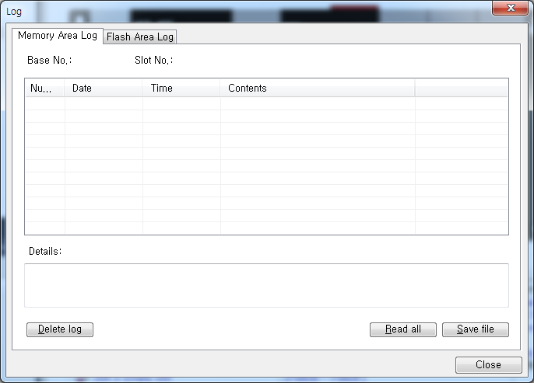

[Figure 7.3.3] Memory Log Area Screen of ‘System Log’

It is possible to check out the date, time, contents when events, such as error occurring or service performing, happened.

7-11

Chapter 7 Diagnosis

1) Flash Area Log
If it is impossible to check out errors or service performances through XG5000 or if a user wants to store the contents in current memory area into flash, when pressing Log Switch on the front side on EtherNet/IP I/F Module, memory area log is automatically stored to Flash.
[Figure 7.3.4] shows the flash area – log screen of ‘System Log.’
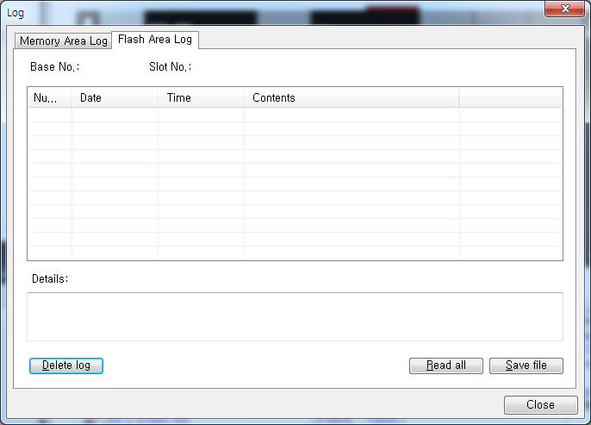

[Figure 7.3.4] Flash Area Log Screen of ‘System Log’

7.4 Remote Communication control

    - Introduction

This function is used for programming, downloading of user program, program debugging, monitoring, etc in network system where PLCs are connected with each other via Ethernet by remote control without moving the physical connection status of XG5000. It is especially convenient for easy access to each device from a place without repositioning when network-connected devices are separated far. XG5000 remote connection service is available under the following Logical Path to attain its purpose.

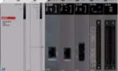PC PLC [1]
IP: 210.206.91.188

PLC [2]
IP: 210.206.91.189

PLC [n]
IP: 210.206.91.190

XG5000

USB or RS-232C

Local connection

Logical connection via Ethernet communication module (remote)

Chapter 7 Diagnosis
7-12
[Fig. 7.4.1] Ethernet network

A network is supposed where RS-232C cable is connected between PC in which XG5000 is installed and PLC #1 station, and PLC #1, PLC #2 and PLC #n are connected with each other via Ethernet in XG5000 of [Fig.7.4.1]. To access the contents of PLC #1 station in the figure above, Local connection is needed in XG5000’s on-line menu. After finishing accessing the contents of PLC #1, disconnect the Local connection with ‘Disconnect’ menu. To access the PLC #n station, select PLC #n by setting the IP address of PLC #n and Base and Slot No. where FEnet module is installed in the PLC #1 station in the remote connection dialog box and connect. Then logical connection between XG5000 and PLC #n will be established via RS-232C and Ethernet. This status is identical to the status that RS-232C cable is connected between PC and PLC #n station and it is available to execute all functions of programming, downloading, debugging and monitoring as in PLC #1.

Also, if Ethernet module (LAN Card) is installed on PC where XG5000 is installed and connected to the identical network to PLC, remote stage 1 connection with PLC is available via Ethernet without local connection via RS-232C.

With the remote connection service of XG5000, easy access to PLC is possible even if the PLC is located at a far place. And re- programming without repositioning the PLC is possible when PLC is located at a place hard to reach.

Decide a PLC connection stage of local, remote stage 1 or 2. Select remote stage 1 here.
7-13

Chapter 7 Diagnosis

    - Setting and Connection
All PLCs connected via XGT network are available to connect with each other by remote connection service. XG5000 remote connection is composed of stage 1 and stage 2 connections as described below.

The followings explains remote 1 and remote 2 connections.

PC PLC [2]
PLC [1]
IP: 192.168.91.188
IP: 192.168.91.189
FDEnet #1
PLC [n]
IP: 192.168.91.190
Remote stage1
XG5000
USB or RS-232C
Local connection
Logical connection via Ethernet module (remote 1)

Logical connection via Ethernet module (remote 2)
PLC [A]
IP:192.168.91.191
Remote stage2
PLC [B]
IP:192.168.91.192

Network 1

Network 2

[Fig. 7.4.2] Remote connection

[Fig. 7.4. 2] shows an example of network system composed of two networks.

Remote stage 1 connection (If RS-232C cable used)
For remote stage 1 connection, XG5000 shall be in off-line state. Click [Online] -> [Connection settings]
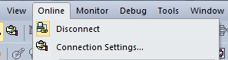
[Fig. 7.4.3] XG5000 remote connection option to select

        - Connection type
It designates the connecting method for local connection. Local connection is applied with RS-232C used as in [Fig. 7.4.3]. Select the port used in PC for a communication port. The case that Ethernet is used for local connection will be described in the next section. Refer to user’s manual of each communication module for the case with other connection types.

        - Connection depth

Chapter 7 Diagnosis
7-14

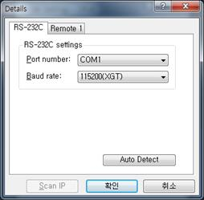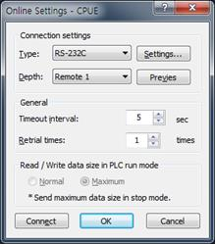

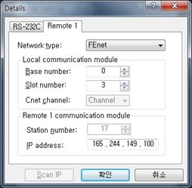

[Fig. 7.4.4] XG5000 remote stage 1 connection

        - Network type
Select a network type for stage 1 connection among Rnet, Fdnet, Cnet, FEnet and FDEnet. XGL-FEnet is to be selected because stage 1 connection is applied through FEnet in [Fig. 7.4.4].

        - Base No.
Specify the base No. where FEnet I/F module of PLC #1 for remote connection is installed.

7-15

Chapter 7 Diagnosis

        - IP address
Specify the IP address of FEnet I/F module installed in the PLC which will be connected with XG5000 in the network 1. Use the IP address of FEnet module installed in PLC #2 station, 192.168.91.189 in [Fig. 7.4.4].

        - Slot
It indicates the slot number where FEnet module is installed in locally connected PLC via RS-232C. Select No.0 in [Fig. 7.4.4] since FEnet installed on PLC #1 is on slot No.0.

Now click [OK] and then select [Connect] on the Online menu.
Since stage 1 connection-completed status is the logical connection status identical to the local connection with RS- 232C cable is connected to the PLC, where all of the on-line menus are available. (Except that CPU type between PLC and presently open project is disagreeable)

1) Precautions for remote connection
Prepare a program suitable for the correspondent CPU type to connect with remotely. If the CPU type is disagreeable between the two, limited functions only will be allowed, where program uploading/downloading and monitoring are not available.

Chapter 7 Diagnosis
7-16

Remote stage 2 connection (RS-232C cable is used for local connection)

For remote stage 2 connection, XG5000 shall be in off-line state. Click [Online] -> [Connection settings] like [fig.7.4.3]

- Connection type
Select Local connection. [Fig. 7.4.5] shows that select RS-232C for Type and Remote 2 for Depth. The communication port choose using PC port. If use Ethernet, explain it in the next chapter. If use other communication module, Please refer to manual each communication modules.

- Connection depth Select Reome 2
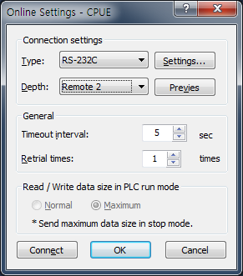
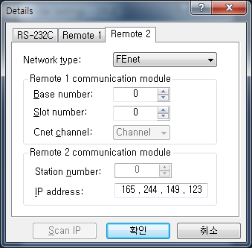
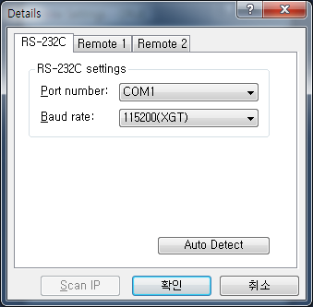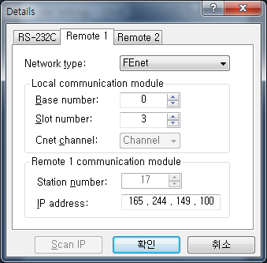

[Fig. 7.4.5] XG5000 remote stage 2 connection

7-17

Chapter 7 Diagnosis

Remote 2 only will be described below since the others are the same in the dialog box above.

- Setting of network type
Select a network type for remote stage 2 connection among XGT Rnet, Fdnet, Cnet, FEnet and FDEnet. Network types of stage 1 and stage 2 connections bear no relation to each other. XGL-FEnet is to be selected since stage 2 connection is with FEnet in [Fig. 7.4.5].

- IP address
Specify the IP address of FEnet I/F module installed in the PLC [B] which will be connected with XG5000 in the network
2. Use the IP address of FEnet module installed in PLC [B] station, 192.168.91.192 in [Fig. 7.4.5].

- Base and slot No.
Set the Base and Slot No. where FEnet module is installed in the PLC [2] which will be connected with stage 2 in the network 2.

Stage 2 connection-completed status as above is the logical connection status identical to the connection with RS-232C cable is connected to PLC [B], where all of the on-line menus are available.

Remote 1 connection directly from PC connected with Ethernet

Remote stage 1 connection via Ethernet without connecting RS-232C is available if a PC where XG5000 is operating is included in PLC Ethernet network.

PC
IP: 210.206.91.187 XG5000
PLC [1]
IP: 210.206.91.188
PLC [2]
IP: 210.206.91.189
PLC [n]
IP: 210.206.91.190

Chapter 7 Diagnosis
7-18

Logical connection via Ethernet communication module (remote)

[Fig. 7.4.6] Remote stage 1 connection system through PC

[Fig. 7.4.6] shows the connection between PC and PLC via Ethernet, where connection to all PLCs on the network is available without RS-232C used in XG5000. In this case local connection is omissible and remote 1 connection is available with all PLCs.

Select ‘Connection settings’ on the Online menu and change the setting in the dialog box as specified below to establish remote stage 1 connection directly via Ethernet.
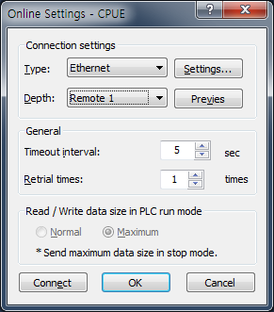
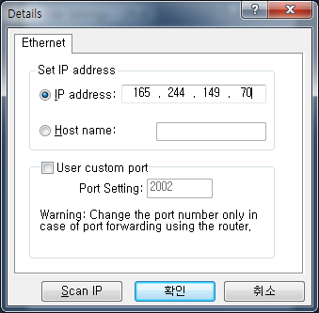

[Fig. 7.4.7] Remote 1 connection directly via Ethernet

7-19

Chapter 7 Diagnosis

  - Connection type
Select an applicable type for connection. In the case of [Fig. 7.4.7], select Ethernet because the connection is established directly via Ethernet without application of RS-232C.

  - Connection depth
Decide a PLC connection stage of remote stage 1 or 2. Select remote 1 here.

  - IP address
Set the IP address of FEnet I/F module to connect to. Use IP address, 210.206.91.190 to connect to PLC [n] in [Fig. 7.4.7].

The rest procedures are the same as with RS-232C used. Now click [OK] and then select [Connect] on the Online menu.

It is accessible through Ethernet which the CPU module direct connection without Ethernet I/F module. CPU direct connection support high performance XGT-series.(High performance XGT: Ethernet port internal CPU)

Chapter 7 Diagnosis
7-20

Remote 2 connection directly from PC connected with Ethernet

Remote stage 2 connection is available via Ethernet if a PC where XG5000 is operating is included in one PLC Ethernet network and one Ethernet is connected with other Ethernet network. The procedures are the same as in remote 1 connection and a setting example of ‘Connection Setting’ is as [Fig. 7.4.6].
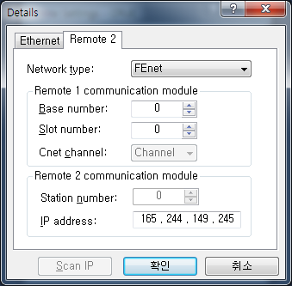
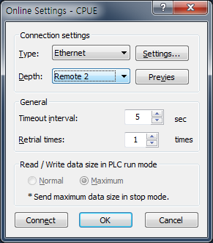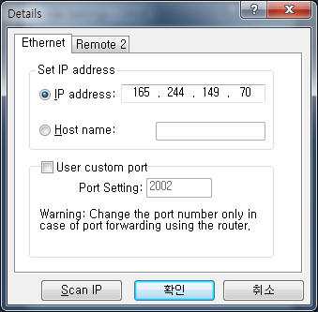

[Fig. 7.4.6] Remote 2 connection directly via Ethernet

Chapter 7 Diagnosis
7-21

- Precautions for operation with remote stage 1 & 2 connection
  - The following menus are not available if the types between the project presently open in XG5000 and the CPU connected with stage 1 or 2 are not identical.
    - Write program and each parameter
    - Read program and each parameter
    - Monitor
    - Flash memory
    - Set Link Enable
    - I/O information
    - Compulsory I/O information
    - I/O SKIP
  - Execute the remote connection with applicable project open of the station to connect to for XG5000 programming through remote stage 1 & 2 connections.
  - Up to 2 stages only are available for the remote connection. More than that is not available for the
remote connection.
- In case of remote connection via XGR redundancy
  - In case of remote connection via XGR redundancy, service is executed. Though you connect to Standby, connection route is Master CPU

Chapter 7 Diagnosis
7-22

A-1
Appendix

Appendix
A.1 Terms

1. IEEE 802.3
IEEE 802.3 regulates standards on Ethernet based on CSMA/CD. In other words it is a short distance net(LAN) based on CSMA/CD (Carrier Sense Multiple Access with Collision Detection)Ethernet devised by IEEE 802.3 Group, divided into the following specific projects.
- IEEE P802.3 - 10G Base T Study Group
- IEEE P802.3ah - Ethernet in the First Mile Task Force
- IEEE P802.3ak - 10G Base-CX4 Task Force
※ Ethernet and IEEE 802.3 must be standardized in RFC894 and RFC1042, and mutual frame processing must be possible.

  - ARP (Address Resolution Protocol)
This Protocol is created to find MAC Address, using an opponent’s IP address in Ethernet LAN.

  - Bridge
This is the device used to connect two networks so that they can operate as if those two were one. Bridge is used to connect two networks an also applied to divide one big network into two small networks for improving performance ability.
    - Related Standards: IEEE 802.1D
    - Bridge (Layer2 Switch) is the devise connected in Layer 2, which extends transmission limit distance of Ethernet and operates in Filtering and Forwarding as well.

  - Client
This refers to a user of network service, or a computer or a program using the resources of other computer (In general, the part who asks for services).

  - CSMA/CD (Carrier Sense Multiple Access with Collision Detection)
Each Client transmits its own data in case network is empty by checking out (Carrier Sense) whether there is a signal or not before sending off data to network. Then, all Clients are same in authority for transmission (Multiple Access), and if Clients more than two ones transmit, collision conflict occurs and the Client that detected these transits again in fixed hours.

  - DNS (Domain Name System)
This system is the method used to convert Domain Name on the internet in alphabet into Internet Number (Namely, IP Address) corresponding to it.

  - Dot Address
This refers to IP Address expressed into ‘100.100.100.100’ and each number is represented in decimal number, and it takes up 1 BYTE among 4 BYTES in total.

  - E-mail Address
This is the address of a user having his login account in the special device connected through the internet, and in general, it is expressed in a user’s ID@ domain name (Device Name). In other words, it is expressed like hjjee@microsoft.com, where @ is called “at” and it is the key board appearing if a user press shift+2 on keyboard. The letters in the back of “@” refer to special institutions (school, research center, corporation …) and the letters in front of “@” becomes a user’s ID.

Appendix
A-2

The end letters in domain name are top-ranked ones, and in case of USA, the following abbreviation is mostly used and in case of Korea, Korea is expressed in .kr for displaying nationality:
.com: usually corporations (company) / .edu: usually educational institutions like university (education). / .ac (academy) used in Korea, / .gov: governmental institutions, for example, NASA - nasa.gov (government) / .mil: sites related to the military. For example, USA air force is “to af.mil, (military)”/ .org means private organizations. Nations are expressed as follows: (/ .au: Australia / .uk: England / .ca: Canade / .kr: Korea / .jp: Japan / .fr: France / .tw: Taiwan, etc.).

  - Ethernet
This net is LAN Connection System (IEEE 802.3) that USA (Xerox), Intel, and DEC jointly developed. Ethernet, a network connection with 10Mbps transmission ability and 1500 BYTE packet used, can collect a variety of computers in network. Thus, it is called “pronoun of LAN” and the diverse products in generality in size, not for special providers, have been launched.

  - FTP (File Transfer Protocol)
This program is used to transmit files between computers among application programs that TCP/IP Protocol provides. Only f a user has Account on the computer he will log in, it is possible to copy files by logging in anywhere wherever the computer is located.

  - Gateway
This part is software/hardware translating two different protocols and is the device corresponding to the exit enabling a user to exchange information with other systems.

  - Header
This device is the part of the packet including own country’s and an opponent country’s addresses, and the part for checking out errors.

  - HTML (Hypertext Markup Language, Standard Language of WWW)
This is the language system for making hypertext texts and the documents made up in HTML are seen via web browser.

  - HTTP (Hypertext Transfer Protocol, Standard Protocol of WWW)
This is the protocol used to provide and receive a variety of files and data existing in World Wide Web (WWW).

  - ICMP (Internet Control Message Protocol)
This protocol creates error messages and test packets for managing internet via extension protocol of IP address and is designed to report errors and take control.

  - IP (Internet Protocol)
This protocol is deigned for network layers for internet. This is the protocol in non-connective datagram which transmits and receives data as data like TCP, UDP, ICMP, IGMP uses IP (32BYTE).

  - IP Address
This term means the address on internet in each computer composed of numbers and this address consists of binary numbers in 32BYTE (4BYTE) size to classify each device on internet. IP address is divided into 2 parts in total and is composed of address for classifying network and host address for dividing hosts. IP address is classified into 3 classes -

A-3
Appendix

(Class) A/ B/ C – according to how many BYTES are allotted to network address and host address. IP address is unique one over the world, so it is not decided at discretion but NIC (Network Information Center), the regional information net center allots when subscribing to internet, and In case of Korea, KRNIC (Korea Network Center) is in charge of allotment. Example) 165,244.149.190

  - ISO (International Organization for Standardization)
This organization is a subsidiary under UN established to enact international standards and to carry out management.

  - LAN (Local Area Network)
This network is a short distance network or an information communication network in region which enables a user to connect a variety of computers in limited scope and to exchange data with each other.

  - MAC (Medium Access Control)
This term refers to the way of deciding which device will use network within given time In Broadcast Network.

  - Node
Each computer connected to network net is called “node,” respectively.

  - Packet
This is a bundle of data which becomes the basic unit for transmitting data via network. In general packet creates a bundle in size from tens to hundreds BYTE. On the front side of each bundle Header is posted and the information on which way this bundle to be sent and more information required are added.

  - PORT number
This number is an identifier used to classify applications on TCP/UDP. On TCP, this PORT number is used to decide to which PORT data should be sent and the program used in general operation system has each own PORT.
Example) 21/tcp: Telnet

  - PPP (Point-to-Point Protocol)
This protocol is an agreement on telephone communication that allows packets to be transmitted. In other words, it is the commonest protocol on internet that enables a computer to be connected to TCP/IP through general telephone lines and modems.
This protocol is similar to SLIP, but it is equipped with modern – communication protocol factors such as error detection, data compression, etc., so it displays excellent performances compared to SLIP.

  - Protocol
Protocol is the regulations on how computers connected to network transmit and receive information with each other. Protocol means the regulation for exchanging messages on high level as the interface between one device and the

Appendix
A-4

other device is specifically described on low level(For example, which BIT/BYTE should go through lines) or files are transmitted through internet.

  - Router
This device is used to transmit data packets between networks. It also judges whether to send data packets to the final destination or not and whether to wait or not if network is busy, and which LAN to be connected to from a plural LAN diverging point. In other words, this device is a special computer /software that manage the connection for more than two networks.

  - Server
This term means the part which passively responds to Client’s request and shares its own resources.

  - TCP (Transmission Control Protocol)
    - Transport Layer Protocol for the Internet
- Supports Transmission/Reception, using Connection
- Supports Multiplexing Function
- Performs reliable transmission of data in connecting - oriented aspect
- Supports transmission of emergency data

  - TCP/IP (Transmission Control Protocol/Internet Protocol)
This term means the agreement on transmission for communication between computers in different model. This protocol plays a role that enables the communication between general PC and medium host, IBM PC and MAC, and among medium or large scaled computers produced by other manufactures. This term is used as a general term of the protocol for transmitting the information between computer networks and included FTP, Telnet, SMTP, etc. TCP is divided into data packets and transmitted by IP, and the packet transmitted is configured by TCP again.

  - Near-end crosstalk
Near-end crosstalk is a kind of disturbance generated by the electricity from a communication signal or a magnetic field that affect other signals in neighboring lines. In telephone line, near-end crosstalk may cause some dialogue contents on other lines to be heard. The phenomenon generated by near-end crosstalk is called “Electro Magnetic Interference.” This may happen on small circuits in computer or audio equipments as well as network lines. This term may be applied to optic signals that disturb each other. For example, as seen in an insulated conductor of a telephone cable, if electrostatic coupling or electromagnetic coupling between one insulated conductor and the other insulated conductor occurs and the phone current on one insulated conductor is derelict to other insulated conductor, crosswalk-talk happens. Of these crosswalk-talks, the crosswalk-talk that happened to a transmitting part called “Near-end crosstalk” and the one that happened to a receiving part is called Far-end crosstalk.

A-5
Appendix

A.2 Flag List

Special Relay (F) List

Device1 | Device2 | Type | Variable | Function | Description
F0000 | - | DWORD | _SYS_STATE | Mode and State | Displays the Mode and Run State of PLC
F0000 | F00000 | BIT | _RUN | RUN | Run State
F0000 | F00001 | BIT | _STOP | STOP | Stop state
F0000 | F00002 | BIT | _ERROR | ERROR | Error state.
F0000 | F00003 | BIT | _DEBUG | DEBUG | Debug State
F0000 | F00004 | BIT | _LOCAL_CON | LOCAL CONTROL | Local Control Mode
F0000 | F00005 | BIT | _MODBUS_CON | MODE BUS MODE | Mode Bus Control Mode
F0000 | F00006 | BIT | _REMOTE_CON | REMOTE MODE | Remote Control Mode
F0000 | F00008 | BIT | _RUN_EDIT_ST | CORRECTING WHILE RUN | Downloading Correction Program while Run.
F0000 | F00009 | BIT | _RUN_EDIT_CHK | CORRECTING WHILE RUN | Internal Processing for Correction while Run
F0000 | F0000A | BIT | _RUN_EDIT_DONE | CORRECTION  COMPLETED WHILE RUN | Correction Completed while Run
F0000 | F0000B | BIT | _RUN_EDIT_END | CORRECTION END WHILE RUN | Correction Ended while Run
F0000 | F0000C | BIT | _CMOD_KEY | OPERATION MODE | Operation Mode Transformed by the Key
F0000 | F0000D | BIT | _CMOD_LPADT | OPERATION MODE | Operation Mode Transformed by the Local PADT
F0000 | F0000E | BIT | _CMOD_RPADT | OPERATION MODE | Operation Mode Transformed by Remote PADT
F0000 | F0000F | BIT | _CMOD_RLINK | OPERATION  MODE | Operation Mode Transformed by Remote  Communication Mode
F0000 | F00010 | BIT | _FORCE_IN | FORCIBLE ENTRY | Forcible Entry State
F0000 | F00011 | BIT | _FORCE_OUT | FORCIBLE OUTPUT | Forcible Output State
F0000 | F00012 | BIT | _SKIP_ON | IN/OUTPUT SKIP | Executing In/Output Skip
F0000 | F00013 | BIT | _EMASK_ON | FAILED MASK | Executing Failed Mask
F0000 | F00014 | BIT | _MON_ON | MONITOR | Executing Monitor
F0000 | F00015 | BIT | _USTOP_ON | STOP | Stopped by Stop Function
F0000 | F00016 | BIT | _ESTOP_ON | ESTOP | Stopped by EStop Function
F0000 | F00017 | BIT | _CONPILE_모드 | COMPILING | Performing Compiling
F0000 | F00018 | BIT | _INIT_RUN | INITIALIZING | Performing Initializing Task
F0000 | F0001C | BIT | _PB1 | PROGRAM CODE 1 | Program Code 1 Selected
F0000 | F0001D | BIT | _PB2 | PROGRAM CODE 2 | Program Code 2 Selected
F0000 | F0001E | BIT | _CB1 | COMPILE CODE1 | Compile Code 1 Selected
F0000 | F0001F | BIT | _CB2 | COMPILE CODE 2 | Compile Code 2 Selected

Appendix
A-6

Device 1 | Device 2 | Type | Variable | Function | Description
F0002 | - | DWORD | _CNF_ER | SYTEM ERROR | Reports Serious Failure State of the System
F0002 | F00020 | BIT | _CPU_ER | CPU ERROR | Errors in CPU Configuration
F0002 | F00021 | BIT | _IO_TYER | MODULE TYPE ERROR | Module Type does not corresponds.
F0002 | F00022 | BIT | _IO_DEER | MODULE REMOVAL ERROR | Module Removed
F0002 | F00023 | BIT | _FUSE_ER | FUSE ERROR | Fuse Disconnected
F0002 | F00024 | BIT | _IO_RWER | MODULE IN/OUTPUT ERROR | Problems occurred in to Module In/Output
F0002 | F00025 | BIT | _IP_IFER | MODULE INTERFACE ERROR | Problems occurred in Special / Communication Module Interface
F0002 | F00026 | BIT | _ANNUM_ER | EXTERNAL DEVICE ERROR | Serious Errors detected from External Devices
F0002 | F00028 | BIT | _BPRM_ER | BASIC PARAMETER | Errors in Basic Parameter
F0002 | F00029 | BIT | _IOPRM_ER | IO PARAMETER | Errors with IO Configuration Parameter
F0002 | F0002A | BIT | _SPPRM_ER | SPECIAL MODULE PARAMETER | Special Module Parameter is in Abnormal State
F0002 | F0002B | BIT | _CPPRM_ER | COMMUNICATION MODULE PARAMETR | Communication Module Parameter is in Abnormal State
F0002 | F0002C | BIT | _PGM_ER | PROGRAM ERROR | Errors in Program
F0002 | F0002D | BIT | _CODE_ER | CODE ERROR | Errors in Program Code
F0002 | F0002E | BIT | _SWDT_ER | SYSTEM WATCH DOG | Scan Watchdog Operated
F0002 | F0002F | BIT | _BASE_POWER_E R | POWER ERROR | Errors in Base Power
F0002 | F00030 | BIT | _WDT_ER | SCAN WATCHDOG | Scan Watchdog Operated
F0004 | - | DWORD | _CNF_WAR | SYSTEM WARNIGN | Reports on the Light Errors of the System
F0004 | F00040 | BIT | _RTC_ER | RTC ERROR | Errors in RTC Data
F0004 | F00041 | BIT | _DBCK_ER | BACKUP ERROR | Problem Occurred in Data Back Up
F0004 | F00042 | BIT | _HBCK_ER | RESTART ERROR | Hot Restart Impossible
F0004 | F00043 | BIT | _ABSD_ER | OPERATION ERROR STOP | Stops due to Abnormal Operation
F0004 | F00044 | BIT | _TASK_ER | TASK COLLIDE | Task Colliding
F0004 | F00045 | BIT | _BAT_ER | BATTERY ERROR | Errors in Battery
F0004 | F00046 | BIT | _ANNUM_WAR | EXTERIAL DEVCIE ERROR | The Light Error of the External Device Detected
F0004 | F00047 | BIT | _LOG_FULL | MEMORY FULL | Log Memory Fully Filled
F0004 | F00048 | BIT | _HS_WAR1 | HIGH SPEED LINK1 | High Speed  Link – More Than Parameter 1
F0004 | F00049 | BIT | _HS_WAR2 | HIGH SPEED LINK2 | High Speed  Link – More Than Parameter 2
F0004 | F0004A | BIT | _HS_WAR3 | HIGH SPEED LINK3 | High Speed  Link – More Than Parameter 3
F0004 | F0004B | BIT | _HS_WAR4 | HIGH SPEED LINK4 | High Speed  Link – More Than Parameter 4
F0004 | F0004C | BIT | _HS_WAR5 | HIGH SPEED LINK5 | High Speed  Link – More Than Parameter 5
F0004 | F0004D | BIT | _HS_WAR6 | HIGH SPEED LINK6 | High Speed  Link – More Than Parameter 6
F0004 | F0004E | BIT | _HS_WAR7 | HIGH SPEED LINK7 | High Speed  Link – More Than Parameter 7

Appendix
A-7

Device 1 | Device 2 | Type | Variable | Function | Description
F0004 | F0004F | BIT | _HS_WAR8 | HIGH SPEED LINK 8 | High Speed  Link – More Than Parameter 8
F0004 | F00050 | BIT | _HS_WAR9 | HIGH SPEED LINK 9 | High Speed  Link – More Than Parameter 9
F0004 | F00051 | BIT | _HS_WAR10 | HIGH SPEED LINK 10 | High Speed  Link – More Than Parameter 10
F0004 | F00052 | BIT | _HS_WAR11 | HIGH SPEED LINK 11 | High Speed  Link – More Than Parameter 11
F0004 | F00053 | BIT | _HS_WAR12 | HIGH SPEED LINK12 | High Speed  Link – More Than Parameter 12
F0004 | F00054 | BIT | _P2P_WAR1 | P2P PARAMETER 1 | P2P – More Than Parameter 1
F0004 | F00055 | BIT | _P2P_WAR2 | P2P PARAMETER 2 | P2P – More Than Parameter 2
F0004 | F00056 | BIT | _P2P_WAR3 | P2P PARAMETER 3 | P2P – More Than Parameter 3
F0004 | F00057 | BIT | _P2P_WAR4 | P2P PARAMETER 4 | P2P – More Than Parameter 4
F0004 | F00058 | BIT | _P2P_WAR5 | P2P PARAMETER 5 | P2P – More Than Parameter 5
F0004 | F00059 | BIT | _P2P_WAR6 | P2P PARAMETER 6 | P2P – More Than Parameter 6
F0004 | F0005A | BIT | _P2P_WAR7 | P2P PARAMETER 7 | P2P – More Than Parameter 7
F0004 | F0005B | BIT | _P2P_WAR8 | P2P PARAMETER 8 | P2P – More Than Parameter 8
F0004 | F0005C | BIT | _CONSTANT_ER | FIXED  PERIOD ERROR F | Fixed Period Errors
F0009 | - | WORD | _USER_F | USER  CONTACING POINT | User Usable Timer
F0009 | F00090 | BIT | _T20MS | 20ms | 20ms Periodic Clock
F0009 | F00091 | BIT | _T100MS | 100ms | 100ms Periodic Clock
F0009 | F00092 | BIT | _T200MS | 200ms | 200ms Periodic Clock
F0009 | F00093 | BIT | _T1S | 1s | 1s Periodic Clock
F0009 | F00094 | BIT | _T2S | 2s | 2s Periodic Clock
F0009 | F00095 | BIT | _T10S | 10s | 10s Periodic Clock
F0009 | F00096 | BIT | _T20S | 20s | 20s Periodic Clock
F0009 | F00097 | BIT | _T60S | 60s | 60s Periodic Clock
F0009 | F00099 | BIT | _ON | ALWAYS - ON | Always On – State Bit
F0009 | F0009A | BIT | _OFF | ALWAYS - ON | Always Off – State Bit
F0009 | F0009B | BIT | _1ON | 1 SCAN - ON | 1st Scan Only On –State
F0009 | F0009C | BIT | _1OFF | 1 SCAN -OFF | 1st Scan Only Off –State
F0009 | F0009D | BIT | _STOG | ANTi - CLOCK | Every Scan Anti –Clocked
F0010 | - | WORD | _USER_CLK | USER-CLOCK | User Set-up Available Clock
F0010 | F00100 | BIT | _USR_CLK0 | DEGIGNATED SCAN REPEATED | On/Off Clock as much as Designated Scan 0
F0010 | F00101 | BIT | _USR_CLK1 | DEGIGNATED SCAN REPEATED | On/Off Clock as much as Designated Scan 1
F0010 | F00102 | BIT | _USR_CLK2 | DEGIGNATED SCAN REPEATED | On/Off Clock as much as Designated Scan 2

Appendix
A-8

Device 1 | Device 2 | Type | Variable | Function | Description
 | F00103 | BIT | _USR_CLK3 | DEGIGNATED SCAN REPEATED | On/Off Clock as much as Designated Scan 3
 | F00104 | BIT | _USR_CLK4 | DEGIGNATED SCAN REPEATED | On/Off Clock as much as Designated Scan 4
 | F00105 | BIT | _USR_CLK5 | DEGIGNATED SCAN REPEATED | On/Off Clock as much as Designated Scan 5
 | F00106 | BIT | _USR_CLK6 | DEGIGNATED SCAN REPEATED | On/Off Clock as much as Designated Scan 6
 | F00107 | BIT | _USR_CLK7 | DEGIGNATED SCAN REPEATED | On/Off Clock as much as Designated Scan 7
F0011 | - | WORD | _LOGIC_RESULT | LOGIC RESULTS | Displays Logic Results
F0011 | F00110 | BIT | _LER | CALCULATION ERROR | On during 1 Scan when Errors made to Calculation
F0011 | F00111 | BIT | _ZERO | ZERO FLAG | On if Calculation Result is 0
F0011 | F00112 | BIT | _CARRY | CARRY FLAG | On if Carry occurred during Calculation
F0011 | F00113 | BIT | _ALL_OFF | ALL OUTPUT OFF | On if All Outputs are OFF
F0011 | F00115 | BIT | _LER_LATCH | CALCULATION  ERROR LATCH | On Maintained when Errors made to Calculation
F0012 | - | WORD | _CMP_RESULT | COMPARISION RESULTS | Display Comparison Results
F0012 | F00120 | BIT | _LT | LT FLAG | On if “ Less Than “
F0012 | F00121 | BIT | _LTE | LTE FLAG | On if “The Same or Less Than”
F0012 | F00122 | BIT | _EQU | EQU FLAG | On if “The Same ”
F0012 | F00123 | BIT | _GT | GT FLAG | On if “Larger Than ”
F0012 | F00124 | BIT | _GTE | GTE FLAG | On “Larger Than or The Same ”
F0012 | F00125 | BIT | _NEQ | NEQ FLAG | On if “Not The Same ”
F0013 | - | WORD | _AC_F_CNT | FREQUENT BLACKOUT | Displays Blackout Frequency
F0014 | - | WORD | _FALS_NUM | FALS NUMBER | Displays the Number of FALS
F0015 | - | WORD | _PUTGET_ERR0 | PUT/GET ERROR 0 | Main Base PUT / GET ERROR
F0016 | - | WORD | _PUTGET_ERR1 | PUT/GET ERROR 1 | Extension Base Step 1 - PUT / GET ERROR
F0017 | - | WORD | _PUTGET_ERR2 | PUT/GET ERROR 2 | Extension Base Step 2 - PUT / GET ERROR
F0018 | - | WORD | _PUTGET_ERR3 | PUT/GET ERROR 3 | Extension Base Step 3 - PUT / GET ERROR
F0019 | - | WORD | _PUTGET_ERR4 | PUT/GET ERRO 4 | Extension Base Step 4 - PUT / GET ERROR
F0020 | - | WORD | _PUTGET_ERR5 | PUT/GET ERROR 5 | Extension Base Step 5 - PUT / GET ERROR
F0021 | - | WORD | _PUTGET_ERR6 | PUT/GET ERROR 6 | Extension Base Step 6 - PUT / GET ERROR
F0022 | - | WORD | _PUTGET_ERR7 | PUT/GET ERROR 7 | Extension Base Step 7 - PUT / GET ERROR
F0023 | - | WORD | _PUTGET_NDR0 | PUT/GET COMPLETED 0 | Main Base PUT / GET COMPLETED
F0024 | - | WORD | _PUTGET_NDR1 | PUT/GET COMPLETED 1 | Extension Base Step 1 PUT / GET COMPLETED
F0025 | - | WORD | _PUTGET_NDR2 | PUT/GET COMPLETED 2 | Extension Base Step 2 PUT / GET COMPLETED
F0026 | - | WORD | _PUTGET_NDR3 | PUT/GET COMPLETED 3 | Extension Base Step 3 PUT / GET COMPLETED
F0027 | - | WORD | _PUTGET_NDR4 | PUT/GET COMPLETED 4 | Extension Base Step 4 PUT / GET COMPLETED

Appendix
A-9

Device 1 | Device 2 | Type | Variable | Function | Description
F0028 | - | WORD | _PUTGET_NDR5 | PUT/GET COMPLETED 5 | Extension Base Step 5 PUT / GET COMPLETED
F0029 | - | WORD | _PUTGET_NDR6 | PUT/GET COMPLETED 6 | Extension Base Step 6 PUT / GET COMPLETED
F0030 | - | WORD | _PUTGET_NDR7 | PUT/GET COMPLETED 7 | Extension Base Step 7 PUT / GET COMPLETED
F0044 | - | WORD | _CPU_TYPE | CPU TYPE | Displays the Information on CPU Type
F0045 | - | WORD | _CPU_VER | CPU VERSION | Displays CPU Version
F0046 | - | DWORD | _OS_VER | O/S VERSION | Displays O/S Version
F0048 | - | DWORD | _OS_DATE | O/S DATE | Displays O/S Distribution Date
F0050 | - | WORD | _SCAN_MAX | MAXIMUM  SCAN TIME | Displays Maximum Scan Time
F0051 | - | WORD | _SCAN_MIN | MINIMUM SCAN TIME | Displays Minimum Scan Time
F0052 | - | WORD | _SCAN_CUR | CURRENT SCAN TIME | Displays Current Scan Time.
F0053 | - | WORD | _MON_YEAR | MONTH /YEAR | Month, Year Data of PLC
F0054 | - | WORD | _TIME_DAY | HOUR / DATE | Hour, Date Data of PLC
F0055 | - | WORD | _SEC_MIN | SECOND / MINUTE | Second, Minute Data of PLC
F0056 | - | WORD | _HUND_WK | 100 YEARS / DAY | 100 Years , Minute Data of PLC
F0057 | - | WORD | _FPU_INFO | FPU CALCULATION RESULT | Displays Calculation Results in Immovable Decimal Point
F0057 | F00570 | BIT | _FPU_LFLAG_I | INACCURATE  ERROR LATCH | Latches if Inexact Errors
F0057 | F00571 | BIT | _FPU_LFLAG_U | UNDERFLOW  LATCH | Latches if Underflow Occurs
F0057 | F00572 | BIT | _FPU_LFLAG_O | OVERFLOW LATCH | Latches if Overflow Occurs.
F0057 | F00573 | BIT | _FPU_LFLAG_Z | 0 DIVISION LATCH | Latches 0 Division
F0057 | F00574 | BIT | _FPU_LFLAG_V | NULL CALCULATION  LATCH | Latches if Null Calculation
F0057 | F0057A | BIT | _FPU_FLAG_I | INACCURATE  ERROR | Reports on Inexact Error Occurrence.
F0057 | F0057B | BIT | _FPU_FLAG_U | UNDEFLOW | Reports if Underflow Occurs.
F0057 | F0057C | BIT | _FPU_FLAG_O | OVERFLOW | Reports if Overflow Occurs
F0057 | F0057D | BIT | _FPU_FLAG_Z | O DIVISION | Reports if O Division
F0057 | F0057E | BIT | _FPU_FLAG_V | NULL CALCUATION | Reports if Null Calculation
F0057 | F0057F | BIT | _FPU_FLAG_E | IRREGULAR VALUE ENTRY | Reports when Entering Irregular Value
F0058 | - | DWORD | _ERR_STEP | ERROR STTEP | Stores Error Step.
F0060 | - | DWORD | _REF_COUNT | REFRESH | Increases if Module Refresh Performed
F0062 | - | DWORD | _REF_OK_CNT | REFRESH OK | Increases if Module Refresh is in Normal State
F0064 | - | DWORD | _REF_NG_CNT | REFRESH NG | Increases if Module Refresh in Abnormal State
F0066 | - | DWORD | _REF_LIM_CNT | REFRESH LIMIT | Increases if Module Refresh in Abnormal State  (Timeout )
F0068 | - | DWORD | _REF_ERR_CNT | REFRESH ERROR | Increases if Module Refresh in Abnormal State
F0070 | - | DWORD | _MOD_RD_ERR_CN  T | MODULE READ  ERROR | Increases if Reading Module 1 Word Abnormally
F0072 | - | DWORD | _MOD_WR_ERR_C  NT | MODULE WRITE  ERROR | Increases if Writing Module 1 Word Abnormally
F0074 | - | DWORD | _CA_CNT | BLOCK SERVICE | Increases if Block Data Service of Module Performed

Appendix
A-10

Device 1 | Device 2 | Type | Variable | Function | Description
F0076 | - | DWORD | _CA_LIM_CNT | BLOCK SERVICE  LIMIT | Increases if Block Data Service in Abnormal State
F0078 | - | DWORD | _CA_ERR_CNT | BLOCK SERVICE  ERROR | Increases if Block Data Service in Abnormal State
F0080 | - | DWORD | _BUF_FULL_CNT | BUFFUR FULL | Increases if CPU Internal Buffer FULL
F0082 | - | DWORD | _PUT_CNT | PUT COUNT | Increases if Performing PUT.
F0084 | - | DWORD | _GET_CNT | GET COUNT | Increases if Performing GET.
F0086 | - | DWORD | _KEY | CURRENT KEY | Displays the Current State of Local Key.
F0088 | - | DWORD | _KEY_PREV | PREVIOUS KEY | Displays the Previous State of Local Key
F0090 | - | WORD | _IO_TYER_N | INCONSISTENT SLOT | Displays Module Type – Inconsistent Slot No.
F0091 | - | WORD | _IO_DEER_N | REMOVAL SLOT | Displays Slot No. where Module Removal Occurred
F0092 | - | WORD | _FUSE_ER_N | FUSE DISCONNECTION SLOT | Displays Slot No. where Fuse Disconnection Occurred
F0093 | - | WORD | _IO_RWER_N | RW ERROR SLOT | Displays Module Read/Write –Error Slot No.
F0094 | - | WORD | _IP_IFER_N | I/F ERROR SLOT | Displays Interface Error Slot No.
F0096 | - | WORD | _IO_TYER0 | MODULE TYPE 0 ERROR | Main Base - Module Type Error
F0097 | - | WORD | _IO_TYER1 | MODULE TYPE 1 ERROR | Extension Base Step 1 – Module Type Error
F0098 | - | WORD | _IO_TYER2 | MODULE TYPE 2 ERROR | Extension Base Step 2 – Module Type Error
F0099 | - | WORD | _IO_TYER3 | MODULE TYPE 3 ERROR | Extension Base Step 3 – Module Type Error
F0100 | - | WORD | _IO_TYER4 | MODULE TYPE 4 ERROR | Extension Base Step 4 – Module Type Error
F0101 | - | WORD | _IO_TYER5 | MODULE TYPE 5 ERROR | Extension Base Step 5 – Module Type Error
F0102 | - | WORD | _IO_TYER6 | MODULE TYPE 6 ERROR | Extension Base Step 6 – Module Type Error
F0103 | - | WORD | _IO_TYER7 | MODULE TYPE 7 ERROR | Extension Base Step 7 – Module Type Error
F0104 | - | WORD | _IO_DEER0 | MODULE  REMOVAL 0 ERROR | Main Base Module Removal Error
F0105 | - | WORD | _IO_DEER1 | MODULE  REMOVAL 1 ERROR | Extension Base Step 1 – Module Removal Error
F0106 | - | WORD | _IO_DEER2 | MODULE  REMOVAL 2 ERROR | Extension Base Step 2 – Module Removal Error
F0107 | - | WORD | _IO_DEER3 | MODULE REMOVAL 3  ERROR | Extension Base Step 3 – Module Removal Error
F0108 | - | WORD | _IO_DEER4 | MODULE REMOVAL 4  ERROR | Extension Base Step 4 – Module Removal Error
F0109 | - | WORD | _IO_DEER5 | MODULE REMOVAL 5  ERROR | Extension Base Step 5 – Module Removal Error
F0110 | - | WORD | _IO_DEER6 | MODULE REMOVAL 6 ERROR | Extension Base Step 6 – Module Removal Error
F0111 | - | WORD | _IO_DEER7 | MODULE REMOVAL 7 ERROR | Extension Base Step 7 – Module Removal Error

Appendix
A-11

Device 1 | Device 2 | Type | Variable | Function | Description
F0112 | - | WORD | _FUSE_ER0 | FUSE DISCONNECTION  0 ERROR | Main Base Fuse Disconnection Error
F0113 | - | WORD | _FUSE_ER1 | FUSE DISCONNECTION  1 ERROR | Extension Base Step 1 – Fuse Disconnection Read/Write Error
F0114 | - | WORD | _FUSE_ER2 | FUSE DISCONNECTION 2 ERROR | Extension Base Step 2 – Fuse Disconnection Read/Write Error
F0115 | - | WORD | _FUSE_ER3 | FUSE  DISCONNECTION 3 ERROR | Extension Base Step 3 – Fuse Disconnection Read/Write Error
F0116 | - | WORD | _FUSE_ER4 | FUSE DISCONNECTION 4 ERROR | Extension Base Step 4 – Fuse Disconnection Read/Write Error
F0117 | - | WORD | _FUSE_ER5 | FUSE DISCONNECTION 5 ERROR | Extension Base Step 5 – Fuse Disconnection Read/Write Error
F0118 | - | WORD | _FUSE_ER6 | FUSE DISCONNECTION 6 ERROR | Extension Base Step 6 – Fuse Disconnection Read/Write Error
F0119 | - | WORD | _FUSE_ER7 | FUSE  DISCONNECTION 7 ERROR | Extension Base Step 7 – Fuse Disconnection Read/Write Error
F0120 | - | WORD | _IO_RWER0 | MODULE RW 0 ERROR | Main Base - Module Read/Write Error
F0121 | - | WORD | _IO_RWER1 | MODULE RW 1  ERROR | Extension Base Step 1 – Module Read/Write Error
F0122 | - | WORD | _IO_RWER2 | MODULE RW 2 ERROR | Extension Base Step 2 – Module Read/Write Error
F0123 | - | WORD | _IO_RWER3 | MODULE RW 3 ERROR | Extension Base Step 3 – Module Read/Write Error
F0124 | - | WORD | _IO_RWER4 | MODULE RW 4 ERROR | Extension Base Step 4 – Module Read/Write Error
F0125 | - | WORD | _IO_RWER5 | MODULE RW 5 ERROR | Extension Base Step 5 – Module Read/Write Error
F0126 | - | WORD | _IO_RWER6 | MODULE RW 6 ERROR | Extension Base Step 6 – Module Read/Write Error
F0127 | - | WORD | _IO_RWER7 | MODULE RW 7 ERROR | Extension Base Step 7 – Module Read/Write Error
F0128 | - | WORD | _IO_IFER_0 | MODULE I/F 0  ERROR | Main Base Module - Interface Error
F0129 | - | WORD | _IO_IFER_1 | MODULE I/F1 ERROR | Extension Base Step 1 – Module Interface Error
F0130 | - | WORD | _IO_IFER_2 | MODULE I/F 2 ERROR | Extension Base Step 2 – Module Interface Error
F0131 | - | WORD | _IO_IFER_3 | MODULE I/F 3 ERROR | Extension Base Step 3 – Module Interface Error
F0132 | - | WORD | _IO_IFER_4 | MODULE I/F 4 ERROR I | Extension Base Step 4 – Module Interface Error
F0133 | - | WORD | _IO_IFER_5 | MODULE I/F 5 ERROR | Extension Base Step 5 – Module Interface Error
F0134 | - | WORD | _IO_IFER_6 | MODULE I/F 6 ERROR | Extension Base Step 6 – Module Interface Error
F0135 | - | WORD | _IO_IFER_7 | MODULE I/F 7 ERROR | Extension Base Step 7– Module Interface Error
F0136 | - | WORD | _RTC_DATE | RTC DATE | Current Date of RTC
F0137 | - | WORD | _RTC_WEEK | RTC DAY | Current Day of RTC
F0138 | - | DWORD | _RTC_TOD | RTC HOUR | Current Time of RTC (ms unit)
F0140 | - | DWORD | _AC_FAIL_CNT | POWER SHUT-OUT FREQUENCY | Stores the Frequency that Power has been Shut out.
F0142 | - | DWORD | _ERR_HIS_CNT | ERROR OCCURRENCE | Stores the Frequency that Error s were Made

Appendix
A-12

Device 1 | Device 2 | Type | Variable | Function | Description
 |  |  |  | FREQUENCY
F0144 | - | DWORD | _MOD_HIS_CNT | MODE CONVERSIO N FREQUENCY | Stores the Frequency that the Mode has been Converted
F0146 | - | DWORD | _SYS_HIS_CNT | HISTORY  OCCURRENCE FREQUENCY | Stores the Frequency that the System History Occurred.
F0148 | - | DWORD | _LOG_ROTATE | LOG ROTATE | Stores Log Rotate Information
F0150 | - | WORD | _BASE_INFO0 | SLOT  INFORMATION 0 | Main Base Slot Information
F0151 | - | WORD | _BASE_INFO1 | SLOT  INFORMATION 1 | Extension Base Step 1 – Slot Information
F0152 | - | WORD | _BASE_INFO2 | SLOT INFORMATION 2 | Extension Base Step 2 – Slot Information
F0153 | - | WORD | _BASE_INFO3 | SLOT INFORMATION 3 | Extension Base Step 3 – Slot Information
F0154 | - | WORD | _BASE_INFO4 | SLOT INFORMATION 4 | Extension Base Step 4 – Slot Information
F0155 | - | WORD | _BASE_INFO5 | SLOT INFORMATION 5 | Extension Base Step 5 – Slot Information
F0156 | - | WORD | _BASE_INFO6 | SLOT INFORMATION 6 | Extension Base Step 6 – Slot Information
F0157 | - | WORD | _BASE_INFO7 | SLOT INFORMATION 7 | Extension Base Step 7 – Slot Information
F0158 | - | WORD | _RBANK_NUM | USED BLOCK NO. | Block No. used Currently
F0159 | - | WORD | _RBLOCK_STATE | FLASH STATE | Flash Block State
F0160 | - | DWORD | _RBLOCK_RD_FLA G | FLASH READ | ON when Reading Data of Flash N Block
F0162 | - | DWORD | _RBLOCK_WR_FLA G | WRITE ON FLASH | ON when Writing Data of Flash N Block
F0164 | - | DWORD | _RBLOCK_ER_FLA G | FLASH ERROR | Errors occurs during Flash N Block Service
F1024 | - | WORD | _USER_WRITE_F | USABLE CONTACTING  POINT | Contacting Point Usable in Program
F1024 | F10240 | BIT | _RTC_WR | RTC RW | Writes and Read Data to RTC
F1024 | F10241 | BIT | _SCAN_WR | SCAN WR | Scan Value Initialization
F1024 | F10242 | BIT | _CHK_ANC_ERR | EXTERNA L SERIOUS FAILURE  REQUEST | Requires Serious Failures from External Devices
F1024 | F10243 | BIT | _CHK_ANC_WAR | EXTERNAL WARNING REQUEST | Requests to Detect Light Failures from External Devices
F1025 | - | WORD | _USER_STAUS_F | USER  CONTACTING POINT | User Contacting Point
F1025 | F10250 | BIT | _INIT_DONE | INTIALIZATION COMPLETED | Displays Initialization Task Performance Completed
F1026 | - | WORD | _ANC_ERR | EXTERNAL SERIOUS FAILURE  INFORMATION | Displays Serious Failures Information of External Devices
F1027 | - | WORD | _ANC_WAR | EXTERNAL LIGHT FAILURE  WARNING | Displays the Light Failures Information of External Devices
F1034 | - | WORD | _MON_YEAR_DT | MONTH / YEAR | Clock Information Data (Month / Year)
F1035 | - | WORD | _TIME_DAY_DT | HOUR / DAY | Clock Information Data ( Hour / Day )
F1036 | - | WORD | _SEC_MIN_DT | SECOND / MINUTE | Clock Information Data (Second / Minute )
F1037 | - | WORD | _HUND_WK_DT | 100 YEARS / DAY | Clock Information Data( 100 Years / Day )

A-13
Appendix

    - Communication Relay (L) List
-Special Register for Data Link

*P2P Parameter: 1~8, P2P Block: 0~63
No. | Key Word | Type | Contents | Contents Description
L006250 | _P2P1_NDR00 | BIT | P2P PARAMETER No. 1 – BLOCK SERVICE IN NORMAL STATE  COMPLETED | Displays P2P PARAMETER No. 1 – BLOCK SERVICE IN NORMAL STATE COMPLETED
L006251 | _P2P1_ERR00 | BIT | P2P PARAMETER No.00 – BLOCK SERVICE IN ABNORMAL STATE COMPLETED | Displays P2P PARAMETER No.00 – BLOCK SERVICE IN ABNORMAL STATE COMPLETED
L00626 | _P2P1_STATUS00 | WORD | IF P2P PARAMETER No.00 – BLOCK SERVICE IN ABNORMAL STATE COMPLETED, ERROR CODE | Displays IF P2P PARAMETER No.00 – BLOCK SERVICE IN ABNORMAL STATE COMPLETED, ERROR CODE
L00627 | _P2P1_SVCCNT00 | DOUBLE WORD | P2P PARAMETER No. 00 – THE NUMBER OF BLOCK SERVICE PERFORMANCES IN NORMAL STATE | Displays P2P PARAMETER No. 00 – THE NUMBER OF BLOCK SERVICE PERFORMANCES IN NORMAL STATE
L00629 | _P2P1_ERRCNT00 | DOULE WORD | P2P PARAMETER No. 1. AND No. 00 – THE NUMBER OF BLOCK SERVICE PERFORMANCES IN ABNORMAL STATE | Displays P P2P PARAMETER No. 1. AND No. 00 – THE NUMBER OF BLOCK SERVICE PERFORMANCES IN ABNORMAL STATE
L006310 | _P2P1_NDR01 | BIT | P2P PARAMETER No. 1 and No. 01– BLOCK SERVICE IN NORMAL STATE COMPLETED | Displays P2P PARAMETER No. 1 and No. 01– BLOCK SERVICE IN NORMAL STATE COMPLETED
L006311 | _P2P1_ERR01 | BIT | P2P PARAMETER No. 1 and No. 01– BLOCK SERVICE IN ABNORMAL STATE COMPLETED | Displays ETER No. 1 and No. 01– BLOCK SERVICE IN ABNORMAL STATE COMPLETED P2P
L00632 | _P2P1_STATUS01 | WORD | IF P2P PARAMETER No.1 AND No. 00  – BLOCK SERVICE IN ABNORMAL STATE COMPLETED, ERROR CODE | Displays IF P2P PARAMETER No.1 AND No. 00 – BLOCK SERVICE IN ABNORMAL STATE COMPLETED, ERROR CODE
L00633 | _P2P1_SVCCNT01 | DOUBLE WORD | P2P PARAMETER No.1 AND No. 01 – THE NUMBER OF BLOCK SERVICE PERFORMANCES IN NORMAL STATE | Displays PARAMETER No.1 AND No. 01 – THE NUMBER OF BLOCK SERVICE PERFORMANCES IN NORMAL STATE
L00635 | _P2P1_ERRCNT01 | DOUBLE WORD | P2P PARAMETER No.1 AND No. 01 – THE NUMBER OF BLOCK SERVICE PERFORMANCES IN ABNORMAL STATE | Displays P2P PARAMETER No.1 AND No. 01 – THE NUMBER OF BLOCK SERVICE PERFORMANCES IN ABNORMAL STATE
[TABLE 2] Communication Flag List in accordance with P2P Service Set-up

Appendix
A-14

A.3 Dimension

Dimension Unit : mm
  - XGL-EIPT
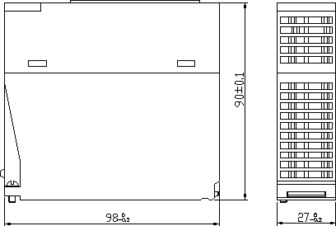

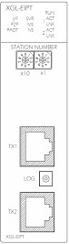

Warranty and Environmental Policy

Warranty

- Warranty Period
The product you purchased is guaranteed for 36 months from the date of manufacture.

- Scope of Warranty
  - The initial diagnosis of faults is basically conducted by your company. However, upon your request, our company or our service network can undertake this task for a fee. If the cause of the fault lies with our company, this service will be provided free of charge.
  - This warranty only applies if the product is used under normal conditions according to the specifications and precautions described in the handling instructions, user manuals, catalogs, and caution labels.
  - Even within the free warranty period, the following cases will be subject to paid repairs:
    - Replacement of consumable and life-limited parts (e.g., relays, fuses, electrolytic capacitors, fans, LCDs, batteries, etc.)
    - Failures or damages caused by improper storage, handling, negligence, or accidents by the customer
    - Failures resulting from the customer's hardware or software design
    - Failures due to modifications without our consent
(Repairs will be refused, even for a fee, if recognized as modified or repaired outside our company)
    - Failures that could have been avoided if the customer's equipment, in which our product is incorporated, had safety devices required by legal regulations or common industry standards
    - Failures that could have been prevented if maintenance and replacement of consumable parts were performed normally according to the handling instructions or user manuals
    - Failures and damages to the product caused by using connected equipment or inappropriate consumables
    - Failures caused by external factors such as fire, abnormal voltage, force majeure, and natural disasters such as earthquakes, lightning, salt damage, wind, and flood damage
    - Failures due to reasons that could not be predicted with the scientific and technical standards at the time of our shipment
    - Other failures, damages, or defects recognized as the responsibility of your company

Environmental Policy

LS ELECTRIC Co., Ltd supports and observes the environmental policy as below.

Environmental Management

LS ELECTRIC considers the environmental preservation as the preferential management subject and every staff of LS ELECTRIC use the reasonable endeavors for the pleasurably environmental preservation of the earth.

About Disposal

LS ELECTRIC’ PLC unit is designed to protect the environment. For the disposal, separate aluminum, iron and synthetic resin (cover) from the product as they are reusable.

1

Warranty and Environment Policy

2

www.ls-electric.com

- Headquarter
LS-ro 127(Hogye-dong) Dongan-gu, Anyang-si, Gyeonggi-Do, 14119, Korea
- Seoul Office
LS Yongsan Tower, 92, Hangang-daero, Yongsan-gu, Seoul, 04386, Korea Tel: 82-2-2034-4033, 4888, 4703 Fax: 82-2-2034-4588
E-mail: automation@ls-electric.com

- Overseas Subsidiaries
- LS ELECTRIC Japan Co., Ltd. (Tokyo, Japan)
Tel: 81-3-6268-8241 E-Mail: japan@ls-electric.com
- LS ELECTRIC (Dalian) Co., Ltd. (Dalian, China)
Tel: 86-411-8730-6495 E-Mail: china.dalian@lselectric.com.cn
- LS ELECTRIC (Wuxi) Co., Ltd. (Wuxi, China)
Tel: 86-510-6851-6666 E-Mail: china.wuxi@lselectric.com.cn
- LS ELECTRIC Middle East FZE (Dubai, U.A.E.)
Tel: 971-4-886-5360 E-Mail: middleeast@ls-electric.com
- LS ELECTRIC Europe B.V. (Hoofddorp, Netherlands)
Tel: 31-20-654-1424 E-Mail: europartner@ls-electric.com
- LS ELECTRIC America Inc. (Chicago, USA)
Tel: 1-800-891-2941 E-Mail: sales.us@lselectricamerica.com
- LS ELECTRIC Turkey Co., Ltd.
Tel: 90-212-806-1225 E-Mail: turkey@ls-electric.com
- Overseas Branches
- LS ELECTRIC Tokyo Office (Japan)
Tel: 81-3-6268-8241 E-Mail: tokyo@ls-electric.com
- LS ELECTRIC Beijing Office (China)
Tel: 86-10-5095-1631 E-Mail: china.auto@lselectric.com.cn
- LS ELECTRIC Shanghai Office (China)
Tel: 86-21-5237-9977 E-Mail: china.auto@lselectric.com.cn
- LS ELECTRIC Guangzhou Office (China)
Tel: 86-20-3818-2883 E-Mail: china.auto@lselectric.com.cn
- LS ELECTRIC Chengdu Office (China)
Tel: 86-28-8670-3201 E-Mail: china.auto@lselectric.com.cn
- LS ELECTRIC Qingdao Office (China)
Tel: 86-532-8501-2065 E-Mail: china.auto@lselectric.com.cn
- LS ELECTRIC Nanjing Office (China)
Tel: 86-25-8467-0005 E-Mail: china.auto@lselectric.com.cn
- LS ELECTRIC Bangkok Office (Thailand)
Tel: 66-90-950-9683 E-Mail: thailand@ls-electric.com
- LS ELECTRIC Jakarta Office (Indonesia)
Tel: 62-21-2933-7614 E-Mail: indonesia@ls-electric.com
- LS ELECTRIC Moscow Office (Russia)
Tel: 7-499-682-6130 E-Mail: info@lselectric-ru.com
- LS ELECTRIC America Western Office (Irvine, USA) Tel: 1-949-333-3140 E-Mail: america@ls-electric.com

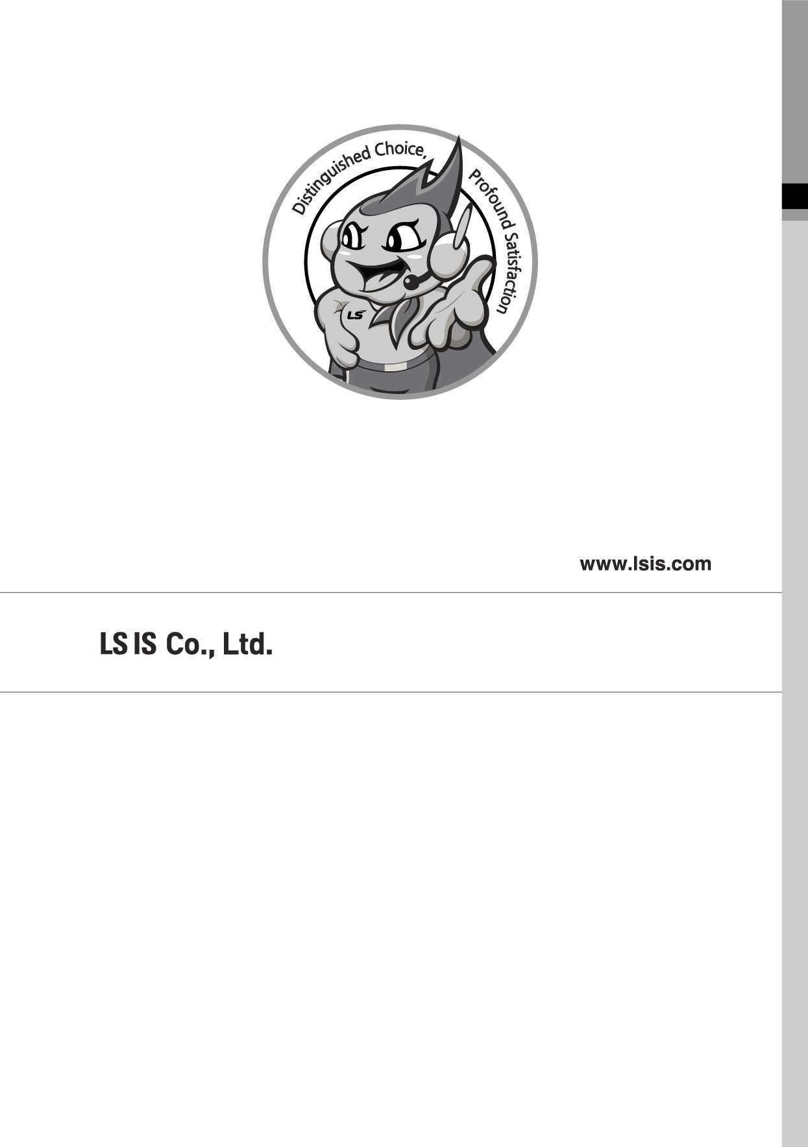
Disclaimer of Liability
LS ELECTRIC has reviewed the information in this publication to ensure consistency with the hardware and software described. However, LS ELECTRIC cannot guarantee full consistency, nor be responsible for any damages or compensation, since variance cannot be precluded entirely. Please check again the version of this publication before you use the product.
ⓒ LS ELECTRIC Co., Ltd 2015 All Right Reserved. 2024.06

