XGL-FEnet Software Design Test

Software Design Test (XGT, FEnet Dedicated Protocol)

First Edition: 2005. 12. 22

Last Edition: 2006. 07. 26 Editor: Daehyun Kwon
Advanced Platform Research Team LSIS R&D Center

1/17

XGL-FEnet Software Design Test

Editing History

Index | Date | Version | Chapter | Revision
1 | 2005.12.22 | 0.1 | All | Created
2 | 2005.12.23 | 0.2 | TB,  CoS | TB, CoS Tested
3 | 2006.01.07 | 0.3 | 6-2-4-1 | RTC AREA SET Retested because of Offset Field.
4 | 2006.01.10 | 0.4 | 6-3-2 ~ 6-3-4  6-4-2 ~ 6-4-4 | TB, CoS Restart, Stop, Delete is tested.
5 | 2006.06.06 | 0.5 | 6-2-4-2  TB | Device Area Write CMD Corrected. TB Multiple Blocks Test
6 | 2006.06.08 | 0.6 | TB, CoS | TB/CoS Alarm Response Frame : TCP -> UDP
7 | 2006.07.26 | 0.7 | 6-2-4-1 | RTC SET Format is changed to RTC Read Format

2/17

XGL-FEnet Software Design Test

1. Overview
This document talks about updated functions and revision on Dedicated Protocol of XGT FEnet.

Frame Structure
The structure of LS Ethernet module’s application frame is as shown below;

Header
IP Header | TCP Header

Application Data Format
Application Header Format | Application Instruction Format

Header Structure (Application Header Format)

Item | Size(byte) | Description
Company ID | 8 | “LSIS-XGT”  (ASCII CODE : 4C 53 49 53 2D 58 47 54)
Reserved | 2 | 0x00 : Reserved area
PLC Info | 2 | - Client(HMI) ➔ Server(PLC) : Don’t care (0x00)  - Server(PLC) ➔ Client(HMI) :  - If Reserved 1 is 0x00, Bit00~05 : CPU TYPE  01(XGK-CPUH), 02(XGK-CPUS)  Bit06 : 0(Redundant Master / Single), 1(Redundant Slave)  Bit07 : 0(CPU operation normal), 1(CPU operation error)  Bit08~12 : System status  1(RUN),2(STOP), 4(ERROR), 8(DEBUG)  Bit13~15 : Reserved
CPU Info | 1 | - Client(HMI) ➔ Server(PLC) : Don’t care (0x00)  - Server(PLC) ➔ Client(HMI) : 0xA0 Note1)
Source of Frame | 1 | - Client(HMI) ➔ Server(PLC) : 0x33  - Server(PLC) ➔ Client(HMI) : 0x11
Invoke ID | 2 | ID used to discriminate the sequence among frames (This number is sent as attached to Response frame)
Length | 2 | Application Instruction’s byte size
FEnet Position | 1 | Bit 0~3 : FEnet I/F module’s Slot No. Bit 4~7 : FEnet I/F module’s Base No.
Reserved 2 (BCC) | 1 | 0x00 : BCC  (Application Header’s Byte Sum)
3/17

XGL-FEnet Software Design Test

Basic Structure of Frame (Application Data Format)

Command Request frame
(external communication device → FEnet I/F module)

Header | Command | Data Type | Reserved Area | Structurized data area
Header | Command | AREA CODE | Reserved Area | Structurized data area
Header | Command | SUB CMD | Reserved Area | Structurized data area

ACK Response frame
(FEnet module → external communication device, if data is received normally)

Header | Command | Data Type | Reserved Area | Error status (2 bytes h’0000) | Structurized data area
Header | Command | AREA CODE | Reserved Area | Error status (2 bytes h’0000) | Structurized data area
Header | Command | SUB CMD | Reserved Area | Error status (2 bytes h’0000) | Structurized data area

NAK Response frame
(FEnet module → external communication device, if data is received abnormally)

Header | Command | Data type | Reserved Area | Error status  (2 bytes: h’FFFF) | Error code (2 byte)
Header | Command | AREA CODE | Reserved Area | Error status  (2 bytes: h’FFFF) | Error code (2 byte)
Header | Command | SUB CMD | Reserved Area | Error status  (2 bytes: h’FFFF) | Error code (2 byte)

Notes
- If hexadecimal data is applied, the Hex. type of data is indicated with ‘h’ or ‘0x’ attached in front of figures inside frame like 01, h’12345, h’34, 0x12 and 0x89AB.
- In the Case of NAK Response frame, you can find the meanings of Error codes. Please Refer
to Appendix A.

4/17

XGL-FEnet Software Design Test

List of Commands

READ

6-1-2) Request Format

6-1-2-1) System Area Read

This function is used to read RTC Data, IO Information, Online History.

CMD | AREA CODE | Reserved | Size | Offset

Item | Size(byte) | Description
CMD | 2 | Read Request : 0x1000
 |  | Device | 0x0010
Reserved | 2 | 0x0000 : Don’t Care
Size | 2 | 1 ~ 1400(Bytes)
Offset | 4 | changeable according to AREA CODE

5/17

XGL-FEnet Software Design Test

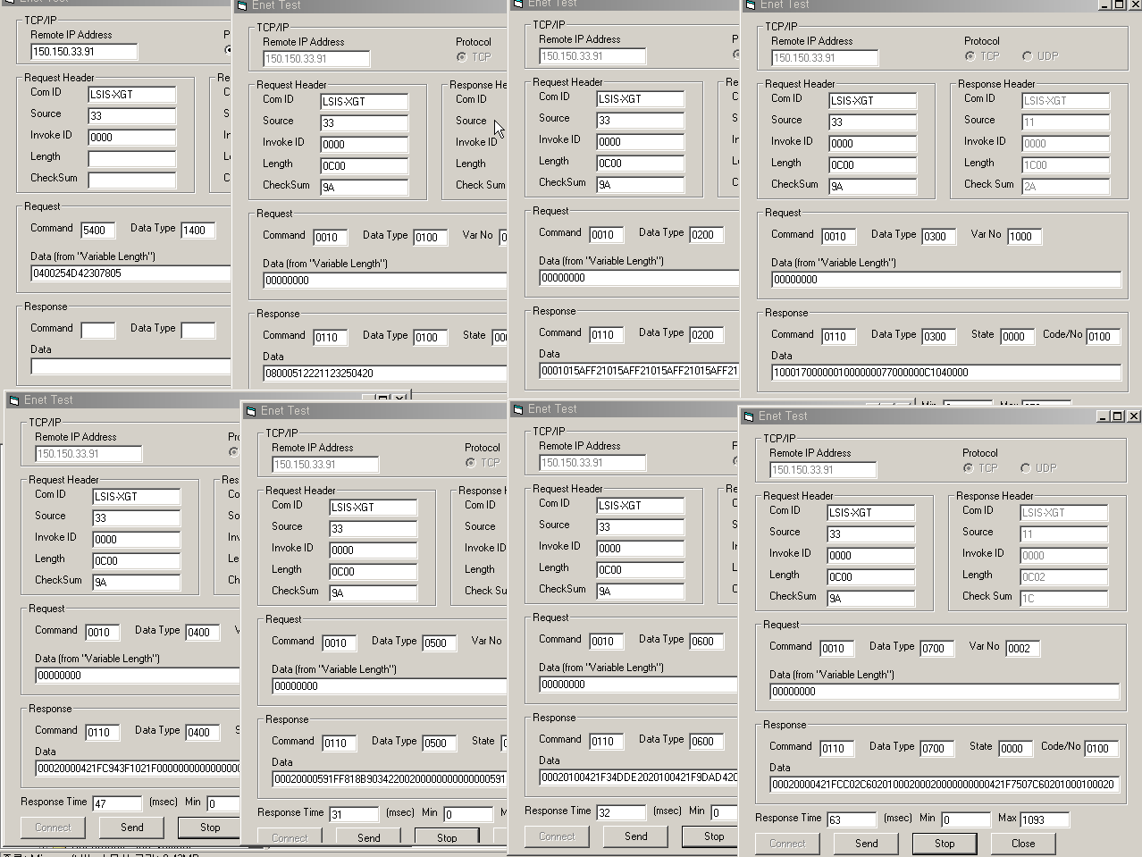

6/17

XGL-FEnet Software Design Test

6-1-2-2) Device Area Read

This area can be accessible through previous protocol’s separate reading and continuous reading. However, the following functions are added to ensure the overall efficiency.

CMD | AREA CODE | Reserved | # of Block | Device Type | Data Type | Bit Position | Offset
 |  |  |  |  |  | Size | Offset
Item |  | Size(byte) | Description
CMD |  | 2 | Read Request : 0x1000
AREA CODE |  | 2 | Device : 0x0010
Reserved |  | 2 | 0x0000 : Don’t Care
# of Block |  | 2 | 1 ~ 64
Device Type |  | 1 | P, M, L, K, T, C, D, R, N, ZR(W) ...
Data Type |  | 1 | X(Bit), B(Byte)
Bit Position |  | 2 | Bit Position : 0 ~ 7  Size of Block : 1 ~ 1400(Bytes)  Size of Block0 + Size of Block1+…+Size of Block64 < 1400
Size of Block |  | 2
Offset |  | 4 | changeable according to AREA CODE

7/17

XGL-FEnet Software Design Test

6-1-3) Response Format

CMD | AREA CODE | Reserved | Status | Reserved | Size | Data..

CF. Previous Dedicated communication service

CMD | Data Type | Reserved | Status | # of  Blocks | # of Data | Data..

6-1-3-1) System /Device Area Read Response

Item | Size(byte) | Description
CMD | 2 | Read Response : 0x1001
 |  | Device | 0x0010
Reserved | 2 | 0x0000
Status | 2 | Normal if it is 0, abnormal if not 0
Reserved | 2 | 0x0000
Size | 2 | Number of Data, 1 ~ 1400(Bytes)
Data | Size

8/17

XGL-FEnet Software Design Test

6-1-4-9) Device Area Read
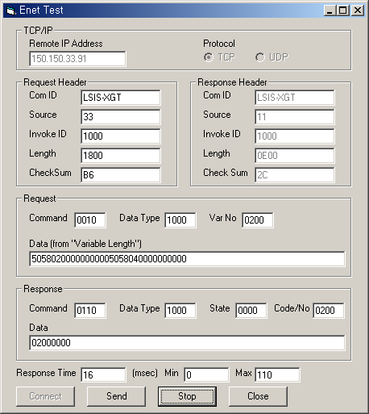
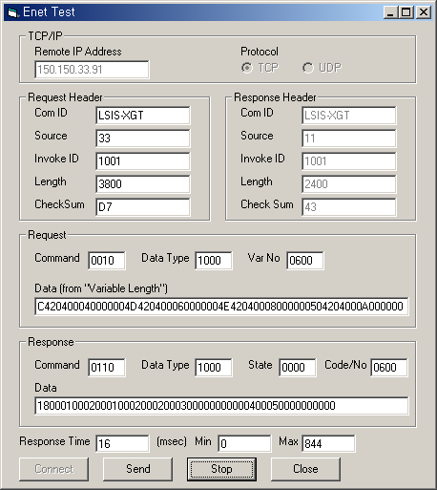

Bit Request Frame
CMD | AREA CODE | Reserved | # of Block | Device Type | Data Type | Bit Position | Offset
0x1000 | 0x0010 | 0x0000 | 0x0002 | 0x50 | 0x58 | 0x02 | 0x00000000
 |  |  |  | 0x50 | 0x58 | 0x04 | 0x00000000

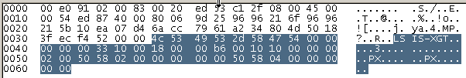 | 0000 00 e0 91 02 00 83 00 20 ed 53 c1 2f 08 00 45 00  0010 00 54 ed 87 40 00 80 06 9d 25 96 96 21 6f 96 96  0020 21 5b 10 ea 07 d4 6a cc 79 61 a2 34 80 4d 50 18  0030 3f ec f4 52 00 00 4c 53 49 53 2d 58 47 54 00 00  0040 00 00 00 33 10 00 18 00 00 b6 00 10 10 00 00 00  0050 02 00 50 58 02 00 00 00 00 00 50 58 04 00 00 00  0060 00 00

Response Frame

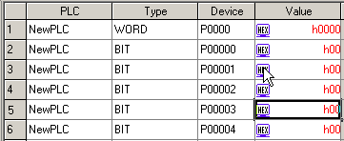 | 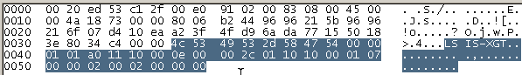
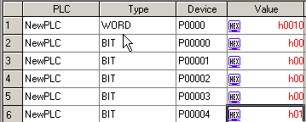 | 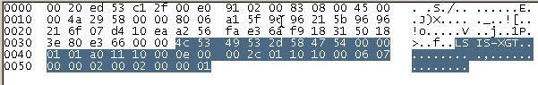

9/17

XGL-FEnet Software Design Test

Byte Request Frame

CMD | AREA CODE | Reserved | # of Block | Device Type | Data Type | Size | Offset
0x1000 | 0x0010 | 0x0000 | 0x0006 | 0x44 | 0x42 | 0x04 | 0x00000000
 | D0 | K1 |  | 0x4B | 0x42 | 0x04 | 0x02000000
 | L2 | M3 |  | 0x4C | 0x42 | 0x04 | 0x04000000
 | N4 | P5 |  | 0x4D | 0x42 | 0x04 | 0x06000000
 |  |  |  | 0x4E | 0x42 | 0x04 | 0x08000000
 |  |  |  | 0x50 | 0x42 | 0x04 | 0x0A000000

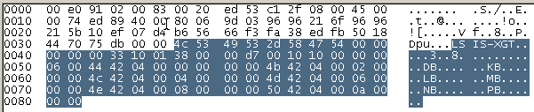 | 0000 00 e0 91 02 00 83 00 20 ed 53 c1 2f 08 00 45 00  0010 00 74 ed 89 40 00 80 06 9d 03 96 96 21 6f 96 96  0020 21 5b 10 ef 07 d4 b6 56 66 f3 fa 38 ed fb 50 18  0030 44 70 75 db 00 00 4c 53 49 53 2d 58 47 54 00 00  0040 00 00 00 33 10 01 38 00 00 d7 00 10 10 00 00 00  0050 06 00 44 42 04 00 00 00 00 00 4b 42 04 00 02 00  0060 00 00 4c 42 04 00 04 00 00 00 4d 42 04 00 06 00  0070 00 00 4e 42 04 00 08 00 00 00 50 42 04 00 0a 00  0080 00 00
Response Frame

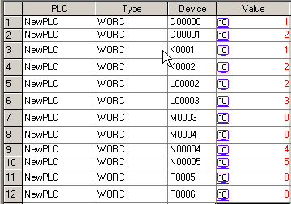 | 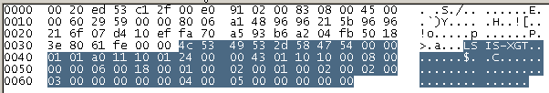
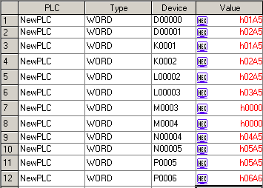 | 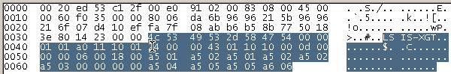

10/17

XGL-FEnet Software Design Test

Byte Request Frame

CMD | AREA CODE | Reserved | # of  Block | Device Type | Data  Type | Size | Offset
0x1000 | 0x0010 | 0x0000 | 0x0006 | 0x52 | 0x42 | 0x04 | 0x0C000000
 | R6 | S7 |  | 0x53 | 0x42 | 0x04 | 0x0E000000
 | T8 | U9 |  | 0x54 | 0x42 | 0x04 | 0x10000000
 | W(ZR)10 | Z11 |  | 0x55 | 0x42 | 0x04 | 0x12000000
 |  |  |  | 0x57 | 0x42 | 0x04 | 0x14000000
 |  |  |  | 0x5A | 0x42 | 0x04 | 0x16000000

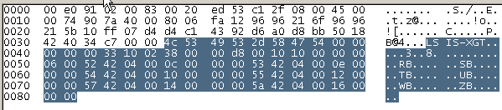 | 0000 00 e0 91 02 00 83 00 20 ed 53 c1 2f 08 00 45 00  0010 00 74 90 7a 40 00 80 06 fa 12 96 96 21 6f 96 96  0020 21 5b 10 ff 07 d4 d4 c1 43 92 d6 a0 d8 bb 50 18  0030 42 40 34 c7 00 00 4c 53 49 53 2d 58 47 54 00 00  0040 00 00 00 33 10 02 38 00 00 d8 00 10 10 00 00 00  0050 06 00 52 42 04 00 0c 00 00 00 53 42 04 00 0e 00  0060 00 00 54 42 04 00 10 00 00 00 55 42 04 00 12 00  0070 00 00 57 42 04 00 14 00 00 00 5a 42 04 00 16 00  0080 00 00

Response Frame

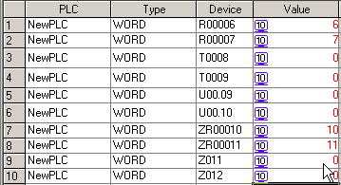 | 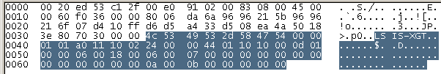
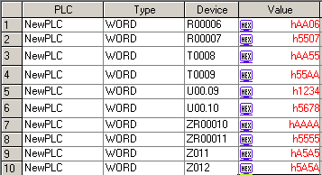 | 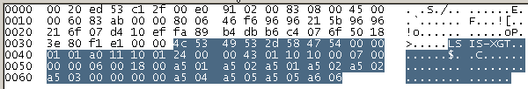

11/17

XGL-FEnet Software Design Test

WRITE

6-2-1) Introduction
·RTC Data SET or Device Data Write Supports;

6-2-2) Request Format

6-2-2-2) Device Area Write

CMD | AREA CODE | Reserved | # of Block | Device Type | Data Type | Size | Offset | Data

Item | Size(byte) | Description
CMD | 2 | Write Response : 0x1010
AREA CODE | 2 | Device : 0x0010
Reserved | 2 | 0x0000
# of Block | 2 | 1 ~ 64
Device Type | 1 | P, M, L, K, T, C, D, R, N, ZR(W)
Data Type | 1 | X, B
Bit Position | 2 | Bit Position : 0 ~ 7  Size of Block : 1 ~ 1400(Bytes)  Size of Block0 + Size of Block1+…+Size of Block64 < 1400
Size of Block | 2
Offset | 4 | changeable according to AREA CODE
Data | Size of Block | Write Data
…

12/17

XGL-FEnet Software Design Test

6-2-3) Response Format

CMD | AREA CODE | Reserved | Status | Error code

6-2-4-2) Device Area Write
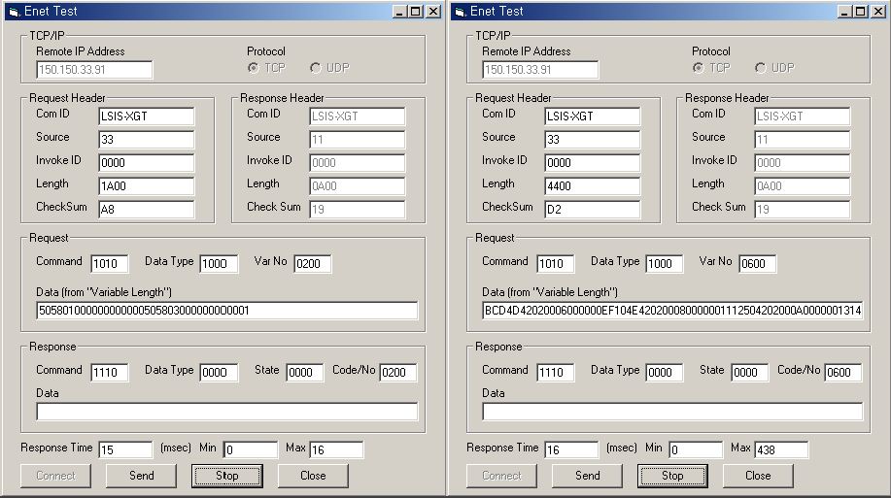

Bit Request Frame

CMD | AREA CODE | Reserved | # of Block | Device Type | Data Type | Bit Position | Offset | Data
0x1010 | 0x0010 | 0x0000 | 0x0002 | 0x50 | 0x58 | 0x01 | 0x00000000 | 00
 |  |  |  | 0x50 | 0x58 | 0x03 | 0x00000000 | 01

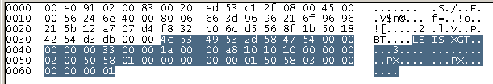 | 0000 00 e0 91 02 00 83 00 20 ed 53 c1 2f 08 00 45 00  0010 00 56 24 6e 40 00 80 06 66 3d 96 96 21 6f 96 96  0020 21 5b 12 a7 07 d4 f8 32 c0 6c d5 56 8f 1b 50 18  0030 42 54 d3 db 00 00 4c 53 49 53 2d 58 47 54 00 00  0040 00 00 00 33 00 00 1a 00 00 a8 10 10 10 00 00 00  0050 02 00 50 58 01 00 00 00 00 00 01 50 58 03 00 00  0060 00 00 00 01

Response Frame

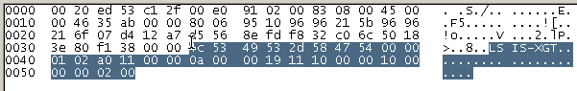  0000 00 20 ed 53 c1 2f 00 e0 91 02 00 83 08 00 45 00  0010 00 46 35 ab 00 00 80 06 95 10 96 96 21 5b 96 96  0020 21 6f 07 d4 12 a7 d5 56 8e fd f8 32 c0 6c 50 18  0030 3e 80 f1 38 00 00 4c 53 49 53 2d 58 47 54 00 00  0040 01 02 a0 11 00 00 0a 00 00 19 11 10 00 00 10 00  0050 00 00 02 00 | 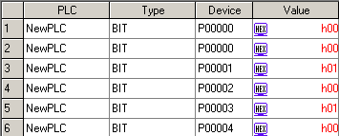

13/17

XGL-FEnet Software Design Test

Byte Request Frame

CMD | AREA CODE | Reserved | # of Block | Device Type | Data Type | Size | Offset
0x1010 | 0x0010 | 0x0000 | 0x0006 | 0x44 | 0x42 | 0x0002 | 0x00000000 | 0x3412
 | D0 | K1 |  | 0x4B | 0x42 | 0x0002 | 0x02000000 | 0x7856
 | L2 | M3 |  | 0x4C | 0x42 | 0x0002 | 0x04000000 | 0xCDAB
 | N4 | P5 |  | 0x4D | 0x42 | 0x0002 | 0x06000000 | 0x10EF
 |  |  |  | 0x4E | 0x42 | 0x0002 | 0x08000000 | 0x1211
 |  |  |  | 0x50 | 0x42 | 0x0002 | 0x0A000000 | 0x1413

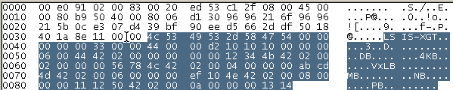 | 0000 00 e0 91 02 00 83 00 20 ed 53 c1 2f 08 00 45 00  0010 00 80 b9 50 40 00 80 06 d1 30 96 96 21 6f 96 96  0020 21 5b 0c e3 07 d4 39 bf 90 ee d5 66 2d df 50 18  0030 40 1a 8e 11 00 00 4c 53 49 53 2d 58 47 54 00 00  0040 00 00 00 33 00 00 44 00 00 d2 10 10 10 00 00 00  0050 06 00 44 42 02 00 00 00 00 00 12 34 4b 42 02 00  0060 02 00 00 00 56 78 4c 42 02 00 04 00 00 00 ab cd  0070 4d 42 02 00 06 00 00 00 ef 10 4e 42 02 00 08 00  0080 00 00 11 12 50 42 02 00 0a 00 00 00 13 14
Response Frame

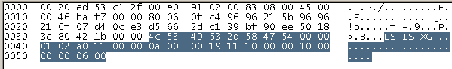  0000 00 20 ed 53 c1 2f 00 e0 91 02 00 83 08 00 45 00  0010 00 46 ba f7 00 00 80 06 0f c4 96 96 21 5b 96 96  0020 21 6f 07 d4 0c e3 d5 66 2d c1 39 bf 90 ee 50 18  0030 3e 80 42 1b 00 00 4c 53 49 53 2d 58 47 54 00 00  0040 01 02 a0 11 00 00 0a 00 00 19 11 10 00 00 10 00  0050 00 00 06 00 | 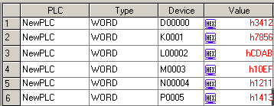

Byte Request Frame

0x1010 | 0x0010 | 0x0000 | 0x0006 | 0x52 | 0x42 | 0x0002 | 0x0C000000 | 0x1615
 | R6 | S7 |  | 0x53 | 0x42 | 0x0002 | 0x0E000000 | 0x1817
 | T8 | U9 |  | 0x54 | 0x42 | 0x0002 | 0x10000000 | 0x1A19
 | W(ZR)10 | Z11 |  | 0x55 | 0x42 | 0x0002 | 0x12000000 | 0x1C1B
 |  |  |  | 0x57 | 0x42 | 0x0002 | 0x14000000 | 0x1E1D
 |  |  |  | 0x5A | 0x42 | 0x0002 | 0x16000000 | 0x201F

0000 00 e0 91 02 00 83 00 20 ed 53 c1 2f 08 00 45 00
0010 00 74 90 7a 40 00 80 06 fa 12 96 96 21 6f 96 96
0020 21 5b 10 ff 07 d4 d4 c1 43 92 d6 a0 d8 bb 50 18
0030 42 40 34 c7 00 00 4c 53 49 53 2d 58 47 54 00 00
0040 00 00 00 33 10 02 38 00 00 d8 00 10 10 00 00 00
0050 06 00 52 42 04 00 0c 00 00 00 53 42 04 00 0e 00
0060 00 00 54 42 04 00 10 00 00 00 55 42 04 00 12 00

14/17

XGL-FEnet Software Design Test

0000 00 e0 91 02 00 83 00 20 ed 53 c1 2f 08 00 45 00  0010 00 80 76 a0 40 00 80 06 13 e1 96 96 21 6f 96 96  0020 21 5b 0c e3 07 d4 39 ff 0a ec d5 7b f4 99 50 18  0030 41 0a 56 22 00 00 4c 53 49 53 2d 58 47 54 00 00  0040 00 00 00 33 00 00 44 00 00 d2 10 10 10 00 00 00  0050 06 00 52 42 02 00 0c 00 00 00 15 16 53 42 02 00  0060 0e 00 00 00 17 18 54 42 02 00 10 00 00 00 19 1a  0070 55 42 02 00 12 00 00 00 1b 1c 57 42 02 00 14 00  0080 00 00 1d 1e 5a 42 02 00 16 00 00 00 1f 20 | 0070 00 00 57 42 04 00 14 00 00 00 5a 42 04 00 16 00  0080 00 00

Response Frame
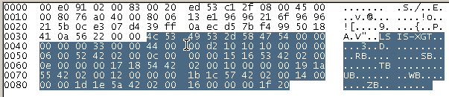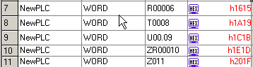

15/17

XGL-FEnet Software Design Test

Appendix

A. Details of error code hex 2 Bytes

Error Code | Error Type | Error details and causes | Remarks
0x00 | Frame Error | BCC Error
0x01
0x02 | Command Error | Unknown Command
0x03 | Sub Command Error | Unknown Sub Command
0x04 | Area Address Error | Request exceeds the area each device supports.
0x05 | Data Value Error | Request abnormal Data (RTC Data, Bit Pos..)
0x10 | Data size error | Request exceeds the max range of 1400 Bytes to read or write at a time.
0x11 | Data type error | Other data type than X,B received.
0x12 | Device type Error | Other device type than P, M, L, K, T, C, U, D, N, R. W. received.
0x13 | Number of blocks exceeded | Number of blocks exceeds 64 at Read/Write Request  Number of blocks exceeds 40 at  TB/CoS Request

16/17

XGL-FEnet Software Design Test

17/17

