CAPSTONE PROJECT REPORT
Report 3 – Software Requirement Specification
GeoSentry (TerraWatch)
Rainfall-Triggered Landslide Hazard Forecasting and Early-Warning System
– October 2026 –

Table of Contents
I. Record of Changes
II. Software Requirement Specification
1. Product Overview
2. User Requirements
2.1 Actors
2.2 Use Cases
2.2.1 Diagram(s)
2.2.2 Descriptions
3. Functional Requirements
3.1 System Functional Overview
3.1.1 Screens Flow
3.1.2 Screen Descriptions
3.1.3 Screen Authorization
3.2 Authentication
3.2.1 Sign Up
3.2.2 Sign In
3.3 Incident Verification Management
3.3.1 Review Verification Queue
3.3.2 Verify / Reject Event
3.4 Community Reporting
3.4.1 Submit Community Report
3.4.2 Review Community Reports
3.5 Monitoring Area (AOI) Management
3.5.1 Configure Monitoring Areas
3.6 Rainfall, Terrain and Feature Snapshot Ingestion
3.6.1 Ingest Rainfall and Extract Terrain
3.6.2 Build Feature Snapshot
3.7 Hazard Forecast Generation and Review (Planned)
3.7.1 Generate 24-Hour Hazard Prediction
3.7.2 Approve / Reject Forecast Proposal
3.8 Emergency Alert Broadcasting
3.8.1 Broadcast Emergency Notification
3.9 Mobile and Offline Alerting (Planned)
3.9.1 Offline Geofence Sync
4. Non-Functional Requirements
4.1 External Interfaces
4.2 Quality Attributes
4.2.1 Usability
4.2.2 Reliability
4.2.3 Performance
4.2.4 Security
4.2.5 Maintainability
5. Requirement Appendix
5.1 Business Rules
5.2 Common Requirements
5.3 Application Messages List
5.4 Supplementary Technical Reference
5.4.1 Acceptance and Release Criteria

I. Record of Changes
Date | A·M·D | In charge | Change Description
2026-09-18 | A | Team | Initial capstone proposal (original TerraWatch scope): remote sensing, DeepLabV3+ segmentation, 3D WebGIS, rescue routing, offline SOS.
2026-10-13 | M | Project owner / Team | Scope pivot: replaced image-segmentation detection with rainfall + terrain, next-24-hour landslide hazard forecasting (PRD v5.0.0, Architecture v2.0.0). Sentinel-2 segmentation, 3D terrain, SOS and rescue dispatch deferred.
2026-10-16 | A | Team (compiled) | Initial Software Requirement Specification (this document), reformatted to the standard capstone report template and cross-checked against the current source tree.
Table 1. Record of Changes
*A - Added M - Modified D - Deleted

II. Software Requirement Specification

1. Product Overview
GeoSentry (TerraWatch) is a web- and mobile-based platform that predicts rainfall-triggered landslide hazard for the next 24 hours in mountainous monitored areas, and coordinates the review and delivery of emergency warnings. It combines recent rainfall observations, next-24-hour weather forecasts and terrain (slope, elevation, relief derived from a DEM) into a versioned feature snapshot, which a baseline/ML model scores as low / medium / high / extreme hazard. A Disaster Officer reviews every proposal before an Administrator confirms and broadcasts it over SMS and push notification (FCM). The context diagram below shows the system boundary and its interactions with end users and external data/delivery providers.
This document replaces an earlier project direction built around Sentinel-2 satellite image segmentation (DeepLabV3+), 3D WebGIS terrain visualization and AI-suggested rescue routing. That scope is preserved as context in Chapter I and §1.4 of the companion architecture notes, but is not part of the requirements specified below; see the Record of Changes for the 2026-10-13 pivot.
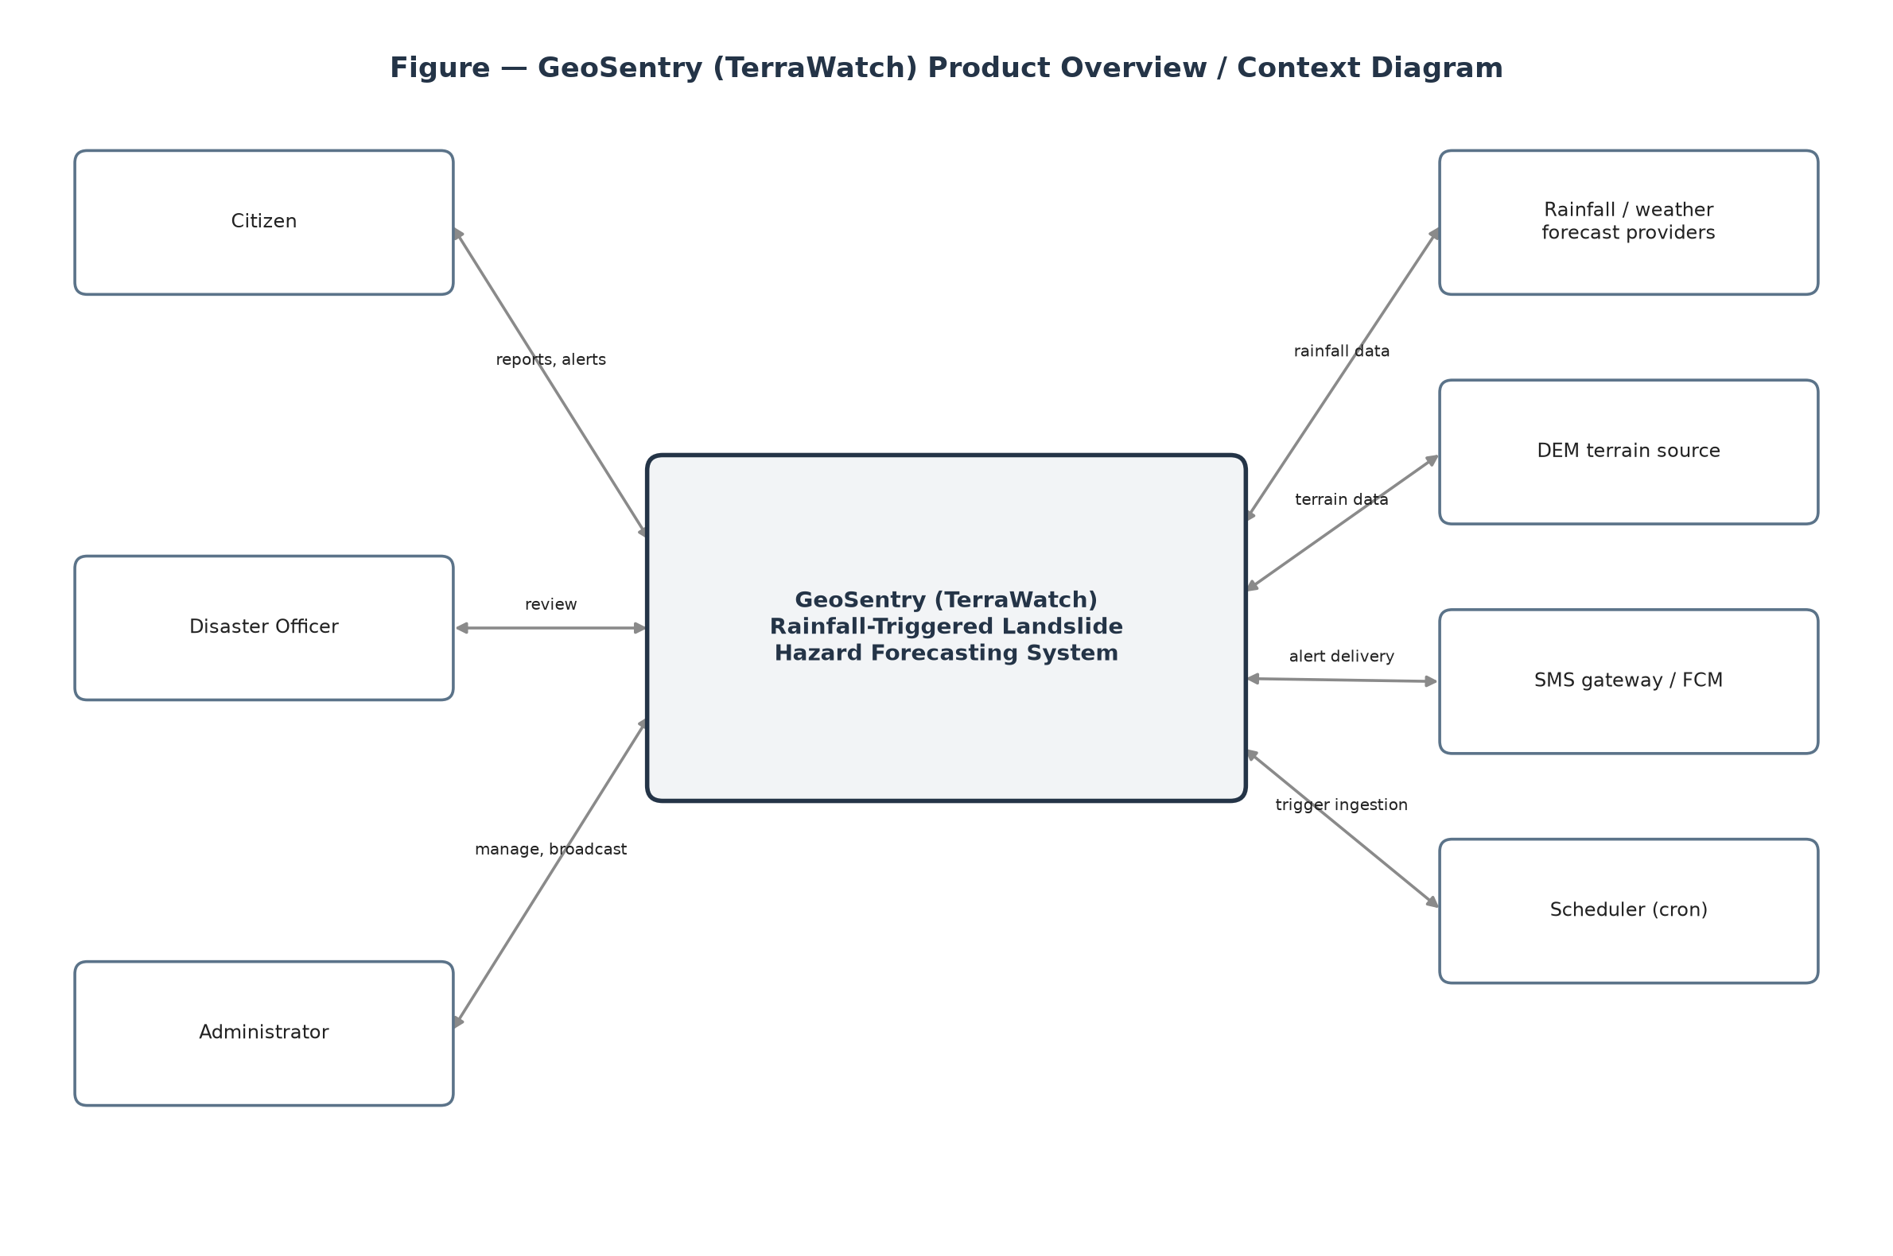
Figure 1. Product Overview

2. User Requirements

2.1 Actors
# | Actor | Description
1 | Administrator | Manages users and RBAC, configures monitoring areas (AOI), and is the only role authorized to approve and broadcast emergency SMS/FCM alerts. Also monitors service health, circuit breakers and the audit trail.
2 | Disaster Officer | PCTT (disaster-prevention) staff who reviews rainfall/forecast evidence and community reports, and verifies or rejects incidents and forecast proposals before any warning is issued.
3 | Citizen | Resident of a monitored mountain area who views active incidents and monitoring areas, submits community reports with photo and GPS, and receives alerts, including an offline-cached view when disconnected.
Table 2. Actors
The original proposal additionally defined a Rescue Team actor for dispatch and AI-suggested routing. Rescue coordination is deferred (see Record of Changes); this role is not part of the current requirement set.

2.2 Use Cases

2.2.1 Diagram(s)
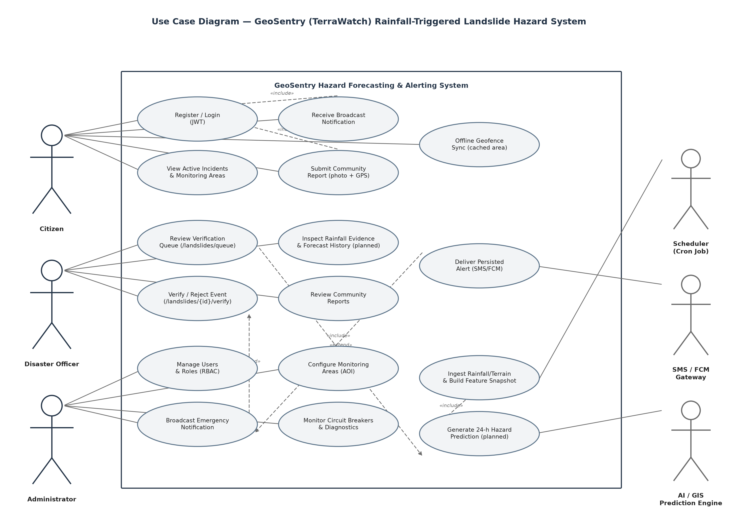
Figure 2. GeoSentry Use Case Diagram

2.2.2 Descriptions
ID | Use Case | Actors | Use Case Description | Status
1 | Sign Up | Citizen, Officer, Admin | Users register a new account on the system. | Implemented
2 | Sign In | Citizen, Officer, Admin | Users log into the system using JWT-based authentication. | Implemented
3 | View Active Incidents | Citizen, Officer, Admin | Users view active landslide incidents as map geometry. | Implemented
4 | View Monitoring Areas | Citizen, Officer, Admin | Users view configured monitoring area (AOI) boundaries. | Implemented
5 | Submit Community Report | Citizen | Citizens submit a report with photo and description about a suspected landslide. | Implemented
6 | Offline Geofence Sync | Citizen | The mobile app reconciles cached hazard geometry on reconnect and runs local geofencing. | Planned
7 | Review Verification Queue | Officer | Officers list pending incidents awaiting review. | Implemented
8 | Verify / Reject Event | Officer | Officers approve or reject a pending incident, recording an audit entry. | Implemented
9 | Review Community Reports | Officer | Officers list and cross-reference citizen-submitted reports. | Implemented
10 | Inspect Rainfall & Forecast Evidence | Officer | Officers inspect rainfall history, terrain and forecast quality for a unit before approving a warning. | Planned
11 | Approve / Reject Forecast Proposal | Officer | Officers approve or reject an AI-generated hazard forecast proposal. | Planned
12 | Manage Users & Roles | Admin | Admins create/update user accounts and assign CITIZEN / OFFICER / ADMIN roles. | Planned (RBAC exists; account-admin UI planned)
13 | Configure Monitoring Areas | Admin | Admins create and list monitoring area (AOI) boundaries. | Implemented
14 | Broadcast Emergency Notification | Admin | Admins confirm scope/template and trigger an SMS/FCM broadcast; non-admin callers receive 403. | Implemented
15 | Monitor Diagnostics & Audit | Admin | Admins inspect circuit-breaker health and publish/inspect internal event-bus diagnostics. | Implemented
16 | Ingest Rainfall & Terrain | Scheduler → GIS Service | The GIS service ingests rainfall observations and extracts DEM-derived terrain features for a unit. | Implemented
17 | Build Feature Snapshot | GIS Service | The GIS service assembles an immutable, versioned rainfall+terrain feature snapshot. | Implemented
18 | Generate 24-Hour Hazard Prediction | Core API → AI Service | Core persists a forecast job; AI validates the snapshot and predicts hazard level or returns unavailable+reason. | Planned
Table 3. Use Case Description

3. Functional Requirements

3.1 System Functional Overview

3.1.1 Screens Flow
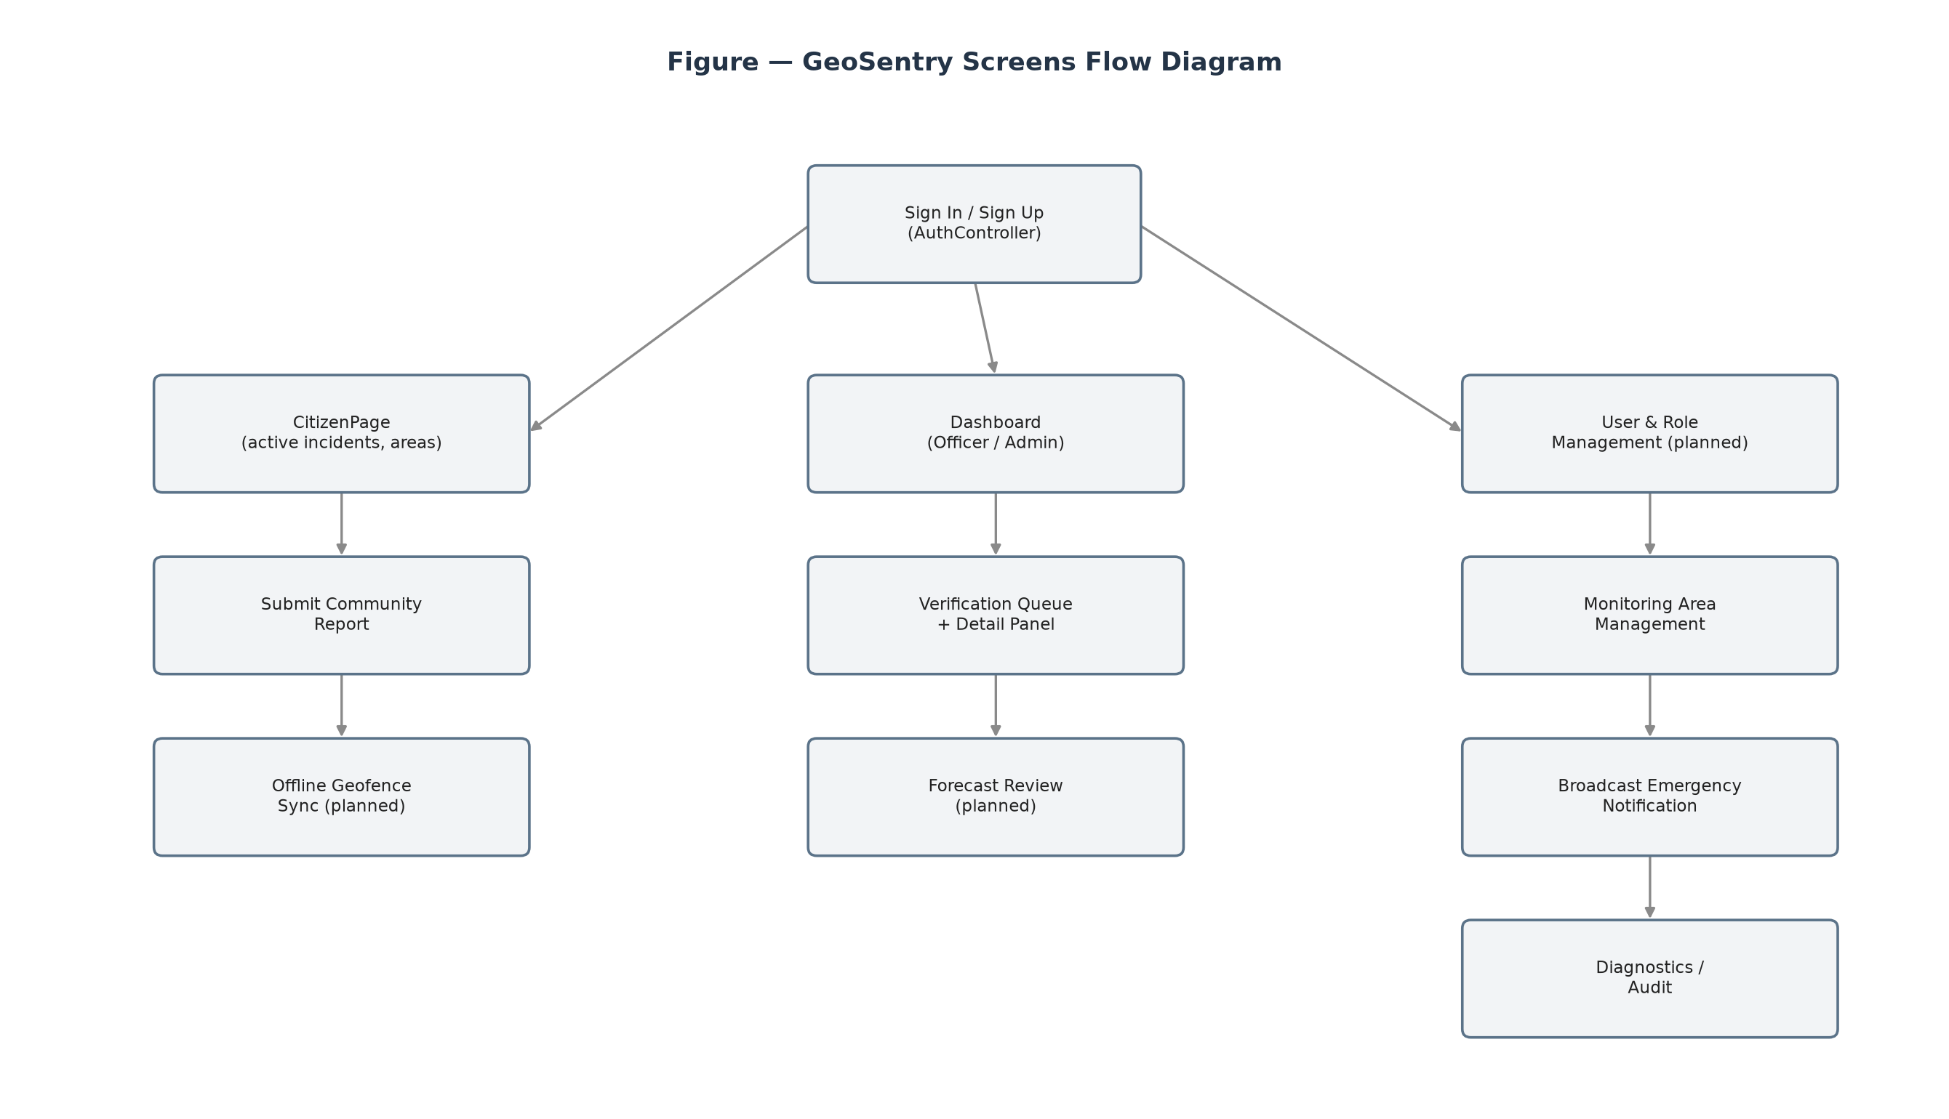
Figure 3. GeoSentry Screens Flow Diagram

3.1.2 Screen Descriptions
# | Feature | Screen | Description | Status
1 | Authentication | Sign In | Allows a user to log into the system with registered credentials (JWT). | Implemented
2 | Authentication | Sign Up | Allows a new user to register a Citizen account. | Implemented
3 | Officer/Admin Console | Dashboard | Operational landing page combining the map, verification queue and detail panel. | Implemented
4 | Incident Review | Verification Queue | Lists pending incidents awaiting Officer review (EventCard list). | Implemented
5 | Incident Review | Detail Panel | Shows evidence for the selected incident and the Verify/Reject actions. | Implemented
6 | Evidence Review | Rainfall Evidence Panel | Displays rainfall history and terrain evidence supporting a forecast. | Planned
7 | Alerting | Broadcast Modal | Lets the Admin configure scope, template, severity and channel, then confirm a broadcast. | Implemented
8 | Alerting | Broadcast History Modal | Shows past broadcasts and their delivery status. | Partial
9 | Alerting | Emergency Alert Prompt | Surfaces an in-app prompt when an unreviewed emergency-worthy event exists. | Partial
10 | Area Management | Monitoring Areas | Lets the Admin create and list monitoring area (AOI) boundaries. | Implemented
11 | Citizen Console | Citizen Page | Citizen map view of active incidents/areas plus report submission. | Implemented
12 | Mobile | App entry / Geofencing | Flutter app skeleton with an on-device geofencing service module. | Partial (screens planned)
Table 4. Screen Description

3.1.3 Screen Authorization
Screen | Citizen | Officer | Admin
Sign In / Sign Up | X | X | X
Citizen Page | X
Dashboard |  | X | X
Verification Queue / Detail Panel |  | X | X
Rainfall Evidence Panel (planned) |  | X | X
Monitoring Areas (configure) |  |  | X
Broadcast Modal / History |  |  | X
Diagnostics (circuit breaker / event bus) |  |  | X
Table 5. Screen Authorization

3.2 Authentication

3.2.1 Sign Up
Function Trigger:
- Primary Trigger: A new user opens the registration screen from the login page.
- Secondary Trigger: A user without an account wants to submit reports or receive alerts.
Function Description:
- Role: Citizen
- Purpose: Allow a new user to create a Citizen account secured by JWT-based authentication.
- Interface: The Sign Up screen includes the following sections:
  - Full Name input
  - Email input
  - Password input
  - Confirm Password input
  - Register button
  - Link to Sign In
Screen Layout:
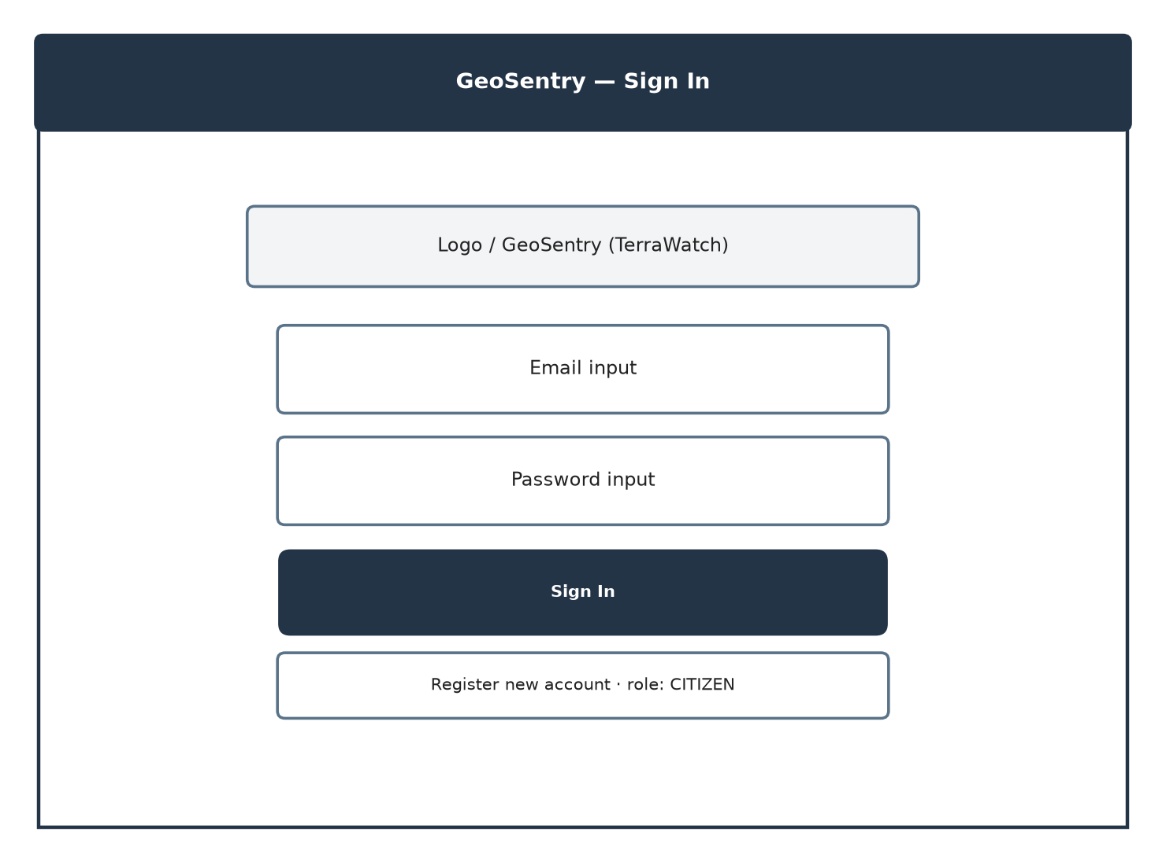
Figure 4. Sign Up / Sign In Screen Layout
Function Details:
- Data:
  - Full Name: user's display name.
  - Email: unique account identifier.
  - Password: hashed before storage (never stored in plain text).
- Validation and Business Rules:
  - In Normal Cases:
    - If all required fields are valid and the email is unique: the system creates the account with role CITIZEN and returns a JWT.
  - In Abnormal Cases:
    - If the email is already registered: the system returns a conflict error.
    - If a required field is empty or the password confirmation does not match: the system returns a validation error naming the field.

# | Component | Comp. type | Editable | Mandatory | Description
1 | Email Input | Input (Email) | Yes | Yes | Registered account identifier.
2 | Password Input | Input (Password) | Yes | Yes | Account password; hashed server-side.
3 | Register Button | Button | No | Yes | Submits the registration request.
Table 6. Sign Up

3.2.2 Sign In
Function Trigger:
- Primary Trigger: A registered user opens the login screen.
- Secondary Trigger: A session token has expired and the user must re-authenticate.
Function Description:
- Role: Citizen, Officer, Admin
- Purpose: Authenticate a user and issue a role-scoped JWT used by all subsequent requests.
- Interface: The Sign In screen includes the following sections:
  - Email input
  - Password input
  - Sign In button
  - Link to Sign Up
Function Details:
- Data:
  - Email / Password: credentials validated against the stored password hash.
- Validation and Business Rules:
  - In Normal Cases:
    - If the credentials are valid: the system returns a JWT embedding the user's role (CITIZEN / OFFICER / ADMIN).
  - In Abnormal Cases:
    - If the credentials are invalid: the system returns 401 Unauthorized.
    - If the account is disabled: the system rejects the login with an explanatory reason.

3.3 Incident Verification Management

3.3.1 Review Verification Queue
Function Trigger:
- Primary Trigger: Officer navigates to the Dashboard after signing in.
- Secondary Trigger: A new incident is created by the GIS/AI pipeline or escalated from a community report.
Function Description:
- Role: Officer
- Purpose: Let an Officer see every incident awaiting a verification decision before it can be escalated to a warning.
- Interface: The Review Verification Queue screen includes the following sections:
  - Navbar (Dashboard, Verification Queue, Monitoring Areas, Broadcast)
  - MapViewer showing incident geometries and monitoring areas
  - VerificationQueue list of EventCards
  - DetailPanel for the selected incident
Screen Layout:
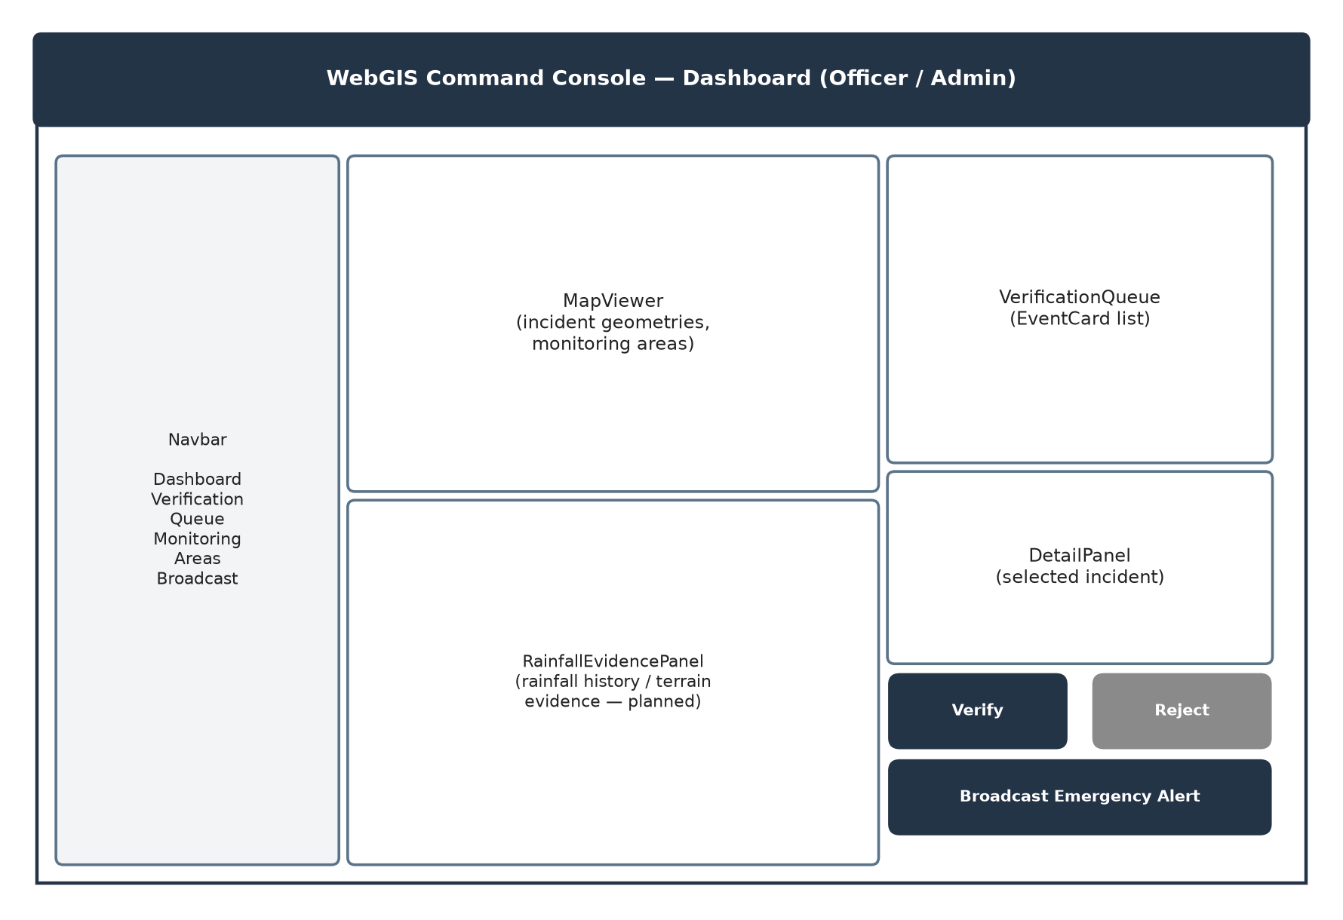
Figure 5. Dashboard / Verification Queue Screen Layout
Function Details:
- Data:
  - Incident: detectionDate, riskLevel, status, confidenceScore, slopeDegrees, ndviDrop.
  - MonitoringArea: name, boundary geometry used to scope the map view.
- Validation and Business Rules:
  - In Normal Cases:
    - If pending incidents exist: the system lists them ordered by detection date, newest first.
    - If an Officer selects an incident: the DetailPanel shows its full evidence.
  - In Abnormal Cases:
    - If the queue is empty: the system shows an empty-state message.
    - If the incident list fails to load: the system shows a retry option and does not silently show stale data.

# | Component | Comp. type | Editable | Mandatory | Description
1 | Incident List | List / EventCard | No | Yes | Lists pending incidents from GET /api/v1/landslides/queue.
2 | Detail Panel | Panel | No | No | Displays evidence for the selected incident.
Table 7. Review Verification Queue

3.3.2 Verify / Reject Event
Function Trigger:
- Primary Trigger: Officer opens an incident's Detail Panel from the Verification Queue.
- Secondary Trigger: Officer has cross-referenced the incident with rainfall evidence and/or community reports.
Function Description:
- Role: Officer
- Purpose: Record an authenticated, auditable decision on a pending incident.
- Interface: The Verify / Reject Event screen includes the following sections:
  - Verify button
  - Reject button
  - Optional officer note field
Function Details:
- Data:
  - Decision: verified / rejected.
  - Officer note: free-text justification.
  - History entry: previousStatus, newStatus, changedBy, changedAt.
- Validation and Business Rules:
  - In Normal Cases:
    - If Verify is clicked: the system sets the incident status to verified and appends a LandslideEventHistory entry.
    - If Reject is clicked: the system sets the status to rejected/false_alarm and appends a history entry.
  - In Abnormal Cases:
    - If the incident was already decided by another officer: the system returns a conflict and asks the user to refresh.
    - If the officer is not authenticated with the OFFICER role: the system returns 403.

# | Component | Comp. type | Editable | Mandatory | Description
1 | Verify Button | Button | No | Yes | Calls PATCH /landslides/{id}/verify with decision=verified.
2 | Reject Button | Button | No | Yes | Calls PATCH /landslides/{id}/verify with decision=rejected.
Table 8. Verify / Reject Event

3.4 Community Reporting

3.4.1 Submit Community Report
Function Trigger:
- Primary Trigger: Citizen observes a possible landslide and opens the report form from the Citizen Page.
- Secondary Trigger: Citizen wants to corroborate an existing incident shown on the map.
Function Description:
- Role: Citizen
- Purpose: Let a citizen submit crowd-sourced evidence (photo + description) to support officer review.
- Interface: The Submit Community Report screen includes the following sections:
  - Photo upload control
  - Description text area
  - Submit Report button
Screen Layout:
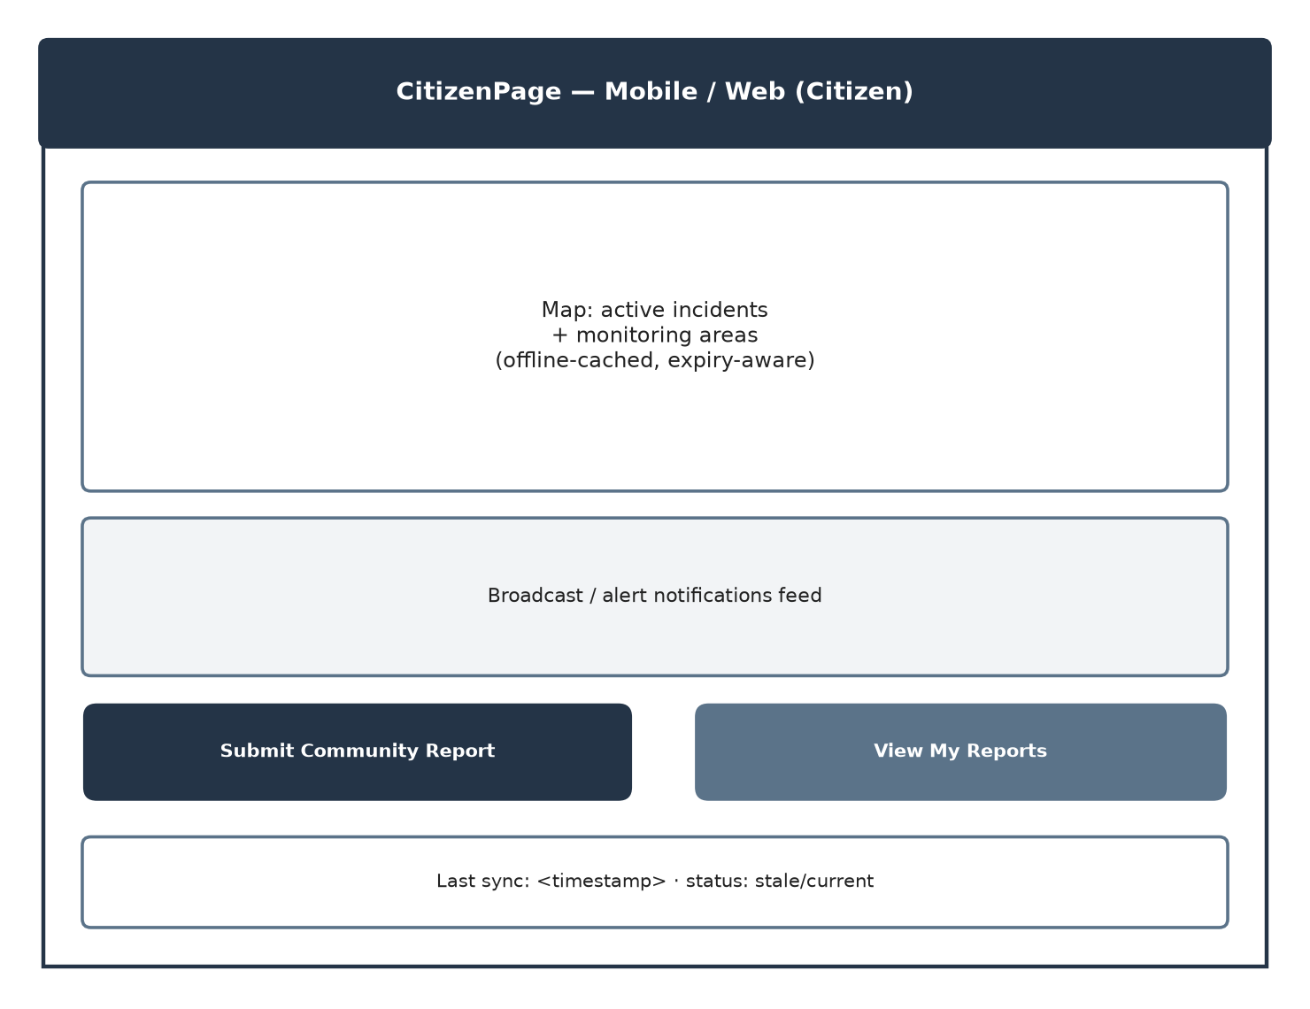
Figure 6. Citizen Page Screen Layout
Function Details:
- Data:
  - reportTime, imageUrl, description: stored against the submitting user's account.
  - status: defaults to pending.
- Validation and Business Rules:
  - In Normal Cases:
    - If the photo and description are valid: the system stores the report with status pending and makes it visible to Officers.
  - In Abnormal Cases:
    - If no photo is attached: the system displays “At least one photo is required.”
    - If the upload exceeds the size limit: the system displays “Image exceeds the maximum allowed size.”

# | Component | Comp. type | Editable | Mandatory | Description
1 | Photo Upload | File Input | Yes | Yes | Attaches field evidence to the report.
2 | Description | Textarea | Yes | No | Free-text description of the observed condition.
3 | Submit Report Button | Button | No | Yes | Calls POST /api/v1/community-reports.
Table 9. Submit Community Report

3.4.2 Review Community Reports
Function Trigger:
- Primary Trigger: Officer opens the Community Reports list from the Dashboard.
Function Description:
- Role: Officer
- Purpose: Let an Officer triage citizen-submitted reports and cross-reference them with incidents.
- Interface: The Review Community Reports screen includes the following sections:
  - Report list with photo thumbnail, submitter, time, status
Function Details:
- Data:
  - Report fields as submitted by the citizen.
- Validation and Business Rules:
  - In Normal Cases:
    - If reports exist: the system lists them with the newest first.
  - In Abnormal Cases:
    - If the report list fails to load: the system shows a retry option.

3.5 Monitoring Area (AOI) Management

3.5.1 Configure Monitoring Areas
Function Trigger:
- Primary Trigger: Admin opens the Monitoring Areas screen.
- Secondary Trigger: A new pilot AOI needs to be registered before rainfall/terrain ingestion can begin.
Function Description:
- Role: Admin
- Purpose: Define and maintain the named polygon boundaries that scope monitoring, ingestion and the WebGIS map.
- Interface: The Configure Monitoring Areas screen includes the following sections:
  - Area name input
  - Description input
  - Boundary geometry editor
  - Active/inactive toggle
  - Create button
Function Details:
- Data:
  - name, description, isActive, createdAt (gis_schema.monitoring_areas).
- Validation and Business Rules:
  - In Normal Cases:
    - If the boundary and name are valid: the system creates the area and makes it available to the GIS pipeline.
  - In Abnormal Cases:
    - If the name is empty or the boundary geometry is invalid: the system returns a validation error.

3.6 Rainfall, Terrain and Feature Snapshot Ingestion
This group has no end-user screen: it is triggered by the Scheduler and executed entirely within the GIS Service (FastAPI, port 8002).

3.6.1 Ingest Rainfall and Extract Terrain
Function Trigger:
- Primary Trigger: A scheduled ingestion job fires on a provider-availability cadence.
- Secondary Trigger: An admin manually re-triggers ingestion for a unit.
Function Description:
- Role: Scheduler → GIS Service
- Purpose: Pull rainfall observations/forecasts and DEM-derived terrain features for a spatial assessment unit.
- Interface: Internal/API operation — no dedicated end-user screen.
Function Details:
- Data:
  - RainfallObservation: unitId, intervalStart/End, amount, availableAt, quality.
  - RainfallForecast: unitId, providerRunId, issuedAt, validFrom/Until.
  - TerrainFeature: slope, elevation, relief, demVersion.
- Validation and Business Rules:
  - In Normal Cases:
    - If the provider returns complete coverage for the interval: the system stores the observation/forecast with its quality flag.
  - In Abnormal Cases:
    - If a gap exists between the latest observation and the issue time: the system records it as missing coverage, never as zero rainfall.
    - If the provider is unavailable: the system returns 503 and does not fabricate data.

3.6.2 Build Feature Snapshot
Function Trigger:
- Primary Trigger: Rainfall and terrain data for a unit are complete as of the current ingestion cycle.
Function Description:
- Role: GIS Service
- Purpose: Assemble an immutable, versioned bundle of rainfall + terrain features as of a given time, to be consumed by one hazard prediction.
- Interface: Internal/API operation — no dedicated end-user screen.
Function Details:
- Data:
  - FeatureSnapshot: unitId/version, asOf, sourceRefs, coverage, quality.
- Validation and Business Rules:
  - In Normal Cases:
    - If all required features are available and within freshness limits: the system persists a new feature_snapshot and returns its ID.
  - In Abnormal Cases:
    - If a required source is stale or incompatible: the system refuses to create the snapshot and reports the reason.

3.7 Hazard Forecast Generation and Review (Planned)
None of the sub-features in this section are implemented yet; the database schema (forecast_runs, forecast_reviews) exists but the Core API does not yet expose a ForecastController, and the AI Service does not yet expose the planned /api/v1/forecasts route. The sequence diagram below specifies the intended end-to-end flow.
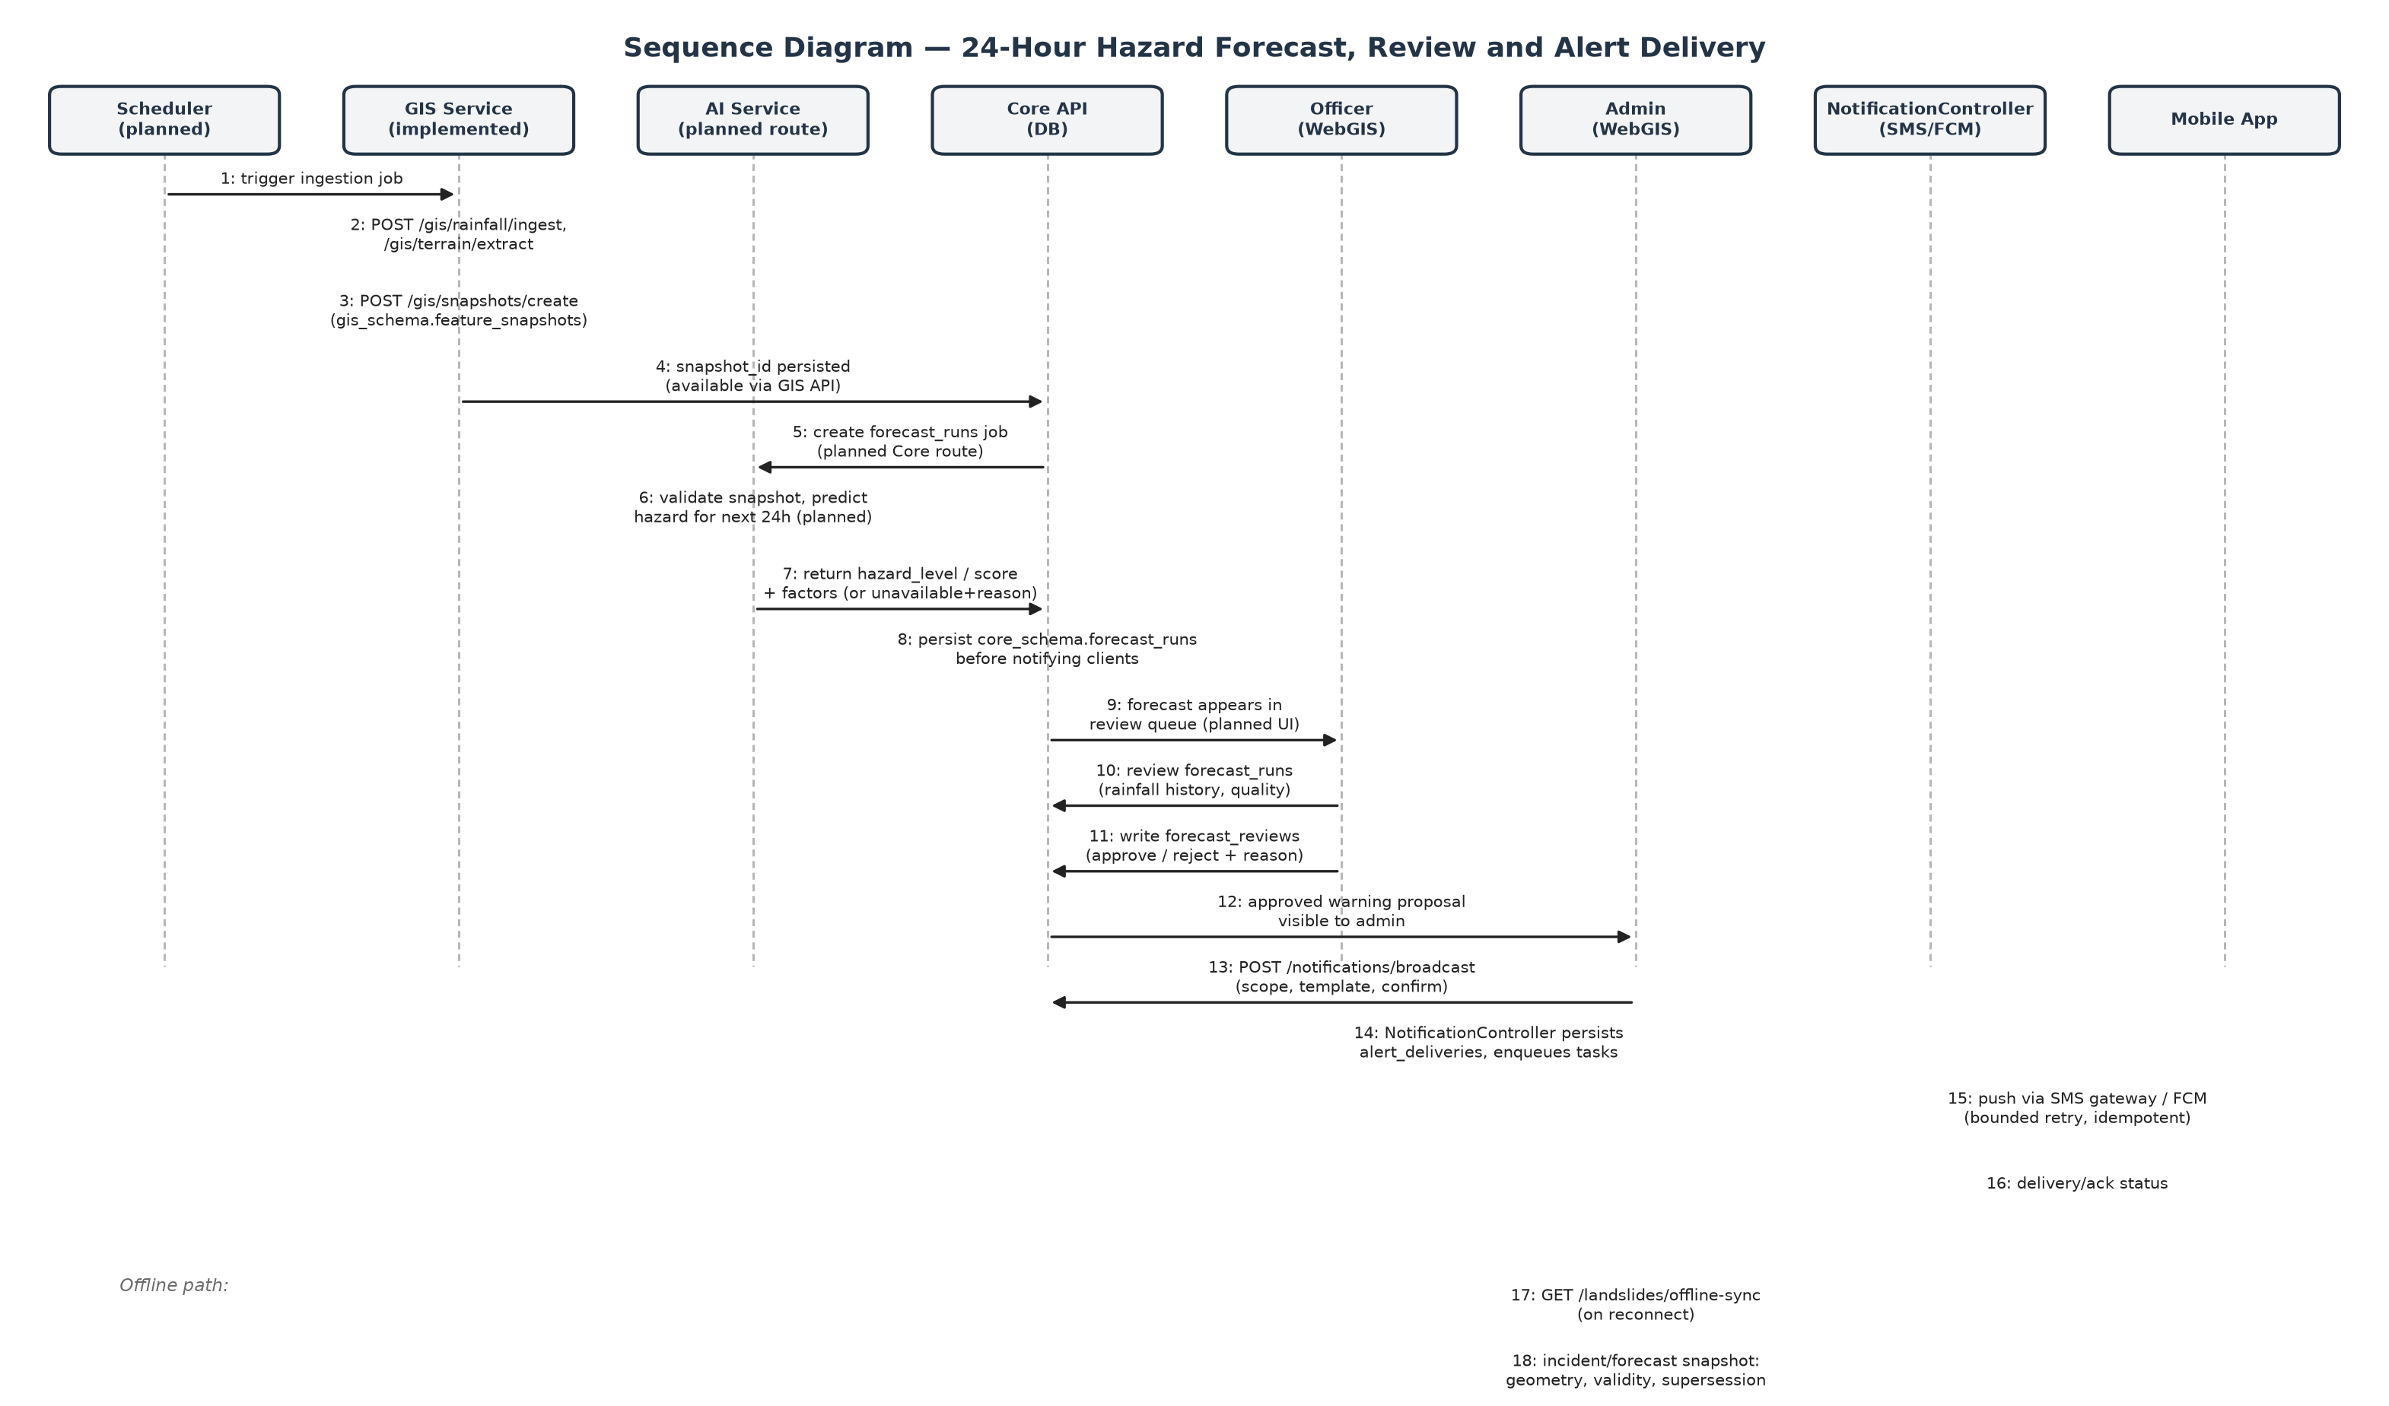
Figure 7. Hazard Forecast Generation, Review and Alert Delivery Sequence

3.7.1 Generate 24-Hour Hazard Prediction
Function Trigger:
- Primary Trigger: A new feature snapshot becomes available for a unit.
Function Description:
- Role: Core API → AI Service
- Purpose: Score a validated feature snapshot for landslide hazard over the next 24 hours.
- Interface: Internal/API operation — no dedicated end-user screen.
Function Details:
- Data:
  - ForecastRun: snapshotId, issuedAt, validFrom/Until, hazardLevel, probability|experimental_score, modelVersion, thresholdVersion.
- Validation and Business Rules:
  - In Normal Cases:
    - If the snapshot is compatible with the released model: the system returns a hazard level with supporting factors.
  - In Abnormal Cases:
    - If the snapshot is stale, incompatible, or no model is released: the system returns availability=unavailable with a reason code and null probability/level.

3.7.2 Approve / Reject Forecast Proposal
Function Trigger:
- Primary Trigger: Officer opens the forecast review queue.
Function Description:
- Role: Officer
- Purpose: Record an authenticated decision on a forecast-based warning proposal, distinct from an observed-incident verification.
- Interface: The Approve / Reject Forecast Proposal screen includes the following sections:
  - Rainfall Evidence Panel (history + forecast charts)
  - Approve button
  - Reject button with reason
Function Details:
- Data:
  - ForecastReview: runId, reviewerId, decision, reason, reviewedAt.
- Validation and Business Rules:
  - In Normal Cases:
    - If approved: the proposal becomes eligible for Admin broadcast; approval does not automatically create a positive training label.
  - In Abnormal Cases:
    - If the run is already superseded or expired: the system returns a conflict.

3.8 Emergency Alert Broadcasting

3.8.1 Broadcast Emergency Notification
Function Trigger:
- Primary Trigger: Admin opens the Broadcast Modal from the Dashboard for a verified incident or approved forecast.
- Secondary Trigger: Admin authors a manual warning when a forecast is unavailable, recording a reason.
Function Description:
- Role: Admin
- Purpose: Confirm scope, template and channel, then persist and deliver an emergency alert. This is the only path that sends a citizen-facing warning; AI scores never trigger a broadcast automatically.
- Interface: The Broadcast Emergency Notification screen includes the following sections:
  - Scope selector (AOI / radius / all subscribers)
  - Severity + template selector
  - Message body (≤160 characters)
  - Channel checkboxes (SMS, FCM)
  - Recipient preview
  - Cancel / Confirm & Send buttons
Screen Layout:
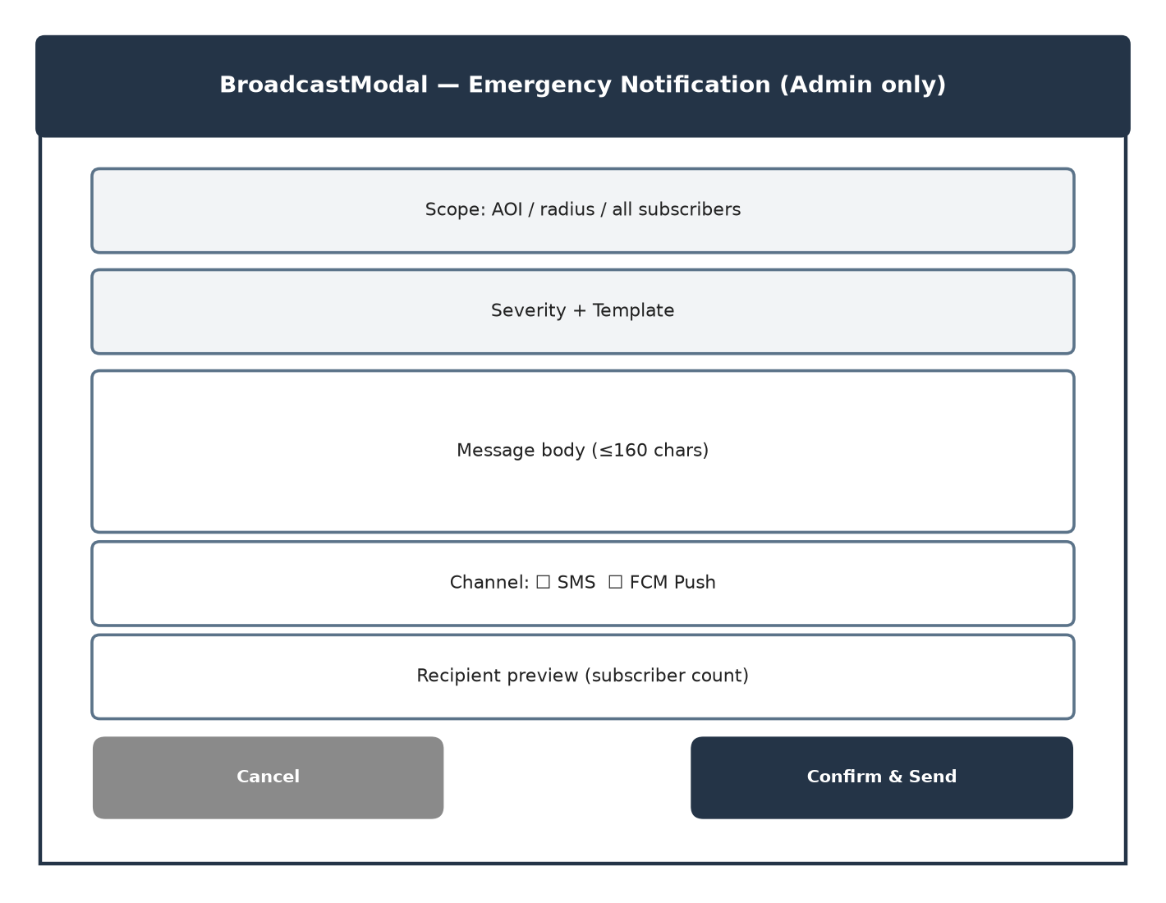
Figure 8. Broadcast Modal Screen Layout
Function Details:
- Data:
  - AlertBroadcast: runId/eventId (nullable), scope, template, severity, actorId.
  - AlertDelivery: broadcastId, recipientId, channel, status, attempts, deliveredAt.
- Validation and Business Rules:
  - In Normal Cases:
    - If Confirm & Send is clicked and the admin role is valid: the system persists the broadcast and alert_deliveries rows, then dispatches to the channel workers.
  - In Abnormal Cases:
    - If a non-admin role calls the broadcast endpoint: the system returns 403.
    - If the message exceeds 160 characters: the system displays “Message exceeds the maximum length.”
    - If no recipients match the scope: the system displays “No subscribers match the selected scope.”

# | Component | Comp. type | Editable | Mandatory | Description
1 | Scope Selector | Dropdown | Yes | Yes | AOI / radius / all-subscribers targeting for the broadcast.
2 | Message Body | Textarea | Yes | Yes | Alert text, capped at 160 characters.
3 | Channel Checkboxes | Checkbox Group | Yes | Yes | Selects SMS and/or FCM delivery.
4 | Confirm & Send Button | Button | No | Yes | Calls POST /api/v1/notifications/broadcast (admin-only).
Table 10. Broadcast Emergency Notification

3.9 Mobile and Offline Alerting (Planned)
The mobile app currently contains only an entry point and a geofencing service module; the screens below are specified for implementation and are not yet built.

3.9.1 Offline Geofence Sync
Function Trigger:
- Primary Trigger: The mobile app regains network connectivity.
- Secondary Trigger: A citizen opens the app after being offline and wants to confirm their cached hazard data is current.
Function Description:
- Role: Citizen
- Purpose: Reconcile the on-device SQLite cache of hazard geometry with the server, and sound a local alarm if the device enters a danger polygon while offline.
- Interface: The Offline Geofence Sync screen includes the following sections:
  - Last-sync timestamp indicator
  - Stale/current status badge
  - Background geofencing service (no UI)
Function Details:
- Data:
  - Cached geometry: run/unit/window, publication status, supersession/revocation metadata.
- Validation and Business Rules:
  - In Normal Cases:
    - If reconnected: the app fetches the offline-sync snapshot and applies it atomically, including revocations.
  - In Abnormal Cases:
    - If still offline: the app continues to use the last cached snapshot, displayed as stale once its validity window has expired — never as a fresh all-clear.

4. Non-Functional Requirements

4.1 External Interfaces
# | Interface | Description
1 | Web Browser | Officers and Admins access the WebGIS console (React 18 / Vite) through modern desktop browsers.
2 | RESTful API | The Core API, GIS Service and AI Service expose REST endpoints under /api/v1/*, fronted by the Nginx gateway.
3 | Rainfall / Weather Forecast Provider API | Supplies rainfall observations/estimates and issued next-24h forecasts to the GIS Service (provider TBD, pilot-dependent).
4 | DEM Terrain Source | Supplies elevation data used to derive slope, elevation and local relief.
5 | SMS Gateway | Delivers text alerts to subscribed citizens; retains the 160-character limit.
6 | Firebase Cloud Messaging (FCM) | Delivers push notifications to the mobile app.
7 | PostgreSQL / PostGIS Database | Stores all application and spatial data across core_schema and gis_schema.
8 | Redis | Optional pub/sub change notification between services; not a durable queue.
Table 11. External Interfaces

4.2 Quality Attributes

4.2.1 Usability
# | Requirement | Description
U1 | Learnability | A new Officer shall be able to open the Verification Queue and reach a Verify/Reject decision within 5 minutes of first login.
U2 | Consistency | The WebGIS console shall maintain a consistent layout, color coding (hazard levels, roles) and terminology across all screens.
U3 | Status transparency | Every forecast or cached mobile view shall visibly distinguish current, stale and unavailable states; none may be presented as a fresh low-hazard result.
Table 12. Usability

4.2.2 Reliability
# | Requirement | Description
R1 | No fabricated results | A service failure or missing/stale input shall return an explicit unavailable result with a reason, never a fabricated low-hazard value or a false “queued” acknowledgement.
R2 | Idempotent delivery | Alert broadcast and delivery tasks shall use idempotency keys and bounded retry to prevent duplicate sends.
R3 | Recovery | A recovery poll shall find pending jobs/tasks after a service restart or a missed Redis notification.
R4 | Data integrity | Incident, report, forecast and audit records shall remain consistent and shall not be silently overwritten by later migrations.
Table 13. Reliability

4.2.3 Performance
# | Requirement | Description
P1 | Geofence query | A server-side geofence query shall complete in under 50 ms.
P2 | Alert delivery latency | Push delivery shall be initiated within 30 seconds, and SMS gateway submission within 60 seconds, of admin confirmation.
P3 | AI inference (legacy prototype) | The existing scene-based inference endpoint targets under 300 ms/patch on CPU and under 30 ms/patch on GPU; the 24-hour forecast model's performance targets remain to be measured once released.
Table 14. Performance

4.2.4 Security
# | Requirement | Description
S1 | Authentication | Only authenticated users holding a valid JWT shall access protected endpoints.
S2 | Authorization | Access is restricted by role (CITIZEN / OFFICER / ADMIN); only ADMIN may broadcast an alert, enforced server-side (HTTP 403 otherwise).
S3 | Password security | Passwords shall be hashed before storage and never logged or returned in API responses.
S4 | Location privacy | Continuous device location shall never be transmitted to the server; GPS is sent only on an explicit citizen action (report submission).
S5 | Secure transport | All client–server communication shall use HTTPS in deployed environments.
Table 15. Security

4.2.5 Maintainability
# | Requirement | Description
M1 | Schema-per-service | Each service shall own its schema (core_schema, gis_schema); no service shall write directly into another service's tables.
M2 | Migration discipline | Schema changes shall be added as new Flyway migrations; existing applied migrations (V1/V2) shall not be rewritten or relabeled.
M3 | Versioned artifacts | Every forecast run shall record its model version and threshold version so results remain reproducible after model updates.
Table 16. Maintainability

5. Requirement Appendix

5.1 Business Rules
ID | Rule Definition | Module / Feature
BR-01 | Every account must be registered with a unique email address. | Authentication
BR-02 | A user's role is exactly one of CITIZEN, OFFICER or ADMIN at any time. | Authentication
BR-03 | Only an Admin may create or change another user's role. | Authentication
BR-04 | Only ADMIN may trigger an emergency broadcast; any other caller receives 403. | Alerting
BR-05 | An AI-produced hazard score shall never trigger a broadcast automatically; an authenticated Officer/Admin review is mandatory first. | Forecast Review / Alerting
BR-06 | A forecast review decision references exactly one immutable forecast run; approval does not, by itself, create a positive training label. | Forecast Review
BR-07 | A prediction issue time t fixes the forecast window [t, t+24h); only feature source records available by t may be used. | Forecast Generation
BR-08 | Missing or stale rainfall input is recorded as missing coverage and shall never be treated as zero rainfall or low hazard. | Rainfall Ingestion
BR-09 | A later forecast run may supersede an earlier run for the same unit; supersession is recorded explicitly. | Forecast Generation
BR-10 | An incident verification decision (verified/rejected) shall be recorded with the authenticated reviewer's identity and a history entry. | Incident Verification
BR-11 | A broadcast message shall not exceed 160 characters, accounting for provider encoding/segmentation. | Alerting
BR-12 | Continuous citizen location shall never be transmitted to the server; GPS accompanies a report only as an explicit user action. | Mobile / Privacy
BR-13 | A cached mobile forecast whose validity window has expired is displayed as stale, never as a fresh hazard assessment. | Mobile / Offline
Table 17. Business Rules

5.2 Common Requirements
ID | Common Requirement
CR-01 | The system shall require authentication before any state-changing request.
CR-02 | The system shall validate all required input before processing a request and shall return field-level validation errors.
CR-03 | The system shall record creation time and latest modification time for all business records.
CR-04 | The system shall restrict access to resources by role, enforced server-side, not only hidden in the UI.
CR-05 | The system shall store all timestamps in UTC and all geometry in WGS84 / EPSG:4326.
CR-06 | The system shall log application errors to support debugging without exposing sensitive data to end users.
CR-07 | The system shall degrade to an explicit unavailable/error result rather than fabricate data when a dependency is unreachable.
Table 18. Common Requirements

5.3 Application Messages List
Message code | Message Type | Context | Content
MSG01 | Inline | Registration — duplicate email | This email address is already registered.
MSG02 | Inline | Registration — validation | Full name is required.
MSG03 | Inline | Registration — validation | Passwords do not match.
MSG04 | Popup | Login — invalid credentials | Invalid email or password.
MSG05 | Inline | Community report — validation | At least one photo is required.
MSG06 | Inline | Community report — validation | Image exceeds the maximum allowed size.
MSG07 | Popup | Incident verification — conflict | This incident has already been reviewed by another officer.
MSG08 | Popup | Broadcast — authorization | Only an administrator may send an emergency broadcast.
MSG09 | Inline | Broadcast — validation | Message exceeds the maximum length (160 characters).
MSG10 | Popup | Broadcast — validation | No subscribers match the selected scope.
MSG11 | System | Forecast — unavailable | Hazard forecast unavailable: required rainfall input is stale or missing.
MSG12 | System | Forecast — unavailable | Hazard forecast unavailable: no released model for this snapshot schema.
MSG13 | System | Monitoring area — validation | Area name and boundary geometry are required.
MSG14 | Push / SMS | Alert delivery | {severity} hazard warning for {area name}: {message}.
MSG15 | System | Mobile — offline | Showing cached data from {last sync time}. Reconnect to refresh.
Table 19. Application Messages List

5.4 Supplementary Technical Reference
The following diagrams are retained from the system's technical design for reference; they are not part of the university report template but document the component architecture, data model and release criteria behind the requirements above.
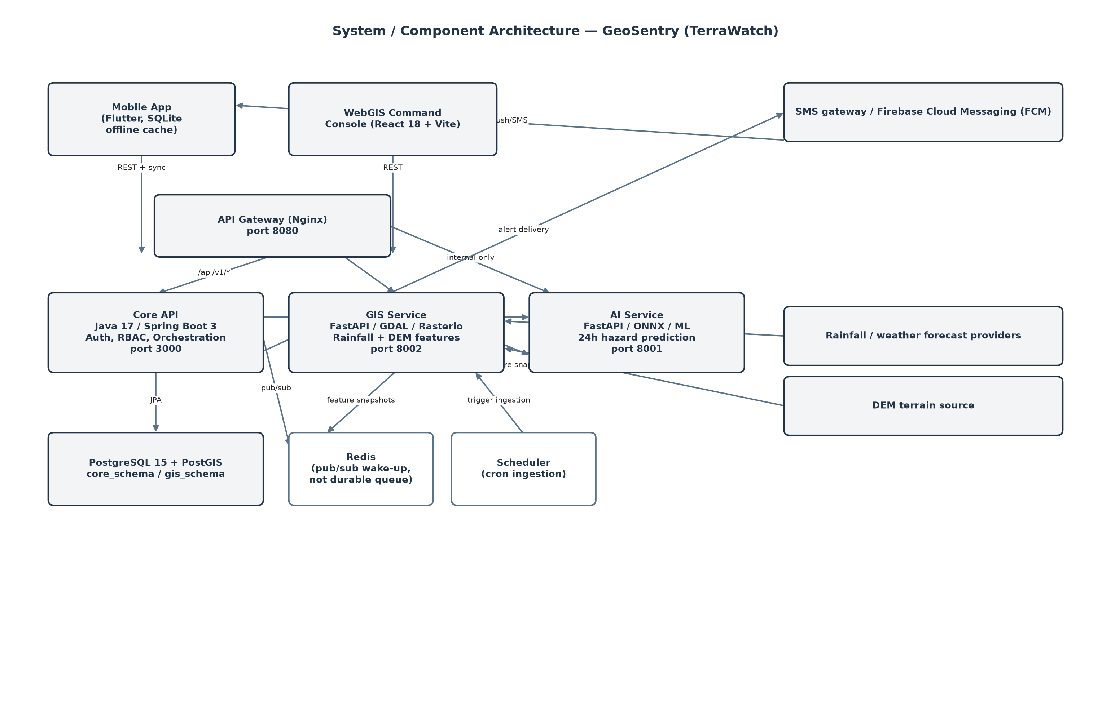
Figure 9. System / Component Architecture (supplementary)
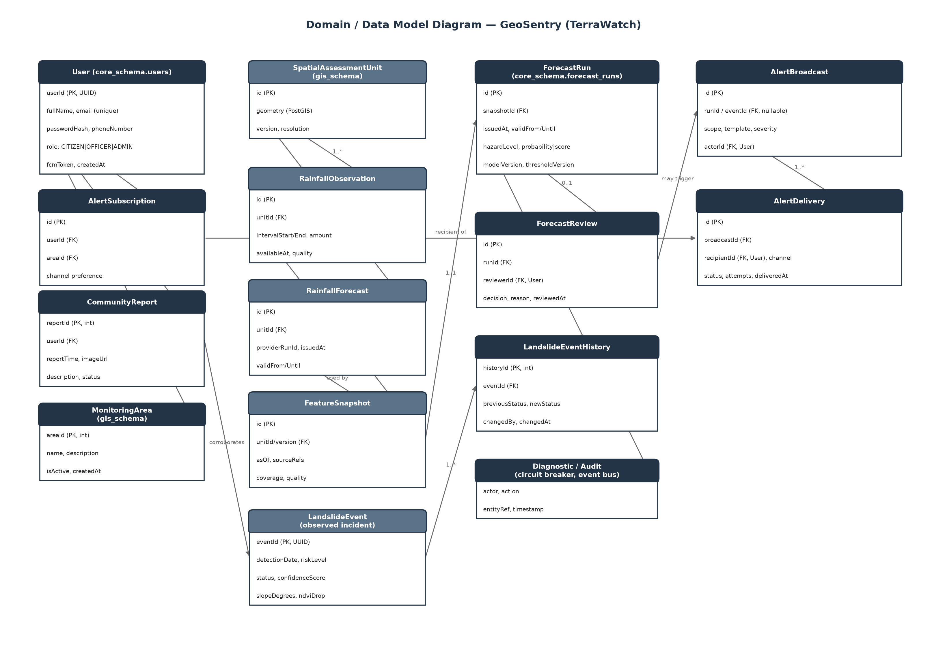
Figure 10. Domain / Data Model Diagram (supplementary)

5.4.1 Acceptance and Release Criteria
Area | Evidence required
Data feasibility | Dated event inventory, coverage/uncertainty assessment, historical weather-forecast availability, and a confirmed pilot AOI decision.
Model quality | Reproducible baseline/candidate comparison, a temporal/spatial split manifest, event recall and false-alarm analysis; no unsupported accuracy percentage.
Release threshold | Agreed minimum recall and maximum false-alarm burden, met by the candidate model, before any non-experimental release.
Reliability | Tested against stale/missing/revised data, expiry, provider outage, restart/retry, duplicate delivery, unauthorized access and offline resync.
Table 20. Acceptance and Release Criteria

