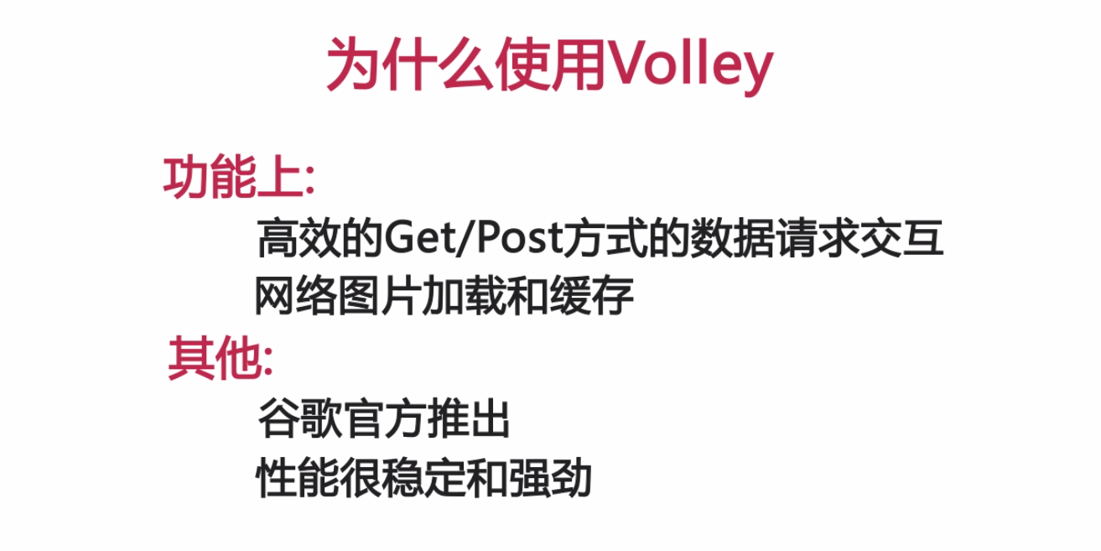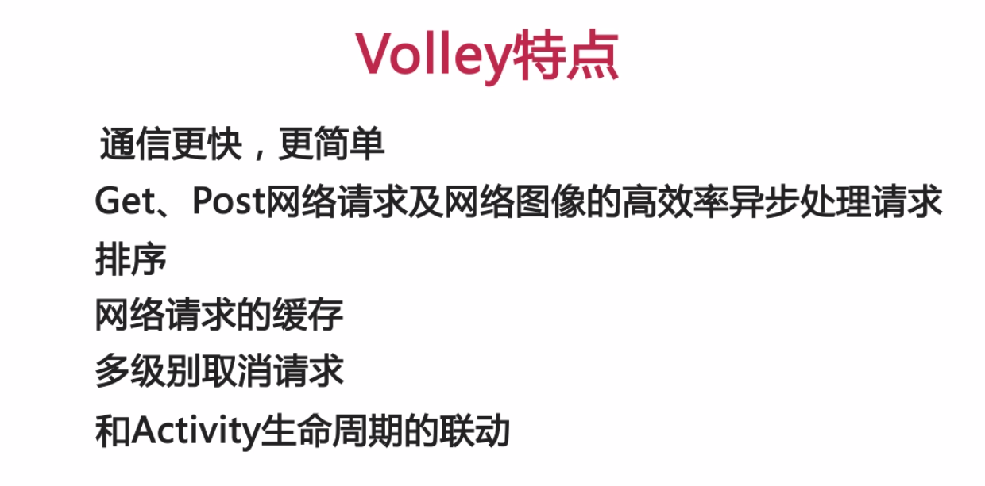

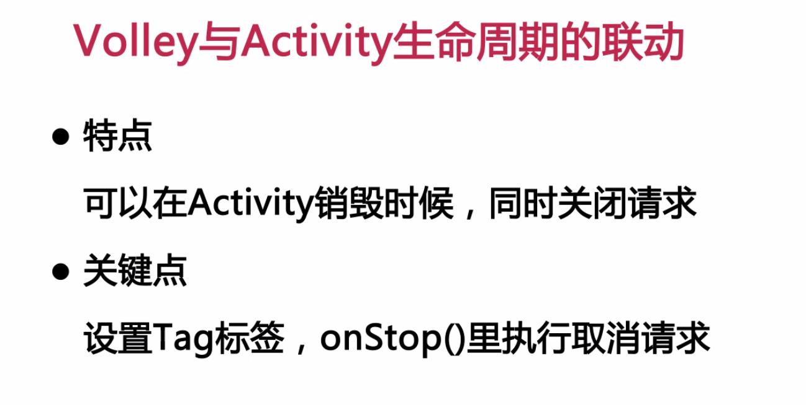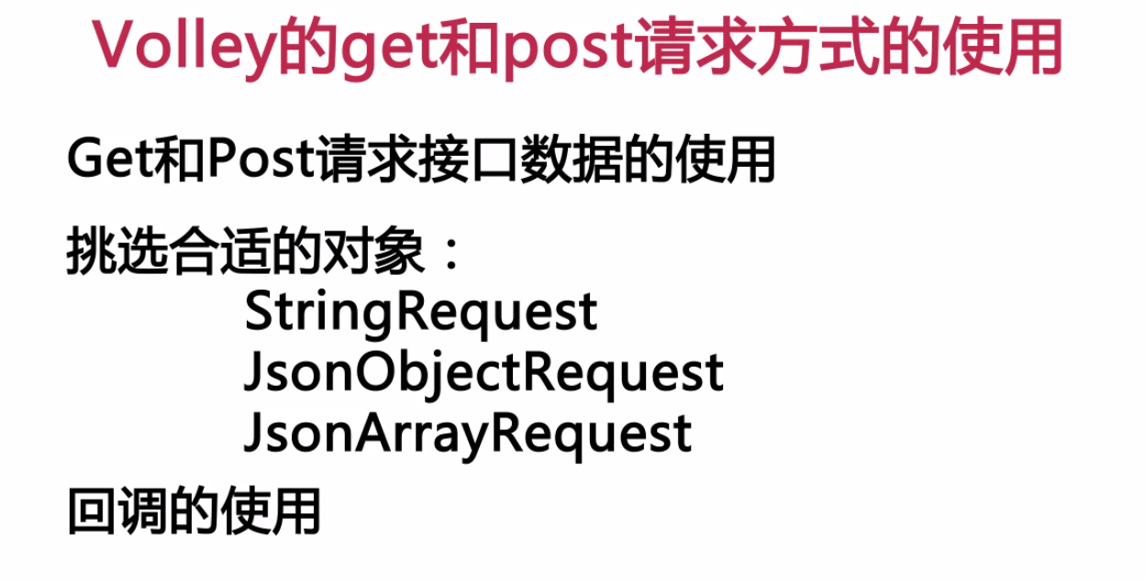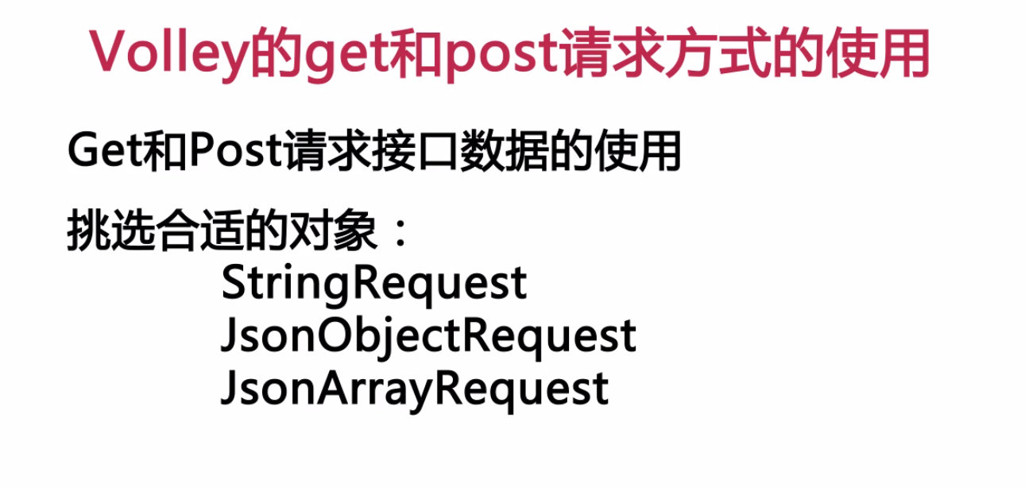

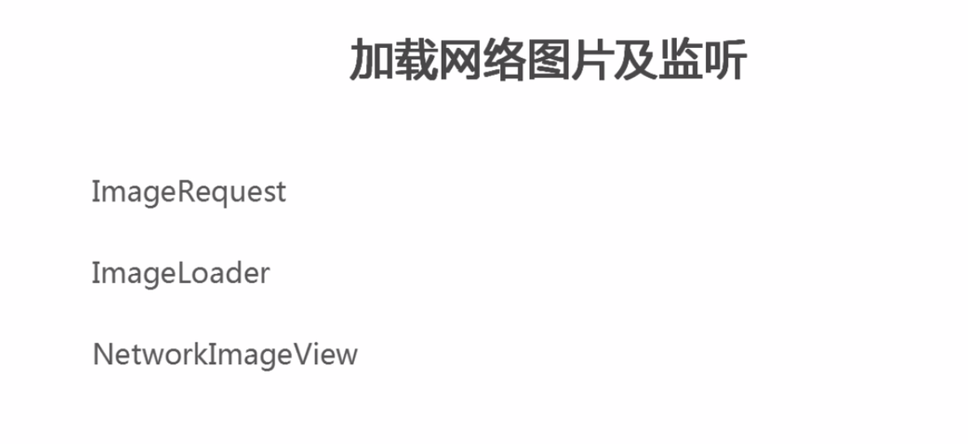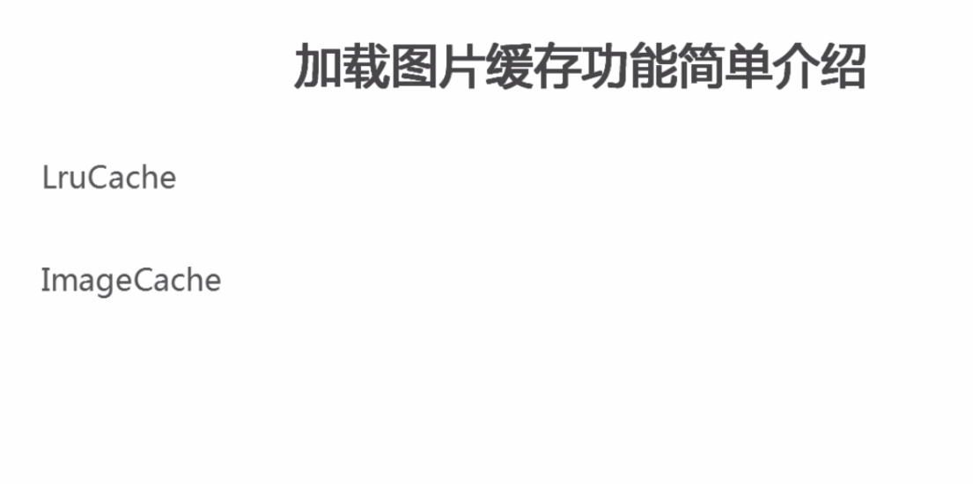

package com.example.ai.application.Volley;

import android.app.Activity;

import android.graphics.Bitmap;

import android.os.Bundle;

import android.support.v4.util.LruCache;

import android.widget.ImageView;

import android.widget.Toast;

import com.android.volley.Request;

import com.android.volley.Response;

import com.android.volley.VolleyError;

import com.android.volley.toolbox.ImageLoader;

import com.android.volley.toolbox.ImageRequest;

import com.android.volley.toolbox.StringRequest;

import com.example.ai.application.R;

import com.example.ai.application.main.mApplication;

/**

* Created by ai on 2016/10/7.

*/

public class VolleyActivity extends Activity {

private String get_tag = "abcGet";

@Override

protected void onCreate(Bundle savedInstanceState) {

super.onCreate(savedInstanceState);

setContentView(R.layout.activity_volley);

//VolleyGet();

//initImageView();

imageLoad();

}

class imageCache implements ImageLoader.ImageCache {

public LruCache<String, Bitmap> cache;

public int max = 10 * 1024 * 1024;

imageCache() {

cache = new LruCache<String, Bitmap>(max) {

@Override

protected int sizeOf(String key, Bitmap value) {

return value.getRowBytes() * value.getHeight();

}

};

}

@Override

public Bitmap getBitmap(String s) {

return cache.get(s);

}

@Override

public void putBitmap(String s, Bitmap bitmap) {

cache.put(s, bitmap);

}

}

private void imageLoad() {

String url = "http://img5q.duitang.com/uploads/item/201304/22/20130422180942_VGTC5.thumb.700_0.jpeg";

ImageLoader loader = new ImageLoader(mApplication.getHttpQueues(),new imageCache());

final ImageView image = (ImageView) findViewById(R.id.volley_imageView);

ImageLoader.ImageListener listener = ImageLoader.getImageListener(image,R.drawable.i01_s,R.drawable.open);

loader.get(url,listener);

}

private void initImageView() {

String url = "http://img5q.duitang.com/uploads/item/201304/22/20130422180942_VGTC5.thumb.700_0.jpeg";

final ImageView image = (ImageView) findViewById(R.id.volley_imageView);

ImageRequest request = new ImageRequest(

url,

new Response.Listener<Bitmap>() {

@Override

public void onResponse(Bitmap bitmap) {

image.setImageBitmap(bitmap);

}

},

0,

0,

Bitmap.Config.RGB_565,

new Response.ErrorListener() {

@Override

public void onErrorResponse(VolleyError volleyError) {

}

}

);

request.setTag(url);

mApplication.getHttpQueues().add(request);

}

private void VolleyGet() {

String url = "http://apis.juhe.cn/mobile/get?phone=18328083078&key=9d7ec2cd058d01cb03e287e9f8ddf62d";

StringRequest request = new StringRequest(

Request.Method.GET,

url,

new Response.Listener<String>() {

@Override

public void onResponse(String s) {

Toast.makeText(VolleyActivity.this, s, Toast.LENGTH_SHORT).show();

}

},

new Response.ErrorListener() {

@Override

public void onErrorResponse(VolleyError volleyError) {

Toast.makeText(VolleyActivity.this, volleyError.getMessage(), Toast.LENGTH_SHORT).show();

}

});

request.setTag(get_tag);

mApplication.getHttpQueues().add(request);

}

@Override

protected void onStop() {

super.onStop();

mApplication.getHttpQueues().cancelAll(get_tag);

}

}