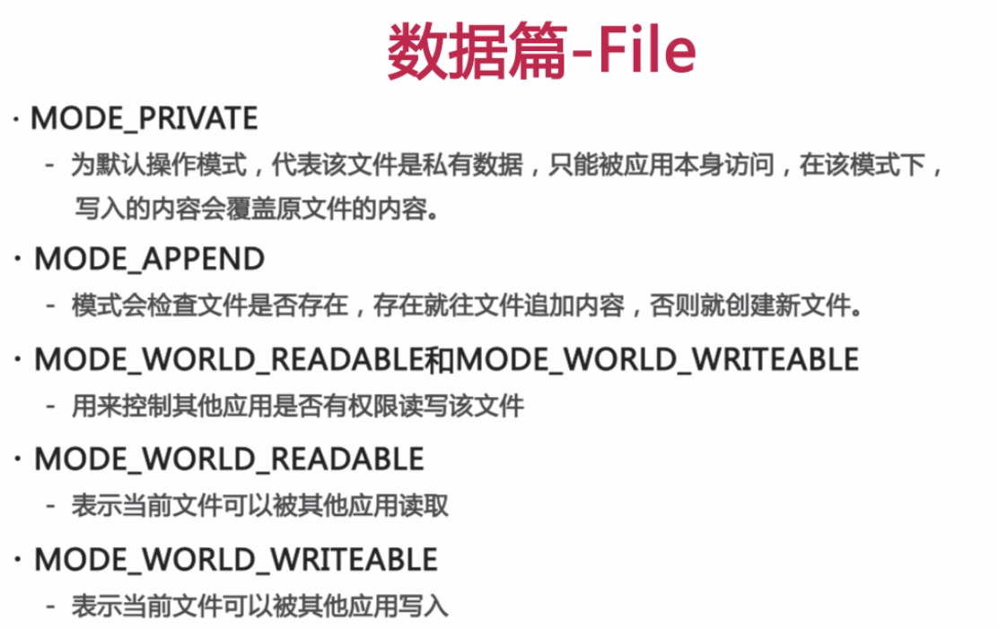

private EditText text;  
  
@Override  
protected void onCreate(Bundle savedInstanceState) {  
 super.onCreate(savedInstanceState);  
 setContentView(R.layout.*activity_main*);  
 text = (EditText) findViewById(R.id.*main_text*);  
 String s = readFiles();  
 if (s != null)  
 text.setText(s);  
  
 setRadioGroup();  
  
 setSave();  
}  
  
private void setSave() {  
 Button save = (Button) findViewById(R.id.*main_save*);  
 save.setOnClickListener(new View.OnClickListener() {  
 @Override  
 public void onClick(View view) {  
 writeFiles(System.*currentTimeMillis*()+" 在文件中写入该句话，再次启动app会读取到EditText中");  
 Toast.*makeText*(MainActivity.this," 写入成功", Toast.*LENGTH_SHORT*).show();  
 }  
 });  
}  
//从文件中读出内容  
private String readFiles()  
{  
 String con = null;  
 try {  
 FileInputStream stream = openFileInput("a.txt");  
 ByteArrayOutputStream outputStream = new ByteArrayOutputStream();  
 byte[] buffer = new byte[1024];  
 int len = 0;  
 while ( (len = stream.read(buffer)) != -1 )  
 outputStream.write(buffer,0,len);  
 con = outputStream.toString();  
 stream.close();  
 outputStream.close();  
  
 } catch (FileNotFoundException e) {  
 e.printStackTrace();  
 } catch (IOException e) {  
 e.printStackTrace();  
 }  
 return con;  
  
}  
//向文件中写入内容  
private void writeFiles(String str)  
{  
 try {  
 FileOutputStream stream = openFileOutput("a.txt",*MODE_PRIVATE*);  
 stream.write(str.getBytes());  
 stream.close();  
  
 } catch (FileNotFoundException e) {  
 e.printStackTrace();  
 } catch (IOException e) {  
 e.printStackTrace();  
 }  
}  
private void fileExecut() throws IOException {  
  
 //安卓默认内置内存卡路径，若有外置的话是：/mnt/extsdcard/  
 String path = "/mnt/sdcard/test";  
 File file01 = new File(path);  
 if ( !file01.exists() ) //文件不存在  
 file01.createNewFile();  
  
 //这个目录是当前应用程序默认的存储目录 data/data/com.example.ai.application/files  
 File file02 = this.getFilesDir();  
  
 //这个目录是当前应用程序默认的缓存目录 当手机内存不足时手机会自动删除缓存目录内的文件  
 File file03 = this.getCacheDir();  
  
 //若data/data/com.example.ai.application/目录下右imooc目录则获得，没有则创建  
 File file04 = getDir("imooc",*MODE_PRIVATE*);  
  
 //获得外置存储目录下对应的文件，同于内置，app卸载时同样会被清除  
 File file05 = getExternalFilesDir("");  
 File file06 = getExternalCacheDir();  
  
 //自己指定的目录在卸载时不会被清除  
  
}