|  |
| --- |
|  |
| Capstone Project Document |

**Hotel Booking System**

Report #1 – Project Introduction

|  |  |  |
| --- | --- | --- |
| **COD Team** | | |
| **Group Members** | Trần Huy Duẫn | SE03268 |
| Nguyễn Thị Lan Phương | SE03168 |
| Nguyễn Hữu Nhật | SE03180 |
| Nguyễn Hải Lý | SE03391 |
| Hoàng Đình Cường | SE03326 |
| **Supervisor** | Mr. Đào Trọng Duy | |
| **Project code** | HBS | |

**- Hanoi, 09/2016 –**

# SIGNATURE PAGE

AUTHOR: Nguyễn Thị Lan Phương 07/09/2016

Team member

REVIEWERS: Trần Huy Duẫn 10/09/2016

Project manager

APPROVAL: Đào Trọng Duy --/09/2016

Supervisor

Record of change

*A - Added M - Modified D – Deleted

|  |  |  |  |  |  |
| --- | --- | --- | --- | --- | --- |
| Effective Date | Changed Item | A,M,D | Change Description | Reason for Change | Rev. Number |
| 07/09/2016 | Introduction, Abstract, Proposal (The idea, Objectives) | A | Create Introduction, Abstract, Proposal (The idea, Objectives) | First version | 1.0 |
| 08/09/2016 | Proposal (Brief description about system, System features), Benefit from project, Critical assumption and constraints, Potential risks | A | Create Proposal (Brief description about system, System features), Benefit from project, Critical assumption and constraints, Potential risks |  | 1.0 |
| 10/09/2016 | Literature Review, Proposal (Idea, System features), References | A, M | Create Literature Review, Proposal (System features), References and Modify Proposal (Idea) |  | 1.1 |
| 10/09/2016 | Literature Review, Proposal (Idea, System features) | M | Modify Literature Review, Proposal (Idea, System features) |  | 1.2 |
| 11/09/2016 | Literature Review, Proposal (Idea, System features) | M | Modify Literature Review, Proposal (Idea, System features) |  | 1.3 |
| 11/9/2016 |  | M | Modify function update request and update contribute request  Modify common function |  | 1.4 |
|  |  |  |  |  |  |
|  |  |  |  |  |  |
|  |  |  |  |  |  |
|  |  |  |  |  |  |

Contents

SIGNATURE PAGE 1

1 INTRODUCTION 3

1.1 Purpose 3

1.2 Acronyms and Definitions 3

2 ABSTRACT 3

3 LITERATURE REVIEW 4

4 PROPOSAL 6

4.1 The idea 6

4.2 Objectives 6

4.3 Brief description about system 7

4.4 System features 8

5 BENEFIT FROM PROJECT 10

5.1 For our group 10

5.2 For user 10

6 CRITICAL ASSUMPTION AND CONSTRAINTS 11

7 POTENTIAL RISKS 11

8 REFERENCES 11

# INtroduction

## Purpose

This document is created as the introduction for project Booking Hotel System– our Capstone Project at FPT University. In this document, we will present the overview of some existing systems, the initial idea for our project, a brief description about our expected system and some potential risks, critical assumptions, constrains. Moreover, this document also shows what system offers for users.

## Acronyms and Definitions

|  |  |
| --- | --- |
| **Acronym & Abbreviation** | **Definition** |
| **HBS** | Hotel Booking System |
|  |  |
|  |  |

Table 1‑1: Definitions and Acronyms

# ABSTRACT

In the past, travels who travel frequently or have to move to work at the different cities. When they plan a trip, they often take a long time to find out hotel through friends or acquaintances about places in other regions.

In recent years, self-travel trends started overwhelm tour trends, especially the group of tourists in the country. The young prefers to go travel, backpacker because they feel free, satisfied and inexpensive. Family with many children prefer type of group travel to explore nature, recreation. Obviously, the biggest benefit of this type of self-travel comfort is traveling follow route you want and finding out hotel with many services and suitable price easily. Especially, nowadays, many travelers are familiar with the process of searching for information, booking airline tickets or hotel reservations online ... to be more active in their trips. Our website was created to solve this problem.

# LITERATURE REVIEW

Nowadays, there are a lot of hotel booking system in different demands are available on internet and users can easily access to it but still have many problems to discuss.

**Mytour.vn:**

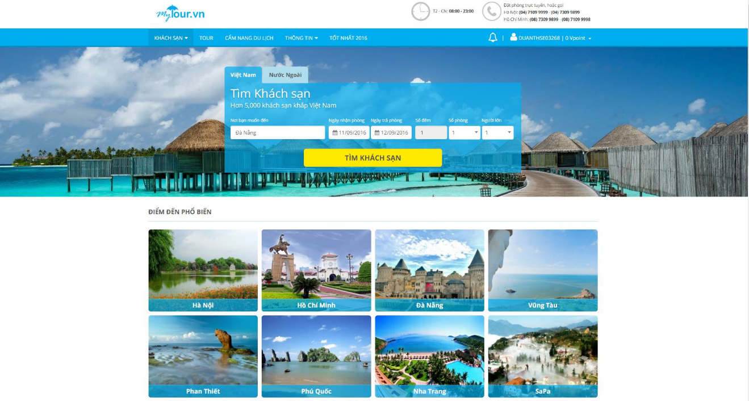

Figure 3‑1: Mytour home screen

The website also provides necessary functions for user, example, searching hotel based on location, description about types of room and services, having system to evaluate point…

*Advantage:*

* Can log in by Facebook or Google.
* Can save hotel into favorites.
* Website can response fast.

*Disadvantages:*

* Improve user interface more friendly.
* Notification system is pretty lean because there are not privacy notices or information requests.
* This system doesn’t have feature to link between hotel manager and website manager.

**Agoda.com:**

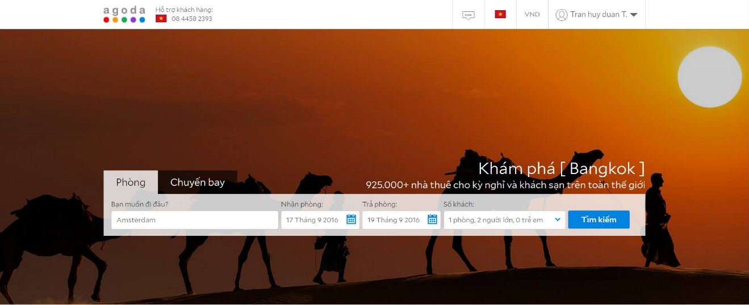

Figure 3‑2: Agoda home screen

This agoda is one of the fastest the online booking website with a list of hundreds of hotel in the world and supporting of 38 different languages.

*Advantage:*

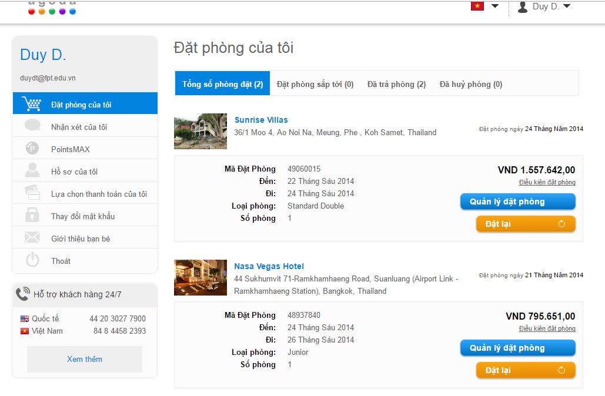

Figure 3‑3: Agoda website's booked screen

* The website interface is beautiful and friendly.
* Displaying the number of people who are watching the hotel and people who have booked.
* See booking based on 3 criteria: Upcoming / Departed / Canceled.
* Hotels are displayed with the hotel name, location, grade point average and comment that the most recent reviews.

*Disadvantages:*

* There are not many hotels in Vietnam. This site focus to foreign users.
* Only accept payment by international payment system.
* Can’t filter with special feature location as place has many events or tourist place.
* Because server and administration are set in UK, if you have problems related to booking as cancellation, compensation..., procedure for resolving will take a long time.

# PROPOSAL

## The idea

To response this demand, we will develop a website to support travelers who travel frequently or have to move to different cities. They will not take time to find out through friends or acquaintances about place at other locations. So, we gave an idea that responses required demand of users about hotel booking system.

Our website links hotel in Viet Nam together and object who we focus is Viet Nam's people. Our website includes necessary functions for user when they travel. For example, user can view all detail information of hotels as price, type of room, hotel services, reviews. The website supports searching function from budget hotel to luxury hotel around destination by district, service... User can give individual's feedback about that hotel. In addition, the website also supports direction from user's location to hotel and supports to search the vicinity of hotel based on user's current position. From the above basic functions, user can freely select, compare and make a decision easily. Hotel manager can perform functions related to booking, request, contribute request and view reports by conditions and for admin can manage all of functions and data of system.

## Objectives

This project is the Capstone Project in FPT University studying program.

The responsibility of this project belongs to all team members. So we must complete all requirements from travelers. During the time doing project, we can learn how to develop a project, how to manage project, how to communicate better between team member, how to control time, how to perform teamwork effectively.

Moreover, we also have experience in ASP.net technology, website designing, software testing. Therefore, we think this project is very necessary for us to enhance skills, knowledge which we studied in FU. This project also makes our CV more fascinating after graduating from FU. This is also a chance for us to prove our proficiency with headhunters.

## Brief description about system

This software is a web application. With friendly and simple interface, users can easily find out what they want without registration. Our website provides the necessary functions for both customer (guest, member), hotel manager, master and admin. For example, for customer, they can find the hotel by location, demand for the services they need, our website supports for user to direct from their location to the hotel, the website also provides full information, reviews, feedback and prices of hotels to they can have more choices. For hotel manager, can perform functions related to booking, request, contribute request and view reports by conditions. For master, can manage functions related to data of system. And for admin, can manage all functions and data of system…

HBS uses familiar technologies as: ASP.net, MVC 5, Bootstrap 3…

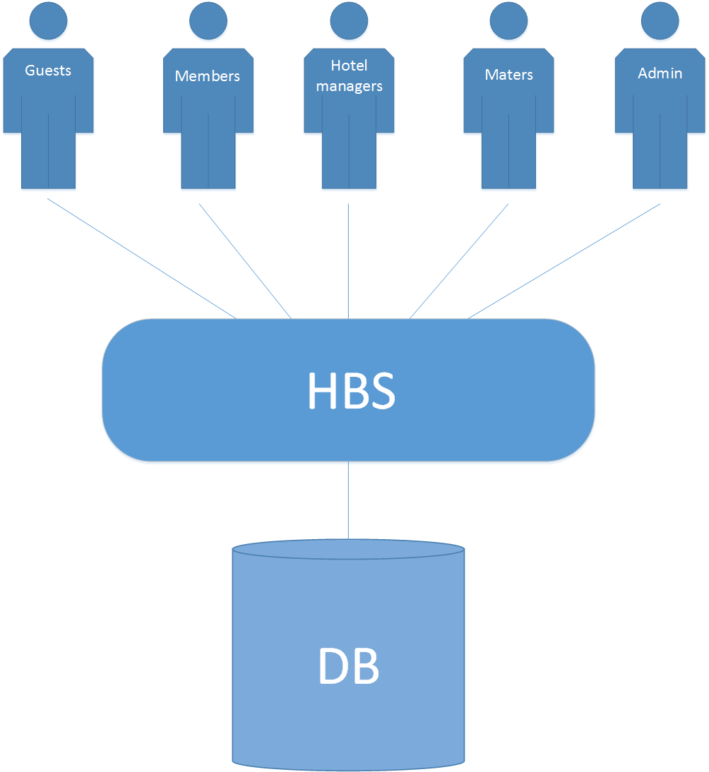

Figure 4‑1: Brief descriptions diagram of HBS system

## System features

In regard to the features of HBS, there are 5 types of user: guest, member, hotel manager, master and admin. There are the detailed features of HBS:

* Common functions (without guest):
* Check Login Status : Check every time page load
  + User Is Active
  + Session Is Active
* Check Function Access: Check user can CRUD to that function.
* Check Data Access: Check user can CRUD that data
* Header: Can Login/Logout and click on icon redirect to Home Page
* Show Date Format: DD/MM/YYYY
* For guest, using website for booking without login:
* Sign up: Create account for HBS.
* Add booking: Allow user to create a booking a hotel room.
* Update booking: Allow user to update booking information .
* Booking detail: Allow to view details of booking.
* Direct to hotels: Direct user to hotel by faster way.
* Find nearby hotels: Allow user to find nearby hotel depend on user describe.
* For member, using website for booking with login:
* Add feedback: Allow user to create a feedback.
* Update feedback: Allow user to update feedback information.
* Add booking: Allow user to create a booking a hotel room.
* Update booking: Allow user to update booking information or booking status.
* Booking Detail: Allow to view details of booking.
* Add request: Allow user to create a request to booking a hotel room.
* Update request: Allow user to update request information or request status.
* Find nearby hotels: Allow user to find nearby hotel depend on user describe.
* Direct to hotels: Direct user to hotel by faster way.
* Cancel booking: Allow user to cancel the booking that created by user.
* Cancel contribute request: Allow user to cancel the contribute request that created by user.
* For hotel manager, using website for relation promote:
* Update booking: Allow user to update booking information.
* Booking detail: Allow to view details of booking.
* Add request: Allow user to create a request to create Master Data.
* Update request: Allow user to update request information or request status .
* Report by condition: Apply user to see static of revenue, user booking hotel.
* Process/manage contribute request: Allow user to approved/disapproved the contribute request from customers.
* Process/manage booking request: Allow to user to approved/disapproved request.
* Cancel contribute request: Allow user to cancel the contribute request that created by user.
* For master, manage website data:
* Authorization data: Allow website manager can give permission to Hotel Manager to make user can edit/delete that data.
* System information: Display system information.
* City list: Allow user to view city information list.
* Add city: Allow user to add city into city list.
* Update city: Allow user to update city information in city list.
* District list: Allow user to view district information list.
* Add district: allow user to add district into district list.
* Update district: Allow user to update district information in district list.
* Location list: Allow user to view location information list.
* Add location: Allow user to add location into location list.
* Update location: Allow user to update location information in location list.
* Hotel list: Allow user to view hotel information list.
* Add hotel: Allow user to add hotel into hotel list.
* Update hotel: Allow user to update hotel information in hotel list.
* Service list: Allow user to view service information list.
* Add service: Allow user to add service into service list.
* Update service: Allow user to update service information in service list.
* Room list: Allow user to view room information list.
* Add room: Allow user to add service into service list.
* Update room: Allow user to update service information in service list.
* Feedback list: Allow user to view feedback information list.
* Booking list: Allow user to view booking information list.
* Update booking: Allow user to update booking information.
* Booking detail: Allow to view details of booking.
* Request list: Allow user to view request information list.
* Update request: Allow user to update request information in request list.
* Report by condition: Apply user to see static of revenue, user booking hotel, visited website, booking.
* Process/manage contribute request: Allow user to approved/disapproved the contribute request from customers.
* Process/manage booking request: Allow to user to approved/disapproved request.
* Delete master data: Allow master delete master data MST010-MST100.
* For admin, manage website:
* Function list: Allow user to view function list.
* Add function: Allow user to add function into function list.
* Update function: Allow user to update function information in function list.
* Authorization function: Allow admin can give permission to user to make user can use that function.
* User list: Allow admin to view user list.
* Add user: Allow admin to add user into user list.
* Update user: Allow admin to update user information.
* Authorization data: Allow website manager can give permission to user to make user can edit/ delete that data.
* System setting: Allow to configure HBS.
* Report by condition: Apply user to see static of revenue, user booking hotel, visited website, booking.

# BENEFIT FROM PROJECT

## For our group

After developing and implementing this project, our group will get some benefits:

* Have more experiences of develop software project.
* Have more knowledge and skill about ASP.net, MVC 5…
* Know how to communicate with team members and how to teamwork more effective.
* If this application is developed, we will get a good mark in Capstone Project. It makes our grade better.

## For user

* For guest, can booking hotel of room, go to that hotel easily because of map’s supporting, save time of searching.
* For member, can booking hotel of room and go to that hotel easily because of map’s supporting; make feedback, evaluation for hotel and save time of searching.
* For hotel manager, have more experiences of management, advertise hotel.
* For master and admin, have more experiences of system management, receive profits from website.

# CRITICAL ASSUMPTION AND CONSTRAINTS

* Critical assumption:
  + Training: All developers can train visual studio, mockup, SQL server… in short time. With programming techniques which we studied at FU, we have to try the best to not missing any deadline in project plan.
  + Human resources: Assume that all members in team have a good healthy to do their tasks.
* Constraints:
  + Time and deadline: We must complete task on time. We do not have more time for us to complete developing and deliver application to teachers. Besides, we have to submit report documents before deadline to teacher can review.
  + Quality: The products must be run well when users perform main functions in Google Chrome 40 and Firefox 30 or higher.
  + Process: We have to follow the software processing of FPT Software.
  + Human resources: There are 5 members in our team, all of members still have to study at school.

# POTENTIAL RISKS

After studying about this project, we find out some problem that we may be encountered:

* It is the first time we manage a project like this, we have no experience in exchange information, managing and controlling work so we may be miss the deadline or under estimate scope, time.
* We have not much knowledge in the framework and technique of ASP.net and web. Therefore, we have to study all of them from the beginning. The project team may face with the difficult technical problems that may requires long time to resolve so that causes the project be delayed.
* Loss data, source code before uploading data to server because of careless.
* Equipment got broken because of careless or accident.
* Human resources: Team member cannot complete their works because of health reasons, key member leave team or un-cooperating on team.
* Change requirements: Requirement changed when some functions cannot be completed or some technologies is not suitable.

# REFERENCES

**[1] Mytour.vn at URL** <http://mytour.vn/>

**[2] Agoda.com at URL** <http://agoda.com/>