DOCX Charts Test
This document includes chart images for chart extraction and description tests.
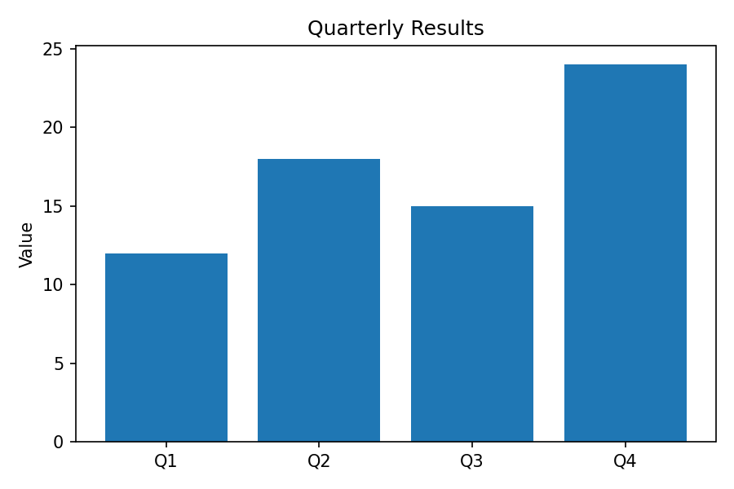
Bar chart: quarterly results.
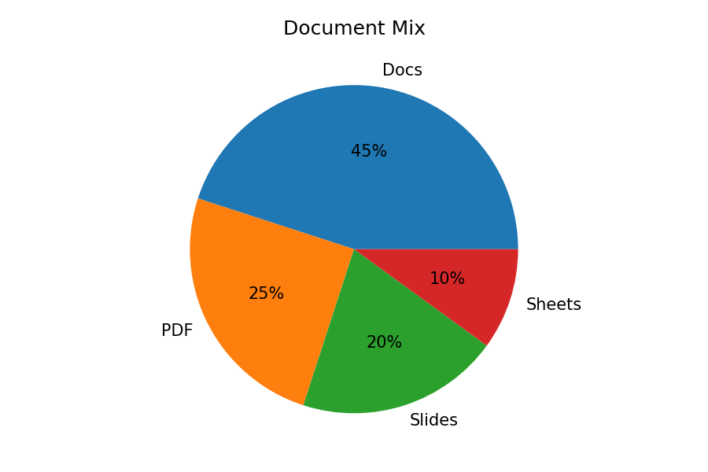
Pie chart: document type distribution. Marker: DOCX_CHARTS_2468

