DOCX Images Test
Embedded image: sample.png
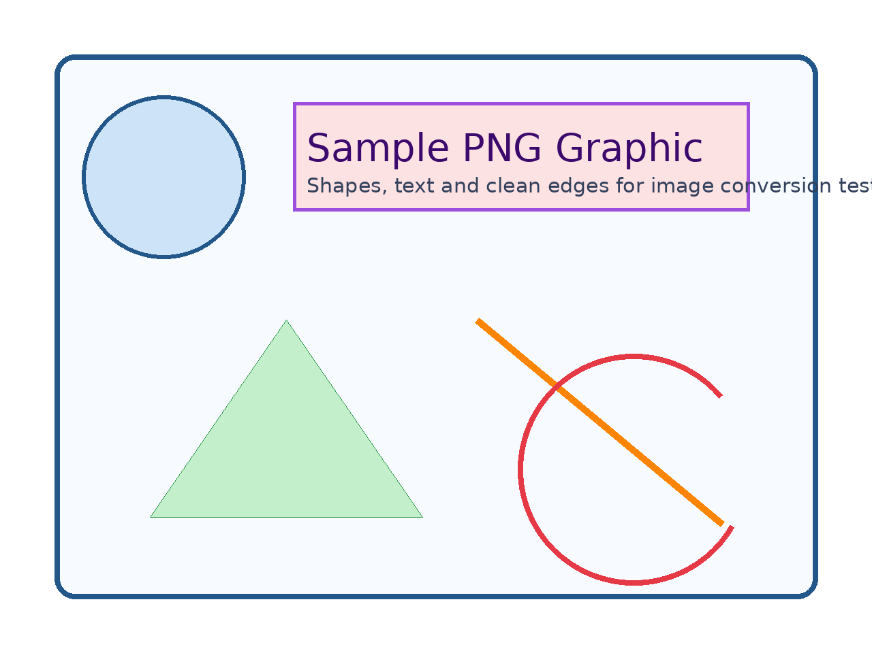
Embedded image: sample.jpg

Embedded image: with-text.png
