[](https://www.pixelduke.com/)

[Skip to content](https://www.pixelduke.com/blog/#content)

* [BLOG](https://www.pixelduke.com/blog/)

* [OPEN-SOURCE](https://www.pixelduke.com/open-source/)

* [WORK](https://www.pixelduke.com/work/)

* [TESTIMONIALS](https://www.pixelduke.com/testimonials/)

* [TALKS](https://www.pixelduke.com/talks/)

* [ABOUT](https://www.pixelduke.com/about/)

[HIRE PEDRO](https://www.pixelduke.com/contact/)

Top of Form

Search



Bottom of Form

May, 17 2021

[JMetro Version 11.6.15 Released](https://www.pixelduke.com/2021/05/17/jmetro-version-11-6-15-released/)

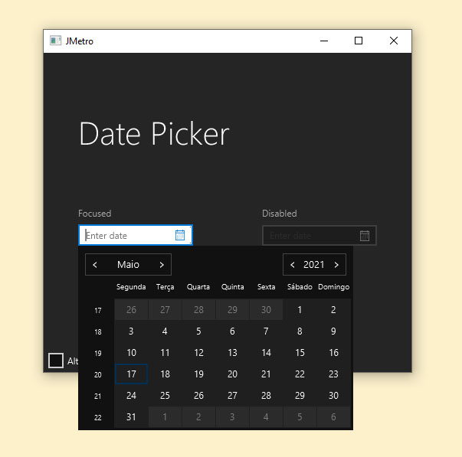

Hello,

This time a new release of JMetro. This new version features bug fixes, tweaks to visual styles, structural changes and changes to the way JMetro is distributed and published.

Read on for more details.

[Continue reading →](https://www.pixelduke.com/2021/05/17/jmetro-version-11-6-15-released/#more-3635)

Mar, 22 2021

[New Java/JavaFX Library FXSkins Released](https://www.pixelduke.com/2021/03/22/new-java-javafx-library-fxskins-released/)

Hi,

This time to announce a new Java / JavaFX library I’ve just released. It’s called FXSkins.

FXSkins is a collection of new Skins for existing JavaFX controls. These Skins will add more functionality to the controls used in your applications with almost no need to make changes to your application’s code.

This library is targeted for the most recent Java versions.

[Continue reading →](https://www.pixelduke.com/2021/03/22/new-java-javafx-library-fxskins-released/#more-3495)

Feb, 15 2021

[New Site Redesign](https://www.pixelduke.com/2021/02/15/new-site-redesign/)

This time something different.

I’ve just updated this site design. I wanted it to look a bit more than a blog site as well as improve the overall appearance. To this effect, I added a front page, a new page layout with 2 columns that replaces the old layout on some pages and tweaked the site’s color scheme. Finally, I also did some small tweaks here and there.

[Continue reading →](https://www.pixelduke.com/2021/02/15/new-site-redesign/#more-3237)

Sep, 29 2020

[JMetro Version 8.6.14 And 11.6.14 Released](https://www.pixelduke.com/2020/09/29/jmetro-version-8-6-14-and-11-6-14-released/)

Another release of JMetro has just came out.

This time the focus has been on fixing bugs and tweaking existing styles. A bunch of these have been fixed in this release.

Besides this, a new feature has been added. It is now also possible to easily add grid lines on table like controls.

Keep on reading for details.

[Continue reading →](https://www.pixelduke.com/2020/09/29/jmetro-version-8-6-14-and-11-6-14-released/#more-3182)

Post navigation

[← Older posts](https://www.pixelduke.com/blog/page/2/)

OPEN-SOURCE

[All](https://www.pixelduke.com/open-source)[JMetro](https://www.pixelduke.com/java-javafx-theme-jmetro)[FXRibbon](https://www.pixelduke.com/fxribbon)[FXParallax](https://www.pixelduke.com/FXParallax)[FXSkins](https://www.pixelduke.com/FXSkins)[Toggle Switch](https://www.pixelduke.com/open-source#toggle-switch)[FXCharts](https://www.pixelduke.com/open-source#date-axis)[Modellus](https://www.pixelduke.com/open-source#modellus)

BLOG CATEGORIES

* [Fluent Design](https://www.pixelduke.com/category/fluent-design/)
* [Java 11](https://www.pixelduke.com/category/java-11/)
* [Web Development](https://www.pixelduke.com/category/web-development/)
* [Wordpress](https://www.pixelduke.com/category/wordpress/)
* [FXSkins](https://www.pixelduke.com/category/fxskins/)
* [JMetro](https://www.pixelduke.com/category/metro/)
* [FXRibbon](https://www.pixelduke.com/category/fxribbon/)
* [FXParallax](https://www.pixelduke.com/category/fxparallax/)
* [Validation](https://www.pixelduke.com/category/validation/)
* [Toggle Switch](https://www.pixelduke.com/category/toggle-switch/)
* [FXCharts](https://www.pixelduke.com/category/fxcharts/)
* [Android](https://www.pixelduke.com/category/android/)
* [Chart](https://www.pixelduke.com/category/chart/)
* [Java](https://www.pixelduke.com/category/java/)
* [Java 8](https://www.pixelduke.com/category/java-8/)
* [JavaFX](https://www.pixelduke.com/category/javafx/)
* [Mobile](https://www.pixelduke.com/category/mobile/)
* [Modellus](https://www.pixelduke.com/category/modellus/)
* [Windows 8](https://www.pixelduke.com/category/windows-8/)
* [Swing](https://www.pixelduke.com/category/swing/)

SOCIAL LINKS

AFFILIATIONS



Theme: PixelDuke - © 2018, 2021 Pixel Duke All rights reserved.



Top of Form



Bottom of Form

Privacy & Cookies: This site uses cookies. By continuing to use this website, you agree to their use.  
To find out more, including how to control cookies, see here: [Cookie Policy](https://automattic.com/cookies/)