Changes to the openthread.io wiki

Navigation:

Visit: <http://www.openthread.io>

Click: TOP_MENU_BAR -> Guides -> Submenu Bar -> Border Router

Left side - Overview, Build and Configuration, WiFi Access Point Setup, Web GUI

Choose "Build and Configuration"

=====================

OLD:

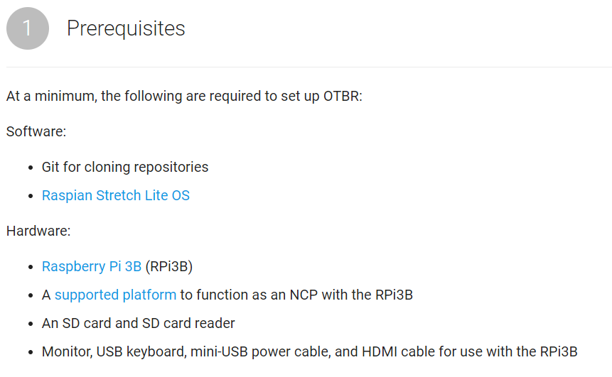

NEW -------------------------------------------------------------------

* Raspberry Pi 3B

link to: https://www.raspberrypi.org/products/raspberry-pi-3-model-b/

Software: Raspian Stretch Lite OS

Link to: <https://www.raspberrypi.org/downloads/raspbian/>

Power Supply: Power requirements for the Raspberry PI + your development board may require the Raspberry PI to have a larger 5V power supply then a spare port on your USB HUB or your computer. Power is very important, if it is wrong - things work then things go wrong, then they work again.

For details see: <https://www.raspberrypi.org/help/faqs/#topPower>

* BeagleBoneBlack (No Built in Wifi Support)

Link to: <http://www.ti.com/tool/BEAGLEBK>

Software: Stretch for Beagle Bone Black

<https://beagleboard.org/latest-images>

Link name: Debian 9.1 2017-08-31 4GB SD LXQT

Filename: bone-debian-9.1-lxqt-armhf-2017-08-31-4gb.img.xz

Power: The BeagleBone Black is often powered via an external 5V ac-adapter.

=====================

(2) Configure Your Hardware

(2A) - the Raspberry Pi – no change

(2B) – The Beagle Bone Black (BBB)

Note:

The Raspberry PI does not include any “on-board-flash-memory” and thus the Raspberry PI always requires an SD Card with a bootable image present to work.

In contrast, the BeagleBoneBlack can boot from either

Option (1) the on board flash memory, or

Option (2) if you press the BOOT button during power up, the BBB will boot from the SD Card.

You must use Option (2) – because the on board Flash memory size is too small to build the Border Router.

The steps are:

1. Download & Expand the compressed Image to a local machine
2. Write the image to a 8gig (or larger) SD Card

Suggested tools: <https://etcher.io/>, or <https://sourceforge.net/projects/win32diskimager/>

1. The BeagleBoneBlack via the BOOT button

**Important:** By default, the BBB boots from on board FLASH (Option 1)

You require Option (2) – booting from the SD Card.

To boot from the SD Card, do the following:

* + - Insert the SD Card into the BBB
    - Remove power from the BeagleBoneBlack
    - Press & Hold the BOOT BUTTON
    - Apply power to the BeagleBoneBlack
    - When the LEDs start to blink, release the button.
    - Important: The Boot Button is only tested at initial power up.
    - This must be repeated every time the BBB is power cycled.

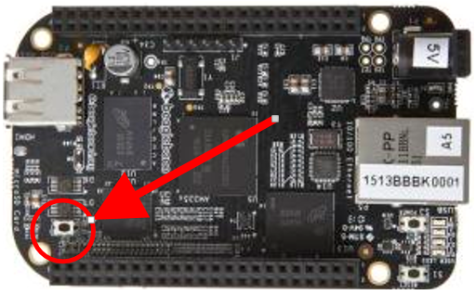

1. Manually expand the SD Card Image to fit your entire SD Card.

(SEE ATTACHED WORD DOCUMENT)

=====================

3) Build & Flash the NCP

NO CHANGE HERE – just add note:

======================

4) Setup the border router

Step 1 – (clone) ame no change

Step 2 – (dependencies) No change

Step 3 – (setup script) No change

Step 4 Attach - (Plug USB eval board in to module)

Add: NOTE: Verify power (See above, about Raspberry PI)

Step 5 – Configure the NCP Device’s Serial port in wpantund

Add (expand your existing note)

The most common names for USB based Serial ports are:

/dev/ttyUSB* or /dev/ttyACM*

Some development boards appear as two USB devices, for example the TI LaunchPads appear as two serial ports, the first (lower numbered) is the actual USB Serial interface, and the second is a debug interface that pretends to be a UART.

Step 6 – I would reword this

I would tell the user to “power cycle the Border router”

Step 7 – Then verify the status of various things.

In SECTION (6) – Trouble shooting, I would add two statements:

Verify power (See above)

Verify the correct USB device for your development board.

=======================

WIFI ACCESS POINT SETUP

For the BeagleBone Black – I would add the following:

* This section is applicable only to the Raspberry PI Model 3B which includes a built in WiFi module

About the IP ADDRESS section,

You might want to include a note about IP Address range selection.

But I’m not sure how to word it correctly.

The concern is this: This seems to assume the local network is using the 192.168.X.X range

Routers produced by Netgear use the 10.x.x.x range

Linksys routers use 192.168.1.x

Dlink routers use 192.168.0.x

NEED HOME FOR THIS:

# Connecting a USB Serial Cable to the Border Router

Often it is helpful to have a USB Serial Cable connection to the Border Router device.

## Raspberry PI

Settings: 115.2K Baud, 8-N-1

USB Serial Cable: <https://www.adafruit.com/product/954>

Connections & How to Enable:

<https://learn.adafruit.com/adafruits-raspberry-pi-lesson-5-using-a-console-cable/enabling-serial-console>

Connections:

<https://learn.adafruit.com/adafruits-raspberry-pi-lesson-5-using-a-console-cable/connect-the-lead>

Beagle Bone Black

Connect Serial Cable to the Beagle Bone Black (115.2K Baud, 8-N-1)

Cable: FTDI Chip model: FTDI-TTL-232-3V3

https://www.digikey.com/products/en?keywords=768-1015-ND

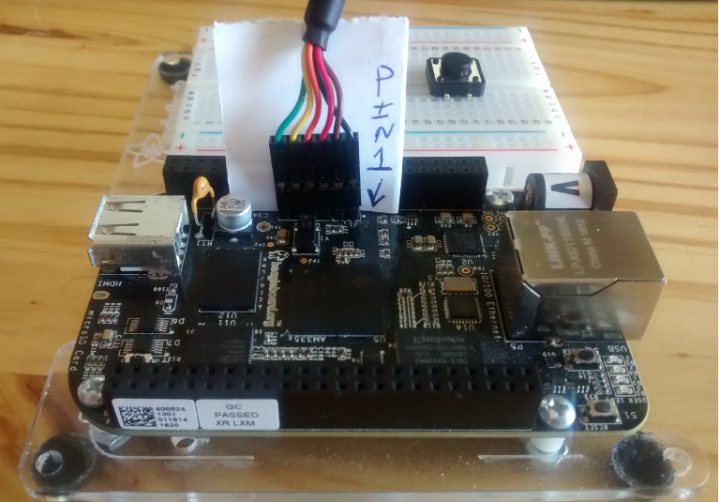

Need link for Adafruit Cable -  <https://www.adafruit.com/product/954>

