For Phase A:

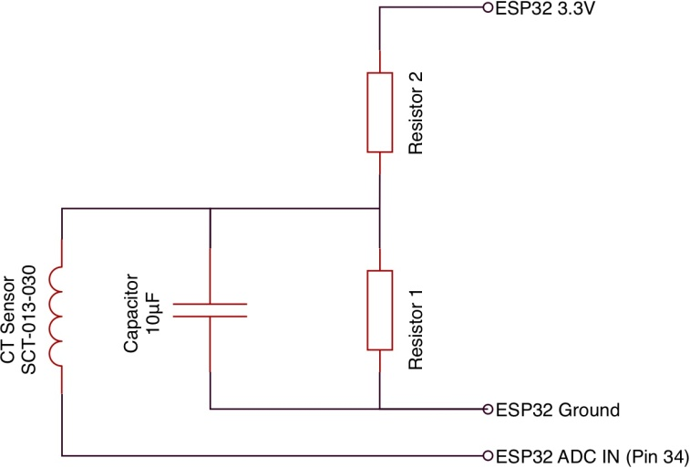 Use Pin 34

For Phase B:

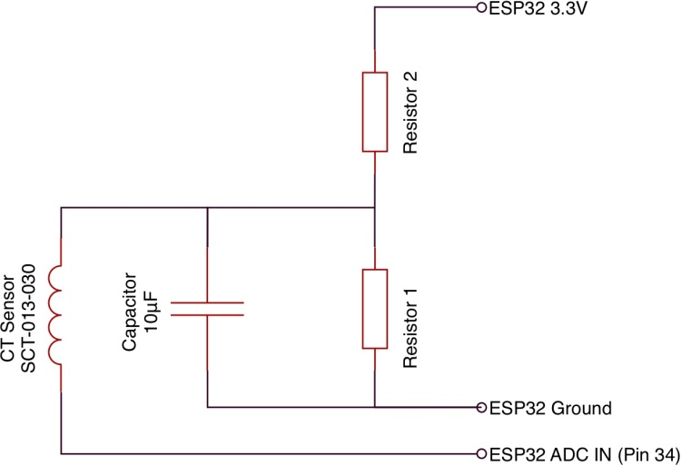 Use Pin 35

Note: I used 2x 270kΩ resistors, but you can use any resistor value between 10k and 470k. Just make sure R1 and R2 are of the same value. Blue wires go to the esp32 inputs, green wires go to the voltage divider circuit.

Note the ESP32-PICO-KIT V4 module needs a 10Kohm pull up added from IO0 to 3.3V or you will need to manually press the EN button after each power up. The two pins are beside each other.

Note, I reused a basic wiring diagram I found somewhere on the internet. Thanks to the original author.