One student questioned the full-wave bridge rectifier circuit drawing in Wednesday’s lecture, asking why we needed four diodes instead of just two. In that drawing, two diodes were redundant, but that was because the picture had an error: the circuit was not rectifying the input voltage -- it was just reproducing it.

The drawing is now fixed, and the slide title now includes the word “bridge”, generally used for this circuit.

In any case, the drawing differs from the usual way of representing this circuit, which is shown below.

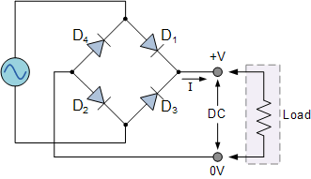

You may check that the above circuit and the one in the slide are equivalent. My intention with the initial (and wrong) drawing was to avoid 45º angles and wire crossings, making circuits more difficult to apprehend. However, my efforts were flunked because the circuit in question is not planar, and you need at least one wire crossing, as shown above, and in my new square angle drawing, which, hopefully, illustrates the signal paths better.

Many thanks to the student: *to err is human but to edit is divine*.