

**Nanotechnologies and Nanoelectronics**

Homework #1

Duarte Miguel de Aguiar Pinto e Morais Marques, 96523 LEFT

Period 2, Semester 1

December 17, 2021

Professor Susana Cardoso de Freitas

1

**Note**: In order to save space, the information is not presented in tables.

**Figures 1 and 2**: Schematics ([3] and [4], respectively) of an early model of a point contact transistor (note: the locations of the emitter and collector are reversed in each figure, regarding the other figure).



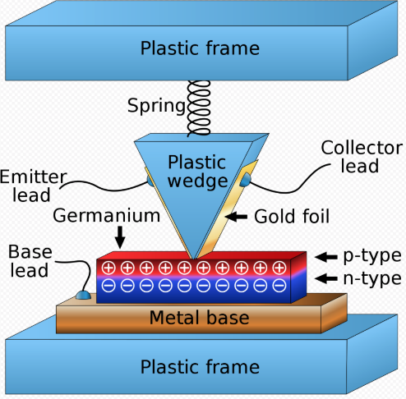

**#1**

**Nobel Awardees**: John Bardeen (University of Illinois, Urbana, IL, USA), Walter H. Brattain (Bell Telephone Laboratories, Murray Hill, NJ, USA) and William B. Shockley (Semiconductor Laboratory of Beckman Instruments, Inc., Mountain View, CA, USA)

**1. Three ideas that were awarded with a Nobel Prize related to Nanotechnologies and Nanoelectronics**

**Brief description of the scientific idea**

**Nobel Prize in:** Physics

**Year**: 1956

These three scientists were awarded the Nobel Prize for their researches on semiconductors and their discovery of the transistor effect. In 1947, John Bardeen and Walter Brattain produced a semiconductor amplifier, which was further developed by William Shockley – they invented the **transistor**. The first transistor ever assembled was called a **point-contact transistor**. In 1947, Walter Brattain (at Bell Labs) fashioned it out of a plastic stand, a chunk of germanium and a plastic triangle. On each side of the plastic triangle, there was gold foil. On the top, there was a spring, which pressed the apex of the triangle into the germanium (thus the name “point-contact transistor” - two metal contacts were pressed onto the surface of the semi-conductor material). In December 23rd 1947, Bardeen and Brattain hooked up a microphone to the left side [see Figure 2; in case of Figure 1, it would be its right side] and an oscilloscope to the right side. As they spoke into the microphone, they could see the voice signal being amplified. That **amplification** is still one of the main uses for a transistor (for example, a telephone detects a low powered signal from a tower and its circuitry amplifies the signal).

**Semiconductors** (such as germanium) have two different ways of conduction electricity: with negative and positive charge carriers (n-type and p-type semiconductors, respectively). By joining the two types, a one-way current valve (a diode) is made. It’s best to think it of this point-contact transistor as two separate one-way current valves; at the center of each, the germanium makes electrical contact with a piece of copper at its base. At the top, a spring presses a thin piece of gold foil into the germanium. Right where the gold touches, there is a thin layer of a positive charge carrier semiconductor; below it, there is the n-type semiconductor. As seen in Figure 2, if a small battery is attached on the left, with its positive terminal connected to the top layer, it allows current to flow. On the right, a larger battery is used, but with its ins reversed. With this configuration, by putting the two in contact, the positive charge carriers are “injected” from left to right. The current on the right

is controlled by that on the left - a signal amplifier is created. Because P=UI, a small battery on the left and a big battery on the right create a device that amplifies any fluctuations in the current on the left side (for example, the output of the microphone).

**Its relevance for Nanotechnologies and Nanoelectronics**

Today, there are transistors in every place where an electronic gadget can be found; they are the workhorse of electronic technology, the device that heralded the start of the digital age. Entire industries based on semiconductors were created in its wake. Technology as we know it would not have been possible if it were not for the transistor. This point contact transistor lies at the heart of a microelectronics revolution and is the key to any transistor. Transistors would not have their current computing power if it weren’t for their continuous development and improvement. However, it is believed this development could face a limit to the amount that bulk material transistors can scale down to via top-down approaches based on Moore’s Law, which observes that the number of transistors in a dense integrated circuit doubles about every two years. This is where Nanotechnologies and Nanoelectronics come into play: the alternative approach is to make them smaller, by building **nanosized** transistors atom by atom via bottom-up methods. Their development is the backbone for today's economy. Intel estimates that about 10 quintillion transistors are shipped each year. In some applications, smaller transistors mean that more of them can fit into a given area, amplifying the device’s electronic signal and making it more effective. The excellent electronic properties, responsiveness, ability to interact with other systems, stability and small size have meant that nanomaterials have become an excellent choice for building the next generation of transistors. Moreover, the bottom-up nanofabrication methods available nowadays mean that many of these transistors can be created and integrated into chips and circuit boards.

**How the scientific idea was implemented in one device, instrument or equipment**

**Circuit boards** (in which the size of nanomaterial-based transistors plays a significant role) and processing components within computers rely heavily on transistors to change and amplify electronic signals. The more transistors per unit area on a chip in a processor, the faster it is―which leads to an overall increase in performance and computing power. The ability to create nanosized transistors means that more transistors can be integrated per area, improving the **chip**’s performance―especially when the nanomaterials used are highly conductive, such as carbon nanotubes (CNTs). Because they can be built from scratch atom by atom, they can be integrated into chips in a customized way to be compatible with the usual architecture of the chip and the different components within a device.

* **Bibliography**: **[1]** <https://www.bell-labs.com/about/awards/1956-nobel-prize-physics/#gref> (Nokia Bell Labs),

**[2]** <https://www.nobelprize.org/prizes/physics/1956/bardeen/facts/> (The Nobel Prize),  **[3]** <https://www.historyofinformation.com/detail.php?entryid=846> (HistoryofInformation.com), **[4]** <https://www.youtube.com/watch?v=RdYHljZi7ys> (Youtube, *How the first transistor worked*),

**[5]** <https://www.mouser.com/blog/nanotechnology-impacted-transistors> (Mouser Electronics)

2

hence the name of the instrument. An electrical potential (by applying voltage) between the metallic tip of the stylus and the surface causes an electric current to flow between them (electrons are extracted from the surface by **quantum tunneling**), despite the fact that they are not in contact. The strength of the current is strongly dependent on the distance. The stylus is extremely sharp, the tip being formed of one single atom (ideally). This enables it to follow even the smallest details of the surface it is scanning. Recording the vertical movement of the stylus makes it possible to study the structure of the surface atom by atom. One can deduce the position of the atoms of the metal surface down to a resolution better than 0.1 nm. This device is shown in Figure 3 and will further be discussed in page 7.

3

**How the scientific idea was implemented in one device, instrument or equipment**

Ruska contributed actively to the development of **commercial mass-produced electron microscopes** that rapidly found applications within many areas of science.He was then appointed by Siemens and took part in the development of the first commercially-available, mass-produced electron microscope, which entered the market in 1939. Microscopy is highly utilized in **failure analysis** for semiconductors and data storage. For instance, it can be used to trace cracked solder at a microelectronic component. Only in the micro-section and with light microscopy can it be seen that the crack origin is in the solder. The combination of different microscopic techniques and the results obtained then allow the determination of the cause of the damage.

* **Bibliography**: **[6]** <https://www.nobelprize.org/prizes/physics/1986/press-release/> (Nobel Prize), **[7]** <https://www.youtube.com/watch?v=HE2yE8SvHmA> (Youtube, *scanning tunneling microscope*), **[8]** <https://en.wikipedia.org/wiki/Scanning_tunneling_microscope> (Wikipedia, *Scanning tunneling microscope*),

**[9]** <https://en.wikipedia.org/wiki/Electron_microscope> (Wikipedia, *Electron microscope*), **[10]** <https://www.zeiss.com/microscopy/us/solutions/manufacturing-assembly/materials-failure-analysis.html> (Zeiss)

**Its relevance for Nanotechnologies and Nanoelectronics**

The invention of the conventional microscope represented a great step forward for science. However, as better and better microscopes were built, it was discovered that there exists a limit that cannot be exceeded - using light waves, it is impossible to distinguish details smaller than the **wavelength** of the **light**. The resolution for a conventional microscope using visible light is about 4 000 Å. The great breakthrough in microscopy came when it was found possible to produce an image of an object using an electron beam, being the starting point the discovery that a magnetic coil can function like an optical lens by Ruska. It also proved possible to combine two or more lenses to increase the magnification. The ability to determine the positions of atoms within materials is useful for nano-technologies **research and development**; for instance, allows for the observation of nanoparticles. Small, stable specimens such as [carbon nanotubes](https://en.wikipedia.org/wiki/Carbon_nanotubes) and small mineral crystals (asbestos fibers, for example) require no special treatment before being examined in the electron microscope. Samples of hydrated materials, including almost all biological specimens have to be prepared in various ways to stabilize them, reduce their thickness and increase their electron optical contrast (staining).

Development of the electron microscope has been very extensive. Its resolving power could be considered theoretically unlimited, since the electron is a point-like particle (however, according to quantum mechanics, every particle has wave characteristics which introduce an uncertainty into the determination of its position).Electron microscopy has since been developed through technical improvements and through the advent of entirely new designs, among them the scanning tunnelling electron microscope. A number of researchers have taken part in both this and the earlier development, but Ruska’s pioneering work is a clearly outstanding achievement.

As for the scanning tunneling microscope, it is clear that entirely new fields are opening up for the study of the structure of matter. Piezoelectrical elements are used to control the horizontal movement of the stylus in two perpendicular directions so that it scans the surface along parallel lines – hence the name “scanning microscope”. The vertical movement of the stylus is controlled and measured using another piezo-element. Horizontal resolution is approximately 2 Å and vertical resolution. approximately 0.1 Å. This makes it possible to depict individual atoms, that is, to study in the greatest possible detail the **atomic structure** of the surface being examined.

This Nobel Prize was awarded jointly to Professor Ernst Ruska, for his fundamental work in electron optics and for the design of the first **electron microscope**, and to Dr. Gerd Binnig and Dr. Heinrich Rohrer for their design of the **scanning tunnelling microscope (STM)**.

The electron microscope’s development began with work carried out by Ruska, as a young student at the Berlin Technical University at the end of the 1920’s. He found that a magnetic coil could act as a lens for electrons, and that such an electron lens could be used to obtain an image of an object irradiated with electrons. A divergent bundle of electrons passing through the coil is focused to a point. By coupling two electron lenses, he produced a primitive microscope. He very quickly improved various details and in 1933 was able to build the first electron microscope with a superior performance (**higher resolution**) to that of the conventional light microscope. The image is recorded on a fluorescent screen or a photographic plate.

The scanning tunneling microscope is based on the principle that the structure of a surface can be studied using a stylus that scans the surface at a fixed distance from it. Vertical adjustment of the stylus is controlled by means of what is termed the tunnel effect,

**Figure 3**: Simplified representation of a modern scanning tunneling microscope [8]

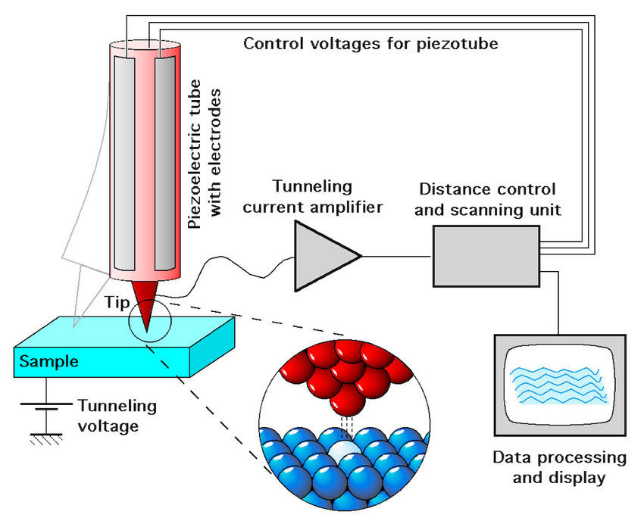

**Year**: 1986

**Brief description of the scientific idea**

**Nobel Prize in:** Physics

**Nobel Awardees**: Professor Ernst Ruska (Fritz-Haber-Institut der Max-Planck-Gesellschaft, Berlin, Federal Republic of Germany), Dr. Gerd Binnig (IBM Zurich Research Laboratory, Rüschlikon, Switzerland) and Dr. Heinrich Rohrer (IBM Zurich Research Laboratory, Rüschlikon, Switzerland)

**#2**

4

**Figure 4**: Model of a C60 fullerene [14]

**Nobel Awardees**: Prof. Robert F. Curl Jr. (Rice University, Houston, TX, USA), Prof. Richard E. Smalley (Rice University, Houston, TX, USA) and Prof. Sir Harold W. Kroto (University of Sussex, Brighton, England)

* **Bibliography**: **[11]** <https://en.wikipedia.org/wiki/Nanotechnology> (Wikipedia), **[12]** <https://www.nobelprize.org/prizes/chemistry/1996/press-release/> (Nobel Prize), **[13]** <https://www.spf.pt/magazines/GFIS/417/article/1304/pdf> (Pacheco J.M., Martins J.L., *Prémio Nobel da Química de 1996*),

**[14]** <https://en.wikipedia.org/wiki/Fullerene> (Wikipedia), **[15]** <https://en.wikipedia.org/wiki/Buckminsterfullerene> (Wikipedia)

**Its relevance for Nanotechnologies and Nanoelectronics**

The molecules C60 were not initially described as nanotechnology; the term was used regarding subsequent work with related carbon **nanotubes** (sometimes called “graphene tubes” or “buckytubes”), thin tubes with closed ends, which suggested potential applications for **nanoscale** **electronics** and devices. No physicist or chemist had expected that carbon would be found in such a symmetrical form other than those already known. In 1990, physicists Wolfgang Krätschmer (Germany) and Donald R. Huffman (USA) produced, for the first time, isolable quantities of C60 by causing an arc between two graphite rods to burn in a helium atmosphere and extracting the carbon condensate so formed using an organic solvent. They obtained a mixture of C60 and C70, the structures of which could be determined. The way was thus open for studying the chemical properties of C60 and other carbon clusters such as C70, C76, C78 and C84. New substances were produced from these compounds, with new and unexpected properties. An entirely new branch of chemistry developed, with consequences in such diverse areas as astrochemistry, **superconductivity** and **materials** chemistry/physics. Nowadays, the family of know fullerenes is very extensive and keeps growing. A whole new chemistry has developed to manipulate the fullerene structure.

The possible technological applications of the buckyballs (the name given to closed fullerenes for their resemblance to the standard ball of “soccer”) for nanomaterials are very large. The possibility of “incarcerating” atoms inside the buckyballs gave rise to the creation of peculiar compounds, some of which can prevent metal atoms from interacting with the exterior. It is also possible to maintain noble gas atoms inside fullerenes, thus creating highly stable molecules. Buckytubes are conducting wires with only a few Angstroms of diameter and have a mechanical resistance much larger to that of steel, thus its many uses.

**How the scientific idea was implemented in one device, instrument or equipment**

Fullerenes have been extensively used for several biomedical applications, such as **tumor research**. While past cancer research has involved radiation therapy, photodynamic therapy (a form of phototherapy involving light and a photosensitizing chemical substance, used in conjunction with molecular oxygen to provoke cell death) is important to study because breakthroughs in treatments for tumor cells will give more options to patients with different conditions. Recent experiments involve the development of new **photosensitizers** with increased ability to be absorbed by cancer cells and trigger cell death. It is also important that a new photosensitizer does not stay in the body for a long time to prevent unwanted cell damage. Fullerenes can be made to be absorbed by HeLa cells (common immortal cells used in cancer research). The C60 derivatives can be delivered to the cells by being associated with different functional groups. Functionalizing the fullerenes aims to increase the solubility of the molecule by the cancer cells.

Once absorbed by the cells, the C60 derivatives would react to light radiation by turning molecular oxygen into reactive oxygen which triggers apoptosis (programmed cell death) in the HeLa cells and other cancer cells that can absorb the fullerene molecule. This research shows that a reactive substance can target cancer cells and then be triggered by light radiation, **minimizing damage to surrounding tissues** while undergoing treatment. When absorbed by cancer cells and exposed to light radiation, the reaction that creates reactive oxygen damages the DNA, proteins, and lipids that make up the cancer cell. This cellular damage forces the cancerous cell to go through apoptosis, which can lead to the reduction in size of a tumor. Once the light radiation treatment is finished **the fullerene will reabsorb the free radicals** to prevent damage of other tissues. Since this treatment focuses on cancer cells, it is a good option for patients whose cancer cells are within reach of light radiation.

As this research continues, the treatment may penetrate deeper into the body and be absorbed by cancer cells more effectively.

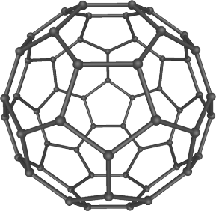

These fullerenes were discovered through vaporized carbon condensed in an atmosphere of inert gas (helium) - the gaseous carbon is obtained, for example, by directing an intense pulse of laser light at a carbon surface. The released carbon atoms are mixed with a stream of helium gas and combine to form clusters of some few up to hundreds of atoms. The gas is then led into a vacuum chamber where it expands and is cooled to some degrees above absolute zero. The **carbon clusters** can then be analyzed with mass spectrometry. In the mass spectrum of the product, discrete peaks appeared corresponding to molecules with the exact mass of sixty or seventy or more carbon atoms, namely C60 (the most predominant), of 720 atomic mass units. Kroto and the Rice team also discovered other fullerenes besides C60 and the list was much expanded in the following years.

These scientists were awarded the Nobel Prize for their discovery of **fullerenes** and the experiment that, in 1985, showed the peculiar stability of the molecule **C60** (named “buckminsterfullerene”), the most common naturally occurring type of fullerene. Fullerenes were new forms of the element carbon, in which the atoms are arranged in closed shells. In other words, a fullerene is an allotrope of carbon whose molecule consists of carbon atoms connected by single and double bonds so as to form a closed or partially closed mesh, with fused rings of five to seven atoms. The molecule may be a hollow sphere, ellipsoid, tube, or many other shapes and sizes.

**Nobel Prize in:** Chemistry

**Year**: 1996

**Brief description of the scientific idea**

**#3**

In nanoscale/microscale devices, a pattern needs to be made on wafers. There are two types of lithography or patterning: **electron beam lithography (EBL)** and photolithography. EBL uses electrons to print (pattern), photolithograph uses light. Both use a resist which is sensitive to either electrons or light, resp. The EBL resist is also very thin; the thickness may range from tens of nanometers to a few hundred nanometers. It is often a polymer dissolved in a liquid solvent. The substrate thickness is usually several hundred microns.EBL is a very flexible system and doesn’t require expensive masks, so it's easy and fast to change a design; it can have small feature sizes down to 10 nanometers or less. Since there's no mask required, a CAD program is used to lay out the pattern to be transferred to the substrate and that pattern is loaded directly into the machine.

Firstly, a thin coat of the **resist** is applied to the substrate (e.g., a semiconductor wafer of silicon), using **spin coating**. When the polymer is exposed to an accurately directed beam of electrons, it undergoes a chemical change. The electron beam forms the **pattern** dot by dot and line by line (the substrate becomes exposed). The substrate coated with the resist is then put onto the e-beam lithography instrument (Fig.5); one of its basic components are an **electron source**, which is, in the case of a Field Emitter Gun (**FEG**), a small sharpen tip that emits a stream of electrons when a high voltage bias is applied: by applying a strong electric field to a solid (for example, tungsten or carbon nanotubes) the electrons tunnel out when the surface barrier becomes very narrow. Systems with higher-resolution requirements need to use FEG sources. There are also **thermionic** **emitters**, where the electrons come from the surface of a filament when heated up in vacuum. Next is an electromagnetic **lens system** (Fig.6); it focuses the beam of electrons (to what can be an extremely small spot size). The lenses and mirrors are shaped in such a way to bend the light and focus it. Below the lens system is a set of **beam** **deflectors** (Fig.7), which can electronically deflect the beam at extremely high speeds; this controls the position of the electron beam, allowing it to be steered to different regions of the substrate (usually in a matter of nanoseconds). The deflection is electrostatic (using two parallel plates and a positive voltage on one and a negative on another) or electromagnetic (using coils which create a magnetic field).

The next step is to remove the substrate from the EBL instrument and to submerge into a **chemical bath**, the developer, which will dissolve the resist material that was exposed to the e-beam. After a brief time, the

**Note**: In the current page, two different topics were answered simultaneously in the first subdivision. The same happens in page 7.

1. **Electron-beam lithography – method using an e-beam to irradiate a surface and generate nanometric-sized features**

**2. Key information on some technologies supporting the Nanoelectronics**

**Principle of operation AND physical mechanisms to write (e.g., 200nm) features using an e-beam lithography tool**

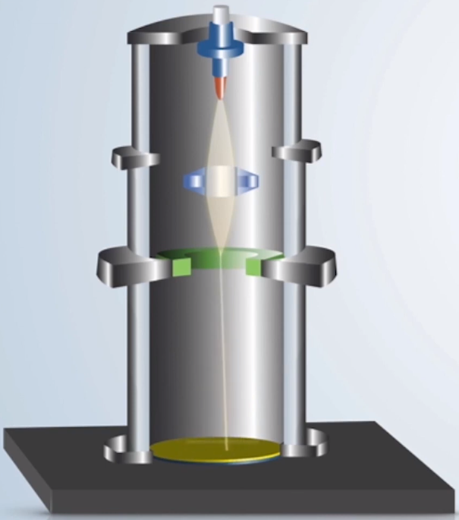

**Substrate**

**Electromagnetic lens system**

**Beam deflectors**

**Electron source**

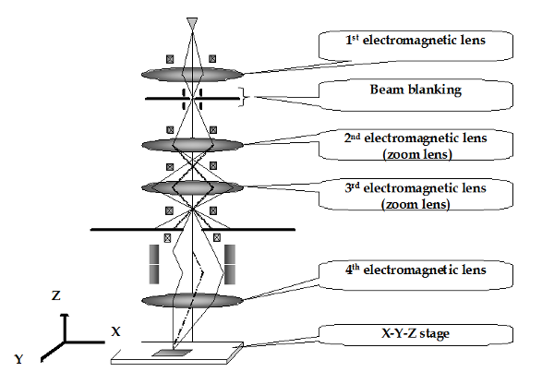

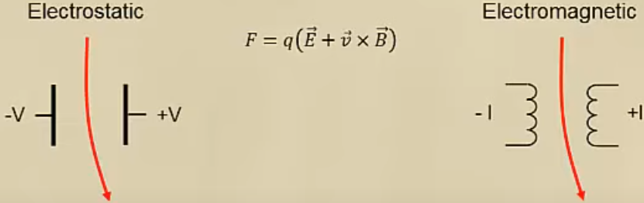

**Figures 5-7**: E-beam lithography instrument [14], electromagnetic lens system for focusing [21] and e-beam deflection [15] (resp.)

substrate is removed, rinsed usually with isopropyl alcohol and dried with pressurized nitrogen gas. The resist layer is intended to be only a temporary layer. To pattern the vacuum deposited thin layers of added material on top of the EBL resist, such as metal, the process used is called **lift off**. Any area where the EBL resist was removed is where the metal sticks to the substrate. When that EBL resist is dissolved away in acetone, the metal that's sitting on top of the resist is also removed.

**Some relevant patents related to e-beam systems for nanotechnology usage**: Some commercial systems: →JEOL JBX-3200MV: variable- -shaped beam, 50 kV energy, for mask making; →JEOL JBX-9500FS: Gaussian raster scan, 100kV for R&D; →Raith 150: R&D (Research and Development, 100eV-30keV; the variable energy can be useful is some applications.

**Physical limits to reduce the size towards 10nm feature sizes**: While the resolution is high, there are still limits and there are three different kinds of phenomena that can limit resolution in the beam lithography and depending on the system we might be limited by one or more of these: -**Spot size** due to electron wavelength and lens NA (Numerical Aperture). The spot size is ≈ λ (electron wavelength)/NA, with typical high resolution beam lithography tools having spot sizes on the order of a nanometer. -**Electron scattering** in the resist/substrate; -**Electron- -electron repulsion** (Coulomb-Coulomb interactions) if the current is too high. Electrons are all negatively charged so if we try to squeeze too many electrons together into a small spot, they will repel each other and spread out. How much they repel is a function of the current. Shooting many electrons at the same time (very high current), there’ll be more repulsion and smearing out of the spot size.

**Commercial device/component for nanoelectronics that could have been produced using EBL**: Nano MOSFETs or other transistors

**Limitations in using an EBL tool to write millions of nano-elements in a 300mm diameter wafer**: Higher throughput always results in **lower resolution** and vice-versa. To get higher throughput: -**Larger spot size**; -**Larger address grid** (in case of shaped beam systems, the writing system most used in mass production today, in which the pattern is divided into rectangles and each one is exposed at a time); -**Higher current** (can result in electron-electron repulsion); -**Moving the xy-stage or beam faster** (harder to control).

The minimum time to expose a given area for a given dose is given by the formula DA=TI, where T is the time to expose the object, I the beam current, D the dose and A the area exposed. This write time does not include time for the stage to move back and forth, as well as time for the beam to be blanked (blocked from the wafer during deflection), as well as time for other possible beam corrections and adjustments in the middle of writing. To cover the ≈700 surface area of a **300 mm** diameter silicon wafer, the minimum write time would extend to 7x seconds, about 22 years. Throughput is a serious limitation for electron beam lithography, especially when writing dense patterns over a large area. E-beam lithography is not suitable for high-volume manufacturing because of its limited throughput. The smaller field of electron beam writing makes for very slow pattern generation compared with photolithography (the current standard).

* **Bibliography**: **[16]** <https://en.wikipedia.org/wiki/Electron-beam_lithography> (Wikipedia, Electron-beam lithography),

**[17]** <https://www.azonano.com/article.aspx?ArticleID=3219> (AZoNano), **[18]** <https://www.youtube.com/watch?v=PWV9pvdRBNY> (Youtube, Electron Beam Lithography), **[19]** <https://www.youtube.com/watch?v=Q4-HsS4eyOU> (Youtube, Introduction to EBL), **[20]** <https://www.youtube.com/watch?v=n4dd_onM_Ns> (Youtube, Lecture 61 (CHE 323) E-Beam Lithography, part 1), **[21]** <https://www.intechopen.com/chapters/8670> (IntechOpen)

5

**How the film quality can be affected by the substrate and/or underlayer interface quality:** No metal is 100% pure, thus impurities in the targets will also be sputtered and incorporated into the thin film, which is undesirable. Impurities can negatively influence the thin film properties, such as the electrical connectivity. Only highly pure sputtering targets can ensure high-quality thin films. The vacuum chamber should be left under vacuum when not in use to keep it as clean as possible.

**Physical limits to reduce the minimum layer thickness below 0.3nm (continuous monolayer)**: As discussed above, to increase step coverage, the **pressure** can be lowered, in order to have a high mean free-path, but that increases the sputtering and deposition rates, which makes it harder to deposit a monolayer. Also, the pressure must be high enough to sustain the plasma – it cannot be sustained at very low pressures. On the other hand, the **diameter of an atom** ranges from about 0.1 to 0.5 nm, which obviously does not allow a monolayer of atoms to have a thickness (equal to the diameter of the atom) below 0.3nm if the diameter is higher than this value. Moreover, electrostatic interactions may occur between the particles, which might make them elevate slightly.

**Commercial device/component for nanoelectronics/nano-optics that could have been produced using magnetron sputtering, in a 300 mm diameter wafer**: Magnetron sputtering sources are the current workhorse of the sputter deposition field, used in perhaps 95% of all sputtering applications. In optics, magnetron sputtering technology has been applied in **transparent conductive glass**. In particular, transparent conductive glass is widely used in flat panel display devices, solar cells, microwave and RF (radio frequency) shielding devices.

* **Bibliography: [22]** <https://www.youtube.com/watch?v=GgD6G3B-2WU> (Youtube, *Introduction to Sputter*)**, [23]** <https://www.youtube.com/watch?v=8mVK5dwyoEY> (Youtube, *Coating - How the PVD sputtering process works*)**, [24]** <https://www.youtube.com/watch?v=oTRmC0eJnYs> (Youtube, *Lecture 46: Sputtering*)**, [25]** <https://en.wikipedia.org/wiki/Sputter_deposition> (Wikipedia, *Sputter deposition*)**, [26]** <https://akademik.adu.edu.tr/fakulte/muhendislik/personel/uploads/aozcelik/thin-film-deposition-iii-1540978523.pdf>**, [27]** <https://www.intechopen.com/online-first/63559> (IntechOpen, *Introductory Chapter: Basic Theory of Magnetron Sputtering*)**, [28]** <https://www.youtube.com/watch?v=fxQ5IFbHLZ4> (Youtube, *Lecture 22 (CHE 323) Sputtering, part 1*)**, [29]** <https://www.youtube.com/watch?v=kvBGjccB7Xo&t=2s> (Youtube, *Lecture 23 (CHE 323) Sputtering, part 2*)**, [30]** <https://avs.scitation.org/doi/10.1116/6.0000594> (Journal of Vacuum Science & Technology A)**, [31]** *Handbook of Thin-Film Deposition Processes and Techniques*, 2nd Edition, Edited by Krishna Seshan (Intel Corporation, Santa Clara, California)

6

**Figure 8**: Sputtering chamber with the target on top [24]. In the middle, there is also a **turbo pump**. The target is, in fact, located under a **movable shutter**. When the shutter is closed, no deposition occurs; when the shutter is open and the plasma is on, deposition occurs (this is important because the plasma effect cannot be removed without some cooling, which takes some time and would lead to unwanted deposition and thickness). The substrate is held in a substrate holder at the top of the chamber. There is also a **thickness monitor** which measures the thickness of the material being deposited in real time.

charged target and physically knock off atoms of the target material’s surface - **sputtering** - which fly off in all directions, including towards the substrate we want to coat and become the thin film. This process continues (layer by layer) until the substrate is coated with the desired thickness. Then, the voltage on the target is turned off and the sputtering stops. If the ion energy is very low (<10-100 eV), there is not enough energy to knock off a target atom and there is no sputtering. Defining **sputter yield** = # of target atoms released / # of ions hitting the target, we would have yield=0. If the ion energy is too large (>10keV), we get ion implantation instead of sputtering (thus, yield=0). There will be some energy in the middle that maxims the yield. The higher the yield, the higher the deposition rate. It can be made increasing pressure, but the mean free path becomes very small. There is a way of increasing the ion densities without increasing the pressure: **magnetron sputtering**. A magnetic field parallel to the wafer (perpendicular to an electric field) is applied; electrons will spiral around the magnetic field, the increased path length means more ionization (because there is a higher probability of slamming into an argon atom), resulting in high density plasma.



2. **Thin film deposition by sputtering – physical method used to deposit thin films (<100nm thick) on a substrate**

**How the pressure of the sputtering gas affects the film quality and sputtering rate:** The **pressure** in which the chamber is kept is a key factor and will have mainly two effects. The deposition rate will mostly be a function of the **sputtering rate**, which is a function of how much argon is there. However, pressure also affects the **mean free path**. With an argon pressure at ≈0.1 Torr, the resulting mean-free path is λ≈0.5mm, much smaller than the distance between the target and wafer, thus there will be many collisions of the sputtered material as it travels to the wafer. At higher gas pressure, the ions can collide with the gas atoms and diffuse into the substrate or chamber wall and condense after moving inside it to a certain depth. Sputter deposition at **higher argon pressures** results in a significant **loss of deposition rate** due to gas **scattering** and **back** **diffusion** of sputtered atoms. The mean-free path of an atom is inversely proportional to the pressure P. For λ≈0.1cm, we have P≈50 mTorr. Therefore, as typically target-substrate separation is many cm, sputtered atoms have to go through tens of collisions before reaching the substrate. This reduces the deposition rate. Too many collisions also prevent ionization and electron energy buildup (reduce ion density and deposition rate). In contrast, for **lower** chamber **pressure** (same power): higher ion energy that increases sputter yield/deposition rate, but fewer to bombard the target for deposition, which **reduces deposition rate**. There will be few collisions and too few ions to bombard and generate secondary electrons, which limits the yield. Therefore, there exists and **optimum pressure** for maximum deposition rate. The pressure cannot be excessively high, in order not to cause arcing in the plasma (electrical breakdown that produces a prolonged electrical discharge). This optimum pressure depends on target-substrate configurations (their separation, target/substrate size, etc.).

**Principle of operation:** The most common thin film vacuum deposition techniques (to deposit thin layers of materials, e.g., metals and insulators, onto substrates) are thermal evaporation, electron beam evaporation and **sputtering**. Sputtering deposition is the dominant technique for most metal deposition and some dielectrics. It is performed in a **vacuum** system. After the target/source and the substrate (for example, a Si wafer) are loaded, vacuum pumps evacuate the chamber to about 5x Torr. Air is continuously removed by the pumps, leaving (nearly) no reactive gases inside. Then, a small amount of (usually) **argon** gas is leaked, taking several minutes for it to fill the chamber and let its pressure equal the room pressure (venting). Argon is used because it’s inert (low reactivity) and will not result in unwanted chemical reactions, leaving it only to be a physical process (**PVD** – Physical Vapor Deposition). A high negative electrical voltage is then applied to the target with a power supply - starting at low power and slowly raising it to avoid heating the target too quickly, which could crack it. This high voltage is strong enough to strip an electron from the argon atom; they become ionized and each one has a positive charge (stretching the plasma). The voltage is applied across two parallel plates; the **cathode** target is generally cooled because the sputtering generates heat. The **plasma** is created with a **DC power source** (preferred for metals) or **radio frequency (RF)** **power source** (for dielectrics). The plasma (emits light) consists of argon ions that accelerate towards the target (very high velocity) and free electrons. It might be concentrated along a magnetic field created by magnetic arrays. The ions are attracted towards the negatively

**(material to deposit)**

**(to feed argon)**

**Principle of operation of a scanning force microscopy system AND measurement of the surface roughness:** SPM is a branch of microscopy that forms images of surfaces using a physical probe that scans them. There are different types of SPM, such as **AFM/SFM (atomic/scanning force microscopy)**, **STM (scanning tunneling microscopy**, mentioned in page 3**)**, SPE (Scanning Probe Electrochemistry), etc. The first two are further discussed below. A SPM raster-scans the tip over the surface. At discrete points, a value is recorded (which value depends on the type of SPM and mode of operation). The nature of the probe tip depends on the type of SPM, but certain aspects are common - the probe must have a very sharp apex: the sharper, the better the resolution. For atomic resolution imaging, the probe must be terminated by a single atom (e.g., silicon). In **constant interaction mode**, a feedback loop is used to physically move the probe closer to or further from the surface. In **constant height mode**, the probe is not moved in the z-axis, but the value of the interaction under study is recorded (the tunnel current for STM, the cantilever oscillation amplitude for non-contact AFM). SPM would not be possible without the piezoelectric effect (deformation of materials due to an electric field). Some advantages of SPM: resolution limited only by the size of the interaction volume (can be as small as a few pm, hence the ability to measure small local differences in height); we can modify the sample (scanning probe lithography); doesn’t require vacuum, but can be observed in air at standard temperature and pressure or submerged in a liquid. Some disadvantages: difficulties may arise if the specimen varies greatly in height over lateral distances of 10 nm or less; generally slower in acquiring images; uncertainties due to time-domain effects, like feedback loop oscillation and mechanical vibration.

3. **Scanning probe microscopy (SPM) – physical method used to create a surface map of a substrate**

allows to raise it and move it somewhere else. The STM therefore allows to reconstruct the image of surfaces with atomic resolution, but also to perform atomic spectroscopy and even manipulate individual atoms.

7

* **Bibliography:** **[32]** <https://www.youtube.com/watch?v=HE2yE8SvHmA> (Youtube, *scanning tunneling microscope*) **[33]** <https://en.wikipedia.org/wiki/Scanning_probe_microscopy> (Wikipedia, Scanning probe microscopy) **[34]** <https://www.youtube.com/watch?v=8gCf1sEn0UU> (Youtube, *Atomic Force Microscope*) **[35]** <https://www.nisenet.org/catalog/scientific-image-atomic-force-microscope-illustration> (NISE), **[36]** <https://www.youtube.com/watch?v=Yvr0URej4S8> (Youtube, *Atomic Force Microscopy Basics*),

**[37]** <https://www.sciencedirect.com/science/article/abs/pii/S2211285519306329> (ScienceDirect), **[38]** <https://afm.oxinst.com/outreach/applications-of-scanning-probe-microscopy>

(Oxford Instruments: Asylum Research), **[39]** <https://www.azonano.com/article.aspx?ArticleID=5693> (AZoNano)

**Example of a commercial device/component for nanoelectronics/biotechnology highly improved thanks to the scanning probe techniques:** In the study and manipulation of **graphene**, AFM has turned out to be an indispensable; numerous parameters can be probed from the signals generated by sample-tip interactions. The most straightforward application is the determination of the number of layers by scanning the edges of graphene sheets, where the stacked sheets form steps; the step height corresponds to the thickness of the graphene sheet.

**Physical limits of the measurement:** The STM is able to surface with **atomic resolution**. Generally, they are very sensitive to noise. Stable high-voltage sources can hold the tip stable to better than 1pm while allowing a maximum **scan range** around 0.5–10 µm. In the SFM, there are more limitations in achieving atomic resolution. An image does not reflect the true topography, but the interaction of the probe with the surface (translational) - tip convolution. This does not often influence the height of a feature, but the lateral resolution. A further problem is the threat of tip jumping due to the cantilever’s spring constant; defects and impurities might be imaged. Other physical limitations have been discussed whilst discussing the principles of operation. Normal AFMs are designed for comparatively large **scan areas** (50–200 µm).

**How the surface mapping can be affected by the substrate material:** i) (Non-)Conductive materials: As STM can only probe conductive surfaces relying on the tunnelling current, AFM was conceived to extend atomic resolution to non-conducting surfaces. On those, silicon tips may be preferred to prevent unwanted charge build-up; ii) Magnetic materials: Magnetic force persists for greater tip-to-sample separations than the van der Waals force. In order to detect magnetic forces, a magnetic coating is applied to the cantilever; iii) Organic/soft materials: Characterizing these interfaces is ideal with non-contact AFM, in order to avoid unwanted perturbation of the soft biological systems.

of the laser spot, which can be used to measure friction and thus **surface roughness**. The two major methods of AFM are **contact and non- -contact**. In the first, the tip touches the surface and strong repulsive forces cause the cantilever to bend as it passes over it. The technology is simpler, but the sample can be damaged by the sharp tip and the tip is grinded down, with reduces the quality of the images. In the second, the tip oscillates up and down. Interactions between it and the surface cause the amplitude to vary. There is less damage because of the fewer contacts (high quality imaging over many scans). **Tapping** mode is similar to contact, but the cantilever is oscillated at its resonant frequency. The AFM can also measure the **force** on the tip due to the surface. The closer they are, the more attracted; at very short distances, the tip is repelled because the atoms cannot penetrate each other. The force measure helps determine characteristics of the surface (like elasticity). Techniques using magnetic (MFM) or electrical (EFM) tips allow to measure other magnetic or electrical properties of the surfaces.

The **AFM** contains a very sharp tip positioned at the end of a **cantilever** to scan over a surface and an optical system using a **laser** to detect the tip’s deflections. When it is brought into contact with the sample and moved along its surface, the laser deviation allows to measure the sample’s profile. The close-range attractive forces between the surface and the tip cause the cantilever to bend towards the surface. As the cantilever is brought even closer to it, increasingly repulsive forces cause the cantilever to bend away. A **z-scanner** moves the cantilever up and down, an **xy- -scanner** moves the sample back and forth underneath the cantilever. A **position detector** records its bending. It works by tracking a laser that is reflected off the flat top of the cantilever; the position detector tracks and records those beam changes. A **feedback loop** is used to control the tip. Lateral forces on the tip can cause the cantilever to bend sideways, which causes the deflection

**Figure 10**: Atomic/scanning force microscope (AFM) [35]

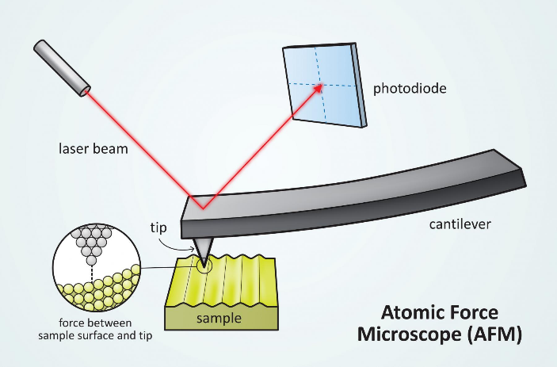

**Figure 9**: Simplified STM [32]; more detail was shown in page 3.

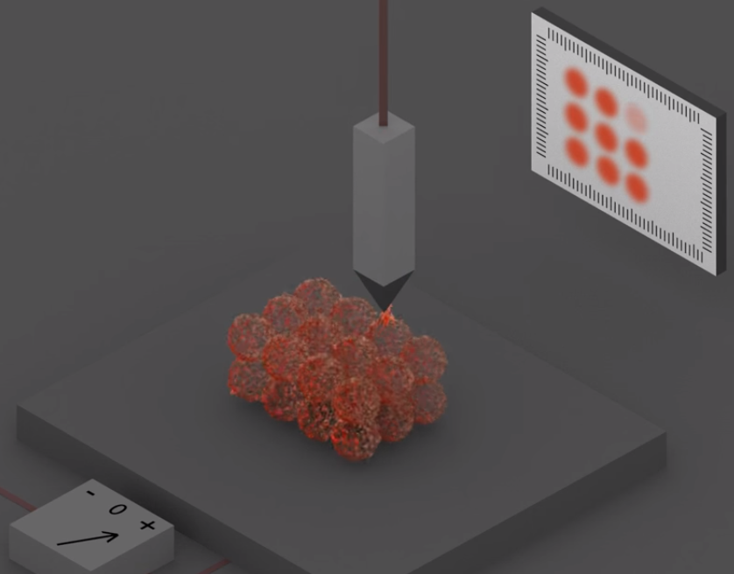

An **STM**’s metallic tip is brought very near the surface of a sample. When the voltage is applied between them, electrons are extracted from the surface by **quantum tunneling**, which occurs at very short distances and creates an electrical current between them. By drawing the **current intensity versus the tip location**, one can deduce the position of the atoms of the metal surface down to a resolution better than 0.1 nm. This way, it is possible to measure the **surface roughness**. Tunneling microscope can also be used for spectroscopy. The **current versus applied voltage** graph gives information about the electronic properties of the material down to nanometer scale. In practice, physicists prefer to measure the derivative of this graph. One can also use the tunneling microscope to move atoms. For example, in some materials, one can bring the tip very close to the atom, which