

**Nanotechnologies and Nanoelectronics**

Homework #4

Duarte Miguel de Aguiar Pinto e Morais Marques, 96523 LEFT

Period 2, Semester 1

February 4, 2022

Professor Susana Cardoso de Freitas

1

**1.** In order to determine the energy that corresponds to the wavelength $λ=405$ nm used in the laser, the following calculations can be made:

$E=hν=\frac{hc}{λ}=\frac{6.626×{10}^{-34}×3×{10}^{8}}{405×{10}^{-9}}≈4.908×{10}^{-19}J≈3.02$**eV** (divided by $1.626×{10}^{-19}J$ in order to get the result in eV).

Assuming a linear dependance of the bandgap of ${In}_{x}{Ga}_{1-x}N$, the bandgap of InGaN is then given by:

$E_{G}\left(InGaN\right)=E_{G}\left({In}_{x}{Ga}_{1-x}N\right)=x∙E_{G}\left(InN\right)+(1-x)∙E_{G}\left(GaN\right)$

This energy value varies from $E_{G}\left(InN\right)=0.6$**eV** (when $x=1$) to $E_{G}\left(GaN\right)=3.4$**eV** (when $x=0$). For the composition of InGaN quoted in the paper (page 1), we have that

$E_{G}\left({In}_{0.13}{Ga}_{0.87}N\right)=0.13×0.6+0.87×3.4=3.036$**eV**

As we can see, this energy value is bigger than the bandgap of InN and smaller than the bandgap of GaN. The photoluminescence studies described in the paper employ a 405nm laser diode as an excitation source to enable photoexcited carrier generation only in the GaInN QWs. By applying this exclusive QW excitation, optical carrier generation in the barrier layers is avoided and carrier transport effects occurring in electroluminescence measurements are reduced. By employing this selective optical pumping of the GaInN QW layers, carrier generation in the barrier layers is avoided and carrier transport effects are reduced. This way, it is possible to more clearly isolate recombination processes in GaInN MQWs, given the potential for carrier injection and carrier leakage to contribute to the “efficiency droop” in EL-based measurements of GaInN-based LEDs at high carrier densities.

**2.** The results demonstrate higher radiative efficiencies at a given carrier concentration for the samples with lower dislocation density. The studies described in the paper found that the measured nonradiative recombination coefficient A varied from $6×{10}^{7}s^{-1}$ to $2×{10}^{8}s^{-1}$ as the dislocation density increased from $5.3×{10}^{8}{cm}^{-2}$ to $5.7×{10}^{9}{cm}^{-2}$, respectively.

The threading dislocation density significantly effects the GaInN MQW efficiency, which supports the argument that threading dislocations behave as nonradiative recombination centers. It has been postulated that threading dislocations act as nonradiative channels, but strong special localization effectively suppresses the QW excitons from being trapped into threading dislocations, leading to highly efficient emissions from GaInN bored devices. The nonradiative nature of the defects was confirmed in this experiment.

To sum up, because dislocations act as non-radiative recombination centers, they increase the rate of the non-radiative Shockley–Read–Hall (SRH) process, **increasing the A coefficient value**. Due to the mathematical expression that defines IQE, as A increases, the internal quantum efficiency decreases.

**3.** The generation rate and the IQE at steady state can be expressed, respectively, as

$G=R_{total}=An+Bn^{2}+Cn^{3}$

$IQE=\frac{Bn^{2}}{G}=\frac{Bn^{2}}{An+Bn^{2}+Cn^{3}}$

The three main carrier-recombination mechanisms in a bulk semiconductor are represented by the recombination coefficients A, B and C. The Shockley-Read Hall nonradiative recombination is expressed as $An$, the bimolecular radiative recombination by $Bn^{2}$ and the Auger nonradiative recombination by $Cn^{3}$. Auger recombination affects LED efficiency only at very high excitation and was not considered in the paper – the $Cn^{3}$ term is much less than the $Bn^{2}$ term considered the small carrier concentration used in the experiments. **However**, in order to solve this question, it was requested to consider all recombination processes, thus all terms will be taken into account.

According to the paper, the sample with the highest threading dislocation density is A (this parameter has a value of $5.7×{10}^{9} {cm}^{-2}$ for this sample). The following parameters will be used for the plot:

$A=2×{10}^{8} s^{-1};$

$B=1×{10}^{-10}{cm}^{3}s^{-1};$

* $C=2.7×{10}^{-30} {cm}^{6}s^{-1}$.

2

The coefficient A for sample A was mentioned in the paper, as well as coefficient B, which can be assumed for room temperatures. Finally, C corresponds to the estimated upper limit value for the Auger coefficient. Using Python, the following plots for the internal quantum efficiency (IQE) of sample A as a function of the carrier concentration n were obtained. These graphs were by using *matplotlib.pyplot* (the code used for the second plot is shown below).

As requested, the plot was made for carrier concentrations n varying from ${10}^{17}{cm}^{-3}$ to ${5×10}^{19}{cm}^{-3}$ and it is shown below. The highest IQE is ${IQE}_{max}$**≈68.27%** and it occurs at $n_{max}$**≈ $8.61×{10}^{18}{cm}^{-3}$**; these values were directly obtained through the Python code. We can see that IQE drops for higher and lower values of the carrier concentration, having a peak in between. This can be inferred from the expression that defines IQE, shown above. When n tends to very large values, the dominant term in the denominator becomes $Cn^{3}$: Auger nonradiative recombination is prevalent, since, in this recombination process, the energy must be transferred to another change carrier. Thus, IQE tends to zero. On the other hand, for smaller values of n, the term $An$ (Shockley-Read Hall nonradiative recombination) becomes more relevant and, for similar reasons, IQE tends to zero. In radiative recombination, an electron from the conduction band directly combines with a hole in the valence band and releases a photon; in Auger recombination, an electron and a hole recombine and the energy is given to a third carrier, an electron in the conduction band. On the other hand, recombination through defects (SRH) occurs via a trap level or defect energy level in the band gap, thus it makes sense that only this phenomenon is prevalent for lower values of n.

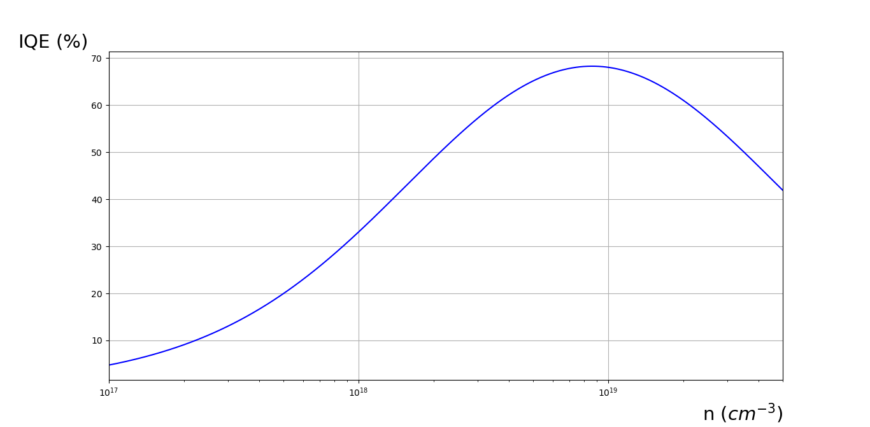

Even though it was not requested, in order to make the drop of IQE and the symmetry of the function clearer, a plot was made for values of n between ${10}^{14} {cm}^{-3}$ and ${10}^{24} {cm}^{-3}$. This graph is shown below, on the left. Moreover, another plot was made, in which it was considered that $C=0{cm}^{6}s^{-1}$– this graph is shown on the right. As it is clear from the plot in red, the Auger nonradiative recombination becomes much more meaningful for higher values of n. As opposed to what was seen before, IQE now tends to 100% when $n→+∞$; this is because both the numerator and denominator of the expression that defines IQE tend to $Bn^{2}$, thus the fraction as a whole tends to 1.

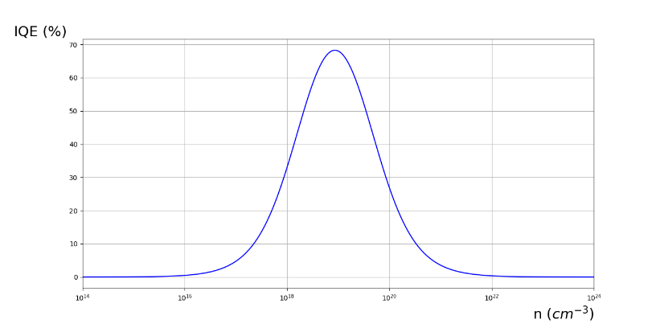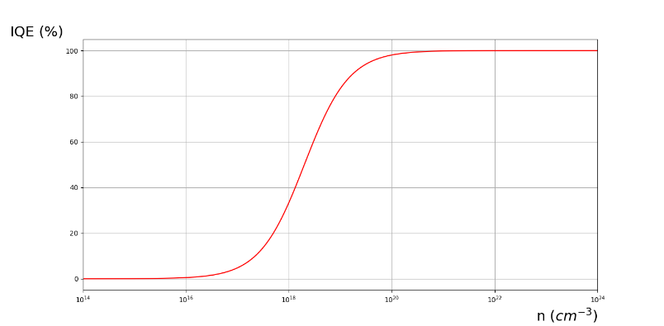

3

**Code used to obtain the second graph (the other two codes are very similar, but changing the limits of n for the first graph and the value of C for the third graph):**

#Import necessary libraries

import numpy as np

from numpy import *

import matplotlib.pyplot as plt

#Constants in SI units

A=2E8

B=1E-10

C=2.7E-30

#Vector of n

n = logspace(14, 24, num=1000)

#Vector of IQE

IQE = (B*(n**2))/(A*n+B*(n**2)+C*(n**3))

#Graph

plt.plot(n, IQE*100, 'b', label=r'Without C')

plt.xlabel(r'n ($cm^{-3}$)', fontsize=21, loc='right')

plt.ylabel(r'IQE ($\%$)', fontsize=21, rotation='horizontal', loc='top')

plt.xlim(1E14, 1E24)

plt.grid()

plt.show()

#Highest IQE and respective n

n_max = n[np.argmax(IQE)]

print ("Value of n (cm^-3): ", n_max)

print ("Value of IQE (%): ", max(IQE)*100)

4