

## Nanostructured Materials and Nanotechnologies

# **Preparation of silica nanoparticles by the**

# **sol-gel method**

**Group F4**

Diogo Silva Serrano (MBiotec) | 105265

Duarte Miguel de Aguiar Pinto e Morais Marques (MEEC) | 96523

Jeanne Louise Clothilde Bation (MEMat) | 104769

Prof. José Paulo Sequeira Farinha

Prof. José Luís Gonçalves

Prof. Pedro Alexandre de Sousa Rosa

Instituto Superior Técnico

Lisbon, Portugal

November 7th 2022

**Abstract**

Nanoparticles have been intensively researched due to their unique properties and potential applications, such as in drug delivery systems. The controllability of the particle size is paramount, since it strongly affects the efficiency of endocytosis, sensing and drug release. In this work, nearly monodispersed silica nanoparticles with average diameters from 34 to 275 nm were synthesized via a **sol-gel method**, using a fixed volume of water and ethanol. The particle size was generally increased by increasing the amounts of catalyst (NH4OH) and silica precursor (TEOS), whereas the increase in temperature generally led to lower diameters. The size of the silica nanoparticles was studied using Dynamic Light Scattering (DLS), Nanoparticle Tracking Analysis (NTA), Scanning Electron Microscopy (SEM) and Transmission Electron Microscopy (TEM). The data obtained by group F2 showed the lowest size differences between the different techniques - these synthesis conditions seem to be the best option for fabrication of silica nanoparticles.

**1. Experimental procedure**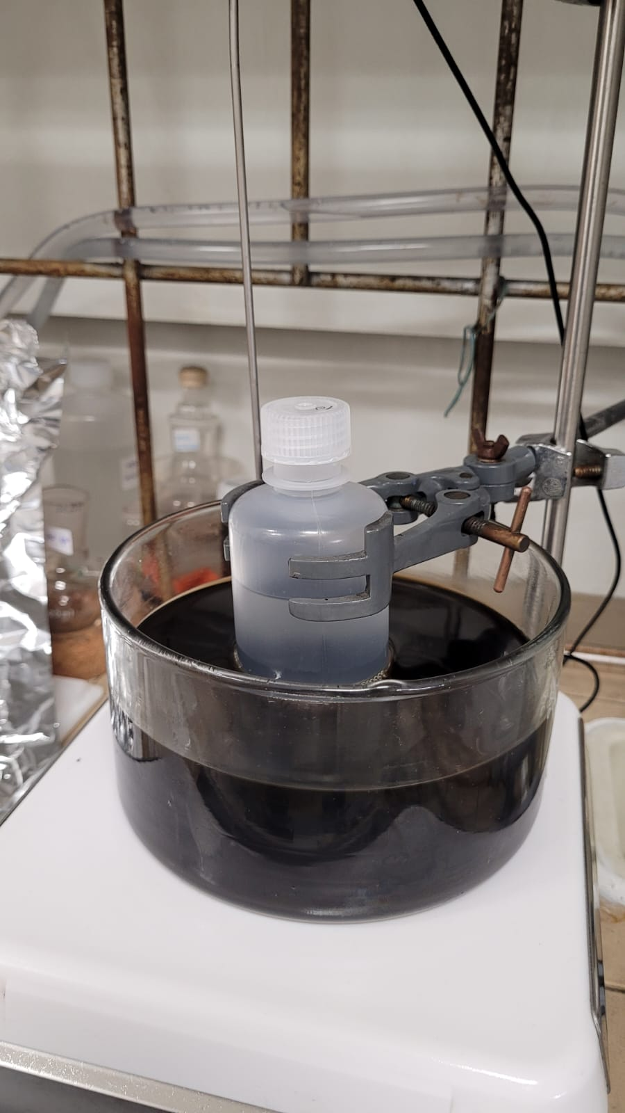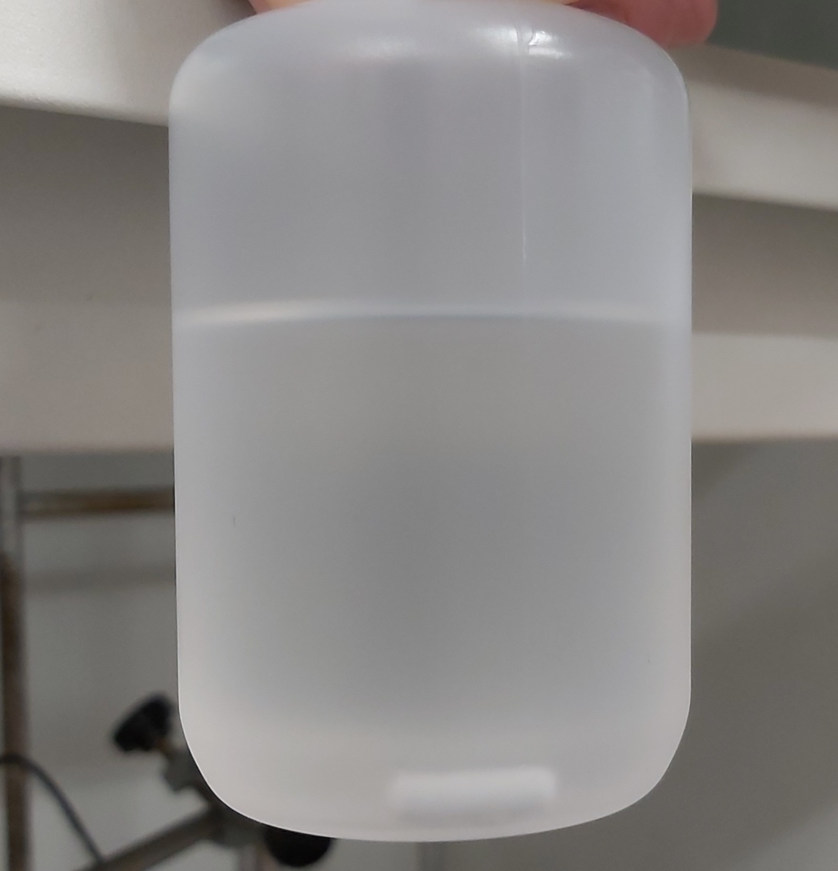

In the first laboratorial session, **silica nanoparticles** were synthesized by a **sol-gel** **method** under base catalyzed reaction conditions. Firstly, the proper amount of water (H2O), ethanol (absolute) and ammonia (NH4OH) 28% were added to a polypropylene flask (the latter using a micropipette). These quantities - corresponding to group F4 - are shown in Table 1. Once a magnetic stirrer had been added to the bottle, it was put in an oil bath at temperature T=70ºC (under gentle stirring), as shown on the right. The agitation keeps the particles in suspension after they have been formed. Once the temperature of the oil bath - measured with a digital thermometer - stabilized, the proper volume of tetraethoxysilane (TEOS) was also added to the solution using the micropipette. The reaction should be left to proceed for 1 hour - in this case, the flask was only handled again one week after the preparation of the nanoparticles.

|  |  |  |  |  |  |
| --- | --- | --- | --- | --- | --- |
| **Group** | **T (ºC)** | **H20** | **Ethanol (absolute)** | **NH4OH 28%** | **TEOS** |
| m (g) | m (g) | V (mL) | V (mL) |
| T1 | 30 | **11.028** | **53.179** | 2.386 | 4.46 |
| T2 | 1.35 |
| T3 | 40 | 2.386 |
| T4 | 1.35 |
| T5 | 50 |
| F1 | 60 | **2.386** | 2.23 |
| F2 | 4.46 |
| F3 | **70** | 2.23 |
| **F4** | **4.46** |

**Table 1**: Synthesis conditions - amount of water (H20) and TEOS (reactants), ethanol (solvent) and ammonia, NH4OH (catalyst), added by each group to the polypropylene flask, as well as the temperatures T of the respective oil baths.

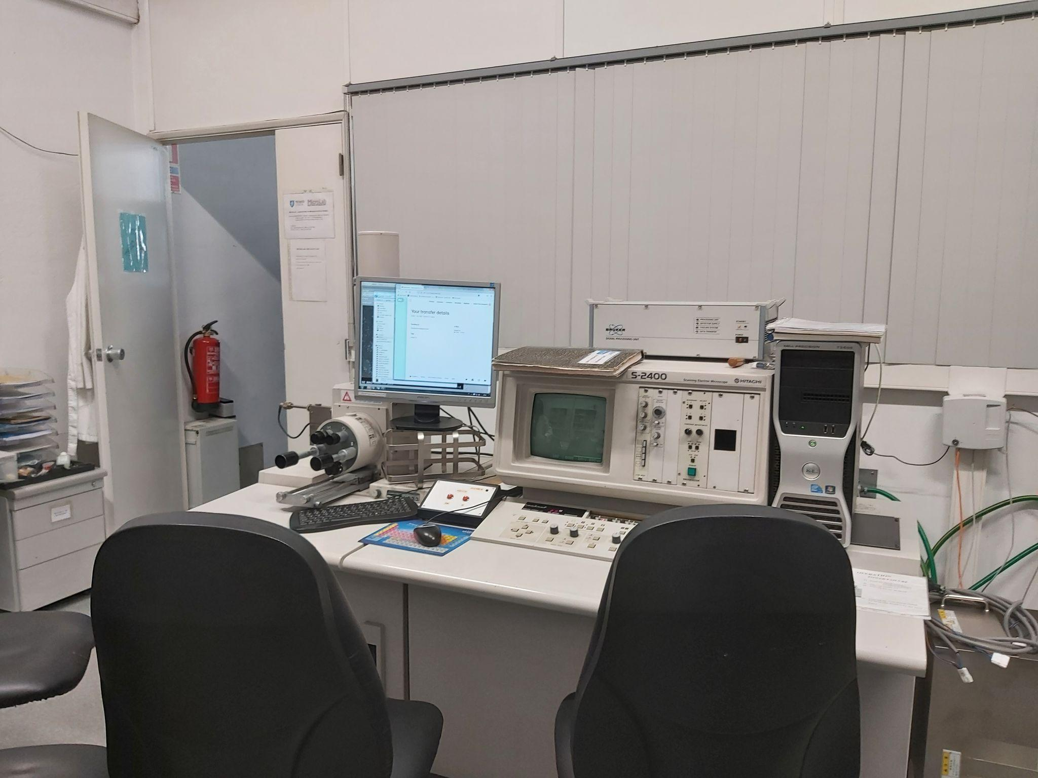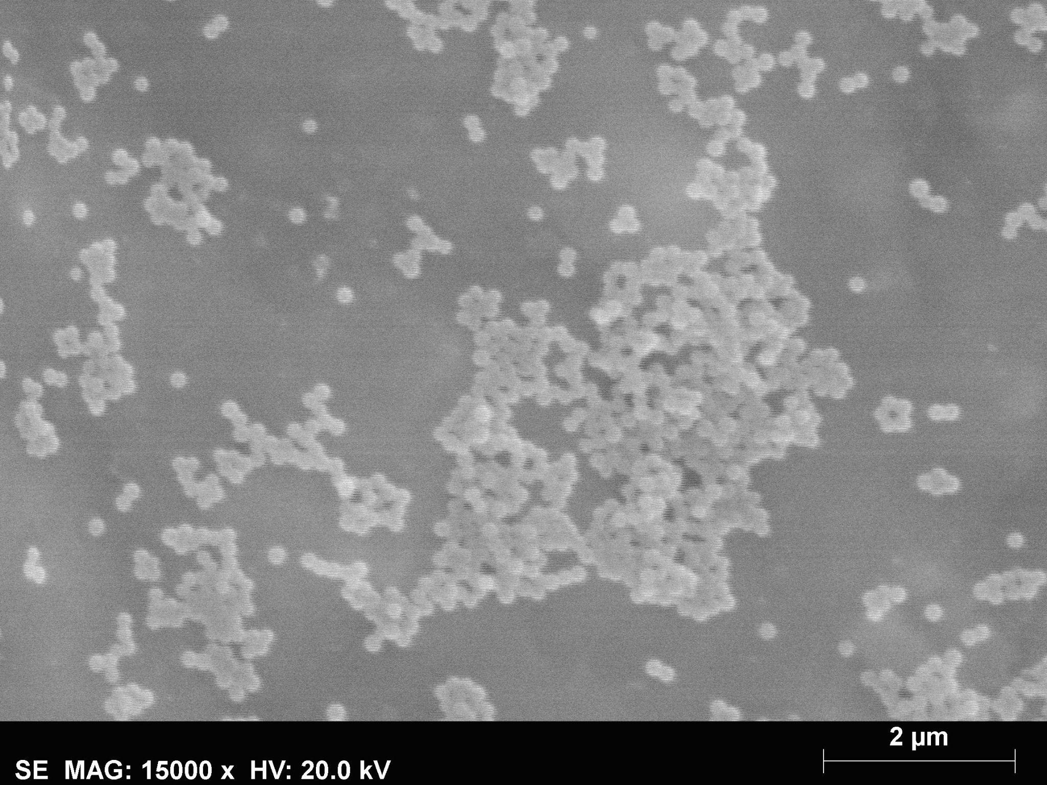

**SEM**

During the second laboratorial session, four images of the silica nanoparticles were obtained using the Scanning Electron Microscope and ten other amplified images were obtained from the Transmission Electron Microscope. The respective setups are shown on the left, as well as one of the respective pictures taken with each device. With these images, the image analysis software [Fiji](http://fiji.sc/Fiji) was used to measure the size distribution, having the diameter of 20 nanoparticles been measured for each set of images and an average final diameter value been obtained, along with the respective standard deviation. TEM has a higher degree of magnification and it can be more difficult to find particles when the solution is too diluted.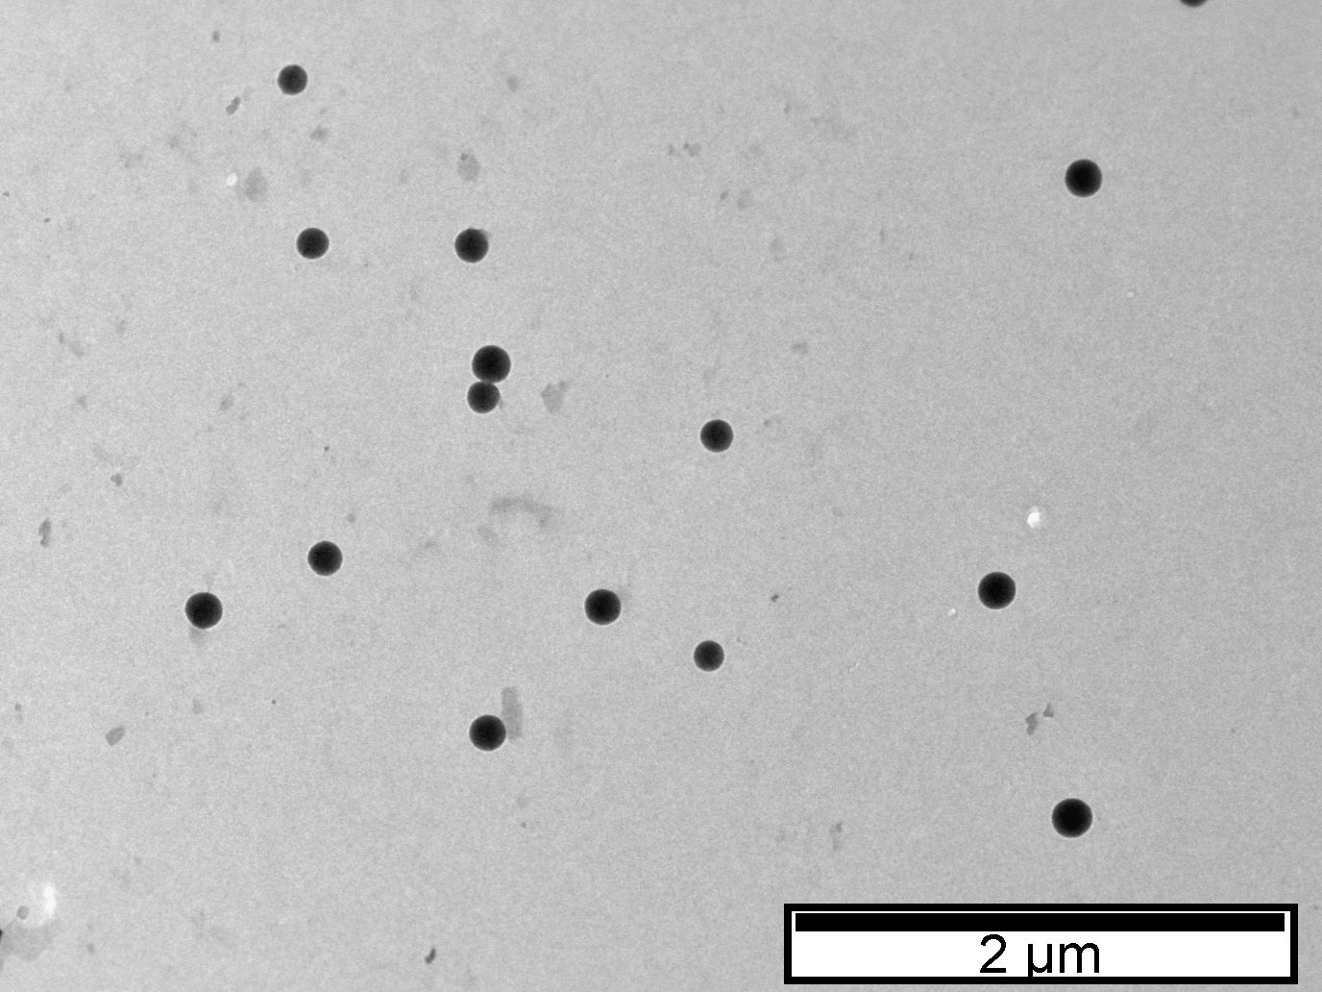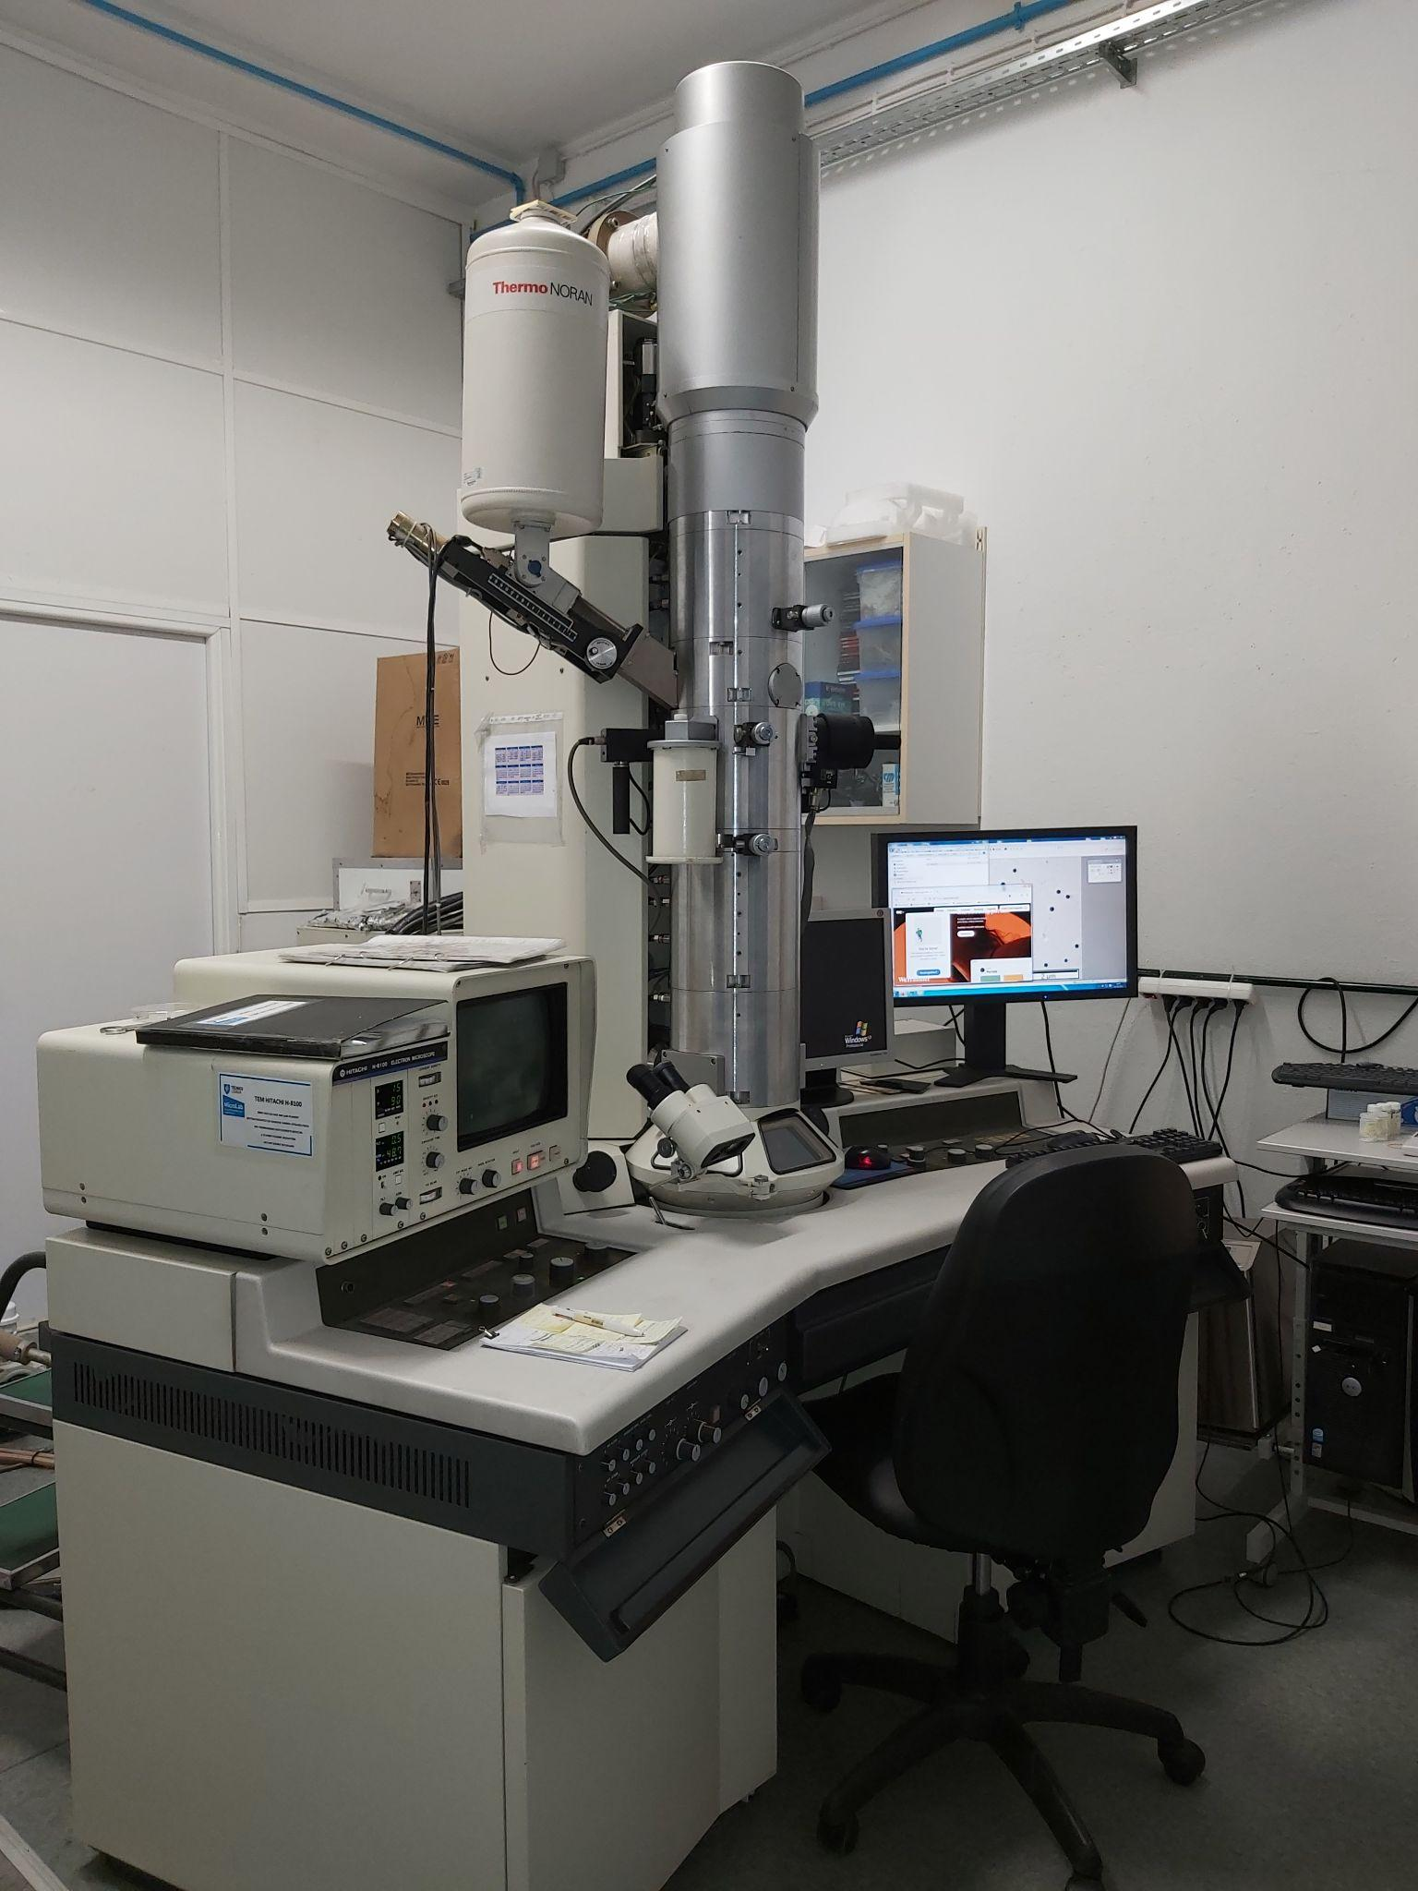

**TEM**

Additionally, the particle sizes and size distributions were obtained by Dynamic Light Scattering (DLS) and Nanoparticle Tracking Analysis (NTA), scattering techniques that measure the diffusion coefficient of nanoparticles in a liquid and obtain the size of the particles (using Stokes-Einstein equation). While DLS retrieves the diffusion coefficient distribution from the overall correlation curve for the particle ensemble, in NTA the diffusion coefficient of the particles is measured individually and the size distribution curve is constructed from these. To prepare the samples, 3 or 4 droplets of the sample were placed in 10mL of water (in TEM/SEM, the sample was not further diluted).

**2. Results**

In order to study the influence of the different quantities shown in Table 1 on the size of the silica nanoparticles, the same procedure was performed by each of the nine groups. All these results are shown in Table 2, in which three of the groups obtained inconclusive results with the TEM technique. Some of these results are shown in graphic form in Figure 1.

|  |  |  |  |  |  |  |  |  |
| --- | --- | --- | --- | --- | --- | --- | --- | --- |
| **Group** | **TEM** | | **SEM** | | **DLS** | | **NTA** | |
| D (nm) | SD (nm) | D (nm) | SD (nm) | D (nm) | SD (nm) | D (nm) | SD (nm) |
| T1 | Inconclusive | | 275.00 | 7.07 | 268.29 | 3.26 | 218.8 | 27.2 |
| T2 | Inconclusive | | 91.60 | 12.41 | 75.7 | 40.3 | 85.5 | 9.4 |
| T3 | 195.74 | 42.33 | 223.92 | 21.20 | 224.69 | 36.21 | 179.8 | 27.5 |
| T4 | 126.0 | 10.2 | 144.3 | 12.1 | 127.79 | 47.82 | 101.0 | 22.0 |
| T5 | 34.3 | 4.2 | 60.30 | 2.38 | 42.91 | 5.51 | 132.4 | 39.7 |
| F1 | 101.09 | 11.18 | 161.98 | 19.21 | 116.70 | 3.84 | 99.2 | 15.0 |
| F2 | Inconclusive | | 166 | 28 | 177.60 | 49.79 | 161.2 | 21.5 |
| F3 | 126 | 18 | 161 | 21 | 149 | 12 | 114 | 15 |
| **F4** | **141.55** | **21.05** | **182.30** | **21.57** | **143.3** | **26.4** | **127.5** | **18.2** |

**Table 2**: Average particle diameters (D) and respective standard deviations (SD) obtained by different groups, using four different techniques: Transmission Electron Microscopy (TEM), Scanning Electron Microscopy (SEM), Dynamic Light Scattering (DLS) and Nanoparticle Tracking Analysis (NTA).

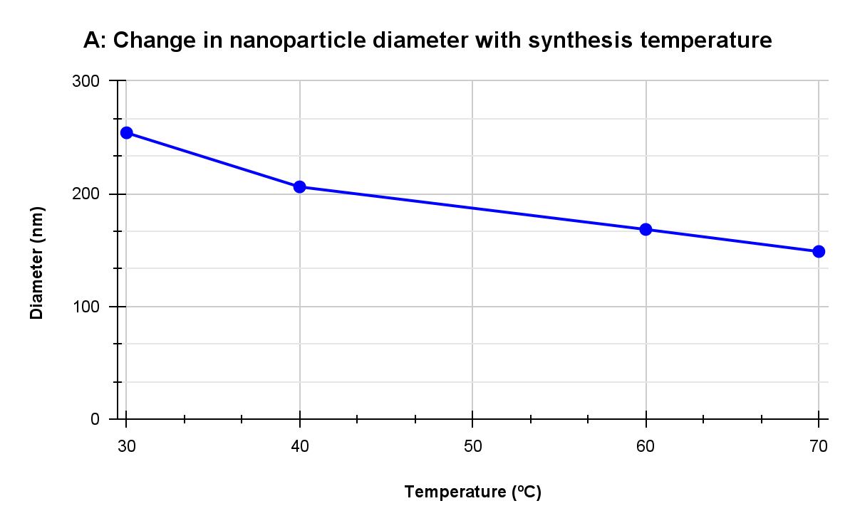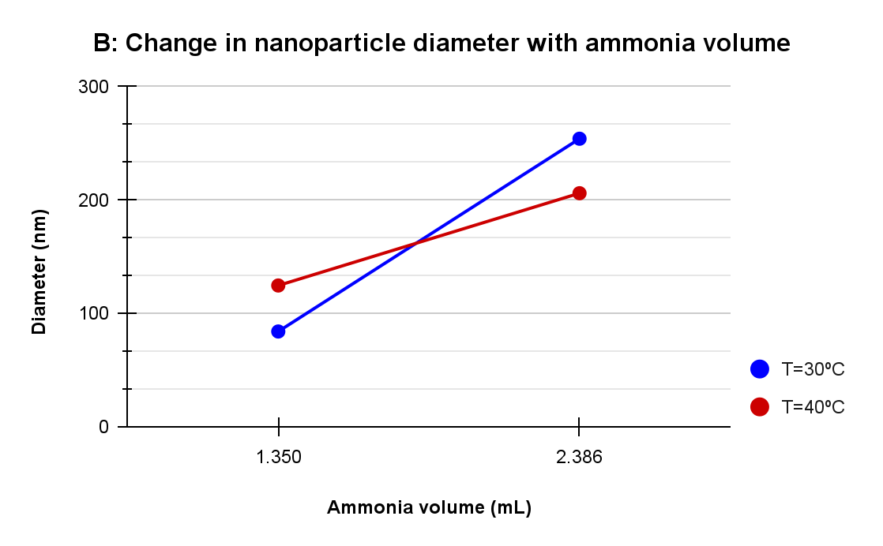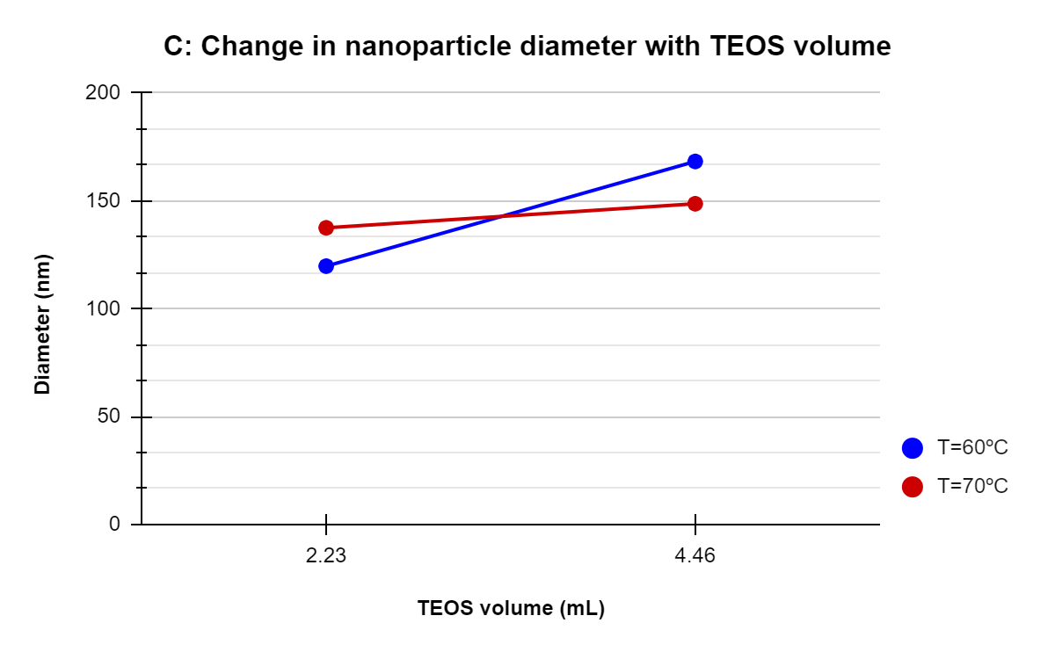

**Figure 1**: Graphical representations of experimental values - (A) Nanoparticle average diameter variation with increasing synthesis temperature, with all other variables constant (groups T1, T3, F2 and F4); (B) Nanoparticle average diameter variation with different amounts of ammonia (NH4OH), with all other variables constant (groups T1 and T2 at 30ºC, groups T3 and T4 at 40ºC); (C) Nanoparticle average diameter variation with different amounts of TEOS, with all other variables constant (groups F1 and F2 at 60ºC, groups F3 and F4 at 70ºC).

The data used to calculate the average particle diameter (and its respective standard deviation) for the DLS technique is plotted in Figure 2, alongside the respective correlation curve - also obtained through this method. As seen below, the three sets of measurements led to similar data sets. The most significant difference corresponds to the average diameter obtained for the first set, smaller than and obtained with the second and third data sets, respectively.

For this analysis, an advanced algorithm - which can be used for samples with polydisperse particles - was chosen, even though the sample used in this laboratory assignment is simple and monodisperse. In DLS, a laser hits the sample, the light diffracts and the software constructs the respective diffraction pattern Particles are moving in solution, thus the diffraction pattern changes with time, which allows the software to construct the **correlation curve**. Once the correlation curve is obtained, the algorithm uses a set of (exponential) functions to determine the equation of the curve and obtains the diffusion coefficient of the sample from it. Using another equation, it can then determine the size of the particles. The value of the correlation curve is inversely proportional to the difference in diffraction patterns; as time progresses, this difference increases, therefore the curve goes to zero. Larger particles move slower, thus the diffraction pattern changes slower in these cases. If the difference grows slower, it takes more time for the curve to go to zero. On the other hand, smaller particles move quicker, thus the curve reaches zero earlier. If the curve didn’t go to zero, it could indicate the presence of impurities (like dust, which could be solved with syringe filters) or aggregation (which would require sonication or even syringe filters to remove bigger aggregates).

In the correlation curve shown in Figure 2, the projection in the y-axis **intersects it below 1**, which means the sample is not too concentrated. If it were the case, instead of hitting one particle and then the detector, the refracted light would then reach successive particles and the same beam of light would be scattered multiple times. This multi-scattering would change the diffraction pattern very quickly, meaning that the software would construct a curve that goes to zero more quickly than it should and the measured size of the particles would be lower than their real values.

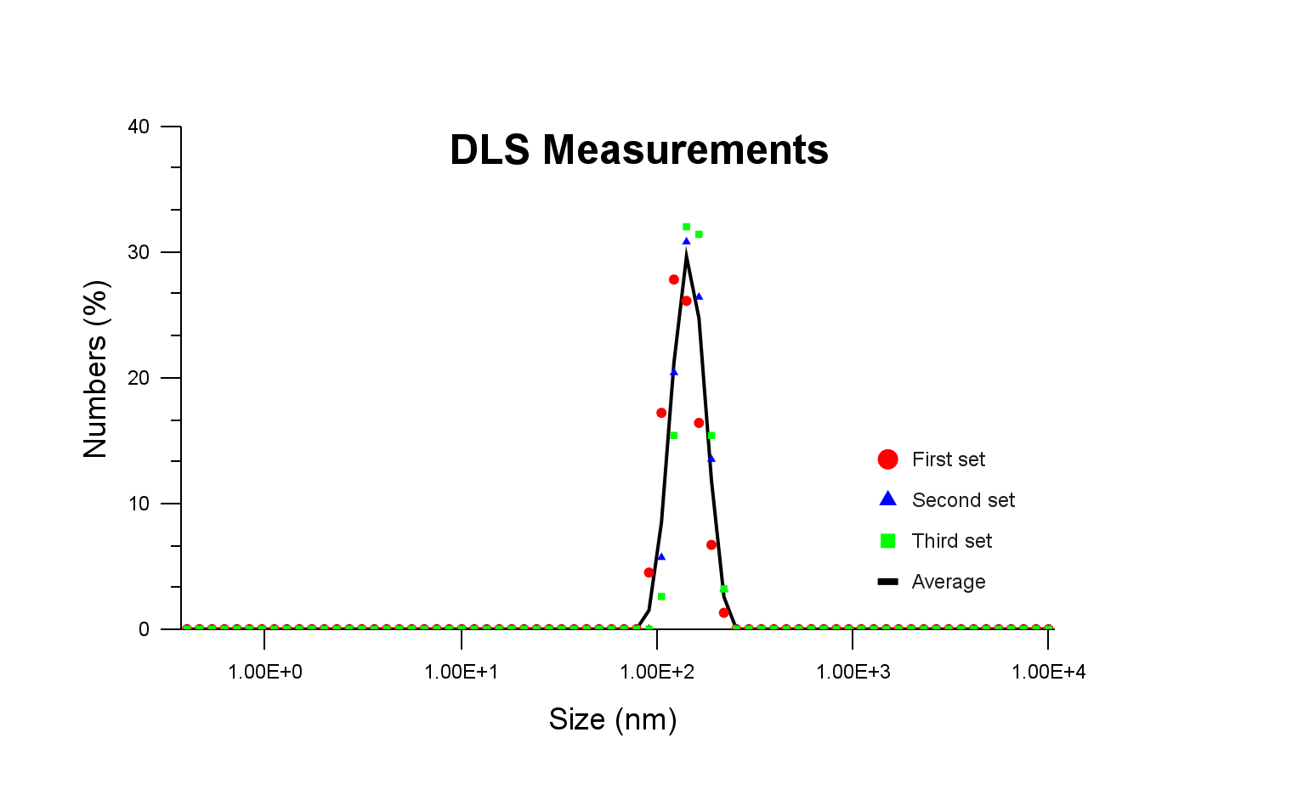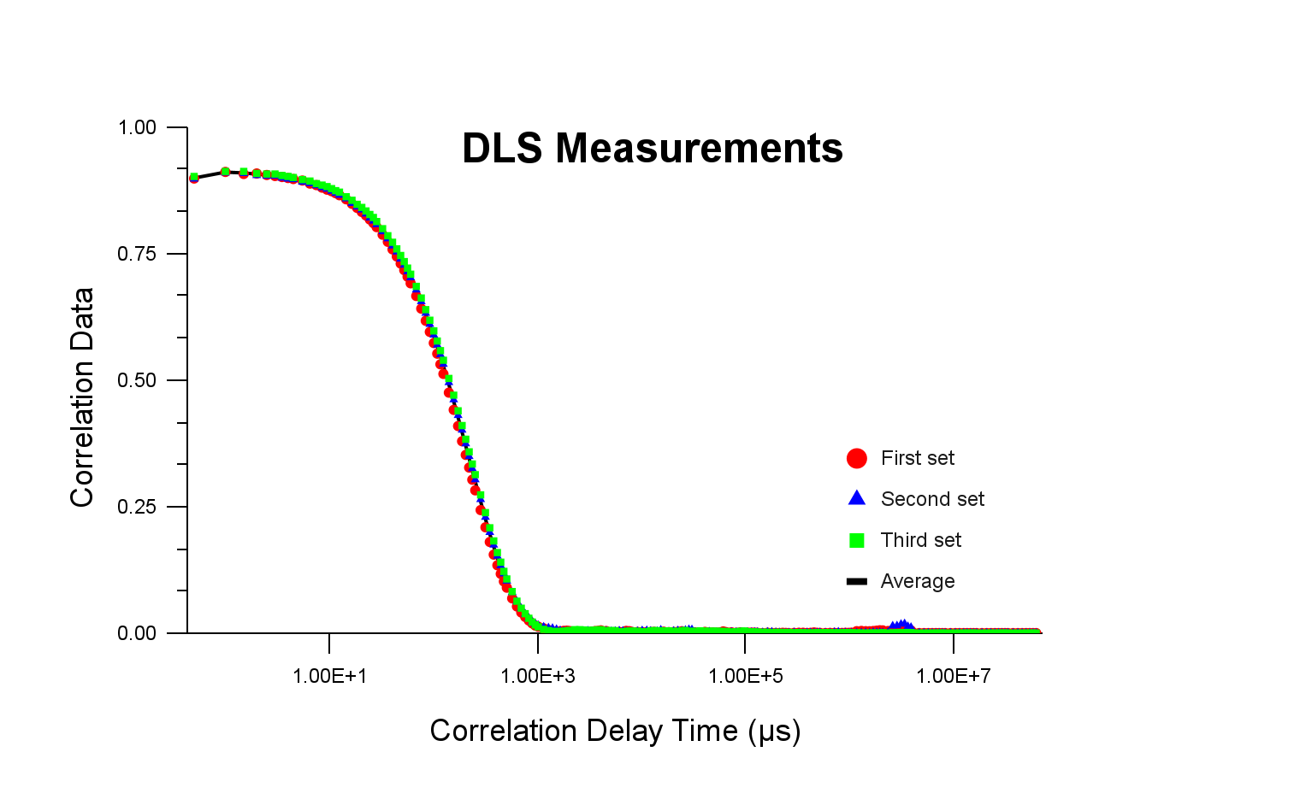

**Figure 2**: Data obtained from the Dynamic Light Scattering (DLS) technique. On the left, size distribution curve; on the right, correlation curve - both using a logarithmic scale in the horizontal axis.

On the other hand, using the Nanoparticle Tracking Analysis (NTA) device (version NTA 3.4 Build 3.4.003, script SOP Standard Measurement), the graphs shown in Figure 3 were obtained directly from the software. For this analysis, 10 second-long videos were captured. The measurements were made at temperature T=18.3ºC, with 25.0 FPS and 249 frames. In this case, five sets of data were obtained, having the respective average been performed for the concentration (in particles/mL). The mean and standard deviation of the merged data are shown in Table 2, having a mode of 127.1nm been obtained. In NTA, the principle of operation is similar to DLS, with light scattering being used; however, instead of detectors, there is a camera. Particles have sizes much lower than the wavelength of the laser, thus what is seen is light scattered by the sample and captured by the camera - not the actual particles. In this case, unwanted particles or aggregates can be selected and ignored by the software. The diffusion coefficient is calculated for each video and the respective average is performed.

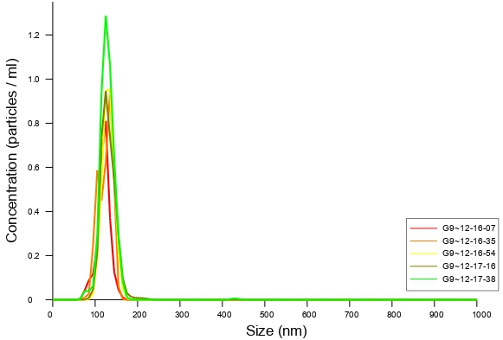 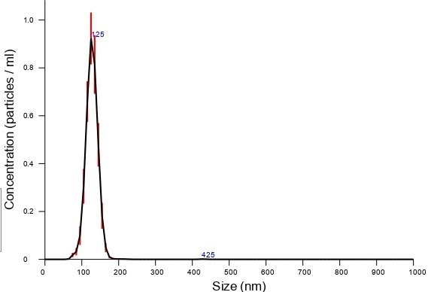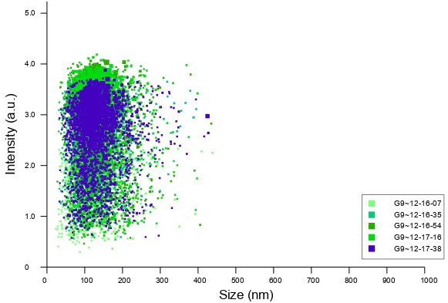

**Figure 3**: Data obtained from the Nanoparticle Tracking Analysis (NTA) technique. On the left, results relative to the concentration (in particles/mL) for five different measurement sets. On the right, averaged concentration values, in which the error bars indicate ±1 standard error of the mean. On the bottom, intensity (a.u.) for each particle size in the five different data sets.

**3. Discussion**

The Stokes-Einstein equation is given by equation 1, in which is the diffusion coefficient, is the radius of the spherical particle, is the dynamic viscosity, is the Boltzmann constant and is the temperature.

(1)

As seen in Table 2, as the temperature increased from T=30ºC to T=40ºC (with all other conditions being the same) in the case of groups T2 and T4, the average diameters increased (at an average of 48.2%). The same tendency was observed for F1 and F3, in which the temperature increased from T=60ºC to T=70ºC and an average increase of 16.7% was obtained, but, in other similar situations (increase in temperature with other factors the same), this relation was not observed - this occurred with T1→T3→F2, having also the changes in F2→F4 and T4→T5 been contradictory (Table 2). **However**, only considering the average values of the particle diameters obtained with the different techniques, the only case in which higher temperature leads to larger sizes is T2→T4 (perhaps due to very low sizes in T2); in all other cases, **higher temperatures** lead to **lower (average) sizes**. The precipitation time at lower temperatures is much longer than that at higher temperatures. It is assumed that nucleation decreases when the synthesis temperature is lower, which presumably results in the generation of large particles. Looking at equation 1, it would seem that higher temperatures would lead to higher *R*; however, as *T* changes, the diffusion coefficient *D* also changes.

Secondly, it can be concluded that an **increase in ammonia** (NH4OH), which leads to higher pH, **caused larger particle sizes** (Figure 1). This catalyst influences the morphology and creates spherical particles. The influence on the size is clear when taking into account the increase made with groups T2→T1 and T4→T3, in which the volume of NH4OH changes from 1.35mL to 2.386mL. With TEM, the average increase for T4→T3 was 69.7%, while T2→T1 led to an average size increase of 203.5%.

The **particle size** can also be **increased by increasing the amount** **of TEOS** (Figure 1). With the data obtained from groups F1 and F2 (in which the volume of TEOS - 2.23mL and 4.46mL, respectively - is the only different synthesis parameter), the average particle diameter showed an average increase of 39.1% as the volume of TEOS increased, while an average increase of 12.5% occurred in F3→F4 (disregarding the data for DLS, in which the average particle size decreased, in contrast to the other measurements). In the presence of higher amounts of the silica precursor, the reaction uses up more material, leading to the creation of bigger nanoparticles. An alternative laboratory procedure could have also tested higher TEOS amounts, in order to find a saturation point in which there is either a threshold of nanoparticle size or generalized aggregation of nanoparticles.

Besides taking into account the effect of the synthesis conditions on the particle size, it is also worth analyzing the variability of the measurements obtained with different techniques, as represented in Figure 4.

In group T5, in which the particle size was below 100 nm, the average particle size measured with NTA was far greater than that calculated from TEM, SEM and DLS. It might stem from poor dispersion of nanoparticles in the medium or aggregates formed with primary nanoparticles. Because of these, the results obtained from TEM and SEM might be more reliable [2].

DLS and NTA are used to obtain the **hydrodynamic radius Rh**, since the solution is diluted. Thus, DLS and NTA should provide generally bigger sizes than SEM/TEM - when particles moved, a layer of water was dragged and the hydrodynamic size was measured; in SEM/TEM, the particles are dry. However, that was not the case with these results - as seen in Figure 4, most particle sizes obtained with SEM were the largest. This could be due to the procedure done in Fiji, in which the particles have to be directly selected by the user, one by one. In SEM, the images are not as amplified as in TEM, which makes it more challenging to obtain accurate results. In TEM, the user problem still remains, even though it is not as significant, due to the high contrast and amplification of the images. DLS and NTA generally provide similar results, having smaller sizes been obtained with NTA (except for groups T2 and T5), which makes sense since unwanted particles or aggregates can be selected and ignored by the software, while DLS takes into account every particle.

Finally, it is worth noting that the data obtained by group F2 led to the smaller differences amongst the sizes obtained with different techniques, having an average difference of 3.70% been obtained - the highest occurred for group T5 (48.1%), having group F4 obtained an average variation of 11.3%. This could suggest that the size of the nanoparticles prepared for group F2 had the **lowest variability**, thus the respective synthesis conditions could be a better option for the fabrication of silica nanoparticles for commercial applications.

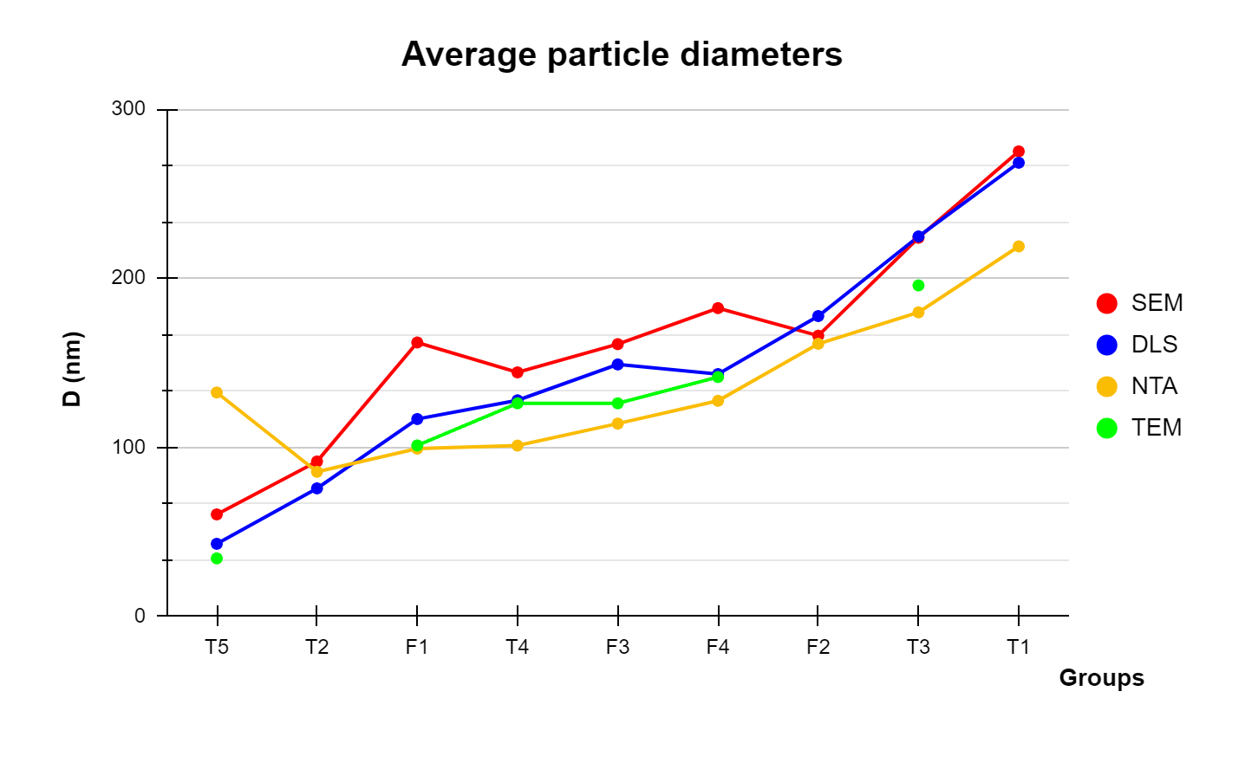

**Figure 4**: Average particle diameters obtained with different techniques and by different groups. The data shown in this graph is presented in Table 2 and the groups in the horizontal axis have been ordered by increasing average particle size (mean of the values obtained for all four techniques). The values of groups T1, T2 and F2 relative to TEM are inconclusive, thus the respective green line is not continuous.

**4. Conclusion**

In this laboratory work, nearly monodispersed and spherical silica nanoparticles having various average diameters from about 34 to 275 nm were synthesized via a sol-gel method. Nine different groups of students prepared the silica nanoparticles in different synthesis conditions, by changing the temperature and the amount of ammonia and TEOS, while maintaining the volume of water and ethanol.

It was concluded that, in general, higher temperatures led to lower particle sizes, probably due to faster precipitations. The main exception occurred with groups T2 and T4, in which the small sizes in T2 were increased in group T4 by changing the temperature from 30ºC to 40ºC. On the other hand, the increase in NH4OH volume increased the particle size, since this component acts as a catalyst. The larger amounts of TEOS also (generally) led to higher diameters, since it is the silica precursor. Finally, it should be expected that an increase in the amount of water (for a high enough NH4OH concentration), not considered in this laboratory procedure, would lead to a decrease in the particle size. The size should also be dependent on the solvent used for the synthesis; to produce larger silica particles, ethanol should be used instead of methanol, due to the differences in the size of nuclei formed in each solvent. The nuclei created in the methanol solvent are smaller than those created in the ethanol solvent because the supersaturation ratio of the hydrolyzed monomer in the methanol solvent is higher than that in the ethanol solvent [2].

Regarding the different techniques, the SEM technique usually led to larger particle sizes, probably due to the fact that the user of the software Fiji had to manually select each particle, in images with relatively low amplification and contrast - this problem was not as significant in TEM. DLS and NTA led to similar results, even though the former generally provided slightly higher values, since it takes into account every single particle, while unwanted particles or aggregates can be selected and ignored by the software in NTA.

**References**

[1] Stober W.; Fink A., Controlled Growth of Monodisperse Silica Spheres in the Micron Size Range, Journal of Colloid and Interface Science, **1967**, *26*, 62-69. *DOI: 10.1016/0021-9797(68)90272-5*;

[2] Kim J. W.; Kim L. U.; Kim C. K., Size Control of Silica Nanoparticles and Their Surface Treatment for Fabrication of Dental Nanocomposites, Biomacromolecules, **2007**, *8*, 215-222. *DOI: 10.1021/bm060560b*;

[3] Zainala N.; Shukor S.; Wab H.; Razak K., Study on the Effect of Synthesis Parameters of Silica Nanoparticles Entrapped with Rifampicin, The Italian Association of Chemical Engineering, 2013, 11, 431-440. *DOI: 10.3303/ACOS1311044*.