### Evaluation Criteria

In the first phase of tabulation, the jury’s assessment will be based on the following criteria:

* Development status of the project;
* Competence and suitability of the team;
* Technology/ Degree of innovation and feasibility of the project;
* Validation and potential of the business model or social and environmental impact.

In the Final Pitch the jury will evaluate each project based on the 3-minute pitch and how the team answered the questions, with the following criteria:

* Business model: validation by customers, revenue model, partnerships, customer acquisition, market and the like;
* Potential for Social and Environmental Impact;
* Technology: feasibility, complexity, quality of prototype, and the like;
* Presentation: quality and effectiveness of the speaker and slides, graphic quality of the prototype and website, among other acceptable supports.

The best projects designed by Tecnico Students in an entrepreneurship course unit

The E.Awards@Técnico is designed to recognize, celebrate and reward the projects, designed by Técnico students within the scope of an entrepreneurship course unit.

If you are developing an entrepreneurship project with potential for social and environmental impact and/or for a business model then this competition is for you.

- 6 Projects will be selected for the Final Pitch (in July)

- All projects will be candidates for the Best Poster award (voting by the IST community)

Which are the awards?

- Best E.Project by Santander - 1 prize of €3.500;

- Honorable Mention by Accenture - 1 prize of €1.000;

- Honorable Mention by Armilar Partner Ventures - 1 prize of €1.000;

- Best Poster by Accenture - 2 prizes of 500€ each;

- Consultancy Hours for the 3 Winning Pitch Projects by Armilar Partner Ventures.

Team/ Project Name*

H2Ohm

Entrepreneurship curricular unite you're attending this semester*

Entrepreneurship, Innovation and Technology Transfer

Who is your Entrepreneurship professor?*

[José Epifânio da Franca](https://fenix.tecnico.ulisboa.pt/homepage/ist11801)

Short description of the idea and business model*

The company H2Ohm sells toys primarily to teach kids about electronic circuits. By including electrical components inside Lego-like blocks, it is possible to connect them to assemble a given electrical circuit. We plan to use each kit to teach about an essential concept in Electronics - for instance, the voltage divider law (tackled in our MVP). Each circuit is implemented in a particular structure (a lighthouse, for example) which can be added to a “city” that the customers build out as they buy more and more of our kits - learning a lot along the way!

Description of the technology/product*

A brick may consist of a plastic body frame with a PCB inside. This PCB includes spring pins in its extremities to connect electrically to other bricks. Some bricks do not include electrical components and are mainly used to build out the structure around the electrical circuit. All the bricks form a kit that is sold as a whole, along with all the explaining and instructions required for its assembly.

What is your market?*

Our main target market consists of kids around the world aged 6-14. However, our products should also appeal to older teenagers. We plan to start selling in the national market and expand our company internationally within the first 5 years of its existence.

What problem are you solving*

Illiteracy regarding Electronics and Electricity amongst the younger generation, the main architects of the evermore technology-driven future coming towards us.

Poster of your Idea (You can use the template available at <https://tt.tecnico.ulisboa.pt/>) -  
> Já envio uma ideia

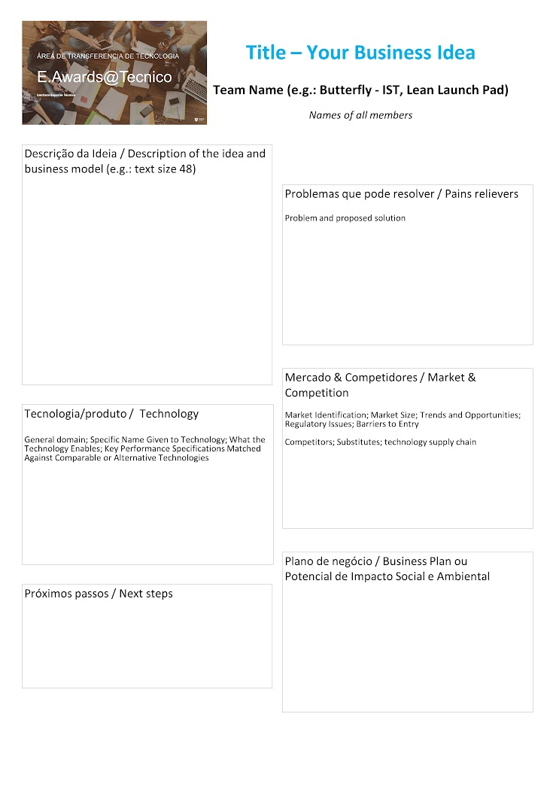

Information about the Team that will participate in the program -> ordem alfabética

#1 Name*

André Santiago Mestre e Costa

#1 E-mail*

andre.mestre.costa@tecnico.ulisboa.pt

#1 IST ID*

93016

#2 Name*

Duarte Miguel de Aguiar Pinto e Morais Marques

#2 E-mail*

duartemarques@tecnico.ulisboa.pt

#2 IST ID*

96523

#3 Name*

Fábio Miguel Magalhães Dias

#3 E-mail*

fabio.dias@tecnico.ulisboa.pt

#3 IST ID*

96201

#4 Name*

Gonçalo Pinto Midões

#4 E-mail*

goncalomidoes@tecnico.ulisboa.pt

#4 IST ID*

96219

#5 Name*

Manuel Ferreira Sardinha Diogo de Matos

#5 E-mail*

manuel.diogo.matos@tecnico.ulisboa.pt

#5 IST ID*

93121

Comments

How did you find out about the competition and what led you to apply?*

E-mail sent by Tech Transfer Office of Tecnico (Rita Silva).