**Design Project: Device microfabrication**

**Micro and Nanofabrication Techniques (TMN)**

**2023**

Evaluation weight: 30% of the total Delivery date: 21 April 2023 @23:59

: ………………………………………………………….

Group members ………………………………………………………….

………………………………………………………….

**The objective of this document is to provide a detailed description of the steps needed for the multilevel microfabrication of temperature sensors connected with through-silicon-vias and ball bonding to a PCB.**

**The method to follow includes the following steps, organized into weekly milestones. Every week we expect to see a summary of the progresses made, so the final project can be delivered in the due date (21 April)**

|  |  |  |  |
| --- | --- | --- | --- |
| Steps | Results expected | Delivery result | Delivery date |
| #1 – Global vision of the nanostructure | (i) To provide a cross section and top view of all the layers needed to fabricate the nanodevice.  (ii) Define the N levels needed during nanofabrication (use drawings and text with comments) | 1-2 slides to present in the discussion on Friday 17 March | 17 March |
| #2 – definition of level 1 | Describe the cross section and top view of that step, including:   * Materials * Dimensions * Processes used for the nanofabrication ((eg. deposition, etching, lithography, …) * Suggestions of specific methods * Suggestion of control and inspection points | 1-2 slides to present in the discussion on Friday 24 March | 24 March |
| #3 – definition of level N/2 | 1-2 slides to present in the discussion on Friday 31 March | 31 March |
| #4 – definition of level N | 1-2 slides to present in the discussion on Friday 14 April | 14 April |
| Final Step | Merge all the process steps into a consistent document, showing drawings and detailed explanation of the process steps needed to fabricate the nanodevice. | A consolidated document (word, powerpoint, pdf) sent by e-mail | 21 April |

Schematics of the device (not to scale)

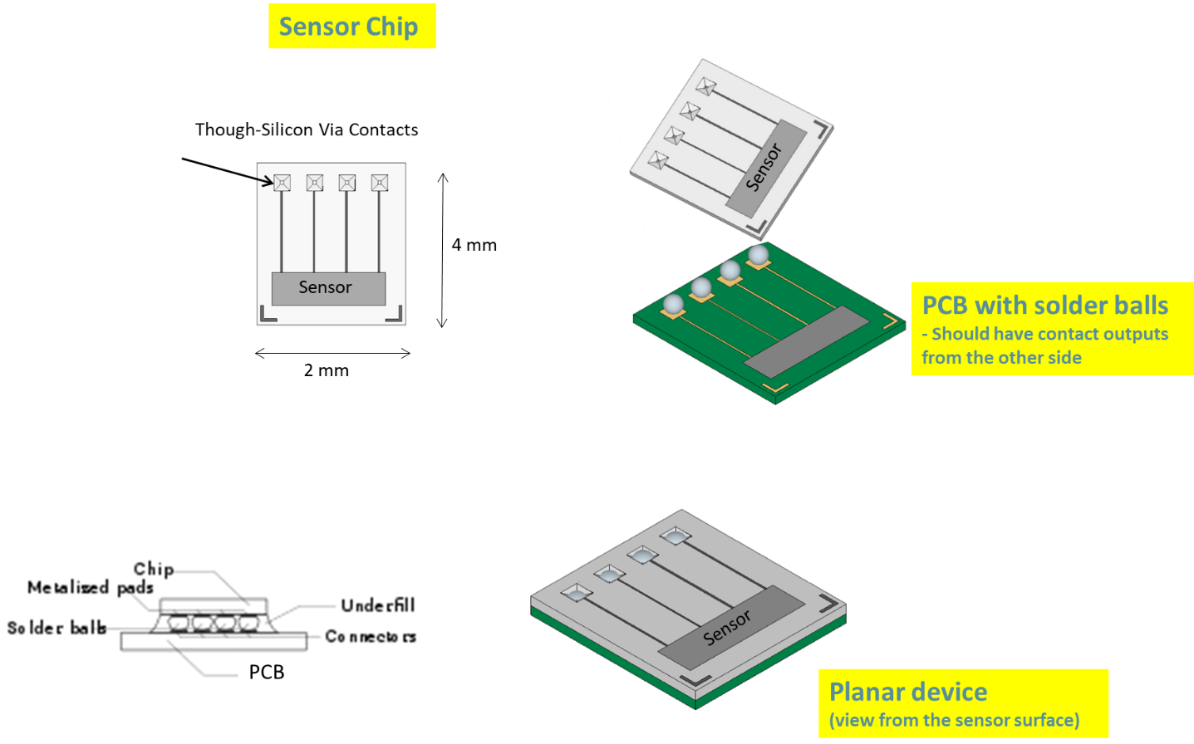

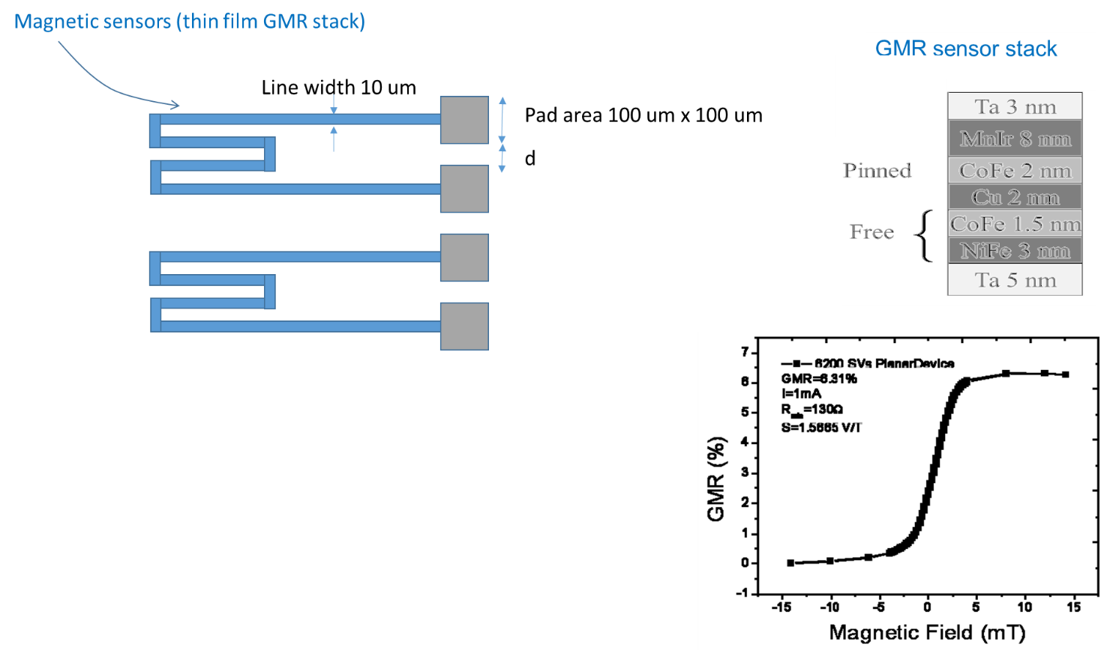

|  |  |  |  |
| --- | --- | --- | --- |
|  |  | **Material** | **Thickness** |
| Silicon wafer frontside | Magnetic thin film sensors (serpentine, 10 um width) | GMR (Giant magnetoresistive thin film stack) | 25.5 nm (several materials, in a multilayer) |
| Contact pads (100x100 um2) | AlSiCu | 300nm |
| Through-silicon-contacts | copper | 350 um thick silicon wafer cavities  Filed with copper |
| Passivation layer | Si3N4 | 400nm |
| Isolation layer between Silicon and metal films | SiO2 thermal oxide | 200nm |
| Silicon wafer backside | Isolation layer between Silicon and metal films | SiO2 thermal oxide | 200nm |
| Through-silicon-contacts | copper |  |
| PCB | Metal spheres |  | 1 mm |