Esta semana:

-Pesquisar métodos de inspeção da GMR stack (era mais qualidade aqui pelo que percebi).

From everything I have seen optical inspection in a high resolution microscope should be used to check for defects in our depositions for example particulate contaminants. Perhaps we should do an inspection of each layer after each deposition. However, it is more important for us to test the sensor electrically with a four point probe after inputting the metallic pads. At that point we can be sure if our GMR stack has any major flaws that cause failure in the serpentine. (Would the SEM help in this?)

-Pesquisar métodos de inspeção para a isolating layer.

Here I think once again we can get by using optical inspection using a microscope and I think that should be what we put in the Step #3 part. However, if an actual in depth profile is needed we could use AFM to get a deeper understanding of the SO2 isolating layer. Maybe that should be a question we ask next time?

-Impor dimensões das coisas (GMR stack and pads)

We should do this one together, Tinha uma proposta que estava num dos desenhos mas tinhas dito que querias alterar coisas

-Arranjar método alternativo para depositar SO2 que não passe dos 150ºC:

Found a paper which uses inductively coupled plasma-chemical vapor deposition (ICP-CVD) to get a layer of SO2 at 60ºC. It seems to be a more advanced way of chemical vapor deposition which allows for lower temperatures. In the paper is mentioned that the deposition rates are around 60-70 nm/min so it should be as fast as our previous idea. Then again we only need to use this in the back side. I guess it is probably a more expensive machine but since there are no price limits involved I think it is our best option. Source: [**https://www.mdpi.com/2079-6412/12/10/1411/pdf**](https://www.mdpi.com/2079-6412/12/10/1411/pdf)

Only other thing we could do is just not put the insulating layer inside the walls of the via hole, if this was the case it would be easier. Technically speaking copper is much more conductive than silicon so no current should escape, although I'm not 100% about that since we have multiple via holes.

SE HOUVER TEMPO:

-Fazer os cálculos da thickness do photoresist:

Don’t understand how exactly can we calculate specific thickness of the photoresist, for everything that I looked at the etch rates are all in the same order of magnitude or one above( meaning 10-200 nm/min). Taking this into account and that our depth of the GMR stack is 26 nm we should have at least ~600 nm of photoresist. However due to all the variations and that in multiple papers all thicknesses of photoresist are over 1 μm we should point more for that number. QUESTION for Susana: IS THERE ANY WAY OF ACTUALLY CALCULATING THIS VALUES?

Sources: [**https://www.nanofab.utah.edu/assets/images/Williams2.pdf**](https://www.nanofab.utah.edu/assets/images/Williams2.pdf)

*Smart fingertip biosensor for food quality control*; Maria Manuela Almeida Pereira de Carvalho

Optimization of the etching parameters of the ion milling system Nordiko 3600; André Filipe Rodrigues Augusto

In the previous presentation (Step #1), we presented the global vision of the nanostructure shown below. In the next three steps (#2, #3 and #4), the following aspects will be covered: materials, dimensions, processes, specific methods, control and inspection points. For that purpose, **each line in the cross section global vision** will be analyzed in separate presentations.

In Step #3, the following will be addressed:

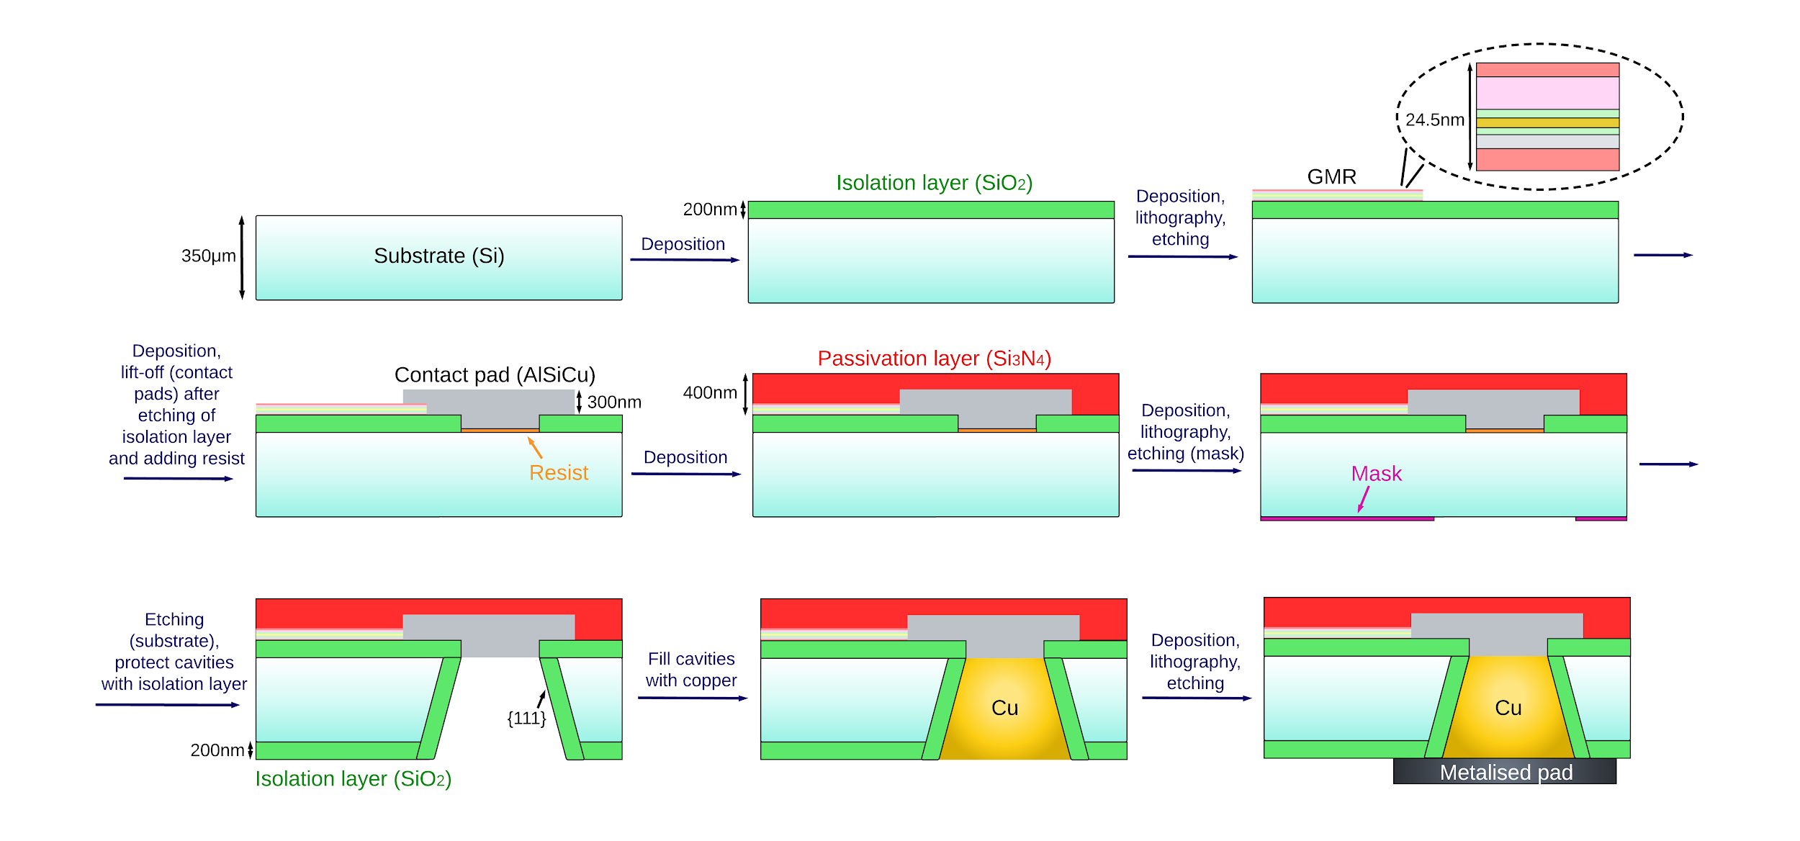

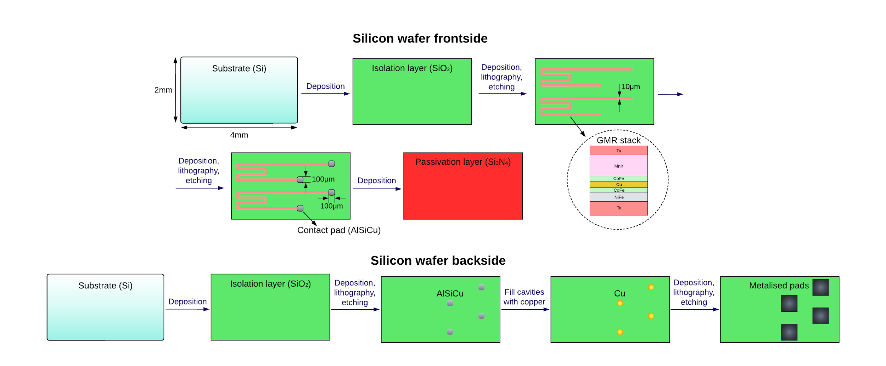

**Pattern and etching of isolation layer**

1. Coat negative photoresist
2. Use mask (exposing photoresist with UV light through a mask)
3. Remove non-exposed photoresist (by a chemical solvent)
4. Etching of isolation layer - wet etching; common:

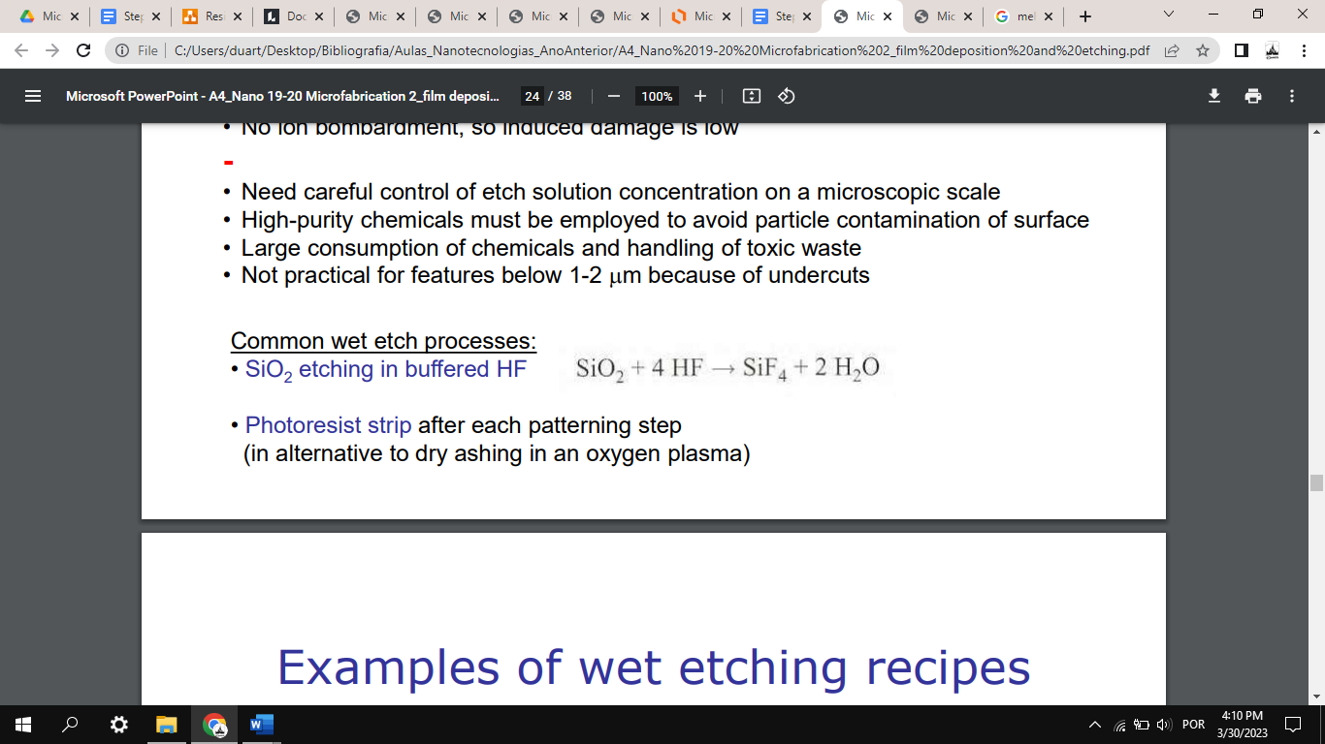

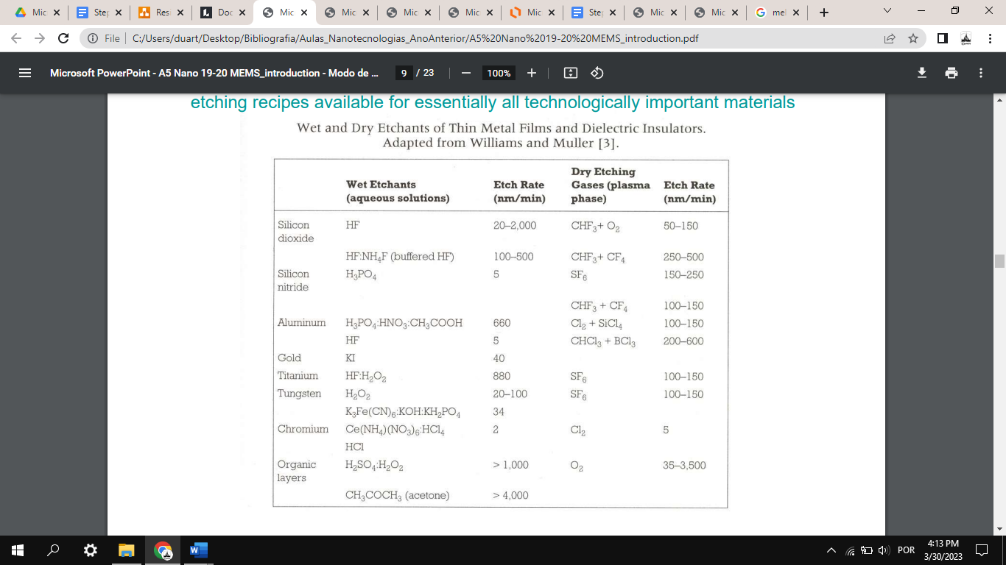

With this etch rate, it would take 6 seconds - 10 minutes to etch 200 nm of SiO2.

Selective method, but isotropic… Moreover, commonly used for large areas and poor control of dimensions…

Maybe we can use reactive ion etching:

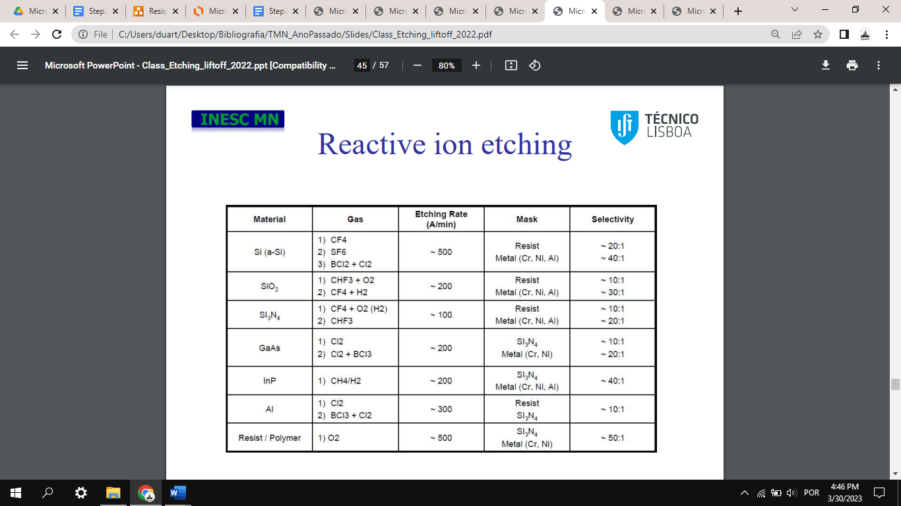 

200 A/min leads to 10 min of etching…

Perhaps this photoresist can still be used in the next step!

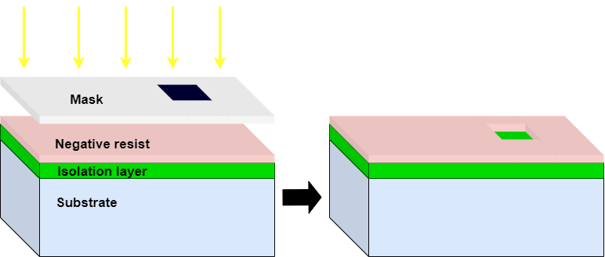

Optical inspection with microscope

**Deposition, pattern and lift-off of resist**

1. Deposit resist on top of photoresist
2. Lift-off photoresist

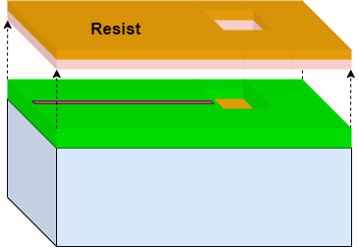

Optical inspection with microscope

**Deposition of contact pads, Lift-off contact pads**

1. Use photoresist, similarly to patterning of isolation layer (deposit photoresist, pattern with mask, etching);
2. Deposit AlSiCu with magnetron sputtering

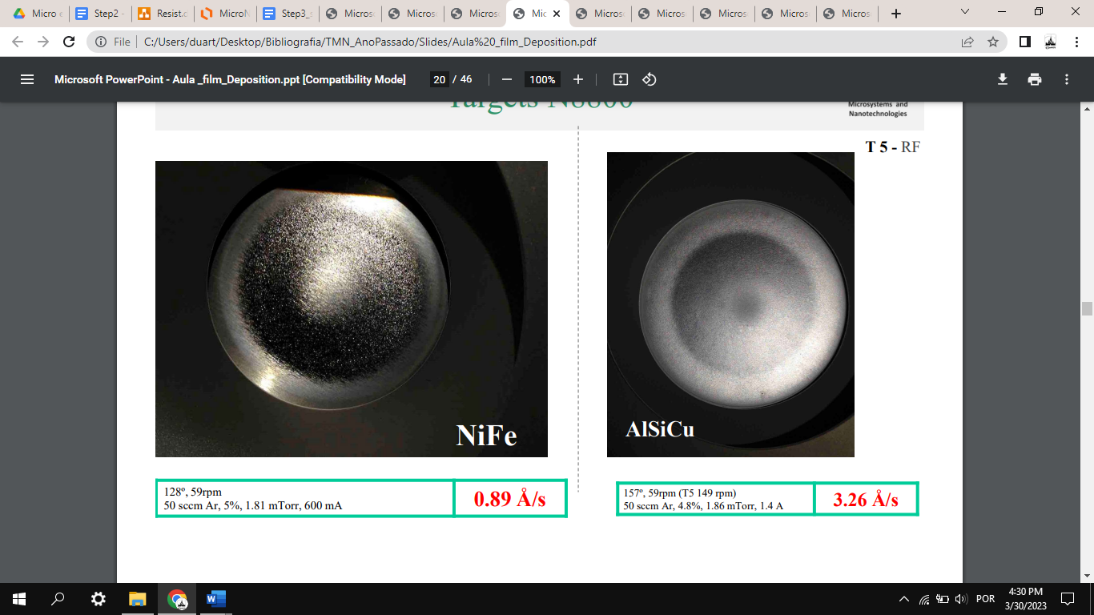

Considering this value, probably not, since it will destroy the photoresist. Maybe even higher temperatures:

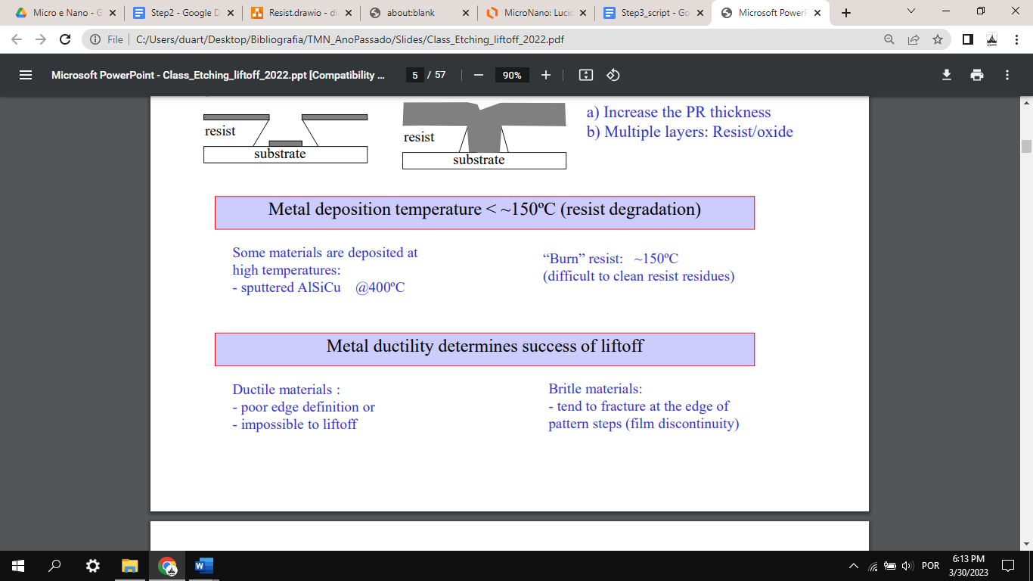

Use atomic layer deposition? - não, 175ºC-400ºC…

1. Lift-off photoresist

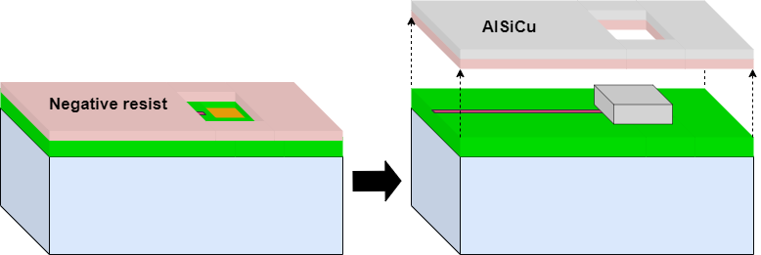

Optical inspection with microscope

Test the sensor electrically with a four point probe after inputting the metallic pads

**Deposition of passivation layer (Si3N4) -> mudar para Step 4**

Chemical vapor deposition (CVD), according to the following equation:

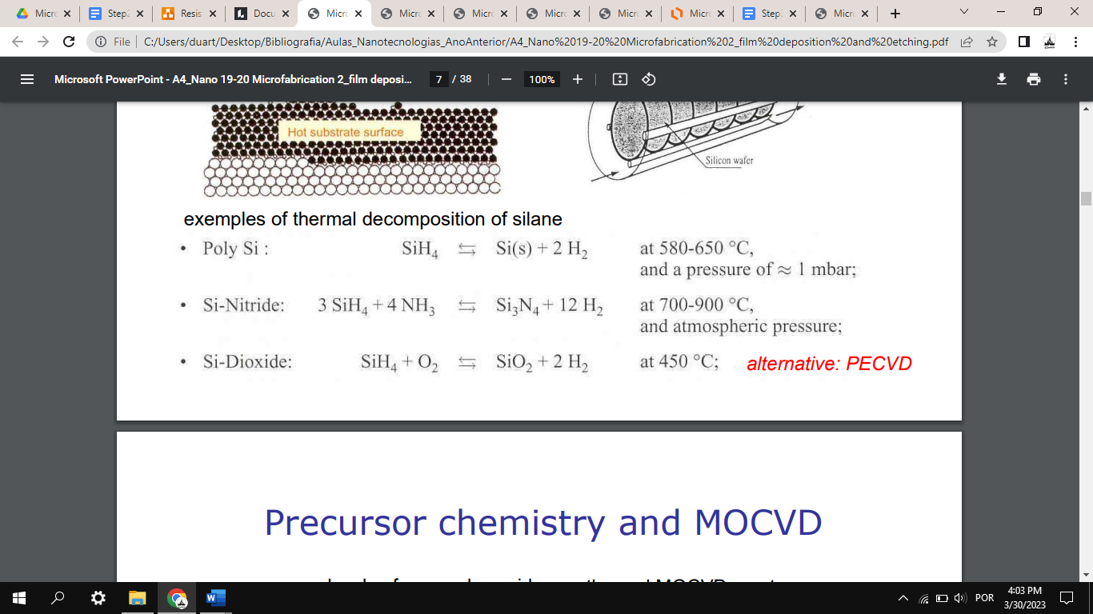 ?

BUT might melt AlSiCu contact pads!

This is fixed using **PECVD**, which occurs at about 200-350ºC with Typical film thickness from 1000 Å to 1 um - compatible with our 400 nm thick passivation layer.

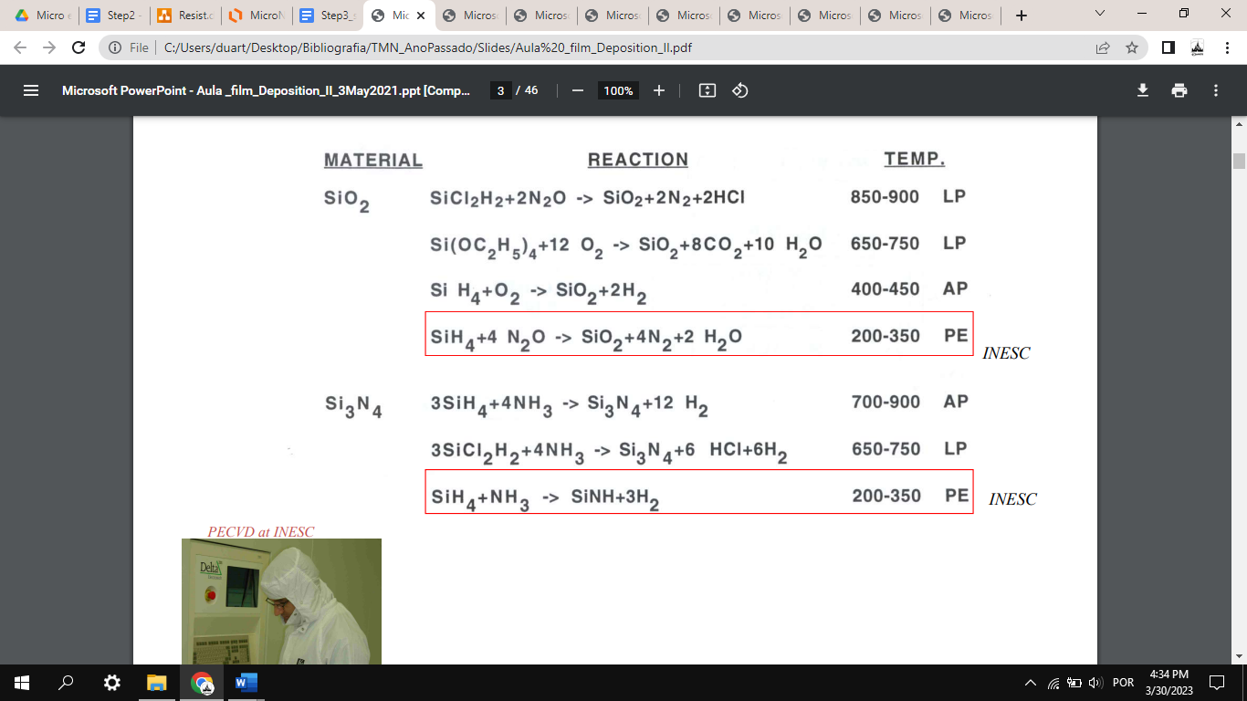

**Deposition, patterning and etching of mask on the backside**

Made of silicon nitride, thus with a similar method as before, but with different layer thickness, perhaps.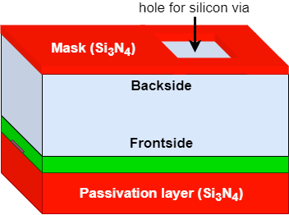

IMPORTANT! CHECK THICKNESS OF MASK - perhaps thicker than passivation layer

Etching:

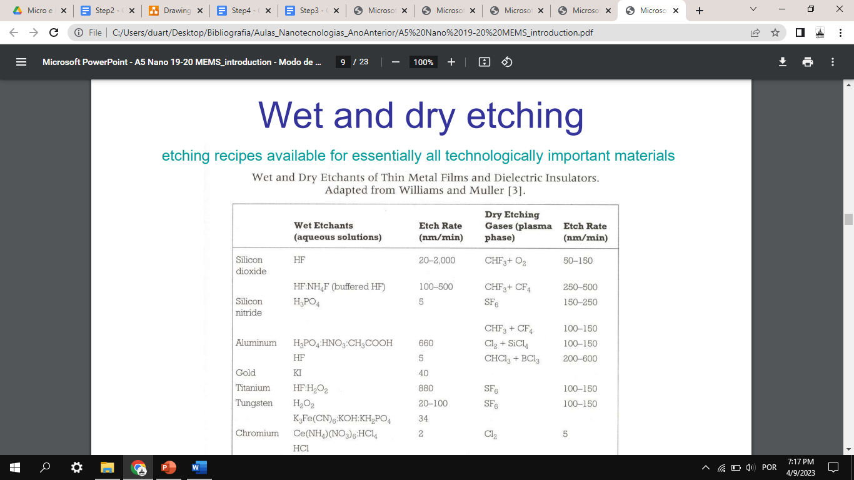

Questions for the professor:

* How to calculate necessary thickness of photoresist for GMR stack? And mask in backside?
* How to deposit AlSiCu without burning photoresist?
* What method to remove remaining photoresists? (wet bench?)