PHOTOLITHOGRAPHY

The most widely used form of lithography is photolithography. Performance of a photolithographic process is determined by its resolution, the minimum feature size that can be transferred with high fidelity; the registration, how accurately patterns on successive masks can be aligned; and throughput, the number of wafers that can be transferred per hour (a measure of the efficiency of the lithographic process). Process steps include exposure, development, oxide etching, and resist stripping.

developer, which removes the unexposed areas of photoresist

the remaining photoresist can be stripped off with a strong acid such as H2SO4 or an acid-oxidant combination such as H2SO4-Cr2O3

An important step, even before lithography proper, is wafer cleaning. Contaminants include solvent stains (e.g., methyl alcohol, acetone, trichloroethylene, isopropyl alcohol, and xylene), dust from operators and equipment, and smoke particles.

The stencil used to repeatedly generate a desired pattern on resist-coated wafers is called a mask. In typical use, a photomask—a nearly optically flat glass [transparent to near ultraviolet (UV)] or quartz plate (transparent to deep UV) with an absorber pattern metal (e.g., an 800-Å-thick chromium layer)—is placed above the photoresist-coated surface, and the mask/wafer system is exposed to UV radiation. The absorber pattern on the mask is generated by e-beam lithography, a technique that yields higher resolution than photolithography. In e-beam lithography, a pattern drawn on a computeraided design (CAD) system is exposed onto the mask. Like resists, masks can be positive or negative. A positive or dark field mask is a mask on which the pattern is clear with the background dark. A negative or clear field mask is a mask on which the pattern is dark with the background clear

Masks making direct physical contact (also referred to as hard contact) with the substrate are called contact masks. Unfortunately, these masks degrade faster because of wear than noncontact, proximity masks (also referred to as soft contact masks), which are slightly raised, e.g., 10–20 µm, above the wafer

CLEAN ROOM

In a Class 1 clean room, the particle count does not exceed 1 particle per cubic foot with particles 0.5 µm and larger, and in a Class 100 clean room, the particle count does not exceed 100 particles per cubic foot with particles 0.5 µm and larger, etc.

Example: In a Class 10 clean room, there are 350 particles (0.5 µm or larger) per cubic meter. The air volume that passes over the wafer in 1 min is (30 m/min) × π(0.125 m ⁄ 2)2 × 1 min = 0.368 m3. The number of dust particles (0.5 µm or larger) contained in that air volume is 350 × 0.368 = 128 particles.

Photoresist Deposition

Lithography is the most expensive step in microelectronics technology, representing up to 35% of the wafer manufacturing cost. Within lithography, photoresist coating is one of the more expensive steps.

For silicon ICs, the resist thickness after a prebake. For miniaturized 3D structures, much greater resist thicknesses are often required, typically ranges between 0.5 and 2 µm

Spin Coating

A common step before spinning on a resist with Si as the substrate is the growth of a thin layer of oxide on the wafer surface by heating it to between 900 and 1150°C in steam or in oxygen. The photoresist is dispensed onto the wafer lying on a wafer platen in a resist spinner (see Figure 1.14).18 A vacuum chuck holds the wafer in place. A speed of about 500 rpm is commonly used during the dispensing step, enabling the spread of the fluid over the substrate. After the dispense step it is common to accelerate to a relatively high speed to thin the fluid to near its final desired thickness. Typicalspin speedsfor thisstep range from 1500–6000 rpm, depending on the properties of the fluid (mostly its viscosity), as well as the substrate. Thisstep can take from 10 secondsto several minutes. The combination of spin speed and time selected for this step will generally define the final film thickness

The resulting polymer thickness, T,

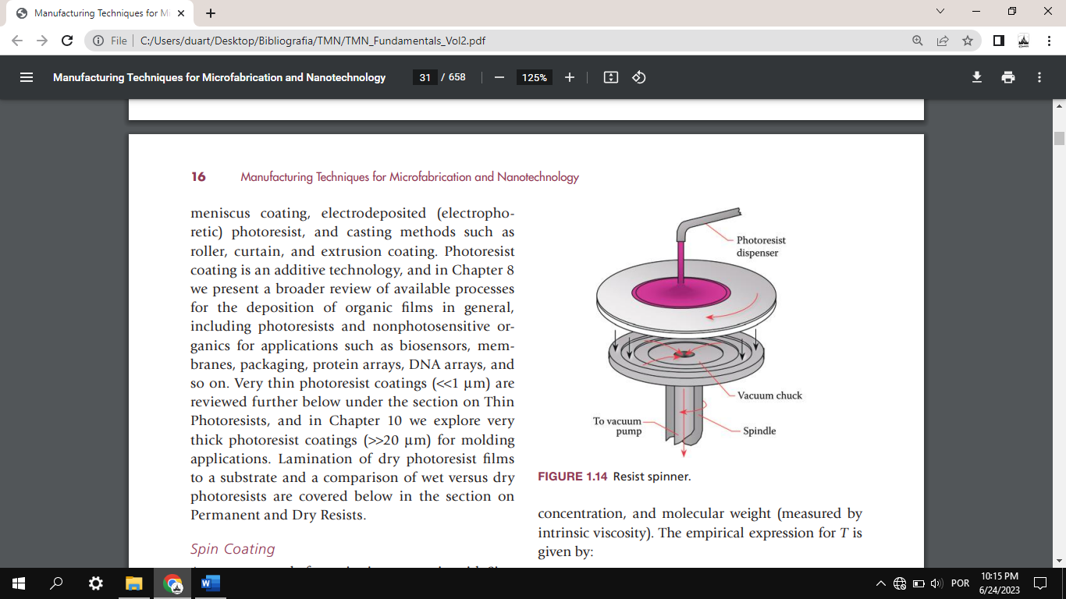 

minimum spin time of 30 seconds is necessary for coating uniformity. The application of too much resist results in edge covering or run-out, hillocks, and ridges, reducing manufacturing yield.

Alternative Photoresist Deposition Methods

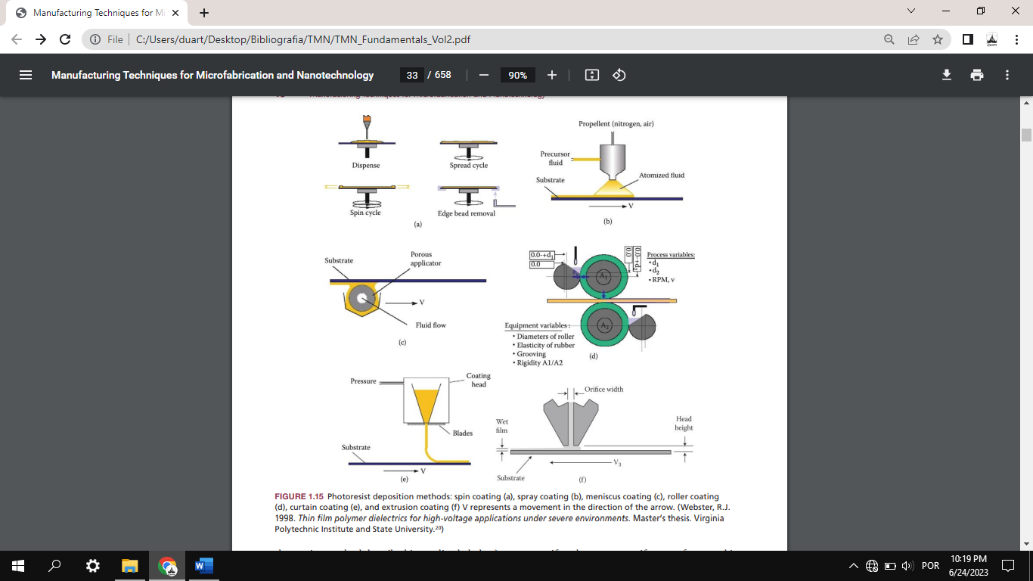

Soft Baking or Prebaking

After resist coating, the resiststill contains up to 15% solvent and may contain built-in stresses. Therefore, the wafers are soft baked (also pre-exposure baked or prebaked) at 90–100°C for about 20 minutes in a convection oven or at 75–85°C for 1–3 minutes with a vacuum hot plate to remove solvents and stress and to promote adhesion of the resist layer to the substrate. This is a critical step in that failure to sufficiently remove the solvent will affect the resist profile. Excessive baking destroys the photoactive compound and reduces sensitivity. Thick resists may benefit from a longer bake time.

Exposure and Postexposure Treatment

After soft baking, the resist-coated wafers are transferred to an illumination or exposure system where they are aligned with the features on the mask. Exposure and Postexposure Treatment After soft baking, the resist-coated wafers are transferred to an illumination or exposure system where they are aligned with the features on the mask

Development

Development is the dissolution of unpolymerized resist

Positive resists are typically developed in aqueous alkaline solutions, and negative resists are developed in organic ones.

Dry development overcomes these problems, as it is based either on a vapor phase process or a plasma.28 In the latter, oxygen-reactive ion etching is used to develop the latent image

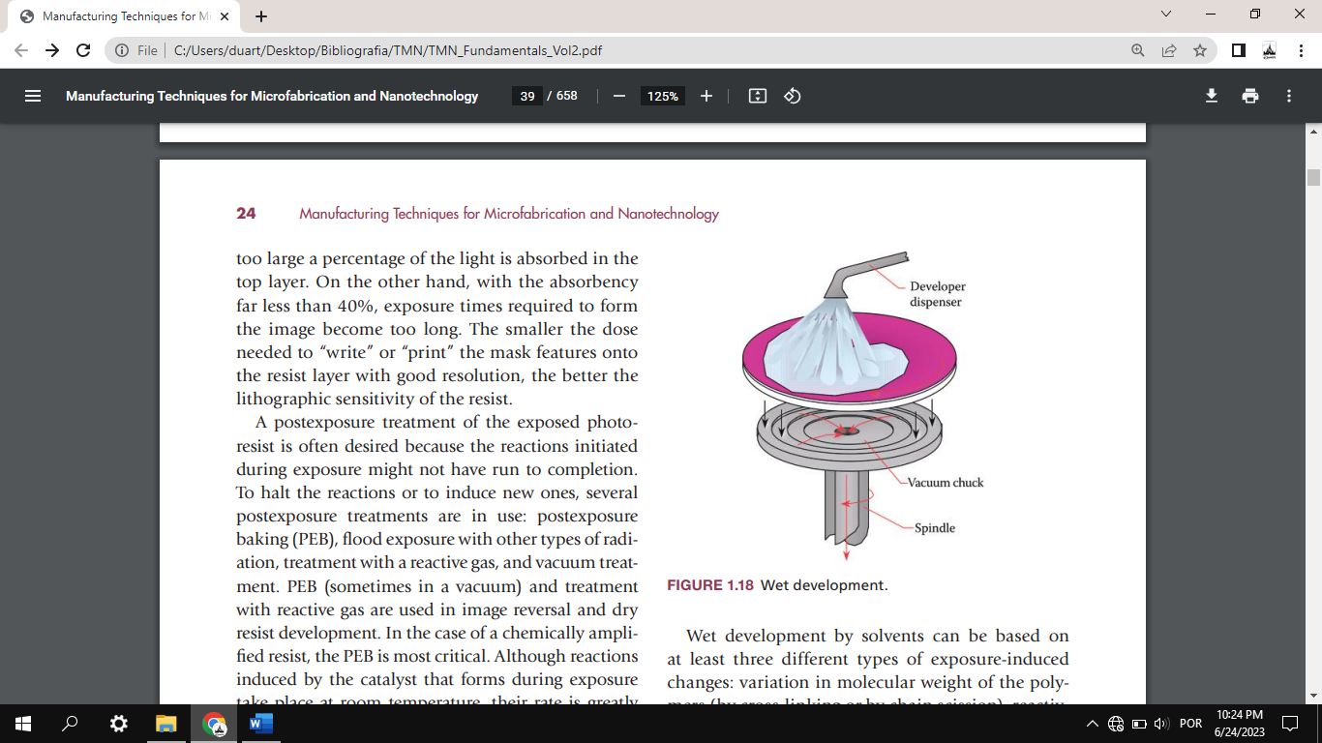

Descumming and Postbaking

A mild oxygen plasma treatment, so-called descumming, removes unwanted resist left behind after development

Before etching the substrate or adding a material, the wafer must be postbaked. Postbaking or hard baking removes residual coating solvent and developer and anneals the film to promote interfacial adhesion of the resist that has been weakened either by developer penetration along the resist/substrate interface or by swelling of the resist (mainly for negative resists). Hard baking also improves the hardness of the film and avoids solvent bursts during vacuum processing. Improved hardness increases the resistance of the resist to subsequent etching steps. Postbaking frequently occurs at higher temperatures (120°C) and for longer times (e.g., 20 min) than soft or prebaking.

Resists

The principal components of photoresists are a polymer (base resin), a sensitizer, and a casting solvent. The polymer changes structure when exposed to radiation;

Resist Tone

If the photoresist is of the type called positive (also positive tone), the photochemical reaction during exposure of a resist weakens the polymer by rupture or scission of the main and side polymer chains, and the exposed resist becomes more soluble in developing solutions. If the photoresist is of the type called negative (also negative tone), the reaction strengthens the polymer by random cross-linkage of main chains or pendant side chains, becoming less soluble (slower dissolving).

Two well-known families of positive photoresists are the single component poly (methylmethacrylate) (PMMA) resists and the two-component diazonaphtoquinone (DNQ)

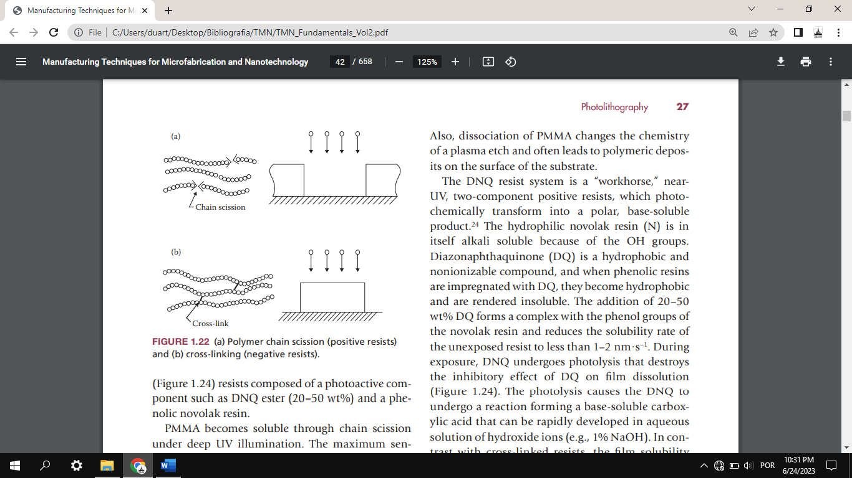

Wafer Priming

Resists, especially positive resists, do not adhere well to a Si wafer. The native silicon dioxide on a Sisurface, typically 20–50 Å thick, forms long-range hydrogen bonds with water adsorbed from the air. When resist is spun onto such a surface, it adheres to the water molecules rather than to the surface, resulting in poor adhesion. A typical resist adhesion promoting primer is 1,1,1,3,3,3-hexamethyldisila- zane (abbreviated HMDS)

Resist Stripping

We now turn to the last step of the photolithographic process.

Wet Stripping

Acetone can be  used if the postbake is not too long or occurs at a low enough temperature. With a postbake of 20 minutes at 120°C, acetone is still fine. But with a postbake at 140°C, the resist develops a tough “skin” and has to be burned away in oxygen plasma.

Dry Stripping

Dry stripping or oxygen plasma stripping

Critical Dimension, Overall Resolution, Line Width Metrology

The absolute size of a minimum feature in an IC or a miniature device, whether it involves a line width, spacing, or contact dimension, is called the critical dimension (CD).

The successful performance of devices depends on the control of the size of critical structures across the entire wafer and from one wafer to another, referred to as line-width control. A rule of thumb is that the dimensions must be controlled to tolerances of at least ± 1/5 of the minimum feature size.

Resist Profiles

Overview of Profile Types

