Each group will receive individual feedback.

No grades are attributed to the quizzes at this point (0 points - no answer; 1 point - answer received).

Any copied content will be regarded as NO ANSWER.

These questions are part of the process runsheet and will be considered in the evaluation of the document.

Checklist for this lab:

1) Check with your mentor if equipment booking is needed.

2) Take all notes on the process runsheet;

3) Include all pictures, graphs, results in the process runsheet;

4) Prepare your runsheet and answers to the Quiz before class;

5) When mounting the sample on the holder, be careful to align the substrate border with the holder flat;

6) Understand the method used for lithography;

7) Compare the patterned features with the expected from the mask layout;

8) Draw top view and side view of your samples on the process runsheet .

Additional Information:

• pag 283-287 Chapter 8: Nanoscale Magnetism, Magnetism and Magnetic Materials, J. Coey

• <http://magnetism.eu/esm/2007-cluj/slides/deteresa1-slides.pdf>

• Nanoelectronics and information technology. Waser R. Wiley-VCH Verlag GmbH; 2003 Apr.

• Fundamentals of microfabrication: the science of miniaturization. Madou MJ. CRC press; 2002 Mar 13.

• From Sand to Silicon: the Making of a Chip | Intel :<https://youtu.be/Q5paWn7bFg4>

⚠ [só subtemos o texto, não o texto que está em imagens]

**1.1. Describe why surface activation/vapor prime is needed prior to coating. Enumerate the sequence steps.**

Resist adhesion to silicon wafers is poor (especially with positive resists), so vapor priming is used to improve it. The native silicon dioxide on a Si surface forms long-range hydrogen bonds with water adsorbed from the air. When resist is spun onto such a surface, it adheres to the water molecules rather than to the surface, resulting in poor adhesion. The sequence steps are the following: 1. Wafer dehydration bake (to remove absorbed water from the surface) and purge oxygen from the chamber; 2. Priming (HDMS is the surfactant used to promote adhesion); 3. Purge prime exhaust; 4. Return to atmosphere (backfill). In our sample, only baking was performed in the surface activation step (made before the lab session). After this, the coating is made by dispensing photoresist on top of the sample and spinning it usually at two different speeds (in our sample, 500 rpm for 10s and then 2500 rpm for 30s). After the spinning process, the desired photoresist thickness should be achieved, after which a soft bake is done (in the lab, 85ºC for 60s).

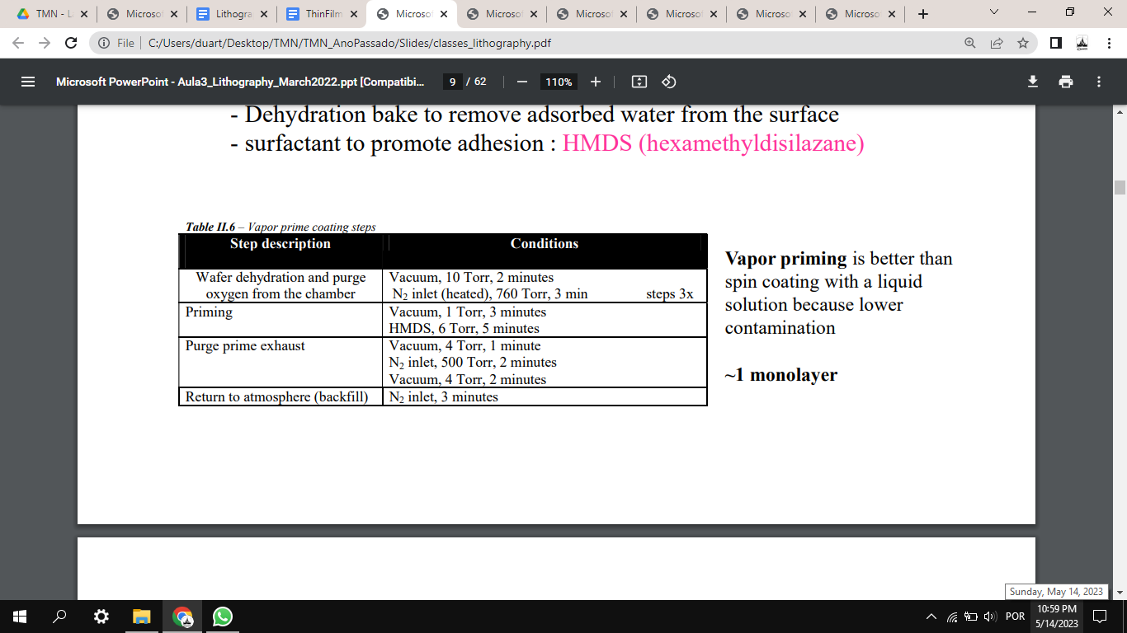

**1.2. How can one change the resist thickness? What are the metrology tools and methods used to control the resist thickness?**

Resist thickness is determined by: resist viscosity, volume of resist dispensed, spinner rotational speed and time of rotation. To control the resist thickness, it can be measured with a profilometer. To evaluate film thickness, stylus profilometry and ellipsometry are more commonly used, but the latter is usually faster. The usual spot size for spectroscopic ellipsometry procedures in which a wide range of wavelengths are used for testing is around 1mm. Smaller spot sizes do exist, but usually this happens at the cost of testing with a reduced number of wavelengths.

**1.3. Describe the exposure process using the lithography system you planned in your process. Quantify all major parameters (wavelength, resolution, etc.).**

Firstly, the sample is placed on the base, where the vacuum is activated. Then, it moves under the laser lens. It is then necessary to make sure the sample is aligned. A camera is used to check the position of the sample; in the screen, darker regions represent the sample is not being observed (there is less reflection) and brighter regions represent the sample (there is more reflection). The straighter side of the sample is defined as a reference for alignment; initially, if the adjustment is major, the vacuum can be turned off and the sample is rotated manually. After the alignment, the computer is used and two points are chosen to measure the angle of the respective line. Then, finer adjustments are made in order to reduce this angle to under 1mrad for both x and y axis. Having aligned the sample, the proper parameters are selected. The DWL machine has a resolution (critical dimension) of down to 0.8µm. For our lithography in particular, a wavelength of 405nm was used for the laser, along with 102mW of power. Additionally, the energy designated as ‘50’ and the focus ‘5’ were selected in the computer. The XYZ stage has a movement resolution of 0.1um^2 and is capable of handling 6’’ wafers. The point (x0,y0) was set at a distance of 5mm from the edge of the mask, both in the x and y positions, by taking into account a centered mask of 15.4mmx15.4mm in the 25.4mmx25.4 mm sample. After all parameters were set, exposure was performed.

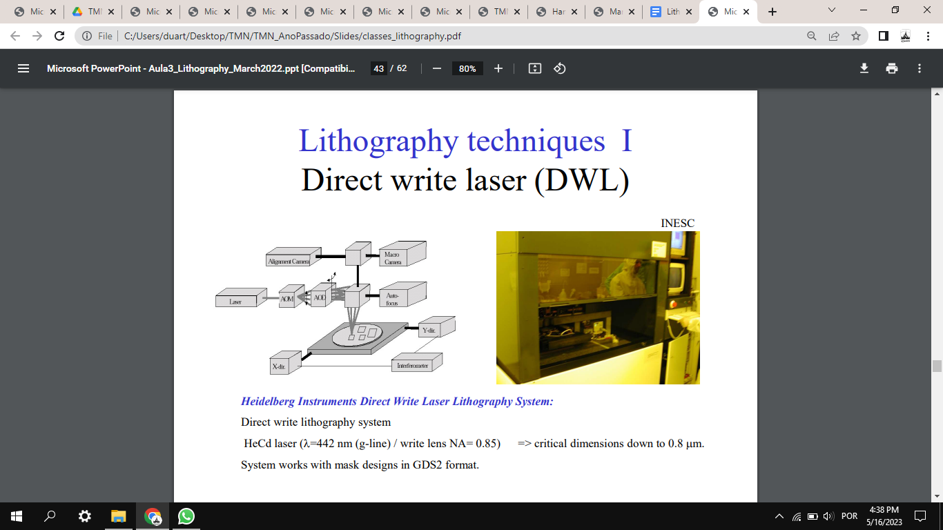

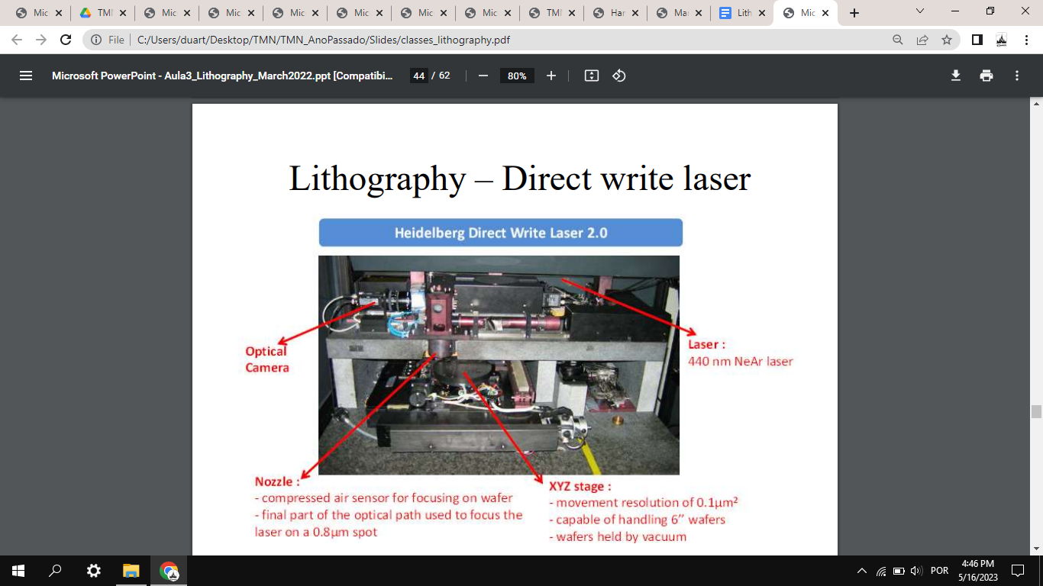

**1.5. What is the minimum feature size achieved with the lithography system you used?**

Around 0.8um - can be slightly decreased by changing the power value and energy (for a fixed wavelength).

**1.6. What parameters (and why) limit the minimum feature size achieved by the lithography method you used? Briefly discuss limitations of optical lithography**

The parameters that limit the feature size are the wavelength and the NA (numerical aperture), since the biggest challenge for the feature size is diffraction of the light. In this case, the lower the wavelength and the higher the NA, the smaller the feature size. Decreasing wavelength and increasing numerical aperture has been proved successful, but at the cost of decreased depth of focus (DOF), thus adding more stringent requirements on planarity and wafer flatness. For example, 250nm CMOS technology is achieved with DUV illumination at 248nm and numerical aperture of about 0.6, yielding a theoretical depth of focus of about 300 nm; this requires the substrate to be planar and flat across the exposure field (usually 25mmx25mm).

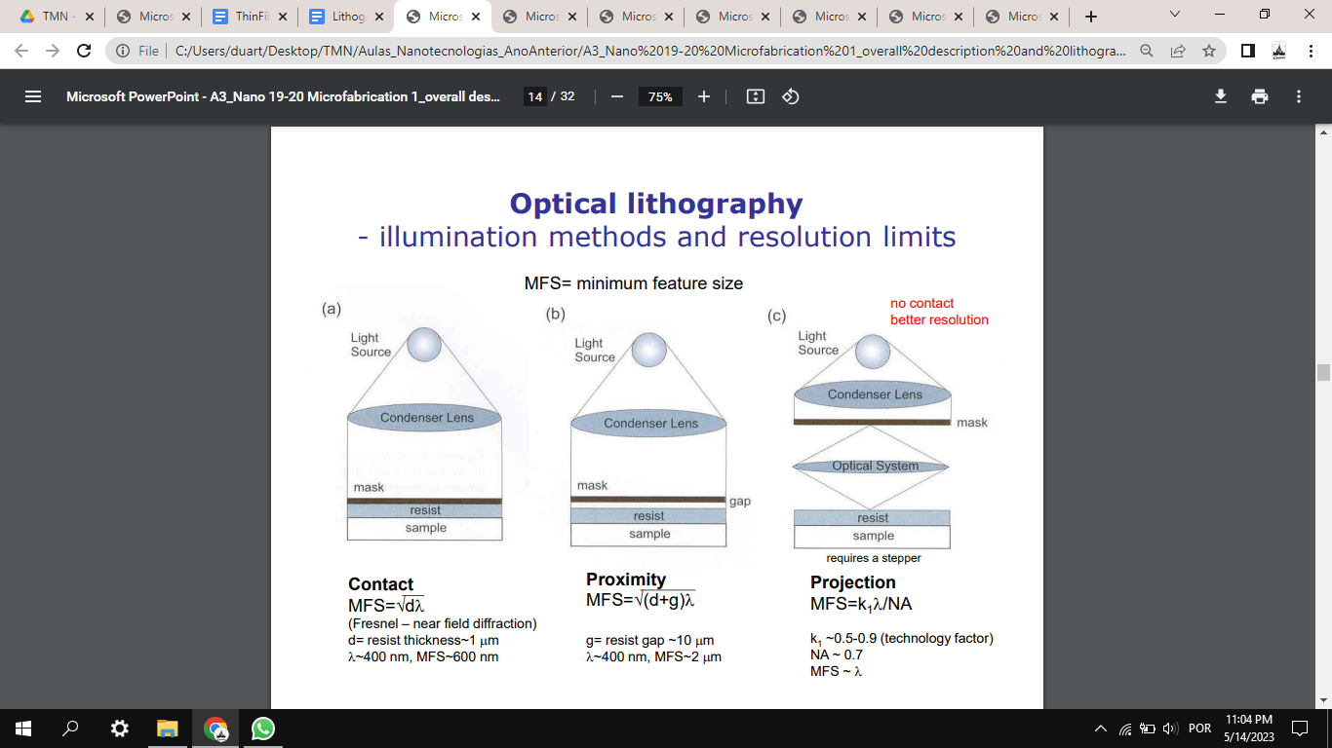

**1.7. Explain the (i) development and (ii) outcomes after exposure, using a positive and a negative resist. Indicate which one is used on your process.**

After exposure, development is performed (in our case, with developer TMA238WA at the SVG track - Develop Line). Firstly, it is necessary to heat the sample and then cool it for some time, in order to harden the photoresist. Some photoresists require a bake after the exposure and before the resist is developed, because this bake assists the chemical reaction that occurs during the exposure. In our case, the bake was performed at 110ºC for 60s and the cooling for 30s. After that, the development is done by using water and a developer on the wafer with liquid and spray form (for 60s, in our case). After this development, in the case of a positive resist, the exposed photoresist should be removed from the sample; in the case of the negative photoresist, the unexposed photoresist is removed from the sample. In our lithography process, positive photoresist was used. The quality of the lithography process can be accessed using microscopic imaging (check for desired patterns) and a profilometer (check for thickness of the resist).

