Thin Film Deposition

The quiz is to be answered up to 2 days after the Laboratorial Session by the Group.

Each group will receive individual feedback.

No grades are attributed to the quizzes at this point (0 points - no answer; 1 point - answer received).

Any copied content will be regarded as NO ANSWER.

These questions are part of the process runsheet and will be considered in the evaluation of the documents

O nome e a foto associados à sua Conta Google serão registados quando carregar ficheiros e enviar este formulário. Apenas o email que introduzir fará parte da sua resposta.

**Checklist for this lab:**

1) Add 2 test samples (glass bars) to your sample during deposition:

- one for resistivity measurements;

- one for thickness evaluation;

2) Take all notes on the process runsheet;

3) Include all pictures, graphs, results in the process runsheet;

4) Prepare your runsheet and answers to the Quiz before class;

**Additional Information:**

• Nanoelectronics and information technology. Waser R. Wiley-VCH Verlag GmbH; 2003 Apr.

• Fundamentals of microfabrication: the science of miniaturization. Madou MJ. CRC press; 2002 Mar 13.

Answer to group of questions 1, 2 or 3 corresponding to the deposition method you used in class and to group of questions 4. General questions

**- SPUTTERING - question group 1;**

- ION BEAM DEPOSITION - question group 2;

- CHEMICAL VAPOR DEPOSITION - question group 3.

**1. SPUTTERING**

**1.1. Describe the process of (i) sputtering of the target and (ii) deposition of materials within the vacuum chamber.**🔴

The plasma (emits light) consists of argon ions Ar+ that accelerate towards the target (very high velocity) and free electrons. The ions are attracted towards the negatively charged target and physically knock off atoms of the target material’s surface - sputtering - which fly off in all directions, including towards the substrate we want to coat and become the thin film. This process continues (layer by layer) until the substrate is coated with the desired thickness. Then, the voltage on the target is turned off and the sputtering stops. In the sputtering process, when an accelerated ion hits the surface atoms, the collision cascade leads to heating of the target and some back-reflected atoms which can leave the surface. The details of these collision cascades basically depend on the relative masses of projectile and target atoms. The threshold energy for sputtering is much higher than the surface binding energy (Wb) of the atoms, since several collisions are needed in order to obtain an atom in the backward direction. To improve the ionization rate, magnetic fields are used to force the electron into helical paths close to the cathode and yield a much higher ionization probability.

**Prepare a schematic drawing and upload it below / use schematic drawings**

**1.2. Upload the schematic drawing here:**🔴

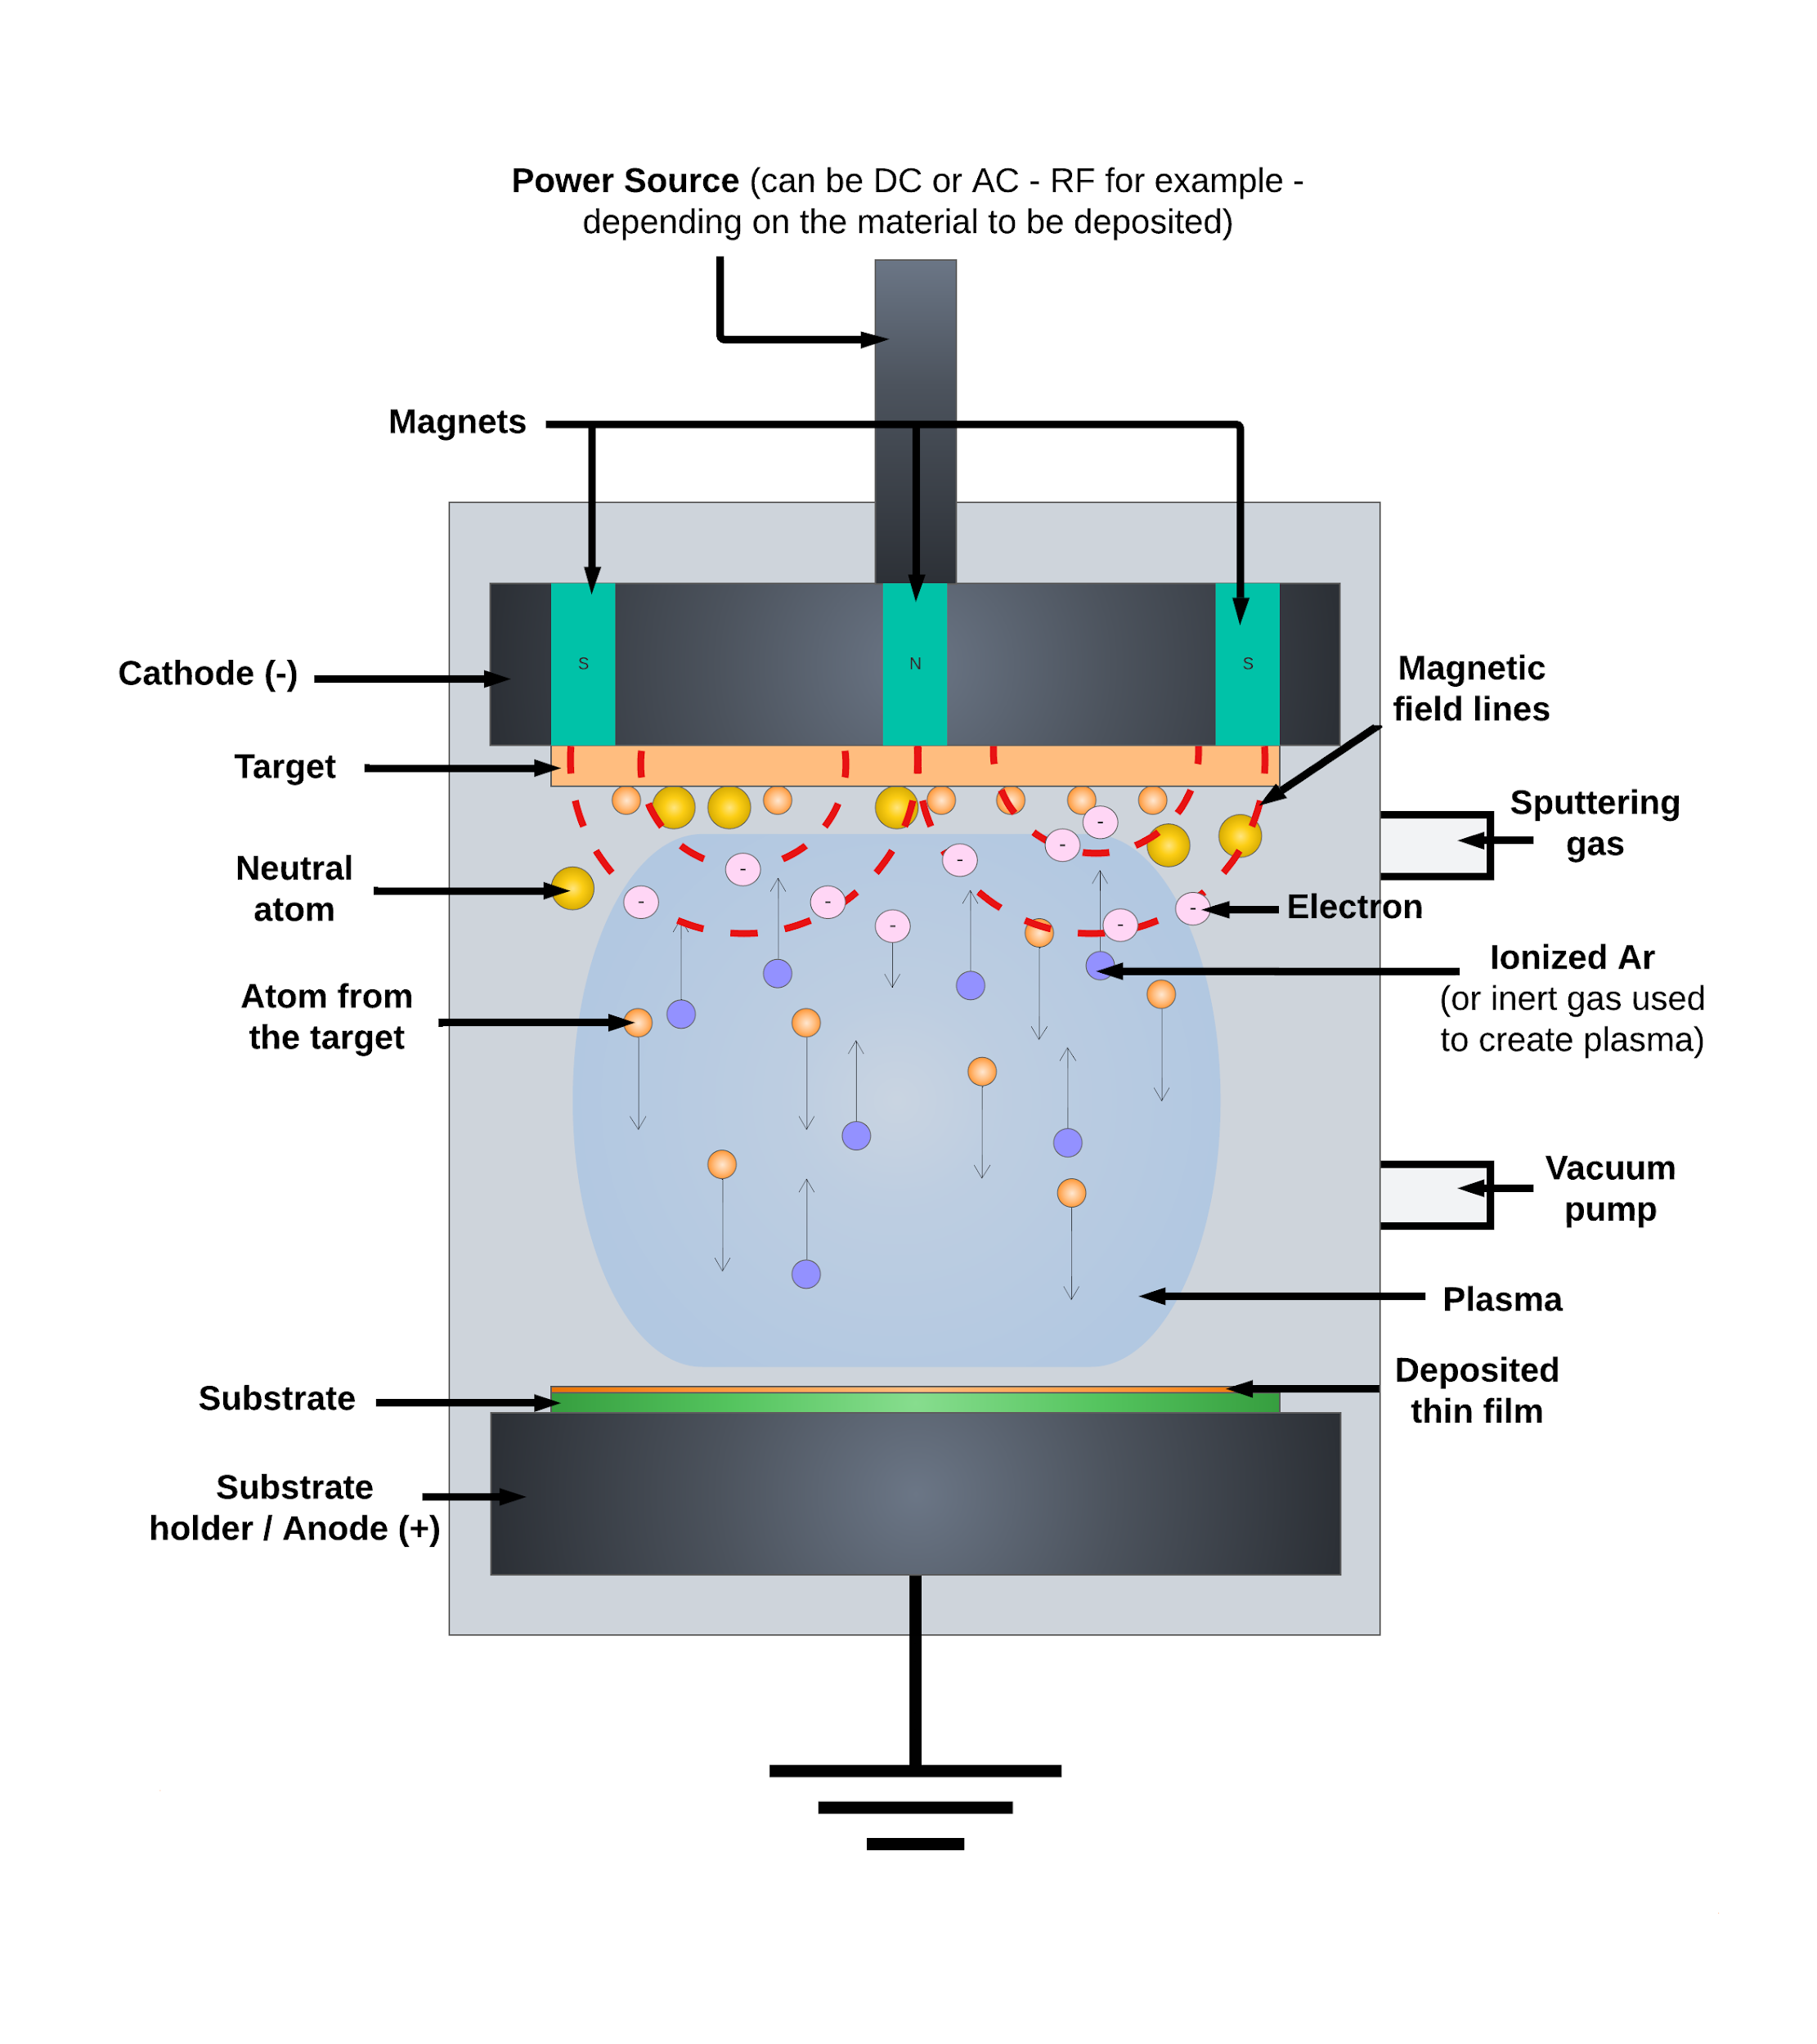

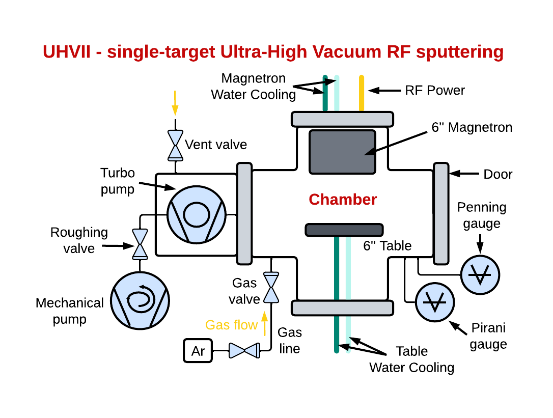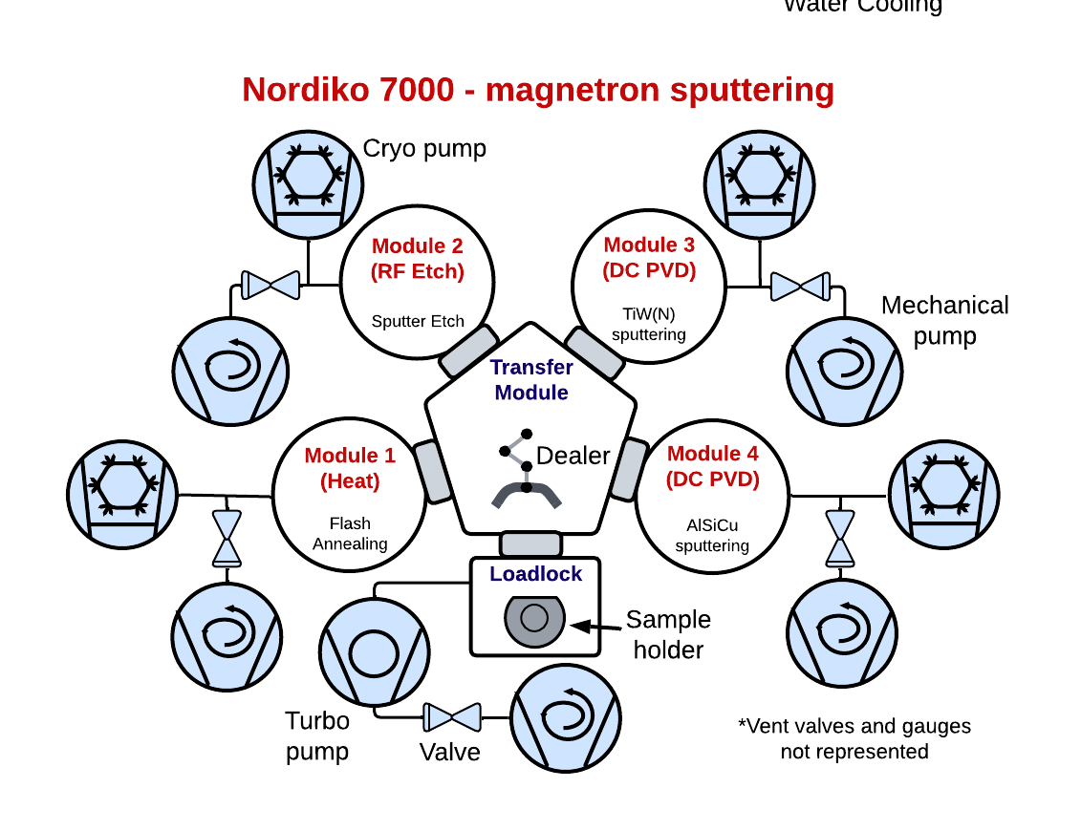

**Save your file as "Group number_Thin Film Deposition"**

**1.3. Describe shortly how the plasma is obtained.**🔴

After the target/source and the substrate are loaded, vacuum pumps evacuate the chamber. Air is continuously removed by the pumps, leaving (nearly) no reactive gasses inside. Then, a small amount of (usually) argon gas is leaked. A high negative electrical voltage is then applied to the target with a power supply - starting at low power and slowly raising it to avoid heating the target too quickly. This high voltage is strong enough to strip an electron from the argon atom; they become ionized and each one has a positive charge (stretching the plasma). The voltage is applied across two parallel plates; the cathode target is generally cooled because the sputtering generates heat. The plasma is created with a DC power source (preferred for metals) or radio frequency (RF) power source (for dielectrics). The plasma (emits light) consists of argon ions Ar+ that accelerate towards the target (at very high velocity) and free electrons. It might be concentrated along a magnetic field created by magnetic arrays. In magnetron sputtering, a magnetic field parallel to the wafer (perpendicular to an electric field) is applied; electrons will spiral around the magnetic field, the increased path length means more ionization (because there is a higher probability of slamming into an argon atom), resulting in high density plasma.

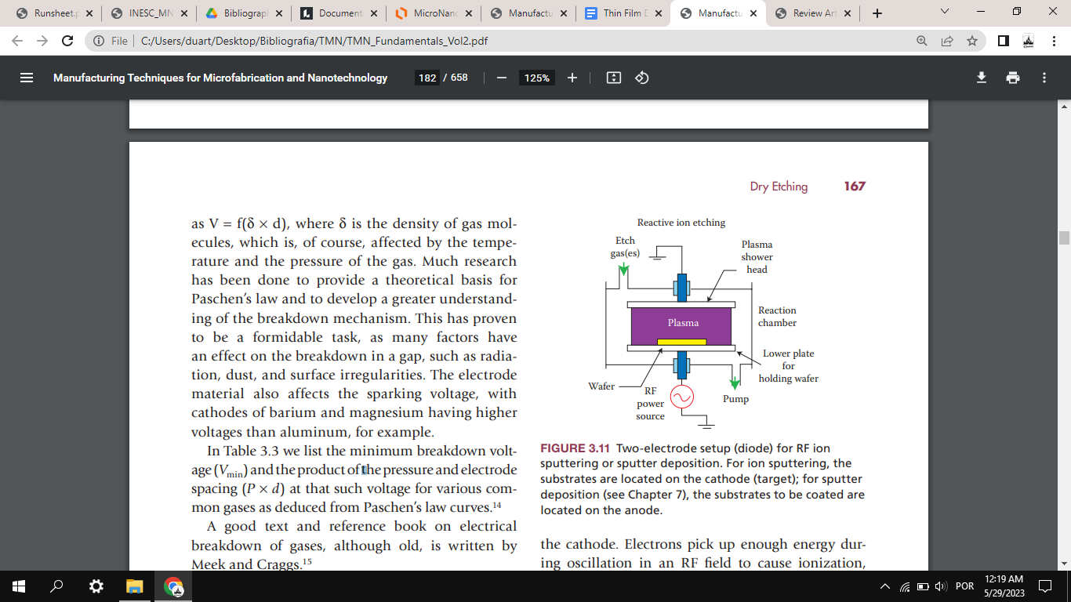

[...]

**4. GENERAL QUESTIONS**

**4.1. Enumerate the targets in use in the machine/What are the targets present inside the machine?**🔴

The first machine we used was the UHV2 (Ultra High Vacuum 2) where Al2O3 was deposited and this was the only target present in the machine. For a second deposition, the N7000 (Nordiko 7000) system was used, which only contains 2 targets (which were used in our process) - AlSiCu and TiW(N2) targets.

**4.2. Enumerate key vacuum components of the deposition machine. Comment on the importance of vacuum for this process**

Key components of the deposition machine (UHV2 and Nordiko 7000, for instance), include: 1) Vacuum pumps - mechanical pump; turbomolecular and/or cryogenic pump; a mechanical pump should always be present in each module (chamber, loadlock) of a vacuum system. In order to go from atmospheric pressure to ultra-high vacuum (UHV), these different types of pumps are used. 2) Pressure sensors - Pirani, Penning and Bayard-Alpert gauges, which allow measuring different ranges of pressure inside the loadlock and chambers in the vacuum system. 3) Transfer module with dealer (for instance, in Nordiko 7000), in case there is more than one chamber - as opposed to UHV2, where there is only one chamber. This is used to transfer the sample between different modules of the system. 4) A door in the loadlock (or chamber, in case of UHV2) to insert and remove the sample manually (in a sample holder/cassette). 5) Roughing valve between the mechanical and turbomolecular pump, since it is first necessary to pump the system using a mechanical pump (rough pump), after which it supports the turbomolecular pump - which cannot work by itself. 6) Gas line and gas valve, in order to insert the gas used in the sputtering process (Argon in UHV2, for instance). 7) Vent valves, used to perform venting in the different chambers of the vacuum system. 8) Other valves - for instance, connected to cryo pumps.

The vacuum inside the chamber is a key factor in sputtering, having mainly two effects. The deposition rate will mostly be a function of the sputtering rate, which is a function of how much argon is there. However, pressure also affects the mean free path. With an argon pressure at ~0.1Torr, the resulting mean-free path is λ~0.5mm, much smaller than the distance between the target and wafer, thus there will be many collisions of the sputtered material as it travels to the wafer. At higher gas pressure, the ions can collide with the gas atoms and diffuse into the substrate or chamber wall and condense after moving inside it to a certain depth. Sputter deposition at higher argon pressures results in a significant loss of deposition rate due to gas scattering and back diffusion of sputtered atoms. The mean-free path of an atom is inversely proportional to the pressure. Contaminations are also reduced by the existence of vacuum within the chamber leading to cleaner surfaces deposited.

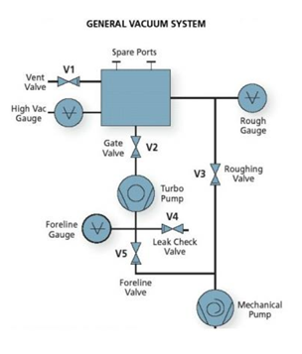

**4.3. Compare the base pressure with the pressure during deposition. Explain.**🔴

When it comes to the UHV2, the base pressure is 4.7x10^-7Torr. The biggest drop in pressure comes from the addition of the Argon in the chamber, in our case with a flux of 45sccm, which leads to a pressure inside the chamber of 2.8x10^-3Torr, since we are adding particles to the inside of the chamber. In the case of N7000, the several modules are at different pressures, but all above 10^-6Torr, before starting the process. Similarly to what happened in UHV2, as the inert gas is pumped into the chambers, the pressure increases to around 3x10^-3Torr. This pressure is maintained during the deposition process.

**4.4. Explain if photoresist could be used in the sample deposited.**🔴

In the case of UHV2 and N7000 (Nordiko 7000), photoresist can be used in the deposited sample, just like it was used in our particular sample (for later lift-off processes). This can be done since in the UHV2 and N7000 machines the substrate does not reach very high temperatures, such as, for instance, in the PECVD machines (usually over 200ºC). Temperature is the main problem when depositing with a photoresist on the sample, since high temperature can burn the photoresist and prevent a lift-off process from being performed.

**4.5. Compare PECVD, Ion beam deposition and magnetron sputtering, in terms of: deposition temperature, deposition rate, stoichiometry control and film quality.**

In magnetron sputtering, the temperature of deposition can vary widely depending on the machine, being able to range from around 50ºC to thousands of degrees. Even though it can be dependent on type of material (metal or dielectric), this process has, as a norm, a low deposition rate compared to PECVD. In magnetron sputtering, different sputtering yields are observed for different target atoms. However, there is generally a good self-regulating mechanism and sputtering quite generally allows the deposition of films with the same stoichiometry as the target. On the other hand, the film quality can be affected by the substrate and/or underlayer interface quality. No metal is 100% pure, thus impurities in the targets will also be sputtered and incorporated into the thin film, which is undesirable. Impurities can negatively influence the thin film properties, such as the electrical connectivity. Only highly pure sputtering targets can ensure high-quality thin films. The vacuum chamber should be left under vacuum when not in use to keep it as clean as possible.

Regarding PECVD, temperatures are usually always superior to 200ºC (which compromises the presence of photoresist in the sample). Usually has higher deposition rates than the other deposition techniques. However, it is difficult to achieve uniformity. Evaporation techniques usually lead to better purity, especially when no gas is included, and since a very high vacuum is used. It allows little to no control of stoichiometry.

Finally, ion beam deposition has a low deposition rate compared to PECVD. This process can be done at low temperatures - even at room temperature. In some cases, the temperature of the substrate is controlled to a few hundred degrees, however. In general, it allows for very high quality films. Ion beam sputtering of chemical compounds is in general nonstoichiometric, due to undesirable ionic emission (high influence of target charging).

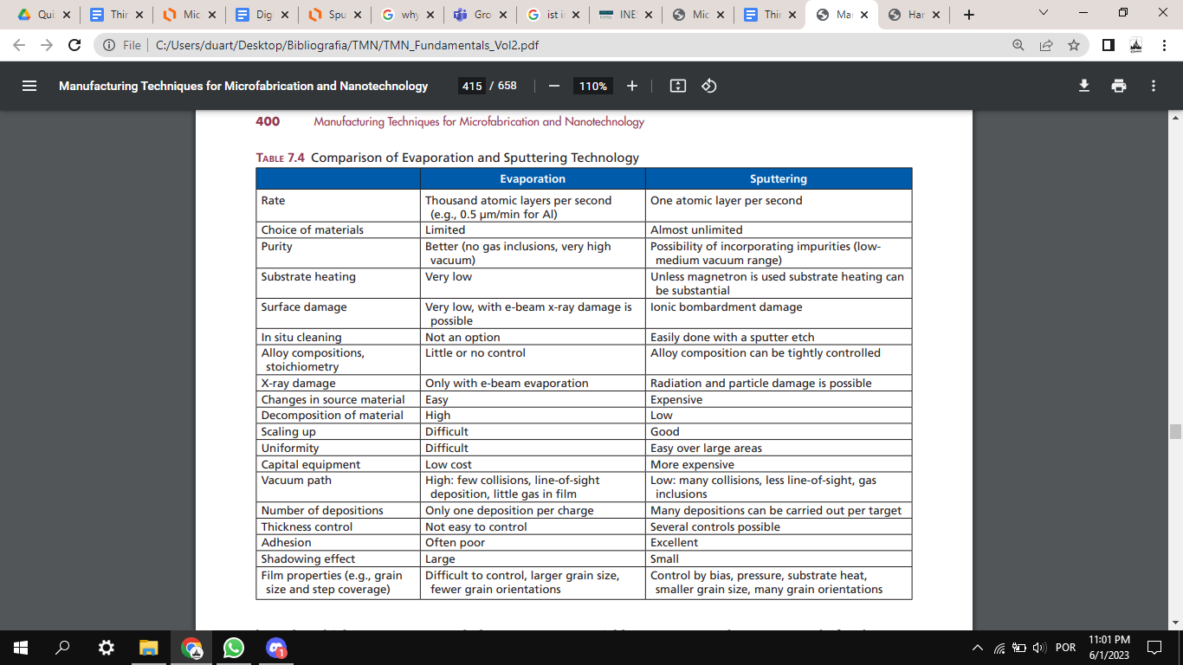

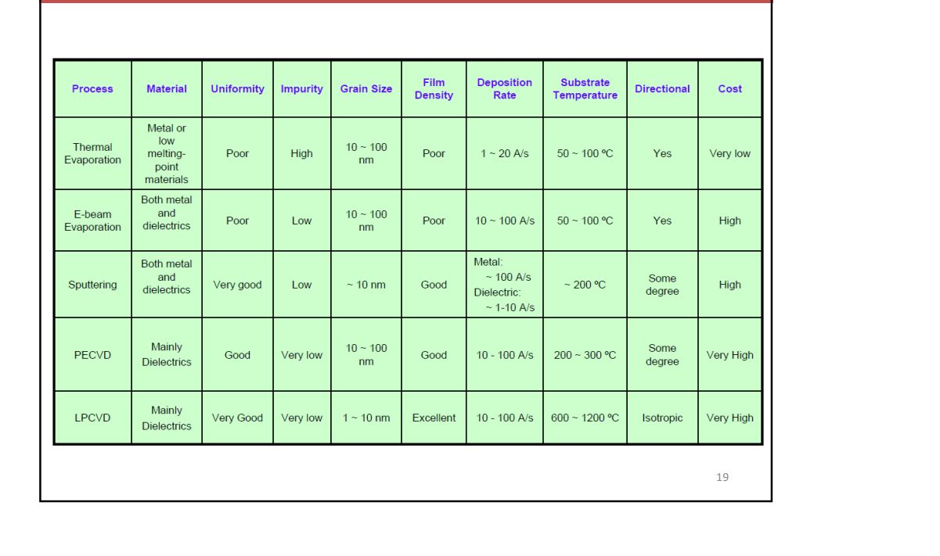

Nordiko 3000, 3600 - ion beam deposition

Uniformity typically around 1.5% (N3000)

Nordiko 7000, UHV2, Nordiko 2000 - magnetron sputtering

Hot process (400 ºC), Degassing module (up to 450 ºC) (N7000), Thickness Uniformity around 1.5%

Oxford - PECVD