The quiz is to be answered up to 2 days after the Laboratorial Session by the Group.

Each group will receive individual feedback.

No grades are attributed to the quizzes at this point (0 points - no answer; 1 point - answer received).

Any copied content will be regarded as NO ANSWER.

These questions are part of the process runsheet and will be considered in the evaluation of the document.

Checklist for this lab:

1) Take all notes on the process runsheet;

2) Include all pictures, graphs, results in the process runsheet;

3) Prepare your runsheet and answers to the Quiz before class;

Additional Information:

• Nanoelectronics and information technology. Waser R. Wiley-VCH Verlag GmbH; 2003 Apr.

• Fundamentals of microfabrication: the science of miniaturization. Madou MJ. CRC press; 2002 Mar 13.

🔵🔴🟢 - já adicionei tudo o que me lembrei/procurei [Beatriz, Duarte, João]

1. ION BEAM ETCHING

**1.1. Describe the ion milling process. Compare with the deposition process. Enumerate key components of the machine and quantify key parameters.** 🔴

Ion milling is a physical etching process - not selective and anisotropic; it consists of ion beam etching with Ar+ (typically). It is a dry etching process, which only includes physical etching; it uses both plasma and acceleration to etch the previously deposited materials - normally used for magnetic materials, for example. The machine includes the loadlock, in which the wafer is manually inserted on the cassette. After a pumping process (for this purpose, a mechanical pump and a cryo pump connected to the loadlock are used), the sample goes to the transfer module and then to the main chamber (Module 1 - both chambers of Nordiko 3600 and Nordiko 8800 are connected to the same transfer module). Inside it, there are two ion sources - deposition gun and assist gun (both used in deposition processes, only the latter in ion milling). The plate holding the sample’s wafer is tilted during etching/deposition, forming an angle between its surface and the ion beam. There are 6 targets for deposition. A mechanical pump and a cryo pump are also connected to the transfer module and the main chamber; the latter also includes a turbomolecular pump. Some key parameters include: 1) Etch rate - depends on the machine and material to be etched, even though, in the laboratory sessions, average values are considered for the whole stack in order to calculate the necessary time. 2) Time of etching (depending on the etch rate and thickness to be etched) and time for cooling down. 3) Angle between ion beam and sample wafer - 45º, 60º or 30º in Labs 1 and 2; in ion beam milling, the ion beam direction is defined by the acceleration grids at the exit of the plasma source. 4) Power (RF Forward) - around 200W in our etching processes. 5) Voltage and current in Grid 1 (V+ and I+) - 553V and 104mA, resp.. 6) Voltage and current in Grid 2 (V- and I-) - 348V and 3mA, resp.. 7) Ar (gas) flux - around 16sccm. 8) Rotation speed of the substrate table - 30rpm in our case. 9) Chamber working pressure - around 10-4 Torr in our etching processes.

**1.2. How does the angle between beam and sample, and sample rotation, can affect the etch rate?**🔴

The sputter yield S depends on the angle of ­incidence of the ions (angle at which ions are directed at the surface - 0° is perpendicular and 90° is glancing. In sputtering (at energies <50 keV), the incoming ions may be modeled as hard spheres colliding with the substrate, with 95% of the incident energy going into the substrate (thus making cooling of the target absolutely required) and 5% of the incident energy carried off by substrate/target atoms. The atoms come off with a cosine distribution - at a glancing angle, the incoming ions do not eject atoms from the substrate/target (S = 0); hitting the substrate perpendicularly leads to fewer atoms being ejected from the substrate/target; in between, there are a maximum number of atoms being kicked out. The sputter etch rate of resist, for example, reaches a maximum at an incidence angle of about 60º, more than twice the rate at normal incidence. The sample rotation is performed in order to obtain a more uniform etch rate within the whole sample - if that did not occur, different areas in the sample would be etched with different characteristics. There are many challenges that arise in the etching process which can make it difficult to have a uniform and controlled etching. Examples of these are trenching, backscattering, angular distribution of ions and redeposition. This last one is a problem that arises when the atoms that are stripped from the bottom of a trench get then redeposited in the side wall. One way to reduce this is in fact to have an angle between the beam and the sample (theoretically the angle for maximum yield is around 60 or 70 degrees - first etching process -, but it can be reduced - for example, to around 30º, as done in the second etching procedure in the Lab - to avoid redeposition) and also have the sample rotating. The 3 main benefits of these 2 parameters is to reduce trenching by blocking the ion beam from the bottom of the step, etch the side walls which will counteract the redeposition and help overall improvement of etching profiles by allowing defined vertical walls on the etched features.

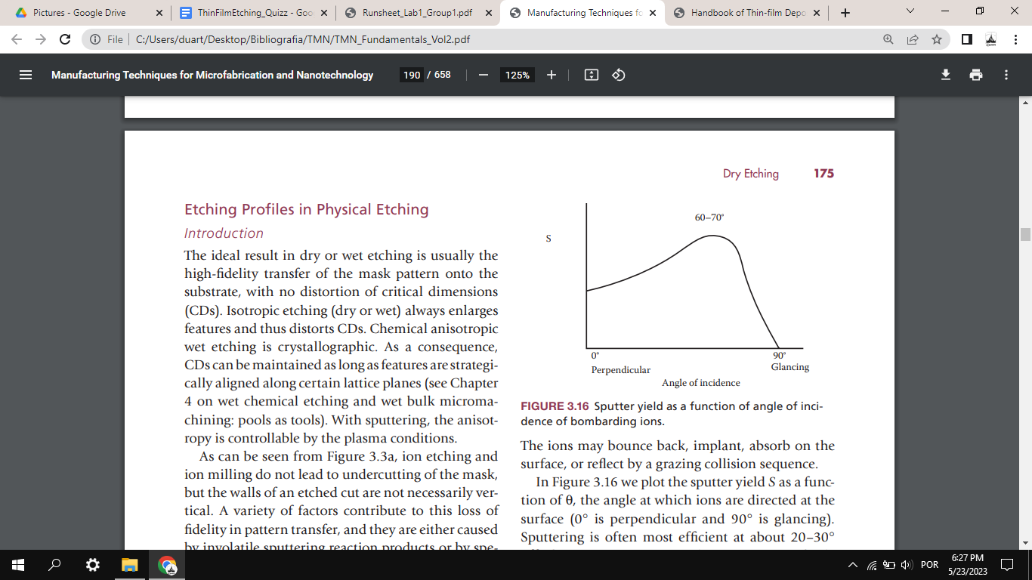

**1.3. Discuss the effect of resist thickness and pattern density on the etching process. Consider the case of an array of 10x10 pillars, distanced of 1um, defined by our standard optical lithography process.**🔴

The higher the pattern density on a certain area, the slower the etching. A large unmasked surface consumes more etch species than a single trench, resulting in a local modulation of the plasma chemistry and the etch rate. This problem, however, should not be very significant in this case, since all the pillars are equally distanced. Additionally, microloading is a problem to be considered in wet etching. There are many challenges that arise in the physical etching process which can make it difficult to have a uniform and controlled etching. Examples of these are trenching, backscattering, angular distribution of ions and redeposition. Moreover, the thickness of the photoresist needs to be determined in order to make sure that, with the given etch rate and time of etching, it is thick enough to protect the layers under it from being partially removed during the process. In the cleanroom of our laboratory sessions, a common practice is to use 1.5um-thick photoresists - this was done in Labs 1 and 2, so far.

**1.4. What parameters can affect the physical removal of material.**🔴

The yield of physical etching methods depends on many different factors which can be combined to obtain the desired etch rate and uniformity of the etching process. Many parameters that affect etching are related to the material(s) we are trying to etch, such as mass of the atoms, binding energy, crystalline structure and even the temperature of the substrate during etching. Other parameters not related to the substrate can be the pressure in the chamber, the mass of the atoms of the gas, the energy with which the ions are bombarded towards the substrate, the angle between the ion beam and the substrate and if there is any rotation of the base of the substrate. Additionally, some adverse ion bombardment effects, due to excessive physical sputtering, are caused by redeposition of material, angular dependence of the process and sputter yield. The kinetic energy of the incoming particles largely dictates which events are most likely to take place at the bombarded surface - like surface damage, substrate heating, reflection, sputtering, or ion implantation. For instance, at energies between 4 and 10 eV, surface migration and surface damage may occur. At energies >10eV, substrate heating, surface damage and material ejection can take place. At even higher energies (>10000 eV) ion implantation (doping) occurs. Sputter etching tends to form facets, ditches and hourglass-shaped trenches and frequently redeposits material.

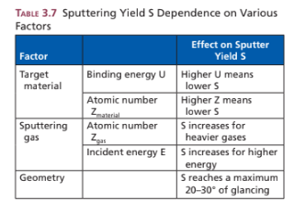

2. WET ETCHING

**2.1. Describe shortly the wet etching process.**🔴

Wet etching is a material removal process that uses liquid chemicals or etchants to remove materials from a wafer. The specific patterns are defined by masks on the wafer. Materials that are not protected by the masks are etched away by liquid chemicals. These masks are deposited and patterned on the wafers in a prior fabrication step using lithography. Wet etching is typically isotropic. It is a purely chemical process, in which reactive species present in solution have to move to the surface, a reaction yielding soluble etch products has to take place and etch products need to move away from the surface. A wet etching process involves multiple chemical reactions that consume the original reactants and produce new reactants. The wet etch process can be described by three basic steps. (1) Diffusion of the liquid etchant to the structure that is to be removed. (2) The reaction between the liquid etchant and the material being etched away. (3) Diffusion of the byproducts in the reaction from the reacted surface. Some advantages of wet etching include: large number of recipes exists to etch virtually every material; can be tailored to have high selectivity; no ion bombardment, so induced damage is low. Some disadvantages/precautions include: need for careful control of etch solution concentration on a microscopic scale; high-purity chemicals must be employed to avoid particle contamination of surface; large consumption of chemicals and handling of toxic waste; not practical for very small features because of undercuts. Common wet etch processes include SiO2 etching in buffered HF or photoresist strip after each patterning step - done several times throughout our laboratory sessions.

**2.2. What parameters can affect the chemical removal of material.**🔴

The parameters that affect the chemical removal of the material are the following: 1) The composition of the etchant material, since this has an influence on the etch rate and the selectivity of the process - it determines the materials that are removed. 2) The temperature, since higher temperatures increase the reaction kinetics and accelerate the etching process. 3) The pH of the etchant influences the ionization and reactivity of the etchant, and so affects the etching rate. 4) The etching time can influence the amount of material that is etched; a longer etching time means that more material is etched. 5) Agitation, such as ultrasonic agitation (similar to the Microstrip, with the ultrasonic bath) can have an important role in the etching process too; it promotes the uniform distribution of the etchant and improves the efficiency of the etching process (the reactants get more easily transported to the surface of the sample). 6) External factors, like light exposure, humidity and atmospheric conditions, can influence the etching process too, since they can introduce additional reactions or affect the stability of the etchant. 7) Finally, the composition, surface roughness, crystal structure and surface orientation can influence the etch rate and selectivity; crystalline materials have lower etch rate on surfaces that are denser in comparison with less dense surfaces. For example, silicon - which has a diamond lattice structure - has different surface densities, with {111}>{100}>{110}, so the etch rate in {100} is 100 times bigger than the etch rate on {111}.

3. GENERAL QUESTIONS

**3.1. Explain how are etching rates calibrated.** 🔴

The calibration of etching rates is done simply by testing the etching for several different materials. For a given material deposited onto a substrate, etching is done at defined parameters and then studied under several tools designed to give us the thickness of the material. An easy way to do this is by depositing resist on part of the sample and leaving another part exposed. After etching, a profilometer can be used to know how much etching was done for a given set of parameters. This way, we can calibrate the etching rates of a given machine for different films.

**3.2. What are the metrology tools and methods used to control the ion milling etching?**🔴

Usual metrology tools to control the results of the ion milling etching process are any tools which can provide depth profile of our sample - for example, using a profilometer (used in our Lab sessions) or an AFM (Atomic force microscope) to verify our sample not only in depth, but also in terms of uniformity and feature definition. For instance, in the first laboratory session, it was verified, using the profilometer, that the thickness etched in the process was lower than expected, which led to another etching procedure. Another simpler alternative that should be taken into account is visual inspection (for example, with a microscope). In case the etching process should result in the creation of paths with/without electrical conductivity, this parameter can also be sampled. For instance, after the ion milling process done in the second laboratory session, a large portion of our sample should contain no TMR stack - only the isolation layer (SiO2). For that purpose, a multimeter was used to check that, in fact, no electrical conductivity existed - this was not true at first, so a second etching procedure was performed, after which that problem was fixed. To monitor the chamber atmosphere composition during the etching, mass spectroscopy can also be used.

**3.3. Indicate the etching rates for different materials (metal, oxides, etc.).**🔴

Some examples include: Si (a-Si) - ~500A/min; SiO2 - ~200A/min; Si3N4 - ~100A/min; GaAs - ~200A/min; InP - ~200A/min; Al - ~300A/min; Resist/polymer - ~500A/min (these values are highly dependant on machine, technique, characteristics of the process). While etching the TMR stack in our laboratory sessions, an average etch rate of 1.1A/s was considered at an angle of 60º, while a value of 0.88A/s was considered for 30º and 45º.

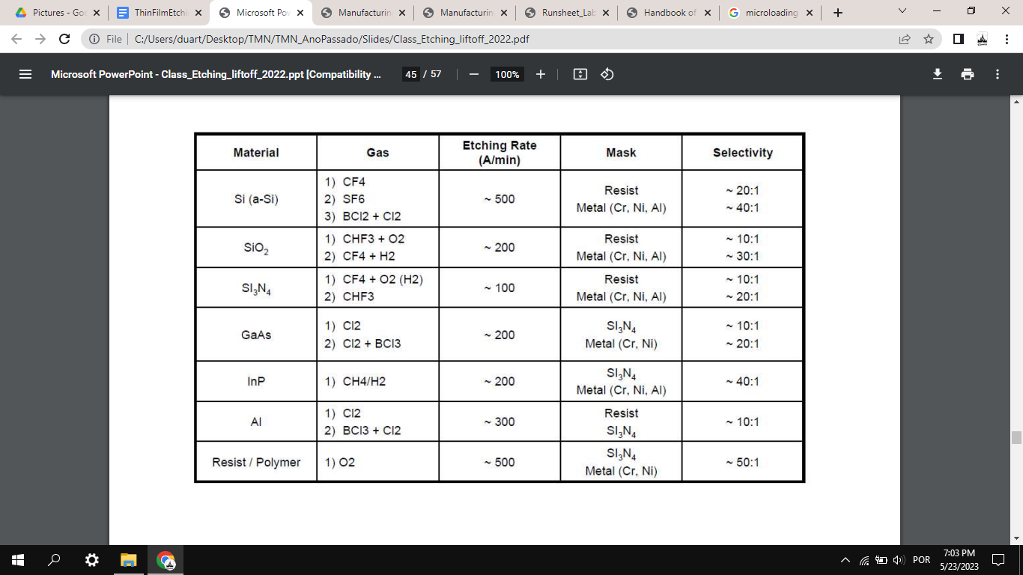

<https://www.seas.upenn.edu/~nanosop/documents/Etchratesformicromachiningprocessing.pdf>

**3.4. Compare chemical and physical etching processes.**🔴

Physical etching relies on the momentum transfer from particles hitting and eroding the surface. In physical etching, ion etching or sputtering, and ion-beam milling, argon or other inert ions extracted from the glow discharge region are accelerated in an electrical field toward the substrate, where etching is purely impact controlled. The method is slow compared with other dry etching means, with etch rates limited to several hundreds of angstroms per minute compared with thousands of angstroms per minute, and higher for chemical and ion-assisted etching. Chemical etching relies on chemical reactions that yield products that are either soluble in the etch solution or volatile at low pressures. Chemical etching reactions are fast and efficient compared with mechanical etching, where atoms are ejected by mechanical force.