**Quizzes**

Lithography Quizz

**1.1. Describe why surface activation/vapor prime is needed prior to coating. Enumerate the sequence steps.**

Resist adhesion to silicon wafers is poor (especially with positive resists), so vapor priming is used to improve it. The native silicon dioxide on a Si surface forms long-range hydrogen bonds with water adsorbed from the air. When resist is spun onto such a surface, it adheres to the water molecules rather than to the surface, resulting in poor adhesion.

The sequence steps are the following:

1. Wafer dehydration bake (to remove absorbed water from the surface) and purge oxygen from the chamber;

2. Priming (HDMS is the surfactant used to promote adhesion);

3. Purge prime exhaust;

4. Return to atmosphere (backfill).

In our sample, only baking was performed in the surface activation step (made before the lab session). After this, the coating is made by dispensing photoresist on top of the sample and spinning it usually at two different speeds (in our sample, 500 rpm for 10s and then 2500 rpm for 30s). After the spinning process, the desired photoresist thickness should be achieved, after which a soft bake is done (in the lab, 85ºC for 60s).

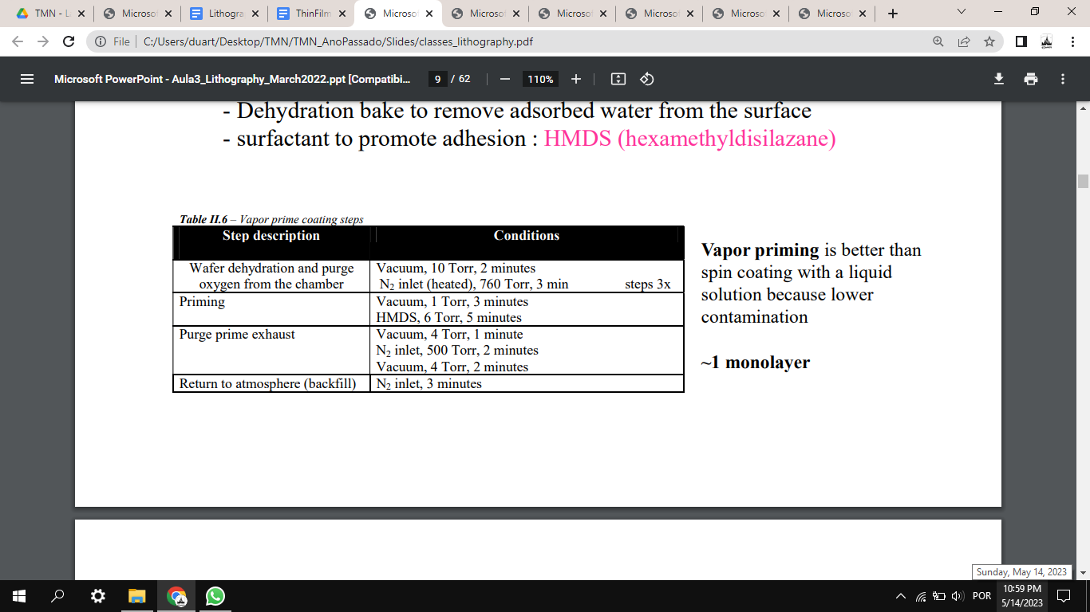

**1.2. How can one change the resist thickness? What are the metrology tools and methods used to control the resist thickness?**

Resist thickness is determined by: resist viscosity, volume of resist dispensed, spinner rotational speed and time of rotation. To control the resist thickness, it can be measured with a profilometer. To evaluate film thickness, stylus profilometry and ellipsometry are more commonly used, but the latter is usually faster. The usual spot size for spectroscopic ellipsometry procedures in which a wide range of wavelengths are used for testing is around 1mm. Smaller spot sizes do exist, but usually this happens at the cost of testing with a reduced number of wavelengths.

**1.3. Describe the exposure process using the lithography system you planned in your process. Quantify all major parameters (wavelength, resolution, etc.).**

Firstly, the sample is placed on the base, where the vacuum is activated. Then, it moves under the laser lens. It is then necessary to make sure the sample is aligned. A camera is used to check the position of the sample; in the screen, darker regions represent the sample is not being observed (there is less reflection) and brighter regions represent the sample (there is more reflection). The straighter side of the sample is defined as a reference for alignment; initially, if the adjustment is major, the vacuum can be turned off and the sample is rotated manually. After the alignment, the computer is used and two points are chosen to measure the angle of the respective line. Then, finer adjustments are made in order to reduce this angle to under 1mrad for both x and y axis. Having aligned the sample, the proper parameters are selected.

The DWL machine has a resolution (critical dimension) of down to 0.8µm. For our lithography in particular, a wavelength of 405nm was used for the laser, along with 102mW of power. Additionally, the energy designated as ‘50’ and the focus ‘5’ were selected in the computer. The XYZ stage has a movement resolution of 0.1um^2 and is capable of handling 6’’ wafers. The point (x0,y0) was set at a distance of 5mm from the edge of the mask, both in the x and y positions, by taking into account a centered mask of 15.4mmx15.4mm in the 25.4mmx25.4 mm sample. After all parameters were set, exposure was performed.

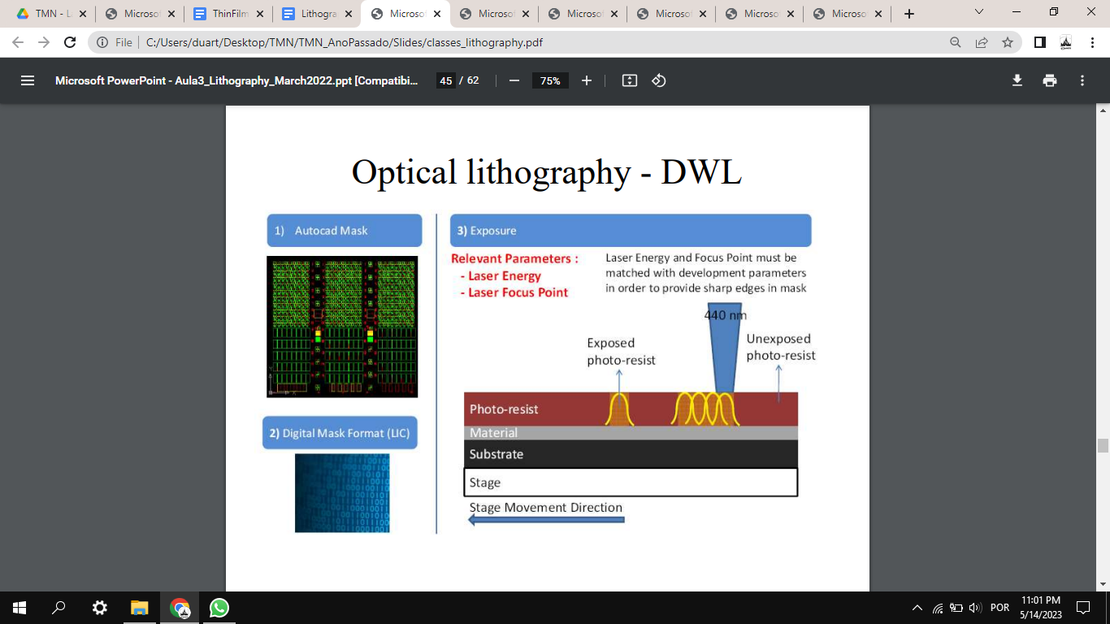

**1.5. What is the minimum feature size achieved with the lithography system you used?**

Around 0.8um - can be slightly decreased by changing the power value and energy (for a fixed wavelength).

**1.6. What parameters (and why) limit the minimum feature size achieved by the lithography method you used? Briefly discuss limitations of optical lithography**

The parameters that limit the feature size are the wavelength and the NA (numerical aperture), since the biggest challenge for the feature size is diffraction of the light. In this case, the lower the wavelength and the higher the NA, the smaller the feature size. Decreasing wavelength and increasing numerical aperture has been proved successful, but at the cost of decreased depth of focus (DOF), thus adding more stringent requirements on planarity and wafer flatness. For example, 250nm CMOS technology is achieved with DUV illumination at 248nm and numerical aperture of about 0.6, yielding a theoretical depth of focus of about 300 nm; this requires the substrate to be planar and flat across the exposure field (usually 25mmx25mm).

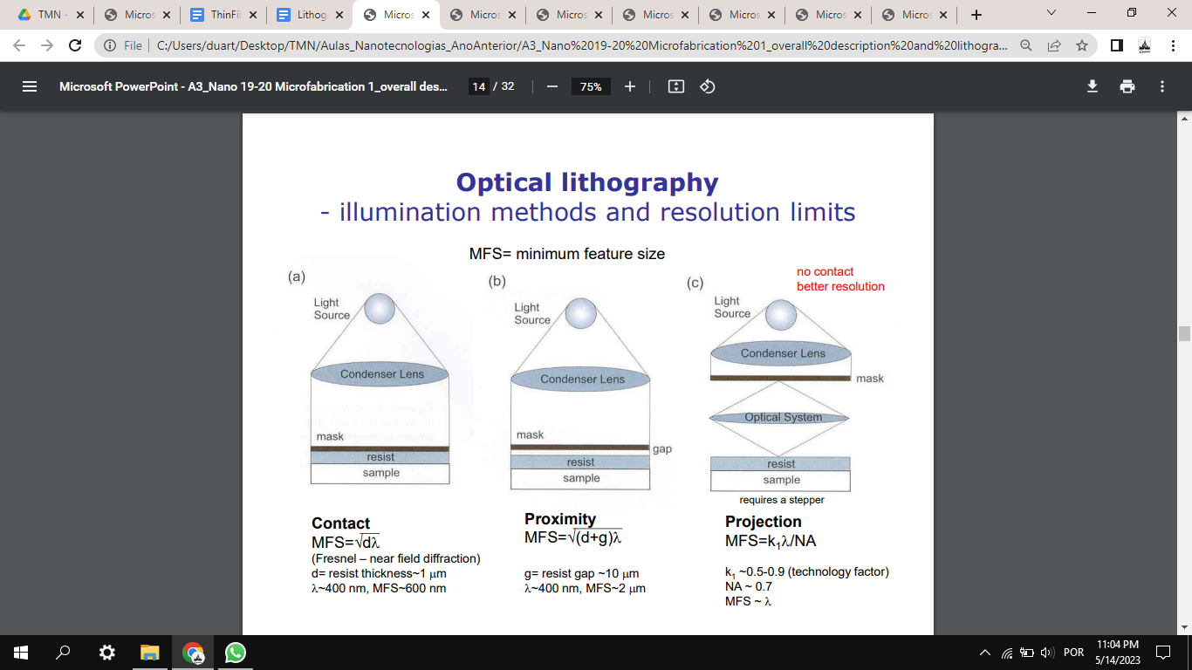

**1.7. Explain the (i) development and (ii) outcomes after exposure, using a positive and a negative resist. Indicate which one is used on your process.**

After exposure, development is performed (in our case, with developer TMA238WA at the SVG track - Develop Line). Firstly, it is necessary to heat the sample and then cool it for some time, in order to harden the photoresist. Some photoresists require a bake after the exposure and before the resist is developed, because this bake assists the chemical reaction that occurs during the exposure. In our case, the bake was performed at 110ºC for 60s and the cooling for 30s.

After that, the development is done by using water and a developer on the wafer with liquid and spray form (for 60s, in our case). After this development, in the case of a positive resist, the exposed photoresist should be removed from the sample; in the case of the negative photoresist, the unexposed photoresist is removed from the sample. In our lithography process, positive photoresist was used. The quality of the lithography process can be accessed using microscopic imaging (check for desired patterns) and a profilometer (check for thickness of the resist).

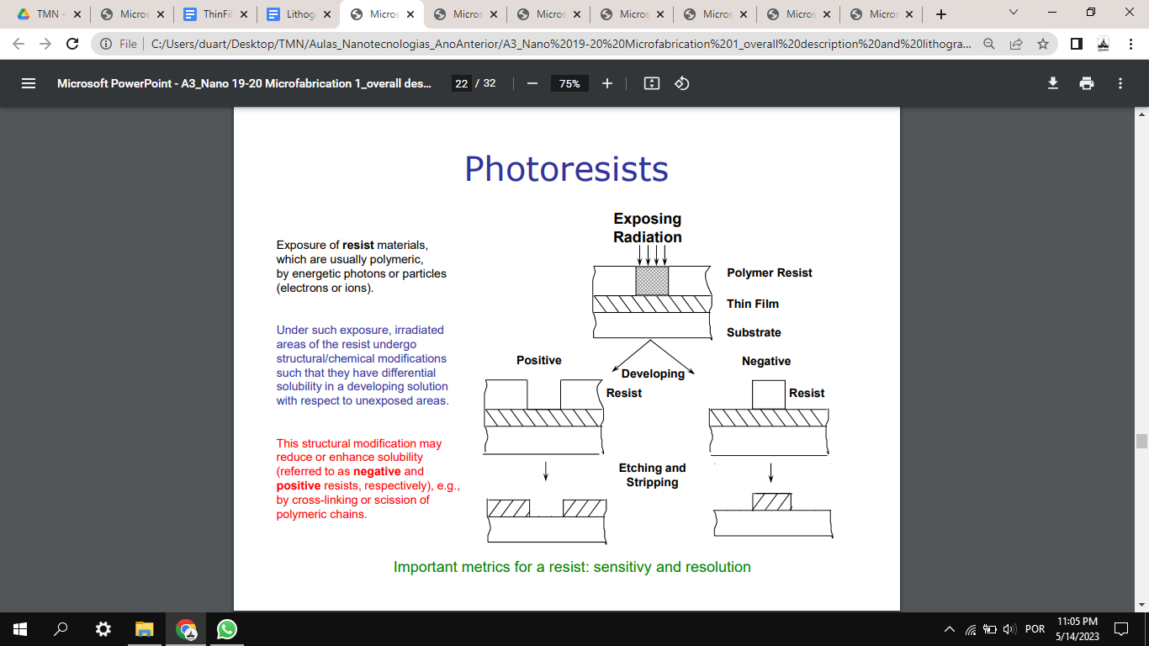

Etching Quizz

1. ION BEAM ETCHING

**1.1. Describe the ion milling process. Compare with the deposition process. Enumerate key components of the machine and quantify key parameters.**

 Ion milling is a physical etching process - not selective and anisotropic; it consists of ion beam etching with Ar+ (typically). It is a dry etching process, which only includes physical etching; it uses both plasma and acceleration to etch the previously deposited materials - normally used for magnetic materials, for example. The machine includes the loadlock, in which the wafer is manually inserted on the cassette. After a pumping process (for this purpose, a mechanical pump and a cryo pump connected to the loadlock are used), the sample goes to the transfer module and then to the main chamber (Module 1 - both chambers of Nordiko 3600 and Nordiko 8800 are connected to the same transfer module). Inside it, there are two ion sources - deposition gun and assist gun (both used in deposition processes, only the latter in ion milling). The plate holding the sample’s wafer is tilted during etching/deposition, forming an angle between its surface and the ion beam. There are 6 targets for deposition. A mechanical pump and a cryo pump are also connected to the transfer module and the main chamber; the latter also includes a turbomolecular pump.

Some key parameters include:

1) Etch rate - depends on the machine and material to be etched, even though, in the laboratory sessions, average values are considered for the whole stack in order to calculate the necessary time.

2) Time of etching (depending on the etch rate and thickness to be etched) and time for cooling down.

3) Angle between ion beam and sample wafer - 45º, 60º or 30º in Labs 1 and 2; in ion beam milling, the ion beam direction is defined by the acceleration grids at the exit of the plasma source.

4) Power (RF Forward) - around 200W in our etching processes.

5) Voltage and current in Grid 1 (V+ and I+) - 553V and 104mA, resp.

6) Voltage and current in Grid 2 (V- and I-) - 348V and 3mA, resp.

7) Ar (gas) flux - around 16sccm.

8) Rotation speed of the substrate table - 30rpm in our case.

9) Chamber working pressure - around 10-4 Torr in our etching processes.

**1.2. How does the angle between beam and sample, and sample rotation, can affect the etch rate?**

 The sputter yield S depends on the angle of ­incidence of the ions (angle at which ions are directed at the surface - 90° is perpendicular and 0° is glancing). In sputtering (at energies <50 keV), the incoming ions may be modeled as hard spheres colliding with the substrate, with 95% of the incident energy going into the substrate (thus making cooling of the target absolutely required) and 5% of the incident energy carried off by substrate/target atoms. The atoms come off with a cosine distribution - at a glancing angle, the incoming ions do not eject atoms from the substrate/target (S = 0); hitting the substrate perpendicularly leads to fewer atoms being ejected from the substrate/target; in between, there are a maximum number of atoms being kicked out.

The sample rotation is performed in order to obtain a more uniform etch rate within the whole sample - if that did not occur, different areas in the sample would be etched with different characteristics.

There are many challenges that arise in the etching process which can make it difficult to have a uniform and controlled etching. Examples of these are trenching, backscattering, angular distribution of ions and redeposition. This last one is a problem that arises when the atoms that are stripped from the bottom of a trench get then redeposited in the sidewall. One way to reduce this is in fact to have an angle between the beam and the sample and also have the sample rotating.

Theoretically, the angle for maximum yield is around 20 or 30 degrees - as done in the second etching procedure in the Lab, to avoid redeposition; even though the sputter yield increases, the overall etch rate decreases (the latter is higher when the angle is 60 degrees). The 3 main benefits of these 2 parameters is to reduce trenching by blocking the ion beam from the bottom of the step, etch the side walls which will counteract the redeposition and help overall improvement of etching profiles by allowing defined vertical walls on the etched features.

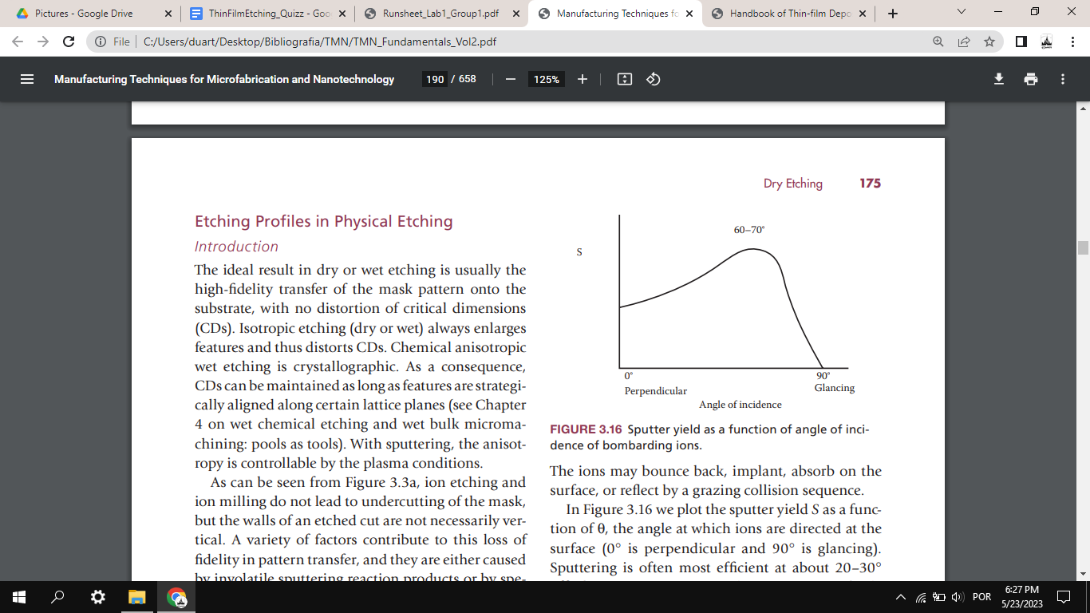

**1.3. Discuss the effect of resist thickness and pattern density on the etching process. Consider the case of an array of 10x10 pillars, distanced of 1um, defined by our standard optical lithography process.**

 The higher the pattern density on a certain area, the slower the etching. A large unmasked surface consumes more etch species than a single trench, resulting in a local modulation of the plasma chemistry and the etch rate. This problem, however, should not be very significant in this case, since all the pillars are equally distanced. Additionally, microloading is a problem to be considered in wet etching.

There are many challenges that arise in the physical etching process which can make it difficult to have a uniform and controlled etching. Examples of these are trenching, backscattering, angular distribution of ions and redeposition. Moreover, the thickness of the photoresist needs to be determined in order to make sure that, with the given etch rate and time of etching, it is thick enough to protect the layers under it from being partially removed during the process. In the cleanroom of our laboratory sessions, a common practice is to use 1.5um-thick photoresists - this was done in Labs 1 and 2, so far.

**1.4. What parameters can affect the physical removal of material.**

 The yield of physical etching methods depends on many different factors which can be combined to obtain the desired etch rate and uniformity of the etching process. Many parameters that affect etching are related to the material(s) we are trying to etch, such as mass of the atoms, binding energy, crystalline structure and even the temperature of the substrate during etching. Other parameters not related to the substrate can be the pressure in the chamber, the mass of the atoms of the gas, the energy with which the ions are bombarded towards the substrate, the angle between the ion beam and the substrate and if there is any rotation of the base of the substrate. Additionally, some adverse ion bombardment effects, due to excessive physical sputtering, are caused by redeposition of material, angular dependence of the process and sputter yield. The kinetic energy of the incoming particles largely dictates which events are most likely to take place at the bombarded surface - like surface damage, substrate heating, reflection, sputtering, or ion implantation. For instance, at energies between 4 and 10 eV, surface migration and surface damage may occur. At energies >10eV, substrate heating, surface damage and material ejection can take place. At even higher energies (>10000 eV) ion implantation (doping) occurs. Sputter etching tends to form facets, ditches and hourglass-shaped trenches and frequently redeposits material.

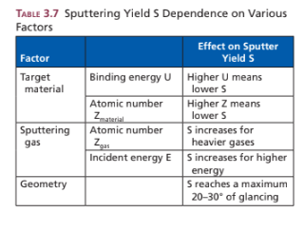

2. WET ETCHING

**2.1. Describe shortly the wet etching process.**

 Wet etching is a material removal process that uses liquid chemicals or etchants to remove materials from a wafer. The specific patterns are defined by masks on the wafer. Materials that are not protected by the masks are etched away by liquid chemicals. These masks are deposited and patterned on the wafers in a prior fabrication step using lithography. Wet etching is typically isotropic. It is a purely chemical process, in which reactive species present in solution have to move to the surface, a reaction yielding soluble etch products has to take place and etch products need to move away from the surface. A wet etching process involves multiple chemical reactions that consume the original reactants and produce new reactants.

The wet etch process can be described by three basic steps:

(1) Diffusion of the liquid etchant to the structure that is to be removed.

(2) The reaction between the liquid etchant and the material being etched away.

(3) Diffusion of the byproducts in the reaction from the reacted surface.

Some advantages of wet etching include: large number of recipes exists to etch virtually every material; can be tailored to have high selectivity; no ion bombardment, so induced damage is low. Some disadvantages/precautions include: need for careful control of etch solution concentration on a microscopic scale; high-purity chemicals must be employed to avoid particle contamination of surface; large consumption of chemicals and handling of toxic waste; not practical for very small features because of undercuts. Common wet etch processes include SiO2 etching in buffered HF or photoresist strip after each patterning step - done several times throughout our laboratory sessions.

**2.2. What parameters can affect the chemical removal of material.**

 The parameters that affect the chemical removal of the material are the following:

1) The composition of the etchant material, since this has an influence on the etch rate and the selectivity of the process - it determines the materials that are removed.

2) The temperature, since higher temperatures increase the reaction kinetics and accelerate the etching process.

3) The pH of the etchant influences the ionization and reactivity of the etchant, and so affects the etching rate.

4) The etching time can influence the amount of material that is etched; a longer etching time means that more material is etched.

5) Agitation, such as ultrasonic agitation (similar to the Microstrip, with the ultrasonic bath) can have an important role in the etching process too; it promotes the uniform distribution of the etchant and improves the efficiency of the etching process (the reactants get more easily transported to the surface of the sample).

6) External factors, like light exposure, humidity and atmospheric conditions, can influence the etching process too, since they can introduce additional reactions or affect the stability of the etchant.

7) Finally, the composition, surface roughness, crystal structure and surface orientation can influence the etch rate and selectivity; crystalline materials have lower etch rate on surfaces that are denser in comparison with less dense surfaces. For example, silicon - which has a diamond lattice structure - has different surface densities, with {111}>{100}>{110}, so the etch rate in {100} is 100 times bigger than the etch rate on {111}.

3. GENERAL QUESTIONS

**3.1. Explain how are etching rates calibrated.**

 The calibration of etching rates is done simply by testing the etching for several different materials. For a given material deposited onto a substrate, etching is done at defined parameters and then studied under several tools designed to give us the thickness of the material. An easy way to do this is by depositing resist on part of the sample and leaving another part exposed. After etching, a profilometer can be used to know how much etching was done for a given set of parameters. This way, we can calibrate the etching rates of a given machine for different films.

**3.2. What are the metrology tools and methods used to control the ion milling etching?**

 Usual metrology tools to control the results of the ion milling etching process are any tools which can provide depth profile of our sample - for example, using a profilometer (used in our Lab sessions) or an AFM (Atomic force microscope) to verify our sample not only in depth, but also in terms of uniformity and feature definition. For instance, in the first laboratory session, it was verified, using the profilometer, that the thickness etched in the process was lower than expected, which led to another etching procedure. Another simpler alternative that should be taken into account is visual inspection (for example, with a microscope). In case the etching process should result in the creation of paths with/without electrical conductivity, this parameter can also be sampled. For instance, after the ion milling process done in the second laboratory session, a large portion of our sample should contain no TMR stack - only the isolation layer (SiO2). For that purpose, a multimeter was used to check that, in fact, no electrical conductivity existed - this was not true at first, so a second etching procedure was performed, after which that problem was fixed. To monitor the chamber atmosphere composition during the etching, mass spectroscopy can also be used.

**3.3. Indicate the etching rates for different materials (metal, oxides, etc.).**

 Some examples include:

Si (a-Si) - ~500A/min;

SiO2 - ~200A/min;

Si3N4 - ~100A/min;

GaAs - ~200A/min;

InP - ~200A/min;

Al - ~300A/min;

Resist/polymer - ~500A/min

(these values are highly dependant on machine, technique, characteristics of the process)

While etching the TMR stack in our laboratory sessions, an average etch rate of 1.1A/s was considered at an angle of 60º, while a value of 0.88A/s was considered for 30º and 45º.

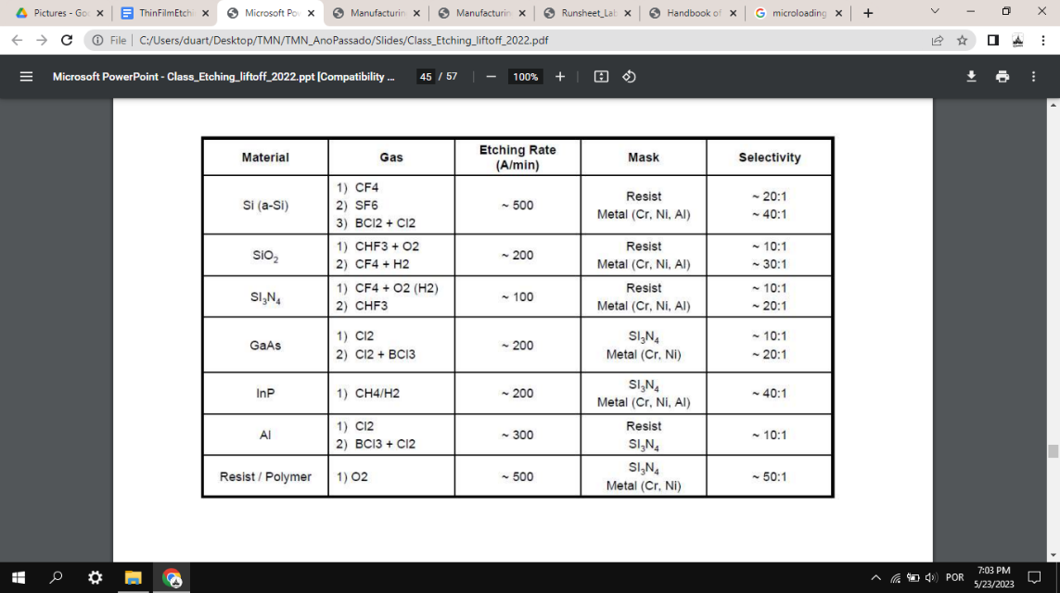

<https://www.seas.upenn.edu/~nanosop/documents/Etchratesformicromachiningprocessing.pdf>

**3.4. Compare chemical and physical etching processes.**

 Physical etching relies on the momentum transfer from particles hitting and eroding the surface. In physical etching, ion etching or sputtering, and ion-beam milling, argon or other inert ions extracted from the glow discharge region are accelerated in an electrical field toward the substrate, where etching is purely impact controlled. The method is slow compared with other dry etching means, with etch rates limited to several hundreds of angstroms per minute compared with thousands of angstroms per minute, and higher for chemical and ion-assisted etching. Chemical etching relies on chemical reactions that yield products that are either soluble in the etch solution or volatile at low pressures. Chemical etching reactions are fast and efficient compared with mechanical etching, where atoms are ejected by mechanical force.

DEPOSITION QUIZZ

**1. SPUTTERING**

**1.1. Describe the process of (i) sputtering of the target and (ii) deposition of materials within the vacuum chamber.**

The plasma (emits light) consists of argon ions Ar+ that accelerate towards the target (very high velocity) and free electrons. The ions are attracted towards the negatively charged target and physically knock off atoms of the target material’s surface - sputtering - which fly off in all directions, including towards the substrate we want to coat and become the thin film. This process continues (layer by layer) until the substrate is coated with the desired thickness. Then, the voltage on the target is turned off and the sputtering stops. In the sputtering process, when an accelerated ion hits the surface atoms, the collision cascade leads to heating of the target and some back-reflected atoms which can leave the surface. The details of these collision cascades basically depend on the relative masses of projectile and target atoms. The threshold energy for sputtering is much higher than the surface binding energy (Wb) of the atoms, since several collisions are needed in order to obtain an atom in the backward direction. To improve the ionization rate, magnetic fields are used to force the electron into helical paths close to the cathode and yield a much higher ionization probability.

Sputtering with a transverse magnetic field produces several important modifications of the basic processes. Target-generated secondary electrons do not bombard substrates because they are trapped in cycloidal trajectories near the target, and thus do not contribute to increased substrate temperature and radiation damage. This allows the use of substrates that are temperature-sensitive (for example, plastic materials) and surface sensitive (for example, metal-oxides-semiconductor devices) with minimal adverse effects. In addition, this class of sputtering sources produces higher deposition rates than conventional source.

**Prepare a schematic drawing and upload it below / use schematic drawings**

**1.2. Upload the schematic drawing here:**

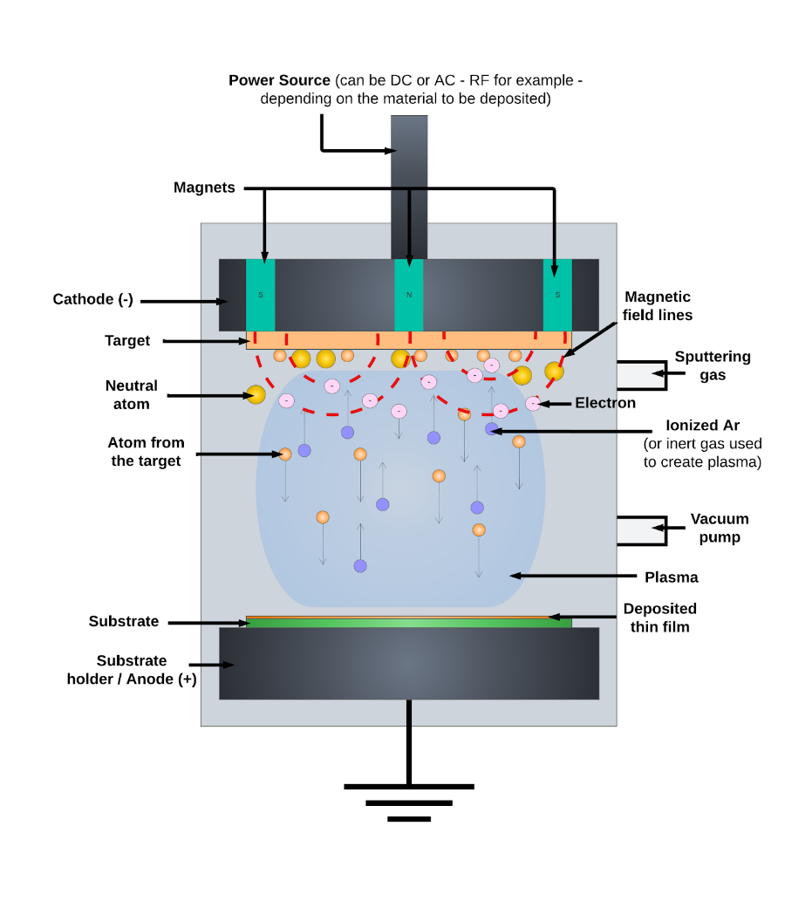

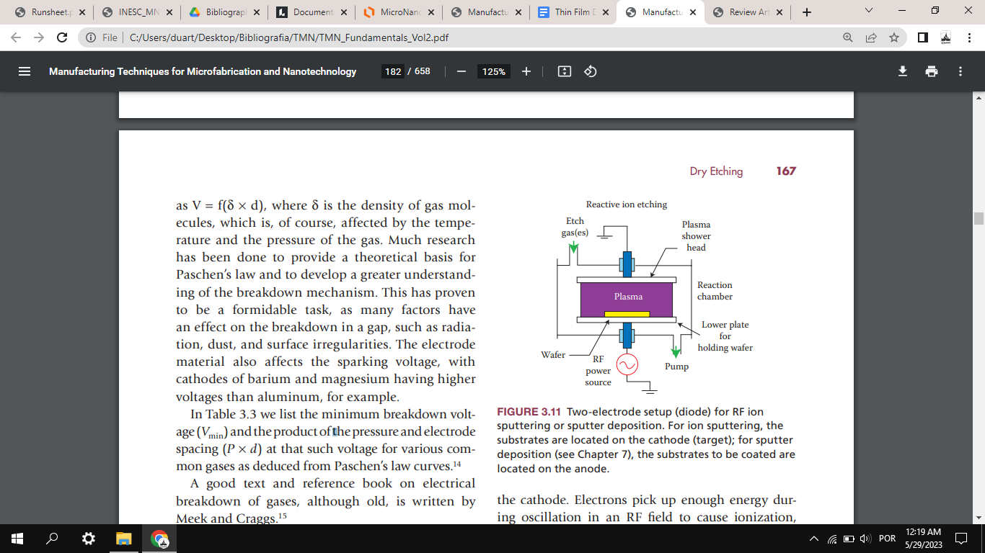**1.3. Describe shortly how the plasma is obtained.**

After the target/source and the substrate are loaded, vacuum pumps evacuate the chamber. Air is continuously removed by the pumps, leaving (nearly) no reactive gasses inside. Then, a small amount of (usually) argon gas is leaked. A high negative electrical voltage is then applied to the target with a power supply - starting at low power and slowly raising it to avoid heating the target too quickly. This high voltage is strong enough to strip an electron from the argon atom; they become ionized and each one has a positive charge (stretching the plasma). The voltage is applied across two parallel plates; the cathode target is generally cooled because the sputtering generates heat. The plasma is created with a DC power source (preferred for metals) or radio frequency (RF) power source (for dielectrics). The plasma (emits light) consists of argon ions Ar+ that accelerate towards the target (at very high velocity) and free electrons. It might be concentrated along a magnetic field created by magnetic arrays. In magnetron sputtering, a magnetic field parallel to the wafer (perpendicular to an electric field) is applied; electrons will spiral around the magnetic field, the increased path length means more ionization (because there is a higher probability of slamming into an argon atom), resulting in high density plasma.

**4. GENERAL QUESTIONS**

**4.1. Enumerate the targets in use in the machine/What are the targets present inside the machine?**

The first machine we used was the UHV2 (Ultra High Vacuum 2) where Al2O3 was deposited and this was the only target present in the machine. For a second deposition, the N7000 (Nordiko 7000) system was used, which only contains 2 targets (which were used in our process) - AlSiCu and TiW(N2) targets.

**4.2. Enumerate key vacuum components of the deposition machine. Comment on the importance of vacuum for this process**

Key components of the deposition machine (UHV2 and Nordiko 7000, for instance), include:

1) Vacuum pumps - mechanical pump; turbomolecular and/or cryogenic pump; a mechanical pump should always be present in each module (chamber, loadlock) of a vacuum system. In order to go from atmospheric pressure to ultra-high vacuum (UHV), these different types of pumps are used.

2) Pressure sensors - Pirani, Penning and Bayard-Alpert gauges, which allow measuring different ranges of pressure inside the loadlock and chambers in the vacuum system.

3) Transfer module with dealer (for instance, in Nordiko 7000), in case there is more than one chamber - as opposed to UHV2, where there is only one chamber. This is used to transfer the sample between different modules of the system.

4) A door in the loadlock (or chamber, in case of UHV2) to insert and remove the sample manually (in a sample holder/cassette).

5) Roughing valve between the mechanical and turbomolecular pump, since it is first necessary to pump the system using a mechanical pump (rough pump), after which it supports the turbomolecular pump - which cannot work by itself.

6) Gas line and gas valve, in order to insert the gas used in the sputtering process (Argon in UHV2, for instance).

7) Vent valves, used to perform venting in the different chambers of the vacuum system. 8) Other valves - for instance, connected to cryo pumps.

The vacuum inside the chamber is a key factor in sputtering, having mainly two effects. The deposition rate will mostly be a function of the sputtering rate, which is a function of how much argon is there. However, pressure also affects the mean free path. With an argon pressure at ~0.1Torr, the resulting mean-free path is λ~0.5mm, much smaller than the distance between the target and wafer, thus there will be many collisions of the sputtered material as it travels to the wafer. At higher gas pressure, the ions can collide with the gas atoms and diffuse into the substrate or chamber wall and condense after moving inside it to a certain depth. Sputter deposition at higher argon pressures results in a significant loss of deposition rate due to gas scattering and back diffusion of sputtered atoms. The mean-free path of an atom is inversely proportional to the pressure. Contaminations are also reduced by the existence of vacuum within the chamber leading to cleaner surfaces deposited.

**4.3. Compare the base pressure with the pressure during deposition. Explain.**

When it comes to the UHV2, the base pressure is 4.7x10^-7Torr. The biggest increase in pressure comes from the addition of the Argon in the chamber, in our case with a flux of 45sccm, which leads to a pressure inside the chamber of 2.8x10^-3Torr, since we are adding particles to the inside of the chamber. In the case of N7000, the several modules are at different pressures, but all above 10^-6Torr, before starting the process. Similarly to what happened in UHV2, as the inert gas is pumped into the chambers, the pressure increases to around 3x10^-3Torr. This pressure is maintained during the deposition process.

**4.4. Explain if photoresist could be used in the sample deposited.**

In the case of UHV2 and N7000 (Nordiko 7000), photoresist can be used in the deposited sample, just like it was used in our particular sample (for later lift-off processes). This can be done since in the UHV2 and N7000 machines the substrate does not reach very high temperatures, such as, for instance, in the PECVD machines (usually over 200ºC). Temperature is the main problem when depositing with a photoresist on the sample, since high temperature can burn the photoresist and prevent a lift-off process from being performed.

**4.5. Compare PECVD, Ion beam deposition and magnetron sputtering, in terms of: deposition temperature, deposition rate, stoichiometry control and film quality.**

In magnetron sputtering, the temperature of deposition can vary widely depending on the machine, being able to range from around 50ºC to thousands of degrees. Even though it can be dependent on type of material (metal or dielectric), this process has, as a norm, a low deposition rate compared to PECVD. In magnetron sputtering, different sputtering yields are observed for different target atoms. However, there is generally a good self-regulating mechanism and sputtering quite generally allows the deposition of films with the same stoichiometry as the target. On the other hand, the film quality can be affected by the substrate and/or underlayer interface quality. No metal is 100% pure, thus impurities in the targets will also be sputtered and incorporated into the thin film, which is undesirable. Impurities can negatively influence the thin film properties, such as the electrical connectivity. Only highly pure sputtering targets can ensure high-quality thin films. The vacuum chamber should be left under vacuum when not in use to keep it as clean as possible.

Regarding PECVD, temperatures are usually always superior to 200ºC (which compromises the presence of photoresist in the sample). Usually has higher deposition rates than the other deposition techniques. However, it is difficult to achieve uniformity. Evaporation techniques usually lead to better purity, especially when no gas is included, and since a very high vacuum is used. It allows little to no control of stoichiometry.

Finally, ion beam deposition has a low deposition rate compared to PECVD. This process can be done at low temperatures - even at room temperature. In some cases, the temperature of the substrate is controlled to a few hundred degrees, however. In general, it allows for very high quality films. Ion beam sputtering of chemical compounds is in general nonstoichiometric, due to undesirable ionic emission (high influence of target charging).

