**Custos**

**PTRobotics**

* X1 Painel solar – Solar Cell 12V 250mA - <https://www.ptrobotics.com/solar/5358-solar-cell-12v-250ma.html>

16.05 €

Envio: 4.67 €

Total: **20.72 €**

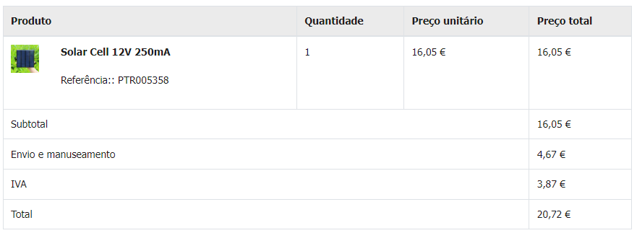

**Bootnroll**

* Servo MG996R 180º 11kg/cm - <https://www.botnroll.com/pt/servos/3168-servo-mg996r-180-11kg-cm.html>

2x 8.90€

* Protoboard Face Simples 70X90MM - <https://www.botnroll.com/pt/pcbs/4537-placa-circuito-impresso-perfurada-face-simples-70x90mm.html>

2x 1.20€

* LDR 5528 VT90N2 5MM - 10K~20K OHM – <https://www.botnroll.com/pt/luz-imagem/3617-vt90n2-ldr-1k-5mm-sensor-de-luz.html>

4x 0.40€

* Resistência 10K 1/4W - <https://www.botnroll.com/pt/resistencias/179-resistencia-10k.html>

7x 0.05€

* STEP-DOWN REGULÁVEL LM2596 10W - <https://www.botnroll.com/pt/conversores-dcdc/937-lm2596-step-down.html>

2x 3.90€

* Conjunto de 10 Cabos Jumper M/M 30cm – <https://www.botnroll.com/pt/jumpers/1083-jumper-wires-premium-12-mm-pack-of-10.html>

2.50€

* BATERIA NI-MH 12V 800MAH AA - BNRA - <https://www.botnroll.com/pt/3-bot-n-roll-one-c/1003-bateria-12v-ni-mh-aa-800mah-wwwbotnrollcom.html>

17.90€

* BOTÃO DE PRESSÃO SPST-NO 1A/250VAC - <https://www.botnroll.com/pt/interruptores-botoes/3154-bot-o-de-press-o-spst-no-1a-250vac-preto.html>

0.50€

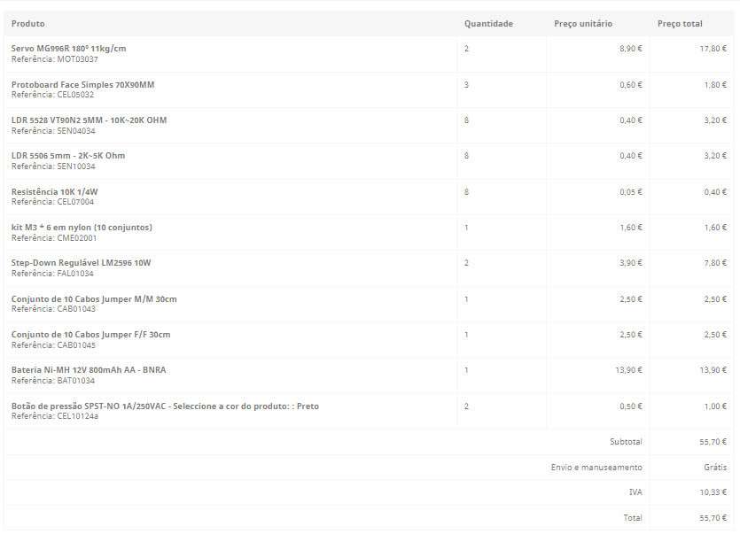

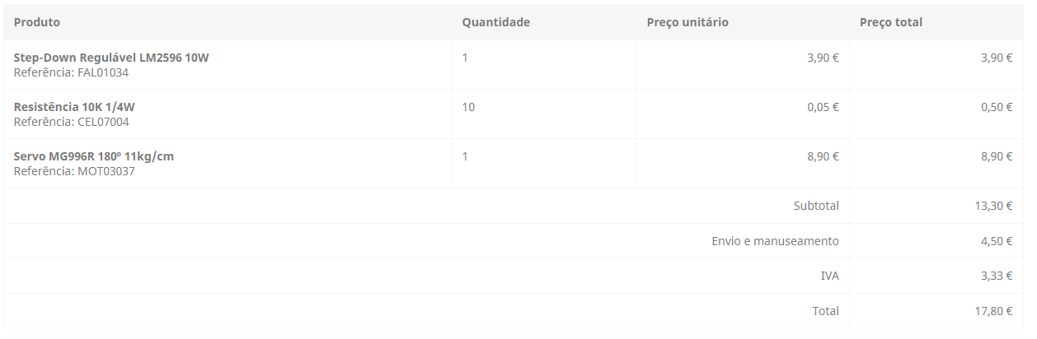

Total:

2 servos + 2 protoboards + 4 LDR 5528 + 7 resistências + 2 step-downs + jumper wires M/M + bateria + botão de pressão =

= 17.80€ + 1.20€ + 1.60€ + 0.40€ + 7.80€ + 2.50€ + 13.90€ + 0.50€ = **45.70€**

**Electrofun**

* Mini Voltímetro Digital LED Vermelho - <https://www.electrofun.pt/display/mini-voltimetro-digital>

5.35€

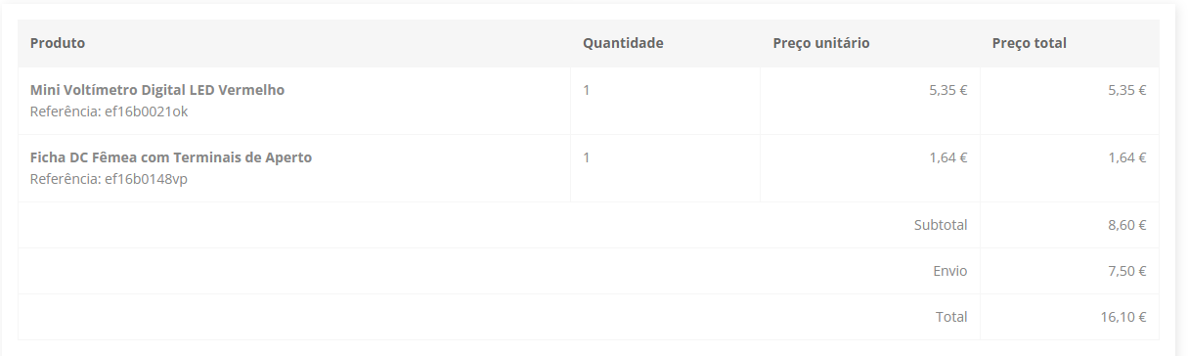

Total: **5.35€**

**Mixtrónica**

* Interruptor Basculante 1 Circuito ON/OFF Preto 15A 250V - <https://mixtronica.com/basculante-interruptores/22642-interruptor-basculante-1-circuito-onoff-preto-15a-250v.html>

1.82€

* Interruptor Pressão 2 Posições Unipolar Redondo ON-OFF - <https://mixtronica.com/pressao-interruptores/11479-interruptor-pressao-2-posicoes-unipolar-redondo-on-off.html>

0.86€

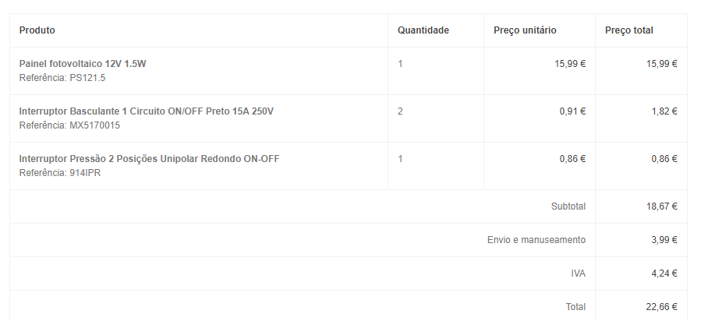

Total: 1.82€ + 0.86€ = **2.68€**

**Mauser**

* Ficha DC fêmea 5.5x2.1mm + Bloco Terminal 2pin c/ parafusos - 2 peças - <https://mauser.pt/catalog/product_info.php?cPath=1874_640_387_1153&products_id=011-3175>

0.80€

|  |  |
| --- | --- |
| |  | | --- | |  | |

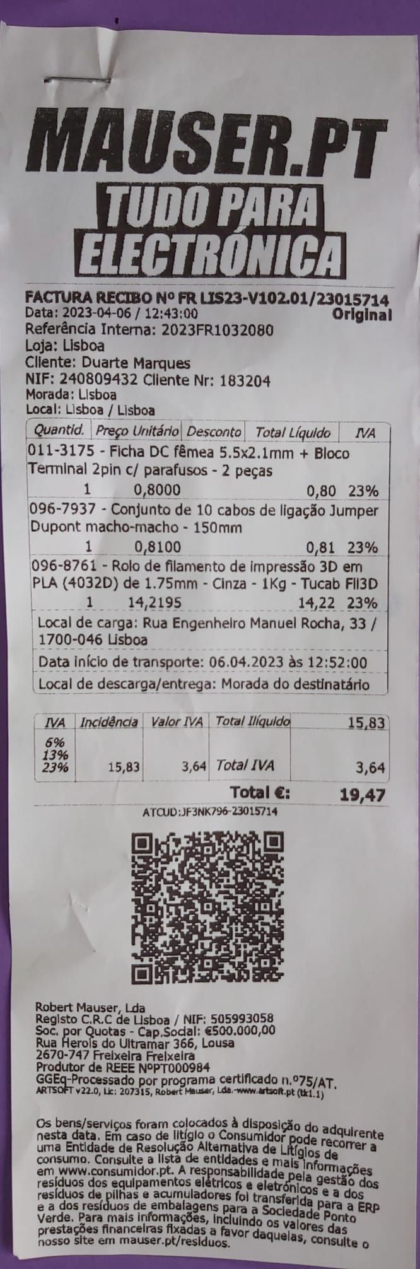

* Ficha DC macho 5.5x2.1x10mm c/ parafusos - <https://mauser.pt/catalog/product_info.php?cPath=735_751_2905_754&products_id=011-0678>

0.92€ (não tenho foto da conta)

Total = 0.80€ + 0.92€ = **1.72€**

**Total = 20.72 € + 45.70€ + 5.35€ + 2.68 € + 1.72€ = 76.17€ -> 38.09€ por pessoa**