**INTRODUCTION**

Antimicrobial resistance (AMR) is currently one of the biggest global health problems and is anticipated to cause approximately 10 million deaths by 2050, if antibiotic abuse continues at the same rate.

Type of AMR in bacteria:

* Intrinsic AMR - the outer layer of the bacteria is complex naturally (a thick extracellular matrix), which makes the bacteria less permeable to antibiotics.
* Acquired AMR - bacteria acquire resistance genes either from another bacterium or through mutation in chromosomal genes

Some bacteria have some **antimicrobial resistance** (AMR), others are **multidrug resistant** (MDR) and **extremely drug-resistant** (XDR).

Total antibiotic consumption has exceeded 4.5 trillion doses in 2020, an ill-effect as such will only increase the overall resistance globally while making the situation uncontrollable if not addressed immediately.

Conventional and molecular methods (**Classic Methods**) for detection of AMR have certain shortcomings that make them difficult to use in remote areas and low income populations:

* Sample preparation adds to the turn-around time (TAT) from 24 to 72 h.
* The cost of analysis is high, because of sophisticated infrastructure and skilled personnel.
* The delayed time of detection, leads to higher mortality and morbidity rates.

Nanotechnology has emerged as an appealing and powerful platform for developing more sensitive, rapid, and affordable AMR diagnostics tools.

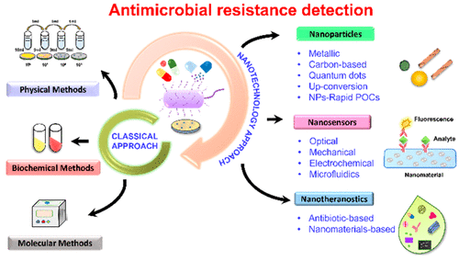

**CLASSICAL APPROACHES FOR AMR DIAGNOSIS**

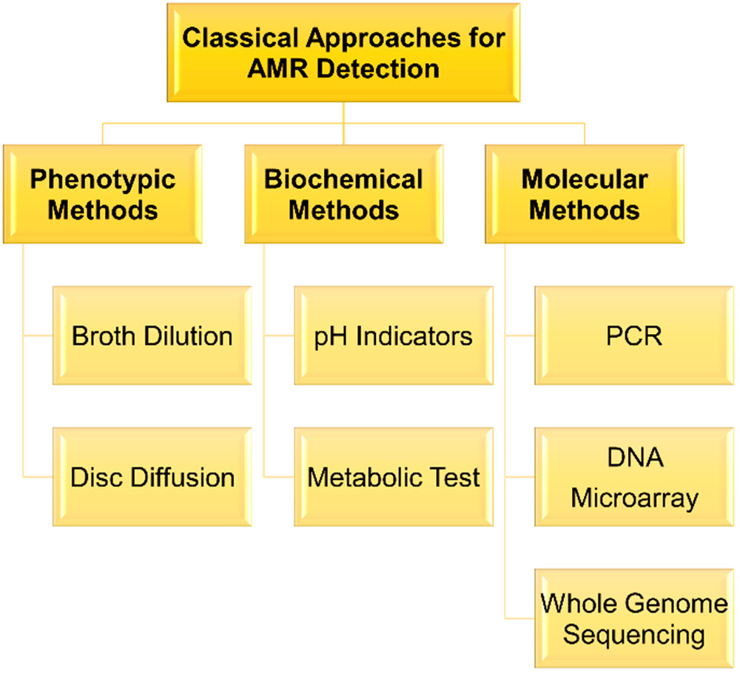

**1 - Phenotypic Methods**

Microbiological culture-based techniques are among the most popular phenotypic methods frequently practiced for bacterial diagnostics:

**1.1 - Broth Dilution**

Broth dilution is a technique in which containers holding identical volumes of broth with antimicrobial solution in incrementally increasing concentrations are inoculated with a known number of bacteria.

With this dilution, the minimum inhibitory concentration (MIC) gives a quantitative result for an antimicrobial resistance of the culture. This concentration is in the range of predefined globally accepted breakpoint values based on clinical breakpoints or epidemiological cut-offs.

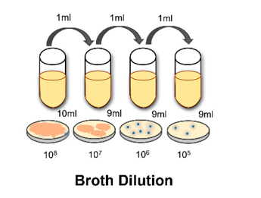

**1.2 - Disc Diffusion**

This method is mostly usually used to perform susceptibility tests (ASTs): the isolated bacteria from a patient sample are classified as either “S”, susceptible, “I”, intermediate, or “R”, resistant.

The AST consists of adding the microbial culture in a disc with a specific antimicrobial solution (Broth Dilution), and the zone of inhibition created is measured. These measures are compared to breakpoint measurements set by organizations like the Clinical and Laboratory Standards Institute (CLSI) and European Committee on antimicrobial susceptibility testing (EUCAST) based on the resistance trends observed in the preceding years.

These tests are directed toward identifying MDR pathogens like methicillin-resistant S. aureus (MRSA), extended spectrum β-lactamase (ESBL) expressing organisms, and carbapenem resistant strains.

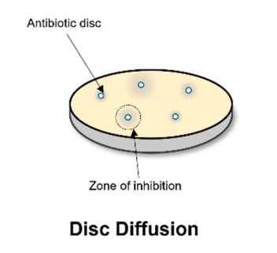

**2 - Biochemical Methods**

The use of biochemical reactions, pH indicators, and antimicrobials to identify a pathogen is a primary step for AMR detection in conventional methods.

**pH Indicators & Metabolic Tests**

For the purpose of identifying the pathogens in a sample, panels of biochemical tests are employed, like sugars for acid production (via oxidation or fermentation) detected using a pH indicator.

In general, these tests are performed by automated systems that can achieve bacterial identification within 8−12 h, including ASTs after only 24 h, and require purified culture.

The AST is based on the broth dilution assay through an optical detection system that detects bacterial growth in the presence of antibiotics over 24 h.

A large quantity of viable cells is required to measure the bacterial growth and turbidity changes, thus reducing the sensitivity of the test.

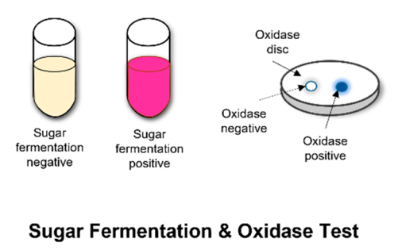

**3 - Molecular Diagnostic Methods**

These methods are used to detect and/or identify the presence or absence of AMR genes.

**3.1 - Polymerase Chain Reaction (PCR) - Based Diagnosis**

PCR-based methods are commonly used to detect the presence of AMR genes in a bacterial isolate.

PCR screening is usually performed to confirm the presence of *vanA* (encoding vancomycin resistance), *mecA* (encoding methicillin resistance), *ampC* (encoding ampicillin resistance), and various genes of *extended-spectrum β-lactamase* (ESBL).

Multiplex PCR refers to the use of polymerase chain reaction to amplify several different DNA sequences simultaneously (as if performing many separate PCR reactions all together in one reaction).

Multiplex PCR for detecting AMR genes is a widely used strategy to detect multiple genes and confirm the presence of a pathogen, antibiotic resistance, and MDR in samples

This process amplifies DNA in samples using multiple primers and a temperature mediated DNA polymerase in a thermal cycler. The primer design for all primer pairs has to be optimized so that all primer pairs can work at the same annealing temperature during PCR.

Loop-mediated isothermal amplification (LAMP) assays have been developed for the detection of genes encoding resistance to first-line or last-resort antibiotics.

LAMP assays for *ESBL* genes, *ampC* genes, and *carbapenemases* in bacteria are generally used due to their rapidity and ease of performance at a single constant temperature.

The new age of PCR is directed toward **an integrated microfluidic device** to replace traditional protocols, which is miniaturized, automatic, reagent-preloaded, commercializable, high-throughput, environment-independent, and disposable and is expected to be accurate, rapid, low-cost and useful in both developed and developing countries.

* An **integrated device for ultrafast photonic PCR** based on photothermal materials, which enhance the extraction, amplification, and detection capabilities for various genes for point-of-care testing (POCT) and detection of infectious disease and diagnosis.
* Development of **nano-PCR** that relies on plasmon driven nano localized thermocycling around gold nanorods (AuNRs) allows significantly reduced reaction volume and rapid temperature response.

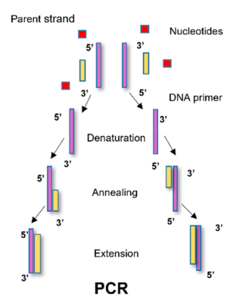

**3.2 - DNA Microarrays**

DNA microarrays are tools to assess genomic diversity by detecting the presence or absence of genes in a test organism as compared to a reference strain.

Comparative genomic hybridizations are done between fluorescently labeled test and reference genes to understand the genomic diversity.

Identibac microarray, for example, determines the presence of AMR genes in both aerobic and anaerobic Gram-negative bacteria (are bacteria that do not retain the crystal violet stain used in the Gram staining method of bacterial differentiation - more complex outer cell wall).

There are also arrays in which AMR genes associated with both Gram-positive and Gram-negative bacteria can be detected.

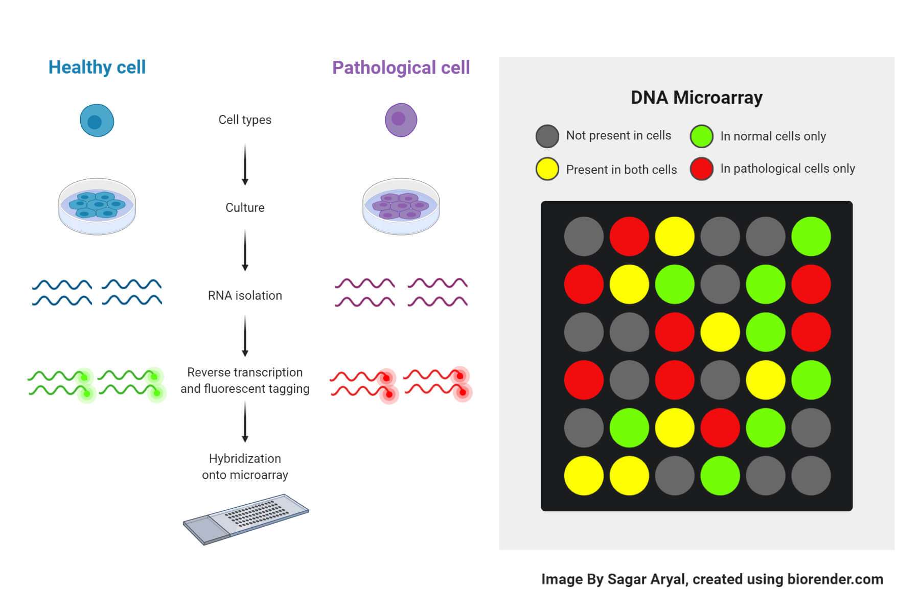

**3.3 - Whole Genome Sequencing (WGS)**

Whole genome sequencing helps to identify pathogens and profile resistance genes.

The standard technique, that is, Sanger’s dideoxy method, relies on the replication of a short DNA target sequence, using *32P-labeled dideoxynucleotide triphosphates*.

Further evolved techniques, such as reversible termination, pyrosequencing, and sequencing by ligation generate parallel sequences.

Detection of the analytes is based on fluorescence, label-free electronic (e.g., change of pH or translocation of the analyte through nanopores), or atomic signals.

WGS can analyze the entire genome for the presence of mobile genetic elements or point mutations known to confer resistance and help to elucidate mechanisms of resistance. For example, *carbapenem* resistance occurs due to *carbapenemase* reaction or by some other mechanisms.

WGS analysis of MRSA, *vancomycin-resistant enterococci* (VRE), MDR *E. coli*, and MDR *P. aeruginosa* species from clinical isolates detected identical resistance patterns to those predicted by the susceptibility profiles.

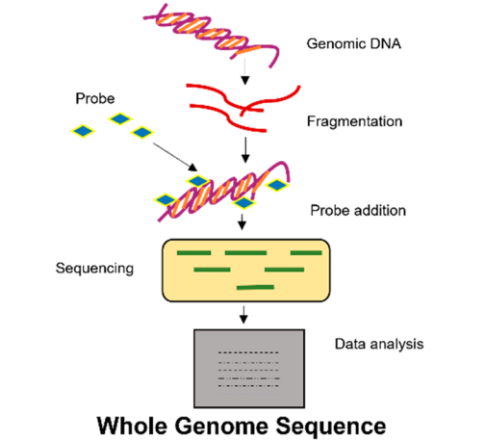

**OBSERVATIONS**

While the classical approaches offer a systematic scheme for diagnosing AMR pathogens, certain factors still limit their widespread applications. For example:

* The phenotypic methods face the challenge of strain diversity within a taxon.
* In the case of molecular methods, results often vary based on the quality of sequences, design of primers and probes, and databases.

Most of these recently emerging techniques are known for their commercial usage across countries. But major goals are still not achieved as these require sophisticated instruments and extensive laboratory resources.

Popular commercial products are based on biochemical analysis or genetic amplification with high TAT(turn-around time) and cost involved.

Most such products are available in tertiary care hospitals or advanced laboratories in urban settings. While infections in rural areas of low and middle-income countries still do not get assessed through such instruments to provide reliable information on antimicrobial resistance.

Due to these challenges with current methods of AMR detection, there is a need for a better approach that can detect AMR rapidly with higher sensitivity and specificity and evaluation directly from the sample.

For this purpose, various advances in nanotechnology-inspired approaches have been extensively explored, aiding in reliable detection of AMR.