**CA266 - Probability & Statistics Assignment**

**Student ID: 20410974**

**Information about the system:**

reliability_probabilities <- c(.97, .68, .89, .93)

num_of_components_in_parallel <- c(1, 5, 3, 2)

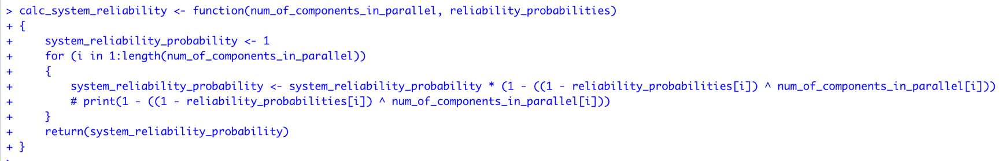**Part A**

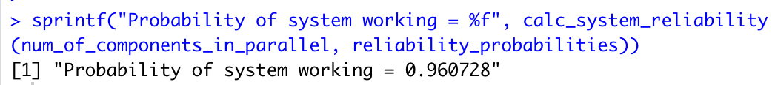**Result**

**Part B**



**Part C**

