**Dash Numbered Parts List – Suggested Workflow**

Josh Tschirhart - [joshuat@jlab.org](mailto:joshuat@jlab.org) – x6653

**Suggested Assembly File Structure / Naming:**

* Assembly (JL00xxxxx) -- Special “parent” assembly file.
  + Dashed Assembly -01 (JL00xxxxx-01)
  + Dashed Assembly -02 (JL00xxxxx-02)
  + Dashed Assembly -03 (JL00xxxxx-03)

1. **Create drawing from special parent assembly file.**
2. **Modify ‘Edit Levels’ settings as needed (or can be done later).**
3. **Delete the current Parts List.**

* Note: If not currently displayed, use **CTRL-L** Layer Settings to make Parts List layer #252 visible in order to delete.

1. **Import Part (*DASH-PARTS-LIST* template):**

* Uncheck ‘Create Named Group’
* Set Layer to ‘Original’
* Select Part from ‘Teamcenter’
* Search for [ **DASH-PARTS-LIST** ] or simply [ **DASH\*** ] / Okay.
* Click *OKAY* once to place, then *Cancel*.

1. **Delete any unneeded QTY columns and drag parts list to reposition.**
2. **Set each QTY column to the appropriate Dashed Subassembly:**

* Select column (hover near top or bottom of column and right-click).
* **Settings > Column >** check ***‘Include Nested Assemblies’***
* Click **‘*Select Parent Component’*** and click dashed assembly [-01,-02,-03] in Assembly Navigator to select.

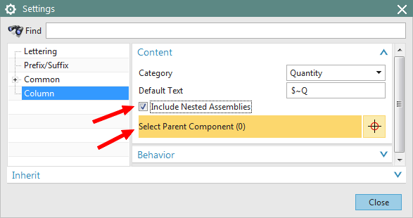

*NOTE: Formatting of the cell text will revert to pre-set styles and will need to be updated.*

*When selecting cells to reformat the style settings,* ***select single or multiple cells ONLY (modifying any settings of a selected column will undo the Nested Assembly selection).***

1. **Format cells *IF borders are invisible (typical when adding columns).***

* Select multiple cells (*NOT column*) / Right-click / **Settings > Common > Cell > Border**
* Set to **Green** and **Solid**.

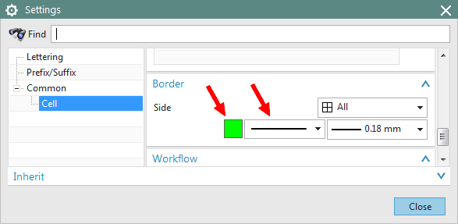

1. **Format cells containing dash numbers [-01,-02…]**

* Select multiple cells / Right-click / **Settings > Common > Cell > Category > *Text***

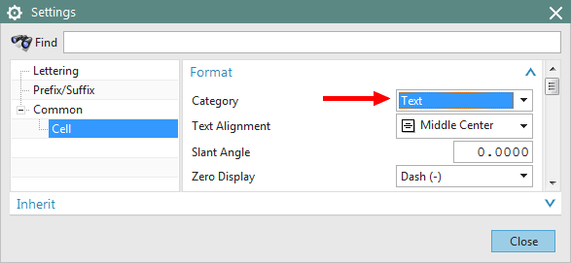

1. **Format cells with ‘QTY REQD’ text:**

* Select multiple cells / Right-click / **Settings > Common > Cell > Inherit > Settings Source > Selected Object**
* Click any nearby header cell containing small **red text** (e.g. ITEM NO., etc.).

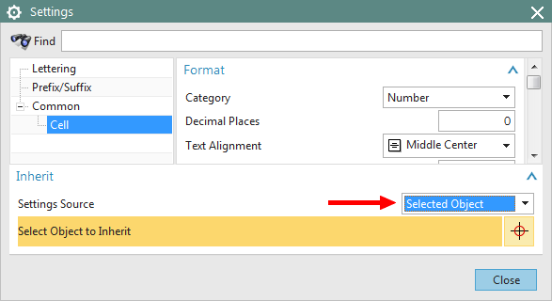

**Dash Numbered Parts List Examples** (Note the automatically generated **X** and **–** characters):

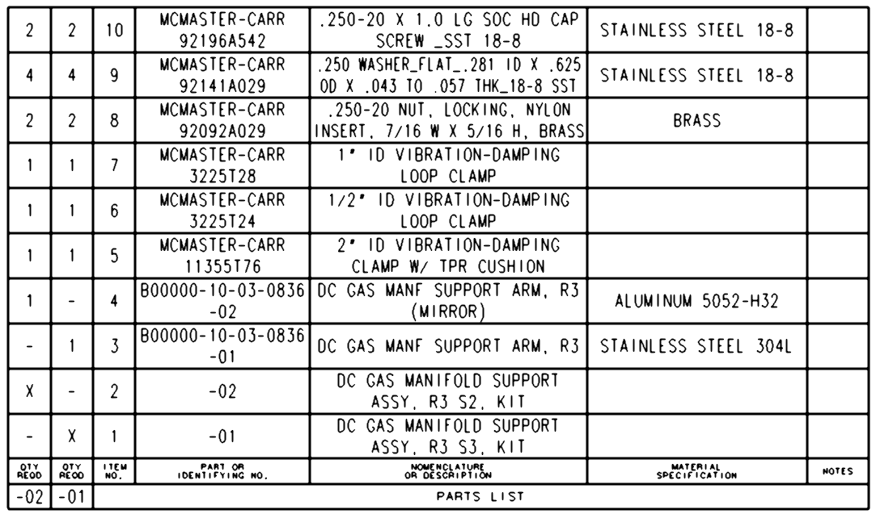

Example Parts List with Dashed Subassemblies included in list.

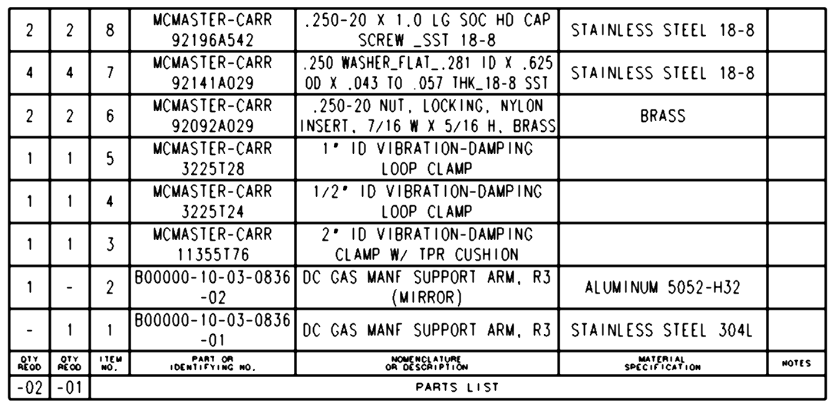

Example Parts List with Dashed Subassemblies not included in list.