**MULTIPLE PARTS LISTS ON A SINGLE DRAWING**

**Setting the Variable in Windows:**

1. Right-click Computer > Properties > Advanced System Settings > Environment Variables
2. Scroll down through list of system variables for *UGII_UPDATE_ALL_ID_SYMBOLS_WITH_PLIST*
3. Edit > Change variable from 1 to 0.

**Creating Additional Parts Lists:**

1. Start (or close/restart) NX after changing the variable to zero.
2. Copy/Paste existing parts list from Sheet 1 to a subsequent sheet(s) *OR* create new list(s) on subsequent sheet(s).

**Home > Parts List**

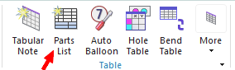

1. After creating the new parts list(s) and saving the file, **set the Windows ‘UGII_UPDATE…’ variable back to 1**, and restart NX (this enables Update Parts List command to update the balloon numbers).

**Important Notes:**

1. **Parts Lists are Independent from one another,** whether on the same or different sheets. The Edit Levels settings must be done for each list, and the numbering system starts over at '1' for each parts list by default (you will need to *manually change the starting number* on subsequent parts lists).

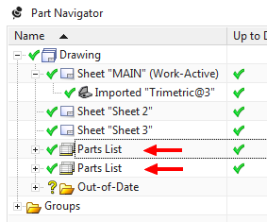

1. **Balloons are tied to ALL parts lists where the Part is listed as an Item.**  If an item appears in more than one parts list, the most recent ‘Update’ operation performed will determine the item number in ALL balloons for that particular item. Therefore:

* **Items should generally only appear within a parts list only ONCE across an entire drawing to prevent competing item numbers** (*unless* the parts lists are intended to be *exact duplicates* of each other and thus have identical item numbers).
* **Parent and Child assemblies/components should NOT be ballooned in the same drawing**. This causes competing item numbers (whichever parts list instance was most recently updated will drive the numbers displayed in the balloons, whether parent or child).