**‘SAVE AS’ OPERATION ON NX 9 PARTS IN TEAMCENTER 11 (NX 12 FORMAT)**

**Highlight Item in Teamcenter > File > Save As**

**Page 1: Assign or Enter a new part number, then click <Next>.**

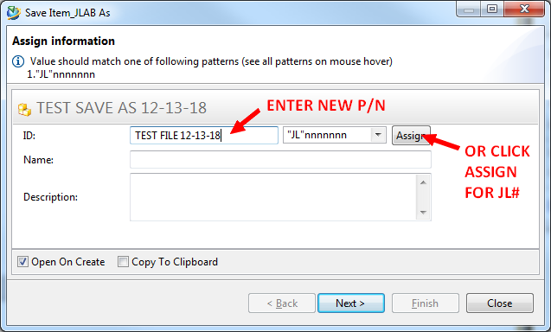

**Page 2: *No changes required* (SKIP THIS PAGE). Click <Next>.**

**Page 3: Edit revision info (expand second line and enter a Revision). *See additional steps below.***

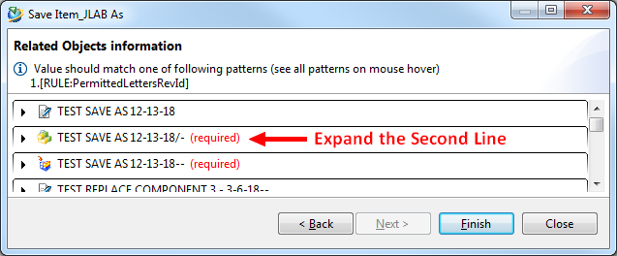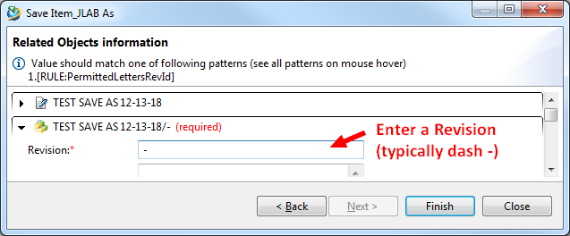

**Page 3: *Additional procedure for some NX 9 objects (NOTE: This is only needed if Project ID/System/Subsystem info had not been assigned in NX 9).***

**Collapse the second line, and Expand the top line:**

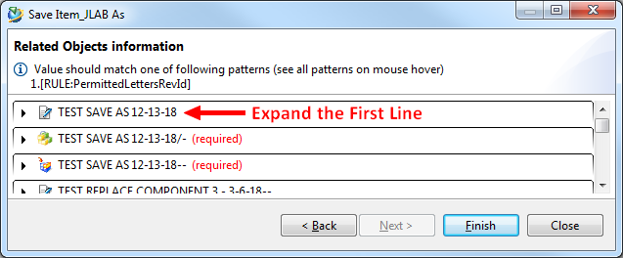

**Highlight and Delete the ProjectID value text “Enter a value”:**

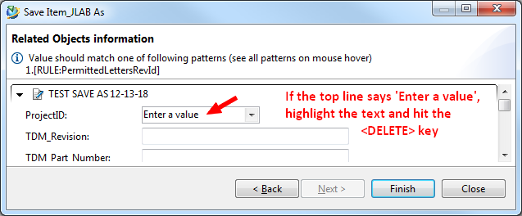

**Click <Finish>.**