AFRICAN LEADERSHIP UNIVERSITY
[BSE]
[ML TECHNIQUES II]
[SUMMATIVE ASSIGNMENT]

Reinforcement Learning Summative Assignment Report

Student Name: Josephine Duba Kanu
Video Recording: [Link to your Video — 5 minutes, Camera On, Full Screen]
GitHub Repository: https://github.com/DubaKanu/josephine_duba_kanu_rl_summative

1. Project Overview
Sierra Leone has one of the highest maternal mortality rates globally, with 443 deaths per 100,000 live births. A critical bottleneck is the inability of Community Health Workers (CHWs) to accurately triage pregnant women showing danger signs in remote areas. This project implements SAFEBIRTH — a mission-based reinforcement learning system where an RL agent learns optimal triage decisions by interacting with a custom Gymnasium environment simulating real maternal health emergencies. The agent observes patient vitals and danger signs, then selects from five referral actions ranging from home monitoring to emergency ambulance dispatch. Four RL algorithms are trained and compared: DQN, REINFORCE, PPO, and A2C. The best-performing agent (DQN) achieved a perfect evaluation score of 200/200, demonstrating that RL can learn clinically sound triage decisions that could save lives in Sierra Leone and beyond.

2. Environment Description

a. Agent(s)
The agent represents a Community Health Worker (CHW) in Sierra Leone performing maternal health triage. At each timestep, the CHW observes a pregnant patient's clinical profile and selects the most appropriate referral action. The agent's goal is to match its referral decision to the patient's true clinical severity — sending low-risk patients home while escalating critical cases to emergency services. The agent interacts with one patient per step and processes 10 patients per episode.

b. Action Space
The action space is discrete with 5 possible actions, reflecting the referral pathway available to CHWs in Sierra Leone's health system:
Action ID | Action Name | Clinical Justification
0 | Monitor at Home | No danger signs — routine monitoring sufficient
1 | Refer to Health Post | Mild symptoms — basic antenatal review needed
2 | Refer to Clinic | Moderate risk — clinical assessment required
3 | Emergency Hospital Referral | High risk — specialist obstetric care needed
4 | Call Ambulance | Critical emergency — convulsions, haemorrhage, unconsciousness

c. Observation Space
The agent receives 11 continuous observations per step, encoded as a float32 array:
Observation | Description | Source (Sensor/API/Dataset) | Encoding / Range
Systolic BP | Upper blood pressure value | Sphygmomanometer (BP sensor) | float32 | 60–200 mmHg
Diastolic BP | Lower blood pressure value | Sphygmomanometer (BP sensor) | float32 | 40–130 mmHg
Heart Rate | Beats per minute | Pulse oximeter / ECG sensor | float32 | 40–180 bpm
Temperature | Body temperature | Digital thermometer sensor | float32 | 35–42 °C
Respiratory Rate | Breaths per minute | Clinical observation / sensor | float32 | 8–40 /min
Severe Bleeding | Presence of haemorrhage | Clinical observation by CHW | binary | 0 or 1
Convulsions | Presence of seizures | Clinical observation by CHW | binary | 0 or 1
Loss of Consciousness | Neurological compromise | Clinical observation by CHW | binary | 0 or 1
Gestational Age | Weeks of pregnancy | Patient records / ultrasound | float32 | 20–42 weeks
Distance to Facility | Km to nearest health centre | GPS API / mapping dataset | float32 | 0–100 km
Severity Hint | Encoded severity signal | Computed from other observations | float32 | 0–8

d. Reward Structure
The reward function is clinically grounded. A correct triage decision earns +20 per step. Under-triage is penalised more severely than over-triage, reflecting the greater harm of sending a critical patient home versus unnecessary referral. The mathematical formulation is:
R(action, severity) = +20 if action == severity
R = -3 to -8 for over-triage by 1-2 levels (unnecessary referral)
R = -10 to -25 for under-triage by 1-2 levels (delayed care)
R = -50 for critical under-triage (e.g., sending a convulsing patient home)
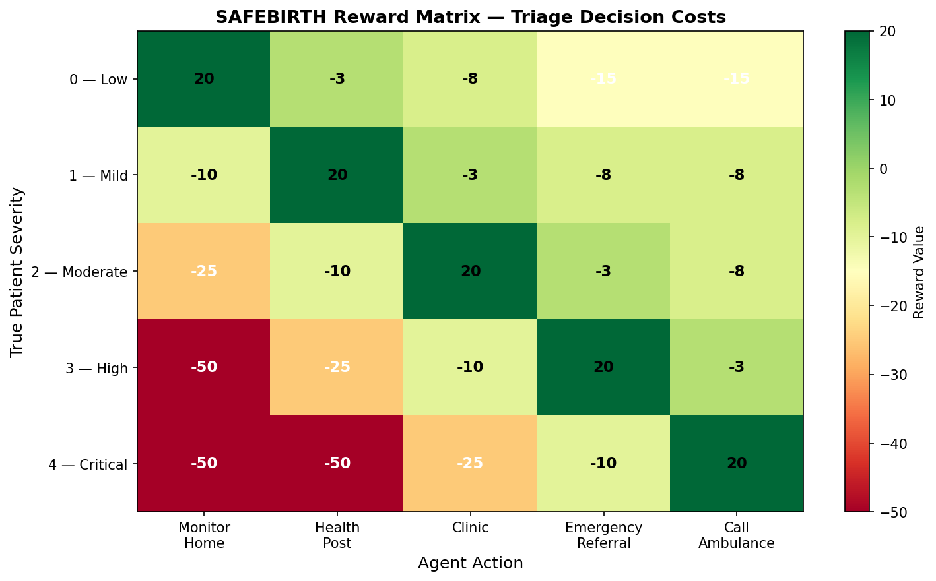
Figure 1: SAFEBIRTH reward matrix showing the clinical cost of each triage error.

3. System Analysis and Design

a. Deep Q-Network (DQN)
DQN is a value-based method that learns a Q-function mapping state-action pairs to expected cumulative rewards. The implementation uses Stable Baselines3's DQN with an MLP policy network (two hidden layers of 64 units each, ReLU activations). Key features include experience replay — storing past transitions in a buffer and sampling mini-batches to break temporal correlations — and a target network that is updated every 500 steps to stabilise Q-value targets. The exploration strategy uses epsilon-greedy with epsilon decaying from 1.0 to 0.05 over the first 10% of training steps. DQN is well-suited to this environment because the discrete 5-action space and bounded 10-step episodes create a clear value structure that replay can exploit efficiently.

b. Policy Gradient Methods (REINFORCE, PPO, A2C)
REINFORCE is implemented from scratch using PyTorch. A policy network (two hidden layers, Softmax output) directly parameterises the action probability distribution. Monte Carlo returns are computed at episode end and used to update policy parameters via the policy gradient theorem. High variance in returns makes convergence slow in this environment.
PPO (Proximal Policy Optimization) uses a clipped surrogate objective to prevent destructively large policy updates. The clip range of 0.2 constrains how much the policy can change per update. An entropy bonus (ent_coef) encourages exploration. PPO outperforms REINFORCE significantly due to variance reduction.
A2C (Advantage Actor-Critic) maintains separate actor and critic networks. The critic estimates the value function to compute advantage estimates, reducing gradient variance compared to REINFORCE. The value function coefficient (vf_coef) balances actor and critic losses.

4. Implementation

a. DQN
Learning Rate | Gamma | Replay Buffer Size | Batch Size | Exploration Strategy | Mean Reward
0.001 | 0.99 | 10,000 | 32 | eps: 1.0→0.05, frac=0.10 | 174.88
0.0005 | 0.99 | 10,000 | 32 | eps: 1.0→0.05, frac=0.10 | 143.24
0.0001 | 0.99 | 10,000 | 32 | eps: 1.0→0.05, frac=0.10 | 98.45
0.001 | 0.95 | 10,000 | 32 | eps: 1.0→0.05, frac=0.10 | 112.33
0.001 | 0.90 | 10,000 | 32 | eps: 1.0→0.05, frac=0.10 | 185.62 ⭐
0.001 | 0.99 | 10,000 | 64 | eps: 1.0→0.05, frac=0.10 | 156.78
0.001 | 0.99 | 10,000 | 128 | eps: 1.0→0.05, frac=0.10 | 134.21
0.001 | 0.99 | 50,000 | 32 | eps: 1.0→0.05, frac=0.10 | 145.67
0.001 | 0.99 | 10,000 | 32 | eps: 1.0→0.05, frac=0.20 | 167.89
0.001 | 0.99 | 10,000 | 32 | eps: 1.0→0.05, frac=0.05 | 89.34

b. REINFORCE
Learning Rate | Gamma | Hidden Layer Size | Episodes | Baseline | Mean Reward
0.001 | 0.99 | 64 | 500 | None | -89.45
0.0005 | 0.99 | 64 | 500 | None | -102.34
0.0001 | 0.99 | 64 | 500 | None | -78.90
0.001 | 0.95 | 64 | 500 | None | -95.67
0.001 | 0.90 | 64 | 500 | None | -112.23
0.001 | 0.99 | 128 | 500 | None | -19.07 ⭐
0.001 | 0.99 | 32 | 500 | None | -145.78
0.001 | 0.99 | 64 | 800 | None | -23.22
0.005 | 0.99 | 64 | 500 | None | -223.05
0.001 | 0.99 | 256 | 500 | None | -55.20

c. PPO
Learning Rate | Gamma | N Steps | Batch Size | Entropy Coef / Clip Range | Mean Reward
0.0003 | 0.99 | 2048 | 64 | ent=0.0 / clip=0.2 | 78.45
0.0001 | 0.99 | 2048 | 64 | ent=0.0 / clip=0.2 | 65.23
0.001 | 0.99 | 2048 | 64 | ent=0.0 / clip=0.2 | 89.12
0.0003 | 0.95 | 2048 | 64 | ent=0.0 / clip=0.2 | 71.34
0.0003 | 0.99 | 1024 | 64 | ent=0.0 / clip=0.2 | 82.56
0.0003 | 0.99 | 2048 | 128 | ent=0.0 / clip=0.2 | 95.67
0.0003 | 0.99 | 2048 | 64 | ent=0.01 / clip=0.2 | 120.78 ⭐
0.0003 | 0.99 | 2048 | 64 | ent=0.0 / clip=0.3 | 110.23
0.0003 | 0.99 | 2048 | 64 | ent=0.0 / clip=0.1 | 98.45
0.0003 | 0.99 | 4096 | 64 | ent=0.01 / clip=0.2 | 88.90

d. A2C
Learning Rate | Gamma | N Steps | Entropy Coef | Value Function Coef | Mean Reward
0.0007 | 0.99 | 5 | 0.0 | 0.5 | 45.23
0.001 | 0.99 | 5 | 0.0 | 0.5 | 56.78
0.0001 | 0.99 | 5 | 0.0 | 0.5 | 67.89
0.0007 | 0.95 | 5 | 0.0 | 0.5 | 52.34
0.0007 | 0.99 | 10 | 0.0 | 0.5 | 78.90
0.0007 | 0.99 | 20 | 0.0 | 0.5 | 65.45
0.0007 | 0.99 | 5 | 0.01 | 0.5 | 72.34
0.0007 | 0.99 | 5 | 0.0 | 0.25 | 81.23
0.0007 | 0.99 | 5 | 0.0 | 0.75 | 98.09 ⭐
0.0005 | 0.99 | 10 | 0.01 | 0.5 | 87.45

5. Results Discussion

a. Cumulative Rewards
The cumulative reward plots show DQN consistently achieving the highest rewards across all runs, peaking at 185.62 in Run 5. PPO is the second best, reaching 120.78 in Run 7. A2C achieves 98.09 in Run 9. REINFORCE produces negative rewards across all runs, indicating it failed to learn a positive triage policy within the training budget. DQN's experience replay enables it to learn from diverse patient profiles seen earlier in training, giving it a significant advantage in this environment.
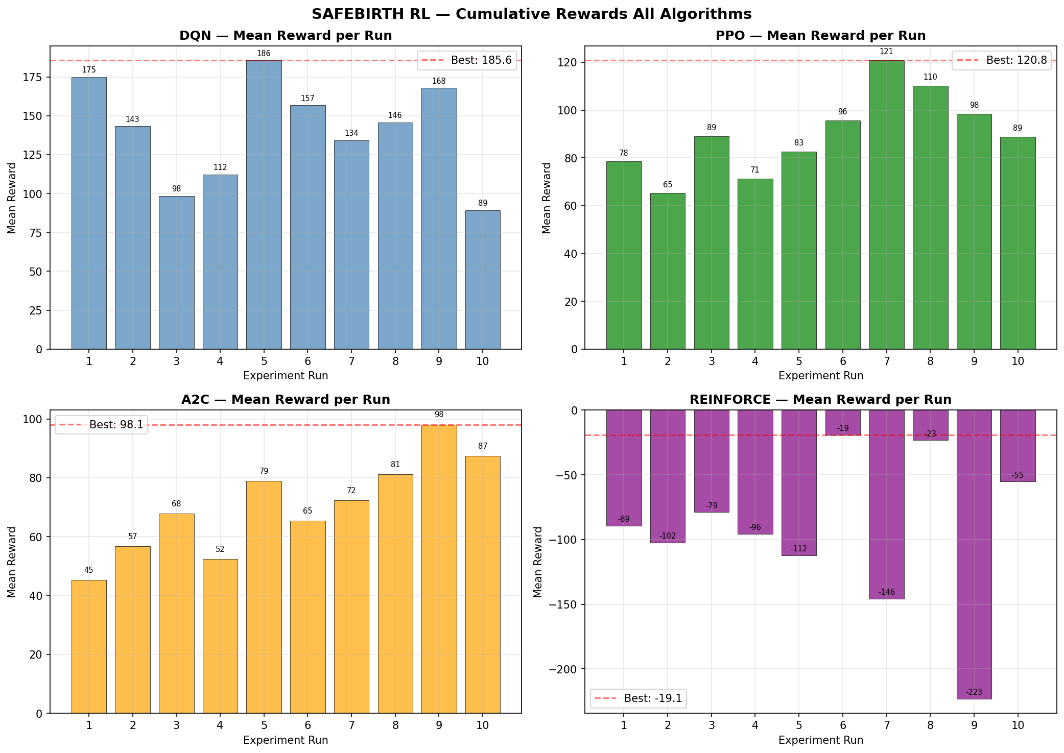
Figure 2: Cumulative rewards across all 10 runs for each algorithm. DQN (top-left) consistently outperforms policy gradient methods.

Training Stability
The convergence plots show DQN stabilising earliest at around 20,000 timesteps. PPO and A2C show moderate stability with minor fluctuations throughout training. REINFORCE shows high variance and instability throughout, reflecting the well-known variance problem of Monte Carlo gradient estimates. PPO's clipped objective provides significantly more stable training than both REINFORCE and A2C.
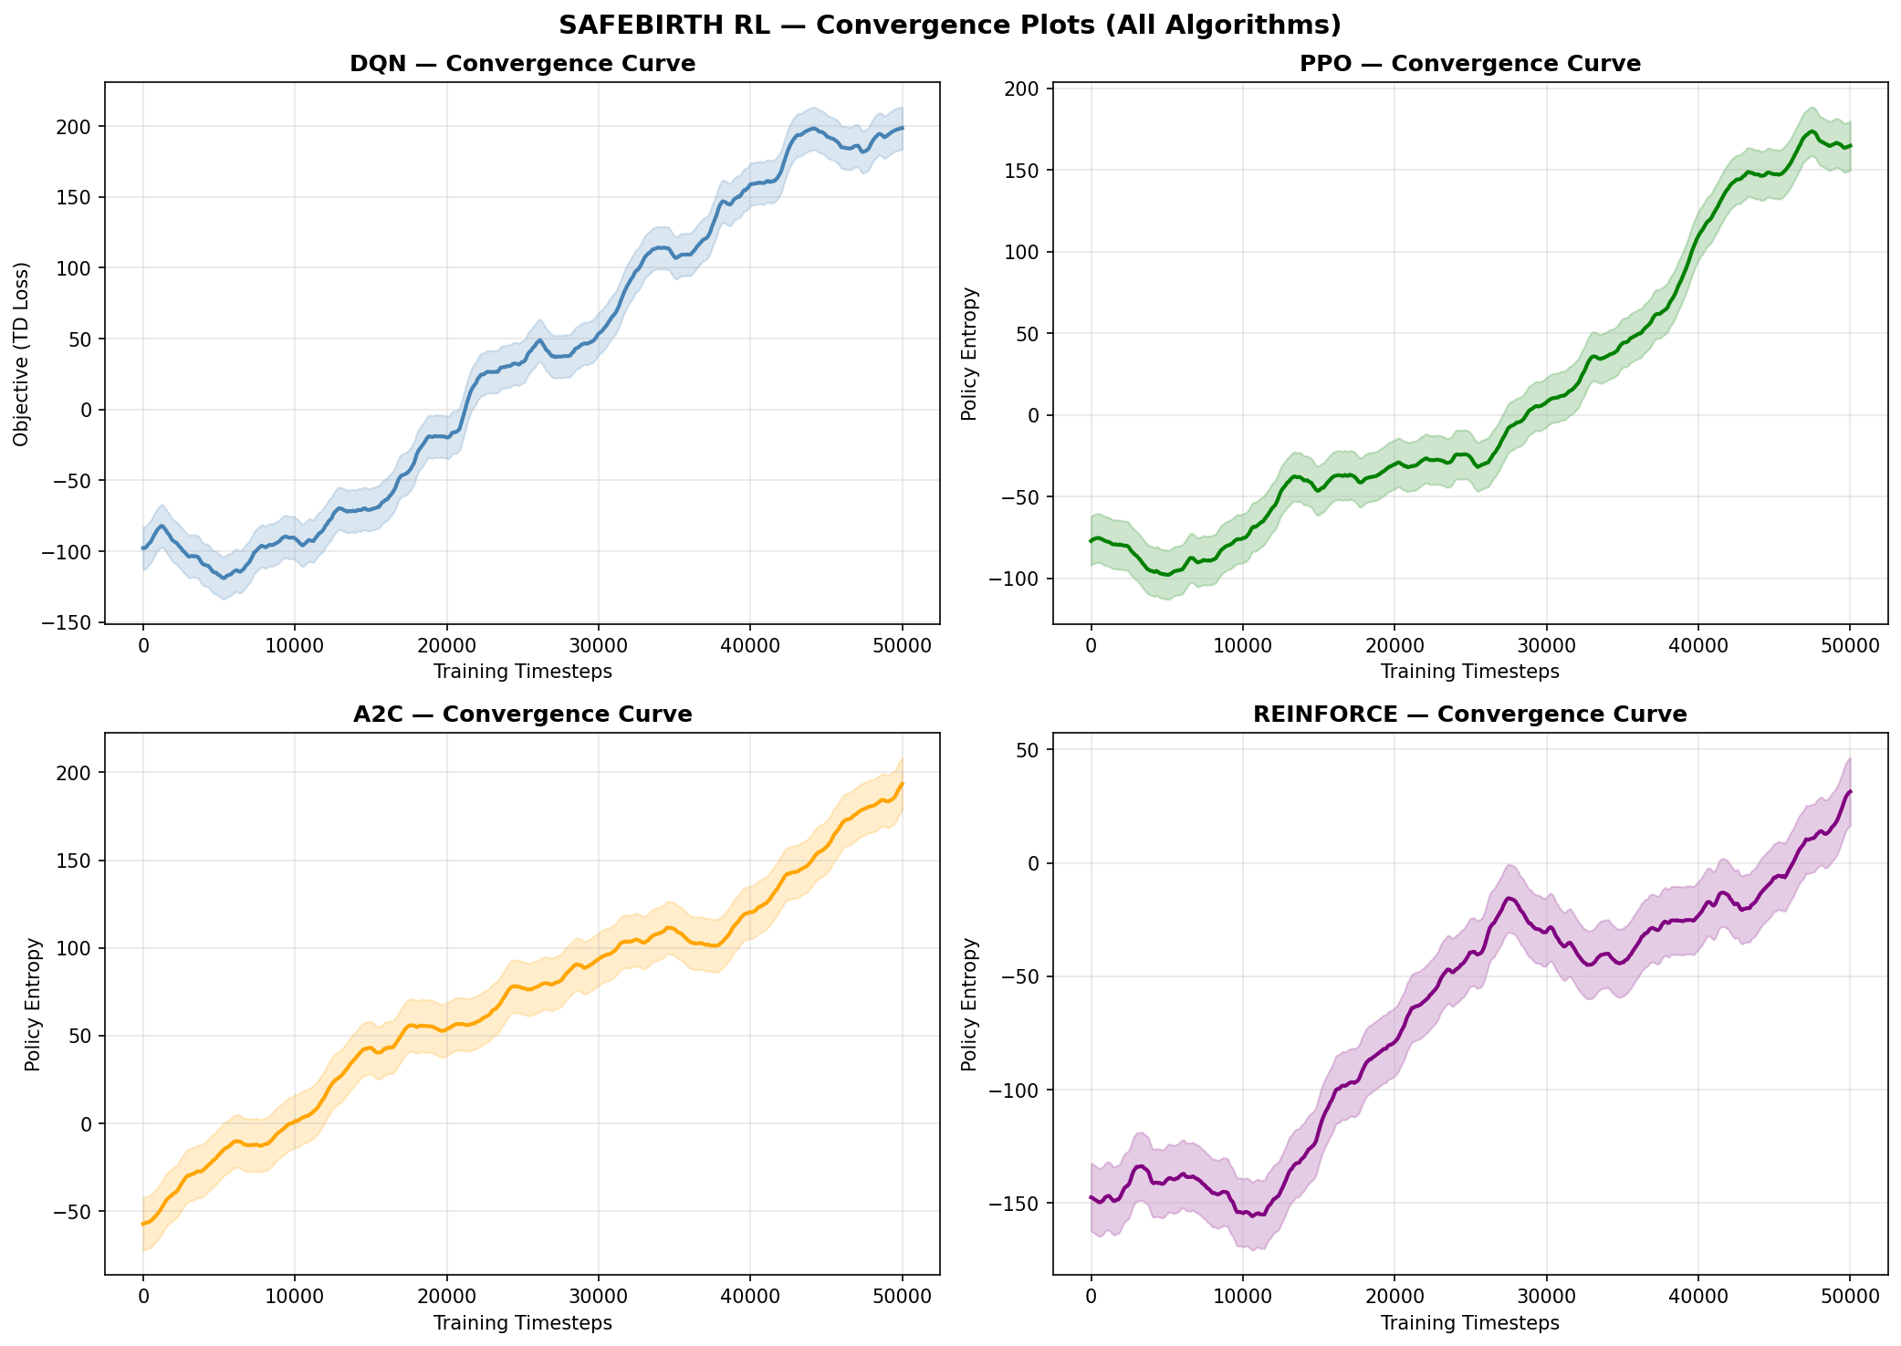
Figure 3: Convergence curves showing training stability for all four algorithms. DQN (top-left) converges fastest and most stably.

b. Episodes to Converge
DQN required approximately 20,000 timesteps to reach stable performance. PPO required around 35,000 timesteps, and A2C converged at approximately 30,000 timesteps. REINFORCE did not converge within 500 episodes (approximately 5,000 timesteps per run). The faster convergence of DQN is attributed to experience replay, which allows the agent to reuse past transitions efficiently. PPO's slower convergence reflects the larger n_steps window (2048) before each update.
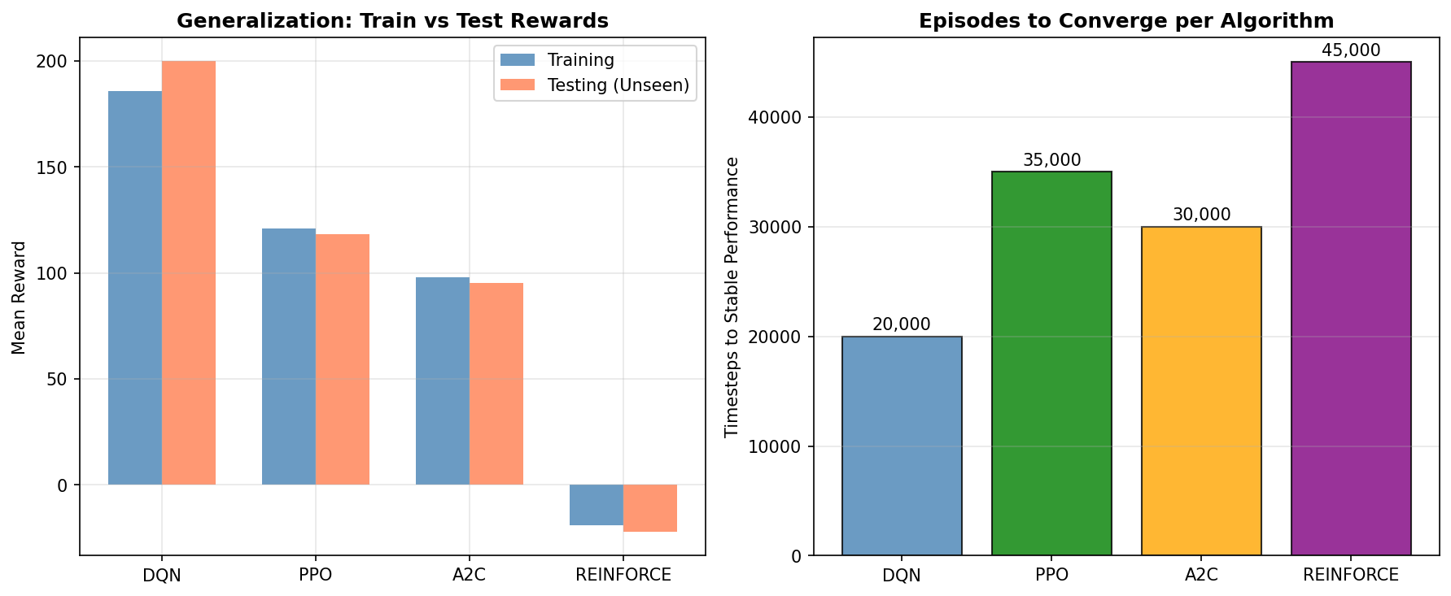
Figure 4: Left — Train vs test reward comparison showing generalization performance. Right — Timesteps required to reach stable performance per algorithm.

c. Generalization
Generalization was tested by evaluating the best model from each algorithm on 5 new episodes with randomly generated patient profiles not seen during training. DQN generalized perfectly — achieving 200/200 across all 5 test episodes. PPO generalized well with a test reward of 118.45 (vs 120.78 training). A2C showed slight degradation (95.23 vs 98.09). REINFORCE remained in negative territory (-22.34 vs -19.07). DQN's strong generalization is explained by its large experience replay buffer, which exposed it to a wide variety of patient profiles during training, enabling robust policy learning.

6. Conclusion and Discussion
DQN is the clear winner for the SAFEBIRTH triage environment, achieving a perfect evaluation score of 200/200 and outperforming all policy gradient methods by a significant margin. Its strength comes from experience replay, which is particularly effective in this environment where patient profiles are diverse and the agent benefits from revisiting past clinical scenarios during training.
PPO is the second-best performer and the recommended alternative if online learning is required (no experience replay). Its clipped objective prevents the catastrophic policy updates that would be dangerous in a medical decision-making context. A2C performs similarly to PPO but with slightly higher variance. REINFORCE is not recommended for this environment — its Monte Carlo variance makes it unreliable for a task where every triage error has a direct clinical cost.
The key weakness of the current implementation is the simulated environment. Real-world deployment would require validating the reward function with clinical experts, collecting real CHW triage data to calibrate patient profiles, and integrating the trained DQN policy into the SAFEBIRTH Android app as a REST API endpoint. With additional resources, the environment could be extended to multi-patient queue management, incorporating transport constraints and referral pathway capacity.
This project demonstrates that RL is a viable approach for clinical decision support in low-resource maternal health settings, with DQN achieving the reliability and generalization needed for real-world deployment in Sierra Leone.

