Nexora AI: INTERACTIVE USER INTERFACE GALLERY V2

Comprehensive Walkthrough of Layout Themes, Pages, and Viewports

INTRODUCTION
This v2 document compiles the complete UI layouts of the Nexora AI response interface, showcasing all desktop pages and responsive mobile viewports. It documents all 6 active preset theme styles supported by the console (Midnight Dark, Light Theme, Cyber Purple, Emerald Green, Sunset Orange, Custom Color) showing side-by-side prompt broadcasts.

1. SECURE AUTHENTICATION PORTAL (MIDNIGHT DARK ONLY)
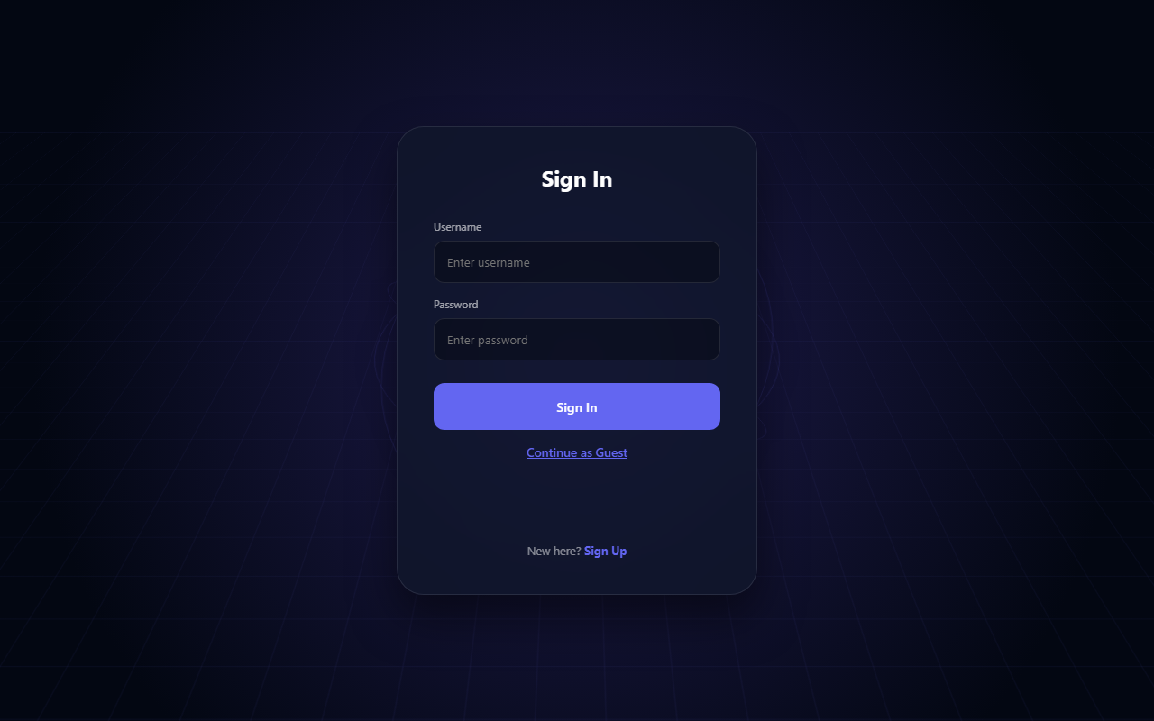
Figure: Secure Sign-In Interface
*Figure 1.1: Secure Sign-In Portal*
**Description of Visible Elements:**
- **Login Form Card**: Holds input text fields for username and credentials.
- **Guest Entry Link**: Bypasses active database authentication to instantly redirect the user context into the main workspace.

2. CORE WORKSPACE THEME VARIATIONS (SHOWCASE)
This section showcases the main broadcast workspace in every possible theme variation:
#### A. LIGHT THEME (BULB ACTIVE)
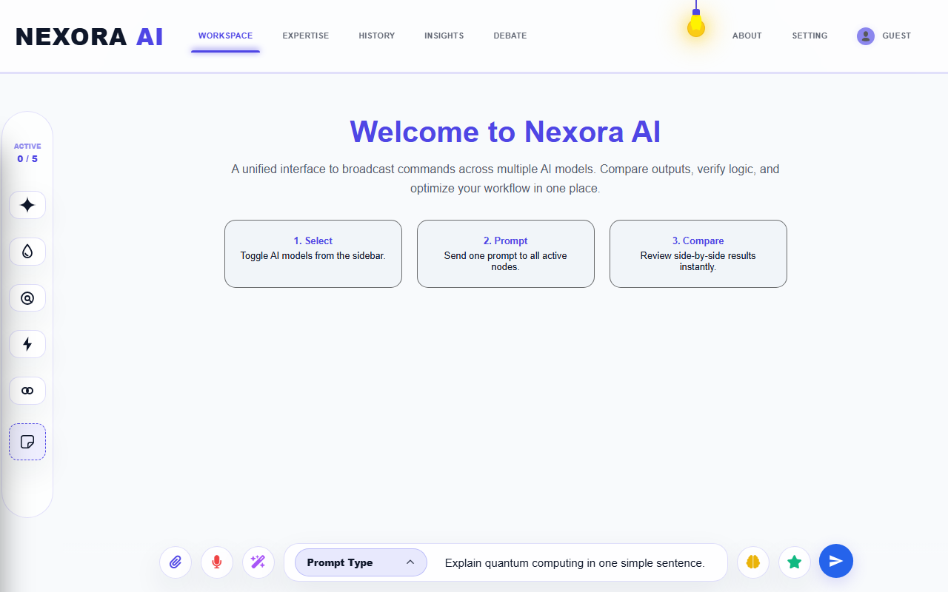
Figure: Light Theme Workspace comparative outputs
*Figure 2.1: Workspace Active Broadcast in Light Theme*
- **Aesthetics**: Clean, soft off-white background with a glowing hanging lightbulb.
#### B. MIDNIGHT DARK THEME
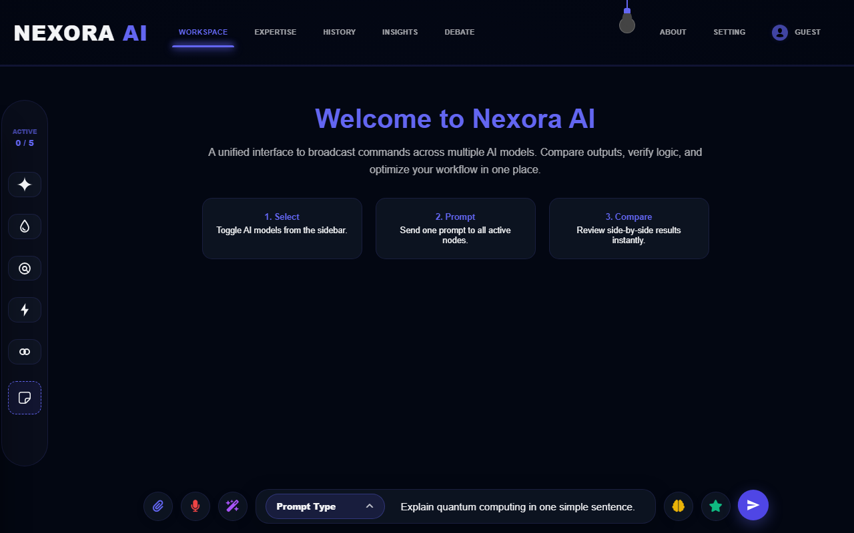
Figure: Midnight Theme Workspace comparative outputs
*Figure 2.2: Workspace Active Broadcast in Midnight Dark Theme*
- **Aesthetics**: Deep dark-blue gradients with matching neon-blue cards and buttons.
#### C. CYBER PURPLE THEME
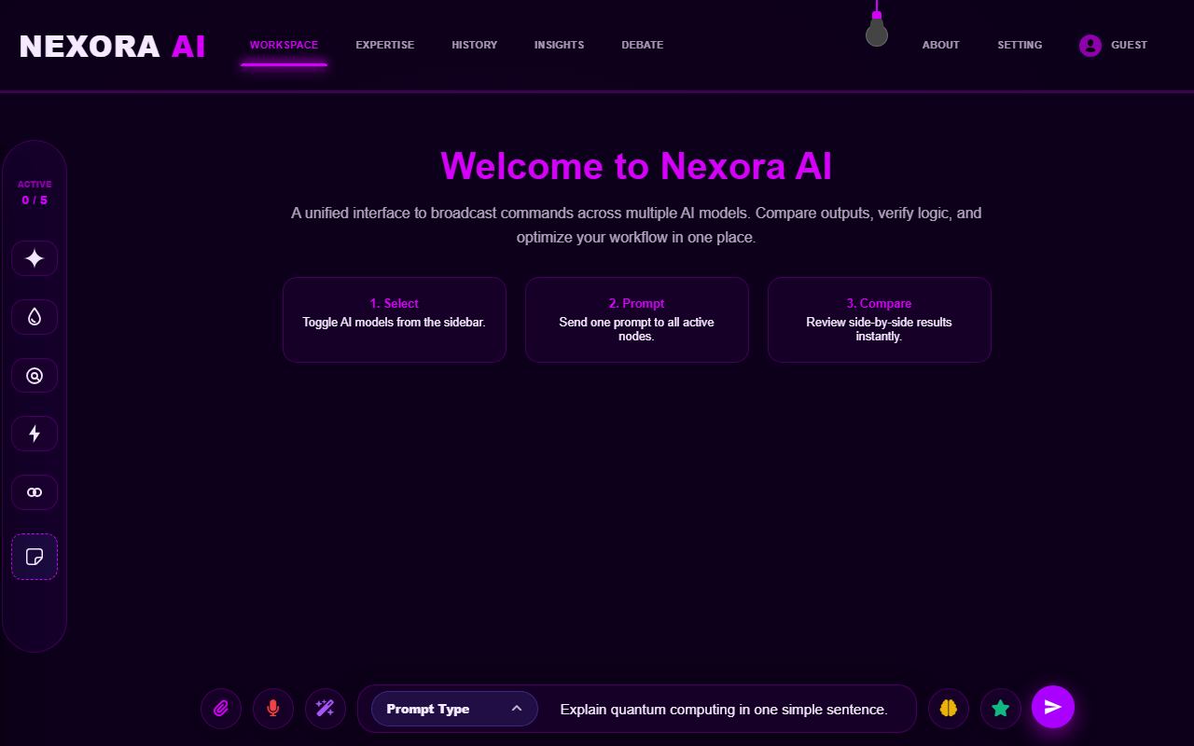
Figure: Cyber Purple Theme Workspace comparative outputs
*Figure 2.3: Workspace Active Broadcast in Cyber Purple Theme*
- **Aesthetics**: Cyberpunk violet accents with glowing dark-magenta panels and borders.
#### D. EMERALD GREEN THEME
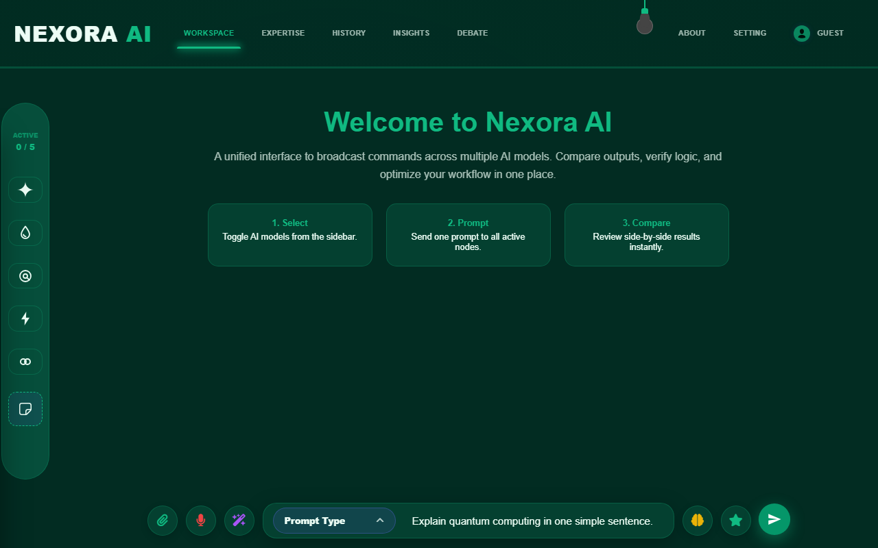
Figure: Emerald Green Theme Workspace comparative outputs
*Figure 2.4: Workspace Active Broadcast in Emerald Green Theme*
- **Aesthetics**: Forest-green workspace gradients matched with bright emerald accents and borders.
#### E. SUNSET ORANGE THEME
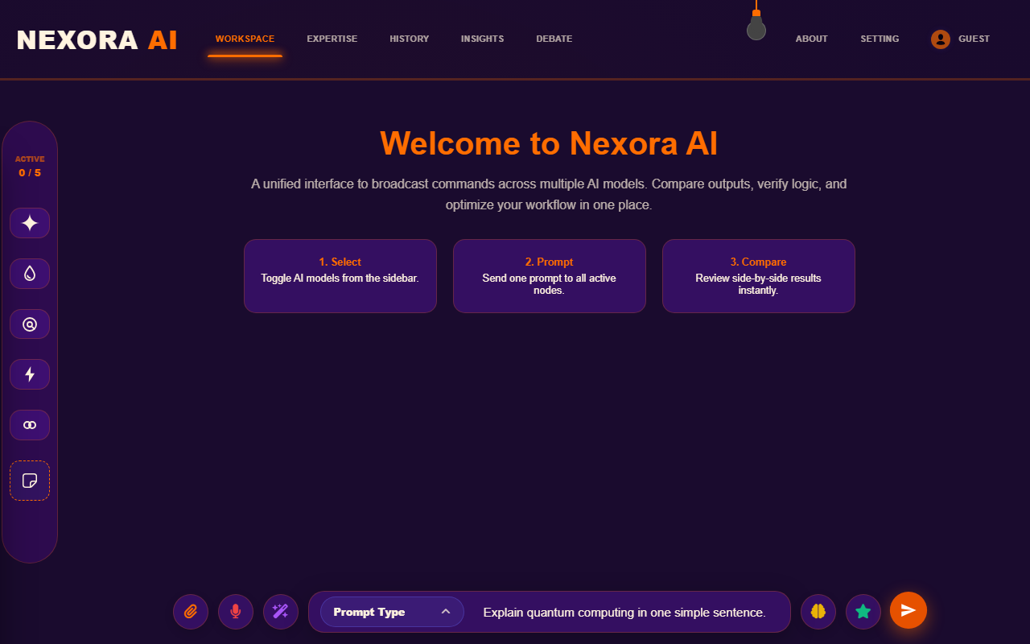
Figure: Sunset Orange Theme Workspace comparative outputs
*Figure 2.5: Workspace Active Broadcast in Sunset Orange Theme*
- **Aesthetics**: Evening purple backdrop matched with vibrant sunset-orange button states and glowing highlights.
#### F. CUSTOM COLOR THEME
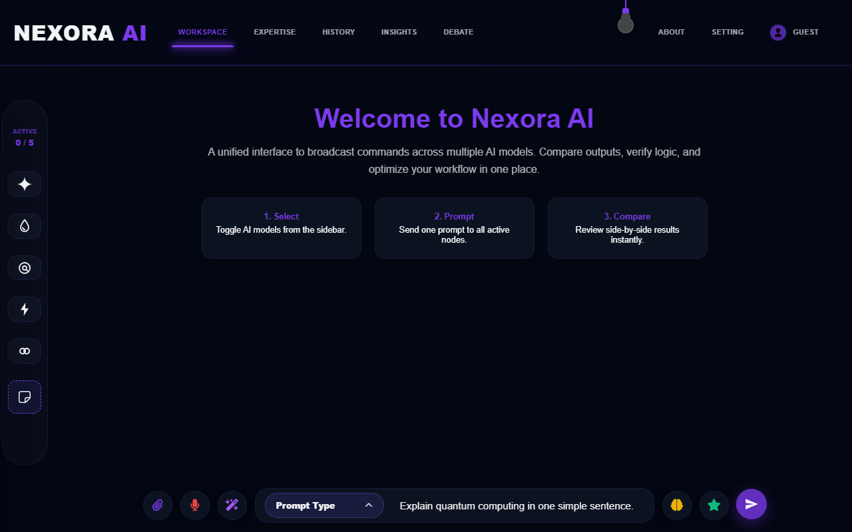
Figure: Custom Color Theme Workspace comparative outputs
*Figure 2.6: Workspace Active Broadcast in Custom Color Theme*
- **Aesthetics**: Standard custom violet/lavender highlight presets for personalized user selections.

3. MODEL EXPERTISE PERSONA CUSTOMIZER (LIGHT MODE)
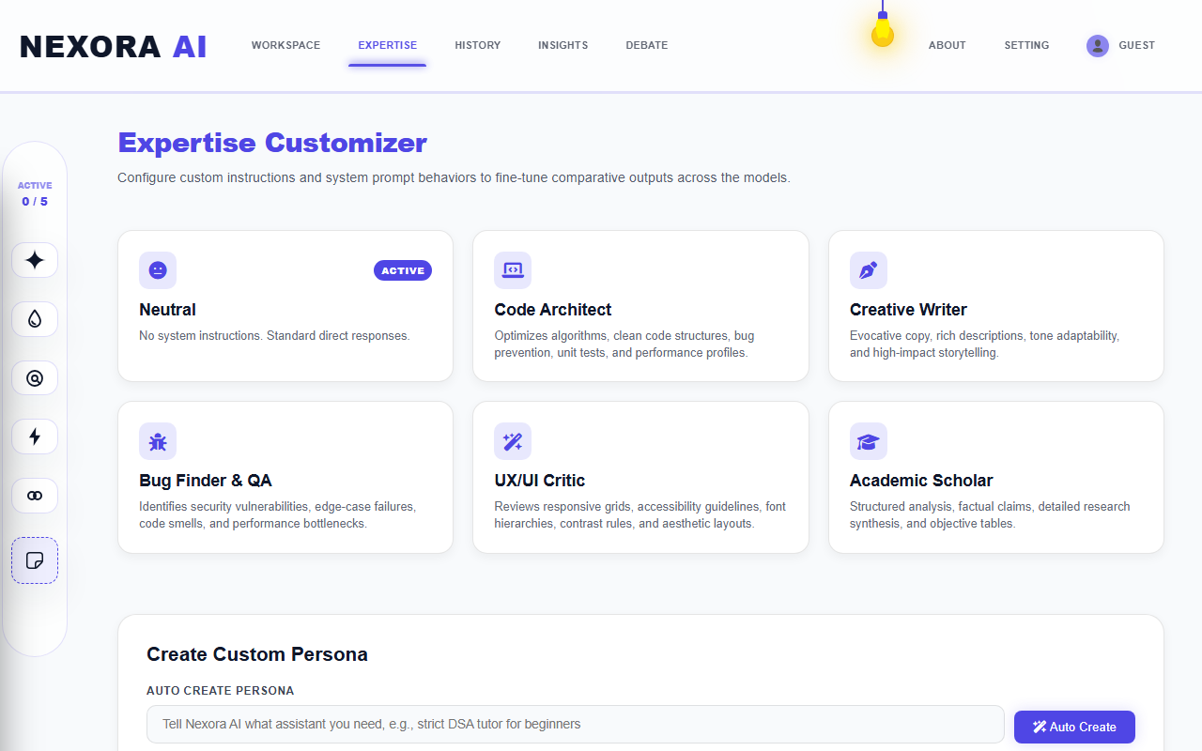
Figure: Model System Instruction Presets in Light Mode
*Figure 3.1: Model System Instructions Configurator (Light Mode)*
**Description of Visible Elements:**
- **Custom Presets**: Cards mapping built-in steerable system instructions (e.g. Code helper, general assistant).
- **System Prompt editors**: Allows inline adjustments to shape comparative behaviors.

4. SESSION HISTORY DIRECTORY (LIGHT MODE)
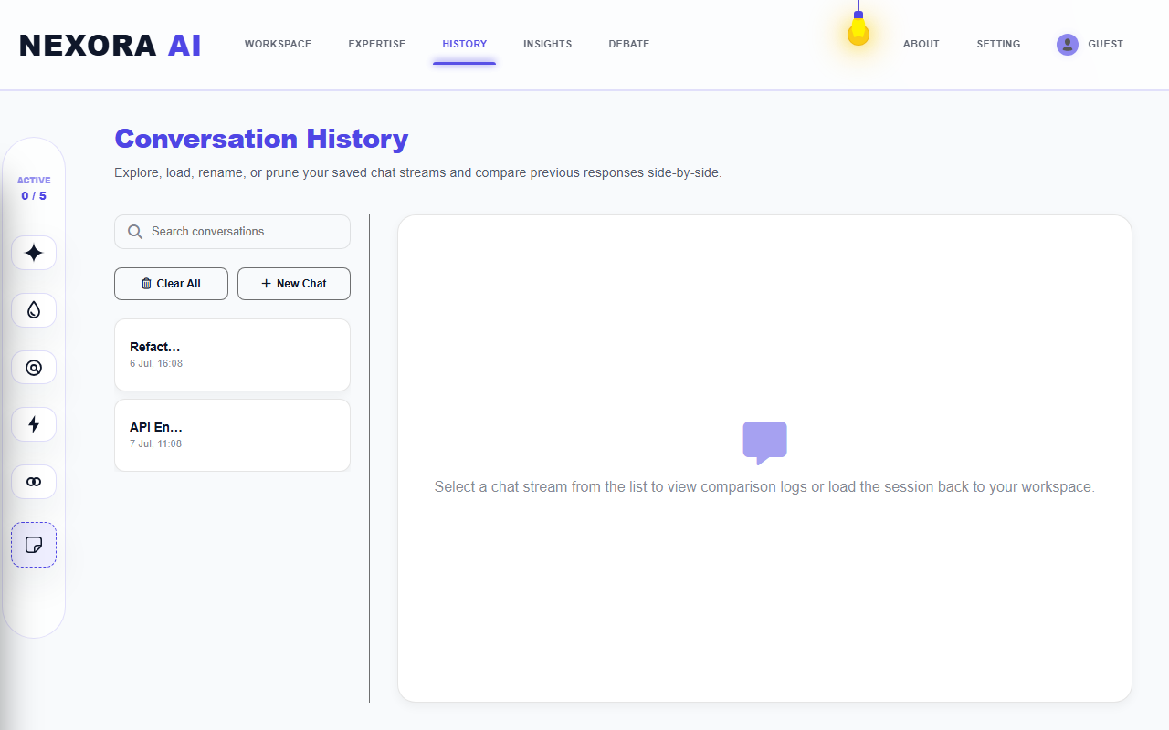
Figure: Conversations Log Directory in Light Mode
*Figure 4.1: Conversations Log Directory (Light Mode)*
**Description of Visible Elements:**
- **Past Logs**: Lists past prompts and target models sorted chronologically.
- **Database sync**: Integrated Mongoose bulkWrite sync.

5. INSIGHTS ANALYTICS DASHBOARD (LIGHT MODE)
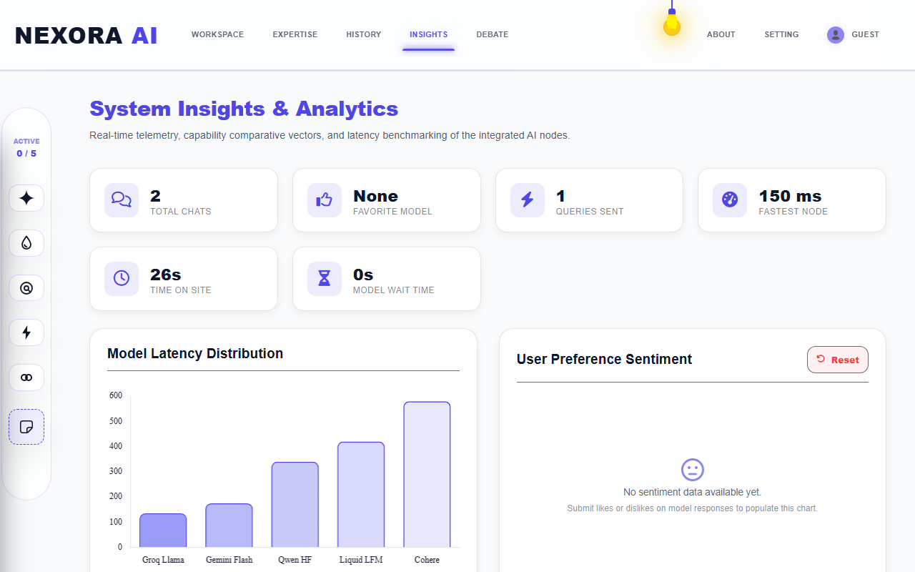
Figure: Insights telemetry graphs in Light Mode
*Figure 5.1: Insights Analytics Dashboard (Light Mode)*
**Description of Visible Elements:**
- **Feedback Sentiment Dial**: Interactive donut chart grouping voting stats (likes/dislikes).
- **Average Speed metrics**: Chart.js lines plotting response latencies over time.

6. MULTI-TURN DEBATE ARENA (LIGHT MODE)
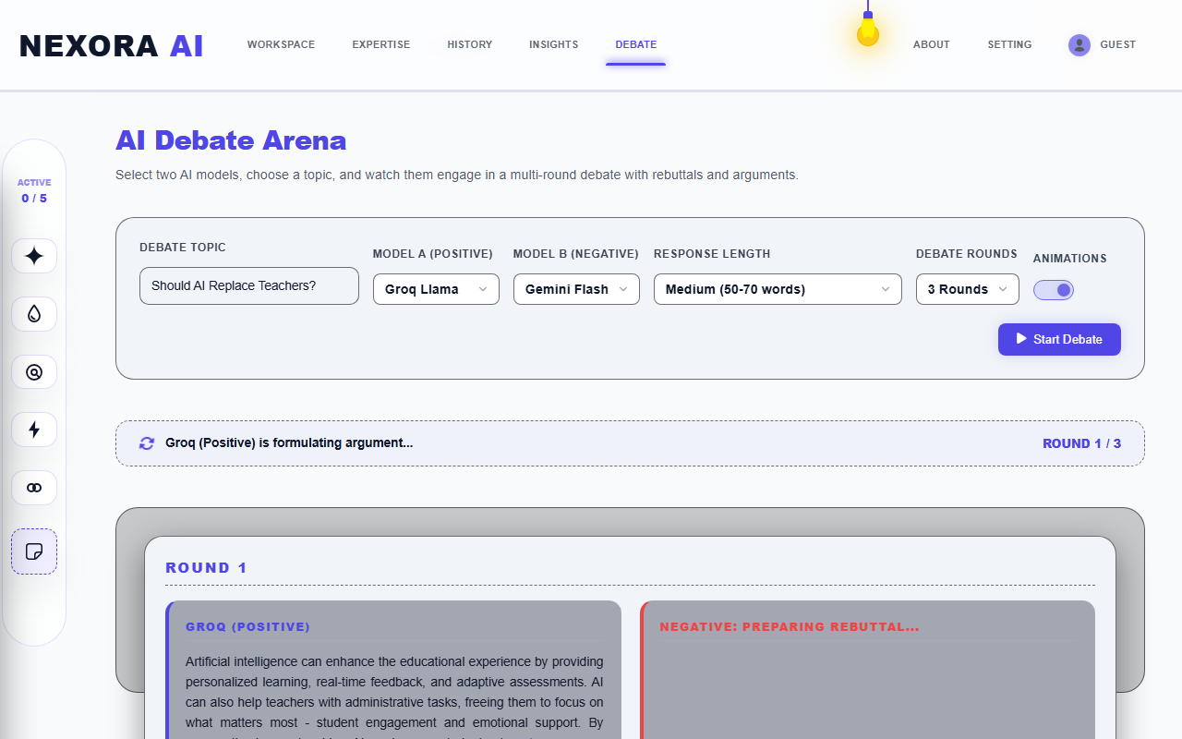
Figure: Model Debate Arena in Light Mode
*Figure 6.1: Multi-Turn AI Debate Arena (Light Mode)*
**Description of Visible Elements:**
- **Active Debate Bubbles**: Shows parallel statements traded between Model A and Model B.
- **Consensus Judge panel**: Automatically parses debate statements to show a summarized outcome.

7. SYSTEM CONFIGURATION & BYOK CREDENTIALS (LIGHT MODE)
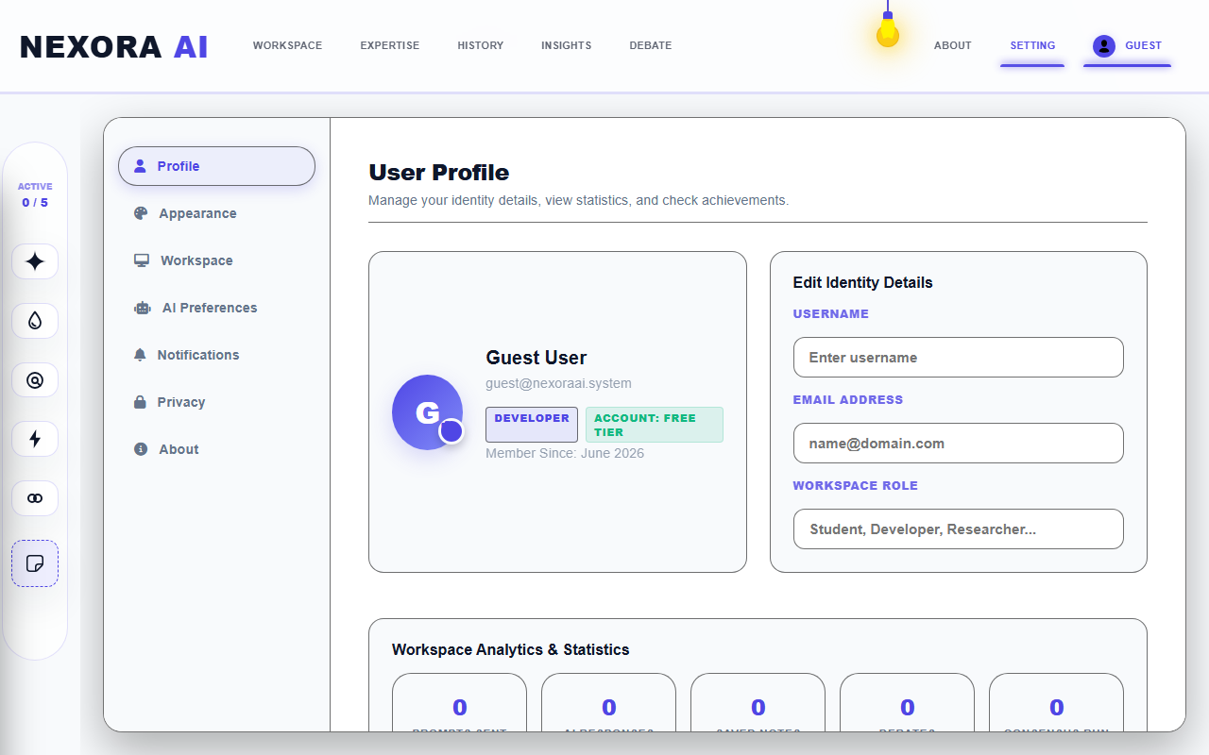
Figure: General Settings Configuration in Light Mode
*Figure 7.1: General Settings Configuration (Light Mode)*
**Description of Visible Elements:**
- **BYOK Credentials Input**: Form boxes to save custom developer API keys.
- **Account details**: Manages profile avatars.

8. RESPONSIVE MOBILE VIEWPORT (LIGHT MODE)
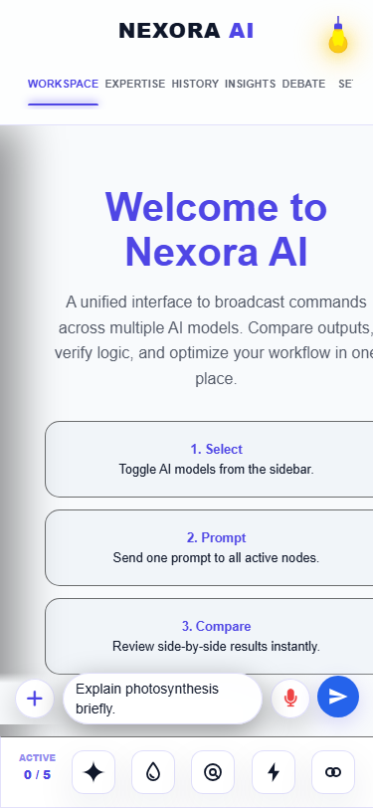
Figure: Mobile Workspace active output in Light Mode
*Figure 8.1: Mobile responsive workspace active output (Light Mode)*
**Description of Visible Elements:**
- **Bottom sticky drawer**: Houses voice speech triggers and command textareas.
- **Vertical card stack**: Stacks comparative answer panels cleanly on mobile viewports.

