MULTI-AI: INTERACTIVE USER INTERFACE GALLERY

A Walkthrough of Workspace Pages, Panels, Themes & Viewports

INTRODUCTION
This document compiles the user interface layouts of the Multi-AI consensus and debate workbench. It displays high-resolution screenshots capturing each primary view (Workspace, Expertise, History, Insights, Debate, Settings) and responsive viewports (Desktop & Mobile) alongside descriptions of visible controls, action buttons, and live telemetry widgets.

1. SECURE AUTHENTICATION PORTAL
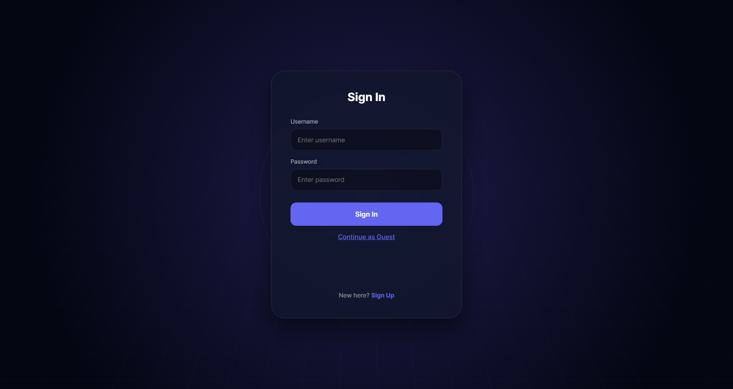
Figure: Secure Sign-In Interface
*Figure 1.1: Secure Sign-In Portal (Dark Theme)*
**Description of Visible Elements:**
- **Login Form Card**: Anchors center coordinates hosting standard Username/Password form fields.
- **Bypass Link**: Features a dedicated Guest button selector allowing reviewers to instantly load the workspace console without active database authentication.
- **Branding Header**: Displays the prominent MULTIAI title lockup.

2. DOCK-AREA WORKSPACE LANDING VIEW
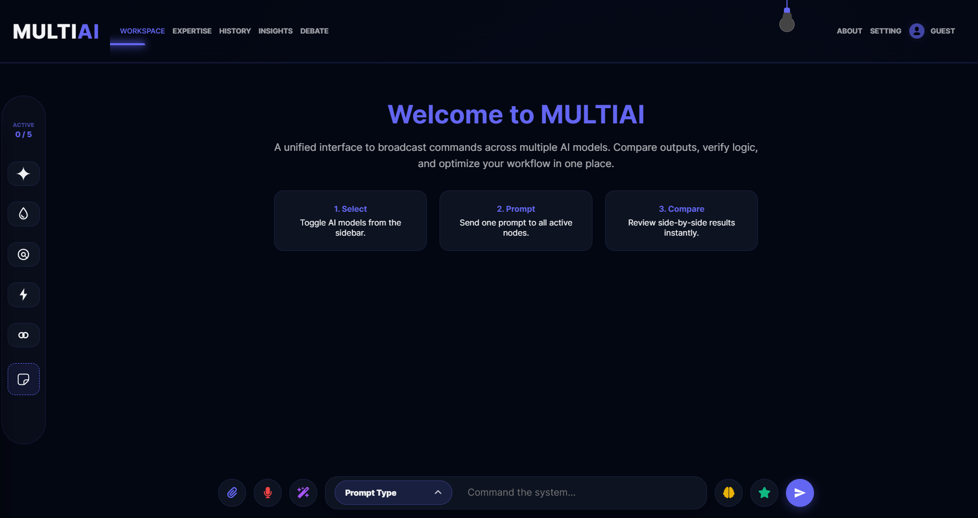
Figure: Workspace Console Landing Page
*Figure 1.2: Workspace Dashboard Landing Page (Dark Theme)*
**Description of Visible Elements:**
- **Welcome Overlay Banner**: Renders central typography explaining system operations (Select, Prompt, Compare).
- **Views Swiper Bar**: Houses horizontal buttons to switch pages (Workspace, Expertise, History, Insights, Debate, About, Settings).
- **Active Model Indicator Badge**: Located in the sidebar, displaying active count ratios (e.g. 0/5 Active).
- **Lightbulb Toggle wire**: Sticky theme switch suspended top-right.

3. SIDE-BY-SIDE RESPONSE CHAT OUTPUTS
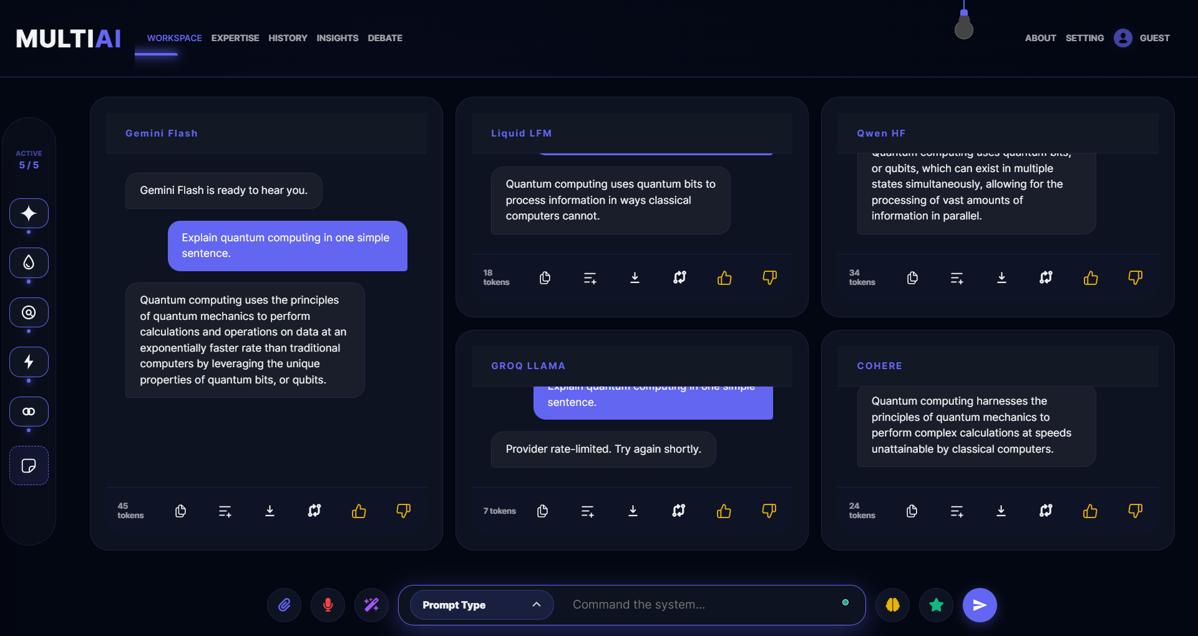
Figure: Comparative Chat Response Cards
*Figure 1.3: Comparative Prompt Broadcast Outputs (Dark Theme)*
**Description of Visible Elements:**
- **Typewriter Response Cards**: Displays side-by-side comparative answers styled in glassmorphic borders.
- **Latency Telemetry Badges**: Details request duration stats (ms) and word counts at the bottom of each card.
- **Feedback triggers**: Incorporates thumbs up/down icons to log user voting preferences in MongoDB.

4. EXPERTISE PERSONA CUSTOMIZER
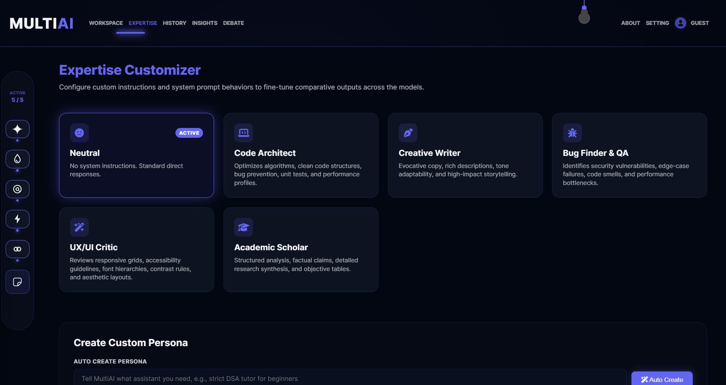
Figure: Model System Prompt Presets
*Figure 1.4: Model System Instructions Configurator (Dark Theme)*
**Description of Visible Elements:**
- **Steerable Presets Grid**: Custom instruction cards guidance mapping different system prompts (e.g., Code review, Creative Writer).
- **System Instruction textareas**: Custom input boxes to modify behaviors.

5. SESSION HISTORY DIRECTORY
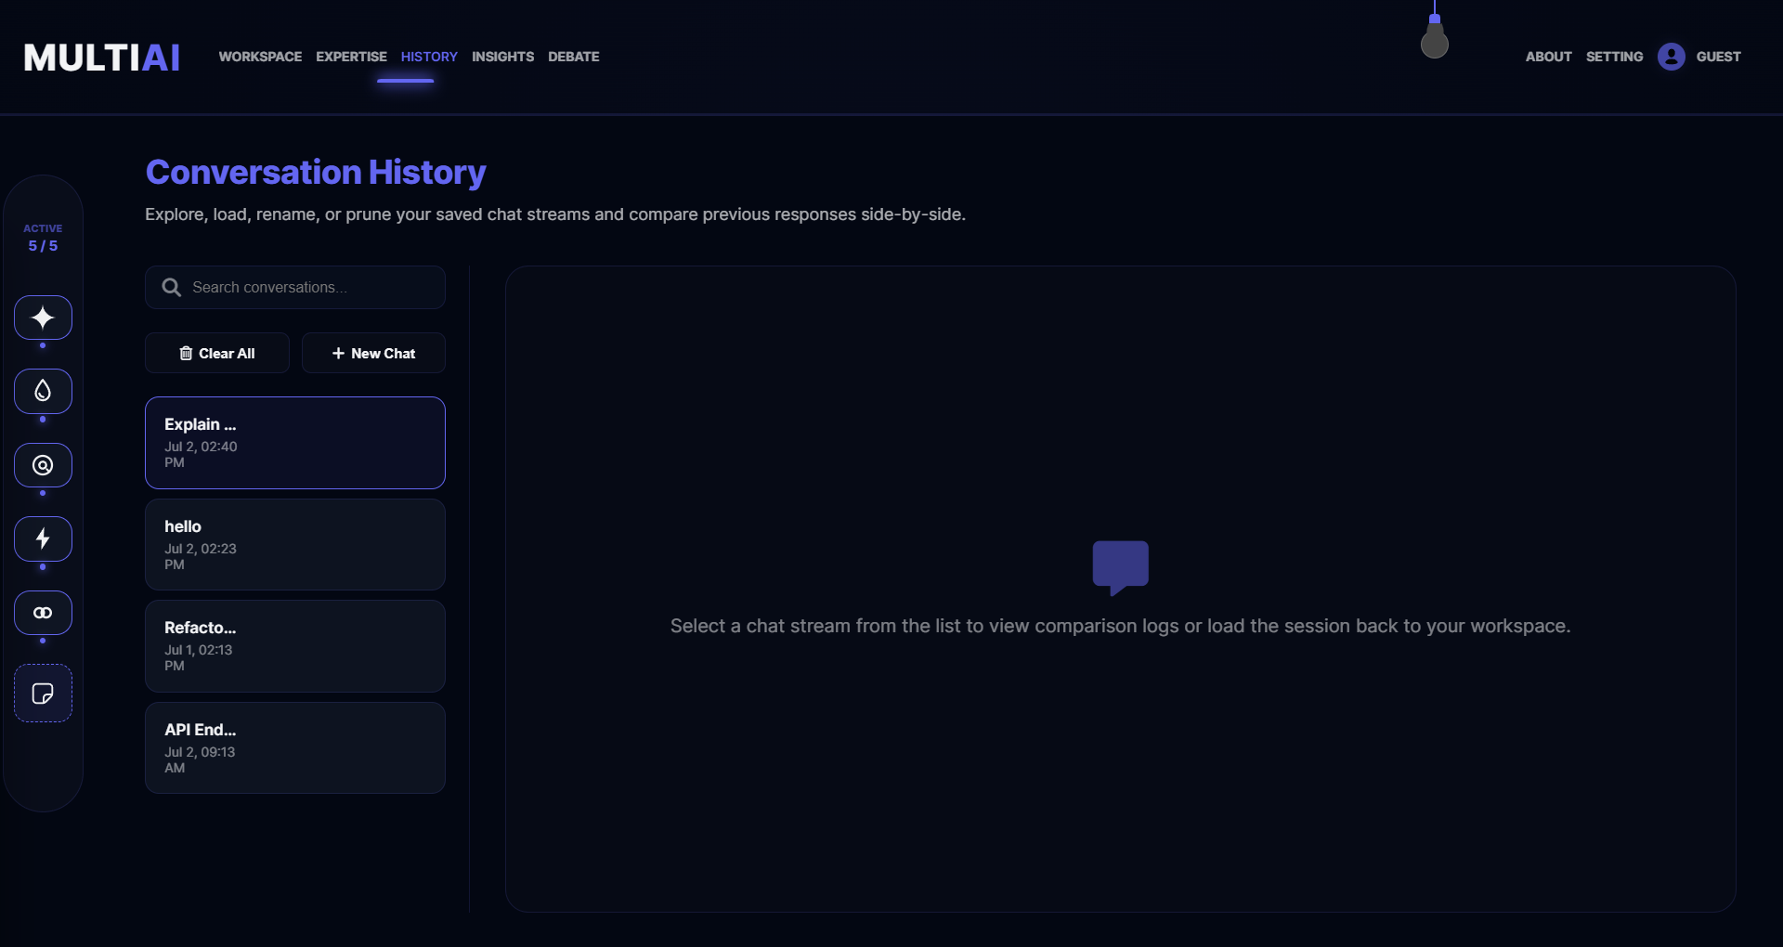
Figure: Conversations Log Directory
*Figure 1.5: Conversations Log Directory (Dark Theme)*
**Description of Visible Elements:**
- **Conversations List**: Displays past queries sorted by timestamps.
- **Differential Sync indicator**: Confirms session data is synced securely using Mongoose bulk write operations.

6. INSIGHTS TELE-ANALYTICS DASHBOARD
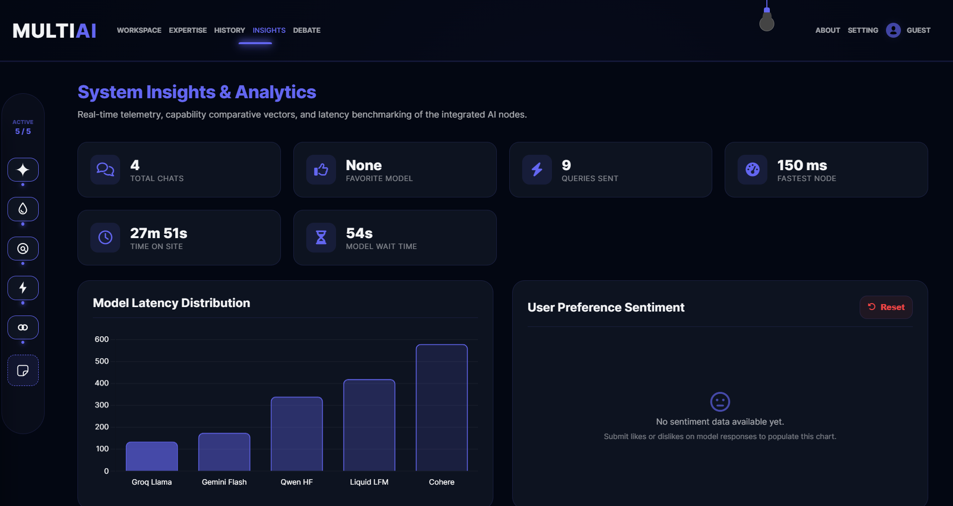
Figure: Telemetry Analytics Graphs
*Figure 1.6: Insights Analytics Dashboard (Dark Theme)*
**Description of Visible Elements:**
- **Feedback Sentiment Dial**: Aggregates likes/dislikes statistics in a donut chart.
- **Avg Response Speed Chart**: Plots model latency benchmarks over time.

7. AUTOMATED MULTI-TURN DEBATE ARENA
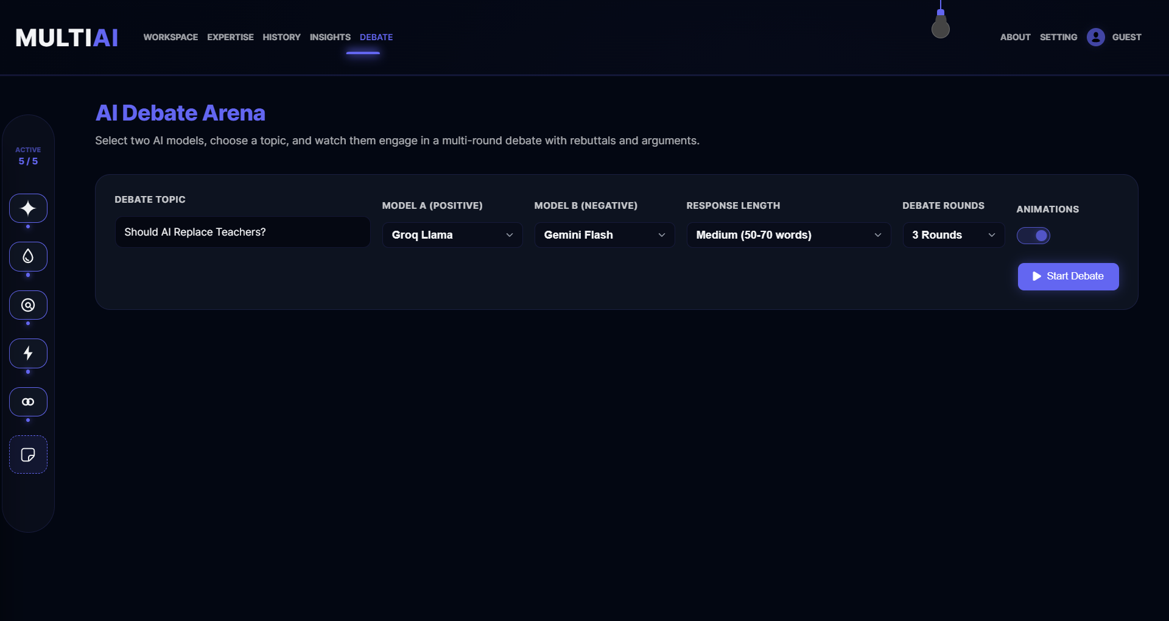
Figure: Model Debate Simulator Panel
*Figure 1.7: Multi-Turn AI Debate Arena (Dark Theme)*
**Description of Visible Elements:**
- **Model A & B selectors**: Configures debating participants.
- **Debate Transcript Box**: Renders alternating turn-based model statements.
- **Consensus judge**: Automatically reviews the debate and displays a consolidated summary.

8. SYSTEM CONFIGURATION & BYOK CREDENTIALS
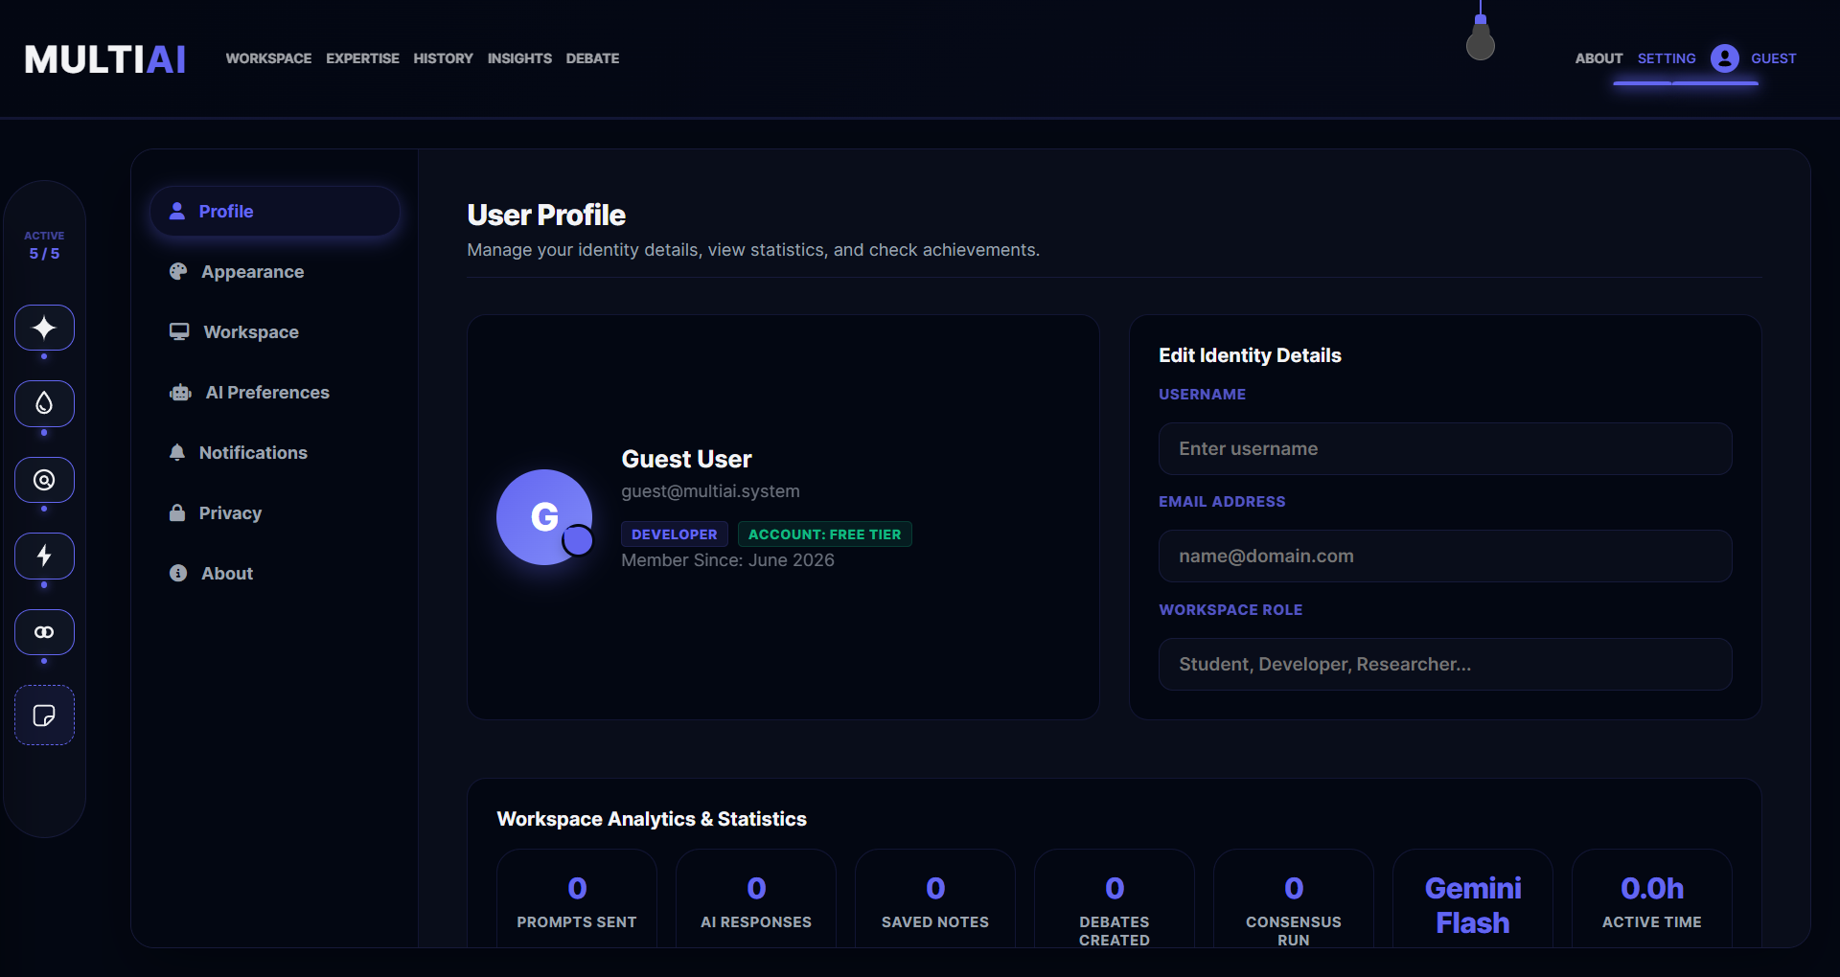
Figure: General Settings Configuration
*Figure 1.8: General Settings Configuration (Dark Theme)*
**Description of Visible Elements:**
- **BYOK Credentials Input**: Allows secure entry of custom API keys (Gemini, OpenRouter, Groq).
- **Account details**: Manages academic profile details.

9. RESPONSIVE MOBILE VIEWPORT VIEWS
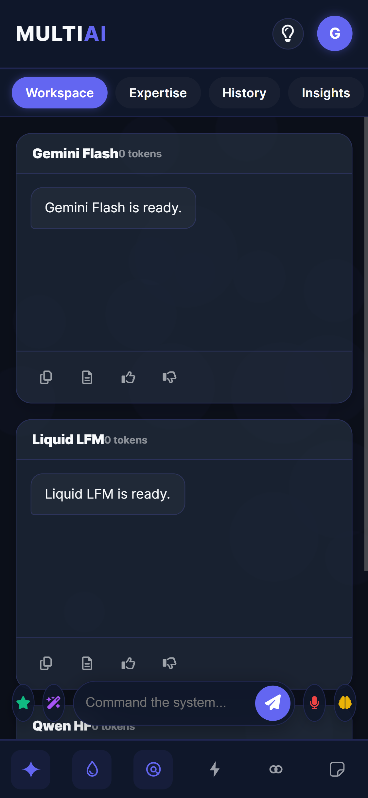
Figure: Mobile Workspace Empty State
*Figure 2.1: Mobile Workspace Landing View (Dark Theme)*
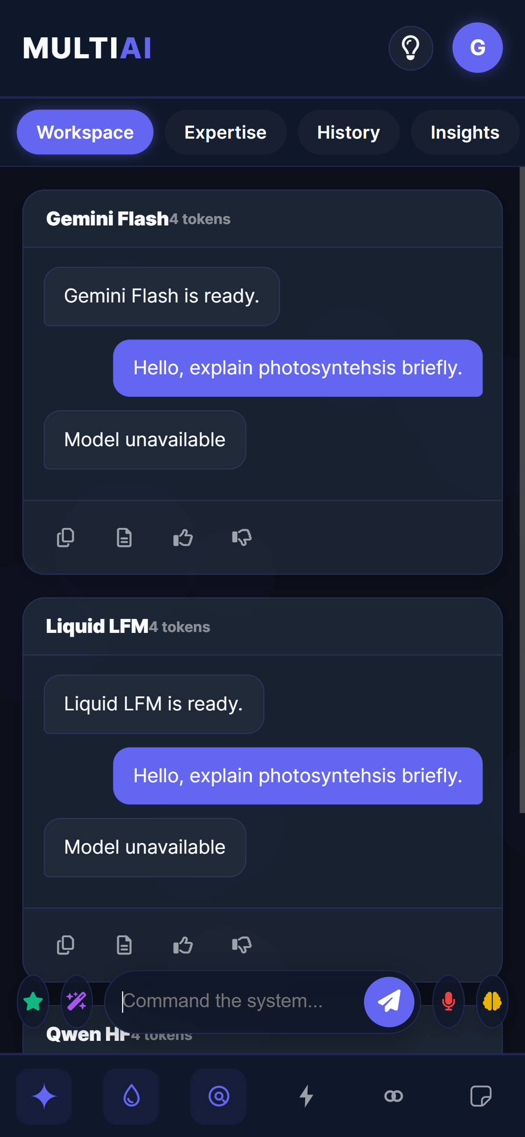
Figure: Mobile Workspace Output Cards
*Figure 2.2: Mobile Workspace Comparative Response Outputs (Dark Theme)*
**Description of Visible Elements:**
- **Compact Bottom Dock**: Condenses the prompt bar and speech indicators into a bottom swiper drawer.
- **Scrollable card stacks**: Stacks comparative response panels vertically to preserve layout aspect ratios.

