E-RAKSHAK FORENSIC INVESTIGATION REPORT
Entity: ENT_0043 | Generated: 2026-08-11 02:16:19
______________________________________________________________________

1. Risk Assessment
Rule-Based Risk Tier: CRITICAL
ML Anomaly Detection: Normal

- Rules Fired:
- TCS-1
- MUL-1

2. Resolved Identity Summary
Identifier Type | Values
Phone Numbers | 9568978194
Bank Accounts | 8644925192
IMEIs | 889255466590515
UPI VPAs | ekiya.suresh@okaxis

3. Rule Analysis (Explainability)

Rule TCS-1
Temporal Coincidence: 1 transaction(s) for entity ENT_0043 had BOTH a phone call AND an active IP session within the correlation window. Details: Transaction of 500000 at 2025-06-07 11:00:00.

Rule MUL-1
Mule Signature detected: entity ENT_0043 was dormant for 30+ days, received 500000, then moved 450000 (90% of inflow) within 1.1 hours. Balance returned near-zero.

4. Unified Evidentiary Timeline
Every event recorded for this entity across all ingested sources, plotted on a single time axis. Transactions, telephony and internet sessions are separated into lanes; shaded bands mark the temporal correlation windows in which a transfer, a call and an IP session coincide. Markers ringed in black are the specific rows cited as evidence in Section 6.
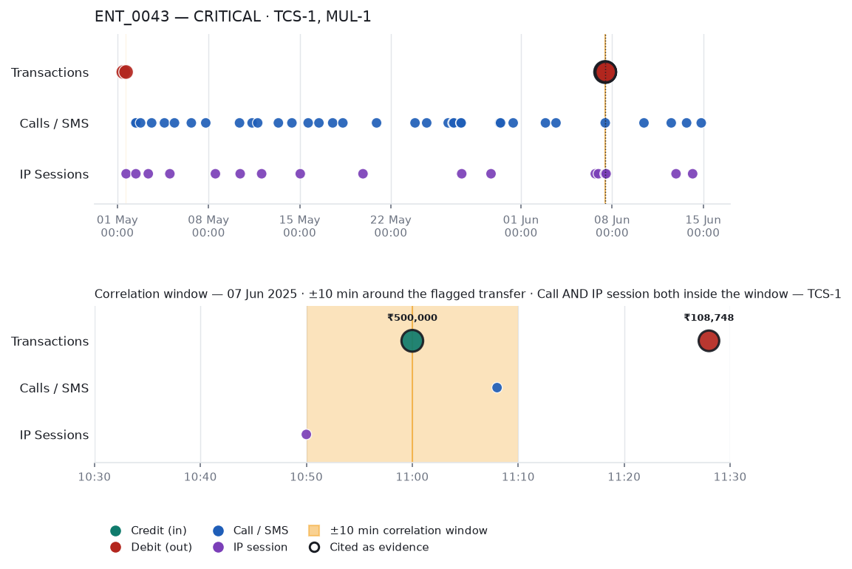

5. Money Flow Neighbourhood
Direct counterparties of this entity. Solid arrows are value transfers labelled with the aggregate amount; dashed arrows are telephony contact carrying no money. Amounts are counted once per transfer from the sending statement, so each figure reconciles with the underlying bank record.
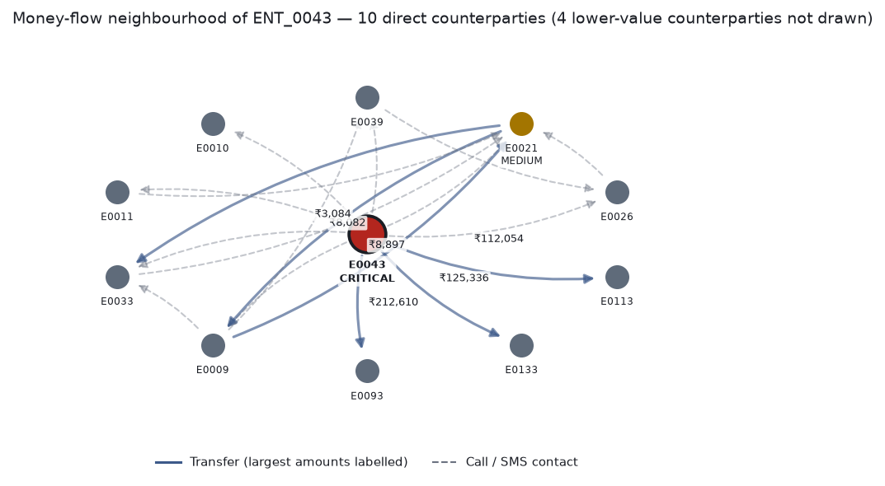

6. Evidence Summary
Timestamp | Type | Amount | Counterparty | Source | Row Ref
2025-05-01 10:58:34 | transaction | -126 | aarush.lall | bank_icici.pdf | 189
2025-05-01 15:57:35 | transaction | -113 | lajita.chatterj  ee | bank_icici.pdf | 188
2025-05-01 16:00:33 | ip_session |  | 127.190.156.179 | ipdr_export.csv | 577
2025-05-02 09:28:53 | call |  | 9841568532 | cdr_export.csv | 1053
2025-05-02 10:01:58 | ip_session |  | 7.153.52.160 | ipdr_export.csv | 571
2025-05-02 10:05:10 | call |  | 9615917225 | cdr_export.csv | 1052
2025-05-02 18:40:52 | call |  | 9669473616 | cdr_export.csv | 1075
2025-05-03 08:54:05 | ip_session |  | 4.193.34.187 | ipdr_export.csv | 579
2025-05-03 15:07:00 | sms |  | 9669473616 | cdr_export.csv | 1055
2025-05-04 14:42:13 | sms |  | 9669473616 | cdr_export.csv | 1070
2025-05-05 00:41:43 | ip_session |  | 58.214.35.77 | ipdr_export.csv | 581
2025-05-05 09:12:21 | call |  | 9576500726 | cdr_export.csv | 1063
2025-05-06 16:16:24 | call |  | 9697139443 | cdr_export.csv | 1069
2025-05-07 18:51:57 | call |  | 9575575808 | cdr_export.csv | 1073
2025-05-08 12:36:54 | ip_session |  | 222.79.98.92 | ipdr_export.csv | 566
2025-05-10 09:04:58 | call |  | 9615917225 | cdr_export.csv | 1061
2025-05-10 10:18:21 | ip_session |  | 43.67.3.203 | ipdr_export.csv | 569
2025-05-11 08:15:09 | sms |  | 9669473616 | cdr_export.csv | 1056
2025-05-11 18:34:44 | call |  | 9820843514 | cdr_export.csv | 1076
2025-05-12 01:50:27 | ip_session |  | 64.177.15.212 | ipdr_export.csv | 568
2025-05-13 08:42:38 | sms |  | 9576500726 | cdr_export.csv | 1080
2025-05-14 09:37:56 | call |  | 9756843172 | cdr_export.csv | 1057
2025-05-15 01:01:19 | ip_session |  | 126.20.237.135 | ipdr_export.csv | 570
2025-05-15 15:36:18 | sms |  | 9669473616 | cdr_export.csv | 1079
2025-05-16 11:27:51 | call |  | 9576500726 | cdr_export.csv | 1066
2025-05-17 12:47:27 | call |  | 9820843514 | cdr_export.csv | 1072
2025-05-18 07:32:14 | call |  | 9575575808 | cdr_export.csv | 1078
2025-05-19 20:38:37 | ip_session |  | 194.139.190.114 | ipdr_export.csv | 580
2025-05-20 21:40:56 | call |  | 9756843172 | cdr_export.csv | 1050
2025-05-23 20:35:05 | call |  | 9697139443 | cdr_export.csv | 1082
2025-05-24 18:05:21 | call |  | 9576500726 | cdr_export.csv | 1067
2025-05-26 09:43:22 | sms |  | 9575575808 | cdr_export.csv | 1065
2025-05-26 18:29:55 | call |  | 9615917225 | cdr_export.csv | 1074
2025-05-26 20:04:17 | call |  | 9615917225 | cdr_export.csv | 1058
2025-05-27 08:53:16 | call |  | 9575575808 | cdr_export.csv | 1081
2025-05-27 09:34:56 | call |  | 9756843172 | cdr_export.csv | 1068
2025-05-27 10:39:28 | ip_session |  | 214.214.220.146 | ipdr_export.csv | 578
2025-05-29 16:37:45 | ip_session |  | 10.137.231.155 | ipdr_export.csv | 567
2025-05-30 08:38:21 | call |  | 9841568532 | cdr_export.csv | 1059
2025-05-30 10:08:47 | call |  | 9756843172 | cdr_export.csv | 1051
2025-05-31 09:30:01 | call |  | 9576500726 | cdr_export.csv | 1077
2025-06-02 20:59:10 | call |  | 9697139443 | cdr_export.csv | 1071
2025-06-03 16:24:25 | call |  | 9756843172 | cdr_export.csv | 1064
2025-06-06 16:48:50 | ip_session |  | 173.116.237.143 | ipdr_export.csv | 575
2025-06-06 22:34:17 | ip_session |  | 143.209.232.74 | ipdr_export.csv | 573
2025-06-07 10:50:00 | ip_session |  | 103.24.146.118 | ipdr_export.csv | 565
2025-06-07 11:00:00 | transaction | 500000 | nan | bank_icici.pdf | 190
2025-06-07 11:08:00 | call |  | 9533357554 | cdr_export.csv | 1049
2025-06-07 11:28:00 | transaction | -108748 | Kritika  Brar | bank_icici.pdf | 194
2025-06-07 11:32:00 | transaction | -125336 | Theodore  Devi | bank_icici.pdf | 192

7. Decision Trace References
TCS-1: bank_row_190, cdr_row_1049, ipdr_row_565
MUL-1: row_190, row_194, row_192, row_191, row_193
______________________________________________________________________
CONFIDENTIAL - FOR LAW ENFORCEMENT USE ONLY
Generated by E-Rakshak Forensic Analysis Platform
Evidence admissible under Indian Evidence Act S.65B with proper certification

