SUSPICIOUS TRANSACTION REPORT (STR)
Filed in accordance with FIU-IND reporting formats under the Prevention of Money Laundering Act (PMLA), 2002, Rule 3
STR Reference: STR-ENT_0043-20260811021619 | Generated: 2026-08-11 02:16:19
______________________________________________________________________

1. Reporting Entity Details
Name of Reporting Entity | ________________________
Reporting Entity Type | Bank / Financial Institution / Telecom Operator
Registration / License No. | ________________________
Branch / Circle | ________________________
Report Generated By System | E-Rakshak Forensic Analysis Platform (ERH26_PS_03)

2. Suspect / Account Holder Identity
Resolved Entity ID | ENT_0043
Name (KYC) | Ekiya Suresh
Phone Number(s) | 9568978194
Bank Account(s) | 8644925192
UPI VPA(s) | ekiya.suresh@okaxis
IMEI(s) | 889255466590515
IP Address(es) | N/A
Current System Risk Tier | CRITICAL

3. Nature / Grounds of Suspicion
This report is filed based on the following deterministic rule firing(s), each mapped to its corresponding FIU-IND suspicious-activity category:
Rule ID | FIU-IND Category | Grounds
TCS-1 | Suspicious Transaction Timing | Transaction executed while the subject held simultaneous active phone call and internet session presence, indicating coordinated real-time facilitation of the transaction.
MUL-1 | Mule Account / Layering of Proceeds | Dormant account activated by a sudden large credit followed by rapid, near-total outflow, consistent with use as a money-mule conduit.

Detailed rule findings:

Rule TCS-1
Temporal Coincidence: 1 transaction(s) for entity ENT_0043 had BOTH a phone call AND an active IP session within the correlation window. Details: Transaction of 500000 at 2025-06-07 11:00:00.

Rule MUL-1
Mule Signature detected: entity ENT_0043 was dormant for 30+ days, received 500000, then moved 450000 (90% of inflow) within 1.1 hours. Balance returned near-zero.

4. Schedule of Suspicious Transactions
S.No | Date/Time | Direction | Amount (INR) | Counterparty | Source / Row Ref
1 | 2025-05-01 10:58:34 | Debit (OUT) | 126.00 | aarush.lall | bank_icici.pdf / 189
2 | 2025-05-01 15:57:35 | Debit (OUT) | 113.00 | lajita.chatterj  ee | bank_icici.pdf / 188
3 | 2025-06-07 11:00:00 | Credit (IN) | 500,000.00 | nan | bank_icici.pdf / 190
4 | 2025-06-07 11:28:00 | Debit (OUT) | 108,748.00 | Kritika  Brar | bank_icici.pdf / 194
5 | 2025-06-07 11:32:00 | Debit (OUT) | 125,336.00 | Theodore  Devi | bank_icici.pdf / 192
6 | 2025-06-07 12:03:00 | Debit (OUT) | 103,862.00 | Kritika  Brar | bank_icici.pdf / 191
7 | 2025-06-07 12:05:00 | Debit (OUT) | 112,054.00 | Arunima  Dugal | bank_icici.pdf / 193

Chronology of reported activity: transactions, telephony and internet sessions for the subject on one time axis. Shaded bands mark the windows in which a transfer coincided with a call and an active internet session.
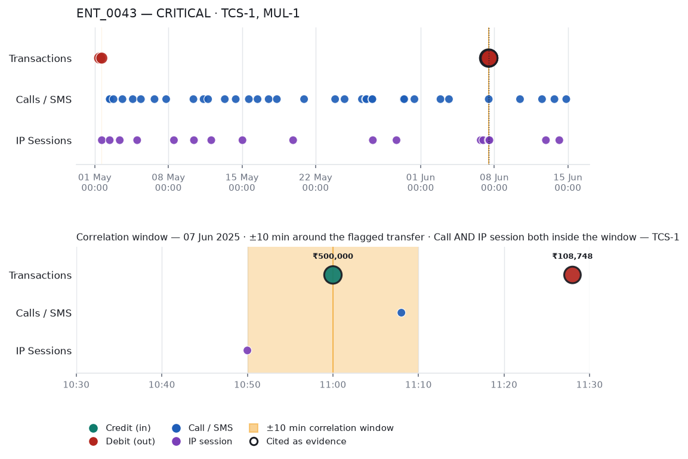

5. Total Value Involved
Total Aggregate Value of Suspicious Transactions: INR 950,239.00
Number of Transactions in Schedule: 7

6. Reporting Officer Certification
I hereby certify that the above transaction(s) have been reviewed and, based on the attached grounds of suspicion, are being reported as suspicious in accordance with the Prevention of Money Laundering Act (PMLA), 2002 and rules made thereunder.
Name of Principal Officer | ________________________
Designation | ________________________
Employee / Badge ID | ________________________
Contact Number | ________________________
Date of Filing | ________________________
Signature | ________________________
______________________________________________________________________
CONFIDENTIAL - SUSPICIOUS TRANSACTION REPORT - FOR FIU-IND FILING USE ONLY
Auto-generated by E-Rakshak Forensic Analysis Platform. Manual officer review and certification required before submission to FIU-IND.

