NEW Cheat Sheet

-git init

-git status

-git add .

-git commit –m “AnyComment”

-git status

-git remote add origin URL of repository

-git remote –v

-git push origin master

-git push origin master --force

Only single file

$git add filename.text

$git commit –m “comment”

-git push origin master --force

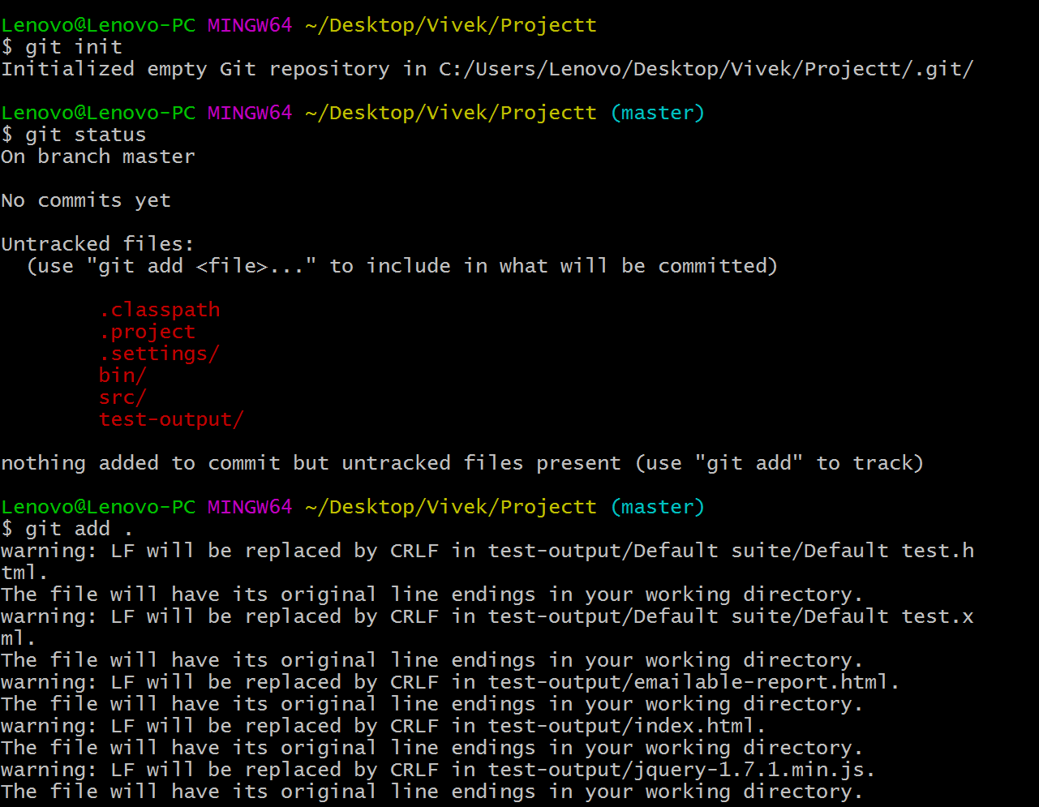

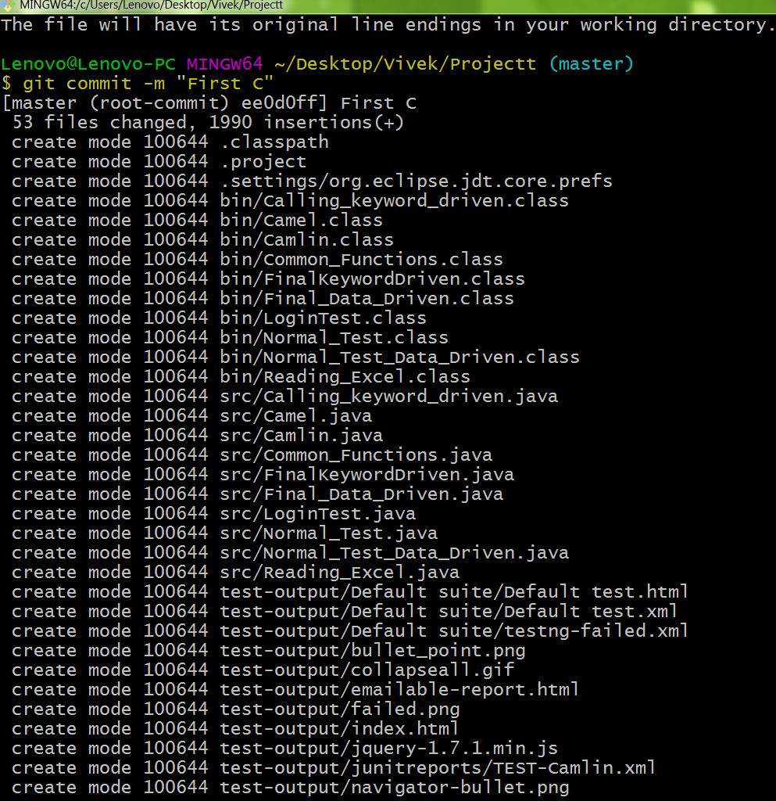

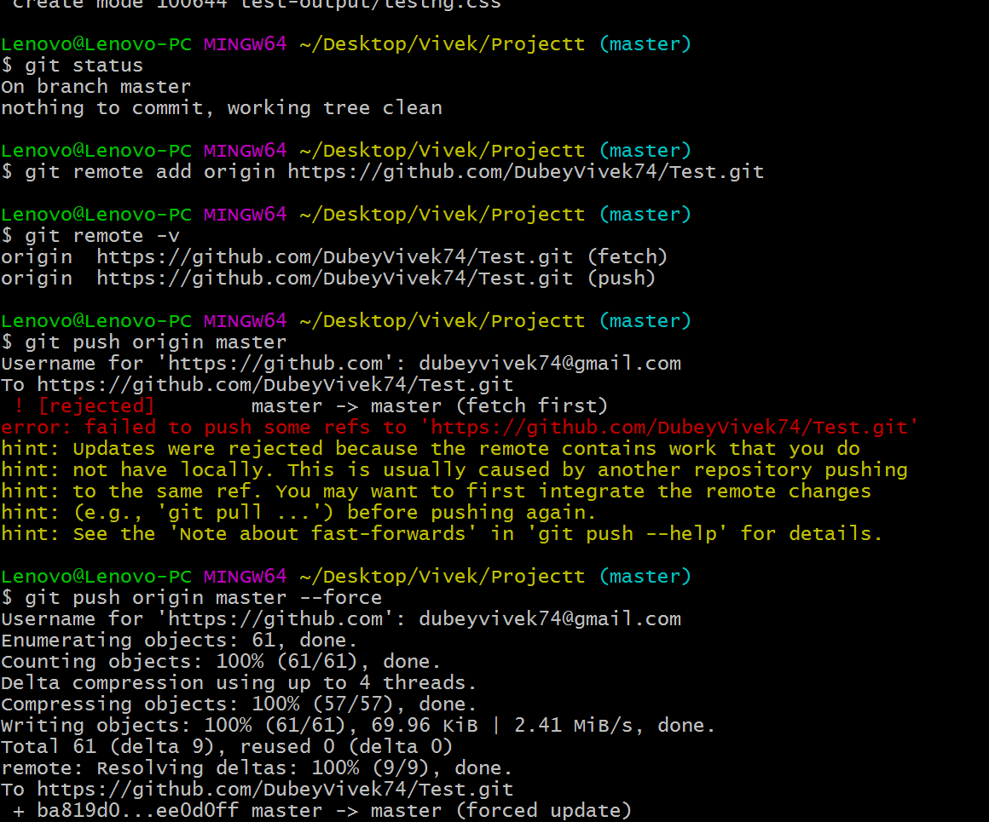

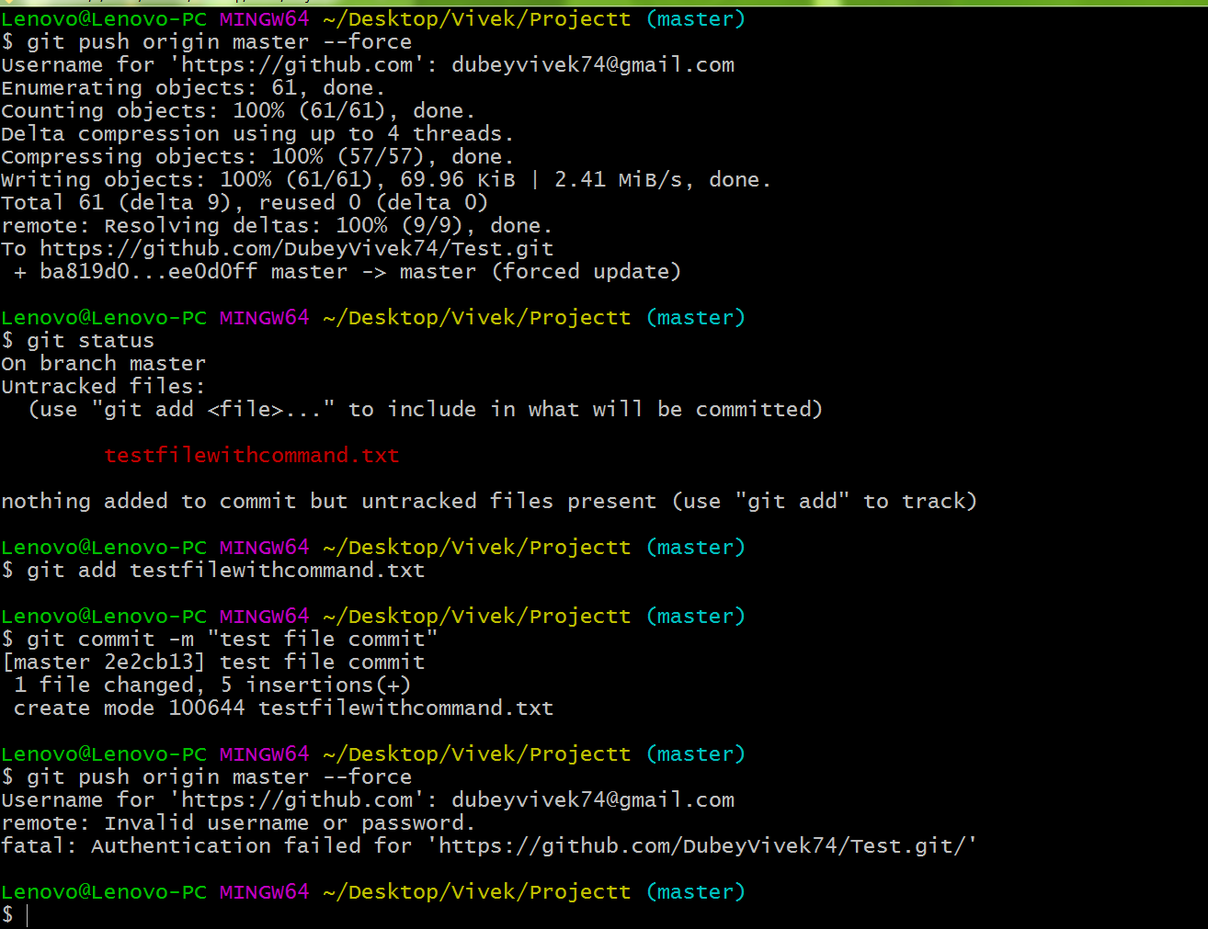

----TRIAL @

2

