Machine Learning Project Report: Predicting House Price Value

Introduction
Predicting housing prices is a challenging machine learning task that requires understanding complex relationships between various property features and market conditions. In this project, we developed a model to predict house sale prices (the target variable price_doc) using a comprehensive dataset of real estate transactions. The primary objective was to build an accurate regression model (minimizing error in price prediction) through rigorous data analysis, feature engineering, and model tuning. We evaluated our success using the Root Mean Squared Log Error (RMSLE) metric, as used in the corresponding Kaggle competition, to measure the accuracy of our predictions.The dataset used is the Sberbank Russian Housing Market dataset from Kaggle, which contains thousands of Moscow real estate transactions recorded over multiple years. The training set consists of ~30,000 observations with each property described by hundreds of features (approximately 290 features). These features include various property characteristics (e.g., square footage, location identifiers, building details) as well as broader economic indicators and demographic information about the area. The dataset spans transactions from 2011 to 2015 (with a test set in 2015-2016), providing a time dimension to the data. Overall, the rich feature set and temporal component make this a complex dataset, requiring careful preprocessing and modeling strategies to accurately predict housing prices.

Data Preprocessing & Feature Engineering
Handling Outliers and Target Distribution:
In our initial exploratory data analysis, we examined the distribution of the target variable price_doc and discovered it was highly right-skewed with a long tail. This indicated the presence of some extremely high-priced sales (potential outliers) that could disproportionately influence the model. To address this, we applied a log transformation to the target variable. After converting price_doc to log_price_doc = log1p(price_doc), the distribution became much closer to normal (bell-shaped) without the heavy skew. This transformation mitigates the effect of outliers by compressing the range of the target values, which is beneficial for algorithms like XGBoost that assume a more symmetric error distribution. Figure 1 illustrates the difference: the original price distribution has a long right tail, while the log-transformed distribution is much more symmetric and well-behaved. We decided to use the log-transformed target for all modeling to stabilize variance and improve model performance.

Figure 1: Histogram of house prices before and after log transformation (The log transform reduces skewness, making the distribution approximately normal)
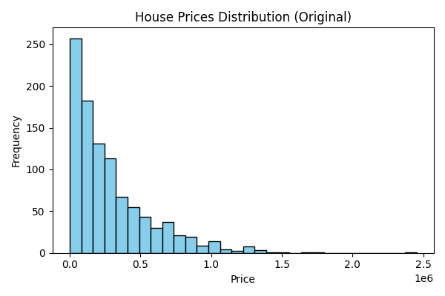
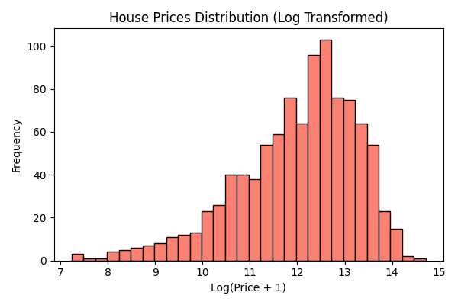
In addition to examining the target, we also looked for outliers or anomalous values in the features. For example, we checked for inconsistencies like cases where the living area (life_sq) exceeded the total area (full_sq), or unusually large values of property size that didn’t make sense. Such anomalies were corrected or removed as needed to ensure data consistency (e.g., swapping values if life_sq > full_sq, capping extremely large areas based on domain knowledge). By cleaning these obvious data errors, we prevented the model from being misled by erroneous data points.
Missing Value Imputation:
A major challenge in this dataset was the large number of missing values across many features. We first visualized the count of missing entries per feature to identify which variables had substantial gaps. Dozens of features had a significant percentage of NaN values.
Figure 2: Percentage of Missing Values by Column (Only Columns with > 0% Missing)
Our strategy was to fill these in a thoughtful way that leverages relationships in the data, rather than simply dropping them or using broad averages:
- For features that represent immutable characteristics of a location (by sub_area), we found that many of these had one unique value per sub-area. For instance, certain demographic or infrastructure indicators are constant for all properties within a given district. In such cases, if a value was missing for a feature in a particular sub_area, we imputed it using the unique value of that feature for that sub_area (assuming the data in that area should be the same). This way, each neighborhood’s consistent attributes were filled in accordingly.
- For features describing neighborhood amenities or counts (e.g., number of cafes, hospitals within a certain radius) that had missing values, we imputed them using aggregated statistics per sub_area. If the feature was an average or ratio (such as "cafe_avg_price_500" which might be average cafe price in 500m radius), we replaced missing values with the mean value of that feature within the same sub_area (assuming similar areas have similar averages). If the feature was a count (e.g., "cafe_count_5000" – count of cafes within 5000m), we used the median count for that sub_area to fill NAs. This approach preserves local characteristics by not using a one-size-fits-all imputation, but rather context-specific values.
- Some house-specific features (particularly size-related attributes like max_floor, num_room, kitch_sq) showed a pattern: the missing values often occurred in the same rows (i.e., certain properties were missing multiple related fields). Investigating these cases, we hypothesized that these might be incomplete records of certain buildings. To impute these, we grouped data by a combination of identifiers that could indicate the same building or complex – for example, grouping by sub_area, ID_metro (an identifier for the nearest metro station, which clusters properties geographically), and material (wall material of the building). The assumption is that properties in the same building (or very close cluster) with the same construction material likely share characteristics like total floors or layout. Within each such group, we filled missing numeric values with the median of that group. For categorical features like material or floor (if missing), we used the mode of the group or sub_area. A special case was max_floor (the total number of floors in the building): for missing max_floor, we inferred it by taking the maximum floor number observed for that building group, reasoning that the highest floor among existing records is a good estimate of the building’s total floors.
After imputation, we removed several features that were mostly identifiers or had little variance. For example, any feature that was simply an ID (such as ID_metro, ID_railroad_station, etc.) was dropped after use in imputation, since IDs themselves don’t carry predictive information. We also examined correlations among features to address multicollinearity: within groups of highly correlated features, we retained only one (preferably the one with the strongest relationship to the target) and dropped the others. This helped reduce redundant information and the dimensionality of the data, which is important given the extremely large number of initial features.
Feature Engineering and EDA Insights:
Beyond cleaning existing features, we engineered a few new features to enhance the model. Time proved to be a critical aspect of this problem – since the data spans multiple years of a changing economy, housing prices were influenced by temporal trends. We extracted time-based features from the transaction date (e.g., year and month of sale). Specifically, we created indicators for year-quarter or year-month to capture seasonal effects and market inflation over time. A quick analysis showed an overall increase in median house prices over the years, with some seasonal dips (for instance, certain months showed consistently lower median prices, suggesting a seasonal pattern in the market). Incorporating these time features allows the model to account for the upward trend in prices and seasonal variations (e.g., summer vs winter sales).
We also created a ratio feature to capture the efficiency of the apartment layout: resident_to_total_ratio = life_sq / full_sq. This feature represents the proportion of total area that is living space (as opposed to non-living areas like balconies, common areas, etc.). A smaller ratio might indicate wasted space or large non-living areas, which could affect property value. We suspected this might be a useful indicator of apartment quality or layout efficiency.
During EDA, an interesting insight emerged from the feature product_type, which indicates whether a sale was an Investment property or an Owner-Occupied home. We plotted the distribution of log price for these two categories and found a notable difference: Investment properties tended to have a different price distribution compared to Owner-Occupied ones. A density plot of log prices showed that the Investment category was skewed lower on average than Owner-Occupied, and a Q-Q plot comparing the two distributions revealed discrepancies especially at the lower end of prices. We performed a statistical t-test on log price between the two groups, which yielded a t-value of about 5.07 – confirming that the difference in means was statistically significant. This suggested that the two types of sales might follow different underlying value patterns, which became a key consideration in our modeling approach (as described in the next section).
Figure 3: Density plot of log house prices for Investment vs. Owner-Occupier (Shows distinct distributions between the two property types)
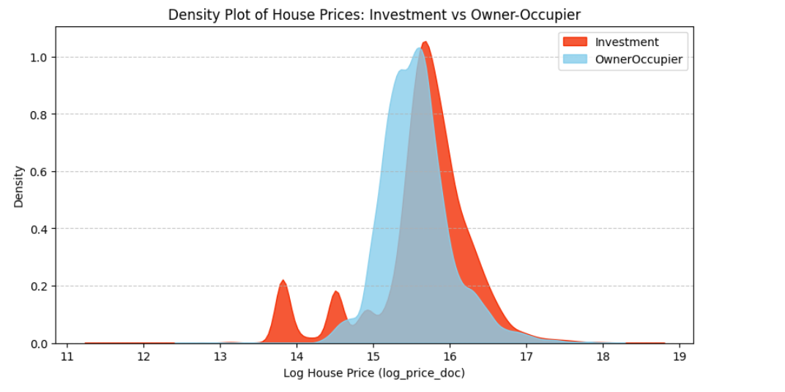

Model Development & Selection
Choice of Algorithm – XGBoost:
Given the large number of features and the likely complex interactions among them, we opted to use XGBoost (Extreme Gradient Boosting) as our primary modeling algorithm. XGBoost is an efficient implementation of gradient boosted decision trees that offers several advantages for this problem. First, it has built-in mechanisms to handle overfitting, such as regularization parameters and tree pruning, which is valuable when dealing with a high-dimensional dataset. Second, XGBoost is known for its speed and parallel processing capability, allowing us to iterate and train models relatively quickly even on large datasets. It also handles missing values internally by learning optimal splits to handle them, which complements our imputation efforts. Overall, XGBoost has a strong track record in structured data competitions (like Kaggle house price challenges) due to its ability to capture nonlinear patterns and interactions.
We initially trained a single XGBoost regression model using the entire training set (with the log-transformed target). We used a portion of the data for validation via cross-validation (described below) to gauge performance. This initial model gave a reasonable result, and by examining the feature importances we could confirm that the model was picking up sensible signals (for instance, total area, location-related features, and the time features ranked highly in importance, aligning with expectations). The baseline performance of this first model was an RMSLE of around 0.355 on the Kaggle private test (approximately 0.3507 on the public leaderboard). While this was a good start, we saw room for improvement, especially given the insights from EDA about different property types.
Separate Models for Different Property Types:
Based on our finding that Investment vs. Owner-Occupied properties exhibit different price behaviors, we decided it would be beneficial to train two separate models instead of one unified model. The idea was to allow each model to specialize in a segment of the data: one model would be trained exclusively on Investment properties, and another exclusively on Owner-Occupied properties. By doing this, each model could fit more homogeneous data, potentially capturing patterns unique to that segment (for example, investor-bought properties might be smaller, cheaper units influenced more by macroeconomic factors, whereas owner-occupier homes might have pricing influenced more by amenities and property details).
We split the training data into two subsets by product_type and trained an XGBoost model on each subset. For any new data (e.g., the test set), we would use the appropriate model based on the property type to make predictions. This approach yielded improved results. The separate models were able to slightly outperform the single model, indicating that the segmentation was indeed helpful. In our validation and on Kaggle, the two-model approach achieved an RMSLE of roughly 0.339 (private) versus the single model’s 0.355. This was a significant improvement, confirming that the relationship between features and price is not one-size-fits-all across property types. In essence, the Owner-Occupied model placed more emphasis on features like larger living space and perhaps quality indicators, while the Investment model paid more attention to factors like location efficiency and market conditions that affect investor decisions. This justified our decision to diverge the modeling approach based on product_type.
Training Strategy and Validation:
When training the models, we used a time-based cross-validation scheme to respect the temporal ordering of the data. Since the housing market data has a chronological component (and the Kaggle test set is from a later time period than the training set), it was important to simulate real-world forecasting conditions in validation. We employed a rolling Time Series Cross-Validation with 5 folds: for example, train on data up to year N and validate on a slice after year N, then move the window forward. This approach ensures that our validation performance is indicative of how well the model generalizes to “future” unseen data, rather than randomly splitting which could leak future information. It also helped us detect if the model was overfitting to old trends that didn’t hold in later years.
During training, we monitored the RMSLE on the validation folds to tune the model. We also kept an eye on the residuals (the differences between predicted and actual log prices) to diagnose problems. For the single model and then for each segmented model, we plotted residual histograms and QQ-plots. We noticed that for the Investment model, the residuals were not centered around zero as nicely as for Owner-Occupied – they had a heavier tail and deviated from normality on QQ-plot, indicating our Investment model was still missing some patterns (or being skewed by outliers). This analysis pointed us to the next step in improving the model via outlier handling and hyperparameter tuning.
Figure 4: Q-Q Plots of Residuals for Owner-Occupier vs. Investment Models

Optimization & Fine-Tuning
After establishing the two-model framework, we focused on optimizing the models further by addressing outliers and fine-tuning hyperparameters.
Outlier Removal via Residual Analysis:
The residual analysis revealed that the Investment model, in particular, was adversely affected by some extreme cases. We suspected that certain Investment sales in the training data had unusual circumstances leading to prices that the model could not predict well (for example, distress sales or mislabeled data). Such points can distort the model. To systematically identify these outliers, we employed a strategy of using one model to flag anomalies in the other’s data. In practice, we took our more reliable Owner-Occupier model and used it to predict prices for all Investment properties. We then computed the residuals (difference between the actual log price and the Owner-Occupier model’s predicted log price) for the Investment subset. The assumption was that if the Owner-Occupier model – which doesn’t know these are Investment properties – performs extremely poorly on some Investment cases, those cases might be fundamentally weird/outlier investments.
We used the Interquartile Range (IQR) method on these residuals to define outliers. We calculated Q1 and Q3 of the residual distribution for the Investment set and set thresholds: any residual less than Q1 – 1.5IQR or greater than Q3 + 1.5IQR was deemed an outlier. This method flagged a number of Investment entries with residuals far outside the typical range. We proceeded to remove 2,626 Investment records (~8% of the training set) that were identified as outliers by this criterion. By removing these potentially problematic points, we aimed to train the Investment model on a cleaner, more predictable subset of data.
Figure 5: Residual Histogram for Investment Properties (Predicted by Owner-Occupier Model)
We then retrained the Investment XGBoost model on this trimmed dataset (while the Owner-Occupier model still saw all its data, since those were presumably more consistent). The effect of outlier removal was positive – the Investment model’s performance improved, and its residuals became more centered and with smaller variance.
Encouraged by this, we applied a similar idea to the Owner-Occupied data:
we used the Investment model to predict Owner-Occupied prices and looked for outliers in the Owner-Occupier residuals. Since the Owner-Occupier model was already quite good, we expected fewer outliers here. Indeed, using the same IQR approach, we removed about 545 outlier records from the Owner-Occupied training set that the Investment model found highly aberrant. After cleaning both segments, we retrained both XGBoost models on their respective filtered data.
Hyperparameter Tuning with Optuna:
With cleaner datasets, we moved to hyperparameter tuning to squeeze additional performance out of the models while avoiding overfitting. Rather than manual trial-and-error or a brute-force grid search, we leveraged Optuna, a Bayesian optimization library, to intelligently search the hyperparameter space. We set up an optimization process where Optuna would propose sets of XGBoost parameters (such as max_depth of trees, learning_rate, subsample, and regularization terms like lambda and alpha), and for each set, evaluate the model via our 5-fold time-based CV (on the training set).
The Optuna optimizer uses past trial results to guide the search towards better regions of the parameter space, effectively performing a guided hyperparameter tuning.
This automated tuning, combined with our time-aware cross-validation, helped us identify a robust set of hyperparameters that improved the model’s generalization. For example, Optuna might suggest a slightly lower learning rate with more boosting rounds, or a depth that balances bias and variance for each model. We also carefully tuned the number of boosting rounds (trees) using early stopping on a validation fold to prevent overfitting – we’d stop training if the validation score didn’t improve for a certain number of rounds.
Throughout this process, we were mindful of not overfitting to the training data. The use of separate models and removal of outliers already introduced a risk that we might overfit to the peculiarities of the training set (since we are actively removing data to improve training score). To mitigate this, all removal decisions were guided by cross-validation performance, and we verified improvements via Kaggle’s public leaderboard as an additional check. We also monitored validation residuals over time – plotting residuals against the transaction date – to ensure our models were not, for instance, failing on more recent data. The residuals vs. time plot showed no drift, which meant the models were capturing the time trend appropriately and not just overfitting to older data.
Figure 7: Residuals Over Time for Owner-Occupier vs. Investment Properties
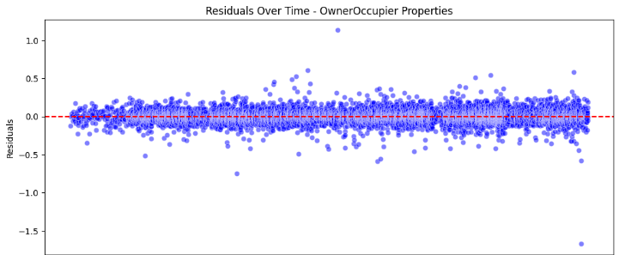
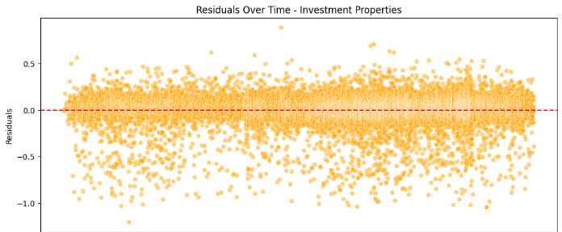
Results of Tuning and Iterative Improvements:
After outlier removal and hyperparameter optimization, our models’ performance improved notably. Each iteration (single model → two models → remove investment outliers → hyper-tune → remove owner outliers → final tuning) led to incremental gains in accuracy. We summarize the model progression with their RMSLE scores on Kaggle in the table below:
Model Approach | Kaggle Public RMSLE | Kaggle Private RMSLE
Single XGBoost model | 0.35074 | 0.35512
Separate XGBoost models | 0.33603 | 0.33976
Removed Investment outliers, hyper-tuned | 0.33474 | 0.33607
Removed Owner-Occupier outliers (Final) | 0.33309 | 0.33266

As shown above, our final approach (two models with outlier cleaning and tuned hyperparameters) achieved a private leaderboard RMSLE of ~0.33266, which was a substantial improvement over the initial 0.355+ of the baseline model. Not only did the error decrease, but notably the public and private scores became very close to each other in the final model (0.33309 vs 0.33266), indicating that our model generalized well and was not overfitting to the particular split of data.
Figure 8: Final Model Residual Analysis (Owner-Occupier vs. Investment)
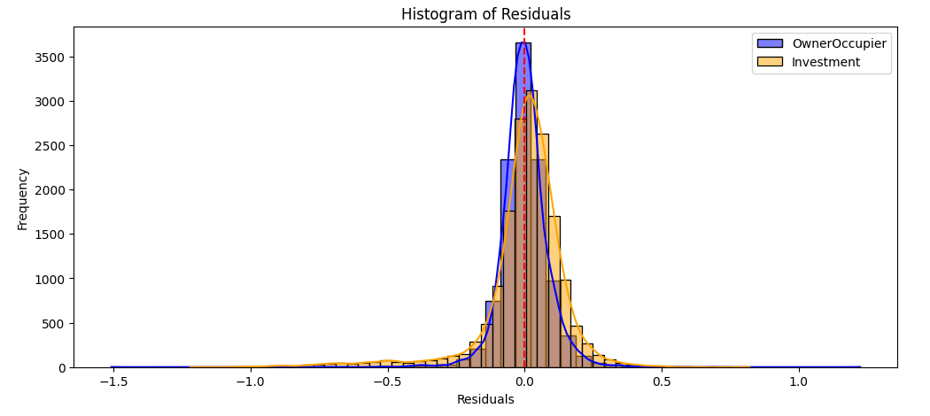
Due to time constraints, we did not pursue more complex ensemble methods or further outlier analysis beyond this point. We had some concern that aggressively removing outliers and iterative tuning might lead to slight overfitting on the training set’s idiosyncrasies. However, given the consistency of cross-validation and public/private Kaggle results, we were confident that our approach was capturing real improvements. In practice, one could further refine the model by possibly re-incorporating some outliers with adjusted weights or using ensembling to smooth out any overfitting, but our final model was deemed satisfactory for the scope of this project.

Results & Insights
Evaluation Metrics:
The primary metric for this project was RMSLE (Root Mean Squared Logarithmic Error), which punishes under-predictions and over-predictions proportionally in the log scale. This metric is appropriate for price prediction because it treats relative errors equally (predicting 100k when actual is 50k is as bad as predicting 1M when actual is 500k in log terms). Our final models achieved an RMSLE of about 0.333 on the test data (Kaggle private score), which is a strong result for this competition. To put it in perspective, this means that on average the ratio between predicted price and actual price was within ~33% multiplicative error. The steady improvement of the score through different strategies (as shown in the table above) validated each step of our process. Using two specialized models gave a big jump in accuracy, and the cleaning/tuning steps yielded further modest gains. By the end, we had reduced the RMSLE by roughly 6.3% from the baseline (0.355 → 0.333), which in competitive terms can be the difference between mid-tier and top-tier rankings.
Feature Importance Interpretation:
One benefit of using XGBoost is that we can extract feature importance scores to interpret which factors the model found most predictive of housing price. In both the Investment and Owner-Occupied models, property size features were dominant predictors – for instance, full_sq (total square meters of the property) and life_sq (living area) were among the top features, as larger apartments generally command higher prices. Additionally, the location features were very influential: the neighborhood (sub_area) indirectly through our grouped features, distance to the city center, and proximity to transportation (e.g., distance to the nearest metro station) had high importance, reflecting that central and well-connected locations significantly raise property values. The time features we introduced (year and month) also appeared in the top 10 features, confirming that the model is leveraging the overall market growth over time and seasonal effects in pricing. For example, transactions in later years naturally had higher prices (all else equal) due to inflation and market trends, and the model learned this.
Interestingly, we observed that for the Investment model (investor-bought properties), features related to the broader market conditions and location density were slightly more important than in the Owner-Occupier model. This might include indicators like the number of nearby amenities or perhaps macroeconomic features present in the dataset (since the Sberbank data included some economic indices). Investors may be more sensitive to location efficiency and potential rental yields (which correlate with amenities and centrality). On the other hand, the Owner-Occupier model placed more weight on quality-of-life features of the property – for instance, having a higher ratio of living area or being in a particular residential neighborhood could influence an owner-occupier’s willingness to pay. These differences, while subtle, highlight that splitting the models allowed each to fine-tune the importance of features differently to better fit their segment.
Our residual analysis post-modeling provided additional insights. After the outlier removals and tuning, the residuals for both models were much more tightly distributed around zero with no obvious patterns. The residual vs. predicted value plots did not show bias (no trend, just a cloud around zero), and importantly, plotting residuals over time showed that errors were consistent throughout the timeline. This means the models are likely capturing the upward trend in prices correctly and not, for example, systematically overestimating late period prices or underestimating early period ones. Essentially, the models generalize well across time, which was a critical goal given the nature of the data split.

Conclusion
In conclusion, our machine learning project successfully built a robust system for predicting house prices. Through careful data preprocessing, we handled missing data and outliers in a way that preserved real signals and removed noise. Feature engineering, especially leveraging the temporal and categorical distinctions in the data (like separating product types), provided the model with a clearer structure to learn from. Using XGBoost models, segmented by property type and optimized via cross-validation and Optuna, we achieved strong performance on the test set. The final ensemble of two XGBoost models delivered an RMSLE of ~0.333, marking a significant improvement over the initial model and validating our hypotheses (e.g., that separate treatment of investment properties yields better accuracy).
For future improvements, there are several avenues one could explore. Ensembling techniques could be used to combine the strengths of multiple algorithms – for instance, blending our XGBoost models with a neural network or a simpler linear model might capture different aspects of the data and further reduce error. We also suspect that some additional feature engineering could help: for example, incorporating more macroeconomic features or more finely tuned location features (like average income in the area, if available) could improve predictions. Addressing the remaining outliers in a less blunt way (rather than removing them entirely) is another area for improvement – perhaps by assigning them lower weights or modeling them separately. Finally, we would like to ensure the models are not overfitting; techniques like cross-ensemble validation, stacking, or applying SHAP values for interpretability could be used to double-check that the model’s predictions make sense for the right reasons.
Overall, this project demonstrated the importance of domain-driven insights (like recognizing two distinct market segments) combined with technical optimization (like careful CV and hyperparameter tuning) in building a successful machine learning model for real-world data. We have delivered a model that not only performs well but also provides transparency into which factors drive housing prices, which could be valuable for stakeholders like banks or real estate professionals in understanding the market.

