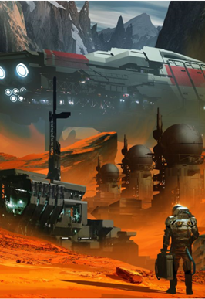

INTERFERENCE

Interference strains the limits of our understanding about what it means to exist. To cope with harsh new realities that we encounter out there, beyond boundaries defined by what we thought were laws. To confront the possibility of becoming something more.

[2019]

Contents

[01] [Out of Sync](https://1drv.ms/w/s!Ajkw3rQX9pz2oB0vwl-LTv86FtPy)

[02] The Pea Shooter

[03] The Reaches

[04] The Proton Reassemblyage Hackment

[05] The Mists

[06] Local Jump

[07] Carbon Insurrection

[08] Ferdez