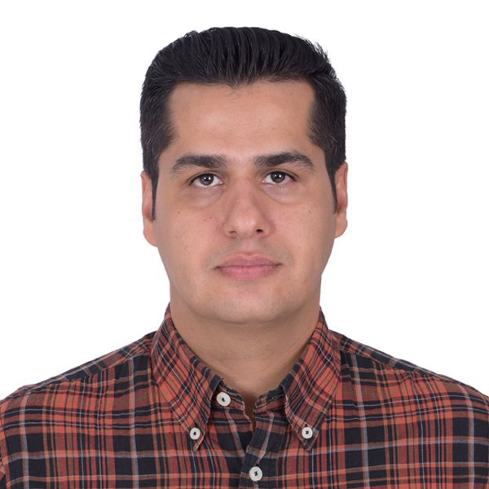

|  |  |
| --- | --- |
|  | Leeghwaterstraat 342, 2628 LX, Delft, The Netherlands. |
|  | 21/September/1983 |
|  | +31618711362 |
|  | [esmaeilimousa@gmail.com](mailto:esmaeilimousa@gmail.com) |
|  | linkedin.com/in/esmaeili-mousa |

**Mousa Esmaeili**

**MSc. of Animal Science**

|  |  |  |  |  |  |  |  |
| --- | --- | --- | --- | --- | --- | --- | --- |
| **Profile** | An executive Animal Science graduate from IA‌ University of Isfahan. Result-driven professional with proven service development and management experience. Accomplished in determining the most optimal operational practices, achieving all objectives and ensuring smooth operations.  I have always enjoyed handling new challenges in my life since they have made me a far-sighted, open-minded, hard-working, self-motivated and independent person with dogged perseverance. | | | | | | |
| **Expertise** | Negotiation  Leadership | Time Management  Teamwork | | | Verbal & Written  Communication | | |
| **Professional**  **Experiences** | Aug **2019-** Present | | **Distributor**  Syngenta | | | Part-time  Netherlands | |
| * Opzetten en Afhalen | | | | | | |
| Jun **2018-** Jun **2019** | | **Poultry Nutritionist**  AmirYusefi Feed Co. | | | Full-time  Iran | |
| * Presenting specialized services as a technical expert to consumers of feed. * Analyzing data of research projects and assessing the result of flocks. | | | | | | |
| May **2016-** Jun **2018** | | **Head of Export Department**  Sepahan Daneh Parsian Co. | | | Full-time  Iran | |
| * Set up the team of export unit and foreign sales marketing in Afghanistan, Iraq, GCC and CIS countries. * Developed a fast delivery service for international customers. * Familiar with the tariff code and custom documents. * Poultry and livestock's nutrition advisor in Afghanistan, Iraq, Qatar, Uzbekistan, and Oman customers of supplements, concentrates and feeds. * Visit flocks to assess condition and performance, supervision on unit management in Afghanistan, Iraq, Uzbekistan, Qatar, and Oman. * Analyze data and results of farms in Afghanistan, Iraq, Uzbekistan, Qatar, and Oman. * In charge of the company pavilion in international exhibitions in Afghanistan, Iraq, Uzbekistan, Qatar, and Oman. | | | | | | |
| Sep **2015-** May **2016** | | **Head of Technical Marketing and Services**  Sepahan Daneh Parsian Co. | | | Full-time  Iran | |
| * Led a team of Nutrition Specialists for poultry farms in Iran. * Developed an understanding of customer service and relations. * Supervision on unit management and feed processing by using supplements or concentrates on the customers' farms. * Analyze data and information about farms and assessing the result of flocks. | | | | | | |
| Dec **2013-** Sep **2015** | | **Poultry Nutrition Specialist**  Sepahan Daneh Parsian Co. | | | Full-time  Iran | |
| * Nutrition Specialist for all kind of broiler and layer farms in Iran. * Suggested some balanced diets based on chicken data and other factors, during the rearing period. * Regular visits from flocks to assess condition and performance, supervision on unit management and feed processing by using a supplement or concentrate on the farms. * Improved the performance results and yield of customers' farms. | | | | | | |
| Apr **2013-** May **2014** | | **Animal Technical Specialist**  Behbud Kavir Zenderud | | | Full-time  Iran | |
| * Nutrition Consultant of the Crap fishery farm. * Supervision on unit management. | | | | | | |
| Aug **2006-** Mar **2011** | | | **Broiler Farm Manager**  Self-employed | | | Full-time  Iran |
| * Unit management and feed processing by using supplements or concentrates. | | | | | | |

|  |  |  |  |  |
| --- | --- | --- | --- | --- |
| **Education** | Sep **2011-** Feb **2016** | | **M.Sc.** inAnimal Science - Animal Breeding  Faculty of Agriculture, Islamic Azad University of Isfahan (Khorasgan), Iran. | |
| Sep **2001-** Jul **2006** | | **B.Sc.** in Animal Science  Faculty of Agriculture, Islamic Azad University of Isfahan (Khorasgan), Iran. | |
| **Courses** | Feb **2020-** May **2020** | | **Animal Breeding and Genetics**  Professional Certificate Program  Wageningen University & Research - edx,  Prof. Hans Komen et al., (3 months - MOOC). | |
| Sep **2019-** Oct **2019** | | **Chicken Behaviour and Welfare**  University of Edinburgh - Coursera,  Dr. Victoria Sandilands, (5 weeks - Webinar). | |
| Dec **2012** | | **Ostrich and Quail Rearing**  Entrepreneurship Development Center, Islamic Azad University of Isfahan, Iran, (16 hours). | |
| Apr **2010** | | **General English Courses**  EC English Language School,  Cape Town, South Africa, (1 week). | |
| Apr **2003-** Sep **2003** | | **Honeybees Breeder**  Technical & Vocational Training Organization,  Isfahan, Iran, (224 hours). | |
| **Volunteer Experience** | Feb **2012-** Mar **2013** | | **Sholi Research Station** | |
| * Worked as part of the research group in the field of Lori-Bakhtiari sheep genetic data analyzer. * Collecting records and estimation of genetic parameters. | | | |
| Mar **2011-** Jun **2011** | | **Shahid Fazweh Research Station** | |
| * Worked as part of the research group in the field of broiler chickens’ diet. * Included effects of onions on chicken body weight and immune system. | | | |
| Jul **2005-** Sep **2005** | | | **Dasht Abi - Rainbow Trout Farming Co.** |
| * Worked as part of the research group in the field of recirculating aquaculture system. | | | |
| **Skills** | **Language:** | Farsi (Persian): Mother tongue  English: Fluent in conversation, reading and writing  Dutch: Basic  Arabic: Basic | | |
| **Computer:** | UFFDA, MSOffice, Matlab, R, CRM, AutoCAD, Adobe‌Photoshop. | | |
| **Hobby** | Cycling, Hiking, Swimming, Traveling, Music. | | | |
| **Conference Papers** | M. Esmaeili, M.A. Talebi, S. Eghbalsaied, "**Estimation of Genetic Parameters of Reproductive Traits in Lori-Bakhtiari Sheep Using Threshold Model (presented in Persian)**", presented at [The National Congress of New Technologies in](https://www.civilica.com/Calendar-NTAS01=%DA%A9%D9%86%DA%AF%D8%B1%D9%87-%DB%8C-%D9%85%D9%84%DB%8C-%D9%81%D9%86%D8%A7%D9%88%D8%B1%DB%8C-%D9%87%D8%A7%DB%8C-%D9%86%D9%88%DB%8C%D9%86-%D8%AF%D8%B1-%D8%B9%D9%84%D9%88%D9%85-%D8%AF%D8%A7%D9%85%DB%8C.html) [Animal Sciences](https://www.civilica.com/Calendar-NTAS01=%DA%A9%D9%86%DA%AF%D8%B1%D9%87-%DB%8C-%D9%85%D9%84%DB%8C-%D9%81%D9%86%D8%A7%D9%88%D8%B1%DB%8C-%D9%87%D8%A7%DB%8C-%D9%86%D9%88%DB%8C%D9%86-%D8%AF%D8%B1-%D8%B9%D9%84%D9%88%D9%85-%D8%AF%D8%A7%D9%85%DB%8C.html), November 20 - 21, 2013, Islamic Azad University of Isfahan (Khorasgan), Isfahan, Iran. | | | |
| **Reference** | Prof. Majid Toghyani, Department of Agriculture-Animal Sciences, Islamic Azad University of Isfahan (Khorasgan), Isfahan, Iran, toghiani@hotmail.com, +989133141302. | | | |
| Dr. Shahin Eghbalsaied , Associate Professor, Department of Agriculture-Animal Sciences, Islamic Azad University of Isfahan (Khorasgan), Isfahan, Iran, [shahin.eghbal@khuisf.ac.ir](mailto:shahin.eghbal@khuisf.ac.ir), +4915221498860. | | | |
| Dr. Mohammad Ali Talebi, Associate Professor, Department of Animal Science Agriculture and Natural Resources Research Center, Shahrekord, Iran, [maitalebi@yahoo.com](mailto:maitalebi@yahoo.com), +989131833943. | | | |