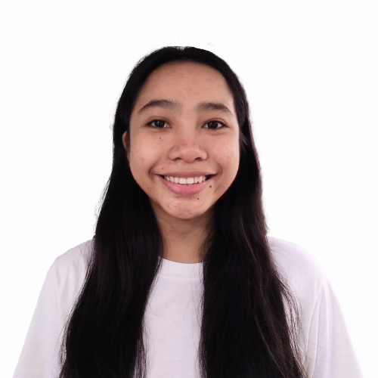**ARABELA KHALE D. VIDAD**

Santa Victoria (Villa Capuchino), Naguilian, Isabela

0921-747-9189

[bellangvidad@gmail.com](mailto:bellangvidad@gmail.com)

**OBJECTIVE**

Seeking for a host training establishment and position that will utilize my fullest potential that will give opportunities to enhance my personality and career growth, and be part of the team making a contribution to the improvement of human health and welfare. I also would like to share my knowledge and skills in this field through active and responsible involvement.

**EDUCATIONAL ATTAINMENT**

* **Senior High School**

Science, Technology, Engineering and Mathematics (STEM)

School of Saint Joseph (Naguilian, Isabela) Inc.

Quezon, Naguilian, Isabela

2018 - present

* **Junior High School**

School of Saint Joseph (Naguilian, Isabela) Inc.

Quezon, Naguilian, Isabela

2014 - 2018

* **Elementary**

Santa Victoria Elementary School

Santa Victoria (Villa Capuchino), Naguilian, Isabela

2008 - 2014

**WORKING EXPERIENCE**

**SKILLS**

* Can operate Microsoft office (Microsoft Word and Microsoft PowerPoint)
* Can work under pressure
* Fast learner
* Good communication skills both English and Filipino

**PERSONAL DATA**

Birthday: September 21, 2002

Birthplace: Cabaruan, Naguiilian, Isabela

Nationality: Filipino

Language spoken: Ilocano and Filipino

**EXTRA CURRICULAR**

* Mathematics Club President
* English Club Officer
* Assistant Editor - in - chief
* Classroom Officer

**CHARACTER REFERENCES**

* Hermelyn S. Galasi

Senior High School Coordinator

School of Saint Joseph (Naguilian, Isabela) Inc.

0905-777-1730

* Lucila B. Aggari

School Principal

School of Saint Joseph (Naguilian, Isabela) Inc.

* Juanito Agbunag

Barangay Captain

Santa Victoria (Villa Capuchino), Naguilian, Isabela

I hereby certify that the above information is true and correct on behalf of my knowledge.

**ARABELA KHALE D. VIDAD**

Work Immersion Applicant