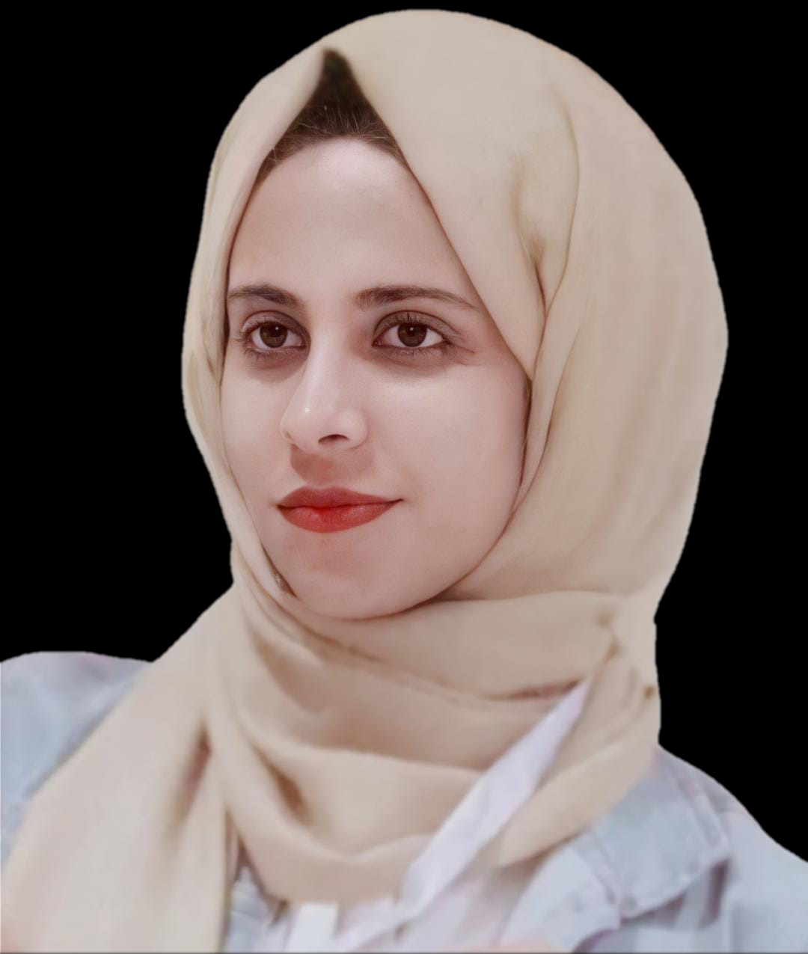

**CAREER OBJECTIVE**

A creative, hard-working and ambitious fresh graduate pharmacist, who is looking for the role of medical representative in a reputable organization to incorporate my knowledge, skills, and training in business development. I possess brilliant presentation skills along with sales certifications, and always open to learning new things to help the company and my future peers grow.

**EDUCATION**

2021 Bachelor’s degree of Pharmacy, The British University in Egypt (GPA: 3.1 - very good)

Graduation project: Anise & Star anise bioactivity assays. (grade: 99%)

2016 The International School of Choueifat – Abu Dhabi

**INTERNSHIPS & ACTIVITIES**

**July 4 – 15, 2021**

Children Cancer Hospital Egypt-57357

Clinical Pharmacy Intern

- Understand the work flow inside the pharmacy, identify the pharmacist’s role in oncology and chemotherapy prescriptions, and apply the knowledge into practice through various case discussions regarding inpatient and critical care areas.

**September 2016 – June 2021**

Student Representative

* Managing and maintaining vital communication between college and students.

**September 2020 – October 2020**

Double Bond Pharmaceutical

Pharmaceutical Business Intern

In a team of 4 members, we worked on a project idea called “Dr. Avocado”, a dieting website tailored to suits every healthy lifestyle seeker, with an affordable price.

**August 2020 – October 2020**

AstraZeneca Company

Medical Representative Intern

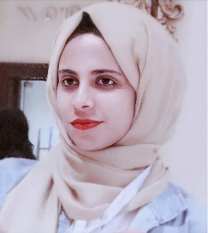Presenting Symbicort turbuhaler to 35 Pharmacies in Giza. In addition, persuade them to download PharmaZy, a new medical application developed by AstraZeneca. Overall, among the top 30 performers, I won 11th place.

**September 2020 – October 2020**

Egyptian Youth Initiative jointly by NPC, UNICEF & WHO

Actively Participating in the Health Awareness Educational Training for “COVID-19 and Mental Health” session.

**September 1- 22, 2020**

Sandoz, Novartis Division Company

Pharmaceutical Companies' Business Functions Roles Intern

A knowledgeable and fruitful internship in aspects of sales, marketing, supply chain management, human resources, pharmacovigilance and regulatory affairs.

**August 2020 – September 2020**

Hikma pharmaceuticals Egypt

Medical representative intern

A valuable experience and insight into the pharmaceutical industry. We learn how to work effectively, efficiently, and ethically within a professional environment, across business operations and corporate functions.

**July 2020 – August 2020**

EVA Pharma

Medical representative intern (Excellent grade)

A comprehensive understanding of all aspects of the pharmaceutical industry's roles, as well as useful workshops on the necessary soft skills. Besides, working as a medical representative to present and educate pharmacists about Limitless C-Zinc, to increase its sales. In addition, keeping accurate and up-to-date records with follow-up actions.

**August 2019 – December 2019**

El Tarshouby Pharmacies Group

Assistant Pharmacist

Ensured safe and accurate supply of medical products to patients, performed accurate dose calculations and patient counseling, and Learned the ability to handle customers effectively and providing the best service possible. 

**CERTIFICATES**

* (2020 - 2021) First place as the best research project presenter. Provider: Prof. Mohey Elmazar, the founding dean of faculty of pharmacy at the British University in Egypt.
* (2020) Excellent grade as medical representative intern. Provider: EVA talent internship academy.
* (2020) Marketing essentials in pharmaceutical companies workshop. Provider: Dr. Rami Azab, marketing and market access director in Mundipharma.
* (2019) Accredited by the European accreditation council for continuing medical education (EACCME) for attending the Arab African International Cancer Congress.
* (2012) Third bestProject “Eye Stick” in the field of Technology, Safety System, at Think Science National Competition. Honored by **His Highness Sheikh Abdullah bin Zayed Al Nahyan, Minister of Foreign Affairs & International Cooperation and Chairman of Emirates Foundation.**

**COURSEWORKS**

* Introduction to business management (16 hrs) - King’s College London online course.
* Pharmacy practice course about upper respiratory tract, gastrointestinal system and ophthalmic cases (30 hrs)

– El Ezaby training department.

* Non communicable diseases pharmacotherapy program (30 hrs) – Clinical Pharmacy Academy.
* Healthcare marketplace (25 hrs) – coursera (University of Minnesota).
* Market research and consumer behavior (20 hrs) - Coursera (IE Business School).
* Brand and product management (30 hrs) - coursera (IE Business School).
* Drug commercialization (20 hrs) - coursera (University of California San Diego).
* Managing project risks and changes (25 hrs) – coursera (University of California, Irvine).
* Projects management: the basics for success (20 hrs) - coursera (University of California, Irvine).

**SKILLS**

**Languages:** Arabic(Native)

English (Very good)

**Computer:** Microsoft Office - Word, Excel, PowerPoint & Outlook (Excellent)

**Personal:**

* Presentation Skills
* Team building skills
* Persuasion and negotiation
* Communication skills
* Multi- tasking skills
* Close attention to details
* Problem solving and objection handling
* Resilient (flexibility)
* Eagerness to learn
* Active listening
* Adaptability