**❓ Questions ❓**

**🏗️Instructions 🏗️**

⚠️ Read the questions carefully ⚠️

⚠️ Make sure to discuss all questions ⚠️

⚠️ All coloring and arrangement should match with the provided design ⚠️

----------------------------------------------------------------------

1️⃣ You are required to clone the design that is provided to you below

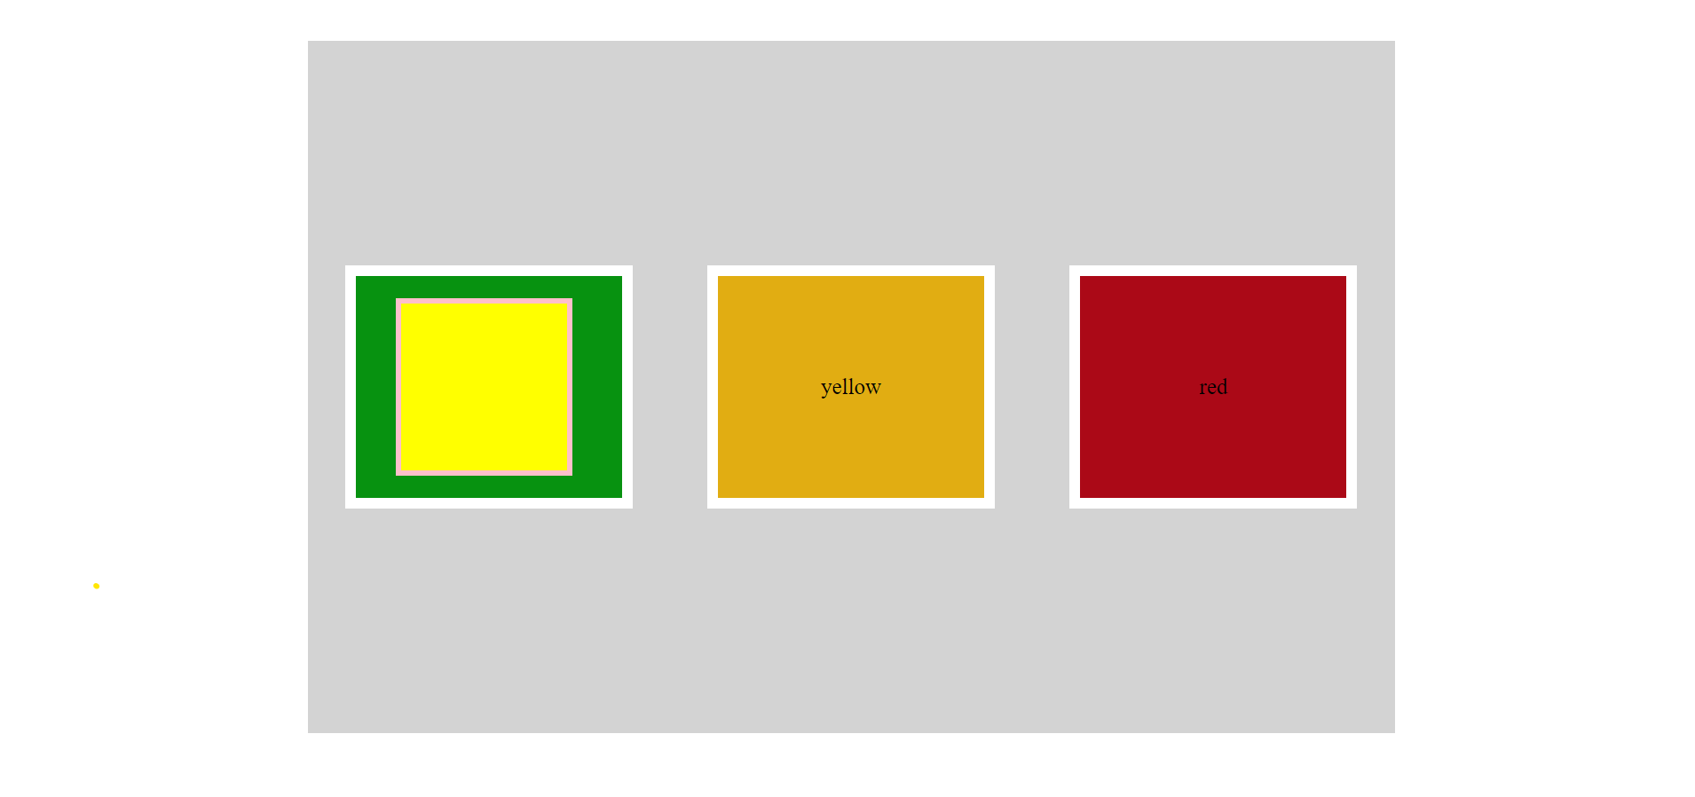

💻 Happy codding 💻

🕥 1:00hr 🕥